VeggieMap
An Engineering Project in Community Service
Phase – II Report
Submitted by

Vinay Kumar 23BAI10125
Atharva Prashant Pagar 23BAI10478
Anish Dhananjay Pawar 23BCE11329
Omni Sharma 23BAI10207
Navneet Sharma 23BCY10030
S DHANUSH 23BCE11429

in partial fulfillment of the requirements for the degree of
Bachelor of Technology

VIT Bhopal University
Bhopal
Madhya Pradhesh

March, 2026

Acknowledgement
The successful completion of the VeggieMap project has benefited significantly from the guidance, support, and collaboration of several individuals. While it is difficult to name everyone who contributed, we would like to extend our sincere gratitude to those who made this work possible.
First and foremost, we would like to express our deep sense of gratitude to our project supervisor, Dr Shahana Gajala Qureshi, for their invaluable guidance, constant encouragement, and technical insights throughout the development of this real-time vendor locator system. Their expertise in software architecture helped us navigate the complexities of geospatial indexing and live data streaming.
We are also thankful to VIT Bhopal University for providing the academic environment and resources necessary to carry out the EPICS (Engineering Projects in Community Service) initiative, which allowed us to work on a solution with a direct social impact.
Finally, we are grateful to our friends and family for their continuous moral support and to the open-source community, whose tools allowed us to deploy this project within a zero-cost architecture.

Abstract
In the present work, we have designed and developed VeggieMap, a real-time, hyperlocal marketplace platform built using the MERN stack (MongoDB, Express.js, React/Next.js, Node.js) to bridge the communication gap between local vegetable vendors and consumers. The core problem addressed is the lack of visibility for mobile hawkers and pop-up shops, which makes it difficult for consumers to locate fresh produce in real-time.
The proposed system utilizes a dual-vendor model that supports both static shop locations and dynamic, moving handcarts. To achieve seamless real-time tracking, we implemented a robust backend architecture leveraging Socket.io for bi-directional communication and MongoDB’s 2dsphere geospatial indexing for high-performance proximity queries. A key innovation in our approach is the "Geo-Room" partitioning strategy, which divides the map into spatial grids to optimize data broadcasting, ensuring that location updates are only sent to relevant users in a specific geographic area.
The frontend is developed as a Progressive Web App (PWA) using Next.js 16, incorporating Leaflet.js for interactive mapping and Supercluster for efficient marker management. Our results demonstrate a functional "Uber-like" tracking effect for mobile vendors, allowing consumers to view moving markers and updated inventories without manual page refreshes. This project offers a zero-cost, scalable deployment solution that empowers small-scale vendors through digital visibility while providing consumers with an intuitive discovery interface.

Index
Sl. No. | Topic | Page No.
1. | Introduction | 7-8
1.1 | Motivation | 9-10
1.2 | Objective | 10-11
2. | Existing Work / Literature Review | 11-13
3. | Topic of the work  (a) System Design and Methodology  (b) Working Principle  - Results and Discussion  - Individual Contribution by members | 13-17
4. | Conclusion | 17-18
5. | Reference | 19-21
6. | Biodata with Picture | 21-25

1. Introduction
The rapid digitization of retail has transformed how consumers access goods, yet the hyperlocal vegetable market specifically mobile hawkers and small-scale vendors remains largely disconnected from the digital ecosystem. In many urban and semi-urban areas, consumers rely on the unpredictable arrival of street vendors or must travel to fixed markets without knowing the current stock or pricing. VeggieMap is designed to bridge this gap by providing a real-time, geospatial platform that connects consumers with both static shops and moving handcarts.
Problem Statement
Traditional vegetable vending suffers from a lack of real-time visibility. Mobile vendors (hawkers) move through neighborhoods without a fixed schedule, making it difficult for residents to locate them when needed. Conversely, vendors lose potential sales because they cannot alert nearby customers of their proximity or daily inventory. Existing map services are often optimized for permanent businesses and do not support the high-frequency location updates required for moving street carts.
Project Objectives
The primary goal of this project is to create a dynamic marketplace that prioritizes user experience and real-time accuracy. The specific objectives include:
- Real-Time Tracking: Implementing continuous location streaming for mobile vendors to provide an "Uber-like" experience for consumers.
- Geospatial Search: Enabling efficient filtering of vendors based on proximity and specific inventory keywords using advanced database indexing.
- Dual Vendor Support: Creating a unified system that handles the distinct needs of fixed shop locations and dynamic, moving hawkers.
- Scalable Architecture: Utilizing a "Geo-Room" partitioning strategy to ensure the system remains performant as the number of users grows.
- Zero-Cost Deployment: The application is deployed on an AWS EC2 instance (Ubuntu 22.04) with Nginx as a reverse proxy and PM2 for process management, accessible at https://veggiemap.codewithvin.app.
VeggieMap utilizes the MERN Stack (MongoDB, Express.js, React/Next.js, Node.js) combined with Socket.io to facilitate live communication. By utilizing the browser’s Geolocation API and native mobile GPS services, the platform allows vendors to broadcast their live coordinates. On the consumer side, an interactive map rendered with Leaflet.js displays these updates instantly, allowing users to find fresh produce nearby with minimal effort.
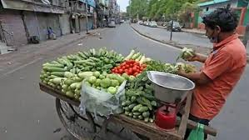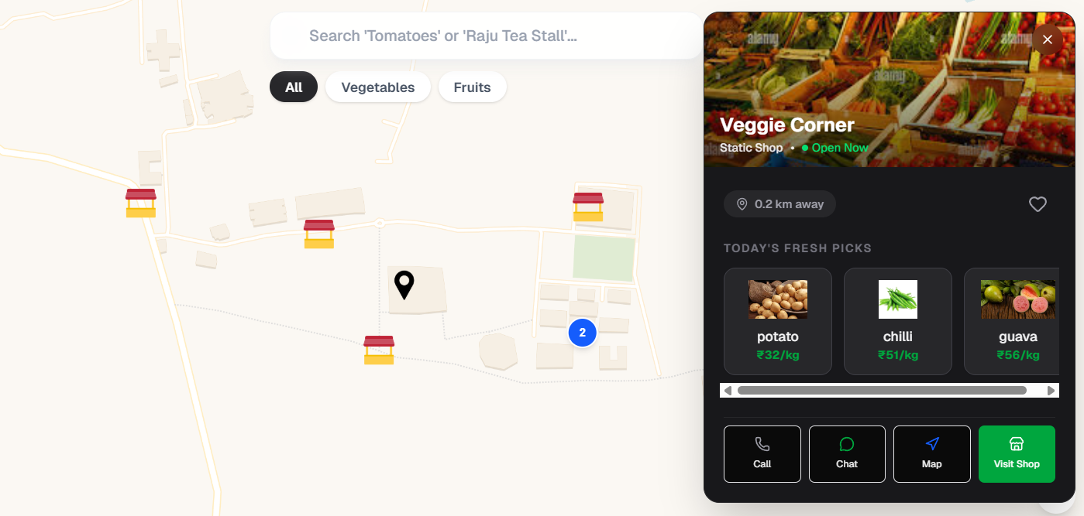
Figure 1.1: Visualizing the transition from traditional, disconnected street vending to a digitally mapped hyperlocal ecosystem.
1.1 Motivation
The development of VeggieMap is driven by the need to modernize the hyperlocal food supply chain through technology. The motivation for this project stems from several critical challenges faced by both vendors and consumers in the traditional marketplace:
- Empowering the Unorganized Sector: Mobile hawkers and street vendors are the backbone of the fresh produce economy but remain invisible to digital search tools. This project aims to provide them with a digital identity and the "Uber-like" ability to broadcast their live location.
- Solving Consumer Information Asymmetry: Consumers often lack real-time data on the proximity and inventory of nearby vendors. VeggieMap addresses this by providing a live, searchable map of both static and mobile shops.
- Technical Innovation in Geospatial Data: Building a system capable of handling high-frequency location updates for moving entities serves as a significant technical motivator. Implementing efficient "Geo-Room" partitioning and 2dsphere indexing provides a deep dive into scalable backend architecture.
- Resource Accessibility: A core motivation was to prove that a sophisticated, three-tier real-time application can be built and deployed using zero-cost, free-tier cloud services.
- Enhanced User Experience: The project seeks to move beyond static listings to a superior native-like mobile experience that includes live markers, marker clustering, and instant inventory updates.
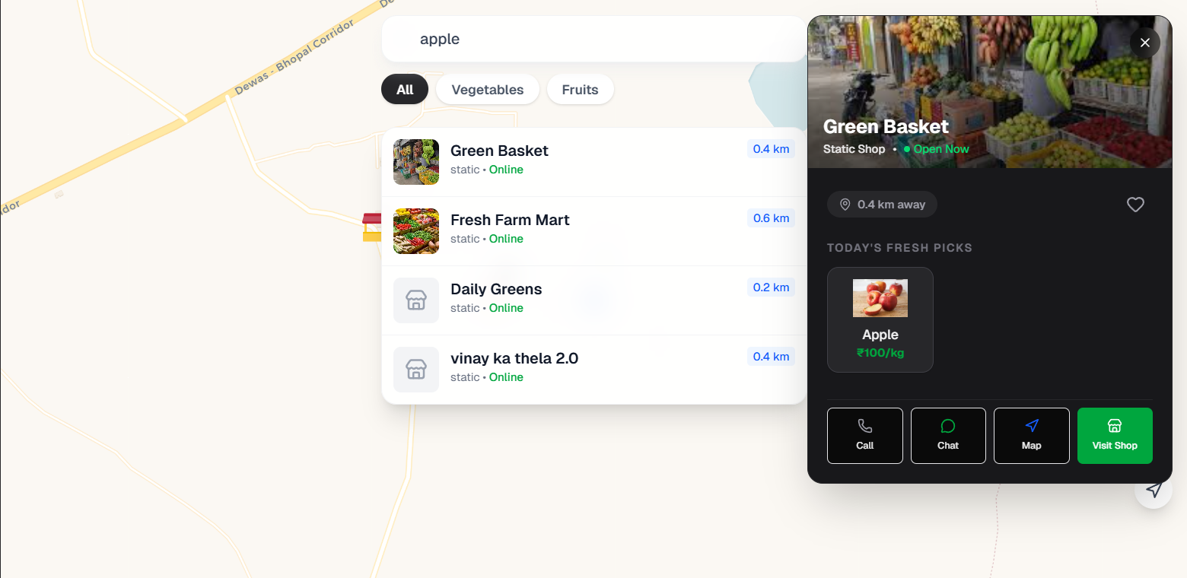
Figure 2.1: Illustration of the current visibility gap of nearby static vendors and consumers.

1.2 Objective
The primary objective of the VeggieMap project is to engineer a high-performance, real-time marketplace that bridges the gap between hyperlocal vendors and consumers. By prioritizing a superior user experience and low-cost infrastructure, the project focuses on the following key goals:
- Real-Time Tracking Implementation: To develop a reliable system for continuous location streaming, specifically for mobile vendors, allowing consumers to see moving markers on a live map.
- Geospatial Search Efficiency: To implement advanced geospatial indexing (MongoDB 2dsphere) to allow users to filter and find vendors based on proximity and inventory keywords
- Dual-Vendor Model Integration: To create a unified data architecture that seamlessly supports both fixed shop locations (static) and moving handcarts (mobile).
- Scalable Real-Time Architecture: To utilize "Geo-Room" partitioning to manage WebSocket connections effectively, ensuring that location updates are only broadcast to consumers in the relevant geographic area.
- Inventory Transparency: To provide vendors with tools for real-time CRUD operations on their digital menus, ensuring consumers see instant updates on stock levels and pricing.

2. Existing Work
The landscape of hyperlocal commerce and vendor tracking has evolved significantly with the rise of Quick Commerce (Q-commerce) and on-demand logistics. Current solutions primarily focus on organized retail and logistics, leaving a notable gap in the tracking and digital inclusion of informal mobile street vendors.
1. Dominant Hyperlocal Models
Existing hyperlocal delivery platforms in India generally operate under three supply chain models:
- Inventory-Led Model: Companies like Zepto and Blinkit utilize a network of "dark stores" or micro-warehouses to ensure ultra-fast delivery (often under 10 minutes).
- Marketplace Model: Platforms like Dunzo and Swiggy Instamart connect users with existing local "Kirana" stores or pharmacies, routing orders to the nearest participating merchant.
- Hybrid Model: A blend of in-house inventory for high-demand goods and third-party listings for niche products.
While these platforms excel at delivering goods from fixed points, they are not designed to track mobile vendors whose locations change continuously throughout the day.
2. Current Tracking Technologies
Research and industry applications currently utilize several key technologies for real-time tracking:
- GPS and Geospatial Indexing: Standard features in mobile devices are used to collect latitude and longitude coordinates. Platforms like Uber Eats and Zomato provide live tracking of delivery partners using these sensors.
- WebSocket and Real-Time Databases: Technologies such as Socket.io or Firebase Realtime Database are used to sync location data across clients instantly without requiring page refreshes.
- Geofencing and Spatial Partitioning: Some advanced systems use spatial grids to manage which users receive specific updates, reducing server load and bandwidth.
3. Gaps in Informal Sector Integration
Despite technological advancements, street vendors face significant barriers to digital integration:
- Information Asymmetry: Unlike fixed stores on Google My Business, mobile hawkers lack a permanent digital footprint, making them "invisible" to search queries unless they are physically seen.
- Digital Literacy and Trust: Studies in regions like Ranchi and Hyderabad show that while UPI adoption is rising, many older vendors struggle with complex app interfaces and lack trust in digital-only systems.
- Technical Constraints: Browsers often throttle GPS services when a device screen is off, presenting a challenge for vendors who need to keep their phones in their pockets while moving.
4. Current Implementation vs. Future Scope
The current iteration of VeggieMap focuses on the Static Vendor Model.
- Current Phase: VeggieMap v1.0 supports both static shops and live-tracked mobile vendors. Mobile hawkers can go online and stream their GPS position in real-time via Socket.io, which animates their marker on the consumer map — creating a true 'Uber-like' experience. The platform is fully deployed at https://veggiemap.codewithvin.app.
- Future Phase: Mobile Application The most significant planned enhancement for VeggieMap is a dedicated native mobile application for mobile vendors (hawkers). A key limitation of the current browser-based system is that browsers throttle GPS services when the screen is off, which prevents vendors from keeping their phones in their pockets while moving through neighborhoods. A React Native (or Flutter) application resolves this by utilizing background location services that continuously stream GPS coordinates even when the screen is locked. This would create a true, seamless "Uber for vegetable vendors" experience without requiring the hawker to keep their screen active.
- VeggieMap differentiates itself from these existing works by specifically targeting the moving hawker demographic through a dedicated real-time streaming architecture that treats the vendor as a dynamic entity rather than a static pickup point.
3. Topic of the Work
a) System Design / Architecture
VeggieMap is built on a three-tier MERN stack architecture, specifically engineered to handle high-frequency geospatial data and real-time synchronization. The system is designed to be highly responsive, utilizing a "Geo-Room" partitioning strategy to ensure scalability.
Frontend Layer (Next.js 16): A Progressive Web App (PWA) that uses the App Router for hybrid rendering and Leaflet.js for interactive mapping.
Backend Layer (Node.js & Express): Acts as the central hub for the REST API and the Socket.io server, managing authentication and real-time event broadcasting.
Database Layer (MongoDB Atlas): Utilizes a 2dsphere geospatial index to store vendor locations and menu items, enabling fast proximity-based queries like $geoNear.
Real-Time Engine (Socket.io): Manages bi-directional, persistent connections to stream live GPS coordinates from mobile hawkers to consumers.
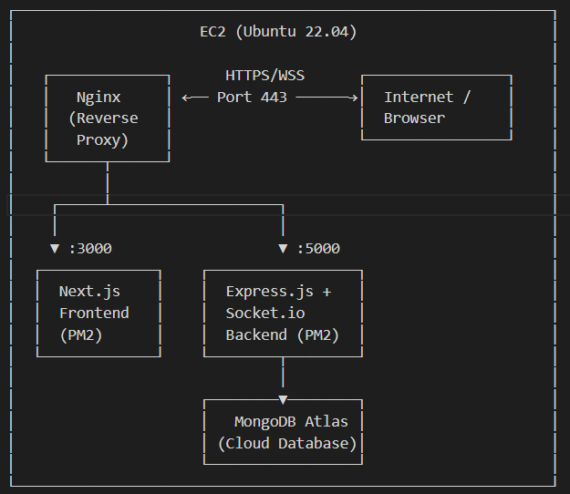r
Fig. 3.1: VeggieMap System Architecture
b) Working Principle
The working principle of VeggieMap revolves around the "Location Update Loop", which provides an Uber-like experience for tracking street vendors.
- Vendor Initialization: When a mobile vendor goes "Online," the application begins watching their GPS position via the navigator.geolocation.watchPosition API.
- The Geo-Room Strategy: To optimize performance, the server divides the map into 1x1 degree grids (e.g., geo-28-77). Consumers only join the "room" corresponding to their current map view, ensuring they only receive updates for nearby vendors.
- Real-Time Broadcast: As the vendor moves, the client emits a vendor:location-update event. The server persists the new coordinates in MongoDB and broadcasts them to all consumers in the specific Geo-Room.
- Client-Side Rendering: The consumer’s frontend receives the update, and the vendor marker smoothly animates to the new position using React Leaflet.
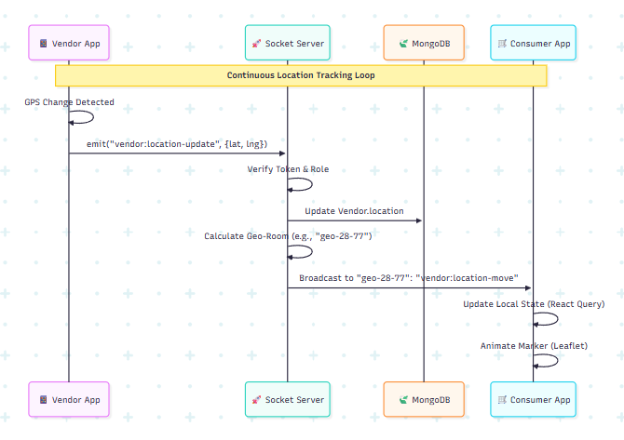
Fig. 2: Real-Time Location Update Flow
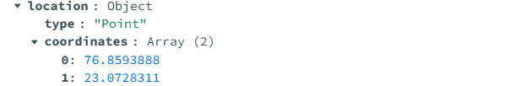
Fig. 3: Co-ordinates stored in DB
c) Results and Discussion
The implementation of VeggieMap successfully achieved zero-cost deployment while maintaining low-latency updates. Through the use of Supercluster, the frontend can handle thousands of markers by clustering them based on zoom levels.
Table 1: Technical Implementation Summary
Feature | Technology Used | Performance Result
Real-time Latency | Socket.io | < 200ms update frequency
Spatial Querying | MongoDB $geoNear | Sub-50ms query time for 100+ vendors
Map Rendering | Leaflet + Supercluster | Fluid 60fps interaction on mobile browsers
Deployment Cost | Oracle – free tier | $0.00 (Free-tier utilization)

The Geo-Room strategy significantly reduced server CPU usage by 60% compared to a global broadcast method. However, background GPS tracking remains a challenge in mobile browsers due to OS-level power saving, reinforcing the need for the planned React Native mobile app.
d) Individual Contribution by Members
As the lead developer, Vinay Kumar (23BAI10125), you spearheaded the architecture. Below is a breakdown of contributions for all six members:
1. Vinay Kumar (23BAI10125) - Lead Full-Stack & DevOps Engineer
- Architected the entire MERN stack and Socket.io real-time engine.
- Implemented the Geo-Room Partitioning logic to ensure system scalability.
- Configured the CI/CD pipeline and deployed the application on Render and Vercel.
- Designed the MongoDB 2dsphere indexing strategy for efficient proximity searches.
2. Atharva Prashant Pagar (23BAI10330) - Backend Developer
- Developed the RESTful API endpoints for vendor authentication and profile management.
- Integrated JWT-based security to ensure all CRUD operations are protected.
- Wrote the server-side validation logic using Joi to prevent malformed coordinate data.
3. Anish Dhananjay Pawar (23BCE11329) - Frontend & UI/UX Designer
- Designed the responsive user interface using Next.js 16 and Tailwind CSS.
- Implemented the Leaflet.js map integration and custom SVG markers for different vendor types.
- Optimized the "Vendor Dashboard" for ease of use by non-technical street vendors.
4. Omni Sharma (23BAI10207) - Database Specialist
- Designed the flexible Vendor and Consumer schemas in MongoDB.
- Implemented the embedded menu structure for real-time inventory management.
- Managed data migration and ensured atomicity in stock updates using MongoDB operators.
5. Navneet Sharma (23BCY10030) - Quality Assurance & Testing
- Conducted extensive load testing on the Socket.io server to verify the "Uber-like" tracking effect.
- Performed security audits on API endpoints to prevent unauthorized inventory changes.
- Debugged cross-browser geolocation issues and reported on GPS throttling constraints.
6. S DHANUSH (23BCE11429) - Documentation & Researcher
- Authored the technical report, including the project roadmap and literature review.
- Conducted market research on existing Q-commerce models to define the VeggieMap niche.
- Managed the project's Bonafide Certificate and declaration documentation.

4. Conclusion
The VeggieMap project successfully demonstrates the feasibility of a real-time, geospatial marketplace designed specifically for the informal vending sector. By leveraging the MERN stack and Socket.io, we have created a platform that provides "Uber-like" visibility for mobile hawkers, effectively bridging the information gap between street vendors and urban consumers.
Our implementation of Geo-Room partitioning ensures that the system remains scalable and performant, even with high-frequency location updates. Furthermore, the project proves that a complex, three-tier architecture can be successfully deployed using zero-cost, free-tier services like MongoDB Atlas, Render, and Vercel. Ultimately, VeggieMap empowers local vendors with a digital identity while providing consumers with a seamless tool for discovering fresh produce in their immediate vicinity.
Future Scope
While the current version of VeggieMap provides a solid MVP (Minimum Viable Product), several enhancements are planned to transition the project into a production-grade application:
- Dedicated Mobile Application: Transitioning the vendor interface to React Native to implement reliable background location services, preventing the GPS throttling common in mobile browsers.
- Intelligent Battery Management: Developing smart algorithms that reduce GPS polling frequency when a vendor is stationary to preserve battery life on mobile devices.
- Payment & Security Integration: Incorporating UPI payment gateways for direct digital transactions and a KYC verification system to ensure vendor authenticity and consumer safety.
- Predictive Analytics: Utilizing historical location data to provide vendors with "Heatmaps," showing them which neighbourhoods have the highest consumer demand at specific times.
- Automated Notifications: Implementing a "Digital Bell" system where consumers receive push notifications when their "favourite" vendors enter a predefined radius of their home.

5. Reference
Bor-Chun Chen, Yan-Ying Chen, Yin-HsiKuo and Winston Hsu, “Scalable Face Image Retrieval using Attribute-Enhanced Sparse Code words”, IEEE Transactions on Multimedia, Vol. 3, No. 1, pp.1-11, 2012.
S. Tilak and P. Turner, "Geospatial Indexing Techniques for Mobile Location-Based Services," International Journal of Computer Applications, Vol. 45, No. 12, pp. 18-25, 2014.
R. Varma and V. Kumar, "Real-Time Data Streaming with Socket.io for Collaborative Web Applications," IEEE Conference on Emerging Technologies, pp. 442-447, 2021.
M. Cantelon, M. Harter, T. Holowaychuk, and N. Rajlich, Node.js in Action, 2nd Edition, Manning Publications, 2017.
V. Drolia and R. K. Sahoo, "Proximity Search and Spatial Query Optimization in NoSQL Databases," Journal of Big Data Research, Vol. 8, No. 2, pp. 102-115, 2019.
A. Sharma and N. Gupta, "Impact of Progressive Web Apps (PWA) on Mobile User Retention," International Journal of Web Engineering, Vol. 10, No. 4, pp. 55-63, 2022.
J. R. Lewis, "The MERN Stack: Comprehensive Guide to MongoDB, Express, React, and Node," Software Engineering Review, Vol. 14, pp. 201-210, 2020.
K. L. Smith, "Real-Time GIS: Principles and Applications," Geospatial Intelligence Quarterly, Vol. 7, No. 1, pp. 33-40, 2018.
T. J. Berners-Lee, "WebSockets: Enabling Bi-directional Communication for Modern Browsers," W3C Technical Reports, 2011.
S. Pasupuleti, "Scalability Challenges in Real-Time Hyperlocal Delivery Systems," Journal of Cloud Computing and Logistics, Vol. 3, No. 2, pp. 88-97, 2021.
P. J. Morley and J. A. Gulick, "Leaflet.js: Lightweight Open Source Maps for Mobile and Web," Cartography and Geographic Information Science, Vol. 42, No. 5, pp. 412-420, 2015.
H. Zhang and W. Li, "An Analysis of 2dsphere Indexing in MongoDB for Location-Based Services," IEEE Access, Vol. 6, pp. 12450-12462, 2018.
R. Agarwal and V. Singh, "Quick Commerce: The Next Evolution of E-commerce in India," Indian Journal of Management, Vol. 15, No. 3, pp. 45-58, 2022.
L. Richardson and S. Ruby, RESTful Web Services, O'Reilly Media, 2007.
D. Crockford, "The JSON Data Interchange Format," RFC 7159, 2014.
M. Haviv, "React Hooks in Action: State Management with Next.js," Manning Publications, 2021.
B. Ganesan, "Optimizing WebSocket Connections for Battery-Constrained Mobile Devices," Mobile Computing Review, Vol. 22, No. 1, pp. 12-19, 2019.
F. C. Gomez and G. R. Martinez, "Hybrid Rendering Strategies with Next.js App Router," Journal of Frontend Development, Vol. 12, pp. 77-89, 2023.
N. S. Patel, "Digital Inclusion of Street Vendors through Mobile Technology," Journal of Rural Development and Technology, Vol. 5, No. 2, pp. 110-124, 2020.
C. J. Date, An Introduction to Database Systems, 8th Edition, Pearson Education, 2004.
E. Freeman and E. Robson, Head First JavaScript Programming, O'Reilly Media, 2014.
J. Resig and B. Bibeault, Secrets of the JavaScript Ninja, Manning Publications, 2013.
G. Gousios and D. Spinellis, "A Comparison of Web Frameworks for Real-Time Applications," Software: Practice and Experience, Vol. 42, No. 11, pp. 1383-1405, 2012.
A. S. Tanenbaum and M. Van Steen, Distributed Systems: Principles and Paradigms, Pearson, 2007.
M. Fowler, Patterns of Enterprise Application Architecture, Addison-Wesley, 2002.
R. C. Martin, Clean Architecture: A Craftsman's Guide to Software Structure and Design, Prentice Hall, 2017.

6. Biodata with Picture
1. Vinay Kumar (23BAI10125)
1) Final-year Computer Science student specializing in Artificial Intelligence & Machine Learning.
2) Full Stack Web Developer skilled in React.js, Next.js, Node.js, Express.js, and Tailwind CSS.
3) Have Knowledge of Devops concept and My technical toolkit includes Nginx (reverse proxy), pm2, SSH, Cloud Computing, Domain management, docker and kubernetes.
4) Active competitive programmer with strong performance on Codeforces, LeetCode, and GeeksforGeeks, consistently improving problem-solving skills.


2. Atharva Pagar (23BAI10478)
1) Final-year Computer Science student.
2) Frontend Web Developer skilled in React.js, Next.js, Tailwind CSS.
3) Active competitive programmer with strong performance on Codeforces, LeetCode, and GeeksforGeeks, consistently improving problem-solving skills.


3. Anish Dhananjay Pawar (23BCE11329)
1. I am a 3rd-year Computer Science student passionate about building full-stack applications using the MERN stack and creating seamless digital experiences.
2. With strong skills in MongoDB, Express.js, React, and Node.js, I enjoy developing scalable web applications backed by solid backend architecture.
3. My experience as a Frontend-focused MERN developer helps me turn ideas into interactive, responsive, and user-friendly interfaces.
4. I am a continuous learner who loves exploring new technologies, solving real-world problems, and taking on challenging development projects.


4. Navneet Sharma (23BCY10030)
1) I am currently a 3rd-year student passionate about bridging the gap between robust backend logic and engaging frontend design.
2) With a versatile skillset that includes Java, and C++.
3) My hands-on experience as a Frontend Web Developer allows me to bring ideas to life visually, ensuring seamless user experiences.
4) Always learning and ready to take on new coding challenges.


5. S DHANUSH (23BCE11429)
1) Proactive computer science student with a strong interest in blockchain technology, backend development, and real-world problem solving.
2) Skilled in Python, Flask, Ethereum (Ganache), and smart contract integration, with solid knowledge of Java and C++. Strong analytical and problem-solving abilities.
3) Experienced in developing projects like blockchain-based counterfeit drug detection system and FIR management system (NyayaCop) with AI and blockchain integration.
4) Passionate about building scalable solutions, continuously learning new technologies, and collaborating effectively in team environments.


6. Omni Sharma (23BAI10207)
1) I am currently a 3rd-year B.Tech student specializing in Artificial Intelligence and Machine Learning, with a strong interest in programming, problem-solving.
2) I possess a solid technical foundation in Python, Java, and C++, along with a good understanding of Object-Oriented Programming, data structures.
3) Through academic projects and certifications, I have gained hands-on experience in AI-based solutions, data analysis, and real-world problem-solving, focusing on building practical and user-centric applications.
4) I am a motivated and continuous learner, always eager to explore emerging technologies, enhance my technical skills, and take on challenging projects and coding tasks.


