=>In previously we have one application one server , let's consider as it manage up to 1000 traffic

=>when more traffic is increse the application will stop working so to solve this problem

VmWare is introduce virtualization

**virtualization**

->In virtualization we are defining more OS and with respect to os we have more servers so if any traffic is increase

it will forward to next server

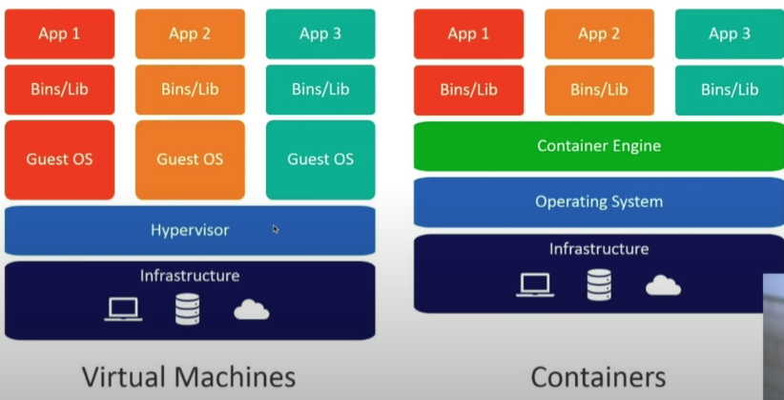

**Disadvantages**

->cost

->maintenance

->scalability

->optimization

->performance

->it does not run many applications with one os

->to solve this Problem we are using docker container

**Docker:**

->Docker is a container platform that allows you to build , test and deploy applications quickly

A developer defines all the applications and it’s dependencies in a docker file which is then used to build docker images that defines in a docker container. Doing this ensures that your applications will run in any application

**What is Docker container:**

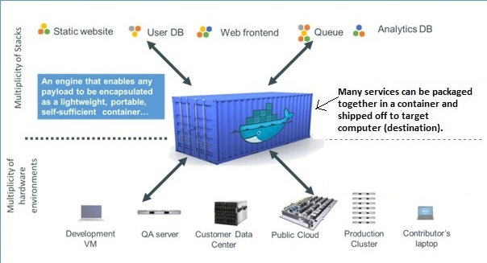

**Runtime:**

->It is used to stop or start the containers

->Runtime is divided into two times

->first one is low level runtime which is know as runc

->runc will works with the os to start or stop the containers

->second one is containerd

->conatinerd is used to manage the runc and also interact with network to pulling the the data using internet

**Engine:**

->It is used to interact with the docker containers example docker daemon

**Orchestration:**

->It is used to scaling the containers

->And also restart to the stoped containers when if want do manually it is more time taking process

So that’s why we are using orchestration

**Docker Images:**

->Docker image is running instance of docker container, which is defined in a docker file

->In some cases any two images may have same id’s this occurs when two images have same content inside the images

->Image id’s are generated based on image content