Project Report on

Design and development of Real-time multitasking Microkernel for ARM7TDMI

Table of Contents
1. Introduction 2
1.1 Embedded Systems 3
1.2 Need of OS in embedded systems 7
1.3Micro Kernel 10
1.4 Kernel 11
1.5 Multi Tasking using Operating System 13
2. ARM Architecture 14
2.1 History 14
2.2 ARM7TDMI 22
2.2.1 Register set and Programming Model 26
2.2.2 Instruction set 31
3. Hardware Board used for demonstration 35
3.1 LPC2138 35
3.2. GPIO Interface 48
3.3. UART Interface 52
5. Software Design and Code developed 58
4.1. Task management and scheduling 58
4.2. Communication and synchronization 60
4.3 Context switching 61
4.4 Application program for demonstrating the Kernel developed 62
5. Simulation and Debugging Tool 63
5.1 Keil Microvision tool for software development and debugging 63
5.2 Features and Advantages 64
5.2 Project creation and Execution using Keil 70
6.Results and Conclusion: 81

Introduction
Real-time systems are those systems whose response is deterministic in time. A real-time microkernel is the near-minimum amount of software that can provide the mechanisms needed to implement a real-time operating system. These mechanisms include low-level address space management, thread management, and inter-process communication (I.P.C). As an operating system design approach, microkernels permit typical operating system services, such as device drivers, protocol stacks, file systems and user interface code, to run in user space. Throughout this document OS and Microkernel are used for same meaning though OS includes device drivers and file system management, which is not present in microkernel.
In this project a 32-task Real Time Microkernel is developed for ARM7TDMI processor which is part of the LPC2138 microcontroller. The micro kernel includes a preemptive priority scheduler and context switching modules for carrying out multi-tasking. Routines to create and manage tasks are developed in the project. Once created, the tasks are scheduled by this scheduler automatically. Subsequently, inter task communication mechanism is added to this scheduler, to make it a small real-time kernel.
Two sets of functions are developed in this project. First one is Kernel functions and second is application functions. Kernel functions are mainly for carrying out task creation, multi-tasking and Inter task communication. The number of application functions can be from 1 to 32. Each of these application functions is created as a task by the microkernel and scheduled by the pre-emptive priority scheduler. Multi tasking of these application tasks is demonstrated in this project are explained in chapter 4 of this document. Following section explains the responsibilities of the various functions implemented in the Kernel along with the function prototypes of the Kernel functions.

1.1 Embedded Systems

An Embedded System is a special-purpose system in which the computer is completely dedicated to the device or system it controls. Unlike a general-purpose computer, such as a personal computer, an embedded system performs one or a few predefined tasks, usually with very specific requirements. Since the system is dedicated to specific tasks, design engineers can optimize it, reducing the size and cost of the product. Embedded systems are often mass-produced, benefiting from economies of scale.

Physically, embedded systems ranges from portable devices such as digital watches and MP3 players, to large stationary installations like traffic lights, factory controllers, or the systems controlling nuclear power plants.

In terms of complexity embedded systems can range from very simple with a single microcontroller chip, to very complex with multiple units, peripherals and networks mounted inside a large chassis or enclosure.

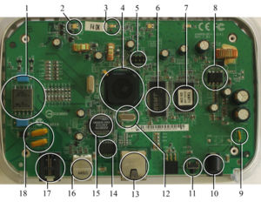

Fig1: Single Microcontroller chip

The common characteristics that distinguish embedded systems from other computing systems are:
- Single-Functioned: An embedded system usually executes a specific program repeatedly. For example a pager is always a pager. In contrast, a desktop system executes a variety of programs.
- Tightly Constrained: All computing systems have constraints on design metrics, but those on embedded systems can be especially tight. A design metric is a measure of an implementation’s features such as cost, performance and power. Embedded systems often must cost low, must be sized to fit onto a single chip, must perform fast enough to process data in real time, and must consume minimum power.
- Reactive and real time: Many embedded systems must continually react to changes in the system’s environment and must compute certain results in real time without delay.
- Dynamic Linking: Some embedded systems are not physically reachable anymore after they have been started (e.g. launched satellites) in order to add software updates. However, more and more of them can still be accessed remotely. Therefore, they should support dynamic linking: object code that did not exist at the time of start is uploaded to the system, and linked in the running OS without stopping it.
Examples of embedded systems:
- Avionics, such as inertial guidance systems, flight control hardware/software and other integrated systems in aircraft and missiles
- Cellular telephones and telephone switches
- Engine controllers and antilock brake controllers for automobiles
- Home automation products, such as thermostats, air conditioners, sprinklers, and security monitoring systems
- Handheld calculators
- Handheld computers
- Household appliances, including microwave ovens, washing machines, television sets, DVD players and recorders
- Medical equipment
- Personal digital assistant
- Videogame consoles
- Computer peripherals such as routers and printers, scanners and fax machines
- Industrial controllers for remote machine operation

Software

Memory
FPGA/ASIC

CPU
Actuators
Sensors
ADC
DAC

Human Interface
Auxiliary systems
(Power, cooling)
Diagnostic Port

Electromechanical Backup & safety

Fig2: Block Diagram of Embedded System

An embedded system is expected to respond, monitor and control external environment using sensors and actuators. Sensor detects the changes in the external environment. Actuator is a mechanical device for moving or controlling a mechanism or system. ADC provides interface to the sensor and DAC provides interface to the actuators. CPU processes the information provided by the sensor and gives necessary control information to the actuators to change the external environment.

In many cases the CPU may not have the ability to execute software satisfying real time constraints, under those circumstances special hardware like FPGA/ASIP is needed. To read the output a human interface is needed. Output may be LCD display panel, LED based informative colour code by which the user can be informed of what is happening inside.

Although the systems are expected to work forever, there are obviously probabilities of failure. To repair the components diagnostic tools are required to interface and check whether it is working. The packing of the embedded system should be as per the requirement of the external environment in which it is placed.

1.2 Need of OS in embedded systems

REAL TIME SYSTEMS
Real-time systems are characterized by the fact that severe consequences will result if logical as well as timing correctness properties of the system are not met. Real Time System’s response is deterministic in time. The Real Time operations must be completed within deadlines. Real-time applications cover a wide range. Most applications for real-time systems are embedded. This means that the computer is built into a system and is not seen by the user as being a computer.

There are two types of real-time systems: SOFT and HARD.

In a SOFT real-time system, tasks are performed by the system as fast as possible, but the tasks don't have to finish by specific times. Failure to meet deadline leads to degradation of system performance.
E.g. Playing a video on a laptop.

In HARD real-time systems, tasks have to be performed not only correctly but on time. Failure to meet the deadline leads to system failure.
E.g. .Atomic Reactor Control, Aircraft On board controller.

Real-time and embedded operating systems

An Operating System is a layer of software that provides low-level services to the application layer, a set of one or more programs executing on the CPU consuming and producing input and output data. The task of managing application layer involves the loading and executing of programs, sharing and allocating system resources to these programs, and protecting these allocated resources from corruption. One of the most important resources of a system is Central Processing Unit (CPU), which is typically shared among a number of executing programs. The operating system is responsible for deciding what program is to run next on the CPU and for how long. This is called Process Scheduling and it is determined by the operating system’s preemption policy. Another very important resource is memory, which is also shared among the applications running on the CPU. The operating system provides the software required for servicing various hardware interrupts, and provides device drivers for driving the peripheral devices present on the system.

Real-time and embedded operating systems are in most respects similar to general purpose operating systems: they provide the interface between application programs and the system hardware, and they rely on basically the same set of programming primitives and concepts. But general purpose operating systems make different trade-offs in applying these primitives, because they have different goals.

OS responsibilities
The basic responsibilities of the operating system are:
(i)Task Management and Scheduling
(ii)Inter-process communication and synchronization
(iii)Memory Management.

General-purpose operating systems also have other responsibilities, which are beyond the horizon of a real-time operating system: file systems and file management, (graphical) user interaction, communication protocol stacks, disk IO, to name a few.

(i)Task management and scheduling

Task Management is a primary job of the operating system: tasks must be created and deleted while the system is running; tasks can change their priority levels, their timing constraints, their memory needs etc. Task management for an RTOS is a bit more dangerous than for a general purpose OS. If a real-time task is created, it has to get the memory it needs without delay, and that memory has to be locked in main memory in order to avoid access latencies due to swapping changing run-time priorities influences the run-time behaviour of the whole system and hence also the predictability which is so important for an RTOS.

In general, multiple tasks will be active at the same time, and the OS is responsible for sharing the available resources (CPU time, memory, etc.) over the tasks. The CPU is one of the important resources and deciding how to share the CPU over the tasks is called “scheduling”.

The general trade-off made in scheduling algorithms is between, on the one hand, the simplicity (and hence efficiency) of the algorithm, and, on the other hand, its optimality. (Algorithms that want to be globally optimal are usually quite complex, and/or require knowledge about a large number of task parameters that are often not straightforward to find on line (e.g., the duration of the next run of a specific task; the time instants when sleeping tasks will become ready to run; etc.). Real-time and embedded operating systems favour simple scheduling algorithms, because these take a small and deterministic amount of computing time, and require little memory footprint for their code.

General purpose and real-time operating systems differ considerably in their scheduling algorithms. They use the same basic principles, but apply them differently because they have to satisfy different performance criterions. A general purpose OS aims at maximum average throughput, a real-time OS aims at deterministic behaviour, and an embedded OS wants to keep memory footprint and power consumption low. A large variety of “real-time” scheduling algorithms exists, but some are standard in most real-time operating systems: static priority scheduling, earliest deadline first and rate monotic scheduling.

(ii) Inter Process Communication and synchronization
The general name IPC collects a large set of programming primitives that the operating system makes available to tasks that need to exchange information with other tasks, or synchronize their actions. Again, an RTOS has to make sure that this communication and synchronization take place in a deterministic way. Besides communication and synchronization with other tasks that run on the same computer, some tasks also need to talk to other computers, or to peripheral hardware (such as analog input or output cards).
This involves some peripheral hardware, such as a serial line or a network, and special purpose device drivers.

(iii) Memory management
The different tasks in the system all require part of the available memory, often to be placed on specified hardware addresses (for memory-mapped IO).
The responsibility of the OS is:

1. To give each task the memory it needs (memory allocation)
2. To map the real memory onto the address ranges used in the different tasks (memory mapping) and
3. To take the appropriate action when a task uses memory that it has not allocated. (Common causes are: unconnected pointers and array indexing beyond the bounds of the array.) This is the memory protection feature of the OS.

1.3Micro Kernel

A microkernel is the near-minimum amount of software that can provide the mechanisms needed to implement an operating system. These mechanisms include low-level address space management, thread management, and inter-process communication (IPC).
In terms of source code size, microkernels (as a rule of thumb) tend to be under 10,000 lines of code. MINIX3 for example has around 4,000 lines of code. Kernels larger than 20,000 lines are generally not considered microkernels. As an operating system design approach, microkernels permit typical operating system services, such as device drivers, protocol stacks, file systems code, to run in user space. If the hardware provides multiple rings or CPU modes, the microkernel is the only software executing at the most privileged level (generally referred to as supervisor or kernel mode). Microkernels are closely related to exokernels. They also have much in common with hypervisors, but the latter make no claim to minimality and are specialized to supporting virtual machines; indeed, the L4 microkernel frequently finds use in a hypervisor capacity.
The historical term nanokernel has been used to distinguish modern, high-performance microkernels from earlier implementations which still contained many system services. However, nanokernels have all but replaced their microkernel progenitors, and the term has fallen into disuse. The figure below shows the microkernel structure and operating system based on microkernel.
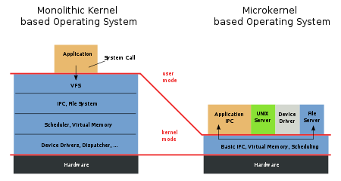

Figure 1.3. Comparison between Microkernel and Monolithic Kernel

Kernel
In computing, the kernel is the central component of most computer operating systems; it is a bridge between applications and the actual data processing done at the hardware level. The kernel's responsibilities include managing the system's resources (the communication between hardware and software components).^{[1]} Usually as a basic component of an operating system, a kernel can provide the lowest-level abstraction layer for the resources (especially processors and I/O devices) that application software must control to perform its function. It typically makes these facilities available to application processes through inter-process communication mechanisms and system calls.
Operating system tasks are done differently by different kernels, depending on their design and implementation. While monolithic kernels execute all the operating system code in the same address space to increase the performance of the system, microkernels run most of the operating system services in user space as servers, aiming to improve maintainability and modularity of the operating system.^{[2]} A range of possibilities exists between these two extremes.
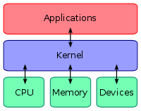

Fig 1.4. Kernel connecting the application software to the hardware of a omputer

On the definition of "kernel", Jochen Liedtke said that the word is "traditionally used to denote the part of the operating system that is mandatory and common to all other software." Most operating systems rely on this concept of the kernel. The existence of a kernel is a natural consequence of designing a computer system as a series of abstraction layers, each relying on the functions of layers beneath it. The kernel, from this viewpoint, is simply the name given to the lowest level of abstraction that is implemented in software. In order to avoid having a kernel, one would have to design all the software on the system not to use abstraction layers; this would increase the complexity of the design to such a point that only the simplest systems could feasibly be implemented.
While it is today mostly called the kernel, originally the same part of the operating system was also called the nucleus or core, and was conceived as containing only the essential support features of the operating system. However the term core has also been used to refer to the primary memory of a computer system, because some early computers used a form of memory called core memory.
In most cases, the boot loader starts executing the kernel in supervisor mode. The kernel then initializes itself and starts the first process. After this, the kernel does not typically execute directly, only in response to external events (e.g., via system calls used by applications to request services from the kernel, or via interrupts used by the hardware to notify the kernel of events). Additionally, the kernel typically provides a loop that is executed whenever no processes are available to run; this is often called theidle process.
Kernel development is considered one of the most complex and difficult tasks in programming. Its central position in an operating system implies the necessity for good performance, which defines the kernel as a critical piece of software and makes its correct design and implementation difficult. For various reasons, a kernel might not even be able to use the abstraction mechanisms it provides to other software. Such reasons include memory management concerns (for example, a user-mode function might rely on memory being subject to demand paging, but as the kernel itself provides that facility it cannot use it, because then it might not remain in memory to provide that facility) and lack of reentrancy, thus making its development even more difficult for software engineers.
A kernel will usually provide features for low-level scheduling of processes (dispatching), inter-process communication, process synchronization, context switching, manipulation of process control blocks, interrupt handling, process creation and destruction, and process suspension and resumption.

1.5 Multi Tasking using Operating System

Multitasking system executes multiple tasks on only one CPU. The CPU switches from one task to other so quickly that an illusion of simultaneous execution is created. Multitasking is the process of scheduling and switching the CPU (Central Processing Unit) between several tasks; a single CPU switches its attention between several sequential tasks. Multitasking maximizes the utilization of the CPU and also provides for modular construction of applications. One of the most important aspects of multitasking is that it allows the application programmer to manage complexity inherent in real-time applications. Application programs are typically easier to design and maintain if multitasking is used.

2. ARM Architecture

2.1 History

ARM (Advanced RISC Machine) processors are meant for particularly high end applications which involve more complex computations. ARM has good speed/power consumption ratio and high code density as needed by an embedded system.

ARM was first developed at Acron Computer Limited of Cambridge England between 1983 and 1985 just after 1980 when the concept of RISC was introduced at Stanford and Berkley. Subsequently ARM limited was formed in 1990.

The ARM popularized the concept of ARM Core which they have licensed to a number of other manufactures to make a variety of chips around the same processor core. Over the last 10 years, the ARM architecture has become the most pervasive 32-bit architecture in the world. Over one billion ARM processors had been shipped worldwide by the end of 2001.ARM cores are widely used in mobile phones, handheld organizers, and a multitude of other every portable consumer devices.

ARM architecture is based on RISC architecture, but it is purely not RISC architecture because it has been enhanced to meet the requirements of embedded applications. The requirements emerge for embedded applications because it needs to have high code density, low power consumption as well as smaller silicon foot print.

2.2 The RISC design philosophy

The ARM core uses RISC architecture. RISC is a design philosophy aimed at delivering simple but powerful instructions that execute within a single cycle at a high clock speed.

The RISC philosophy concentrates on reducing the complexity of instructions performed by the hardware because it is easier to provide greater flexibility and intelligence in software rather than hardware. As a result, a RISC design places greater demands on the compiler.
In contrast, the traditional complex instruction set computer (CISC) relies more on the hardware for instruction functionality, and consequently the CISC instructions are more complicated. Fig.3 illustrates these major differences.

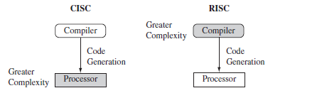

Fig2.1. CISC Vs RISC.
CISC emphasizes hardware complexity. RISC emphasizes compiler complexity.
The RISC philosophy is implemented with four major design rules:

1. Instructions—RISC processors have a reduced number of instruction classes. These classes provide simple operations that can each execute in a single cycle. The compiler or programmer synthesizes complicated operations (for example, a divide operation) by combining several simple instructions. Each instruction is a fixed length to allow the pipeline to fetch future instructions before decoding the current instruction. In
contrast, in CISC processors the instructions are often of variable size and take many
cycles to execute.
2. Pipelines—The processing of instructions is broken down into smaller units that can be executed in parallel by pipelines. Ideally the pipeline advances by one step on each cycle for maximum throughput. Instructions can be decoded in one pipeline stage. There is no need for an instruction to be executed by a miniprogram called microcode as on CISC processors.
3. Registers—RISC machines have a large general-purpose register set. Any register can contain either data or an address. Registers act as the fast local memory store for all data processing operations processing operations. In contrast, CISC processors have dedicated registers for specific purposes.
4. Load store architecture—The processor operates on data held in registers. Separate load and store instructions transfer data between the register bank and external memory. Memory accesses are costly, so separating memory accesses from data processing provides an advantage because you can use data items held in the register bank multiple times without needing multiple memory accesses. In contrast, with a CISC design the data processing operations can act on memory directly.

These design rules allow a RISC processor to be simpler, and thus the core can operate at higher clock frequencies. In contrast, traditional CISC processors are more complex and operate at lower clock frequencies. Over the course of two decades, however, the distinction between RISC and CISC has blurred as CISC processors have implemented more RISC concepts.

2.3 The ARM Design Philosophy

There are a number of physical features that have driven the ARM processor design. First, portable embedded systems require some form of battery power. The ARM processor has been specifically designed to be small to reduce power consumption and extend battery operation essential for applications such as mobile phones and personal digital assistants (PDAs).

High code density is another major requirement since embedded systems have limited memory due to cost and/or physical size restrictions. High code density is useful for applications that have limited on-board memory, such as mobile phones and mass storage devices.

In addition, embedded systems are price sensitive and use slow and low-cost memory devices. For high-volume applications like digital cameras, every cent has to be accounted for in the design. The ability to use low-cost memory devices produces substantial savings.

Another important requirement is to reduce the area of the die taken up by the embedded processor. For a single-chip solution, the smaller the area used by the embedded processor, the more available space for specialized peripherals. This in turn reduces the cost of the design and manufacturing since fewer discrete chips are required for the end product. ARM has incorporated hardware debug technology within the processor so that software engineers can view what is happening while the processor is executing code. With greater visibility, software engineers can resolve issues faster, which have a direct effect on the time to market and reduce overall development costs.

The ARM core is not a pure RISC architecture because of the constraints of its primary application the embedded system. In some sense, the strength of the ARM core is that it does not take the RISC concept too far. In today’s systems the key is not raw processor speed but total effective system performance and power consumption.

Instruction Set for Embedded Systems

The ARM instruction set differs from the pure RISC definition in several ways that make
the ARM instruction set suitable for embedded applications:

■ Variable cycle execution for certain instructions—Not every ARM instruction executes
in a single cycle. For example, load-store-multiple instructions vary in the number
of execution cycles depending upon the number of registers being transferred. The
transfer can occur on sequential memory addresses, which increases performance since
sequential memory accesses are often faster than random accesses. Code density is also
improved since multiple register transfers are common operations at the start and end
of functions.

■ Inline barrel shifter leading to more complex instructions—The inline barrel shifter is
a hardware component that preprocesses one of the input registers before it is used
by an instruction. This expands the capability of many instructions to improve core
performance and code density.

■ Thumb 16 bit Instruction set—ARM enhanced the processor core by adding a second
16-bit instruction set called Thumb that permits the ARM core to execute either
16- or 32-bit instructions. The 16-bit instructions improve code density by about
30% over 32-bit fixed-length instructions.

■ Conditional Execution—An instruction is only executed when a specific condition has
been satisfied. This feature improves performance and code density by reducing branch
instructions.

■ Enhanced Instructions—The enhanced digital signal processor (DSP) instructions were
added to the standard ARM instruction set to support fast 16×16-bit multiplier operations
and saturation. These instructions allow a faster-performing ARM processor in some cases to replace the traditional combinations of a processor plus a DSP.
These additional features have made the ARM processor one of the most commonly used 32-bit embedded processor cores. Many of the top semiconductor companies around the world produce products based around the ARM processor.
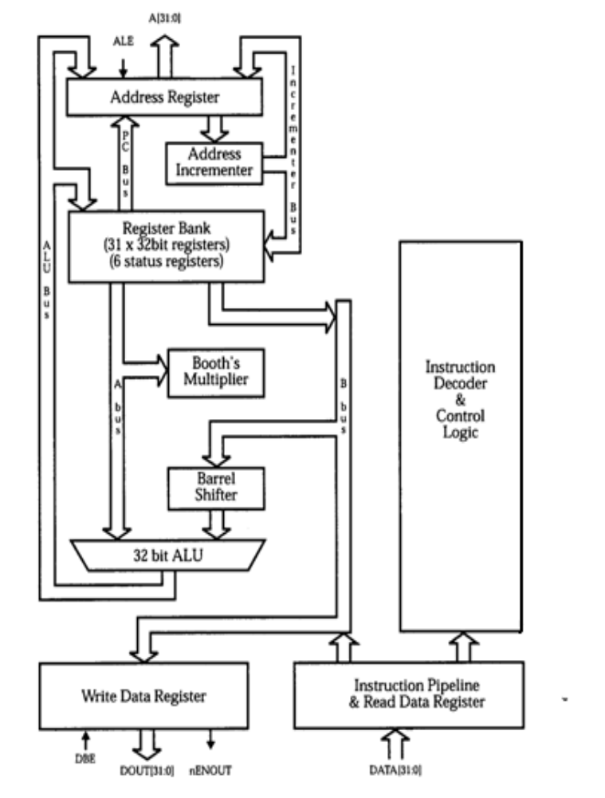
2.4 ARM ARCHITECTURE

Fig.2.2. ARM Architecture
Any architecture is characterized by the data path as well as control path. Data path is organized in such a way that the operands are not directly fetched from the memory; the operands are typically stored in the register file. Instructions typically use two source registers and a single result or destination register.

The register bank is connected to the ALU via two data paths one data path is ‘A’ bus another data path is ‘B’ bus. The bus goes via the barrel shifter, the barrel shifter pre processes the data which comes from one of the source registers. The barrel shifter can shift the data to the left, shift to the right or rotate the data before the data is given to the ALU. Barrel Shifter and ALU are combinational circuits. The operation that the ALU carries out as well as operation that the barrel shifter carries out can take place in one cycle itself which speeds up the execution. Register bank is used for generation of address. PC is part of register bank and can generate address, the other register banks can be used for manipulation of address. The registers can have code, address and data.

Incrementer block increments or decrements register values independent of the ALU. Instruction decoder and control logic block provides control signals. The address bus is [0:31] i.e. 32 bit. Data buses are also [0:31] i.e. 32 bit. The processor is 32 bit processor which can operate on 32 bit operands and the addresses it generates are also 32 bit.

ARM Bus Technology

Embedded systems use different bus technologies than those designed for x86 PCs. The most common PC bus technology, the Peripheral Component Interconnect (PCI) bus, connects such devices as video cards and hard disk controllers to the x86 processor bus. This type of technology is external or off-chip (i.e., the bus is designed to connect mechanically and electrically to devices external to the chip) and is built into the motherboard of a PC.

In contrast, embedded devices use an on-chip bus that is internal to the chip and that allows different peripheral devices to be interconnected with an ARM core.

There are two different types of devices attached to the bus

1. Bus Master: A logical device capable of initiating a data transfer with another device across the same bus (ARM processor core is a bus Master).
2. Bus Slave: A logical device capable only of responding to a transfer request from a bus master device (Peripherals are bus slaves)

A bus has two architecture levels. The first is a physical level that covers the electrical characteristics and bus width (16, 32, or 64 bits). The second level deals with protocol—the logical rules that govern the communication between the processor and a peripheral.

AMBA Bus Protocol
The Advanced Microcontroller Bus Architecture (AMBA) was introduced in 1996 and has been widely adopted as the on-chip bus architecture used for ARM processors.
The first AMBA buses are
- The ARM System Bus (ASB)
- ARM Peripheral Bus (APB).

Later ARM introduced another bus design, called the ARM High Performance Bus (AHB). Using AMBA, peripheral designers can reuse the same design on multiple projects. A peripheral can simply be bolted onto the on-chip bus without having to redesign an interface for each different processor architecture. This plug-and-play interface for hardware developers improves availability and time to market.

AHB provides higher data throughput than ASB because it is based on a centralized multiplexed bus scheme rather than the ASB bidirectional bus design. This change allows the AHB bus to run at higher clock speeds and to be the first ARM bus to support widths of 64 and 128 bits.
ARM has introduced two variations on the AHB bus:
  - Multi-layer AHB
  - AHB-Lite.

In contrast to the original AHB, which allows a single bus master to be active on the bus at any time, the Multi-layer AHB bus allows multiple active bus masters.

AHB-Lite is a subset of the AHB bus and it is limited to a single bus master. This bus was developed for designs that do not require the full features of the standard AHB bus.
AHB and Multi-layer AHB support the same protocol for master and slave but have different interconnects. The new interconnects in Multi-layer AHB are good for systems with multiple processors. They permit operations to occur in parallel and allow for higher throughput rates.

2.2 ARM7TDMI

ARM7TDMI
The ARM7TDMI processor employs a unique architectural strategy known as THUMB, which makes it ideally suited to high-volume applications with memory restrictions, or applications where code density is an issue.

The THUMB Concept
The key idea behind THUMB is that of a super-reduced instruction set. Essentially, the ARM7TDMI processor has two instruction sets:
• The standard 32-bit ARM set
• A 16-bit THUMB set
The THUMB set’s 16-bit instruction length allows it to approach twice the density of standard ARM code while retaining most of the Arm’s performance advantage over a traditional 16-bit processor using 16-bit registers. This is possible because THUMB code operates on the same 32-bit register set as ARM code.

Thumb’s Advantages
THUMB instructions operate with the standard ARM register configuration, allowing excellent interoperability between ARM and THUMB states. Each 16-bit THUMB instruction has a corresponding 32-bit ARM instruction with the same effect on the processor model.

The major advantage of a 32-bit (ARM) architecture over a 16-bit architecture is its ability to manipulate 32-bit integers with single instructions, and to address a large address space efficiently. When processing 32-bit data, a 16-bit architecture will take at least two instructions to perform the same task as a single ARM instruction.

However, not all the code in a program will process 32-bit data (for example, code that performs character string handling), and some instructions, like Branches, do not process any data at all.

If a 16-bit architecture only has 16-bit instructions, and a 32-bit architecture only has32-bit instructions, then overall the 16-bit architecture will have better code density, and better than one half the performance of the 32-bit architecture. Clearly 32-bit performance comes at the cost of code density.

THUMB breaks this constraint by implementing a 16-bit instruction length on a 32-bit architecture, making the processing of 32-bit data efficient with a compact instruction coding. This provides far better performance than a 16-bit architecture, with better code density than a 32-bit architecture.

Thumb has higher code density—the space taken up in memory by an executable program than ARM. For memory-constrained embedded systems, for example, mobile
phones and PDAs, code density is very important. Cost pressures also limit memory size,
width, and speed.

THUMB also has a major advantage over other 32-bit architectures with 16-bit instructions. This is the ability to switch back to full ARM code and execute at full speed. Thus critical loops for applications such as
• fast interrupts
• DSP algorithms
can be coded using the full ARM instruction set, and linked with THUMB code. The overhead of switching from THUMB code to ARM code is folded into sub-routine entry time. Various portions of a system can be optimized for speed or for code density by switching between THUMB and ARM execution as appropriate.

ARM-THUMB Interworking
To call a THUMB routine from an arm routine the core has to change state. BX and BLX instructions can be used to switch the state. Processor enters THUMB state if bit 0 of the address in Rn is set to binary 1, otherwise it enters arm state.
BX R0; BLX R0

THUMB Instruction Decoding

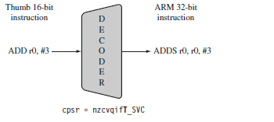
Fig.2.3 Thumb Instruction Decoding

The THUMB instruction decoder is placed in the same instruction data path or instruction pipeline path. The decoder is thumb instruction decompressor i.e.it decompresses or translates the 16 bit instruction to 32 bit instruction which is actually decoded by the ARM instruction decoder.
NOMENCLATURE
ARM uses the nomenclature shown below is to describe the processor implementations. The letters and numbers after the word “ARM” indicate the features a processor may have.
ARM { x }{ y }{ z }{ T }{ D }{ M }{ I }{ E }{J }{ F }{ -S }
x → family
y → memory management / protection unit
z → cache
T → Thumb 16 bit decoder
D → JTAG debug
M → fast multiplier
I → Embedded ICE macro cell
E → enhanced instruction (assumes TDMI )
J → Jazelle
F → vector floating-point unit
S → synthesizable version

- All ARM cores after the ARM7TDMI include the TDMI features even though they may not include those letters after the “ARM” label.
- The processor family is a group of processor implementations that share the same hardware characteristics. For example, the ARM7TDMI, ARM740T, and ARM720T all share the same family characteristics and belong to the ARM7 family.
- JTAG is described by IEEE 1149.1 standard Test Access Port and boundary scan architecture. It is a serial protocol used by ARM to send and receive debug information between the processor core and test equipment.
- Embedded ICE macrocell is the debug hardware built into the processor that allows breakpoints and watchpoints to be set.
- Synthesizable means that the processor core is supplied as source code that can be compiled into a form easily used by EDA tools.

2.2.1 Register set and Programming Model

General-purpose registers hold either data or an address. They are identified with the letter r prefixed to the register number. For example, register 4 is given the label r4.Figure shows the active registers available in user mode—a protected mode normally used when executing applications. The processor can operate in seven different modes. All the registers shown are 32 bits in size. There are up to 18 active registers: 16 data registers and 2 processor status registers. The data registers are visible to the programmer as r0 to r15.

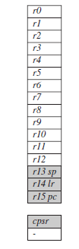
Fig.6 Registers available in user mode

The ARM processor has three registers assigned to a particular task or special function: r13, r14, and r15. They are frequently given different labels to differentiate them from the other registers.
- Register r13 is traditionally used as the stack pointer (SP) and stores the head of the stack in the current processor mode.
- Register r14 is called the link register (lr) and is where the core puts the return address whenever it calls a subroutine.
- Register r15 is the program counter (pc) and contains the address of the next instruction to be fetched by the processor.

Depending upon the context, registers r13 and r14 can also be used as general purpose registers, which can be particularly useful since these registers are banked during a processor mode change. However, it is dangerous to use r13 as a general register when the processor is running any form of operating system because operating systems often assume that r13 always points to a valid stack frame.

In ARM state the registers r0 to r13 are orthogonal —any instruction that you can apply to r0 you can equally well apply to any of the other registers. However, there are instructions that treat r14 and r15 in a special way.

In addition to the 16 data registers, there are two program status registers:CPSR and SPSR (the current and saved program status registers, respectively).The register file contains all the registers available to a programmer. Which registers are visible to the programmer depends upon the current mode of the processor.

Current Program Status Register (CPSR)
The ARM core uses the CPSR to monitor and control internal operations. The CPSR is a dedicated 32-bit register and resides in the register file. Figure shows the basic layout of a generic program status register. The shaded parts are reserved for future
expansion.
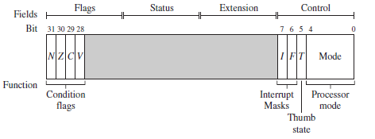
Fig.7 A Generic Program Status Register

The CPSR is divided into four fields, each 8 bits wide: flags, status, extension, and control. In current designs the extension and status fields are reserved for future use. The control field contains the processor mode, state, and interrupts mask bits. The flags field contains the condition flags.

N – Negative flag; this bit is set when the 31 bit (most significant bit) of result is one, otherwise it is reset.
Z – Zero flag; this bit set if the result is zero, otherwise it is reset.
C – Carry flag; this bit is set when there is a carry out of addition, and no borrow for subtraction, otherwise it is reset.
V – overflow flag; this bit is set when there is overflow in signed arithmetic operations The I and F bits correspond to interrupt masking and the T bit tells the thumb state (whether the processor is in normal mode or thumb mode).

The least significant five bits of CPSR indicate the mode in which processor is currently operating. Except in user mode in all other modes it is possible to write appropriate value in these bits for changing to any other mode. The mode also can be changed when exception or interrupt occurs. The following exceptions and interrupts result in mode change: reset, interrupt request, fast interrupt request, software interrupt, data abort, prefetch abort and execution of undefined instruction.

Processor Modes
The processor mode determines which registers are active and the access rights to the CPSR register itself. Each processor mode is either privileged or nonprivileged: A privileged mode allows full read-write access to the CPSR. Conversely, a nonprivileged mode only allows read access to the control field in the CPSR but still allows read-write access to the condition flags.

There are seven processor modes in total: six privileged modes (abort, fast interrupt request, interrupt request, supervisor, system, and undefined) and one nonprivileged mode (user).

The processor enters abort mode when there is a failed attempt to access memory. Fast interrupt request and interrupt request modes correspond to the two interrupt levels available on the ARM processor. Supervisor mode is the mode that the processor is in after reset and is generally the mode that an operating system kernel operates in. System mode is a special version of user mode that allows full read-write access to the cpsr. Undefined mode is used when the processor encounters an instruction that is undefined or not supported by the implementation. User mode is used for programs and applications.

Banked Registers
Fig.8 shows all 37 registers in the register file. Of those, 20 registers are hidden from a program at different times. These registers are called banked registers and are identified by the shading in the diagram. They are available only when the processor is in a particular mode; for example, abort mode has banked registers r13_abt, r14_abt and spsr_abt. Banked registers of a particular mode are denoted by an underline character post-fixed to the mode mnemonic or _mode.

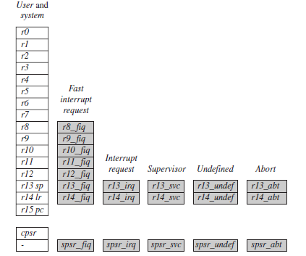
Fig.8 Complete ARM Register Set

Every processor mode except user mode can change mode by writing directly to the mode bits of the CPSR. All processor modes except system mode have a set of associated banked registers that are a subset of the main 16 registers. A banked register maps one-to one onto a user mode register. If you change processor mode, a banked register from the new mode will replace an existing register.

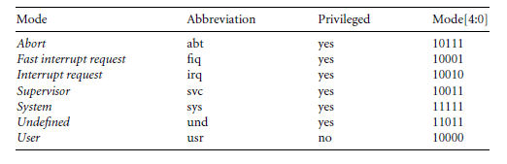

Table 1 Processor Modes

2.2.2 Instruction set

The following shows the type of instructions that ARM support.
- Data Processing Instructions
- Branch Instructions
- Load-store Instructions
- Software Interrupt Instruction
- Program Status Register Instructions

I. Data Processing Instructions:-
The data processing instructions manipulate data within registers. Most data processing instructions can process one of their operands using the barrel shifter. If we use the S suffix on a data processing instruction, then it updates the flags in the CPSR. Move and logical operations update the carry flag C, negative flag N, and Zero flag Z. The carry flag is set from the result of the barrel shift as the last bit shifted out. The N flag is set to bit 31 of the result. The Z flag is set if the result is zero. The following instructions are Data processing instructions.
i) Move instructions: This instruction is used to move the content of one register to another register. The below instructions are the Move instructions
MOV: move a 32-bit value into a register Rd=RS
MOVN: move the NOT of the 32 bit value into a register Rd= ~RS

ii) Barrel Shifter: A unique and powerful feature of ARM processor is ability to shift the 32-bit binary pattern in one of the source registers left or right by a specific number of positions before it enters the ALU. This is done by using the Barrel shifter. This preprocessing or shift occurs within the cycle time of the instruction. The five different shift operations that we can use within the barrel shifter given below.
LSL: logical shift left
LSR: logical shift right
ASR: arithmetic right shift
ROR: rotate right
RRX: rotate right extended

iii) Arithmetic Instructions: The arithmetic instructions implement and subtraction of 32-bit signed and unsigned values. Some of the instructions of Arithmetic instructions are given below.
ADD: add two 32-bit values.
ADC: add two 32-bit values and carry
SUB: subtract two 32-bit values
SBC: subtract with carry of two 32-bit values
RSB: reverse subtract of two 32-bit values
RSC: reverse subtract with carry of two 32-bit values

iv) Logical Instructions: Performs the logical operations on two source registers
AND: logical bitwise AND of two 32-bit values
ORR: logical bitwise OR of two 32-bit values
EOR: logical exclusive OR of two 32-bit values.
BIC: Logical bit clear (AND NOT)

v) Comparison Instructions: The comparison instructions are used to compare or test a register with a 32 bit value. They update the CPSR flag bits (N, Z, C, V) according to the result, but do not affect other registers. After the bits have been set, the information can then be used to change program flow by using conditional execution. We do not need to apply the S suffix for comparison instructions to update the flag. The following instructions are Comparison instructions
CMP (compare) ‏: flags set as a result of R1-R2
CMN (compare negated) ‏: flags set as a result of R1+R2
TST (test for equality of two 32-bit values): flags set as a result of R1&R2
TEQ (test for equality of two 32-bit values)‏: flags set as a result of R1^R2
vi) Multiply Instructions: The multiply instructions multiply the content of a pair of registers and, depending upon the instruction, accumulate the results in with another register. The long multiplies accumulate onto a pair of registers representing a 64 bit value. The final result is placed in a destination register or a pair of registers.
MUL: multiply
MLA: multiply and accumulate

II. Branch Instructions: A branch instruction changes the flow of execution or is used to call a routine. This type of instruction allows programs to have subroutines, if-then-else structures, and loops. The change of execution flow forces the program counter pc to point to new address. The below shown instructions are Branch instructions.
B: branch
BL: branch with link
BX: branch exchange
BLX: branch exchange with link

III. Load-store Instructions: Load-store instructions transfer data between memory and processor registers.
There are three types of load-store instructions:
i. single register transferring
ii. Multiple register transfer
iii. Swap

i) Single register transferring: These instructions are used for moving a single data item in and out of a register. The data types supported are signed and unsigned words (32-bit), half words (16-bit), and bytes. The following instructions are various load-store single-register transfer instructions.
LDR: load word into a register
STR: save byte or word from a register
LDRB: load byte into a register
STRB: save byte from a register
LDRH: load half word into a register
STRH: save half word into a register
LDRSB: load signed byte into a register
LDRSH: load signed half word into a register

ii) Multiple register transfer: - Load-store multiple instructions can transfer multiple registers between memory and the processor in a single instruction. The transfer occurs from a base address register Rn pointing into memory. Multiple-register transfer instructions are more efficient from single-register transfers for moving blocks of data around memory and saving and restoring context and stacks. If an interrupt has been raised, then it has no effect until the load-store multiple instruction is complete.
LDM: load multiple registers
STM: save multiple registers

iii) Swap: The swap instruction is a special case of a load-store instruction. It swaps the contents of memory with the contents of a register. This instruction is an atomic operation- it reads and writes a location in the same bus operation, preventing any other instruction from reading or writing to that location until it completes.

IV. Software Interrupt Instruction: A software interrupt instruction (SWI) causes a software interrupt exception, which provides a mechanism for applications to call operating system routines. The following instruction comes under software interrupt instruction. SWI: software interrupt
V. Program Status Register Instructions: The ARM instruction set provides two instructions to directly control a program status (PSR)
MRS: This instruction transfers the contents of either the CPSR or SPSR into a register
MSR: This instruction transfers the content of a register into the CPSR or SPSR
Together the above two instructions are used to read and write the CPSR or SPSR

3. Hardware Board used for demonstration

3.1 LPC2138

The LPC2138 microcontrollers are based on a 32 bit ARM7TDMI-S CPU with real-time emulation and embedded trace support, that combines the microcontroller with embedded high speed flash memory of 512 kB. A 128-bit wide memory interface and unique accelerator architecture enable 32-bit code execution at the maximum clock rate. For critical code size applications, the alternative 16-bit Thumb mode reduces the code by more than 30 % with minimal performance penalty.
Due to their tiny size and low power consumption, LPC2138 microcontrollers are ideal for the applications where miniaturization is a key requirement, such as access control and point-of-sale. A blend of serial communications interfaces ranging from a USB 2.0 Full Speed device, multiple UARTS, SPI, SSP to I2Cs and on-chip SRAM of 8 kB up to 40 kB, make these devices very well suited for communication gateways and protocol converters, soft modems, voice recognition and low end imaging, providing both large buffer size and high processing power. Various 32-bit timers, single or dual 10-bit ADC(s), 10-bit DAC, PWM channels and 45 fast GPIO lines with up to nine edge or level sensitive external interrupt pins make these microcontrollers particularly suitable for industrial control and medical systems.

ARCHITECTURAL OVERVIEW:
The LPC2138 consists of an ARM7TDMI-S CPU with emulation support, the ARM7 Local Bus for interface to on-chip memory controllers, the AMBA Advanced High performance Bus (AHB) for interface to the interrupt controller, and the VLSI Peripheral Bus (APB, a compatible superset of ARM’s AMBA Advanced Peripheral Bus) for connection to on-chip peripheral functions. The LPC2138 configures the ARM7TDMI-S processor in little-endian byte order. AHB peripherals are allocated a 2 megabyte range of addresses at the very top of the 4 gigabyte ARM memory space. Each AHB peripheral is allocated a 16 kB address space within the AHB address space. LPC2138 peripheral functions (other than the interrupt controller) are connected to the APB bus. The AHB to APB bridge interfaces the APB bus to the AHB bus. APB peripherals are also allocated a 2 megabyte range of addresses, beginning at the 3.5 gigabyte address point. Each APB peripheral is allocated a 16 kB address space within the APB address space. The connection of on-chip peripherals to device pins is controlled by a Pin Connect Block

FEATURES OF LPC2138 MICROCONTROLLER:
- It is a 32-bit ARM7TDMI-S microcontroller in a tiny LQFP64 package.
- 8 kB to 40 kB of on-chip static RAM.
- 512 kB of on-chip flash memory.
- In-System Programming/In-Application Programming (ISP/IAP).
- 10-bit ADCs provide a total of 6/14 analog inputs.
Single 10-bit DAC provides variable analog output
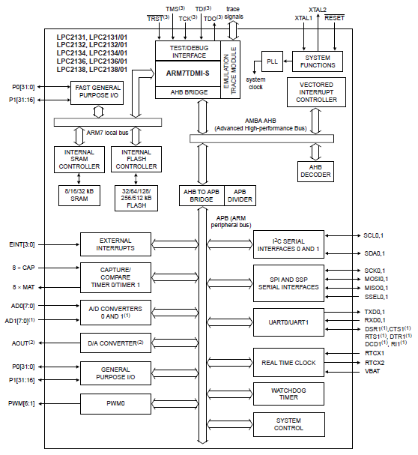
Figure 3. Architecture of LPC2138

ON CHIP FLASH MEMORY

The LPC2138 incorporates a 512 kB Flash memory system. This memory may be used for both code and data storage. Programming of the Flash memory may be accomplished in several ways: over the serial built-in JTAG interface, using In System Programming (ISP) and UART0, or by means of In Application Programming (IAP) capabilities. The application program, using the IAP functions, may also erase and/or program the Flash while the application is running, allowing a great degree of flexibility for data storage field firmware upgrades, etc.

ON CHIP SRAM
On-chip Static RAM (SRAM) may be used for code and/or data storage. The on-chip SRAM may be accessed as 8-bits, 16-bits, and 32-bits. The LPC2138 provide 32 Kb of static RAM. The LPC2138 SRAM is designed to be accessed as a byte-addressed memory.

CRYSTAL OSSCILATOR

While an input signal of 50-50 duty cycle within a frequency range from 1 MHz to 50 MHz can be used by the LPC2138 if supplied to its input XTAL1 pin, this microcontroller’s onboard oscillator circuit supports external crystals in the range of 1 MHz to 30 MHz only. If the on-chip PLL system or the boot-loader is used, the input clock frequency is limited to an exclusive range of 10 MHz to 25 MHz.

PHASE LOCKED LOOP (PLL)
The PLL accepts an input clock frequency in the range of 10 MHz to 25 MHz only. The input frequency is multiplied up into the CCLK with the range of 10 MHz to 60 MHz using a Current Controlled Oscillator (CCO). The multiplier can be an integer value from 1 to 32 (in practice, the multiplier value cannot be higher than 6 on the LPC213x due to the upper frequency limit of the CPU). The CCO operates in the range of 156 MHz to 320 MHz, so there is an additional divider in the loop to keep the CCO within its frequency range while the PLL is providing the desired output frequency. The output divider may be set to divide by 2, 4, 8, or 16 to produce the output clock. Since the minimum output divider value is 2, it is insured that the PLL output has a 50% duty cycle

INTERRUPT CONTROLLER

The Vectored Interrupt Controller (VIC) accepts all of the interrupt request inputs and categorizes them as Fast Interrupt Request (FIQ), vectored Interrupt Request (IRQ), and non-vectored IRQ as defined by programmable settings. The programmable assignment scheme means that priorities of interrupts from the various peripherals can be dynamically assigned and adjusted.
Fast interrupt request (FIQ) has the highest priority. If more than one request is assigned to FIQ, the VIC combines the requests to produce the FIQ signal to the ARM processor. The fastest possible FIQ latency is achieved when only one request is classified as FIQ, because then the FIQ service routine does not need to branch into the interrupt service routine but can run from the interrupt vector location. If more than one request is assigned to the FIQ class, the FIQ service routine will read a word from the VIC that identifies which FIQ source(s) is (are) requesting an interrupt.
Vectored IRQs have the middle priority. Sixteen of the interrupt requests can be assigned to this category. Any of the interrupt requests can be assigned to any of the 16 vectored IRQ slots, among which slot 0 has the highest priority and slot 15 has the lowest.
Non-vectored IRQs have the lowest priority.
The VIC combines the requests from all the vectored and non-vectored IRQs to produce the IRQ signal to the ARM processor. The IRQ service routine can start by reading a register from the VIC and jumping there. If any of the vectored IRQs are pending, the VIC provides the address of the highest-priority requesting IRQs service routine, otherwise it provides the address of a default routine that is shared by all the non-vectored IRQs. The default routine can read another VIC register to see what IRQs are active.
INTERRUPT SOURCES

Each peripheral device has one interrupt line connected to the Vectored Interrupt Controller, but may have several internal interrupt flags. Individual interrupt flags may also represent more than one interrupt source.

FAST GENERAL PURPOSE PARALLEL I/O (GPIO)

Device pins that are not connected to a specific peripheral function are controlled by the GPIO registers. Pins may be dynamically configured as inputs or outputs. Separate registers allow setting or clearing any number of outputs simultaneously. The value of the output register may be read back, as well as the current state of the port pins. LPC2138 introduces accelerated GPIO functions over prior LPC2000 devices:

• GPIO registers are relocated to the ARM local bus for the fastest possible I/O timing.
• Mask registers allow treating sets of port bits as a group, leaving other bits unchanged.
• All GPIO registers are byte addressable.
• Entire port value can be written in one instruction.
Features

• Bit-level set and clear registers allow a single instruction set or clear of any number of bits in one port.
• Direction control of individual bits.
• Separate control of output set and clear.
• All I/O default to inputs after reset
10-BIT ADC
The LPC2138 contain two analog to digital converters. These converters are single 10-bit successive approximation analog to digital converters. While ADC0 has six channels, ADC1 has eight channels. Therefore, total number of available ADC inputs is 14.

Features

• 10 bit successive approximation analog to digital converter.
• Measurement range of 0 V to VREF (2.0 V ≤ VREF ≤ VDDA).
• Each converter capable of performing more than 400,000 10-bit samples per second.
• Every analog input has a dedicated result register to reduce interrupt overhead.
• Burst conversion mode for single or multiple inputs.

10-bit DAC

The DAC enables the LPC2138 to generate a variable analog output. The maximum DAC output voltage is the VREF voltage.
Features

• 10-bit DAC.
• Buffered output.
• Power-down mode available

USB 2.0 DEVICE CONTROLLER
The USB is a 4-wire serial bus that supports communication between a host and a number (127 max) of peripherals. The host controller allocates the USB bandwidth to attached devices through a token based protocol. The bus supports hot plugging, unplugging, and dynamic configuration of the devices. All transactions are initiated by the host controller.

Features

• Fully compliant with USB 2.0 Full-speed specification.
• Supports 32 physical (16 logical) endpoints.
• Supports control, bulk, interrupt and isochronous endpoints.
• Scalable realization of endpoints at run time.
• Endpoint maximum packet size selection (up to USB maximum specification) by software at run time.
• RAM message buffer size based on endpoint realization and maximum packet size.
• Supports SoftConnect and GoodLink LED indicator. These two functions are sharing one pin.
• Supports bus-powered capability with low suspend current.
• Supports DMA transfer on all non-control endpoints
• One duplex DMA channel serves all endpoints
• Allows dynamic switching between CPU controlled and DMA modes
• Double buffer implementation for bulk and isochronous endpoints.

UARTS

The LPC2138 contain two UARTs. In addition to standard transmit and receive data lines, UART1 also provides a full modem control handshake interface. Compared to previous LPC2000 microcontrollers, UARTs in LPC2138 introduce a fractional baud rate generator for both UARTs, enabling these microcontrollers to achieve standard baudrates such as 115200 with any crystal frequency above 2 MHz.

Features

• 16 byte Receive and Transmit FIFOs.
• Register locations conform to ‘550 industry standard.
• Receiver FIFO trigger points at 1, 4, 8, and 14 bytes
• Built-in fractional baud rate generator covering wide range of baud rates without a need for external crystals of particular values.
• Transmission FIFO control enables implementation of software (XON/XOFF) flow control on both UARTs.
• LPC2138 UART1 equipped with standard modem interface signals. This
module also provides full support for hardware flow control (auto-CTS/RTS).
I2C-BUS SERIAL I/O CONTROLLER
The I2C-bus is bidirectional, for inter-IC control using only two wires: a serial clock line (SCL), and a serial data line (SDA). Each device is recognized by a unique address and can operate as either a receiver-only device (e.g., an LCD driver or a transmitter with the capability to both receive and send information (such as memory)). Transmitters and/or receivers can operate in either master or slave mode, depending on whether the chip has to initiate a data transfer or is only addressed. The I2C-bus is a multi-master bus, it can be controlled by more than one bus master connected to it.

Features

• Compliant with standard I2C-bus interface.
• Easy to configure as master, slave, or master/slave.
• Programmable clocks allow versatile rate control.
• Bidirectional data transfer between masters and slaves.
• Multi-master bus (no central master).
• Arbitration between simultaneously transmitting masters without corruption of serial data on the bus.
• Serial clock synchronization allows devices with different bit rates to communicate via one serial bus.
• Serial clock synchronization can be used as a handshake mechanism to suspend and resume serial transfer.
• The I2C-bus can be used for test and diagnostic purposes
GENERAL PURPOSE TIMERS/EXTERNAL EVENT COUNTERS

The Timer/Counter is designed to count cycles of the peripheral clock (PCLK) or an externally supplied clock and optionally generate interrupts or perform other actions at specified timer values, based on four match registers. It also includes four capture inputs to trap the timer value when an input signals transitions, optionally generating an interrupt.
Multiple pins can be selected to perform a single capture or match function, providing an application with ‘or’ and ‘and’, as well as ‘broadcast’ functions among them.
The LPC2138 can count external events on one of the capture inputs if the minimum external pulse is equal or longer than a period of the PCLK. In this configuration, unused capture lines can be selected as regular timer capture inputs, or used as external interrupts.

Features

• A 32-bit timer/counter with a programmable 32-bit prescaler.
• External event counter or timer operation.
• Four 32-bit capture channels per timer/counter that can take a snapshot of the timer value when an input signal transitions. A capture event may also optionally generate an interrupt.
• Four 32-bit match registers that allow:
– Continuous operation with optional interrupt generation on match.
– Stop timer on match with optional interrupt generation
– Reset timer on match with optional interrupt generation.
• Four external outputs per timer/counter corresponding to match registers, with the following capabilities:
– Set LOW on match.
– Set HIGH on match.
– Toggle on match.
– Do nothing on match.
WATCHDOG TIMER

The purpose of the watchdog is to reset the microcontroller within a reasonable amount of time if it enters an erroneous state. When enabled, the watchdog will generate a system reset if the user program fails to ‘feed’ (or reload) the watchdog within a predetermined amount of time.

Features

• Internally resets chip if not periodically reloaded.
• Debug mode.
• Enabled by software but requires a hardware reset or a watchdog reset/interrupt to be disabled.
• Incorrect/Incomplete feed sequence causes reset/interrupt if enabled.
• Flag to indicate watchdog reset.
• Programmable 32-bit timer with internal pre-scaler.
• Selectable time period from (TPCLK × 256 × 4) to (TPCLK × 232 × 4) in multiples of TPCLK × 4.

PULSE WIDTH MODULATOR

The PWM is based on the standard timer block and inherits all of its features, although only the PWM function is pinned out on the LPC2141/42/44/46/48. The timer is designed to count cycles of the peripheral clock (PCLK) and optionally generate interrupts or perform other actions when specified timer values occur, based on seven match registers. The PWM function is also based on match register events. The ability to separately control rising and falling edge locations allows the PWM to be used for more applications. For instance, multi-phase motor control typically requires three non-overlapping PWM outputs with individual control of all three pulse widths and positions.
Two match registers can be used to provide a single edge controlled PWM output. One match register (MR0) controls the PWM cycle rate, by resetting the count upon match.
The other match register controls the PWM edge position. Additional single edge controlled PWM outputs require only one match register each, since the repetition rate is the same for all PWM outputs. Multiple single edge controlled PWM outputs will all have a rising edge at the beginning of each PWM cycle, when an MR0 match occurs.
Three match registers can be used to provide a PWM output with both edges controlled. Again, the MR0 match register controls the PWM cycle rate. The other match registers control the two PWM edge positions. Additional double edge controlled PWM outputs require only two match registers each, since the repetition rate is the same for all PWM outputs.
With double edge controlled PWM outputs, specific match registers control the rising and falling edge of the output. This allows both positive going PWM pulses (when the rising edge occurs prior to the falling edge), and negative going PWM pulses (when the falling edge occurs prior to the rising edge).
VPB BUS

The VPB divider determines the relationship between the processor clock (CCLK) and the clock used by peripheral devices (PCLK). The VPB divider serves two purposes. The first
is to provide peripherals with the desired PCLK via VPB bus so that they can operate at the speed chosen for the ARM processor. In order to achieve this, the VPB bus may be slowed down to 1⁄2 to 1⁄4 of the processor clock rate. Because the VPB bus must work properly at power-up (and its timing cannot be altered if it does not work since the VPB divider control registers reside on the VPB bus), the default condition at reset is for the VPB bus to run at 1⁄4 of the processor clock rate. The second purpose of the VPB divider is to allow power savings when an application does not require any peripherals to run at the full processor rate. Because the VPB divider is connected to the PLL output, the PLL remains active (if it was running) during Idle mode.

SERIAL COMMUNICATION
When a microcontroller communicates with the outside world, it provides data in byte-sized chunks. In some cases, such as printers, the information is simply grabbed from the 8-bit data bus and presented to the 8-bit data bus of the printer. This can work only if the cable is not too long, since long cables diminish and ever distort signals. Furthermore, and 8-bit data path is expensive. For these reasons, serial communication is used for transferring data between two systems located at distances of hundreds of feet to millions of miles apart.
The fact that in serial communication a single data line is used instead of the 8-bit data line of parallel communication makes it not only much cheaper but also makes it possible for two computers located in two different cities to communicate over the telephone.
Serial data communication uses two methods, a synchronous and asynchronous. The synchronous method transfers a block of data at a time while the synchronous transfers a single byte at a time. It is mean possible to write software to use either of these methods, but the programs can be tedious and long. For this reason, there are special IC chips made by many manufacturers for serial data communications. These chips are commonly referred to as UART (universal asynchronous receiver-transmitter) and USART (universal synchronous -asynchronous receiver-transmitter).
RS232 STANDARDS
To allow compatibility among the data communication equipment made by various manufacturers an interfacing standard called RS232, was set by the electronics industries association (EIA) in 1960. RS 232 is the standard defined for the connection of "Data Terminal Equipment" (DTE) to "Data Communications Equipment" (DCE).
DTE (Data Terminal Equipment) is a generic term for an item which forms part of the "information processing" portions of a system. Examples are: computer, printer, and terminal.
DCE (Data Communications Equipment) is a device, which provides an interface between a DTE and a communications link.

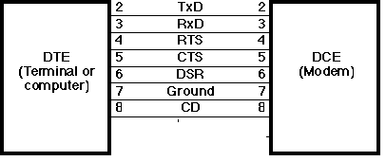
INTERFACE FOR DTE/DCE CONNECTION
All Signals Are “Ground Referenced” to in Pin 7
TXD, RXD---- Transmit and Receive Signal
RTS---- Request to Send, from DTE
CTS---- Clear to send, from DCE together with RTS
DTE---- Data Terminal Ready, indicates to the modem that a DTE is Connected and enabled.
DSR--- Data Set Ready, indicates to the DTE that the modem is present and turned on
CD-- Carrier Detect, indicates that this modem is receiving a signal from the remote modem.

In RS 232, a 1 is represented by -3 to -25V which is called Mark, while a 0 bit is + 3 to + 25V which is called Space. To connect any RS 232 to a µc system, voltage converters such as Max 232are used. Max 232 IC chips are commonly referred to as line drivers.8.3. MAX 232. The RS 232 is not compatible with micro controllers, so a line driver converts the RS 232's signals to TTL voltage levels

RS 232 WIRING AND CONNECTORS


RS 232 WIRE
RS-232 Defines Serial, Asynchronous communication, Serial bits are encoded and transmitted one at a time. Asynchronous characters can be sent at any time and bits are not individually synchronized. This is standard for transfer of characters across copper wire.

3.2. GPIO Interface

GPIO stands for General Purpose Input Output. Every physical GPIO port is accessible via either the group of registers providing an enhanced features and accelerated port access or the legacy group of registers
• Accelerated GPIO functions:
– GPIO registers are relocated to the ARM local bus so that the fastest possible I/O
timing can be achieved
– Mask registers allow treating sets of port bits as a group, leaving other bits unchanged
– All registers are byte and half-word addressable
– Entire port value can be written in one instruction
• Bit-level set and clear registers allow a single instruction set or clear of any number of bits in one port
• Direction control of individual bits
• All I/O default to inputs after reset
• Backward compatibility with other earlier devices is maintained with legacy registers appearing at the original addresses on the VPB bus

Applications of GPIO
• General purpose I/O
• Driving LEDs, or other indicators
• Controlling off-chip devices
• Sensing digital inputs
• General purpose I/O
• Driving LEDs, or other indicators
• Controlling off-chip devices
• Sensing digital inputs

8.3 Pin description

LPC2141/2/4/6/8 has two 32-bit General Purpose I/O ports. Total of 30 input/output and a single output only pin out of 32 pins are available on PORT0. PORT1 has up to 16 pins available for GPIO functions. PORT0 and PORT1 are controlled via two groups of 4 registers as shown in tables below. The GPIO ports on the board are used for controlling the LEDs.
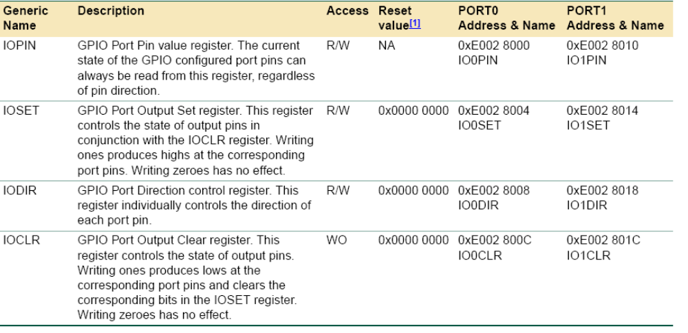

Table 3.1 Register set of GPIO

State of the output configured GPIO pin is determined by writes into the pin’s port IOSET and IOCLR registers. Last of these accesses to the IOSET/IOCLR register will determine the final output of a pin.
In case of a code:
IO0DIR = 0x0000 0080 ;pin P0.7 configured as output
IO0CLR = 0x0000 0080 ;P0.7 goes LOW
IO0SET = 0x0000 0080 ;P0.7 goes HIGH
IO0CLR = 0x0000 0080 ;P0.7 goes LOW
pin P0.7 is configured as an output (write to IO0DIR register). After this, P0.7 output is set to low (first write to IO0CLR register). Short high pulse follows on P0.7 (write access to IO0SET), and the final write to IO0CLR register sets pin P0.7 back to low level.

For obtaining an immediate output of 0s and 1s on a GPIO port

Write access to port’s IOSET followed by write to the IOCLR register results with pins outputting 0s being slightly later then pins outputting 1s. There are systems that can tolerate this delay of a valid output, but for some applications simultaneous output of a binary content (mixed 0s and 1s) within a group of pins on a single GPIO port is required.
This can be accomplished by writing to the port’s IOPIN register.
Following code will preserve existing output on PORT0 pins P0.[31:16] and P0.[7:0] and at the same time set P0.[15:8] to 0xA5, regardless of the previous value of pins P0.[15:8]:
IO0PIN = (IO0PIN && 0xFFFF00FF) || 0x0000A500
The same outcome can be obtained using the fast port access.
Solution 1: using 32-bit (word) accessible fast GPIO registers
FIO0MASK = 0xFFFF00FF;
FIO0PIN = 0x0000A500;
Solution 2: using 16-bit (half-word) accessible fast GPIO registers
FIO0MASKL = 0x00FF;
FIO0PINL = 0xA500;
Solution 3: using 8-bit (byte) accessible fast GPIO registers

Writing to IOSET/IOCLR .vs. IOPIN
Write to the IOSET/IOCLR register allows easy change of the port’s selected output pin(s) to high/low level at a time. Only pin/bit(s) in the IOSET/IOCLR written with 1 will be set to high/low level, while those written as 0 will remain unaffected. However, by just writing to either IOSET or IOCLR register it is not possible to instantaneously output arbitrary binary data containing mixture of 0s and 1s on a GPIO port.
Write to the IOPIN register enables instantaneous output of a desired content on the parallel GPIO. Binary data written into the IOPIN register will affect all output configured pins of that parallel port: 0s in the IOPIN will produce low level pin outputs and 1s in IOPIN will produce high level pin outputs. In order to change output of only a group of port’s pins, application must logically AND readout from the IOPIN with mask containing 0s in bits corresponding to pins that will be changed, and 1s for all others. Finally, this result has to be logically ORred with the desired content and stored back into the IOPIN register.
Output signal frequency considerations when using the legacy and enhanced GPIO registers
The enhanced features of the fast GPIO ports available on this microcontroller make GPIO pins more responsive to the code that has task of controlling them. In particular, software access to a GPIO pin is 3.5 times faster via the fast GPIO registers than it is when the legacy set of registers is used. As a result of the access speed increase, the maximum output frequency of the digital pin is increased 3.5 times, too. This tremendous increase of the output frequency is not always that visible when a plain C code is used, and a portion of an application handling the fast port output might have to be written in an assembly code and executed in the ARM mode.

3.3. UART Interface

LPC2148 chip has two UART interfaces. Universal Asynchronous Receiver and Transmitter is the serial communication interface used in this project. The features of the UART are given below.
- 16 byte Receive and Transmit FIFOs
• Register locations conform to ‘550 industry standard.
• Receiver FIFO trigger points at 1, 4, 8, and 14 bytes.
• Built-in fractional baud rate generator with autobauding capabilities.
• Mechanism that enables software and hardware flow control implementation.

UART0 contains registers organized as shown in Table below. The Divisor Latch Access Bit (DLAB) is contained in U0LCR and enables access to the Divisor Latches.

UART0 Receiver Buffer Register (U0RBR - 0xE000 C000, when DLAB = 0, Read Only)
The U0RBR is the top byte of the UART0 Rx FIFO. The top byte of the Rx FIFO contains the oldest character received and can be read via the bus interface. The LSB (bit 0) represents the “oldest” received data bit. If the character received is less than 8 bits, the
unused MSBs are padded with zeroes. The Divisor Latch Access Bit (DLAB) in U0LCR must be zero in order to access the U0RBR. The U0RBR is always Read Only. Since PE, FE and BI bits correspond to the byte sitting on the top of the RBR FIFO (i.e. the one that will be read in the next read from the RBR), the right approach for fetching the valid pair of received byte and its status bits is first to read the content of the U0LSR
register, and then to read a byte from the U0RBR.

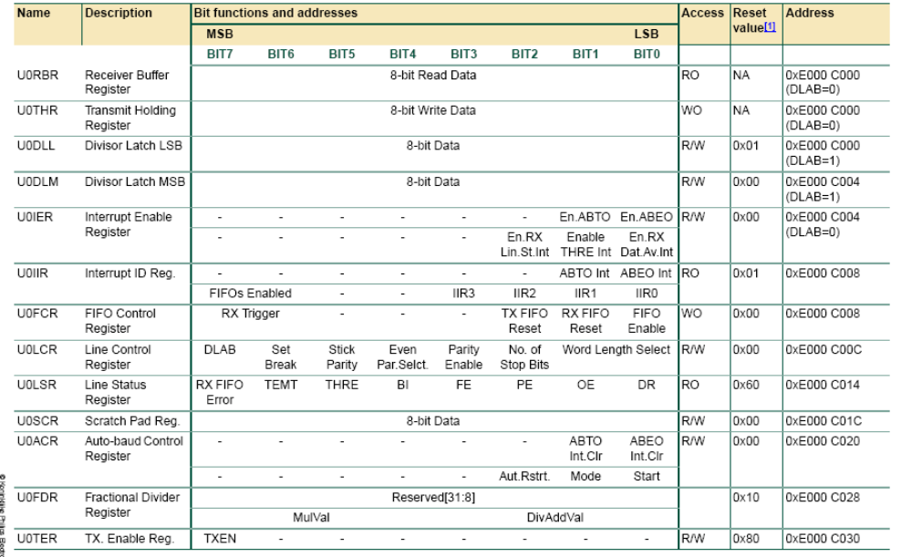

Table 3.2 Register set of UART

UART0 Transmit Holding Register (U0THR - 0xE000 C000, when DLAB = 0, Write Only)
The U0THR is the top byte of the UART0 TX FIFO. The top byte is the newest character in the TX FIFO and can be written via the bus interface. The LSB represents the first bit to transmit. The Divisor Latch Access Bit (DLAB) in U0LCR must be zero in order to access the U0THR. The U0THR is always Write Only.

UART0 Divisor Latch Registers (U0DLL - 0xE000 C000 and U0DLM - 0xE000 C004, when DLAB = 1)
The UART0 Divisor Latch is part of the UART0 Fractional Baud Rate Generator and holds the value used to divide the clock supplied by the fractional prescaler in order to produce the baud rate clock, which must be 16x the desired baud rate (Equation 1). The U0DLL and U0DLM registers together form a 16 bit divisor where U0DLL contains the lower 8 bits of the divisor and U0DLM contains the higher 8 bits of the divisor. A 0x0000 value is treated like a 0x0001 value as division by zero is not allowed.The Divisor Latch Access Bit (DLAB) in U0LCR must be one in order to access the UART0 Divisor Latches.

UART0 Fractional Divider Register (U0FDR - 0xE000 C028)
The UART0 Fractional Divider Register (U0FDR) controls the clock pre-scaler for the baud rate generation and can be read and written at user’s discretion. This pre-scaler takes the VPB clock and generates an output clock per specified fractional requirements.

This register controls the clock pre-scaler for the baud rate generation. The reset value of
the register keeps the fractional capabilities of UART0 disabled making sure that UART0 is fully software and hardware compatible with UARTs not equipped with this feature.
UART0 baudrate can be calculated as:


Where PCLK is the peripheral clock, U0DLM and U0DLL are the standard UART0 baud
rate divider registers, and DIVADDVAL and MULVAL are UART0 fractional baudrate
generator specific parameters.
The value of MULVAL and DIVADDVAL should comply to the following conditions:
1. 0 < MULVAL ≤ 15
2. 0 ≤ DIVADDVAL ≤ 15

If the U0FDR register value does not comply to these two requests then the fractional
divider output is undefined. If DIVADDVAL is zero then the fractional divider is disabled and the clock will not be divided. The value of the U0FDR should not be modified while transmitting/receiving data or data may be lost or corrupted.

UART0 baudrate calculation
Example 1: Using UART0baudrate formula from above, it can be determined that system
with PCLK = 20 MHz, U0DL = 130 (U0DLM = 0x00 and U0DLL = 0x82), DIVADDVAL = 0
and MULVAL = 1 will enable UART0 with UART0baudrate = 9615 bauds.
Example 2: Using UART0baudrate formula from above, it can be determined that system
with PCLK = 20 MHz, U0DL = 93 (U0DLM = 0x00 and U0DLL = 0x5D), DIVADDVAL = 2
and MULVAL = 5 will enable UART0 with UART0baudrate = 9600 bauds.

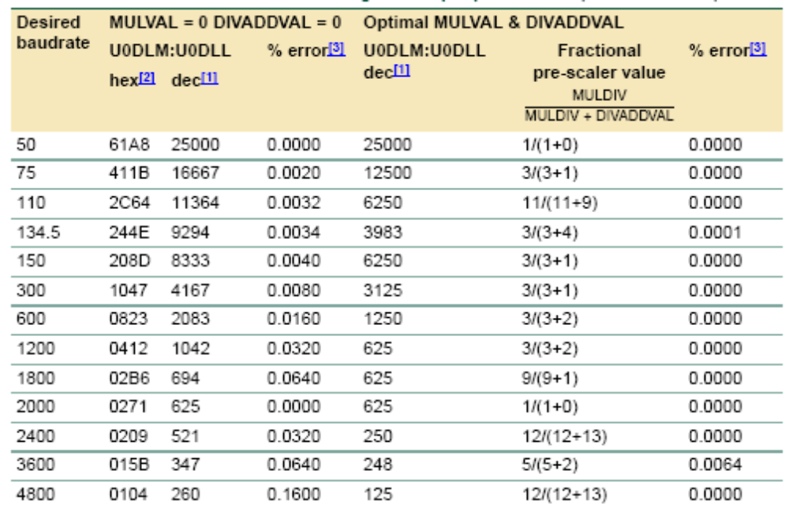
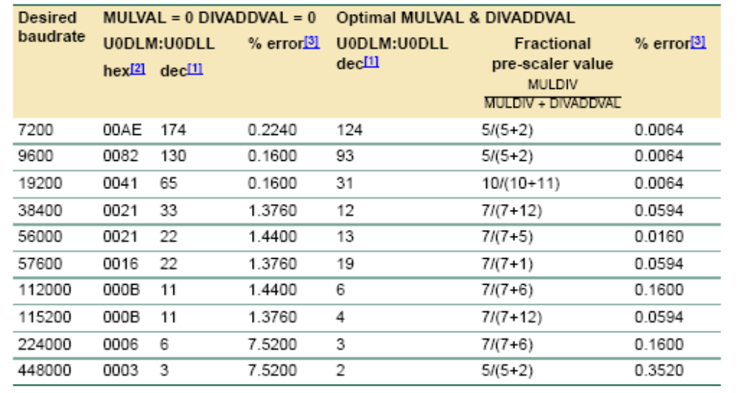
Table 3.3 UART baud rate calculation tables

UART0 Interrupt Enable Register (U0IER - 0xE000 C004, when DLAB = 0)
The U0IER is used to enable UART0 interrupt sources. It allows the user to enable or disable a specific UART interrupt.

UART0 Interrupt Identification Register (U0IIR - 0xE000 C008, Read Only)
The U0IIR provides a status code that denotes the priority and source of a pending
interrupt. The interrupts are frozen during an U0IIR access. If an interrupt occurs during
an U0IIR access, the interrupt is recorded for the next U0IIR access.

The UART0 RLS interrupt (U0IIR[3:1] = 011) is the highest priority interrupt and is set whenever any one of four error conditions occur on the UART0 Rx input: overrun error (OE), parity error (PE), framing error (FE) and break interrupt (BI). The UART0 Rx error condition that set the interrupt can be observed via U0LSR[4:1]. The interrupt is cleared upon an U0LSR read.
The UART0 RDA interrupt (U0IIR[3:1] = 010) shares the second level priority with the CTI interrupt (U0IIR[3:1] = 110). The RDA is activated when the UART0 Rx FIFO reaches the trigger level defined in U0FCR[7:6] and is reset when the UART0 Rx FIFO depth falls below the trigger level. When the RDA interrupt goes active, the CPU can read a block of data defined by the trigger level.
The CTI interrupt (U0IIR[3:1] = 110) is a second level interrupt and is set when the UART0 Rx FIFO contains at least one character and no UART0 Rx FIFO activity has occurred in 3.5 to 4.5 character times. Any UART0 Rx FIFO activity (read or write of UART0 RSR) will clear the interrupt. This interrupt is intended to flush the UART0 RBR after a message has been received that is not a multiple of the trigger level size. For example, if a peripheral wished to send a 105 character message and the trigger level was 10 characters, the CPU would receive 10 RDA interrupts resulting in the transfer of 100 characters and 1 to 5 CTI interrupts (depending on the service routine) resulting in the transfer of the remaining 5 characters

UART0 Line Control Register (U0LCR - 0xE000 C00C)
The U0LCR determines the format of the data character that is to be transmitted or received.
UART0 Line Status Register (U0LSR - 0xE000 C014, Read Only)
The U0LSR is a read-only register that provides status information on the UART0 TX and RX blocks. Table below shows the line status bits.
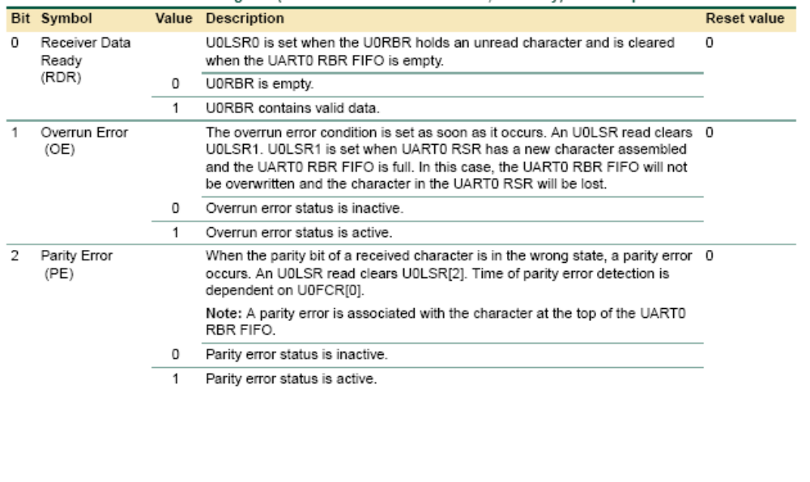
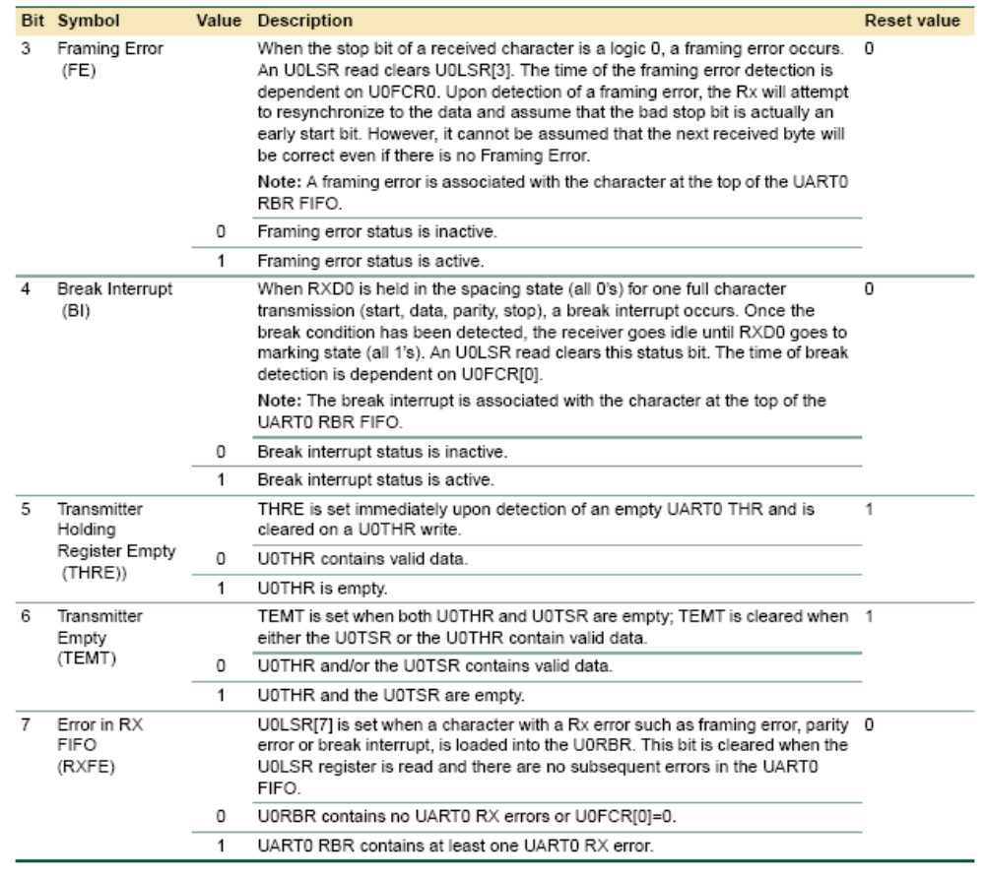

Table 3.4 Line Status Register

Software Design and Code developed
The realtime microkernel has two major responsibilities. First one is Task management and scheduling and second one is Intertask communication and synchronization as explained below.

4.1. Task management and scheduling
Task (or “process”, or “thread”) management is a primary job of the operating system: tasks must be created and deleted while the system is running; tasks can change their priority levels, their timing constraints, their memory needs; etcetera. Task management for an RTKernel is a bit more critical than for a general purpose OS: if a real-time task is created, it has to get the memory it needs without delay, and that memory has to be locked in main memory in order to avoid access latencies due to swapping; changing run-time priorities influences the run-time behaviour of the whole system and hence also the predictability which is so important for an RTOS. So, dynamic process management is a potential problem for an RTOS, therefore not recommended, though it is implemented in this project.
In general, multiple tasks will be active at the same time, and the OS is responsible for sharing the available resources (CPU time, memory, etc.) over the tasks. The CPU is one of the important resources, and deciding how to share the CPU over the tasks is called “scheduling”. The general trade-off made in scheduling algorithms is between, on the one hand, the simplicity (and hence efficiency) of the algorithm, and, on the other hand, its optimality. Real-time operating systems favour simple scheduling algorithms, because these take a small and deterministic amount of computing time, and require little memory footprint for their code.
General purpose and real-time operating systems differ considerably in their scheduling algorithms. They use the same basic principles, but apply them differently because they have to satisfy different performance criterions. A general purpose OS aims at maximum average throughput, a real-time OS aims at deterministic behaviour. In this project a dynamic priority pre-emptive scheduling algorithm is implemented. Shown Below are the prototypes of the Task Management and scheduling related functions implemented in the project
osrc_t thread_create (int 32*ptid, int32 pri, void (*pfunc)(void))
Creates a thread with the entry point pointed to by pfunc, and makes it ready to run. If the priority is higher than the current thread’s priority, it schedules the created thread. Returns OK if successful, or ERR on error.
void thread_suspend (int32 tid)
Suspends the specified task (puts it in the wait state).
void thread_resume (int32 tid)
Resumes the specified task (puts it in the ready/running state depending on the priority).
int32 thread_self (void)
Returns the id of the current task.
int32 thread_getpri (int32 tid)
Returns the priority of the specified task.
myrc_t thread_setpri (int32 tid, int32 pri)
Sets the priority of the specified task. Additionally, performs scheduling if required due to the change in the task priority.
void os_init (void)
Initializes the common OS data structures. Calls thread_init for thread specific initializations. Later, this function will call other object initialization functions.
void thread_init (void)
Initializes thread specific data structures.
void thread_schedule (void)
Runs the thread scheduler.
void thread_switch_context (int32 *pcurcxt, int32 *pnxtcxt) (Assembly code)
Internal function to do the context switch. Takes in the pointers to the arrays containing contexts of the current and new task. Swaps these contexts and returns to new task.

4.2. Communication and synchronization
Second major responsibility of an OS is commonly known under the name of Inter-Process Communication (IPC). (“Process” is, in this context, just another name for “task”.) The general name IPC collects a set of programming primitives that the operating system makes available to tasks that need to exchange information with other tasks, or synchronize their actions. In this project Inter task communication is carried out using semaphores. Semaphore is an object used for intertask communication in operating system. It is for informing the kernel about the status of the task for its waiting for a resource or releasing a resource. Every semaphore must be created before it is used. Below are the prototypes of the Inter Task Communication Synchronization related functions implemented in the project.
osrc_t ossem_create (int32 count, int32 *psid)
Creates a semaphore with the specified initial count and returns the id in *psid.
Returns OK if successful, or ERR on error.
void sem_post (int32 semid)
Posts the specified semaphore. Reschedules the tasks if posting the semaphore could cause a task switch.
void sem_wait (int32 sid)
Waits for a semaphore. If the semaphore is unavailable, puts the current task in waiting state and schedules another task.

4.3 Context switching

Context switching is done when a processor switches from one task to another task. Context is mainly the Register snapshot of the processor when a task is under execution.
This function is called after the scheduler if task switching is required. In this project is this function is implemented using ARM assembly language programming. This routine saves all the registers of the first task on the stack of the task or context area and restores all the registers from the stack or context area of the next task. At the end of this task the control switches to second task.

thread_switch_context

STR R2,[R0,#0X0]
STR R3,[R0,#0X4]
STR R4,[R0,#0X8]
STR R5,[R0,#0XC]
STR R6,[R0,#0X10]
STR R7,[R0,#0X14]
STR R8,[R0,#0X18]

STR R9,[R0,#0X1C]
STR R10,[R0,#0X20] ; //save all the registers
STR R11,[R0,#0X24]
STR R12,[R0,#0X28]

MRS R12,CPSR
STR R12,[R0,#0X2C]

STR R14,[R13]
SUB R13,R13,#04
STR R13,[R0,#0X4C]

;/*
;* Restore all the registers from the memory space pointed to by
; * the second argument.
; */
;

LDR R2,[R1,#0X0]
LDR R3,[R1,#0X4]
LDR R4,[R1,#0X8]
LDR R5,[R1,#0XC]
LDR R6,[R1,#0X10]
LDR R7,[R1,#0X14]
LDR R8,[R1,#0X18]

LDR R9,[R1,#0X1C]
LDR R10,[R1,#0X20] ;//RESTORE all the registers
LDR R11,[R1,#0X24]
LDR R12,[R1,#0X2C]
MSR CPSR_f,R12 ;cxsf ;flags
;MSR CPSR_c,R12 ;clears modes and irq settings
;MSR CPSR_x,R12 ; no change ;dont use
;MSR CPSR_s,R12 ; no change ;dont use
LDR R12,[R1,#0X28]

LDR R0,[R1,#0X4C]
ADD R0,R0,#04
MOV R13,R0
LDR R14,[R13]

BX R14

END

4.4 Application program for demonstrating the Kernel developed
Total of 8 tasks have been created using the Task related functions designed in this project

void root(void)
{
thread_create (&tid1, 8, thread1);
thread_create (&tid2, 7, thread2);
thread_create (&tid3, 6, thread3);
thread_create (&tid4, 5, thread4);
thread_create (&tid5, 4, thread5);
thread_create (&tid6, 3, thread6);
thread_create (&tid7, 2, thread7);
thread_create (&tid8, 1, thread8);

ossem_create(0,&sid1);
ossem_create(0,&sid2);
ossem_create(0,&sid3);
ossem_create(0,&sid4);
ossem_create(0,&sid5);
ossem_create(0,&sid6);
ossem_create(0,&sid7);
ossem_create(0,&sid8);

thread_setpri (0,OS_MIN_PRI);
sem_post(sid8);
//thread_schedule();

return;
}

5. Simulation and Debugging Tool

5.1 Keil Microvision tool for software development and debugging
Keil development tools designed for ARM processor-based microcontroller devices support every level of developer from the professional application engineer to the student just learning about embedded software development. The industry-standard Keil makes C/C++ Compilers, Macro Assemblers, Debuggers, Real-Time Kernels, simulation models, and evaluation boards for ARM, Cortex-M, Cortex-R4, 8051, C166, and 251 processor families. It also supports ALL ARM-compatible derivatives and helps us in getting the projects completed on schedule.
The µVision4 IDE is a window-based software development platform that combines a robust and modern editor, project manager, and make facility. µVision4 integrates all the tools we need to develop embedded applications including C/C++ compiler, macro assembler, linker/locator, and a HEX file generator. The µVision4 IDE offers numerous features and advantages that help us to develop embedded applications quickly and successfully. The Keil tools are easy to use, and are guaranteed to help us achieve design goals in a timely manner. µVision4 helps expedite the development process of embedded application by providing the following:
- Full-featured source code editor,
- Device Database for configuring the development tool
- Project Manager for creating and maintaining projects
- Integrated Make Utility functionality for assembling, compiling, and linking embedded applications
- Dialogs for all development environment settings
- True integrated source-level and assembler-level Debugger with high-speed CPU and peripheral Simulator,
- Advanced GDI interface for software debugging in the target hardware and for connecting to the Keil ULINK Adapter family
- Flash programming utility for downloading the application program into Flash ROM
- Links to manuals, on-line help, device datasheets, and user guides.

5.2 Features and Advantages
Feature | Advantage
The µVision4 Simulator is the only debugger that simulates most on-chip peripherals. | Write and test application code before production hardware is available. Investigate different hardware configurations to optimize the hardware design.
System Viewer capabilities can be used to monitor the content of peripherals. | View and define one’s own views to supervise peripherals. Detailed status information is available and can be changed directly within the System Viewer window.
The Code Coverage functionality of the µVision4 Simulator provides statistical analysis data of program's execution. | Safety-critical systems can be thoroughly tested and validated. Execution analysis reports can be viewed and printed for certification requirements.
The Logic Analyzer functionality is used to graphically display variable changes. | Study the signal and variable changes in graphical form, and view their dependency or correlation.
The µVision4 Device Database automatically configures the development tools for the target microcontroller. | Device settings are delivered and have been tested. Developers are provided with default settings that practically eliminate the time needed to configure the tool.
A Template editor to insert common text sequences or header blocks. | Use templates to insert standard text, header descriptions, and generic code blocks into the program structure.
The function Browser for navigating quickly among coded procedures. | Save time during development. Use this functionality in addition to the Find functions.
The Configuration Wizard provides a graphical interface to maintain device and start-up code settings. | Instead of scanning or scrolling through the start-up file, we can use an advanced GUI-like feature.
The µVision4 IDE integrates additional third-party tools like VCS, CASE, and FLASH/Device Programming. | Quickly access development tools and third-party tools. All configuration details are saved in the µVision4 project file.
The Keil ULINK USB-JTAG Adapter family supports Debugging and Flash programming, and are delivered with configured algorithm files, which can be modified and adapted to particular needs. | Only one tool is used for debugging and programming. No extra configuration time is required.
The Target Debugger and Simulator User Interface has been implemented with the same look and feel. | Considerably shortens the learning curve.
µVision4 combines a Project Manager, Make Utility, Debugger, and a modern Editor into a single user interface environment. | Accelerates application development.  While editing, we can configure the debugger features. While debugging, we can make source code changes. Nevertheless, these changes are effective after we re-build the project.
The Multi-Project Manager allows us to enhance the design overview by integrating various projects into one project file. | Combine µVision4 projects, which logically depend on each other, into one Multi-Project, and thus, increase the overview, consistency, and transparency of embedded system application design. We may build or re-build projects individually or in batch-mode.
Debug Restore Views allow us to define and save multiple window layouts. | We can quickly select the view, which best suits the analysis needs. Define debug layouts on a global level or for individual projects. This feature saves a lot of time, since we do not have to re-define the screen layout.
Drag and Drop objects. | Most objects can be dragged and dropped from one window to the other. Windows can be moved anywhere on the visual surface. This increases flexibility, for instance, we may have multiple memory and variable watch windows.

EMBEDDED C
The programming Language used here in this project is an Embedded C Language. This Embedded C Language is different from the generic C language in few things like
  - Data types
  - Access over the architecture addresses.

The Embedded C Programming Language forms the user friendly language with access over Port addresses, SFR Register addresses etc.
EMBEDDED C DATA TYPES:
Data Types | Size in Bits | Data Range/Usage
unsigned char | 8-bit | 0-255
signed char | 8-bit | -128 to +127
unsigned int | 16-bit | 0 to 65535
signed int | 16-bit | -32,768 to +32,767
sbit | 1-bit | SFR bit addressable only
bit | 1-bit | RAM bit addressable only
sfr | 8-bit | RAM addresses 80-FFH only

Signed char:
- Used to represent the – or + values.
- As a result, we have only 7 bits for the magnitude of the signed number, giving us values from -128 to +127.
SOFTWARE
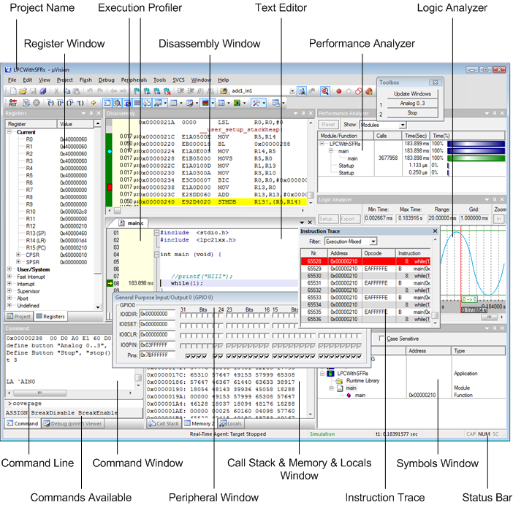
As any windows-based application, µVision4 also provides a menu for command selection, a toolbar where we can rapidly select command buttons, and the commonly known windows features. We can split, tile, hide, open, and move windows even to another physical screen. Nevertheless, source code files have to stay in the Editor Window and cannot be floated. We can define our own screen layouts, which will be remembered individually for each project. In addition, we can save preferred layouts and switch among their definitions.
User Interface
The µVision4 User Interface offers menus, toolbars, keyboard shortcuts, dialog boxes, and windows to manage the various aspects of embedded project.
- Menu bars provide commands for editor operations, project maintenance, development tool option settings, program debugging, external tool control, window selection and manipulation, and on-line help.
- Toolbar buttons allow us to rapidly execute µVision4 commands.
- File Menu and Commands: It lists the commands to manipulate files. Provide access to the license manager and Device Database from this menu.
- Edit Menu and Commands: It lists the commands that are accessible when working with the editor. Provides navigation between bookmarks, configure the editor, set syntax highlighting, and defines short-keys, keywords, and templates from this menu.
- View Menu: It lists the commands that display or hide the Status Bar, toolbars, and windows. While in Debug Mode, we can enforce windows to refresh periodically from this menu.
- Project Menu and Commands: It lists the commands available to control the project.
- Flash Menu: It lists the commands and options available for Flash programming.
- Debug Menu and Commands: It lists the commands to debug the application as: set or remove breakpoints, single stepping commands, execution profiling, and call the debug-function editor.
- Peripherals Menu: It lists the peripherals that are currently simulated. The list is CPU dependent.
- Tools Menu: It offers the possibility to link third-party tools to µVision4. Customize this menu to our needs.
- SVCS Menu: It offers access to software version control systems. This menu can be customized.
- Window Menu: It lists the commands to split, tile, and close windows. In addition, Debug Restore Views can be saved via this menu.
- Help Menu: It lists commands to contact the support, open various help systems, and to access knowledge articles.

5.2 Project creation and Execution using Keil

Create Project
The section provides a step-by-step procedure to create a simple µVision4 project. µVision4 includes a project manager that makes it easy to design embedded applications, and only a few step are needed to create a new project:
- Create Project File and Select Device explains the steps to create the project file and how to select the microcontroller from the Device Database.
- Create New Source Files explains a possible way of creating a new source file.
- Add Source Files to Project explains the best way of adding an existing file to the project.
- Build Project explains the build commands and how errors and warnings can be tracked.
- Create HEX File explains the configuration option required for creating a HEX file.
Create Project File and Select Device
Create Project File Folder and Specify Project Name
To create a new project file, select the Project — New µVision Project… menu.
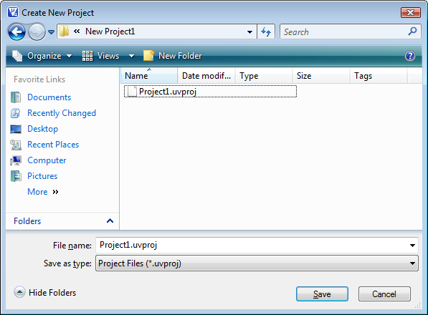

The Create New Project dialog asks us for the new project file name. Navigate to the folder where the new project will reside. It is good practice to use a separate folder for each project. Use the icon Create New Folder in this dialog to create a new empty folder. Select this folder and enter the file name for the new project, i.e. Project1. µVision4 creates a new project file with the name PROJECT1.UVPROJ, which contains a default target and file group name. We can see these names in the Project Window.
Select the Target Microcontroller from the Device Database. When we create a new project, µVision4 asks us to select a device for the project. The Select Device dialog box shows the µVision4 device database. Just select the microcontroller that is being used. The micro controller LPC2138 is being used in our project. This selection sets the tool options needed for the LPC21328 device and simplifies the tool configuration.
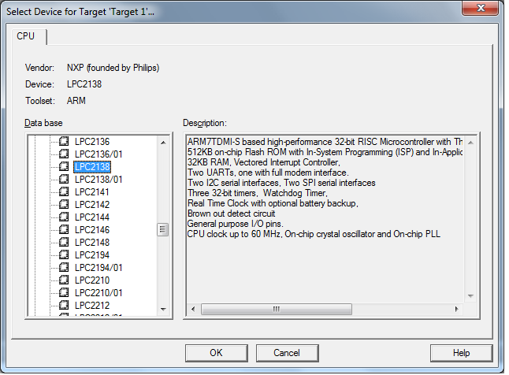

Copy and Add the Startup Code An embedded program requires some kind of microcontroller initialization code that needs to match the configuration of our hardware design. This Startup Code depends also on the tool chain we are using. Since we might need to modify that file to match your target hardware, the file should be copied to your project folder.
For most devices, µVision4 asks you to copy the chip-specific Startup Code to your project. This is required on almost all projects (exceptions are library projects and add-on projects). The Startup Code performs configuration of the microcontroller device and initialization of the compiler run-time system. Therefore you should answer this question with YES.

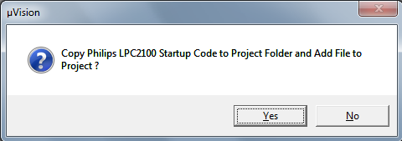

Create New Source Files
You may create a new source file with the menu option File — New. This opens an empty editor window where you can enter your source code. µVision4 enables the C color syntax highlighting when you save your file with the dialog File — Save As... under a filename with the extension *.C. Save the example file under the name MAIN.C.
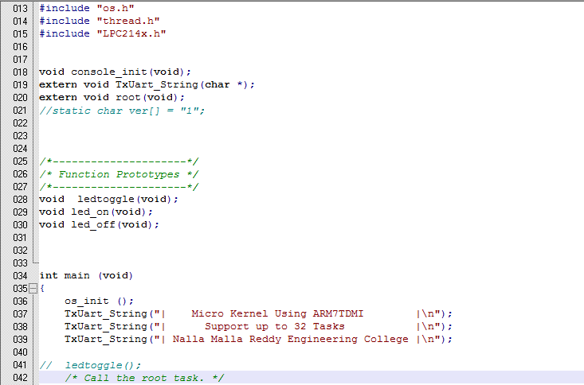

Add Source Files to Project
Once you have created your source file, you can add this file to your project. µVision4 offers several ways to add source files to a project. For example, you can select the file group in the Project Window and open the Context Menu.
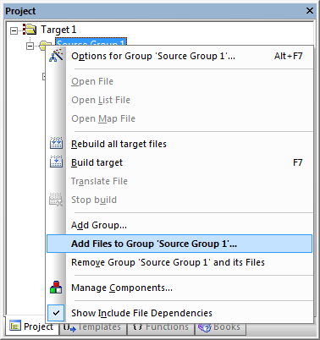
The option Add Files to Group opens the standard files dialog. Select the file MAIN.C you have just created and click Add.
Build Project
Typically, the tool settings under Project — Options for Target are all you need to start a new application. You may translate all source files and link the application by clicking on the Build button of the toolbar.
When you build an application, µVision4 displays errors, warnings, and any other messages in the Build Output Window. Double-click on a message to open the corresponding source file.
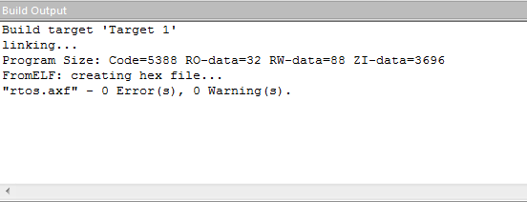

After building the project, you may: Modify existing source code or add new source files to the project. The Build button translates only modified or new source files and generates the executable file.
µVision4 maintains a file dependency list and knows all include files used within a source file. Even the tool options are saved in the file dependency list, so that µVision4 rebuilds files only when needed.
With the Rebuild command, all source files are translated, regardless of modifications. Test Programs with the µVision4 Debugger. The µVision4 Debugger offers two operating modes: Simulator that allows you to verify your application on your PC, or Target Debugging with an Evaluation Board or your hardware platform.
Program your application into Flash ROM. µVision4 integrates command-line driven Flash Utilities or can use a ULINK USB-JTAG family Adapter for Flash programming.
You may need to create a HEX file to use Flash programming utilities. Create HEX File
Once you have successfully generated your application you can start debugging. After you have tested your application, it is required to create an Intel HEX file to download the software into an EPROM programmer or simulator. µVision4 creates HEX files with each build process when Create HEX file under Options for Target — Output is enabled.
You may start your PROM programming utility after the make process when you specify the program under the option User — Run User Program #1 as explained under Start External Tools.
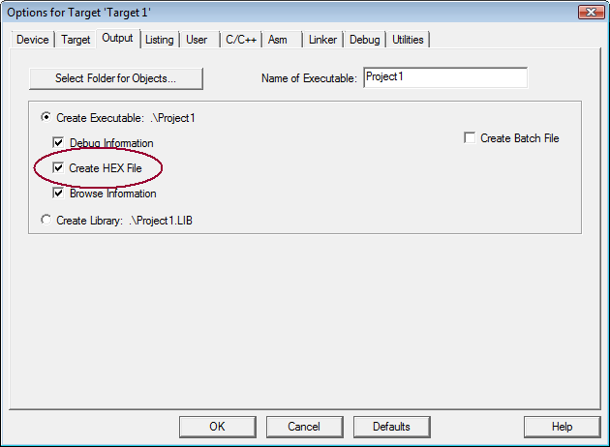
Debugging
This chapter describes the Debug Mode of µVision4 and guides you through the user interface to test a sample program. Simulation mode and the different options available for program debugging are also discussed.
Using the Debugger is an introduction to simulation and program execution.
Debug Windows and Dialogs describes the features available while debugging.
Expressions you may use in debug commands.
Tips and Tricks some advanced techniques for a better understanding of the debugger capabilities.
You can use the µVision4 Debugger to test the applications you develop. The Debugger offers two operating modes that can be selected in the Options for Target — Debug dialog.
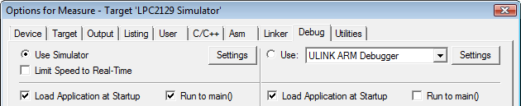

Use Simulator, configures the µVision4 Debugger as software-only product that simulates most features of a microcontroller without actually having target hardware. You can test and debug your embedded application before the hardware is ready. µVision4 simulates a wide variety of peripherals, including the serial port, external I/O, and timers. Peripheral simulation capabilities vary depending on the device you have selected.
Use Target Debugger, like the ULINK ARM Debugger, is a hybrid product that combines µVision4 with a hardware debugger interfacing to your target system. The following debug devices are supported:
JTAG/OCDS Adapter: which connects to on-chip debugging systems like the ARM Embedded ICE.
Monitor: that can be integrated with user hardware or is available on many evaluation boards.
Emulator: which connects to the MCU pins of the target hardware.
In-System Debugger: which is part of the user application program and provides basic test functions.
Third-party tool developers may use the Keil Advanced GDI to interface µVision to their own hardware debuggers.
Using the Debugger
The µVision4 Debugger is powerful, yet very easy to use.
Whether you are simulating a target device, or controlling that target device using an emulator, the interface provided by µVision4 can be used virtually the same way.
While debugging, you have full access to your source code. You can control program execution using the high-level code (C/C++) or assembly level code view. You may even edit your program while in Debug mode.
Simulation describes the capabilities and the Debug Menu. Start Debugging guides you through the first steps and the configuration options. Application Program Execution shows you different ways to step through the code while debugging.
The µVision4 Debugger simulates up to 4GB (Giga Bytes) of memory. Memory areas can be mapped for read, write, or code execution access. The µVision4 Simulator traps and reports any illegal memory access. In addition to memory mapping, the Simulator also provides support for the integrated peripherals of the various microcontroller devices. When you select a microcontroller from the Device Database, µVision4 configures the peripherals, instruction set and timimg accordingly. Refer to Create a Project File for more information about selecting a device.
You may select and display the on-chip peripheral components using the Debug menu. You can also change the aspects of each peripheral using the controls in the dialog boxes.The Simulator is cycle accurate, and, where possible, accurately simulates instructions and on-chip peripheral timing Can provide external stimulus using the debugger C script language
Start Debugging
The µVision4 Debug Mode starts with the menu command Debug — Start/Stop Debug Session. Depending on the settings under Options for Target — Debug, the µVision4 Debugger loads the application program and executes the startup code.
µVision4 saves the editor screen layout and restores the screen layout of the last debug session. If the program execution stops, µVision4 opens an Editor Window with the source text, or shows CPU instructions in the Disassembly Window.
The next executable statement is marked with a yellow arrow.
During debugging, most editor features are still available. For example, you can use the Find command, or correct program errors. Program source text of your application is shown in the same windows.
The µVision4 debug mode differs from the edit mode in the following aspects:
The Debug Menu and Debug Commands are available. The additional Debug Windows and Dialogs are discussed in the following.
The project structure or tool parameters cannot be modified. All build commands are disabled.
Application Program Execution
µVision4 allows you to run your application program in several different ways:
With the Debug Menu and Debug Commands.
With the Run till Cursor line command of the Context Menu, available in the Editor or Disassembly window.
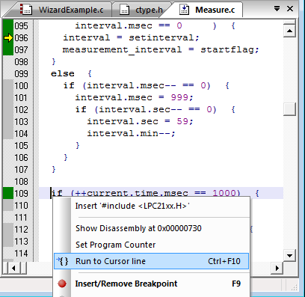
In the Command Window page you can use the Go, Ostep, Pstep, and Tstep commands.
After strating debugging if there are no errors a window appears as such
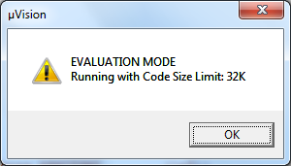
Peripherals Menu
The Peripherals menu includes dialogs to display and change on-chip peripheral settings.
The content of this menu is tailored to show the peripherals of the specific CPU selected for your application.
Dialogs are typically available for System Configuration, Interrupts, UARTs, I2C, Timer/Counters, General Purpose I/O, CAN, Pulse-Width Modulators, Real-Time Clocks, and Watchdog Timers.
This menu is active in Debug Mode only and offers, for example, the following dialogs
Menu Item | Description
Interrupts | Interrupt Controller
I/O Ports | I/O Ports
Serial | Serial Port
Timer | Timers/Counters
Watchdog | Watchdog Timer
A/D Converter | Analog to Digital Converter
D/A Converter | Digital to Analog Converter
I²C Controller | I²C Controller
CAN Controller | CAN Controller
Click on the peripherals menu GPIO Port-1 to see the results
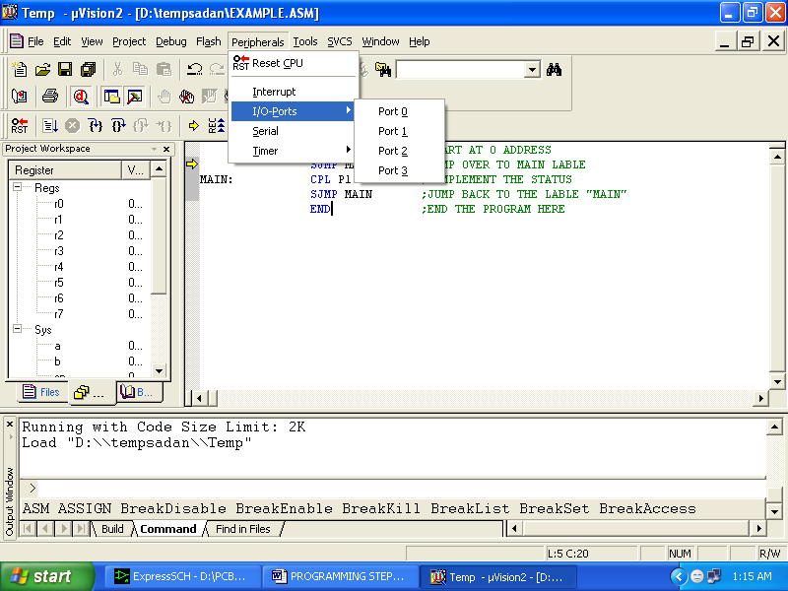

6.Results and Conclusion:
This results of this projects shown in figures 6.1 and 6.2 using the Keil uVision simulator. Total 8 tasks are created and scheduled. Each task sends different message to the UART terminal0 which can be observed in the Debugger environment of the tool. Once a task is completed it posts a semaphore for another task and waits for another semaphore indefinitely. Whenever it gets a semaphore it gets scheduled. The context switching and scheduling functions are implemented in C and ARM assembly language. Along with these function two application tasks are developed.
Task 1: Sends display data related to Taks1 on UART0, blinks LEDs, posts a semaphore for task2
Task 2: waits for the semaphore, and sends different data related to task2 on UART0 and toggles the LED status.
The simulation output using Keil Microvision tools are shown in Fig.
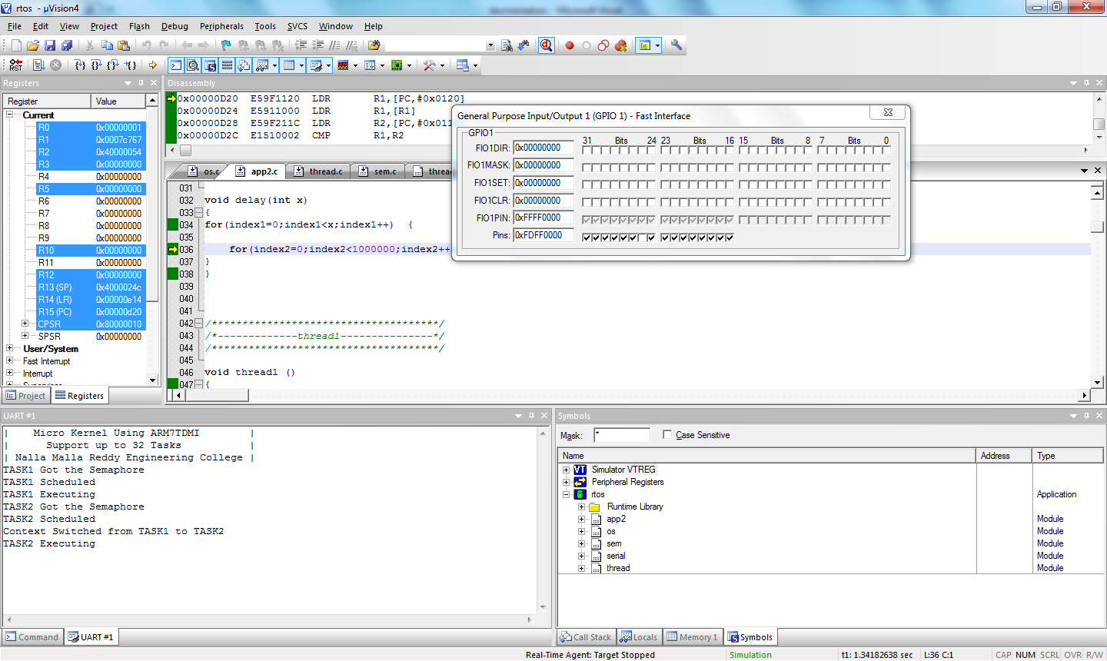

Figure 6.1. Simulation results with uart and GPIO windows
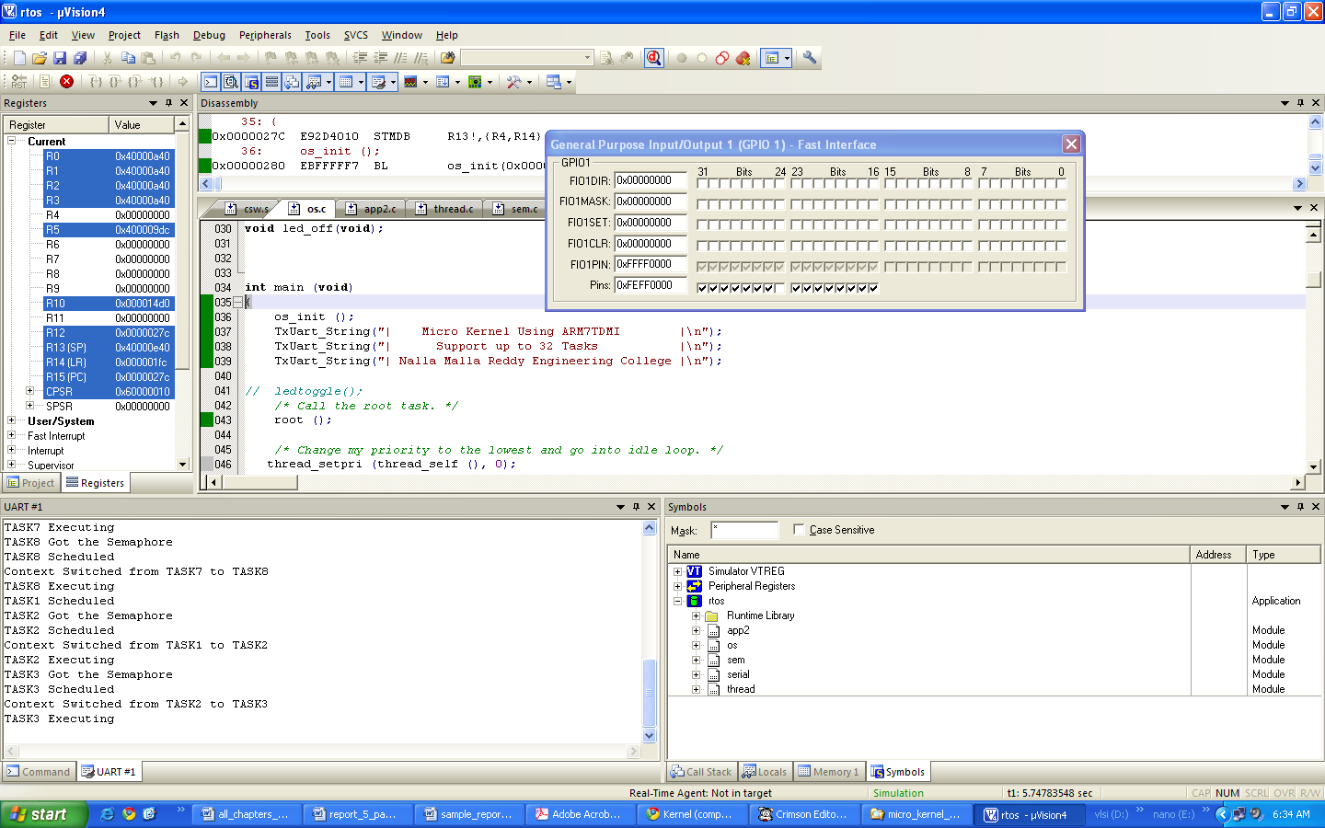

Figure 6.1. Simulation results showing context switching across Task7 to Task1

The same results are demonstrated on the test board based on LPC2138 explained in section 3.4. Flash Magic tool used for loading the software in the microcontroller board.
Conclusion:
A real time microkernel for ARM7TDMI is successfully developed and demonstrated in this project. The tools used are uVision for Software development and debugging, Flash Magic is used for flash loading. Microkernel developed in this project can be used for multi-tasking. The application areas are avionics on board computers, industry process automation, auto mobile electronics.

