**CSS flexible box layout**

The **CSS flexible box layout** module defines a CSS box model optimized for user interface design, and the layout of items in one dimension. In the flex layout model, the children of a flex container can be laid out in any direction, and can "flex" their sizes, either growing to fill unused space or shrinking to avoid overflowing the parent. Both horizontal and vertical alignment of the children can be easily manipulated.

[**The flex model**](https://developer.mozilla.org/en-US/docs/Learn/CSS/CSS_layout/Flexbox#the_flex_model)

When elements are laid out as flex items, they are laid out along two axes:

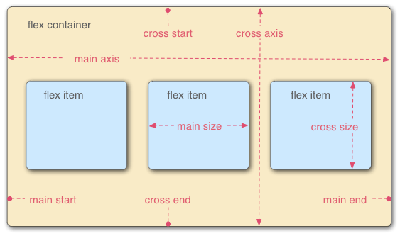

* The **main axis** is the axis running in the direction the flex items are laid out in (for example, as a row across the page, or a column down the page.) The start and end of this axis are called the **main start** and **main end**.
* The **cross axis** is the axis running perpendicular to the direction the flex items are laid out in. The start and end of this axis are called the **cross start** and **cross end**.
* The parent element that has display: flex set on it (the [<section>](https://developer.mozilla.org/en-US/docs/Web/HTML/Element/section) in our example) is called the **flex container**.
* The items laid out as flexible boxes inside the flex container are called **flex items** .

### [Properties](https://developer.mozilla.org/en-US/docs/Web/CSS/CSS_flexible_box_layout#properties)

* [flex](https://developer.mozilla.org/en-US/docs/Web/CSS/flex)
* [flex-basis](https://developer.mozilla.org/en-US/docs/Web/CSS/flex-basis)
* [flex-direction](https://developer.mozilla.org/en-US/docs/Web/CSS/flex-direction)
* [flex-flow](https://developer.mozilla.org/en-US/docs/Web/CSS/flex-flow)
* [flex-grow](https://developer.mozilla.org/en-US/docs/Web/CSS/flex-grow)
* [flex-shrink](https://developer.mozilla.org/en-US/docs/Web/CSS/flex-shrink)
* [flex-wrap](https://developer.mozilla.org/en-US/docs/Web/CSS/flex-wrap)
* [order](https://developer.mozilla.org/en-US/docs/Web/CSS/order)

### [Properties for alignment](https://developer.mozilla.org/en-US/docs/Web/CSS/CSS_flexible_box_layout#properties_for_alignment)

The properties align-content, align-self, align-items and justify-content initially appeared in the Flexbox specification, but are now defined in Box Alignment. The Flexbox spec now refers to the Box Alignment specification for up to date definitions. Also additional alignment properties are now defined in Box Alignment.

* [justify-content](https://developer.mozilla.org/en-US/docs/Web/CSS/justify-content)
* [align-content](https://developer.mozilla.org/en-US/docs/Web/CSS/align-content)
* [align-items](https://developer.mozilla.org/en-US/docs/Web/CSS/align-items)
* [align-self](https://developer.mozilla.org/en-US/docs/Web/CSS/align-self)
* [place-content](https://developer.mozilla.org/en-US/docs/Web/CSS/place-content)
* [place-items](https://developer.mozilla.org/en-US/docs/Web/CSS/place-items)
* [row-gap](https://developer.mozilla.org/en-US/docs/Web/CSS/row-gap)
* [column-gap](https://developer.mozilla.org/en-US/docs/Web/CSS/column-gap)
* [gap](https://developer.mozilla.org/en-US/docs/Web/CSS/gap)

https://developer.mozilla.org/en-US/docs/Web/CSS/CSS_flexible_box_layout/Basic_concepts_of_flexbox