Report on
SIMULATION BASED ASSIGNMENT
School of Computer Science & Engineering.

Course Code: CSE 316
Course Title: Operating System
Faculty: Baljit Singh Saini

Name: Perala Bhargavi Vinay
Reg.ID: 11803021
Section: K18KK – B 38.
Email Address: bhargavivinay9302@gmail.com
GitHub Link:
https://github.com/vinay1001/Banker-s_Algorithm



Problem Statement:
Write a multithreaded program that implements the banker's algorithm. Create n threads that request and release resources from the bank. The banker will grant the request only if it leaves the system in a safe state. It is important that shared data be safe from concurrent access. To ensure safe access to shared data, you can use mutex locks.

Code:
#include <stdio.h>
#include <stdlib.h>
#include <unistd.h>
#include <pthread.h>
#include <stdbool.h>
#include <time.h>
#include<iostream>
using namespace std;

int no_process ,no_resources;
int p_number= 0;
void*process(void *arg);
pthread_mutex_t lock; //to lock the threads
pthread_cond_t condition;

int main()
{
//taking input for no.of process
cout<<"Enter total no.of processes - ";
cin>>no_process; //taking input of process number

//taking input for no.of resources
cout<<"Enter no.of resources - ";
cin>>no_resources; //taking inpput of no of resources

//taking input for total availability of resources;
int current_resources[no_resources];
cout<<"Enter total instances for each resource (R1 R2 ...) - ";
for(int i = 0;i<no_resources;i++)
{
cin>>current_resources[i];
}

int allocated_resources[no_process][no_resources];
//taking input for allocated resources for eaach process
for(int i = 0;i<no_process;i++)
{
cout<<"Enter allocated resources for process "<<(i+1)<<" - ";
for(int j = 0;j<no_resources;j++)
{
cin>>allocated_resources[i][j];
}
cout<<"\n";
}

cout<<"\n\n\n";

int max_req[no_process][no_resources];
//taking input for max_requirement of resources for each process
for(int i = 0;i<no_process;i++)
{
cout<<"Enter maximum resources for process "<<(i+1)<<" - ";
for(int j = 0;j<no_resources;j++)
{
cin>>max_req[i][j];
}
cout<<"\n";
}

int rem_need[no_process][no_resources]; //matrix for remaining need of resources for each process;

for(int i = 0;i<no_process;i++)
{
for(int j = 0;j < no_resources;j++)
{
rem_need[i][j] = max_req[i][j] - allocated_resources[i][j];
}
}

//array to store safe sequence
int safe_seq[no_process];
for(int i = 0;i<no_process;i++)
{
safe_seq[i] = -1;
}
bool s;
//cout<<"\nFINAL OUTPUT - "<<s

int copy_current_resources[no_resources];
for(int i = 0;i<no_resources;i++)
{
copy_current_resources[i] = current_resources[i];
}

bool finish[no_process]; //to store finish status of processes;
for(int i = 0;i<no_process;i++)
{
finish[i] = false; //initially all processes are not finished
}

int no_finish = 0; //no_of finished processes are zero initially

while(no_finish <no_process)
{
bool safe = false;

for(int i = 0;i<no_process;i++) //running loop for each process to check for finish status
{
if(!finish[i])
{
bool possible = true;
for(int j = 0;j<no_resources;j++)
{
if(rem_need[i][j] > copy_current_resources[j]) //checking need and availability of resources for each process
{
possible = false;
break;
}
}

if(possible)
{
for(int j = 0;j<no_resources;j++)
{
copy_current_resources[j] += allocated_resources[i][j];
}
safe_seq[no_finish] = i;
finish[i] = true; //updating the finish status
no_finish++;
safe = true;
}
}
}

if(!safe)
{
for(int j = 0;j<no_process;j++)
{
safe_seq[j] = -1;
s = false; //no safe sequence found after all process checks.
cout<<"NO SAFE SEQUENCE FOUND";
sleep(5);
exit(0);
}
}
}
s = true;

if(s == true){
cout<<"SAFE SEQUENCE IS : ";
for(int i = 0;i<no_process;i++)
{

cout<<safe_seq[i] + 1<<"\n\n";
}
}

//creating and running threads
pthread_t processes[no_process];
pthread_attr_t attr;
pthread_attr_init(&attr);

int processNumber[no_process];
for(int i=0; i<no_process; i++) processNumber[i] = i;{

for(int i=0; i<no_process; i++)
{ pthread_create(&processes[i], &attr, process,(void *)(&processNumber[i]));

}

for(int i=0; i<no_process; i++)
{ pthread_join(processes[i], NULL);}

for(int i = 0;i<no_process;i++)
{
cout<<"\n\n\n";
cout<<"----------PROCESS "<<safe_seq[i]+1<<"\n\n";
int k = safe_seq[i];
cout<<"Maximum requirement - ";
for(int j = 0;j < no_resources;j++)
{cout<<max_req[k][j]<<" ";}
cout<<"\n";
cout<<"Allocated - ";
for(int j = 0;j < no_resources;j++)
{cout<<allocated_resources[k][j]<<" ";}
cout<<"\n";
cout<<"Needed - ";
for(int j = 0;j < no_resources;j++)
{cout<<rem_need[k][j]<<" ";}
cout<<"\n";
cout<<"\n\n";

cout<<"Available for allocation\n";
sleep(1);
cout<<"Resource Allocated\n";
sleep(1);
cout<<"Process started\n";
sleep(1);
cout<<"Process terminated and resources released";
cout<<"\nCurrent Available Resources - ";

for(int j = 0;j < no_resources;j++)
{
current_resources[j] = current_resources[j] + allocated_resources[k][j];
cout<<current_resources[j]<<" ";
}
cout<<"\n\n\n";

}
}
return 0;
}
//thread process to be performed to use mutex lock
void *process(void*arg)
{
int p = *((int *) arg);
//resources locked
pthread_mutex_lock(&lock);

cout<<"\nThread created successfully\n";

}

Banker’s Algorithm:

The banker’s algorithm is a resource allocation and deadlock avoidance algorithm that tests for safety by simulating the allocation for predetermined maximum possible amounts of all resources, then makes an “s-state” check to test for possible activities, before deciding whether allocation should be allowed to continue.

Deadlock:
A deadlock is a situation in which two computer programs sharing the same resource are effectively preventing each other from accessing the resource, resulting in both programs ceasing to function. The earliest computer operating systems ran only one program at a time.

Safe Sequence:
The sequence of processes in a system, that assures that their execution doesn’t create any deadlock.

If there are n no. of processes in a system, each process needs certain instances of resources available. Banker’s Algorithm allows to check whether there could be a chance of deadlock if the process continue to access the resources. Banker’s Algorithm helps to create the safe sequence of processes.
Algorithm:
- Repeat steps 2 to 25 While( finished < Processes)//p times
- {
- Safe = false;

- Repeat steps 5 to 24 For p from 1 to processes //p times
- {
- If(!finished)
- {
- Possible = true;
- For r from 1 to resources
- {
- If(needed_resources > available_resources)
- {
- Possible = false;
- Break;
- }
- }

- If(possible = false)
- {
- Free the resources for that process //r times
- And add to available resources

- Add process p to safe sequence.
- }
- }
- }
- }

Complexity of Algorithm:
The outside while loop runs p(no.of active processes) times,and for each process for loop also runs p times to check need and availability condition.After each process is completed the r resources will be freed using for loop.

So the time complexity for bankers algorithm is r*(P*P).

r → No.of resources.
P → No.of Active Processes.

Constraints:

- Number of processes and resources can’t be altered during the execution of code. They should be fixed initially.
- This code provides only one safe sequence even if multiple safe sequences are possible.
- Speed of execution depends on total no.of active processes in the system.

Code Execution and Test Cases:

Test Case 1: Input - Safe sequence is possible
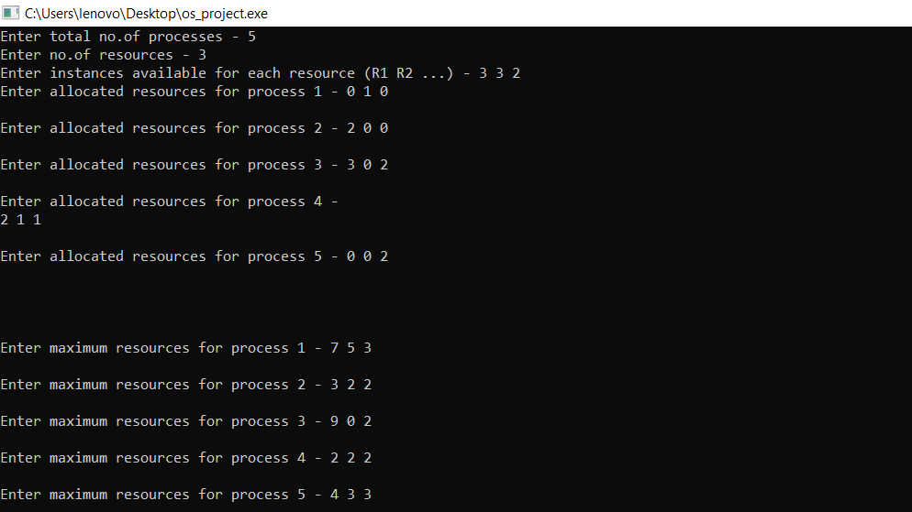

Output:
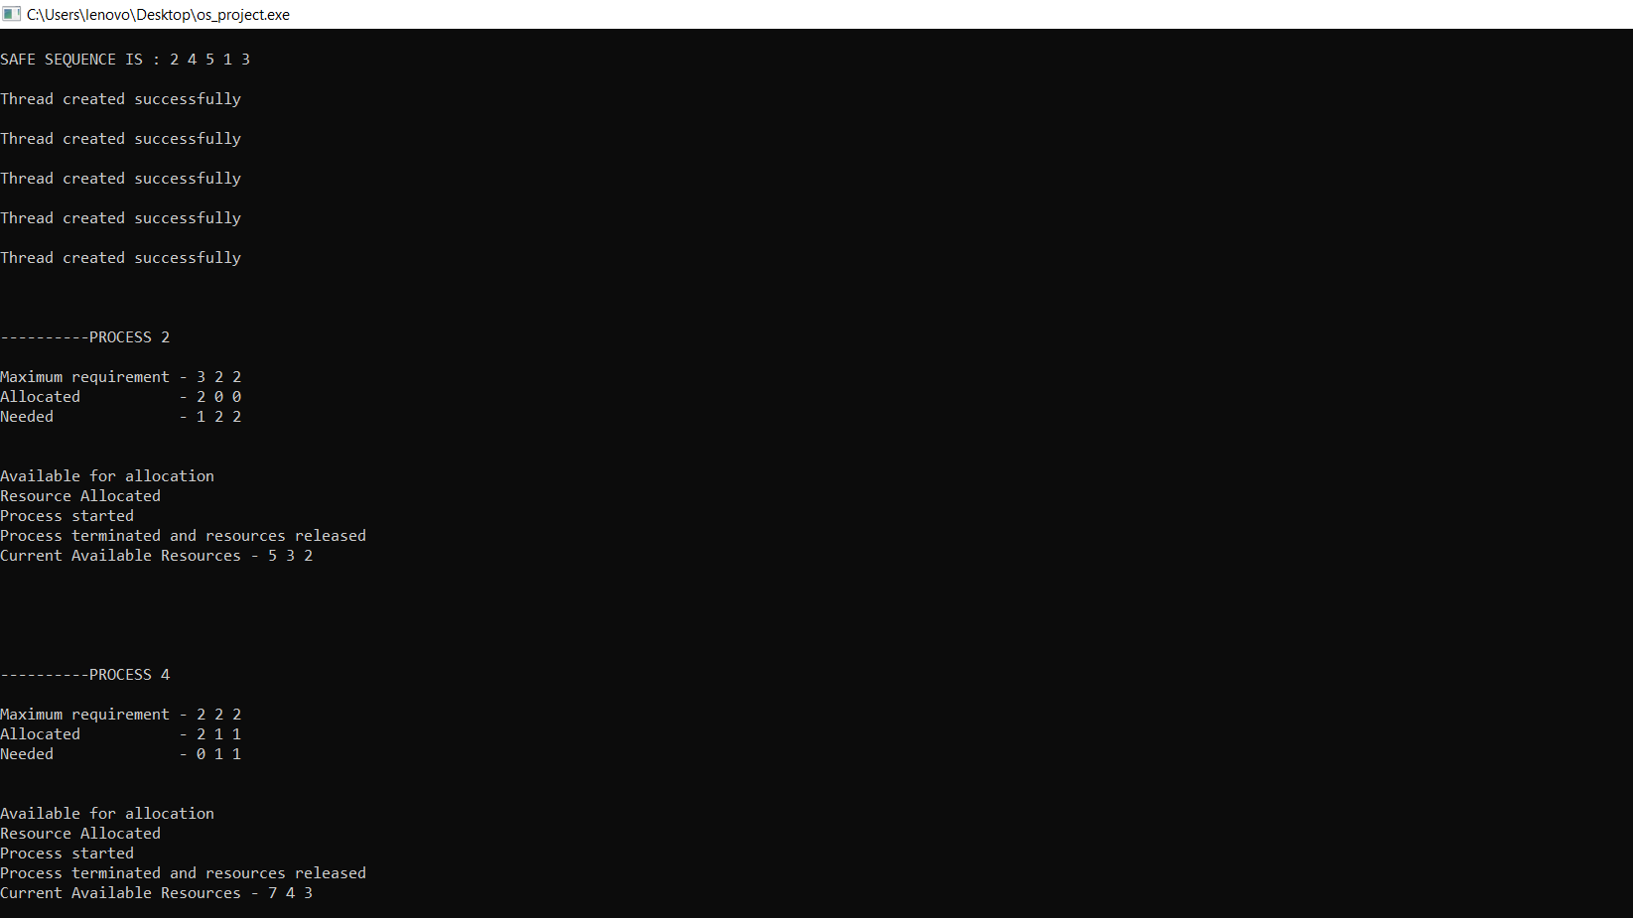
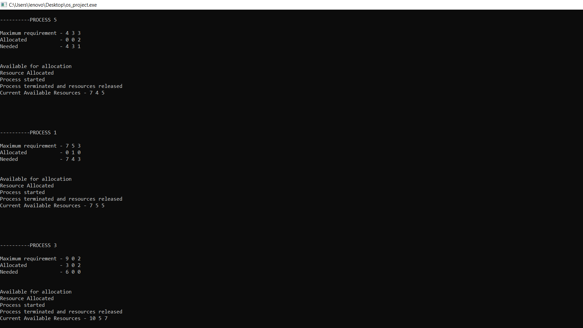

Test Case 2: Input and ouput – safe sequence is not possible

