The final analysis from two tables “Trips” and “json_weather_data” shows that.

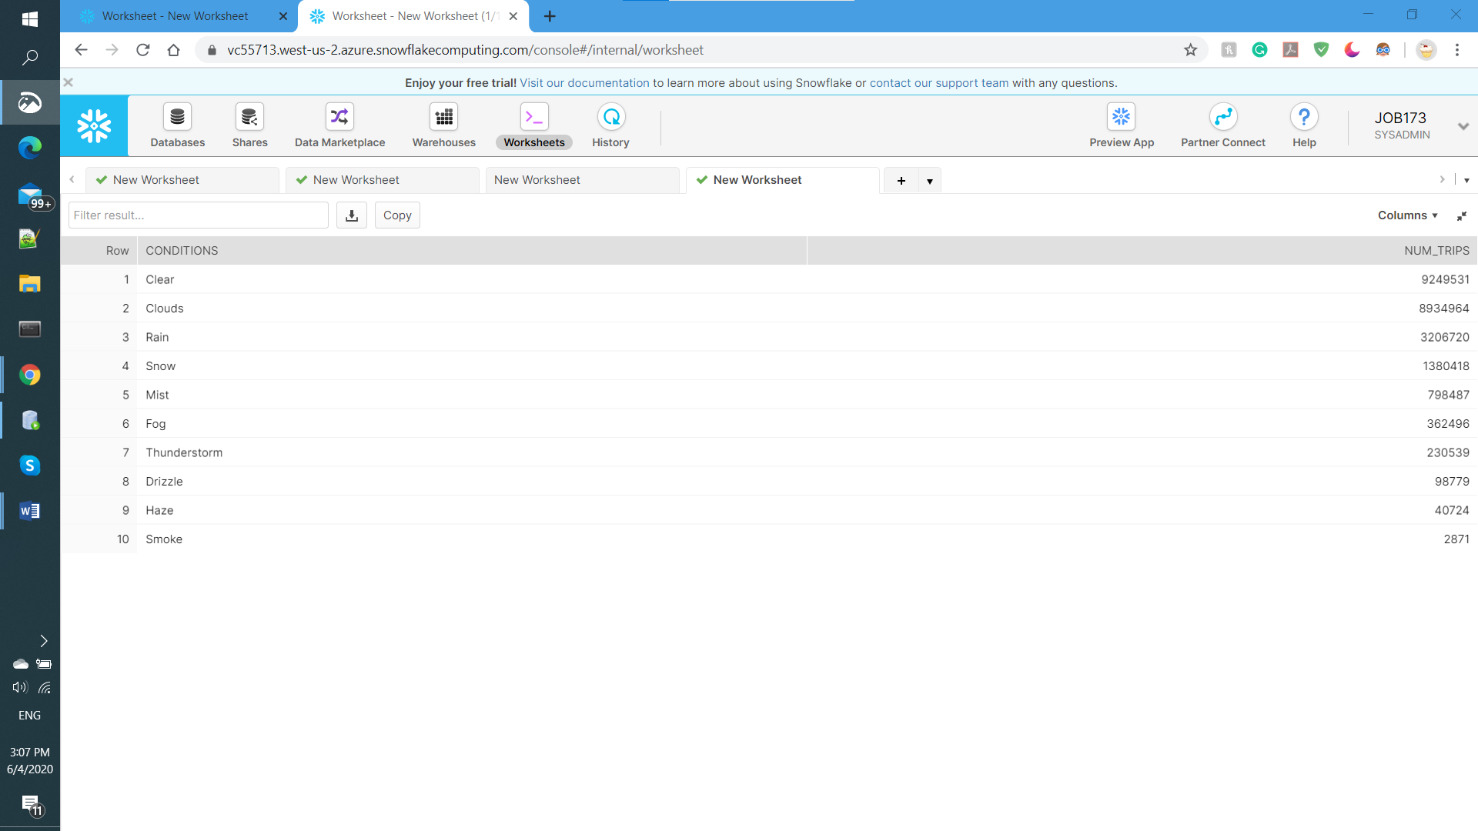

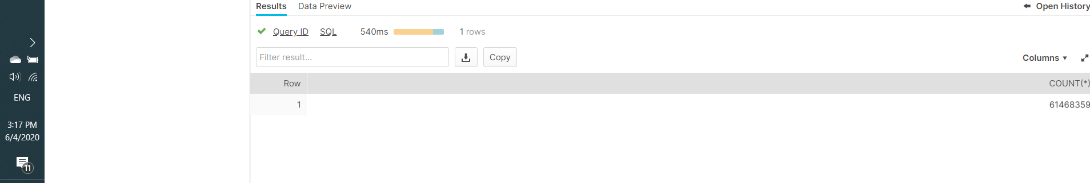

1. When the weather is Clear then the Trips(Num_Trips) is more which is “9249531” from the to Total Trips “61468359”.
2. When the Weather is Smoke the the Trips(Num_Trips) is lowest which is “2871” from the Total Trips ‘’61468359”.

From this data we can conclude number of trips to the different Weather Conditions.