**Screen -1:** Class mentor selection radio option and save mentor button through school admin login.

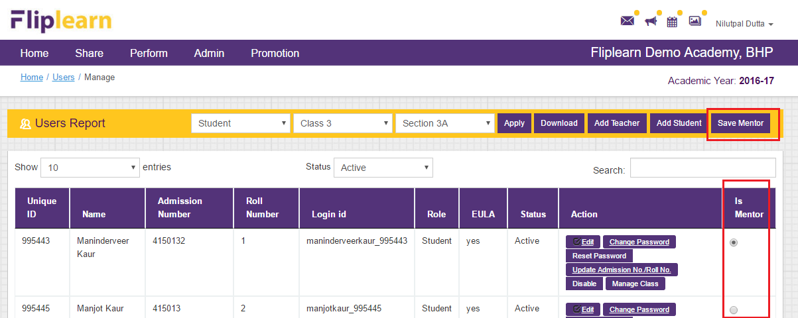

**Screen -2:** Class mentor of the month highlight on home page of student (login as student)

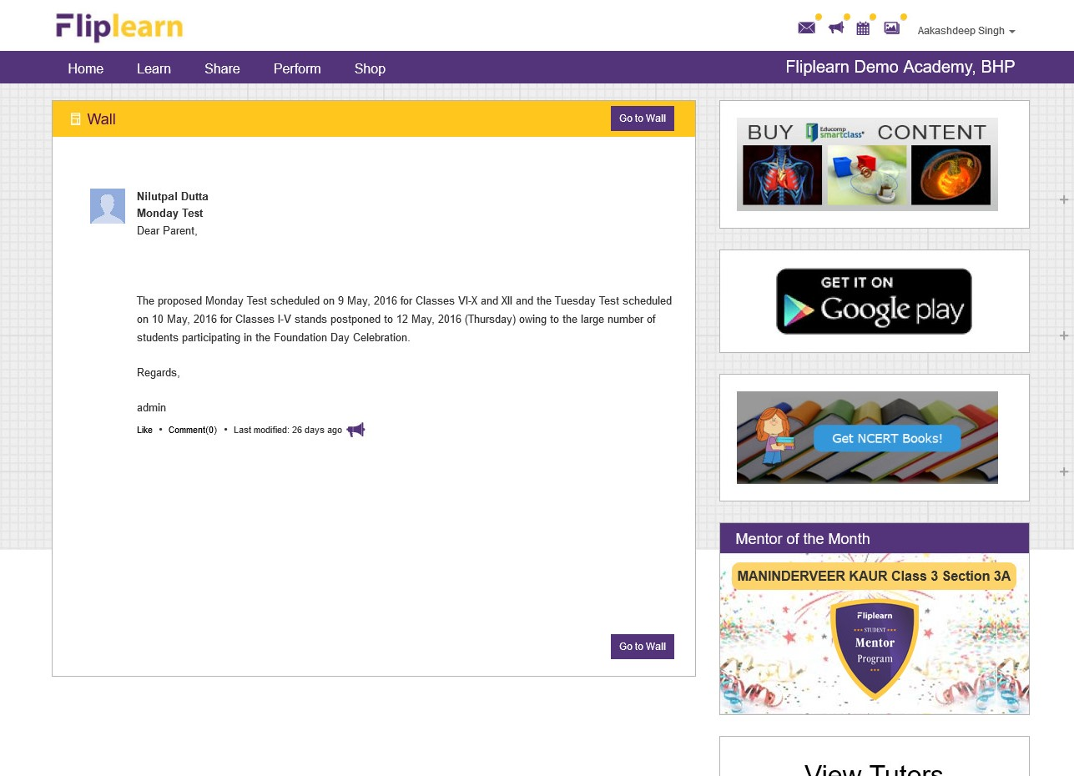

**Screen -3:** Class mentor of the month highlight on home page of parent (login as parent)

