**Q1) Derive the expression for total power in wind?**

**Ans)**

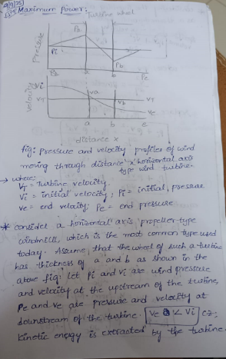

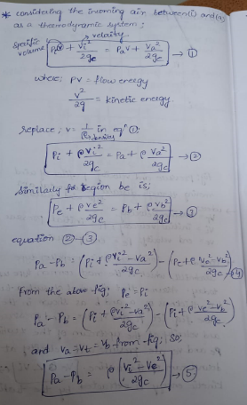

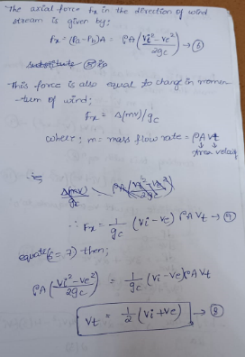

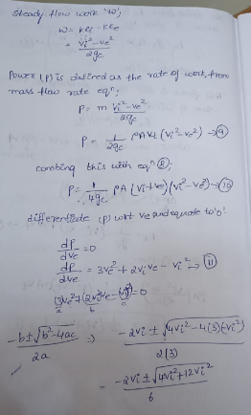

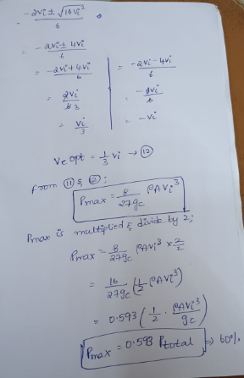

**Q2) Classify and explain about wind turbines?**

**Ans) Wind turbine:** A wind turbine is a device that converts kinetic energy from the wind into mechanical energy.

* If the mechanical energy is used to produce electricity, the device may be called a wind generator or wind charger.
* If the mechanical energy is used to drive machinery, such as for grinding grain or pumping water, the device is called a windmill or wind pump.
* There are two types of windmills: a) Horizontal b) Vertical

**Horizontal Windmill:**

The common wind turbine with a horizontal (or almost horizontal) axis, is simple in principle, but the design of a complete system, especially a large one that will produce electric power economically, is complex. The horizontal axis types generally have better performance, They have been used for various applications, but the two major areas of interest are electric power generation, and pumping water.

**(i) Horizontal axis propeller type using single blade:**

In this arrangement, a long blade is mounted on a rigid hub. Induction generator and gear box are also shown. If extremely long blades (above say 60 m) are mounted on rigid hub, large blade root bending moment may occur due to tower shadow, gravity and sudden shifts in wind directions. To reduce rotor cost, use of low cost counter weight is recommended which balance long blade centrifugally.

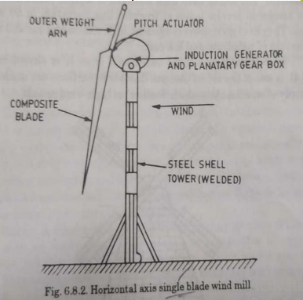

**Advantages of one bladed rotor:**

* Simple blade controls-lower blade weight and cost- lower gear box cost.
* Counter weight costs less than a second blade.
* Counter weight can be inclined to reduce blade coning.
* Pitch bearings do not carry centrifugal force.
* Blade root spar can be large diameter i.e. more rugged.

**Disadvantages:**

(i) Vibration produced, due to aerodynamic torque.

(ii) Unconventional appearance.

(iii) Large blade root bending moment.

(iv) Starting-torque reduced by ground boundary layer.

**(ii) Horizontal axis multi bladed type:**

This type of design for multiblades, made from sheet metal or aluminium. The rotors have high strength to weight ratios and have been known to service hours of freewheeling operation in 60 km/hrwinds. They have good power coefficient, high starting torque and added advantage of simplicity and low cost.

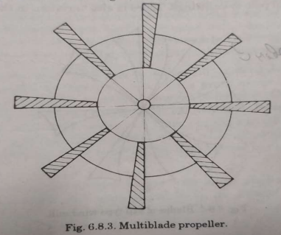

**Vertical Axis WindTurbine:** The rotating axis of the blades is perpendicular to the direction of wind. The main rotor shafts runs vertically. These are mainly beneficial in areas with turbulent wind flow such as roof tops, coastlines, cityscapes etc.. In vertical axis wind turbine Maintenance and Inspection is easy.

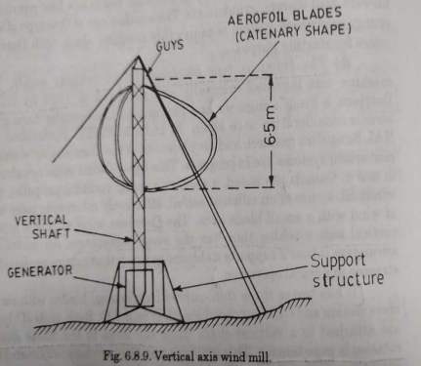

**(i) The Savonius Rotor:**

It consists of two-half-cylinders facing opposite directions in such a way as to have almost an S-shaped cross section. These two semi-circular drums are mounted on a vertical axis perpendicular to the wind direction with a gap at the axis between the two drums.

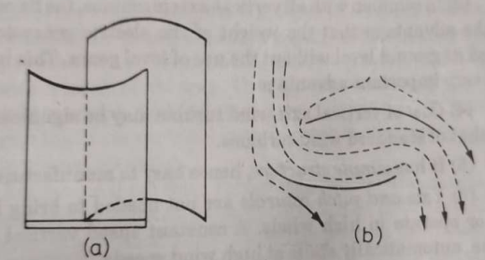

**Characteristics of Savonius Rotor:** Self starting, Low speed, Low efficiency.

**(ii) The Darrieus type machine(High velocity wind):** It has two or three thin, curved (egg beater) blades with airfoil cross section and constant chord length. Both ends of blades are attached to a vertical shaft. Thus the force in the blade due to rotation is pure tension.

**Characteristics of Darrieus Rotor:** (i) Not self starting (ii) High speed

(iii) High efficiency (iv) Potentially low capital cost.

**Q3) How energy from wind can be extracted? Explain the process by using suitable diagram?**

**Ans)** Energy from wind can be extracted by converting the kinetic energy of moving air into mechanical energy, and then into electrical energy using a wind energy conversion system (WECS) such as a wind turbine.

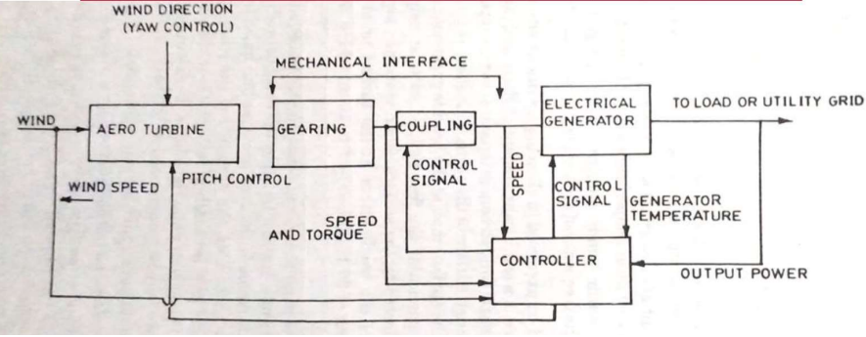

* Aero Turbines convert energy in moving air to rotary mechanical energy.
* A mechanical interface consisting of a step up gear and a suitable coupling transmits the rotary mechanical energy to an electrical generator.
* The output of this generator is connected to the load or power grid as the application warrants.
* The rotor can be in a fixed orientation with the swept area perpendicular to the predominant wind direction.
* The purpose of the controller is to sense wind speed, wind direction, shafts speed.
* Output power and generator temperature as necessary and appropriate control signals for matching the electrical output to the wind energy input and protect the system from extreme conditions brought upon by strong winds.

**Q4) Explain the working of biogas digester with the help of diagram?**

**Ans)** Biogas is generated by fermentation or digestion of organic matter in the presence of aerobic and anaerobic micro-organisms.

A **biogas digester** (also known as a **biogas plant**) is a device that converts **organic waste materials**—such as animal dung, crop residues, and kitchen waste—into **biogas** (a mixture of methane and carbon dioxide) through a biological process called **anaerobic digestion**.This process occurs **in the absence of oxygen** and produces both **biogas** for fuel and **slurry** that can be used as a fertilizer.

The digestion takes place in the following steps:

i) Enzymatic hydrolysis ii) Acid formation iii) Methane formation.

**i) Enzymatic hydrolysis:** In this step the complex organic matter like starch, protein, fat, carbohydrates etc are broken down to simple structures using anaerobic microorganisms.

**ii) Acid formation:** In this step the simple structures formed in the enzymatic hydrolysis step are further reacted by anaerobic and facultative microorganisms (which thrive in both the presence and absence of oxygen) to generate acids.

**iii) Methane formation:** In this step the organic acids formed are further converted to methane and CO2 by anaerobic micro-organisms (anaerobes).

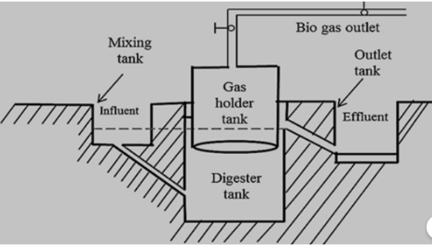

**Working of Biogas plant-**  
1) Biogas is made in a digester which is a tank filled with bacteria that eat organic waste and give flammable gas (biogas).  
2) The bacteria in the tank should be taken care of well and proper food is to be given.  
3) The bacteria convert organic matter into methane gas through anaerobic respiration.  
4) The operator of the biogas system feeds the digester with household by-products like kitchen waste, manure, etc.  
5) The methane gas produced can be used for cooking, lighting, etc.  
6) The waste which is fully digested will form an organic fertilizer.  
7) Its main part consists of:  
a. Mixing tank  
b. Inlet chamber  
c. Digester  
d. Outlet chamber  
e. Overflow tank  
8) This is also called anaerobic digester, biodigester, or a bioreactor.

**Q5) With a neat sketch explain the devices employed for wave energy?**

**Ans) (i) Float Wave Power Machine:** Float moves up &down in the water. Four vertical main-folds that are Part of platform guide the flow. A piston is attached to the float which Compress the air in the cylinder which is stationary in stationary. The downward motion of piston draws air into the cylinder through inlet valve. The upward motion compresses the air & sends it through outlet to the storage tank.

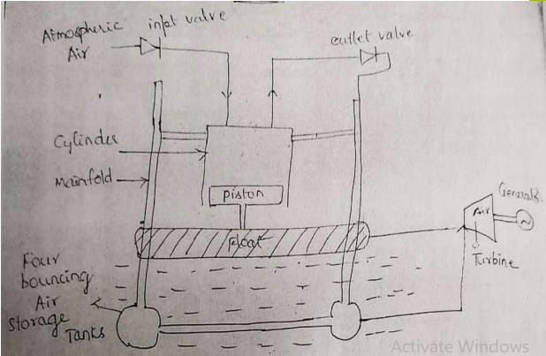

**(ii) Hydraulic Accumulator Wave Machine:**

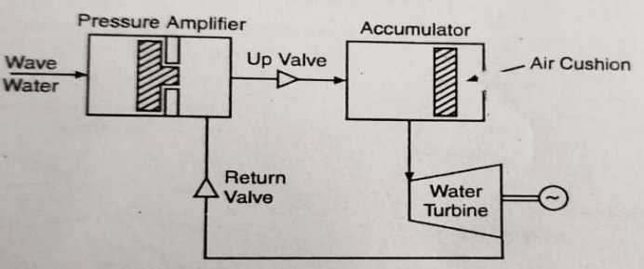

**Pressure Amplifier:** The waves enter the cylinder of pressure amplifier at the bottom and move the main piston. The pressure of the closed loop fluid is amplified to about 5 bar.

**Hydraulic Accumulator:** The high-pressure fluid is conducted through a one-way up valve to a hydraulic accumulator. The accumulator has air cushions on the top which helps to maintain a constant pressure.

**(iii) The Dolphin-Type Wave-Power Machine:**

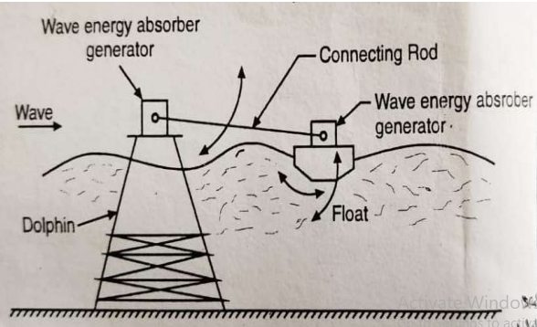

* The major components of the system are a dolphin, a float, a connecting rod and two electrical generators.
* The float has two motions.
* The rolling motion about its own fulcrum with the connecting rod is amplified and converted into continuous rotary motion with the help of gears.
* The electrical generator is driven. The other vertical motion is also amplified and converted into rotary motion to drive the gears.

======================================================

**Q6) What is geothermal energy? Explain about different types of geothermal resources?**

**Ans)** The word geothermal comes from the Greek words geo (Earth) and therme (heat). Geothermal energy is heat from within the Earth. Geothermal energy is generated in the Earth’s core, almost 4,000miles beneath the Earth’s surface.

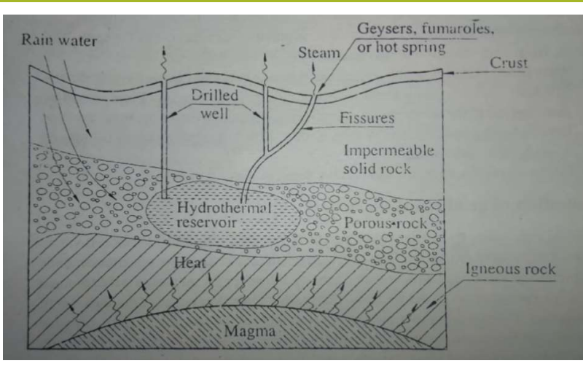

**Hydrothermal Systems:** Hydrothermal systems are those in which water is heated by contact with the hot rock as explained above. Hydrothermal systems are in turn subdivided into (1) vapor dominated and (2) liquid-dominated systems.

**1) Vapor-dominated systems :** In these systems the water is vaporized into steam that reaches the surface in a relatively dry condition at about 400°F (205°C) and rarely above 8 bar.

* This steam is the most suitable for use in turboelectric power plants, with the least cost.
* The Geysers plant in the United States, the largest in the world today, and Larderello in Italy, are both vapor-dominated systems.

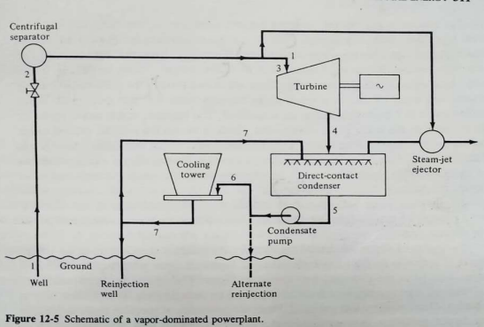

**2) Liquid-dominated systems :** In these systems the hot water circulating and trapped underground is at a temperature range of 350 to 600°F.

* Liquid-dominated systems, however, are much more plentiful than vapour dominated systems and, next to them, require the least extension of technology.
* The U.S. Geological Survey shows from 900 to 1400 quads (Q) (1Q about 10 J) of energy available from liquid-dominated systems with liquid above 300°F.

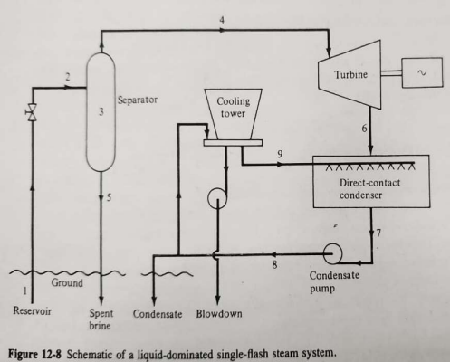

**3) Geopressured Systems:** Geopressured systems are sources of water, or brine, that has been heated in a manner similar to hydrothermal water, except that geopressured water is trapped in much deeper underground acquifers, at depths between 8000 to 30,000 ft .

* It has a relatively high salinity of 4 to 10 percent and is often referred to as brine.
* The U.S. Geological Survey estimates 100 Q of electricity from the thermal content of geopressured water and 500 Q of energy in the gas.

**4) Petrothermal Systems:** Magma lying relatively close to the earth's surface heats overlying rock as previously explained When no underground water exists, there is simply hot, dry rock (HDR).

* This energy, called petrothermal energy represents by far the largest resource of geothermal energy of any type, as it accounts for about 85 percent of the geothermal resource base of the United States.