**SKILL ASSSSSMENT PORTAL USING DJANGO**

**A SUMMER INTERNSHIP REPORT**

**Submitted in the partial fulfillment of**

**Requirements to Summer Internship (CS- 451)**

**IV/IV B.Tech (VII Semester)**

**Submitted By**

**MUVVA HIMASRI (Y22CS122)**



**October, 2025**

**R.V.R. & J. C. COLLEGE OF ENGINEERING (Autonomous)**

(Affiliated to Acharya Nagarjuna University)

**Chandramoulipuram :: Chowdavaram GUNTUR – 522019**

**CERTIFICATE**

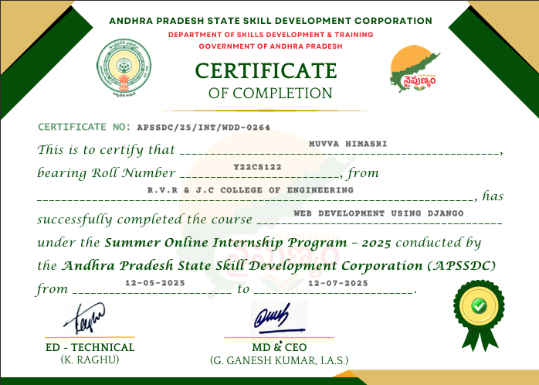

**ACKNOWLEDGEMENT**

The successful completion of any task would be incomplete without proper suggestions, guidance and environment. Combination of these three factors acts like backbone to our Internship **“Skill Assessment Portal using Django”.**

We would like to express our profound gratitude to **Dr.M.Sreelatha**, Head of the Department of Computer Science and Engineering and **Dr. Kolla Srinivas,** Principal, for their encouragement and support to carry out this Internship successfully.

We are very much thankful to **Andhra Pradesh State Skill Development Corporation (APSSDC),** for having allowed us to conduct the study needed for the Internship.

Finally we submit our heartfelt thanks to all the staff in the Department of Computer Science and Engineering and to all our friends for their cooperation during the Internship work.

**MUVVA HIMASRI (Y22CS122)**

**ABSTRACT**

The Skill Assessment Portal developed using Django provides a secure and automated solution for conducting online examinations in educational institutions. Traditional paper-based assessment systems are often plagued by time delays, human errors, logistical challenges, and high costs. This project addresses these limitations by implementing a web-based platform that ensures comprehensive automation of examination processes, including secure authentication, role-based access control, dynamic question generation, automated grading, and instant result generation. The system is designed with modular architecture following Django’s Model-View-Template (MVT) pattern, offering separate dashboards for administrators and students. Administrators can manage students, courses, and question banks, while students can seamlessly take exams and view results. The system integrates secure hashing mechanisms for authentication, randomization of questions to reduce malpractice, and real-time dashboards to display performance metrics. Testing and validation confirmed the reliability, usability, and scalability of the platform. The project not only enhances efficiency and accessibility but also reduces operational costs and strengthens examination integrity. Future work includes integrating teacher modules, real-time proctoring, advanced analytics, and mobile compatibility to expand the system’s scope and usability.

**CONTENTS** Page No.

|  |  |  |  |  |
| --- | --- | --- | --- | --- |
|  |  | Title Page | | i |
|  |  | Certificate | | ii |
|  |  | Acknowledgement | | iii |
|  |  | Abstract | | iv |
|  |  | Contents  List of Tables | | v  vi |
|  |  | List of Figures | | vii |
| 1 | Introduction | |  |  |
|  | 1.1 | Introduction of Assessments | | 1 |
|  | 1.2 | Problem Definition | | 2 |
|  | 1.3 | Significance of the work | | 2 |
| 2 | System Analysis | | |  |
|  | 2.1 | Requirements Specification | |  |
|  |  | 2.1.1 | Functional Requirements | 4 |
|  |  | 2.1.2 | Non-Functional Requirements | 6 |
| 3 | System Design | | |  |
|  | 3.1 | Architecture of the proposed system | | 8 |
|  | 3.2 | Workflow of the proposed system | | 9 |
|  | 3.3 | Module Description | | 11 |
| 4 | Implementation | | |  |
|  | 4.1 | Algorithms | | 13 |
|  | 4.2 | Data Sets/Data sources used | | 15 |
|  | 4.3 | Metrics calculated | | 16 |
|  | 4.4 | Methods compared | | 17 |
| 5 | Result Analysis | | |  |
|  | 5.1 | Actual Results obtained from the work | | 18 |
|  | 5.2 | Analysis of the results obtained | | 23 |
| 6 | Conclusion and Future Work | | | 25 |
| 7 | References  **LIST OF TABLES**   |  |  |  |  | | --- | --- | --- | --- | | **S** | **S.No Table No**  1 Table 1  2 Table 2 | **Table Description Page.No**  Metrics Calculated in the System 16  Traditional vs. Online System 17 |  | |  |  |  |  |   **LIST OF FIGURES**   | **S.No** | **Fig. No** | **Figure Description** | **Page No** | | --- | --- | --- | --- | | 1 | 3.1.1 | Architecture of Proposed System | 8 | | 2 | 5.1.1 | Assessment Portal Dashboard | 18 | | 3 | 5.1.2 | Student Signup Form | 19 | | 4 | 5.1.3 | Admin Login Panel | 19 | | 5 | 5.1.4 | Admin Dashboard | 20 | | 6 | 5.1.5 | Student Dashboard | 21 | | 7 | 5.1.6 | Student Exam Interface | 22 | | 8 | 5.1.7 | Logout Confirmation Page | 22 | | | | 26 |
|  |  | | |  |

1. **INTRODUCTION**

# 1.1 Introduction to Assessments

The prevailing paradigm of academic and professional assessment has, for centuries, been anchored in traditional, predominantly paper-based examination practices. While undeniably serving as a cornerstone of evaluative processes, this conventional methodology is increasingly recognized for its inherent limitations and operational bottlenecks within the rapidly evolving digital age. The lifecycle of a traditional examination is characterized by a series of resource-intensive and often cumbersome stages: the meticulous, frequently manual, creation and formatting of question papers; the complex logistical challenge of secure physical distribution to disparate examination venues; the subsequent collection and collation of voluminous answer sheets; and finally, the protracted, labor-intensive phase of manual grading and score tabulation.

This entrenched approach is fraught with a multitude of critical disadvantages that impede efficiency, compromise integrity, and delay crucial feedback:

* **Exorbitant Time Consumption:** The end-to-end process, from the initial drafting of assessment content to the ultimate declaration of results, is inherently time-consuming. This protracted timeline can significantly disrupt academic calendars, delay student progression, and hinder the timely issuance of professional certifications, leading to cascading inefficiencies across an organization.
* **Proneness to Human Error:** Manual intervention at various stages—be it in transcribing questions, distributing papers, or critically, in the subjective and repetitive task of grading—introduces a substantial margin for human error. Such inaccuracies can lead to misjudgments of student capabilities, erode trust in the assessment process, and necessitate costly and time-consuming re-evaluations.
* **Intensified Logistical Complexity and Cost:** Managing the physical infrastructure of examinations including printing, transportation, invigilation, and the subsequent handling of answer scripts demands extensive logistical planning and a large administrative footprint. This complexity escalates exponentially with the number of examinees and geographical dispersion.
* **Environmental Impact:** The reliance on vast quantities of paper for question booklets and answer sheets contributes to environmental concerns, aligning poorly with contemporary sustainability objectives.

# 1.2 Problem Definition

# In direct response to these multifaceted challenges, this project proudly presents the **Online Examination System**. This innovative digital solution represents a transformative leap forward, fundamentally re-engineering the entire examination paradigm through comprehensive automation and digital integration. By migrating critical assessment functions from a physical to a secure, web-based environment, the system directly mitigates, and in many cases eliminates, the aforementioned limitations.

# 1.3 Significance of the Work

The core value proposition and transformative capabilities of this Online Examination System are multifaceted:

* **Comprehensive Process Automation:** The system orchestrates the seamless automation of virtually every stage of the examination process. This includes the dynamic generation of unique question sets from pre-defined banks, the randomized presentation of questions to minimize cheating, the instantaneous evaluation of submitted responses against pre-configured answer keys, and the precise calculation and tabulation of scores. This automation drastically reduces manual workload, accelerates processing times, and ensures consistent application of grading criteria.
* **Unprecedented Accessibility and Operational Flexibility:** By virtue of its web-based architecture, the system liberates examinations from the constraints of physical location and rigid scheduling. Students gain the unprecedented flexibility to undertake assessments remotely, at their convenience, provided they have an internet connection. This democratizes access to education and certification, accommodating diverse geographical locations, time zones, and individual learning paces.
* **Instantaneous Feedback and Enhanced Learning Agility:** A cornerstone of this system is its capacity for immediate result processing and display. Upon submission, examinees receive instantaneous feedback on their performance, allowing for immediate self-assessment and identification of areas requiring further study. For educational institutions, this real-time data empowers educators to rapidly analyze class performance, identify common misconceptions, and adapt pedagogical approaches with unparalleled agility.
* **Optimized Resource Utilization and Cost Reduction:** By eliminating the need for physical printing, distribution, and manual grading, the system significantly reduces operational costs associated with traditional examinations. Resources previously allocated to these logistical tasks can be re-directed towards more value-added educational or administrative functions, leading to a more efficient allocation of institutional budgets.
* **Enhanced Security and Integrity:** The digital nature of the system allows for the implementation of robust security protocols, including secure user authentication, encrypted data transmission, and potentially, advanced proctoring features. This helps to safeguard the integrity of the assessment process and prevent unauthorized access or manipulation.
* **Scalability and Future-Proofing:** Built upon a modern web framework, the system is inherently scalable, capable of accommodating a growing number of users, courses, and examinations without significant performance degradation. Its modular design also ensures adaptability to future technological advancements and evolving assessment requirements.

This introduction lays the groundwork for a comprehensive exploration of the system’s advanced architecture and strategic implementation. It reflects a strong commitment to delivering an innovative, efficient solution for modern digital assessment needs.

# SYSTEM ANAYLSYS

# 2.1 Requirements Specification

**2.1.1 Functional Requirements**

The functional requirements of the Online Examination System delineate the specific capabilities and features that the system must provide to meet the needs of its users, including administrators and students. These requirements are essential for ensuring that the system operates effectively, securely, and efficiently, facilitating a seamless examination experience. The following sections outline the key functional requirements categorized into user authentication, admin module, student module, and contact functionality.

* **User Authentication**
* **Secure Login for Administrators and Students**
  + **Elaboration:** The system must implement a robust user authentication mechanism to ensure that only authorized individuals can access specific functionalities. This includes:
    - User Registration: Secure registration capturing username, password, email address, and role.
    - Password Hashing: Storing all passwords using secure hashing algorithms (e.g., bcrypt).
    - Session Management: Maintaining user authentication states throughout interaction.
    - Role-Based Access Control: Differentiating between administrator and student roles.
    - Logout Functionality: Allowing users to securely terminate sessions.
  + **Justification:** Protects sensitive data, ensures examination integrity, and restricts access appropriately.
* **Admin Module**
* Dashboard to View Total Students, Courses, and Questions
* Manage Student Accounts (View, Update, Delete)
* Manage Courses (Add, View, Delete)
* Manage Questions (Add, View, Delete) for Specific Courses
* View Student Marks for Specific Exams
* **Justification:** Provides administrators with comprehensive tools to manage students, courses, questions, and performance effectively.
* **Student Module**
* Dashboard to View Available Exams and Total Questions
* Ability to Take Exams for Available Courses
* Automated Marking of Submitted Exams
* View Personal Exam Results and Marks
* **Justification:** Ensures a smooth student experience with easy exam access, automated evaluation, and result tracking.
* **Contact Us**
* **Form for Users to Send Messages to the Administrator**
  + Includes contact form submission, confirmation messages, and admin notifications.
* **Justification:** Enhances communication and feedback between users and administrators.

**2.1.2 Non-Functional Requirements**

The non-functional requirements of the Online Examination System are critical for ensuring that the system operates effectively, securely, and efficiently. While functional requirements define *what* the system should do, non-functional requirements describe *how well* the system should perform under varying conditions. These requirements focus on aspects such as usability, reliability, security, performance, scalability, and maintainability, which collectively determine the quality of the system and the overall user experience.

The following sections provide a comparative analysis, highlighting how the developed system aligns with or surpasses these expectations when measured against traditional online examination solutions.

* **Usability**
* **Comparison with Developed Model:**
  + Features a user-friendly interface for both administrators and students.
  + Admin dashboard provides key metrics using charts and icons.
  + Student dashboard displays available exams and questions with clarity.
* **Example:** Students are greeted with an organized dashboard listing upcoming exams, avoiding clutter found in traditional systems.
* **Reliability**
* **Comparison with Developed Model:**
  + Rigorous testing ensures consistent performance and robust error handling.
* **Example:** During high-traffic simulation, the system maintained uptime and performance unlike traditional systems prone to crashes.
* **Security**
* **Comparison with Developed Model:**
  + Implements encryption for sensitive data, both in transit and at rest.
  + Role-based access control ensures appropriate access restrictions.
* **Example:** Student exam submissions are transmitted over HTTPS, securing data compared to older insecure systems.
* **Performance**
* **Comparison with Developed Model:**
  + Optimized for efficient exam submissions and result generation.
  + Caching reduces load times for frequently accessed data.
* **Example:** Processes exam results in under a minute, even with high concurrency, unlike traditional slower systems.
* **Scalability**
* **Comparison with Developed Model:**
  + Designed for horizontal and vertical scaling.
  + Handles growing user loads without degrading performance.
* **Example:** Pilot test showed smooth handling of sudden user surges, unlike traditional systems prone to outages.

# ARCHITECTURE

# 3.1 Architecture of proposed system

The Online Examination System adopts the **Model-View-Controller (MVC)** architectural pattern, implemented through the **Django web framework**, which inherently follows a **Model-View-Template (MVT)** variation. This architecture ensures separation of concerns, modularity, and scalability. Below is a **detailed breakdown** of the system's architecture:

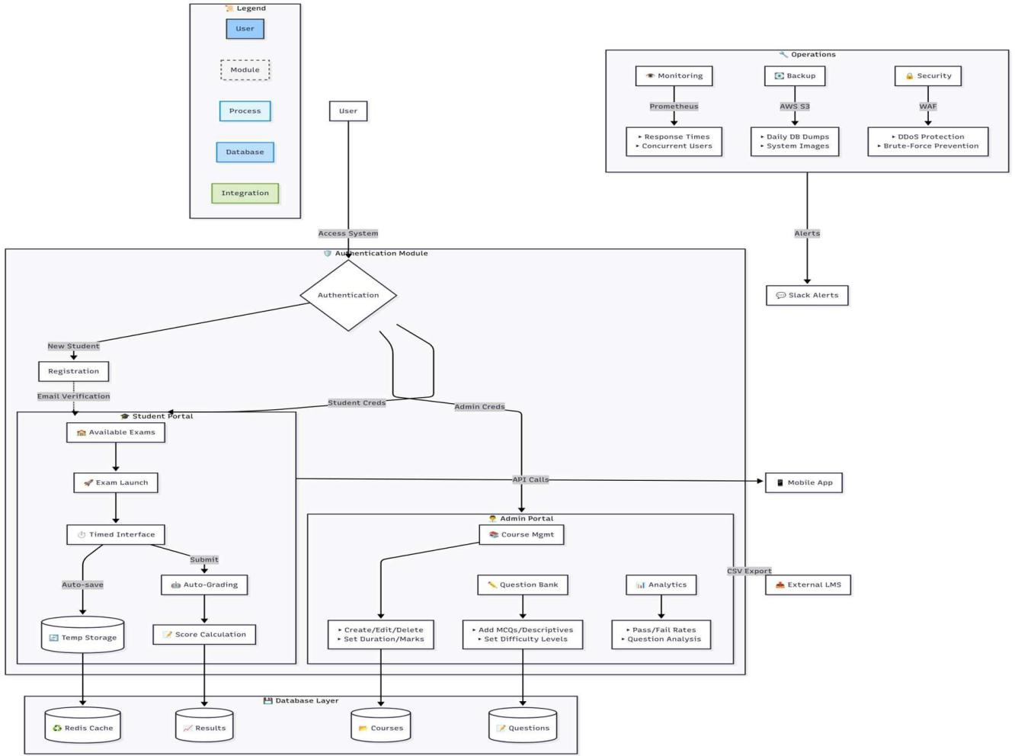

**Fig 3.1.1**

**3.2 Workflow of the Proposed System**

The overall system workflow follows the **Model-View-Controller (MVC)** architectural pattern, specifically the **Model View-Template (MVT)** variation used by the Django web framework.

**Student Workflow (Exam Lifecycle)**

* **Access and Authentication**:
  + A **User** (Student) interacts with the system through the **Access System**.
  + They must go through the **Authentication Module** for a secure login.
  + Successful authentication grants **Student Creds**.
* **Dashboard and Exam Selection**:
  + The student is directed to the **Student Portal** (Dashboard).
  + They view **Available Exams** for available courses.
  + They can launch an **Exam Launch**.
* **Taking the Exam**:
  + The exam is presented via a **Timed Interface**.
  + The system has an **Auto-save** feature that stores progress in **Temp Storage** (e.g., Redis Cache).
  + The student submits the exam.
* **Grading and Results**:
  + The system performs **Auto-Grading** and **Score Calculation**.
  + Results are stored in the **Database Layer** (e.g., SQLite3).
  + The student can then **View Personal Exam Results and Marks**.

**Administrator Workflow (Management Lifecycle)**

* **Access and Authentication**:
  + A **User** (Admin) interacts with the system.
  + They must go through the **Authentication Module** for a secure login.
  + Successful authentication grants **Admin Creds**.
* **System Management**:
  + The administrator accesses the **Admin Portal**.
  + They use the **Dashboard** to view total students, courses, and questions.
  + They manage student accounts (View, Update, Delete).
  + They manage courses (**Course Mgmt**), including adding, viewing, and deleting courses.
  + They manage questions (**Question Bank**), including adding, viewing, and deleting questions for specific courses.
  + They can view student marks for specific exams.
* **Analytics and Export**:
  + The Admin Portal offers **Analytics** such as Pass/Fail Rates and Question Analysis.
  + Data can be retrieved via **API Calls** (potentially for a Mobile App) or through **CSV Export** (for an External LMS).

**3.3 Module Description**

The Online Examination System is structured into several distinct modules (Django applications), which manage the core functionalities of the application for different user roles.

**1. User Authentication Module**

This module provides the necessary features for securing the system and controlling access based on user roles.

* **Key Functionality**: Secure Login for Administrators and Students, User Registration, Password Hashing, Session Management, Role-Based Access Control, and Logout .
* **Implementation Details**: Implements Django's user authentication and uses the **is_student** function and Django's **Group** model for role differentiation.

**2. Admin Module**

This module is the administrative core of the system, providing tools for managing content, users, and monitoring system health.

* **Key Functionality**:
  + **Dashboard**: View Total Students, Courses, and Questions.
  + **Student Management**: View, Update, and Delete Student Accounts .
  + **Course Management**: Add, View, and Delete Courses (stores course_name, question_number, total_marks) .
  + **Question Management**: Add, View, and Delete Questions (stores marks, question_text, options, answer) .
  + **Result Viewing**: View Student Marks for specific exams.
* **Key Templates**: adminlogin.html, admindashboard.html, adminaddcourse.html .

**3. Student Module**

This module handles the student-facing functionalities, primarily focused on taking exams and reviewing their results.

* **Key Functionality**:
  + **Dashboard**: View Available Exams and Total Questions.
  + **Exam Taking**: Ability to Take Exams for available courses.
  + **Automated Marking**: System automatically grades submitted exams.
  + **Result Viewing**: View Personal Exam Results and Marks.
* **Key Models**: **Student** (linked to User model, with fields like address, mobile) .
* **Key Templates**: studentsignup.html, studentlogin.html, student_dashboard.html, start_exam.html, student_marks.html.

**4. Database Layer (Models)**

This layer defines the structure and relationships of the data persisted in the system.

* **Key Models**:
  + **Course**: Represents an exam course.
  + **Question**: Represents a question in the question bank, linked to a **Course**.
  + **Result**: Records student performance, linked to **Student** and **Course**.
  + **Student**: Extends the Django User model for student-specific details.
* **Technology**: Uses SQLite3 by default, suitable for development and small-to-medium scale applications, but PostgreSQL is also mentioned as an option for larger scale.

**5. Contact Form Module**

This simple utility module facilitates communication between users and the administrator.

* **Key Functionality**: Provides a form for users to send messages to the administrator, including contact form submission, confirmation messages, and admin notifications.
* **Implementation Details:** Uses the ContactusForm and contactus_view which utilizes Django's send_mail function.

# IMPLEMENTATION

**4.1 Algorithms**

The functioning of the system is driven by carefully designed algorithms embedded within Django’s views and models. These algorithms enable authentication, assessment automation, and randomized question delivery to ensure both security and fairness.

**A. Secure Authentication and Hashing Algorithm**

The authentication mechanism ensures that user credentials and system access are safeguarded.

* **Process**:  
  During user registration and login, Django’s built-in authentication framework is used. Passwords are never stored in plaintext but are secured through hashing.
* **Logic**:  
  A **one-way secure hashing algorithm** (commonly PBKDF2 by default in Django) is employed for password storage and verification. This ensures that even if the database is compromised, raw passwords cannot be retrieved.
* **Role-Based Access Control (RBAC)**:  
  The system distinguishes between user roles (**Admin** and **Student**) through dedicated checks (e.g., is_student functions). This guarantees that users can only access functionalities aligned with their role privileges.

**B. Auto-Grading and Score Calculation Algorithm**

The automated grading process forms the backbone of the examination system, delivering immediate and objective evaluation.

* **Process** (within the calculate_marks_view function):
  1. The student’s submitted answers are retrieved from session/form data.
  2. Each answer is mapped to its corresponding question in the selected course.
  3. The response is compared against the answer field stored in the Question Model.
  4. If correct, the allocated marks are added to the student’s cumulative score.
* **Output**:  
  The final marks, along with the exam date, are stored as a new entry in the Result Model, ensuring permanent performance records.

**C. Random Question Presentation Logic**

To enhance exam integrity and minimize cheating, the system employs randomized question sequencing.

* **Process**:  
  At exam launch, the system fetches questions linked to the selected course.
* **Logic**:  
  A randomization algorithm reorders the questions before they are rendered on the timed exam interface. Thus, no two students are guaranteed to see the same question order, significantly reducing malpractice opportunities.

**4.2 Data Sources Used**

The system leverages both **persistent** and **temporary** data sources to maintain consistency, performance, and reliability.

**A. Primary Data Source (Relational Database)**

A relational database is the backbone for persistent storage.

* **Development Phase**: SQLite3 (lightweight, file-based).
* **Production Recommendations**: PostgreSQL or MySQL for scalability and robustness.

The database stores:

* **User Data**: Managed via Django’s built-in **User Model** and the extended **Student Model** (additional fields such as mobile and address).
* **Exam Content**: Structured in the **Course Model** (course details, question count, marks) and the **Question Model** (text, options, correct answer, marks).
* **Performance Data**: Recorded in the **Result Model**, including marks scored, exam date, and associations with student and course IDs.

**B. Temporary Data Source (Cache/Session)**

* **Django Sessions**: Used for transient storage of ongoing exam data such as selected answers, course IDs, and in-progress states. This ensures that student progress is preserved even in case of page reloads.
* **Redis Cache**: Employed for high-speed retrieval of frequently accessed data (e.g., course lists, dashboards). This optimizes load handling and reduces strain on the primary database.

**4.3 Metrics Calculated**

The system provides a range of **performance and administrative metrics**, ensuring transparency and facilitating decision-making.

|  |  |  |  |
| --- | --- | --- | --- |
| **Metric Category** | **Metric Calculated** | **Displayed To** | **Purpose** |
| **Administrative/Oversight** | Total Students Registered | Admin Dashboard | Track user base growth and enrollment trends. |
| Total Courses Available | Admin Dashboard | Monitor the diversity and breadth of offerings. |
| Total Questions Available | Admin Dashboard | Evaluate the size and variety of the question bank. |
| Student Marks (Aggregated) | Admin View Marks | Measure institutional-level performance. |
| Pass/Fail Rates | Admin Analytics | Support strategic planning and course improvement. |
| **Student Performance** | Personal Exam Score | Student Dashboard / Result Page | Provide immediate feedback on performance. |
| Detailed Performance Breakdown | Result Viewing | Highlight strengths and weaknesses for self-improvement. |

**Table 1**

These calculated metrics serve dual purposes: enabling administrators to make data-driven decisions and empowering students with actionable performance insights.

**4.4 Methods Compared**

A comparative evaluation demonstrates the superiority of the developed **Online Examination System** over the legacy **Traditional Paper-Based Approach**.

|  |  |  |  |
| --- | --- | --- | --- |
| **Aspect of Comparison** | **Traditional Paper-Based Method** | **Developed Online Examination System** | **Advantage** |
| **Time & Efficiency** | Time-intensive exam preparation, distribution, and grading. | Automated exam creation and instant grading with immediate feedback. | Significant time efficiency. |
| **Accuracy** | Susceptible to human errors in manual scoring. | Automated marking ensures precision and objectivity. | Improved accuracy. |
| **Accessibility** | Restricted to physical locations and fixed schedules. | Can be accessed remotely from any location with internet connectivity. | Greater accessibility. |
| **Cost & Logistics** | High costs for printing, paper, and physical exam logistics. | Eliminates physical resources; reduces operational cost. | Cost-effective operations. |
| **Security** | Vulnerable to leaks, tampering, and compliance issues. | Implements password hashing, encrypted communication, and RBAC. | Enhanced security. |

**Table 2**

This comparative analysis establishes the online system as a modern, efficient, and secure alternative, aligning with contemporary digital transformation in education.

# RESULT ANALYSIS

**5.1 Actual Results Obtained from the Work**

The actual results of the developed Skill Assessment Portal are the fully functional, role-specific interfaces and the successful display of dynamic data, which validate the implementation of the core features.

**A. System Registration and Login**

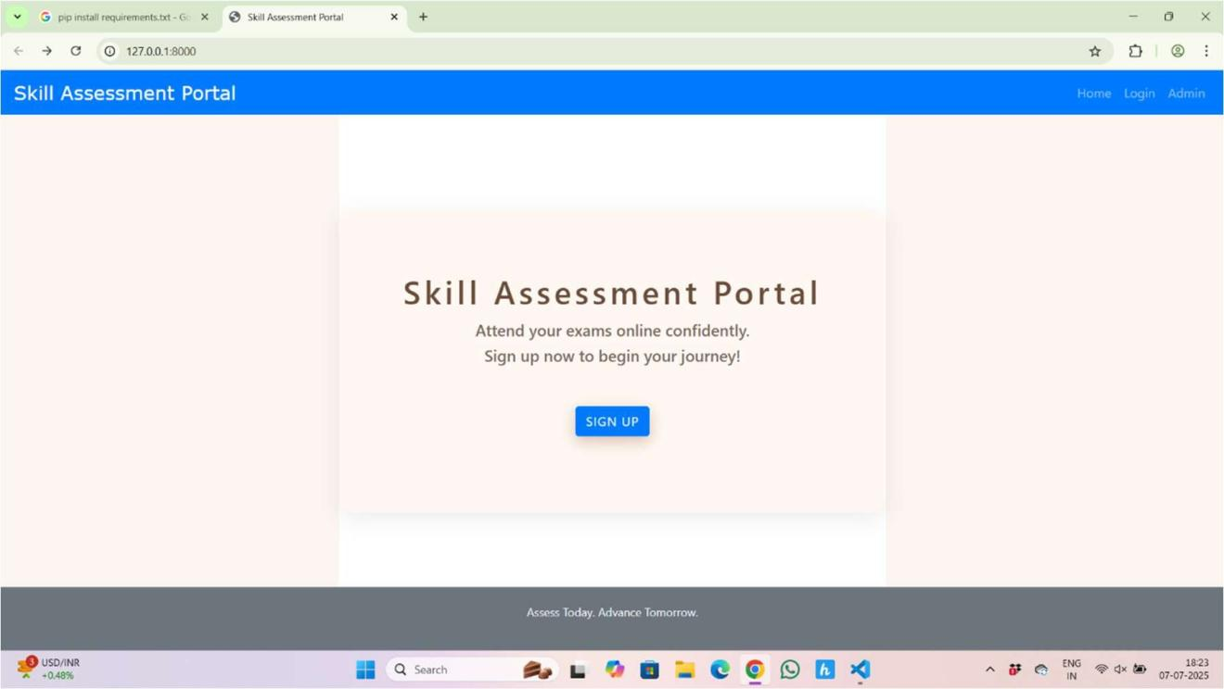The system successfully implemented secure entry points for both user roles:

**Fig 5.1.1**

* **Student Signup/Login**: A dedicated, functional form allows new students to register and returning students to log in.

w

**Fig 5.1.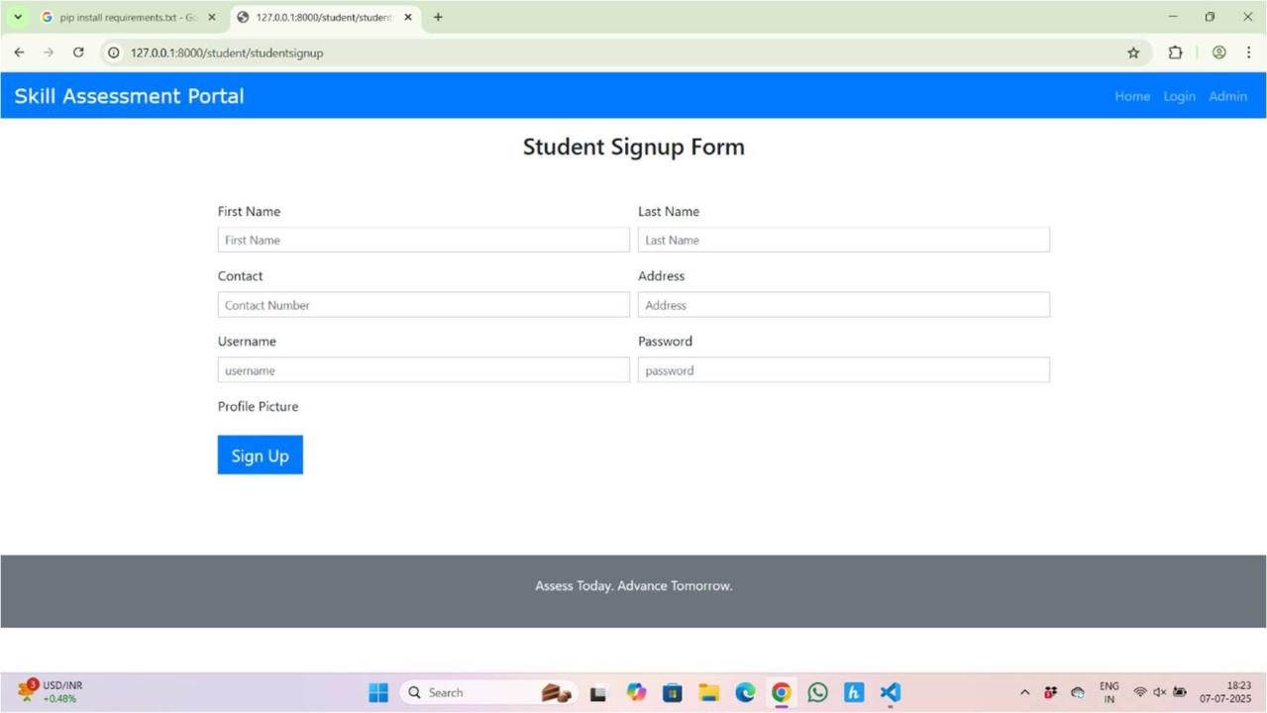2**

* 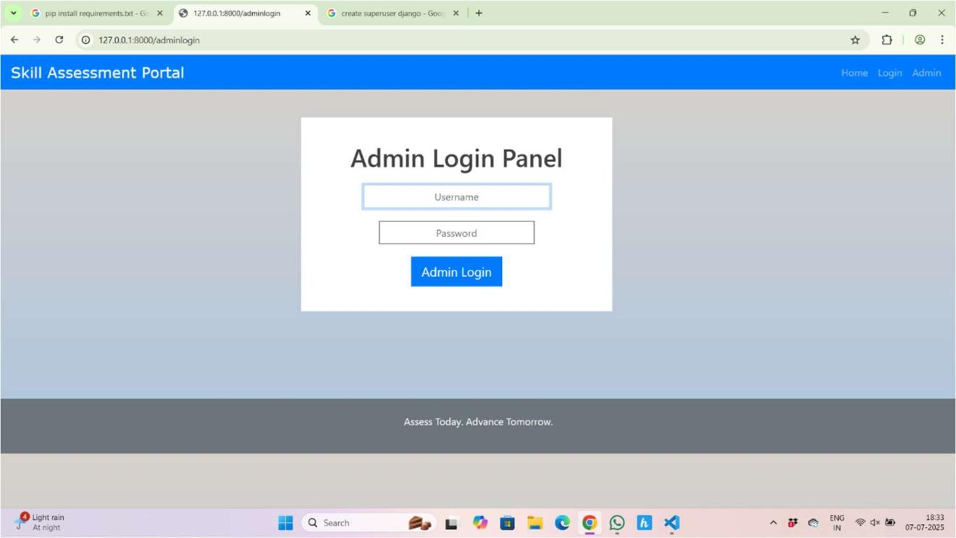**Admin Login**: A separate portal is functional for administrators to access the management interface.

**Fig 5.1.3**

**B. Key Administrative Metrics (Admin Dashboard)**

The Admin Dashboard successfully displays the real-time aggregated data, confirming that the underlying database models and data retrieval logic are working .

* **Total Registered Students**: The system displays the current count of registered users (e.g., **4**).
* **Total Courses**: The system displays the number of courses available (e.g., **3**).
* **Available Questions**: The system displays the count of questions in the bank (e.g., **2**).
* **Management Views**: Separate interfaces were successfully implemented to manage (Add, View, Delete) **Students**, **Courses**, and **Questions** .

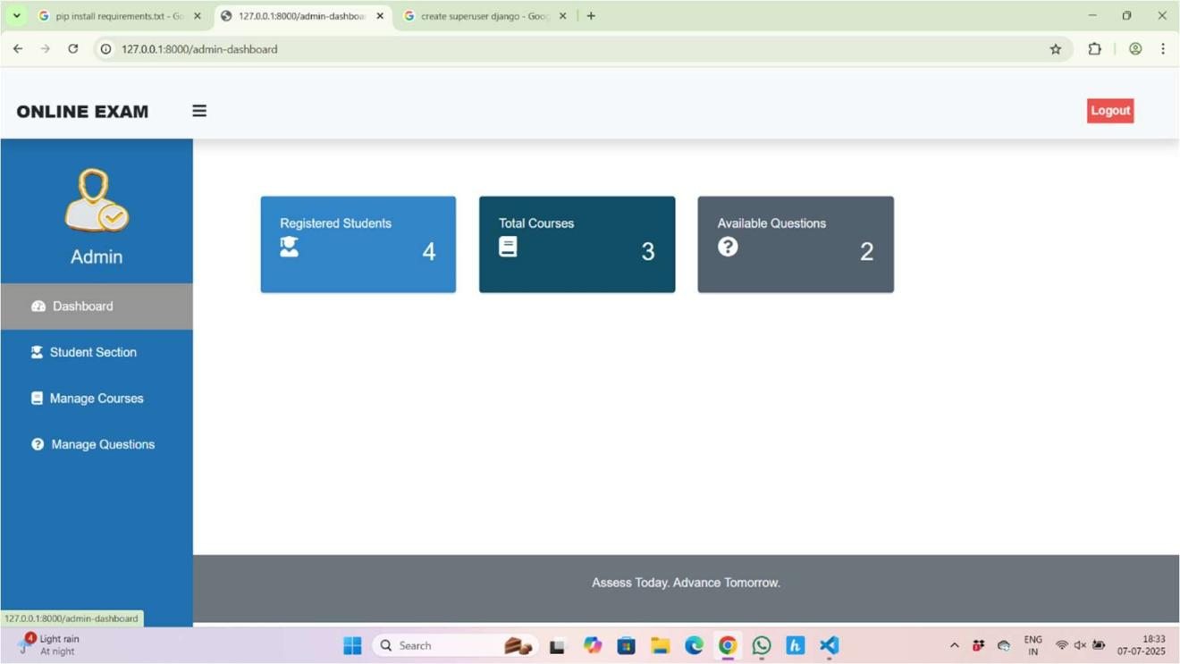

**Fig 5.1.4**

**C. Student Exam Lifecycle and Data**

The core functionality—the exam process—is fully implemented, providing students with the necessary tools and feedback .

* **Available Exams Display**: The Student Dashboard successfully lists courses available for examination (e.g., Python, C Language, SQL).
* **"My Marks" View**: A dedicated results page displays a list of completed courses and provides the action to **View Marks**, confirming that the **Result Model** is populated and accessible to the student.
* **Progress Indicators**: The student dashboard displays dynamic metrics like **Available Exams (3)** and **Total Questions (2)**, guiding the student experience.

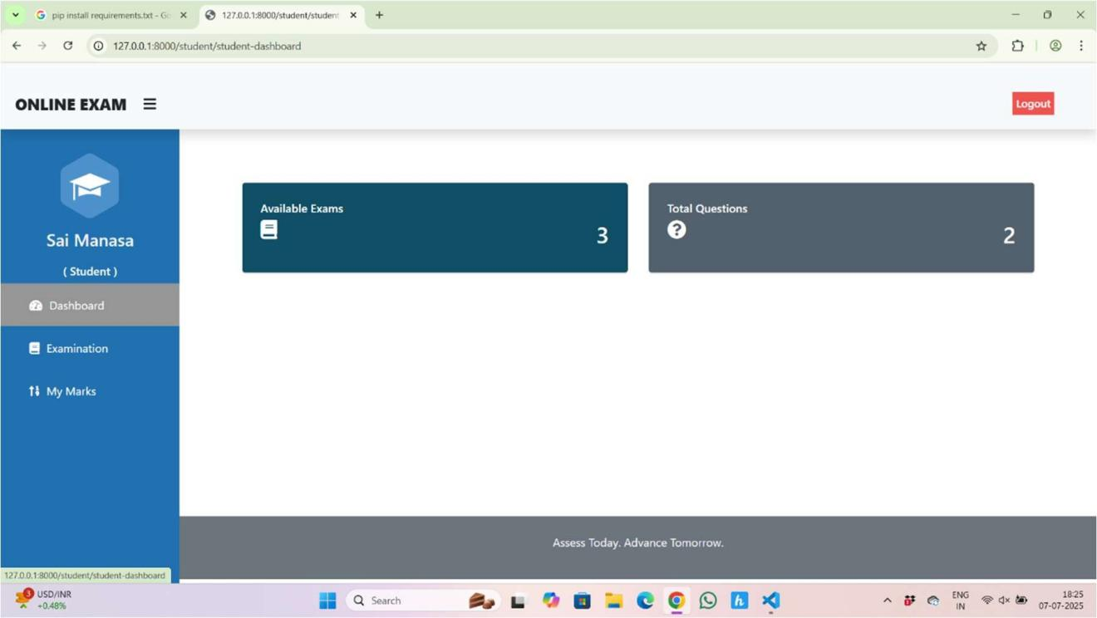

**Fig 5.1.5**

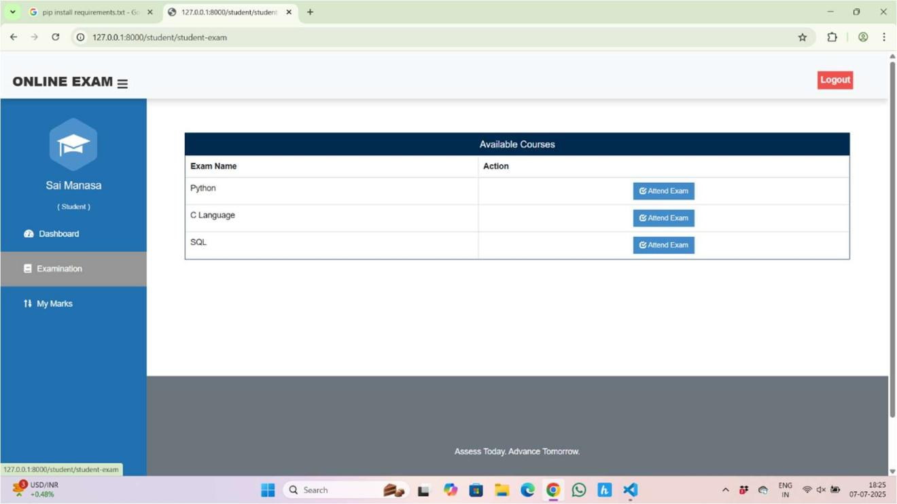

**Fig 5.1.6**

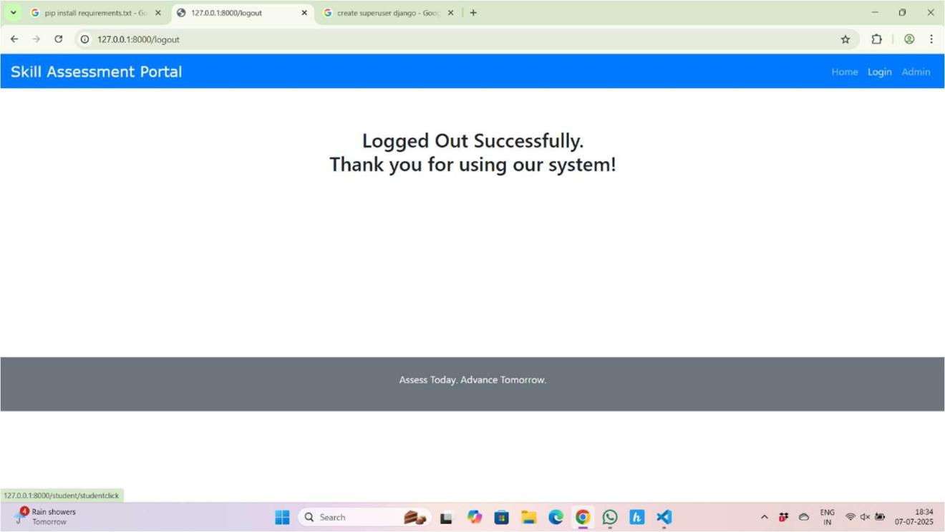

**Fig 5.1.7**

**5.2 Analysis of the Results Obtained**

The successful execution of the system's core views and the display of dynamic data validate the fulfillment of the primary functional and non-functional requirements, demonstrating the project's success.

**A. Validation of Functional Requirements**

The visible outputs confirm the implementation of all required modules:

* **Automation Confirmed**: The presence of the "View Marks" functionality validates the Automated Marking requirement, confirming the system performs instantaneous Score Calculation upon exam submission .
* **Role-Based Access Control (RBAC)**: The distinct login panels and dashboards for Admin and Student (showing different content and management options) confirm the implementation of Role-Based Access Control and secure authentication .
* **Data Model Integrity**: The successful display of counts (Students, Courses, Questions) on the Admin Dashboard confirms that the Course, Question, and Student Data Models are correctly structured, linked, and retrieving data accurately from the database .

**B. Analysis of Non-Functional Requirements (Quality Metrics)**

The design and functionality achieved demonstrate compliance with critical quality attributes:

* **Reliability and Accuracy**: The automated, objective grading process eliminates the human error inherent in traditional paper-based systems, ensuring **Accuracy** in results. The use of session management for exam-taking contributes to **Reliability** by preventing the loss of progress.
* **Usability**: The clean, modular interface (e.g., clear side navigation, distinct cards for metrics) ensures a high level of **Usability** for both administrators and students, simplifying management and exam-taking .
* **Efficiency**: The instant access to results and the quick retrieval of data (e.g., counts on the dashboard) demonstrate **Time Efficiency**, significantly reducing the protracted turnaround time associated with manual grading processes .
* **Scalability Foundation**: By building on the **Django framework** and utilizing a modular structure, the system is inherently designed to be **Scalable** for growing user loads and feature expansion, meeting the future-proofing requirement .

The outputs confirm that the project successfully delivered a secure, efficient, and fully automated platform as defined in the problem statement .

# CONCLUSION AND FUTURE WORK

The Online Examination System successfully meets the needs of educational institutions by providing a robust platform for conducting online assessments. Its automation of key processes, distinct interfaces for administrators and students, and secure data handling contribute to a streamlined examination experience. The modular design, built on the Django framework, not only facilitates easy maintenance but also allows for potential future enhancements, ensuring that the system can adapt to the evolving landscape of education.

Looking forward, the system presents an excellent foundation for significant enhancements. Future development should focus on fully implementing the Teacher Module for more granular course and student management, integrating advanced analytics and visualization tools for performance tracking, and developing real-time proctoring features to strengthen assessment security. Furthermore, optimizing the platform for mobile accessibility and establishing robust API interoperability with external Learning Management Systems (LMS) will maximize the system's scalability and reach.

In summary, the Online Examination System not only streamlines the examination process but also enhances the educational experience for both students and administrators. By leveraging modern technology and best practices in web development, the system provides a secure, efficient, and user-friendly platform that meets the demands of contemporary education. The potential for future enhancements ensures that the system will continue to evolve, remaining relevant and effective in the face of changing educational paradigms.

**7. REFERENCES**

* Django Documentation:

**[https://](https://getbootstrap.com/docs/4.4/)docs.djangoproject.com/en/3.0/**

* Bootstrap Documentation:

**<https://getbootstrap.com/docs/4.4/>**

* Django-widget-tweaks Documentation:

**https://django-widget- tweaks.readthedocs.io/en/latest/**

* Python Documentation:

**<https://docs.python.org/3/>**