SIDDAGANGA INSTITUTE OF TECHNOLOGY, TUMKUR-572103

(An Autonomous Institute, Affiliated to Visvesvaraya Technological University, Belagavi)



**Industrial Training Report on**

**“LIFE SAVER APPLICATION”**

**Submitted in partial fulfillment of requirement for the award of**

**INDUSTRIAL TRAINING CERTIFICATE**

**In**

**COMPUTER SCIENCE AND ENGINEERING**

**Submitted by**

SIDDESH M G 1SI16CS104

**DEPARTMENT OF COMPUTER SCIENCE AND ENGINEERING**

**2018 – 19**

SIDDAGANGA INSTITUTE OF TECHNOLOGY, TUMKUR-572103

(An Autonomous Institute, Affiliated to Visvesvaraya Technological University, Belagavi)

**COMPUTER SCIENCE AND ENGINEERING**



***CERTIFICATE***

Certified that the industrial training project work entitled **“LIFE SAVER S APPLICATION”** is a bonafied work carried by **SIDDESH M G(1SI16CS104)** in fulfillment for the completion of industrial training in Bachelor of Engineering in Computer Science and Engineering and Information Science and Engineering in Siddaganga Institute of Technology, an autonomous institute under Visveswaraya Technological University, Belagavi during the academic year 2018 – 19.

**ACKNOWLEDGEMENT**

We offer our humble pranams at the lotus feet of his Holiness, Dr. Sree Sree Shivakumara, Swamigalu, President and His Holiness, Sree Sree Siddalinga Swamigalu, President, Sree Siddaganga Education Society, Sree Siddaganga mutt for bestowing upon their blessings.

We deem it as a privilege to thank Dr. M N Channabasappa, Director, SIT, Tumakuru and Dr. Shivakumaraiah, Principal, SIT, Tumakuru for fostering an excellent academic environment in this institution, which made this endeavor fruitfully.

We would like to express our sincere gratitude toDr. R SUMATHI ,Professor and Head ,Department of CSE and Dr. R APARNA, Professor and Head, Department of ISE, SIT Tumakuru for their encouragement and valuable suggestions.

Above all, we like to express sincere gratitude to our parents for their support all along.

SIDDESH M G 1SI16CS104

# About Monkfox

# Share your expertise!

Contribute your bit to our mission of changing the higher education landscape. Most of us know the key challenge in current education system is an outdated curriculum & lack of exposure about ongoing / upcoming technologies in the industry.

Monkfox is building a community of professionals, experts, enthusiasts & teachers who understand this problem and are willing to change by sharing their expertise. Currently, we are working across all branches of Engineering to provide students with the much needed engagement to bring them at employable standards of the industry.

If you an expertise in any area (Non Technical As Well) relevant for students in higher education and you wish to share your knowledge with students, Monkfox is the place to be. Even with a very small contribution of your time and knowledge, you can create a big difference in students' lives.

We propose the following 2 flexible ways to get associated and start contributing :-

**1. Technology Advisor**

You will help us in designing/updating course modules in your area of expertise. Sometime, you are expected to speak to Instructors, Head of Department in a College to ensure expectations. Your engagement may not exceed more than 2-3 Hours in a month.

**2. Course Instructor**

You may engage with us for two/three weekends in a quarter, to deliver the programs online/offline in domain of your expertise to students. Each engagement will be scheduled subject to your confirmation.

We have also prepared a list of frequently asked questions [**(FAQs)**](http://monkfox.com/about/#faqs)which will help you get some of the answers. If you still have questions, please feel free to [**contact us**](https://monkfox.com/contact-us/).

**CONTENTS:**

**Chapter no. Content Page No.**

**Abstract**

**LIST OF FIGURES i**

**LIST OF TABLES ii**

**1. INTRODUCTION**

* 1. Objective of the project
  2. Organization of the report

**2. BLOCK DIAGRAM**

**3. TOOLS AND TECHNOLOGY USED**

**4. COMPLETE INTENDED CODE**

**5. SNAPSHOTS**

**Figure No. Figure Name**

5.1. Login Page

5.2. Sign Up Page

5.3. To Add Emergency Number

5.4 Expandable List View

5.5. Navigation Drawer

5.6 Do’s And Don’ts

5.7 Search Bar

5.8 Push Notifications

5.9 Dynamic content

**6. CONCLUSION AND FUTURE SCOPE**

**7. REFERENCES**

**REFERENCESAND APPENDIX 19 – 29**

**ABSTRACT**

Many times we may come across the emergency situations, where a emergency guide can help us, but due to network problems one may not be able to communicate regarding what to do at that situation.

In this application we are providing a simplified user friendly guide to the user in both online and offline modes.

We provide user authentication feature for personalized guide.

Person in emergency can send his location in native SMS app

**CHAPTER 1:**

**-- INTRODUCTION - -**

**1.1 OBJECTIVE OF THE PROJECT-**

The main objective of the app is to provide instant guide to the user at the time of his emergency by providing both online and offline modes by providing theinstant messaging and calling option for the user in one click.

* 1. **ORGANIZATION OF THE REPORT-**

The report is divided into 7 chapters.

Report begins with introduction in Chapter 1.

Chapter 2 describes the firebase database block diagram.

Chapter 3 describes tools and technology used.

Chapter 4 describes the complete intended code .

Application snapshots are shown in chapter 5.

Chapter 6 describes conclusion and future scope.

Chapter 7 describes reference.

**CHAPTER 2:**

**FIREBASE DATABASE BLOCK DIAGRAM**

App

Firebase Authentication(Login/Sign up)

Firebase Real Time Database (Update Details)

Retrieve Data From Firebase

Firebase Notifications

Firebase Dynamic Lines

User Usage

**CHAPTER 3:**

**TOOLS AND TECHNOLOGY USED**

* Android Studio.
* Fire Base.
* Expandable List View.
* Search Tool Bar.
* Card View.
* Recycler View.
* Navigation Drawer.
* Push notifications.
* Real time disease alert.
* URL’s.
* Web View (online mode).

**CHAPTER 4:**

**COMPLETE INTENDED CODE**

**// To be attached later//**

**CHAPTER 5:**

**SNAPSHOTS**

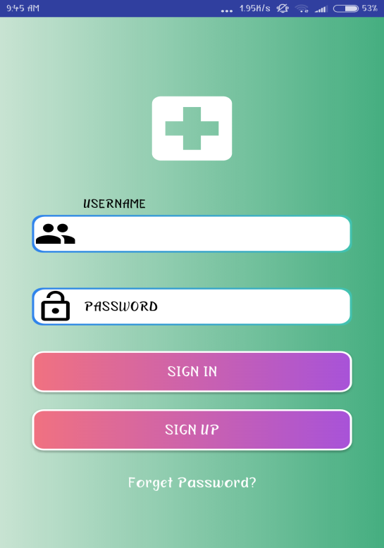 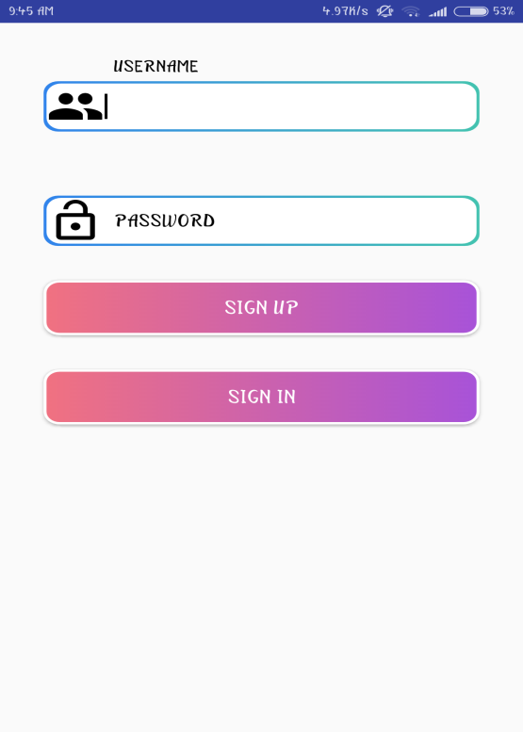

**Fig i: Login Page Fig ii: Sign up Page**

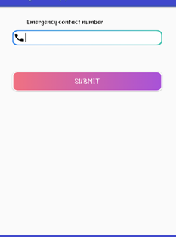 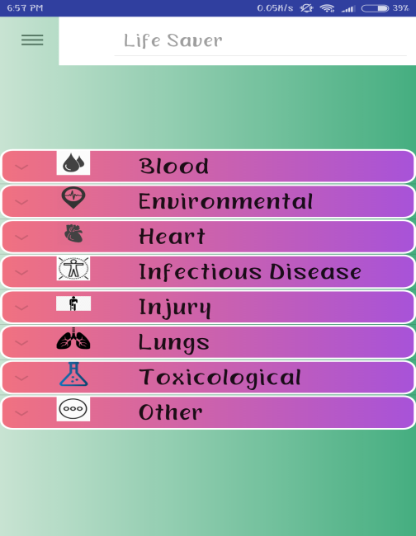

**Fig iii. To add emergency no. Fig iv. Expandable List View**

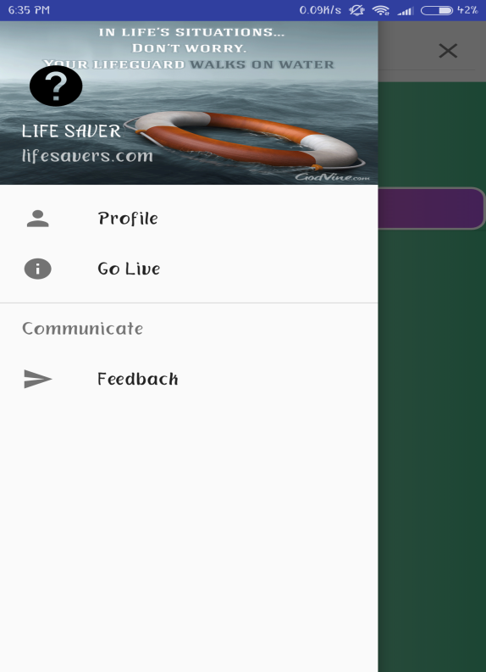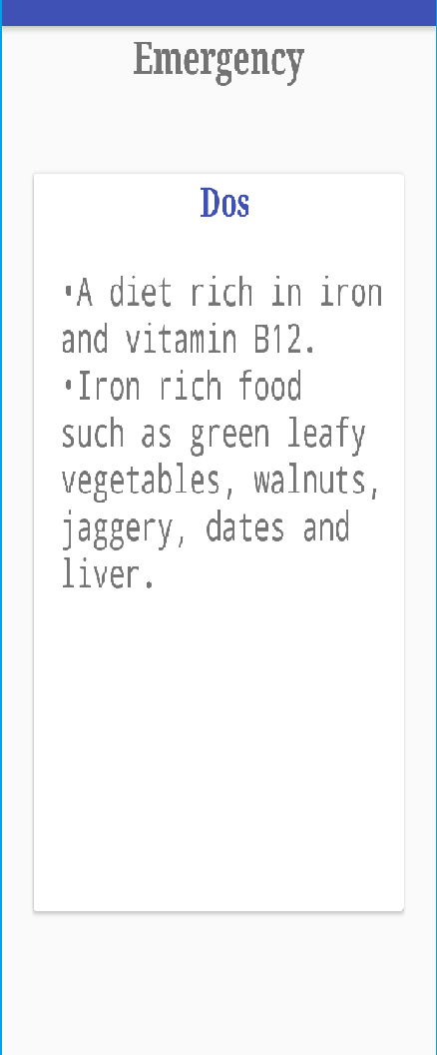

**Fig v: Navigation Drawer Fig vi:Do’s and Don’ts**

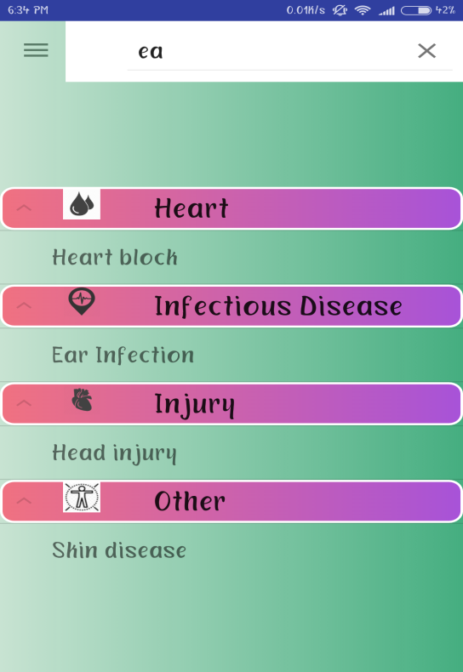 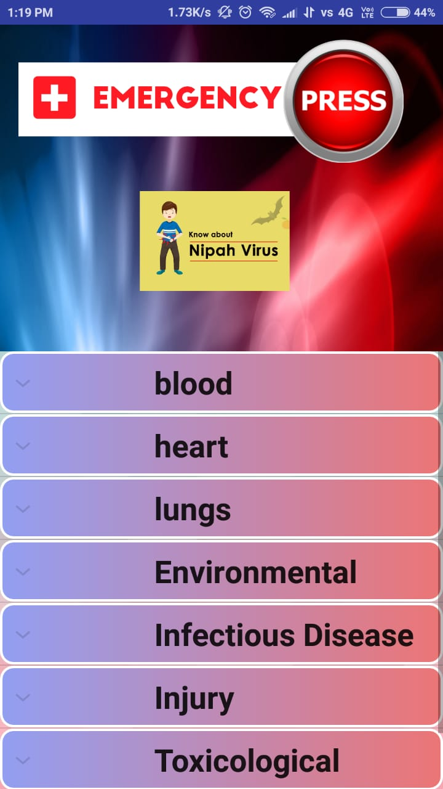

**Fig vii: Search Bar**

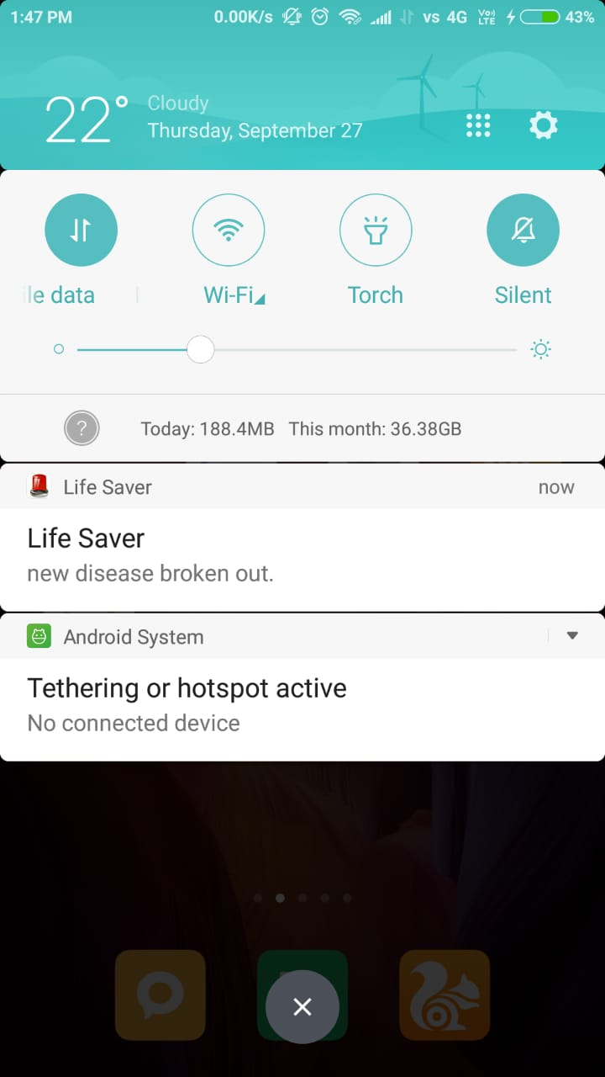

**CHAPTER 6:**

**FUTURE SCOPE**

* Real Time GPS Tracking.
* Real Time Video Streaming using API’s.
* Instantaneous emails and social media posts.

**CHAPTER 7:**

**REFERENCES**

**/ To be attached later/**

**DECLARATION**

I hereby declare that the Industrial Training Report entitled (“LIFE SAVERS”) is an authentic record of the team work as requirements of Industrial Training during the period from 4-6-2018 to 14-7-2018 for the award of degree of B.E in Information Science and Computer Science And Engineering ,Siddaganga Institute Of Technology,Tumkur,under the guidance of Mr.Bandenawaz Bagwan.and Mr.Neelegandan.

Date: 13-07-2018

SIDDESH M G 1SI16CS104

**CERTIFICATE**

This is to certify that **SIDDESH M G(1SI16CS104)** have completed Industrial Training Programme during the period from 4-6-2018 to 14-7-2018 in our organization as a Fulfillment of Bachelor’s Degree in Engineering in Computer/Information Science And Engineering .We were trained in the field of Web development and Android Application Development.

( Mr.Bandenawaz Bagwan)

**Signature/Seal of Training Manager**