VISVESVARAYA TECHNOLOGICAL UNIVERSITY

JNANA SANGAMA, BELGAUM - 590014



##### A Report on

**“MUNICIPALITY WASTE MANAGEMENT”**

##### Submitted in the partial fulfillment for Database Management Laboratory: An Open Ended Problem.

##### Submitted By:

**NAME (USN)**

**SIDDESH M G 1SI16CS104**

**SUMANTH M 1SI16CS115**

**Under the guidance of:**

**Mrs. Shruti k Mr. Raghavendra M**

**Assistant Professor Assistant Professor**



DEPARTMENT OF COMPUTER SCIENCE AND ENGINEERING

SIDDAGANGA INSTITUTE OF TECHNOLOGY, TUMKUR-572103

(An Autonomous Institute, Affiliated to Visvesvaraya Technological University, Belgaum, Recognized by AICTE and Accredited by NBA, New Delhi)

**2018-2019**

**ACKNOWLEDGEMENT**

A successful project is a fruitful culmination of efforts by many people, few directly involved and others who encourage and extend their support from the background, in silence. We avail this opportunity to express our gratitude to all those who have contribute their valuable assistance and support in making our project a success.

We express our deep sense of gratitude, indebtedness and sincere salutations to His Holiness **Dr. Sree Sree Sree Shivakumara Swamigalu**, President, Sree Siddaganga Education Society, for being a constant source of inspiration.

We express our gratitude to **Dr. K P Shivananda**, Principal, Siddaganga Institute of Technology and **Dr. R Sumathi**, Professor and Head of Department, Computer Science and Engineering, for fostering an excellent academic environment.

We are thankful, immensely and remain indebted to **Prof. Shruti K** and **Prof. Raghavendra M,** Assistant Professor Department of Computer Science and Engineering, for being our guide, who in spite of their busy schedule was a remarkable and constant source of motivation to us. His guidance, encouragement and constructive suggestions during difficult phases of the project gave us impetus to carry out the task. He indeed was the driving force during the entire course of successful completion of project.

**TABLE OF CONTENTS**

1. ABSRTRACT………………………………………………….04
2. INTRODUCTION……………………………………………..05
3. REQUIREMENT SPECIFICATION

3.1 REQUIREMENTS……………………………...........06

3.2 ENTITIES AND ATTRIBUTES...………………......06

3.3 RELATIONSHIP TYPES…………………………....07

1. CONSTRAINTS……………………………………………….08
2. DESIGN

5.1 ER DIAGRAM…………………………………….....09

5.2 SCHEMA…………………………………………….10

1. IMPLEMENTATION

6.1 TOOLS………………………………………………11

6.2 QUERIES……………………………………………12

1. CONCLUSION………………………………………………...00

**ABSTRACT**

We intend to implement the Municipality waste management database which can be used by the government for maintaining the the data of the properties under the department.

This database is necessary because the data about the waste disposed and all the details about the vehicles owned by the particular department will be stored under the databse. It will have the details of the driver who are working under the department and the details of the vehicle they are driving.

The database will make the tracking work easier and also the government can keep track about the details of the department so that they can be managed efficiently.

The implementation of the database points out the problems in the department and provides a platform for better utilization of the resources.it also helps the government during surveys about the waste disposal.

**INTRODUCTION**

There is nothing quite like traveling, like seeing a new place for the first time or returning to a favorite place. People of all ages, from all countries, travel to foreign places for many different reasons – namely work, family and leisure. Whether by plane, train, ship or automobile, travel is generally a pleasurable experience, at least for the people who can financially afford comfortable and safe methods of travel. But it has more benefits than satisfying one’s need to make [money](https://www.privatewriting.com/blog/tips-how-to-save-money-in-college), as well as to see loved ones and enjoy one’s self on vacation. There are other benefits of traveling that many people often overlook.

Here we propose to develop to plan a perfect trip planner to the users by providing them the facilities to book flights and accommodation in advance. Users can also pay money online and also book taxi in various locations. Users can not only plan the trip for them alone, but also for their entire family, friends group or any other dependents that they have.

Traveling is good for a person of any age. It not only helps people to form a better understanding of themselves, their beliefs and their lives, it also provides people with a better understanding of the world in which they live, even if it’s beyond their immediate environment. And it may even help a person to feel connected to the many people living in the world, even if their lives never meet, even if their lives are so completely different that they may as well be from different planets.

**REQUIREMENT AND SPECIFICATION**

**3.1 REQUIREMENT**

* MySQL Server
* Text Editor

**3.2 ENTITIES AND ATTRIBUTES**

EMPLOYEE:

* SSN
* Name
* Salary
* Address
* Bdate

MUNICIPLAITY DEPARTMENT:

* Dno
* Dname
* Dlocation

GARBAGE:

* House_no
* G_type
* G_qty

TRUCKS:

* Reg_no
* Model_name

LOCATION:

* ward_no
* Area Name

DEPENDENTS:

* ssn
* dname
* drelation
* Dsex
* D_bdate

COLLECTS:

* SSN
* House_no
* cdate

DRIVES:

* SSN
* Reg_no

VISITS:

* SSN
* Ward_no

CONTROLS:

* Dno
* House_no

OWNS:

* Dno
* Reg_no

COMES_UNDER:

* Dno
* Ward_no

**3.2 RELATIONSHIP TYPES**

* ONE TO ONE:DRIVES
* ONE TO N: COLLECTS
* N TO M: COMES_UNDER
* N TO ONE: OWNS

**3.3 CONSTRAINTS**

* Only one person can drive a particular car at a time.
* Can collect garbage from a particular house once a day.

**ER Diagram:**

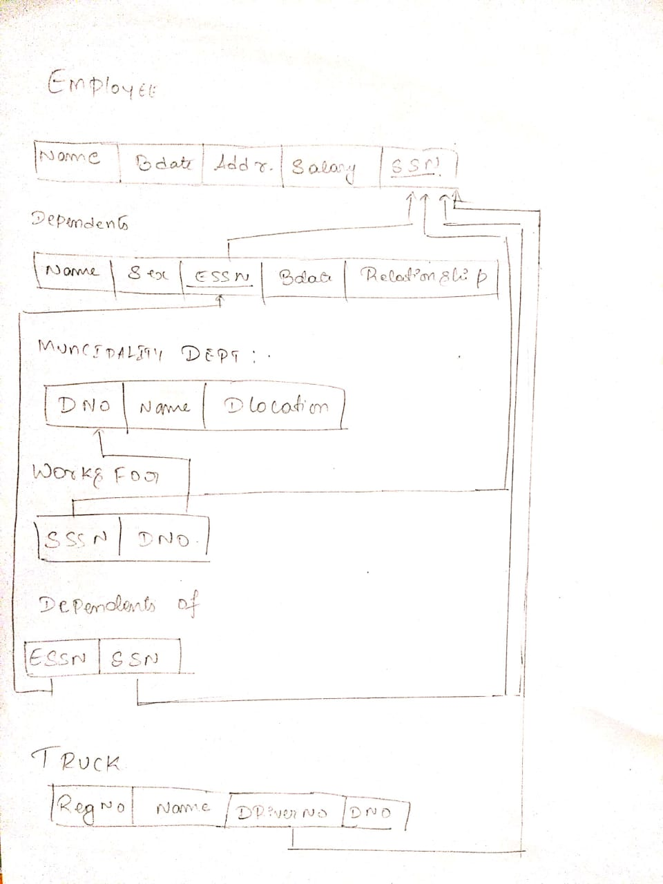

**Relational Schema Diagram:**

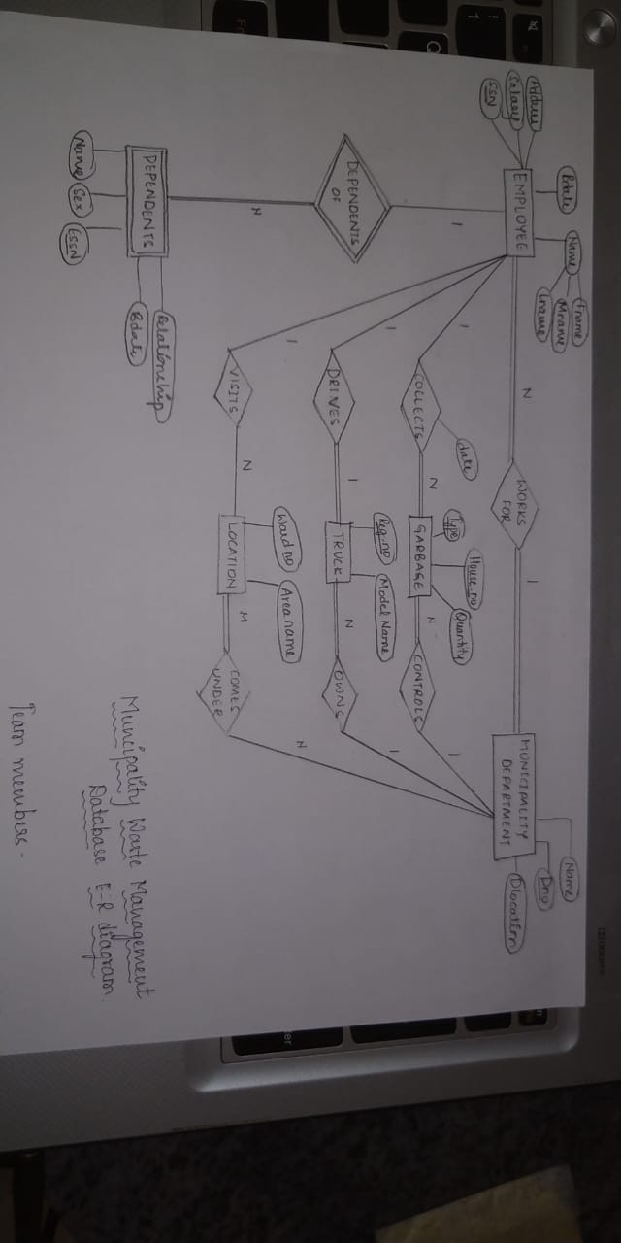

**IMPLEMENTATION**

**6.1 TOOLS**

MySQL is an Oracle-backed open source relational database management system ([RDBMS](https://searchdatamanagement.techtarget.com/definition/RDBMS-relational-database-management-system)) based on Structured Query Language ([SQL](https://searchsqlserver.techtarget.com/definition/SQL)). MySQL runs on virtually all platforms, including [Linux](https://searchdatacenter.techtarget.com/definition/Linux-operating-system), [UNIX](https://searchdatacenter.techtarget.com/definition/Unix) and [Windows](https://searchwindowsserver.techtarget.com/definition/Windows). Although it can be used in a wide range of applications, MySQL is most often associated with web applications and online publishing.

MySQL is an important component of an open source enterprise stack called [LAMP](https://whatis.techtarget.com/definition/LAMP-Linux-Apache-MySQL-PHP). LAMP is a web development platform that uses Linux as the operating system, [Apache](https://whatis.techtarget.com/definition/Apache) as the web server, MySQL as the relational database management system and [PHP](https://whatis.techtarget.com/definition/PHP-Hypertext-Preprocessor) as the object-oriented scripting language. (Sometimes [Perl](https://whatis.techtarget.com/definition/Perl) or [Python](https://whatis.techtarget.com/definition/Python) is used instead of PHP.)

Originally conceived by the Swedish company MySQL AB, MySQL was acquired by Sun Microsystems in 2008 and then by Oracle when it bought Sun in 2010. Developers can use MySQL under the GNU General Public License ([GPL](https://searchdatacenter.techtarget.com/definition/GNU-General-Public-License-GNU-GPL-or-simply-GPL)), but enterprises must obtain a commercial license from Oracle.

Today, MySQL is the RDBMS behind many of the top websites in the world and countless corporate and consumer-facing web-based applications, including Facebook, Twitter and YouTube.

MySQL is based on a [client-server](https://searchnetworking.techtarget.com/definition/client-server) model. The core of MySQL is MySQL server, which handles all of the database instructions (or commands). MySQL server is available as a separate program for use in a client-server networked environment and as a library that can be embedded (or linked) into seperate applications.

MySQL operates along with several utility programs which support the administration of MySQL databases. Commands are sent to MySQLServer via the MySQL client, which is installed on a computer.

MySQL was originally developed to handle large databases quickly. Although MySQL is typically installed on only one machine, it is able to send the database to multiple locations, as users are able to access it via different MySQL client interfaces. These interfaces send SQL statements to the server and then display the results.

**6.2 QUERIES**

create table Employee

(

ssn number(10) primary key,

fname varchar(20),

mname varchar(20),

lname varchar(20),

bdate date,

address varchar(20),

salary number(10),

dno number(10),

FOREIGN KEY (dno) REFERENCES Department(dno)

);

create table Department

(

dname varchar(20),

dno number(10) primary key,

dlocation varchar(20)

);

create table Garbage

(

house_no number(10) primary key,

gtype varchar(10),

gqty number(10)

);

create table Trucks

(

regi_no number(10) primary key,

model_name varchar(10)

);

create table Location

(

ward_no number(10) primary key,

area_name varchar(10)

);

create table Dependent

(

name varchar(10),

ssn number(10) primary key,

dbdate date,

sex varchar(10),

relationship varchar(10),

FOREIGN KEY (ssn) REFERENCES Employee(ssn)

);

create table Collects

(

ssn number(10),

house_no number(10),

cdate date,

FOREIGN KEY (ssn) REFERENCES Employee(ssn),

constraint PK_D primary key (ssn, house_no,cdate),

FOREIGN KEY (house_no) REFERENCES Garbage(house_no));

create table Drives

(

ssn number(10),

regi_no number(10),

constraint PK_D1 primary key (ssn, regi_no),

FOREIGN KEY (ssn) REFERENCES Employee(ssn),

FOREIGN KEY (regi_no) REFERENCES Trucks(regi_no));

create table Visits

(

ssn number(10),

ward_no number(10),

constraint PK_D2 primary key (ssn, ward_no),

FOREIGN KEY (ssn) REFERENCES Employee(ssn),

FOREIGN KEY (ward_no) REFERENCES Location(ward_no));

create table Controls

(

dno number(10),

house_no number(10),

constraint PK_D3 primary key (dno, house_no),

FOREIGN KEY (dno) REFERENCES Department(dno),

FOREIGN KEY (house_no) REFERENCES Garbage(house_no));

create table Owns

(

dno number(10),

regi_no number(10),

constraint PK_D4 primary key (dno, regi_no),

FOREIGN KEY (dno) REFERENCES Department(dno),

FOREIGN KEY (regi_no) REFERENCES Trucks(regi_no));

create table Comes_Under

(

dno number(10),

ward_no number(10),

constraint PK_D5 primary key (dno, ward_no),

FOREIGN KEY (dno) REFERENCES Department(dno),

FOREIGN KEY (ward_no) REFERENCES Location(ward_no));

**CONCLUSION**

We have successfully developed the project that has various tables as specified.

We have also successfully added the specified constraints in every entity also able to run the queries on the created tables and relationships.

The main objective of our project has hence forth been achieved effectively and efficiently, which can be used for the efficient room booking. Thus providing an opportunity for the users to pre plan their trip booking rooms in advance and reserving accommodation thus provide maximum customer satisfaction.