Data Pipeline Architecture

Source Data Server

O que é Amazon QuickSight? - dataRain - Serviço base na nuvem

For the given task I have chosen the above architecture for the data pipeline.

I have taken the following tables from the AdventureWorks Datawarehouse

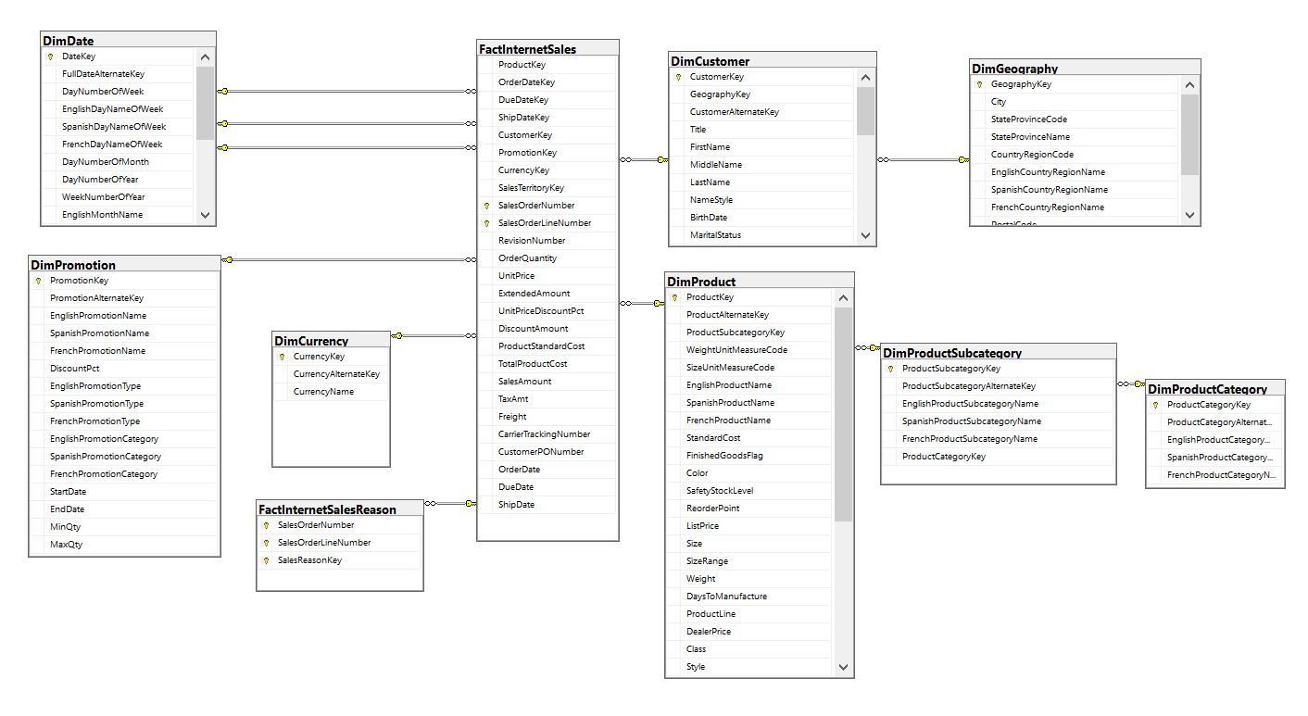

Below are the steps taken in details:

1. Extract data from Github(source) from a given list of files to the server(local)
2. Convert data to UTF8 encoding (needed to load data into Redshift)
3. Transfer the files to S3 for loading

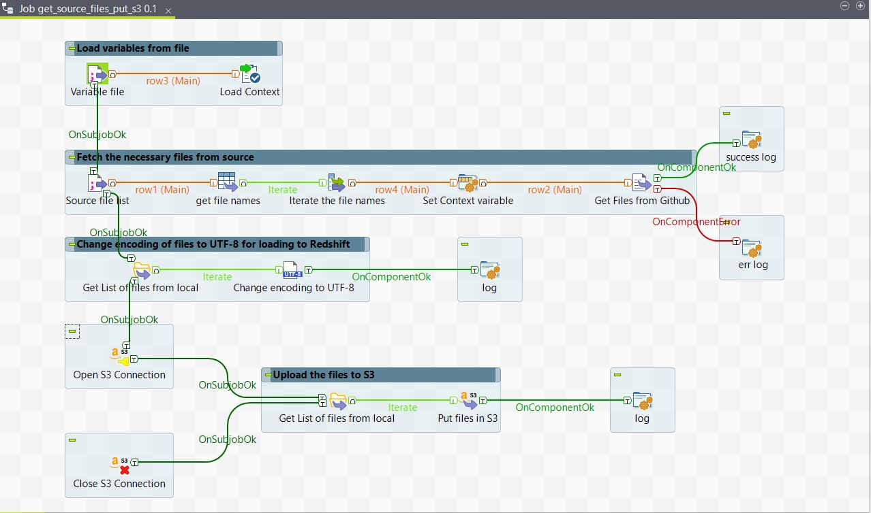

The above image shows the first 3 steps described. All the file names, paths and configs are passed through the context variables.

1. Once the files are transferred to S3, we can then load the files to Redshift tables which are created in advance (refer create_table_scripts.sql)
   1. The tables are created with an addition column called load_time as I have implemented the SCD Type 2 approach. The latest data will be taken with respect to the load_time for future changes using the below queries:

drop table if exists staging_" +{REDSHIFT_TABLE_NAME}+ ";

create table staging_"+{REDSHIFT_TABLE_NAME}+" (like "+{REDSHIFT_TABLE_NAME}+");

alter table staging_"+{REDSHIFT_TABLE_NAME}+" drop column load_time;

copy staging_"+{REDSHIFT_TABLE_NAME}+" from 's3://source-datasets/"+{REDSHIFT_TABLE_NAME}+".csv'

credentials 'aws_access_key_id="+context.aws_access_key+";aws_secret_access_key="+context.aws_secret_key+"'

delimiter '|' region 'eu-west-1';

insert into "+{REDSHIFT_TABLE_NAME}+"

(select s.*, sysdate as load_time from staging_"+{REDSHIFT_TABLE_NAME}+" s) ;

drop table staging_"+{REDSHIFT_TABLE_NAME}+";

commit;

* 1. The data will first be loaded to the staging tables and then inserted into the main tables with the load_time addition.

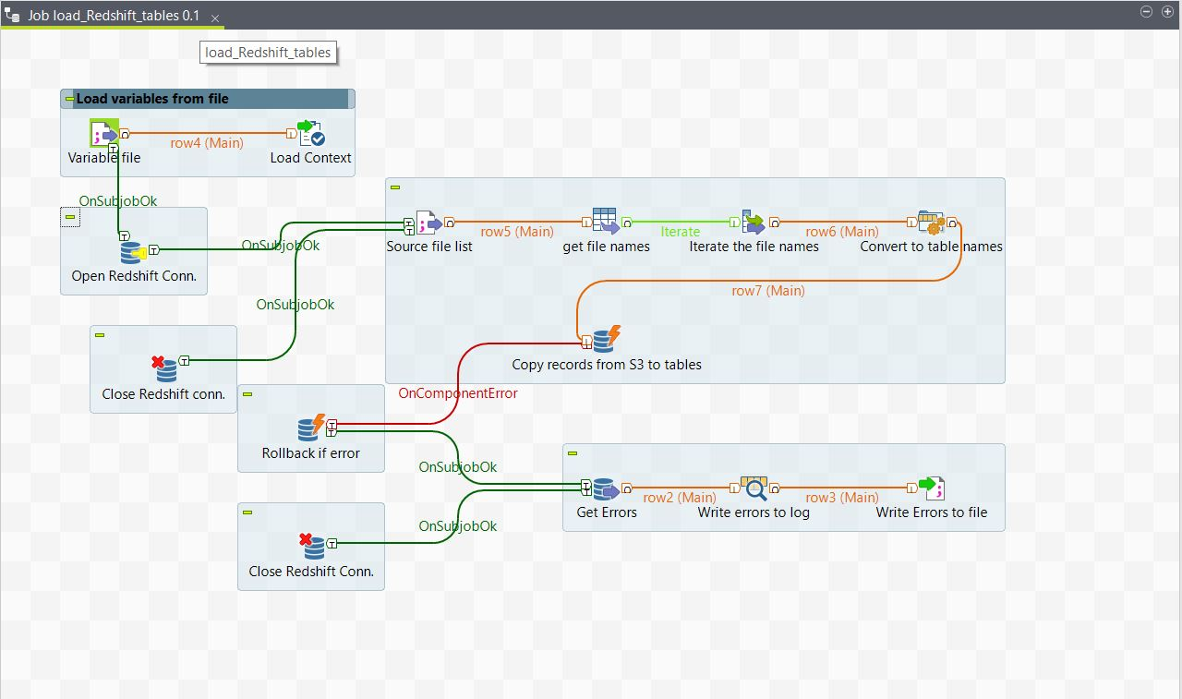

1. The errors during loading can be loaded to a different file from the temp table stl_load_errors using the below query:

select query, substring(filename,22,25) as filename,line_number as line,

substring(colname,0,12) as column, type, position as pos, substring(raw_line,0,30) as line_text,

substring(raw_field_value,0,15) as field_text,

substring(err_reason,0,45) as reason

from stl_load_errors

order by query desc

1. Once the data is loaded, there is an option to transform the data into new tables for analysis by using materialized views on Redshift. Since I have taken the approach of using AWS Quicksight as my BI Tool we can do the transformations on Quicksight considering this is relatively small data.

Using different analysis and small transformations of the data, I have created the following dashboard views.