PROJECT 1 :FILE CONVERSION

**Company Logo to be placed here**



NAME :KIRAN.C.BADIGER   
USN :1ST21CS095

E -MAIL : kirancbadigerpcmbt20@gmail.com

NAME :VINAY.B.D  
USN :1ST21CS236

E -MAIL : [vv985482@gmail.com](mailto:vv985482@gmail.com)

NAME : BHAVANA.G

USN : 1ST21CS038

E-MAIL :bhavanagbhavanag05@gmail.com

NAME : RAGHAVI.N.VANDAGANUR

USN : 1ST21CS166

E-MAIL : raghavivandaganur@gmail.com

NAME :RAKSHITH.H.S

USN : 1ST21CS168

E-MAIL : rakshithchinnu0070@gmail.com

# ACKNOWLEDGEMENT

While I was making this project , a lot of information that I found helped me in chapter and I am glad that I was able to complete this project and was able to understand many things.

It gave me an immense pleasure while doing this project because it was not just a project but , a source to learn not just about chapter but also I inculcated many qualities like responsibility , punctuality , confidence and what not.

The journey of making this project was so nice and in all this my teachers who supported me all the time , cleared my doubts and the parents support also played a big role and my friends too helped me . I thank to all of them and wish that they keep supporting me like this.

Doing work on time is something everyone needs to learn and through this project I have improved my timing and also it made my thinking skills better .

A project is a bridge between theoretical and practical learning and with this thinking I worked on the project and made it successful due to timely support and efforts of all who helped me.

Once again thank you Sir/Ma'am to give me this project and to make me learn so many things .I have no more valuable words to express my thanks , but my heart is still full of favour received from every person.

ABOUT THE C0MPANY:

Varcons Technologies Pvt Ltd is a digital service provider that aims to provide software, designing and marketing solutions to individuals and businesses. At VCT, we believe that service and quality is the key to success.

We provide all kinds of technological and designing solutions from Billing Software to Web Designs or any custom demand that you may have. Experience the service like none other!

Some of our services include:

Development - We develop responsive, functional and super-fast websites. We keep User Experience in mind while creating websites. A website should load quickly and should be accessible even on a small view-port and slow internet connection, We develop sophisticated customisable softwares using Java and other programming Languages as per the clients needs’

Mobile Application - We offer a wide range of professional android, iOS & Hybrid app development services for our global clients, from a start up to a large enterprise.

Design - We offer professional Graphic design, Brochure design & Logo design. We are experts in crafting visual content to convey the right message to the customers.

Consultancy - We are here to provide you with expert advice on your design and development requirement.

Videos - We create a polished professional video that impresses your audience

# INDEX

|  |  |  |
| --- | --- | --- |
| NO.S | TITLE | PAGE NO. |
| 1 | Brief overview on project | 01 |
| 2 | Advantages and challenges while completing project | 01 |
| 3 | Software and hardware requiement for project | 02 |
| 4 | Implementation of project | 03-05 |
| 5 | Conclusion | 06 |
| 6 | Bibliography | 07-08 |

**A BRIEF OVERVIEW ON THE PROJECT**:

This Java project is a general-purpose, concurrent, class-based, object- oriented computer programming language that is specifically designed to have as few implementation dependencies as possible and it helps to learn how to define and call the function in code.

It is intended to let application developers "write once, run anywhere" (WORA), meaning that code that runs on one platform does not need to be recompiled to run on another and from doing this project we get know about class must allow the objects to cooperate during the execution.

# 2.ADVANTAGES AND CHALLENGES WHILE COMPLETING THE PROJECT.

The main advantage is of our given project (TYPING SPEED CALCULATOR)

* ▪  It can be easily accessible by anyone, and the user need not have any back information while accessing this feature.
* ▪  The main highlight of this project is its much more efficient compared to its other versions and it’s also much more user friendly.
* ▪  The output that is attained by the user is more accurate as it’s more efficient and its also a reliable implying the user need not worry about the Output obtained by this Calculator.

CHALLENGES

These were the some of challenges which we needed to deal while the completion of this project (TYPING SPEED CALCULATOR)

▪ The main challenge was that we needed to input the precise characters for the programs implementation.

The main advantage is of our given project (TYPING SPEED CALCULATOR)

* ▪  It can be easily accessible by anyone, and the user need not have any back information while accessing this feature.
* ▪  The main highlight of this project is its much more efficient compared to its other versions and it’s also much more user friendly.
* ▪  The output that is attained by the user is more accurate as it’s more efficient and its also a reliable implying the user need not worry about the Output obtained by this Calculator.

CHALLENGES

These were the some of challenges which we needed to deal while the completion of this project (TYPING SPEED CALCULATOR)

▪ The main challenge was that we needed to input the precise characters for the programs implementation.

**SOFTWARE AND HARDWARE REQUIRMENTS FOR JAVA PROJECT :**

# Hardware Requirement for Java :

Minimum hardware requirement to download Java on your Windows operating system as follows:

* Minimum Windows 95 software
* IBM-compatible 486 system
* Hard Drive and Minimum of 8 MB memory
* A CD-ROM drive
* Mouse, keyboard and sound card

# Software requirement for Java :

Nowadays, Java is supported by almost every operating systems. Whether it is a Windows, Macintosh and Unix all supports the Java application development. So you can download any of the operating system on your personal computer. Here are the minimum requirement.

The software require for project includes package necessary to successfully compile and build the program.

* Operating System
* Java SDK or JRE 1.6 or higher
* Java Servlet Container (Free Servlet Container available)
* Supported Database and library that supports the database connection with Java.

IMPLEMENTATION OF THE PROJECT with Screenshots:

CsvToJson

package customdata;

import java.io.File;  
import java.io.FileReader; import java.io.FileWriter; import java.io.IOException;

import java.util.List; import java.util.ArrayList; import java.util.Set;

import com.opencsv.CSVReader;

import org.json.simple.JSONObject; import org.json.simple.JSONArray; import org.json.simple.JSONValue;

public class CsvToJson {  
private List<RowData> rows = null;

public CsvToJson () {  
this.rows = new ArrayList<RowData>();

}

public void readCsvDataFromFile (String filepath) { CSVReader csvReader = null;  
FileReader fileReader = null;  
File file = null;

int lineNum = -1;

try {  
file = new File(filepath); if(!file.exists() || file.isDirectory()) {

System.err.println("File cannot be processed: " + file);

return; }

fileReader = new FileReader(file); csvReader = new CSVReader(fileReader);

List<String> headers = new ArrayList<String>(); String [] nextLine = null;

while ((nextLine = csvReader.readNext()) != null) { lineNum++;

if (lineNum == 0) {  
for (String header : nextLine) {

headers.add(header); }

continue; }

RowData row = new RowData(); int colNum = 0;  
for (String column : nextLine) {

String header = headers.get(colNum); row.putData(header, column); colNum++;

}

this.rows.add(row); }

} catch (IOException e) { e.printStackTrace();

} finally { try {

fileReader.close(); } catch (Exception e1) {

// Do nothing }

} };

private String getRowsAsJson () { JSONArray jsonArr = new JSONArray(); for (RowData row : this.rows) {

JSONObject jsonObj = new JSONObject(); Set<String> keySet = row.getKeySet();

for (String key : keySet) { jsonObj.put(key, row.getData(key));

}

jsonArr.add(jsonObj); }

return JSONValue.toJSONString(jsonArr); }

public void printJsonData () { System.out.println(this.getRowsAsJson());

}

public void writeJsonDataToFile(String filepath) { FileWriter fileWriter = null;  
try {

fileWriter = new FileWriter(filepath); fileWriter.write(this.getRowsAsJson()); fileWriter.close();

} catch (IOException e) { e.printStackTrace();

} }

}

MyClass

import customdata.*;

public class MyClass {  
public static void main(String args[]) {

CsvToJson csvToJson = new CsvToJson(); csvToJson.readCsvDataFromFile("./file.csv"); csvToJson.printJsonData(); //csvToJson.writeJsonDataToFile("./file.json");

} }

RowData

package customdata;

import java.util.Set; import java.util.Map; import java.util.HashMap;

public class RowData {  
private Map<String, String> map = null;

public RowData () {  
this.map = new HashMap<String, String>();

}

public Set<String> getKeySet () { return this.map.keySet();

}

public String getData (String key) { return this.map.get(key);

}

public void putData (String key, String value) { this.map.put(key, value);

}

public String toString () { return this.map.toString();

} }

File.csv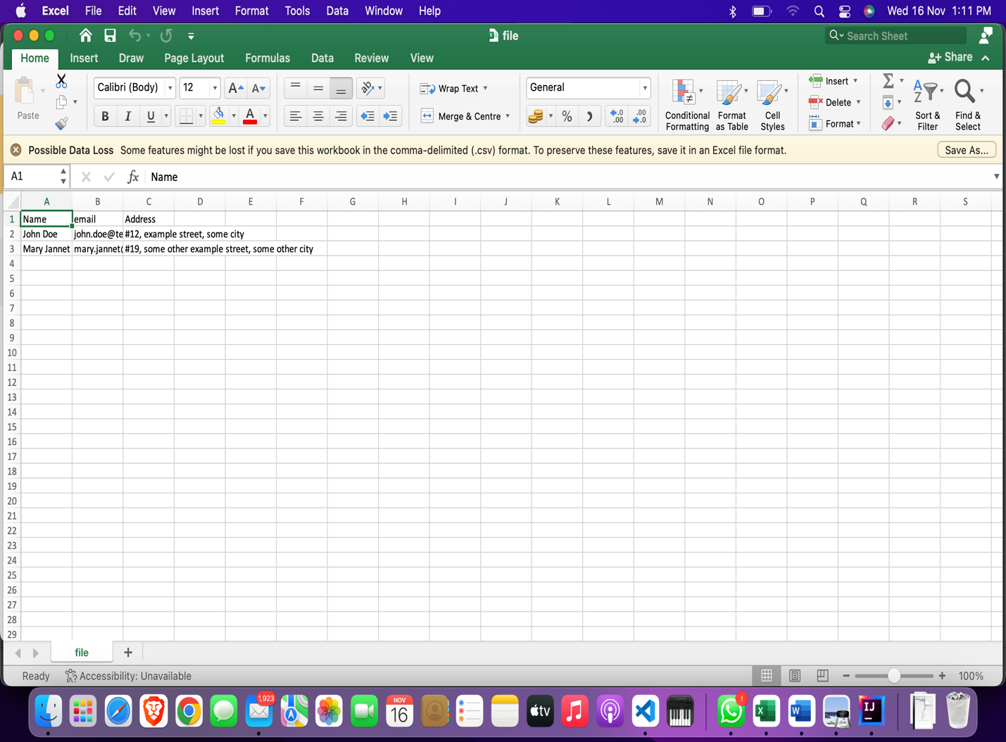

CONCLUSION:

At the beginning while we had started this code we had certain issues regarding the character initializations and declarations which was the very complicated at the beginning but at the end we understood the characters which were needed and this program was initialized at the end.

The main reason this program was made to ensure that the user gets accurate values given back to him which meant that the program was successfully complied/executed.

The main teaching we got from this project was that we understood the working behind the statements (if, else if) which are the basic statements which we have used in this program.  
The final conclusion we have attained was that we had experienced a good amount of team work was needed to do this project and this also helped us to understand our idea’s and this helped us to complete this project Successfully.

THANK YOU

# BIBLIOGRAPHY:

* “Core Java™, Volume I--Fundamentals (8th Edition) “ , by Cay S. Horstmann, Prentice Hall; 8

edition (April 18, 2008).

* “Effective Java (2nd Edition)” , by Addison-Wesley; 2 edition (May 28, 2008) .
* “Java The Complete Reference, 8th Edition”, McGraw-Hill Osborne Media; 8 edition (June 22, 2011).
* A Programmer's Guide to Java SCJP Certification: A Comprehensive Primer (3rd Edition), Addison-Wesley Professional; 3 edition (December 29, 2008).
* “More Java Pitfalls: 50 New Time-Saving Solutions and Workarounds” , by Michael C. Daconta (Author), Kevin T. Smith (Author), Donald Avondolio (Author), W. Clay Richardson (Author), Wiley; 1 edition (February 3, 2003).
* “Head First Servlets and JSP: Passing the Sun Certified Web Component Developer Exam “, by Bryan Basham (Author), Kathy Sierra (Author), Bert Bates (Author), O'Reilly Media; Second Edition edition (April 1, 2008).
* “Head First Design Patterns”, Elisabeth Freeman (Author), Eric Freeman (Author), Bert Bates (Author), Kathy Sierra (Author), Elisabeth Robson (Author), O'Reilly Media; 1 edition (November 1, 2004)
* “EJB 3 in Action”, Debu Panda (Author), Reza Rahman (Author), Derek Lane (Author),

Manning Publications; 1 edition (April 16, 2007).

* “JBoss: A Developer's Notebook” , Norman Richards (Author), Sam Griffith (Author), O'Reilly
* Enterprise Java™ Security: Building Secure J2EE™ Applications, Marco Pistoia (Author), Nataraj Nagaratnam (Author), Larry Koved (Author), Anthony Nadalin (Author), Addison- Wesley Professional; 1 edition (February 27, 2004).

PAGE NO:07

* “Java EE 6 Development with NetBeans 7”, Author: David Heffelfinger, Published: June 2011, PACKT Publishing, UK. NetBeans IDE 7.0 Cookbook, Author: Rhawi Dantas, Published: May 2011, PACKT Publishing, UK
* “Art of Java Web Development: Struts, Tapestry, Commons, Velocity, JUnit, Axis, Cocoon,

InternetBeans, WebWork”, Neal Ford (Author), Manning Publications (November 1, 2003).

* “Struts 2 in Action”, Don Brown (Author), Chad Michael Davis (Author), Scott Stanlick

(Author), Manning Publications; 1 edition (May 1, 2008).

* “Hibernate in Action (In Action series)”, Christian Bauer (Author), Gavin King (Author), Manning Publications (August 1, 2004) “Web Services Essentials (O'Reilly XML)”, Ethan Cerami (Author), O'Reilly Media (February 2002) .
* “Object-Oriented Software Construction (Book/CD-ROM) (2nd Edition)” ,Bertrand Meyer

(Author), Prentice Hall; 2nd edition (March 21, 2000).

* Java Black Book, Steve Holzner (Author), Steven Holzner (Author), Paraglyph Press; Second Edition edition (July 1, 2002)