R Programming Lab - Experiments 11 to 21

Experiment 11: Read a .csv file and display its contents
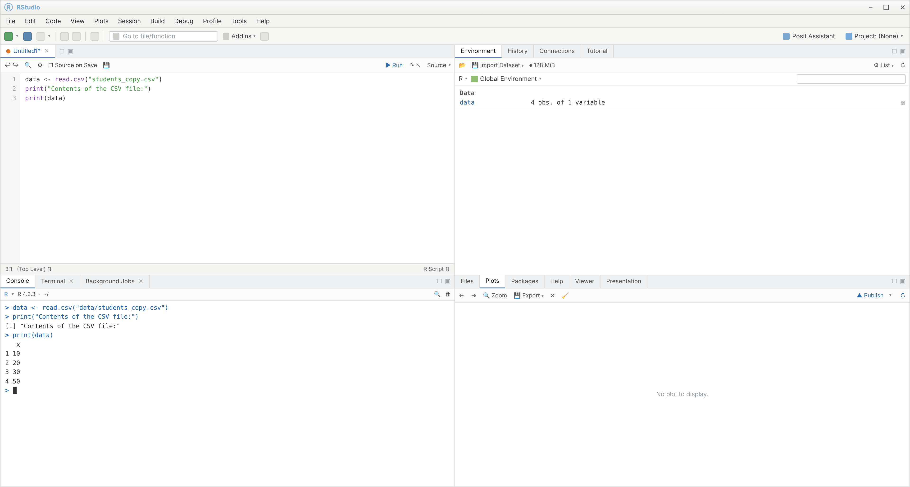

Experiment 12: Reshape the air quality dataset and compute monthly averages
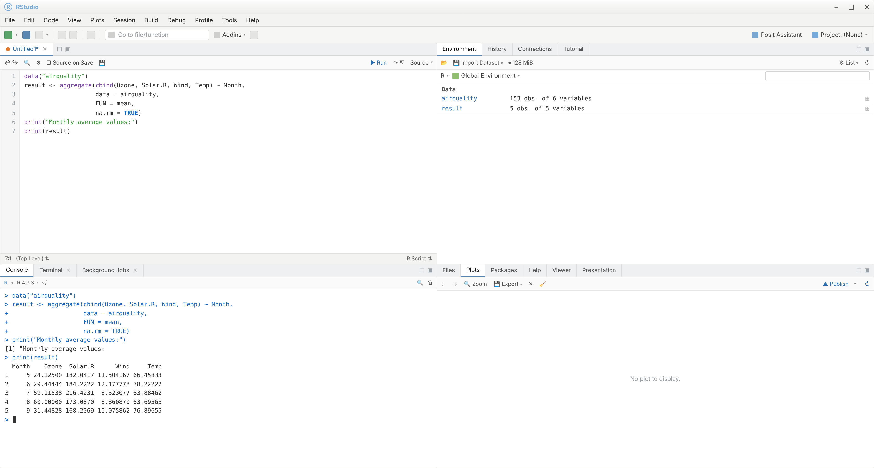

Experiment 13: Combine multiple arrays row-wise
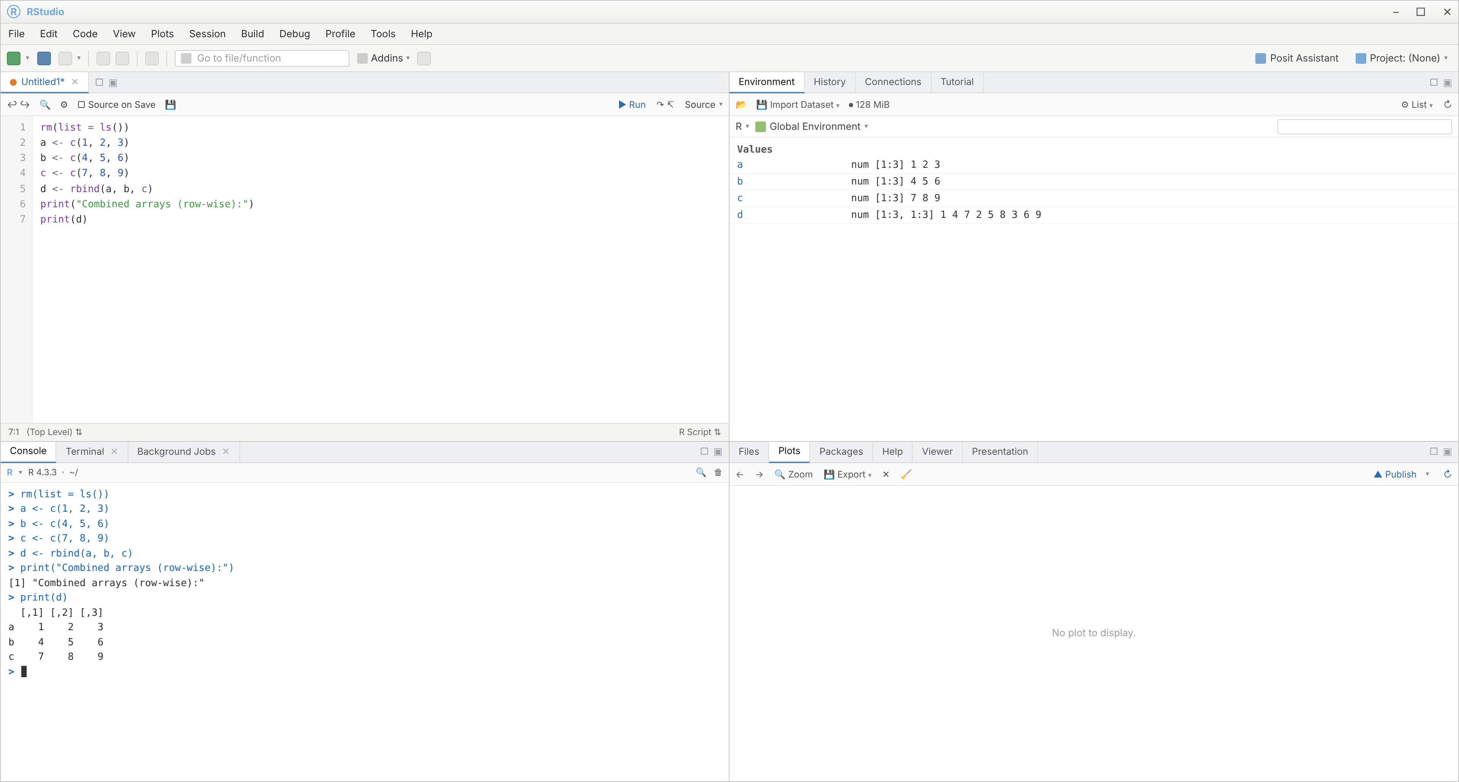

Experiment 14: Explore and manipulate the ChickWeight dataset (sort, aggregate by Diet)
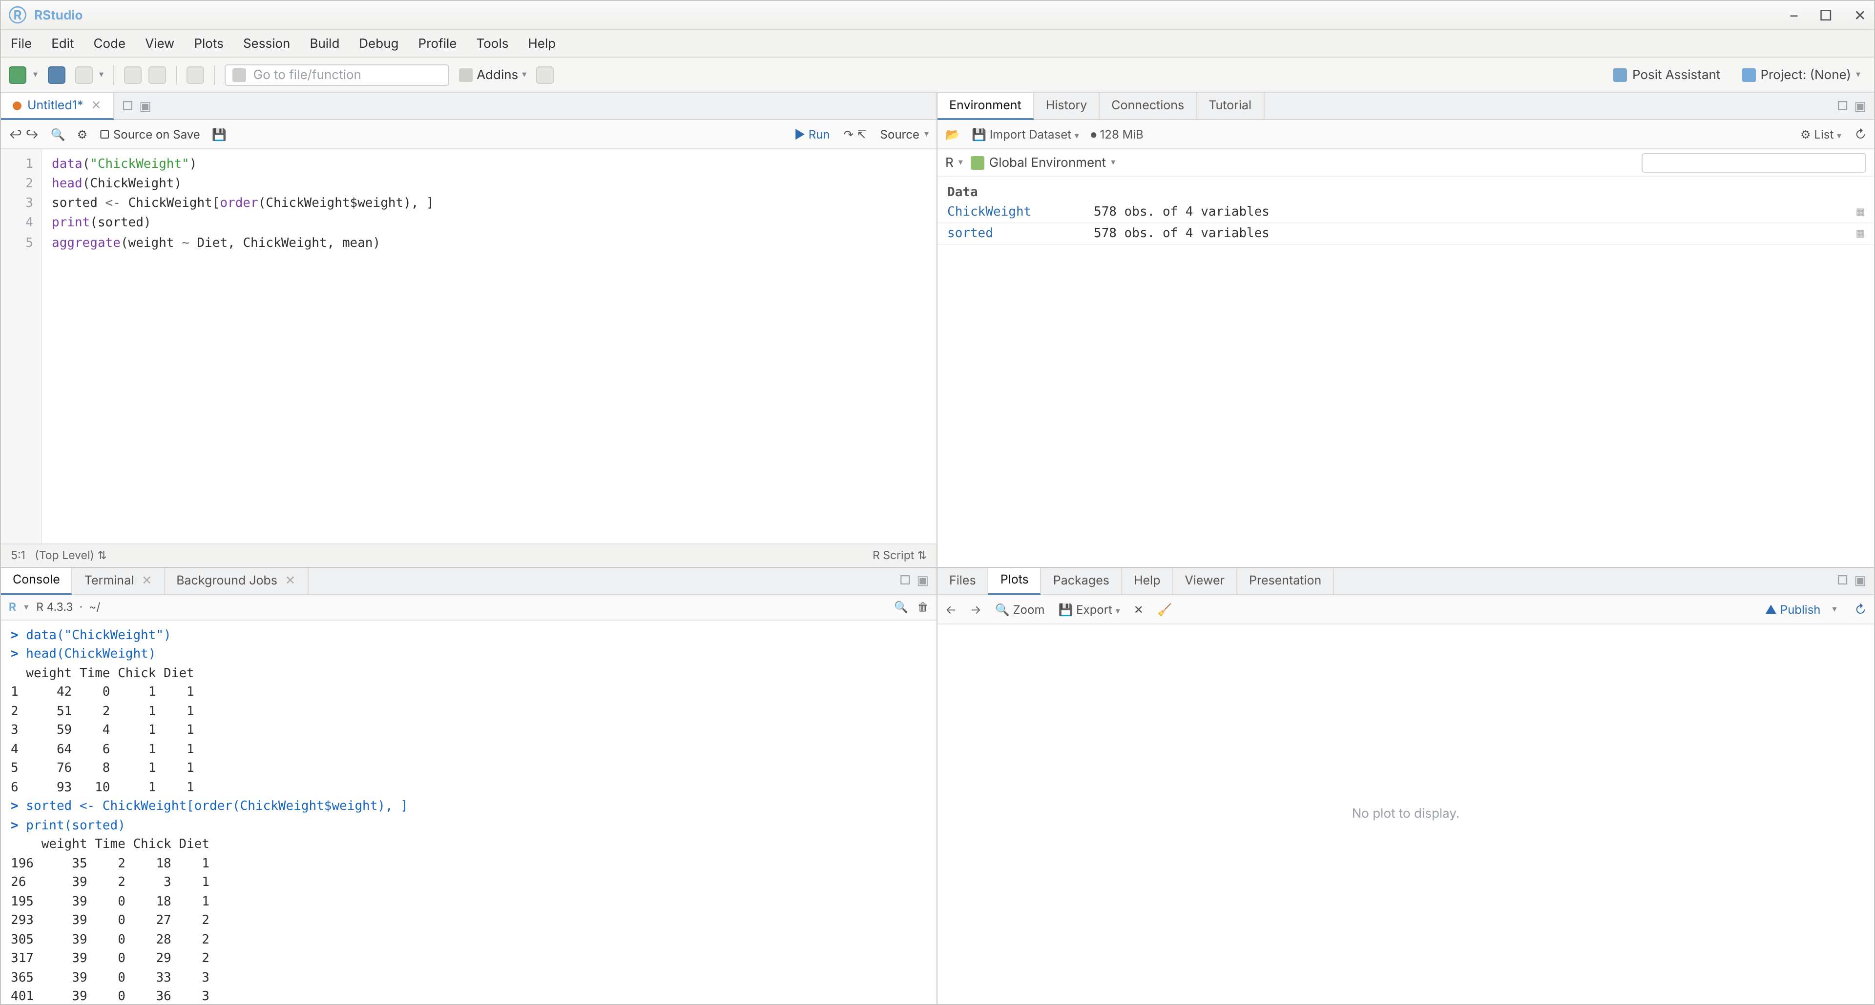

Experiment 15: Perform EDA on the iris dataset (summary, sd, quantiles, grouping)
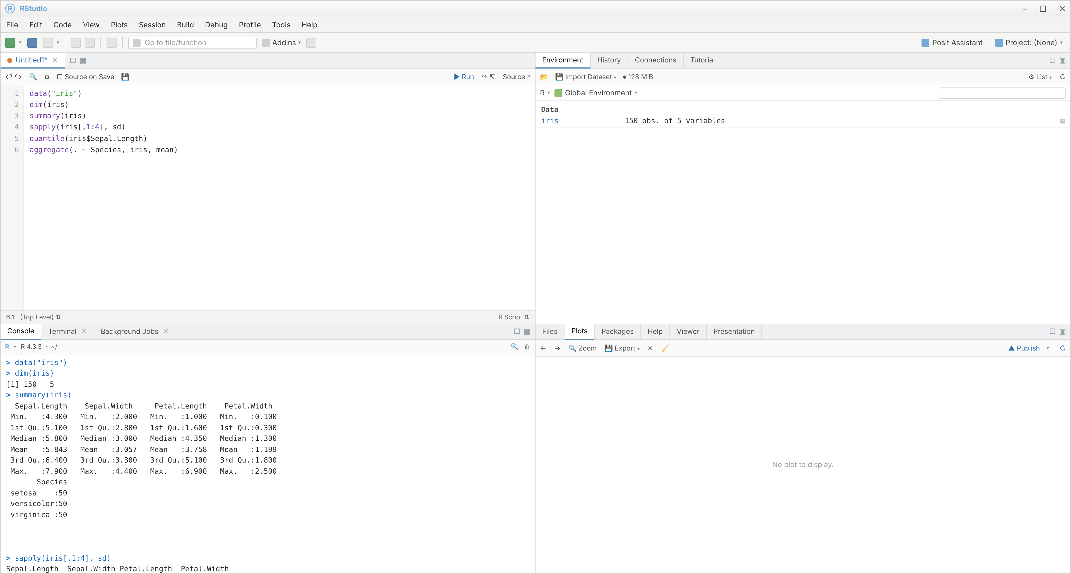

Experiment 16: Explore the USArrests dataset with summary statistics and a histogram
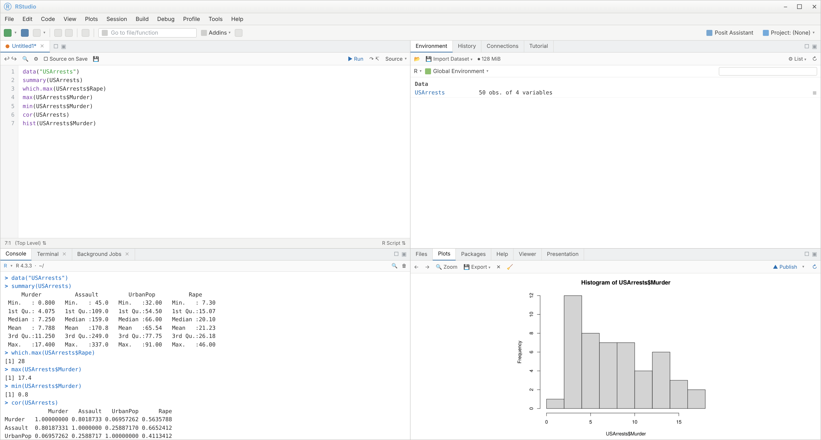

Experiment 17: Explore the Titanic dataset with a bar chart of survival by gender
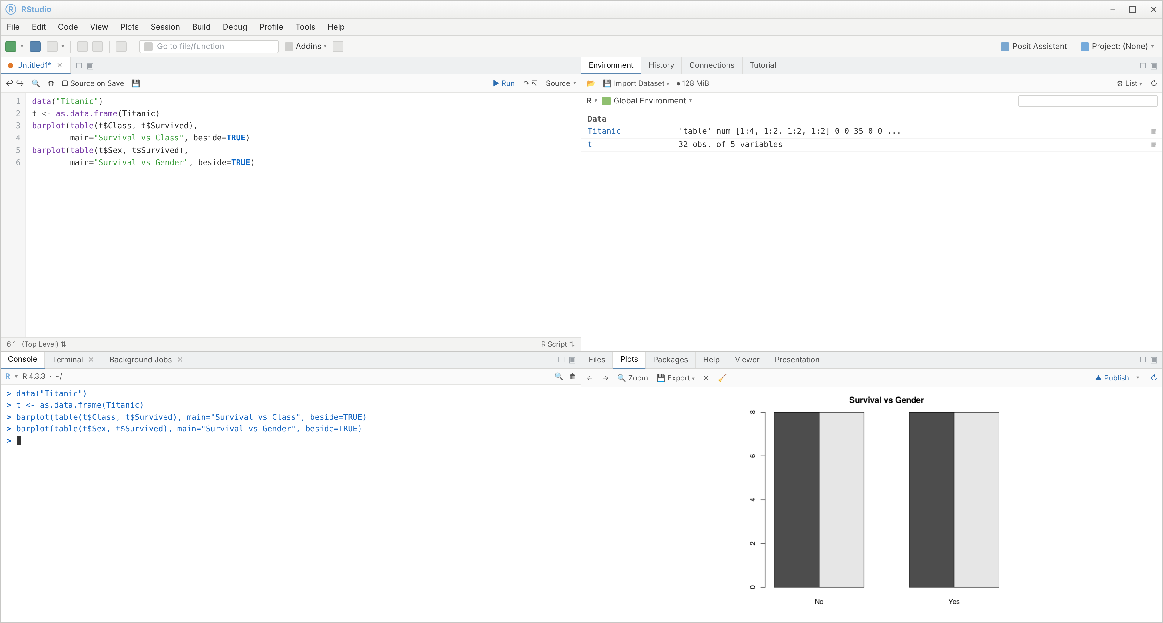

Experiment 18: Create graphs in R - boxplot, histogram, bar plot, line chart, scatter plot
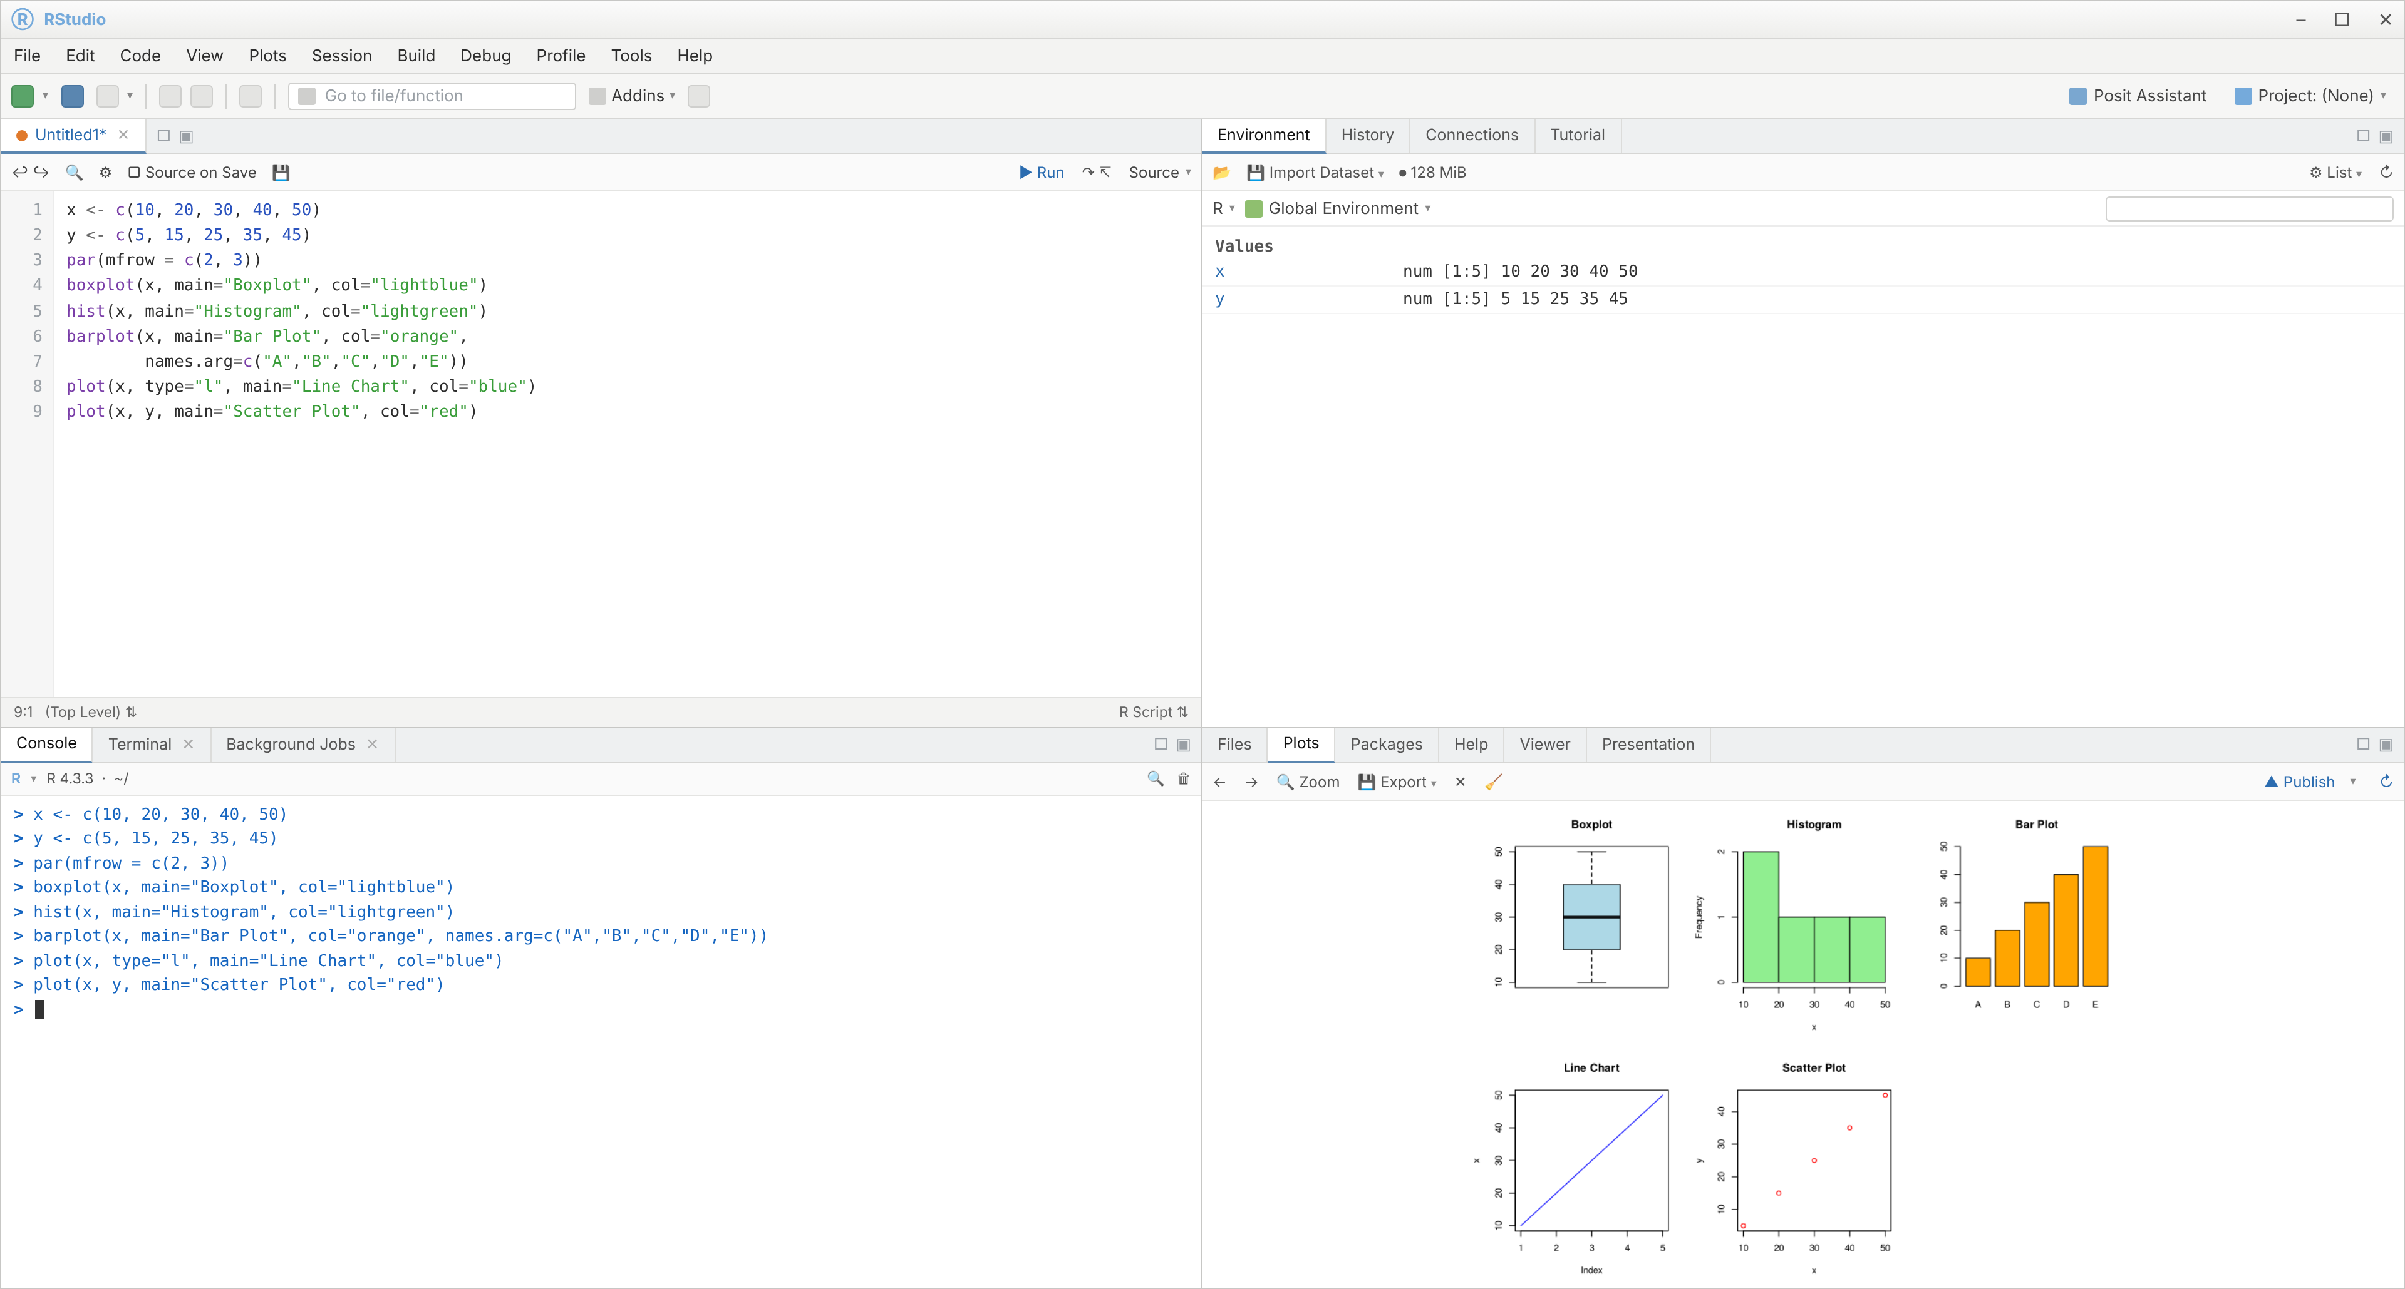

Experiment 19: Build a regression model (Sales ~ Spend) and predict Sales
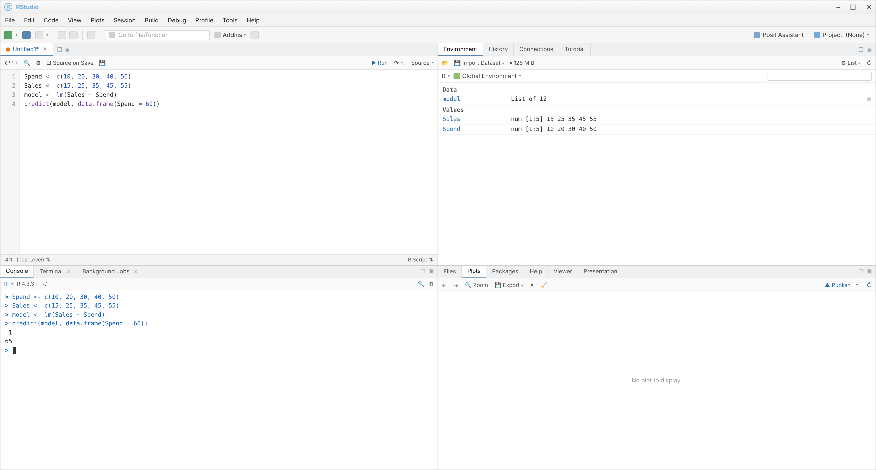

Experiment 20: Multiple regression on ChickWeight (Time and Diet) and compute model error
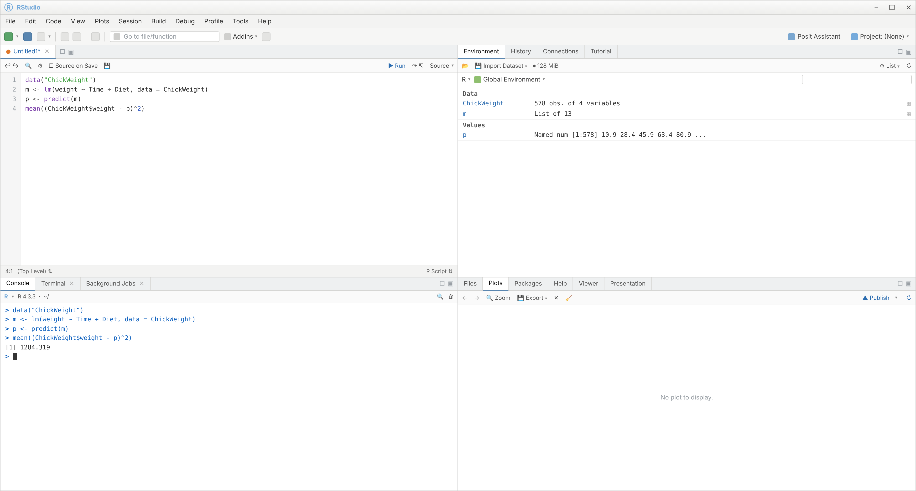

Experiment 21: Logistic regression on iris (Species ~ Petal.Length + Petal.Width) with confusion matrix
