R Programming Lab - Experiments 1 to 10

Experiment 1: Create numeric, character, and logical vectors and display type and content
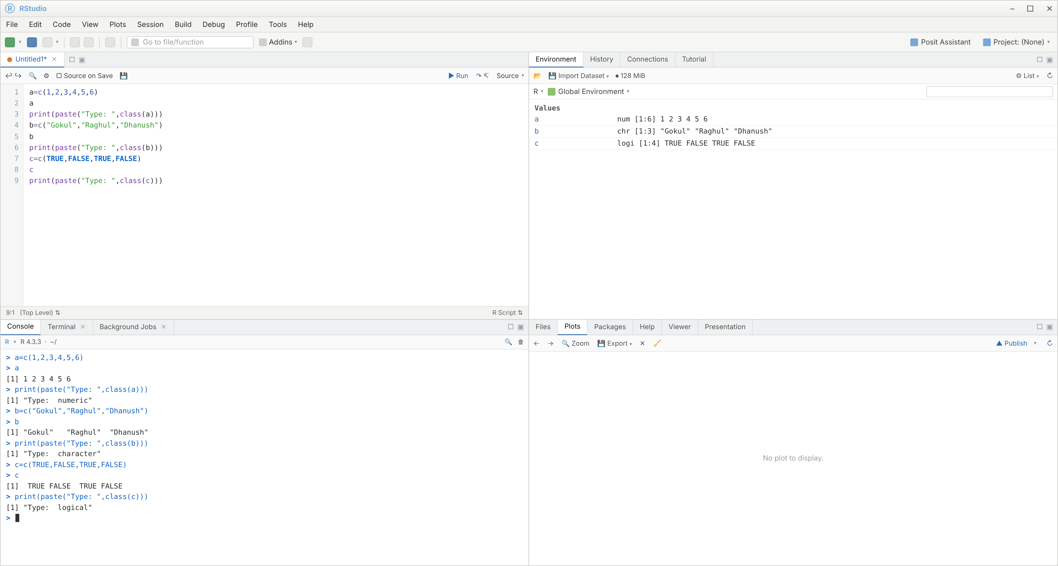

Experiment 2: Create labeled matrices (5x4, 3x3, 2x2) filled by row/column
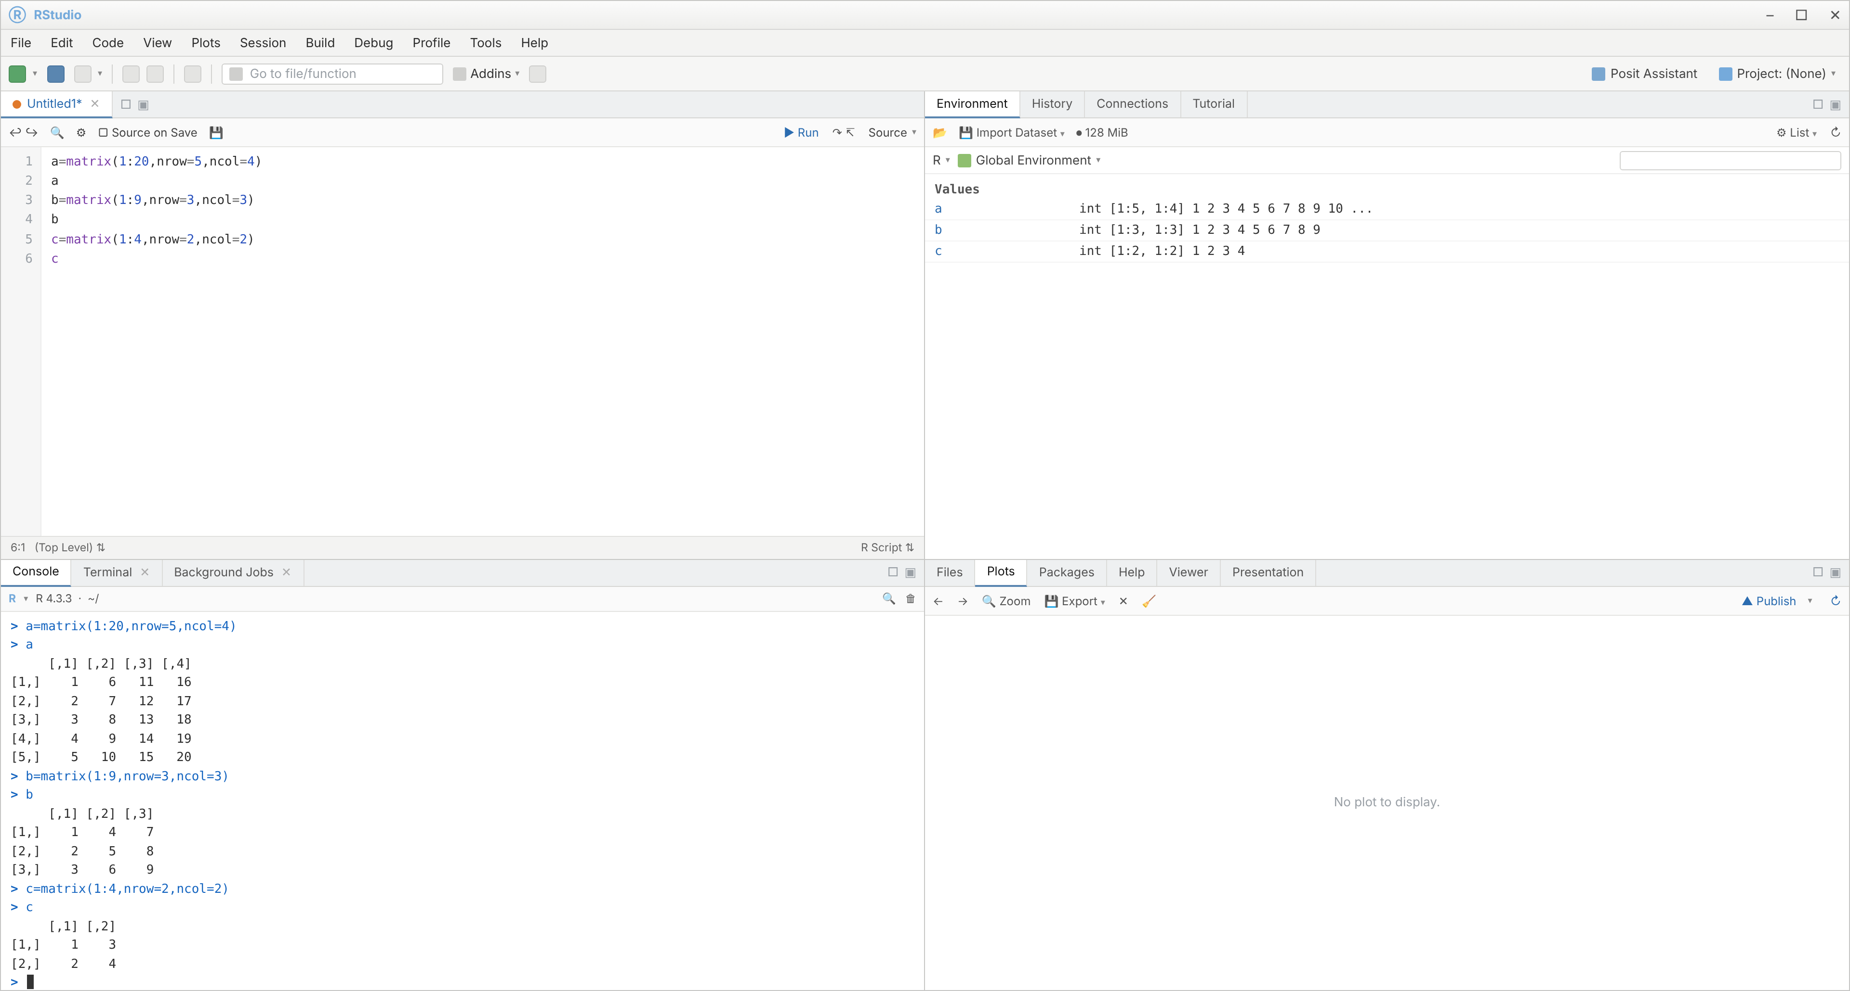

Experiment 3: Create and display a 3D array with specified rows, columns, and tables
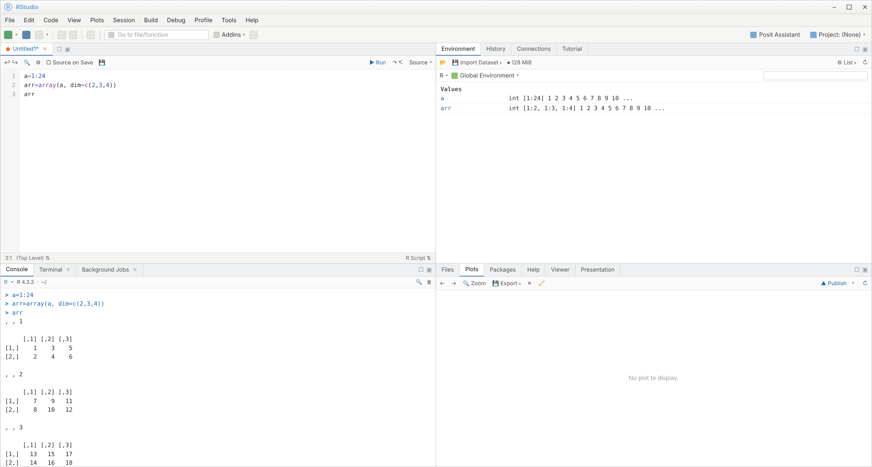

Experiment 4: Create arrays from vectors with dimension names and print specific elements
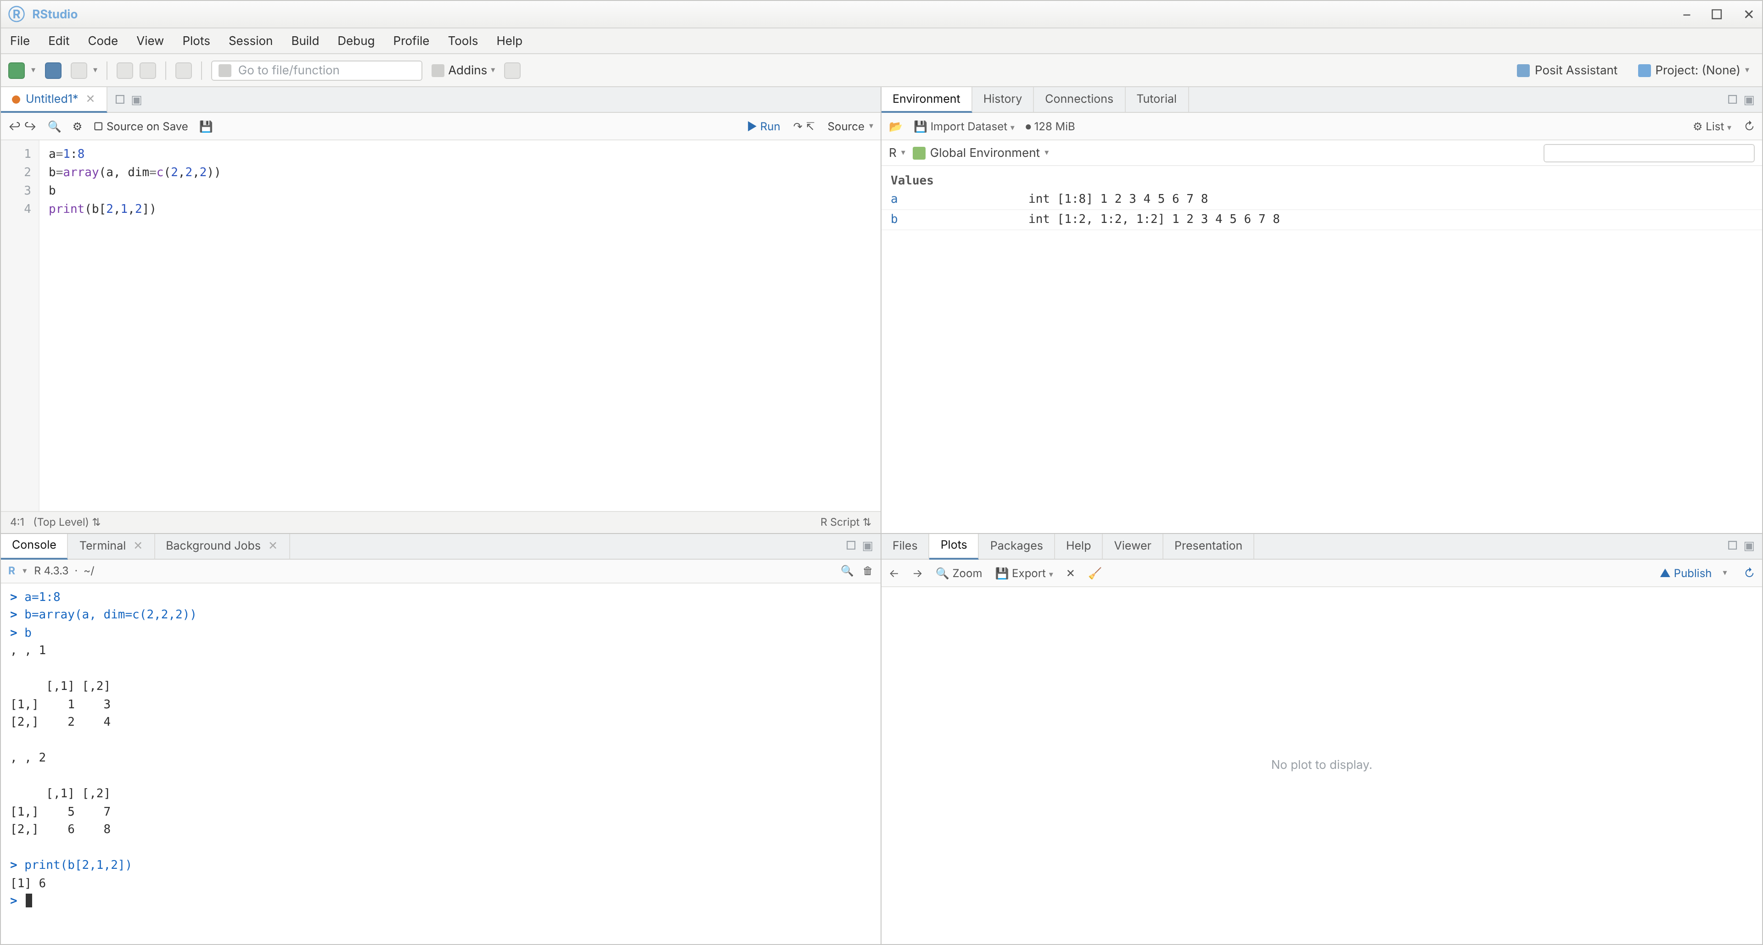

Experiment 5: Create and manipulate factor variables
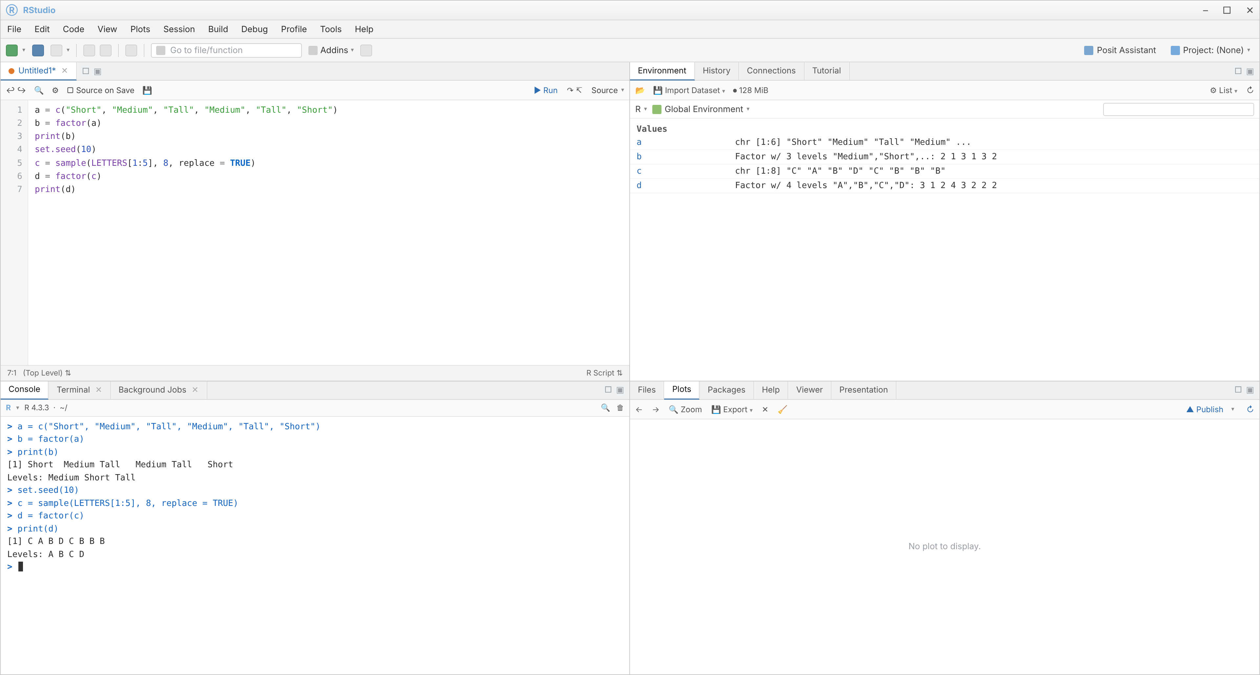

Experiment 6: Create an R list containing vectors, matrices, and functions; display contents
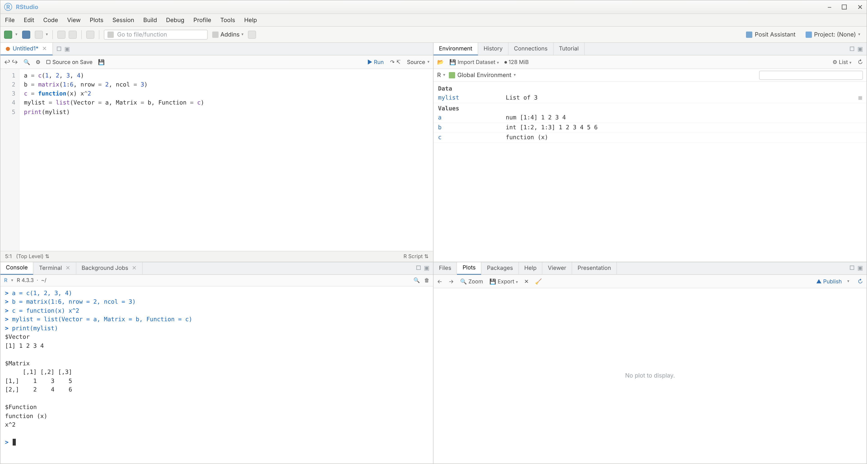

Experiment 7: Factors of a number, 10 random integers (-50 to 50), and FizzBuzz (1-100)
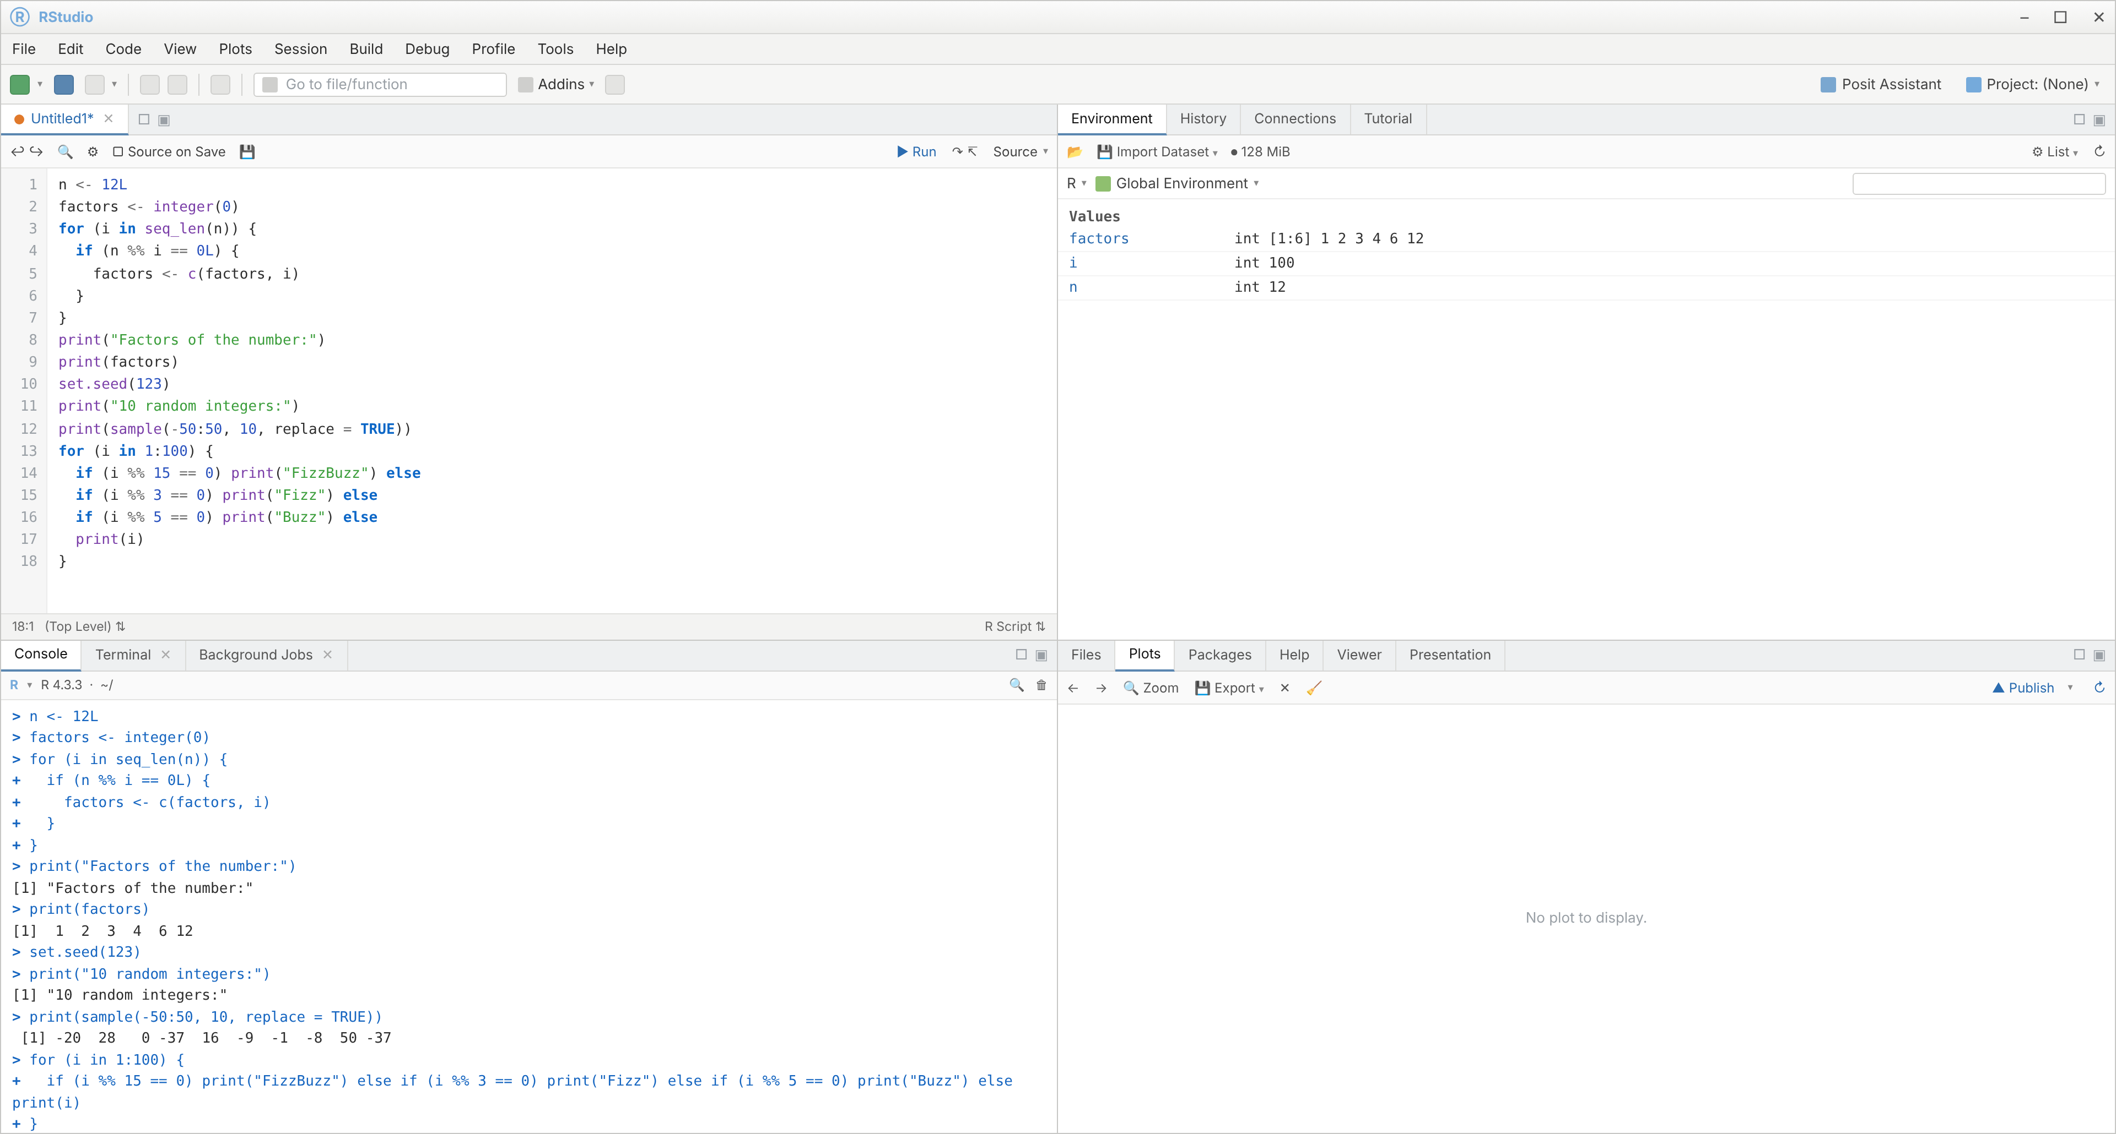

Experiment 8: Generate random numbers from a normal distribution and count occurrences
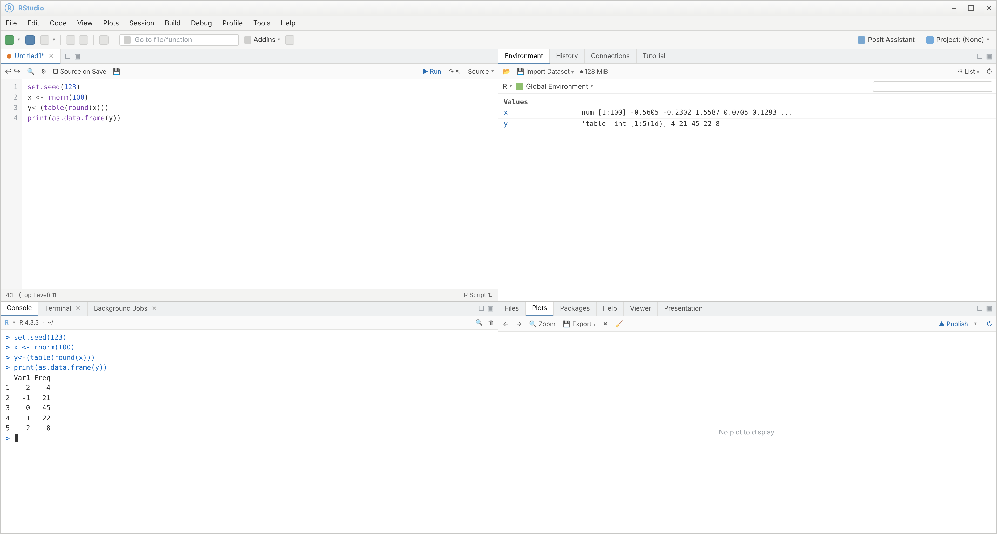

Experiment 9: Create an empty plot with specified axis limits
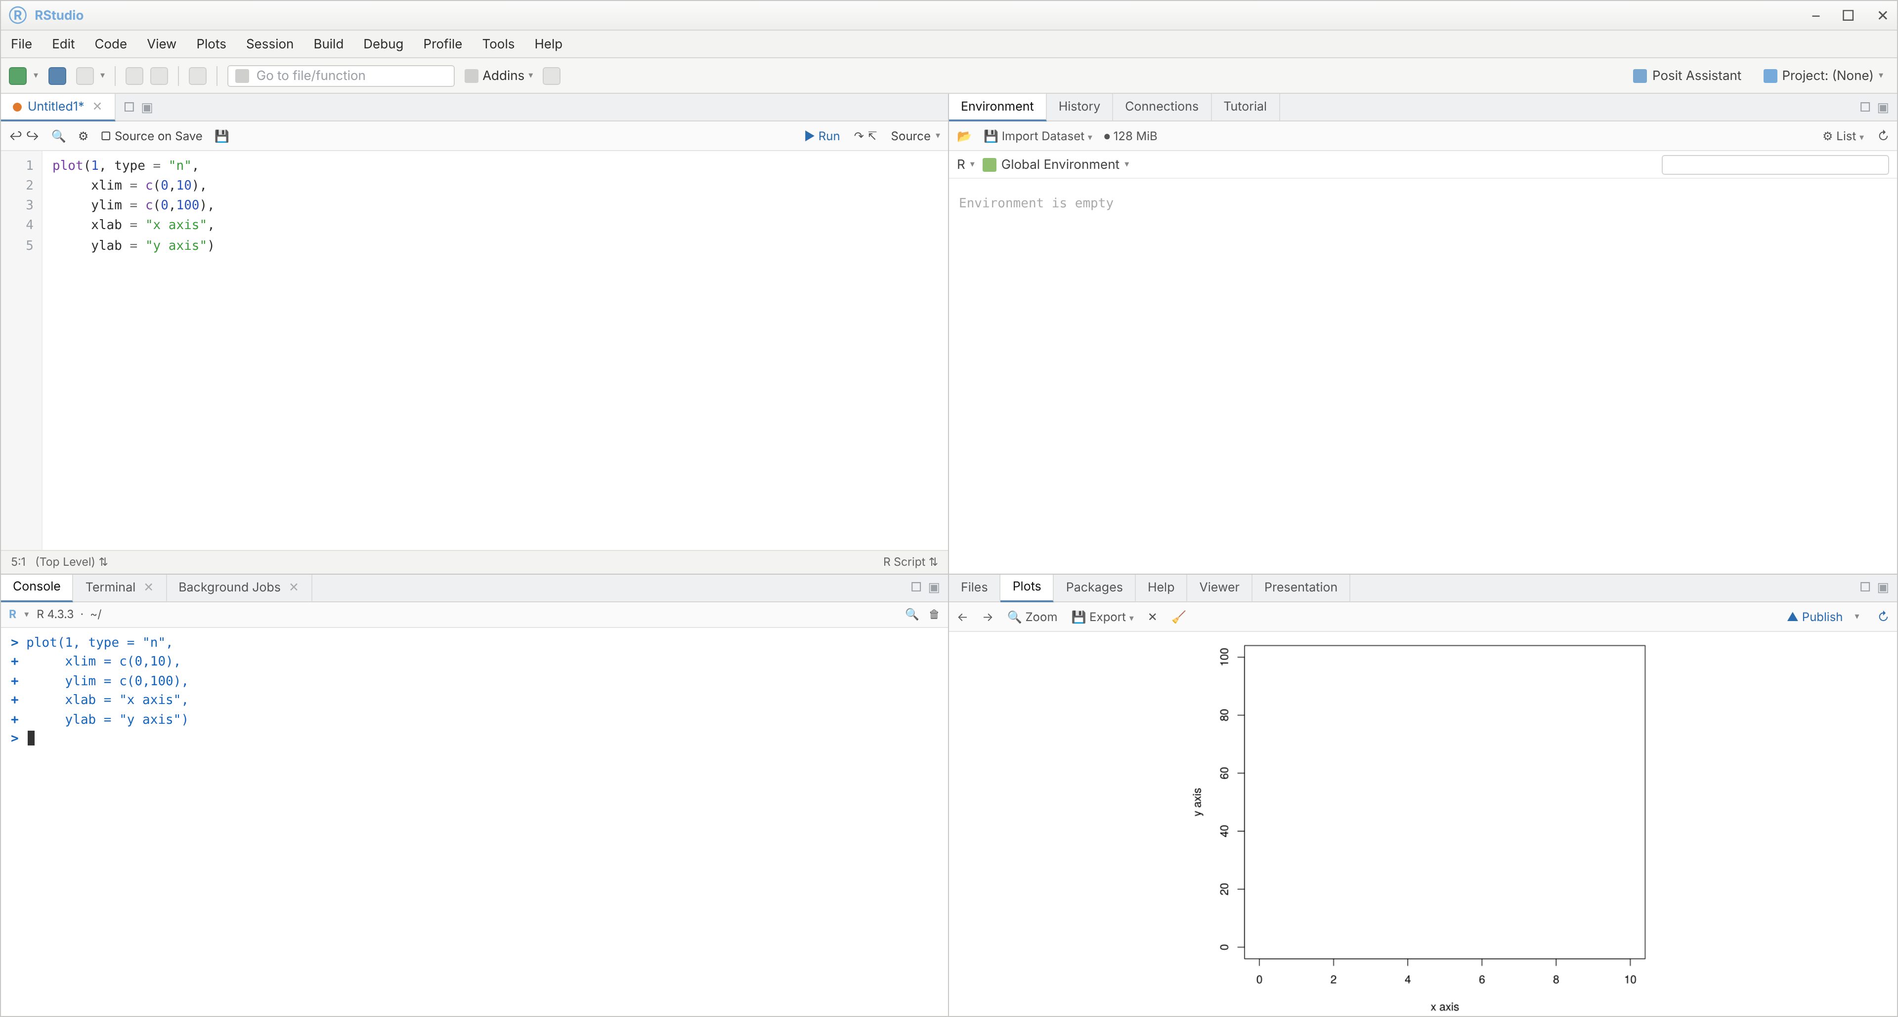

Experiment 10: Create and explore a data frame exam_data (extract, add, sort, save to file)
