DBMS Lab – MySQL Experiments
Name: Kayyala Vinay
Reg no:192524278

Experiment 1: DDL Commands using CREATE, ALTER, TRUNCATE and DROP
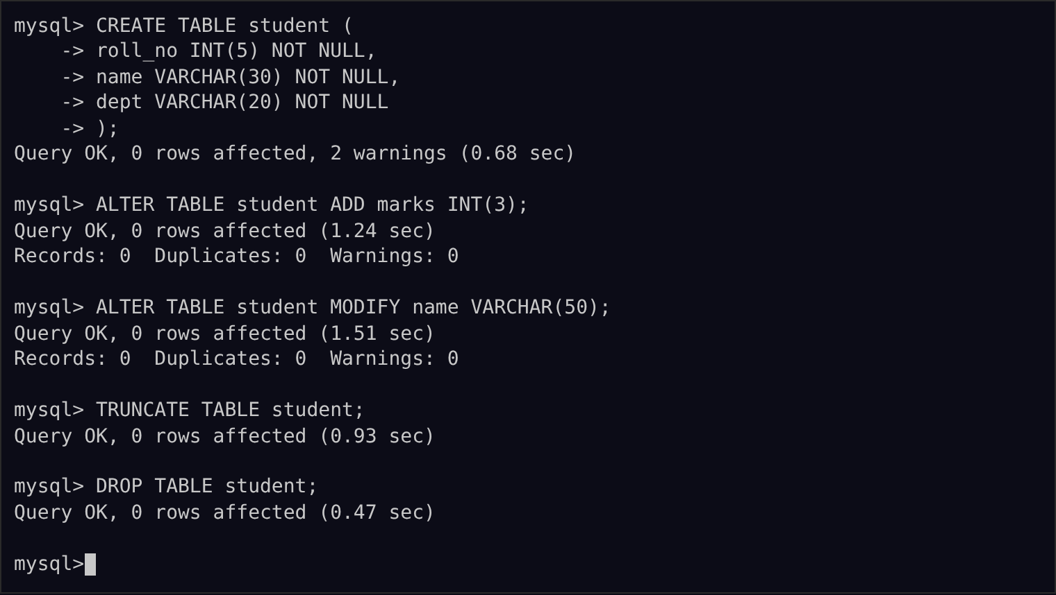

Experiment 2: DDL Commands with Constraints – PRIMARY, FOREIGN KEY, UNIQUE, CHECK, DEFAULT, NOT NULL
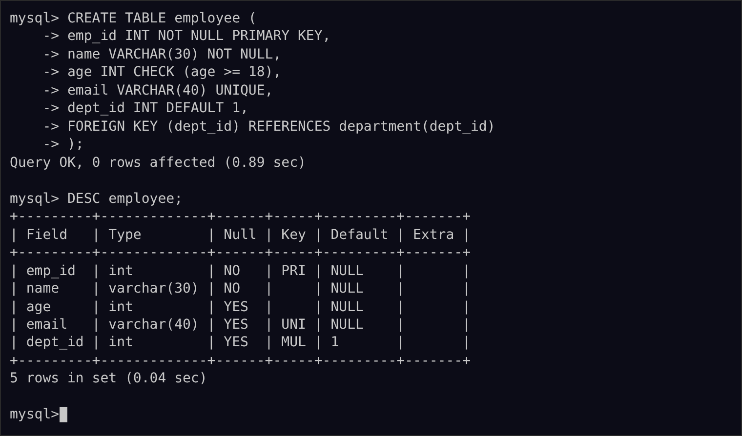

Experiment 3: DML Commands using INSERT, SELECT
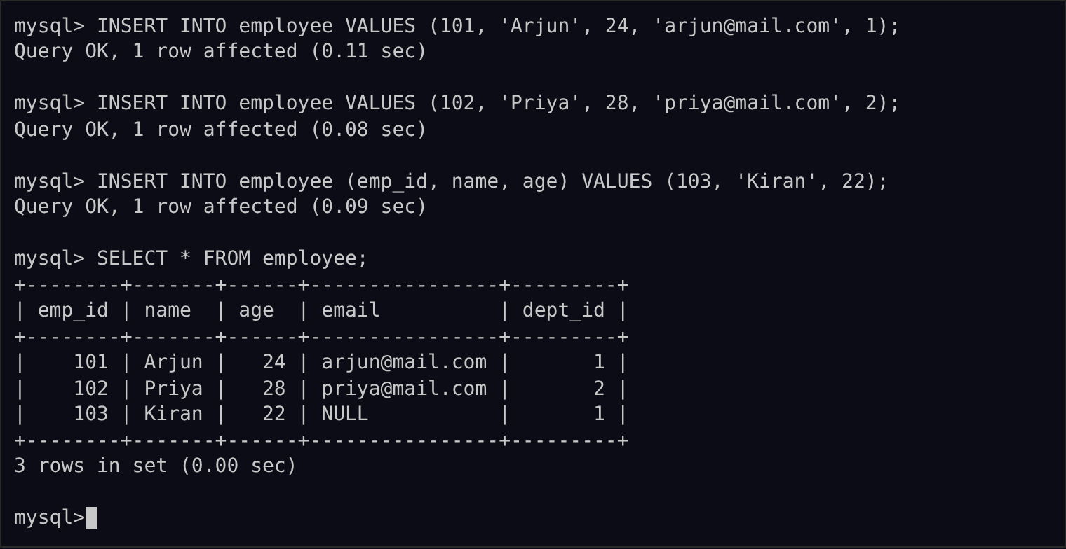

Experiment 4: DML Commands using UPDATE, DELETE
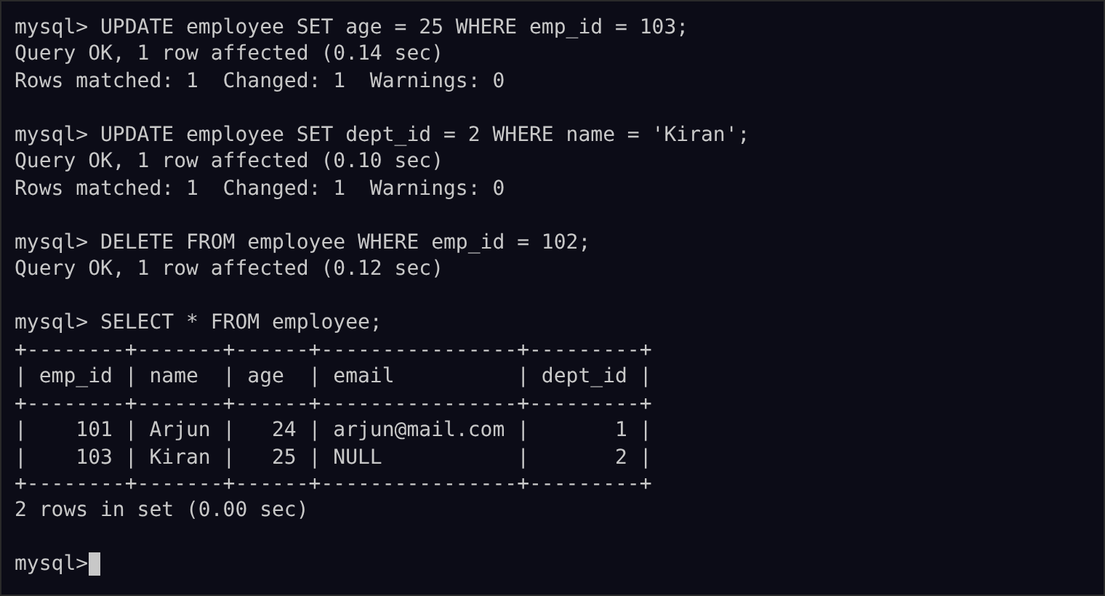

Experiment 5: TCL Commands – COMMIT, SAVEPOINT, ROLLBACK
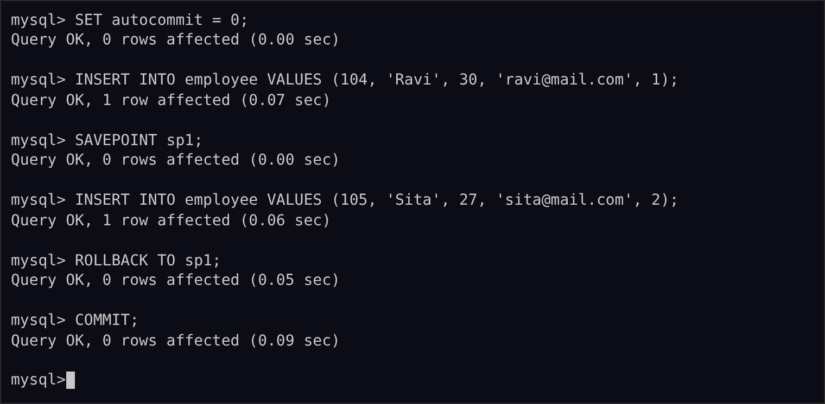

Experiment 6: DCL Commands – GRANT, REVOKE
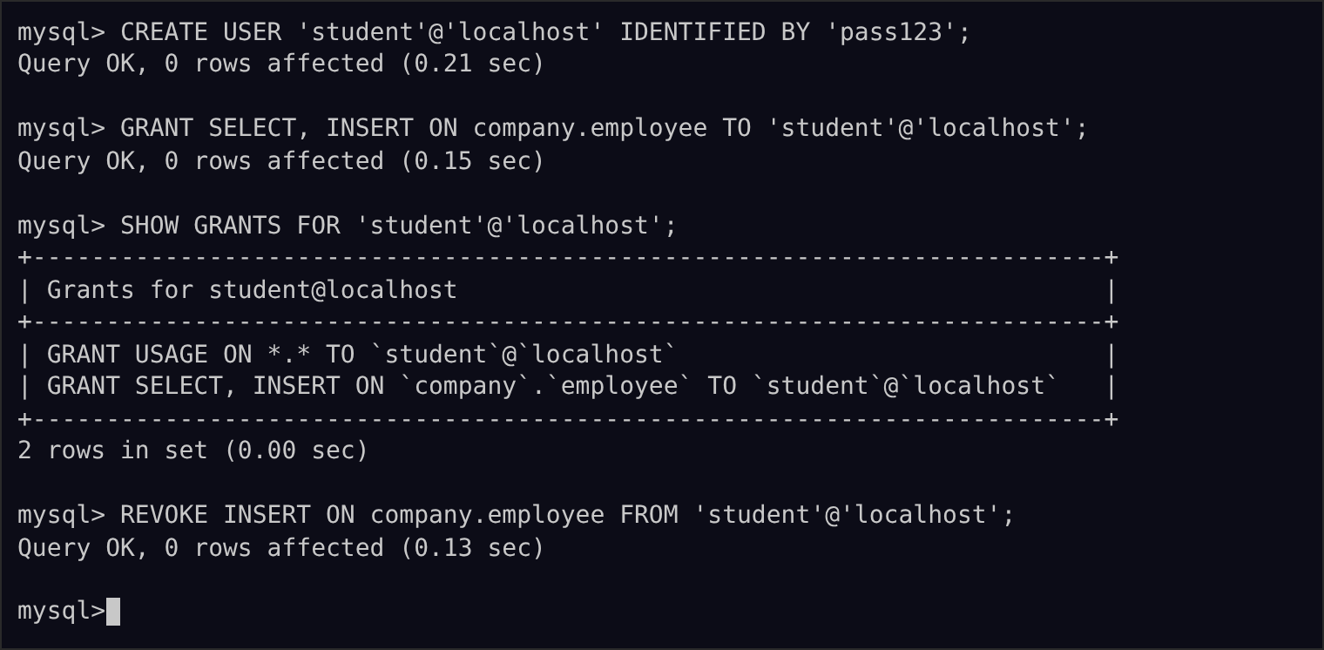

Experiment 7: SELECT with various clauses – WHERE, pattern matching
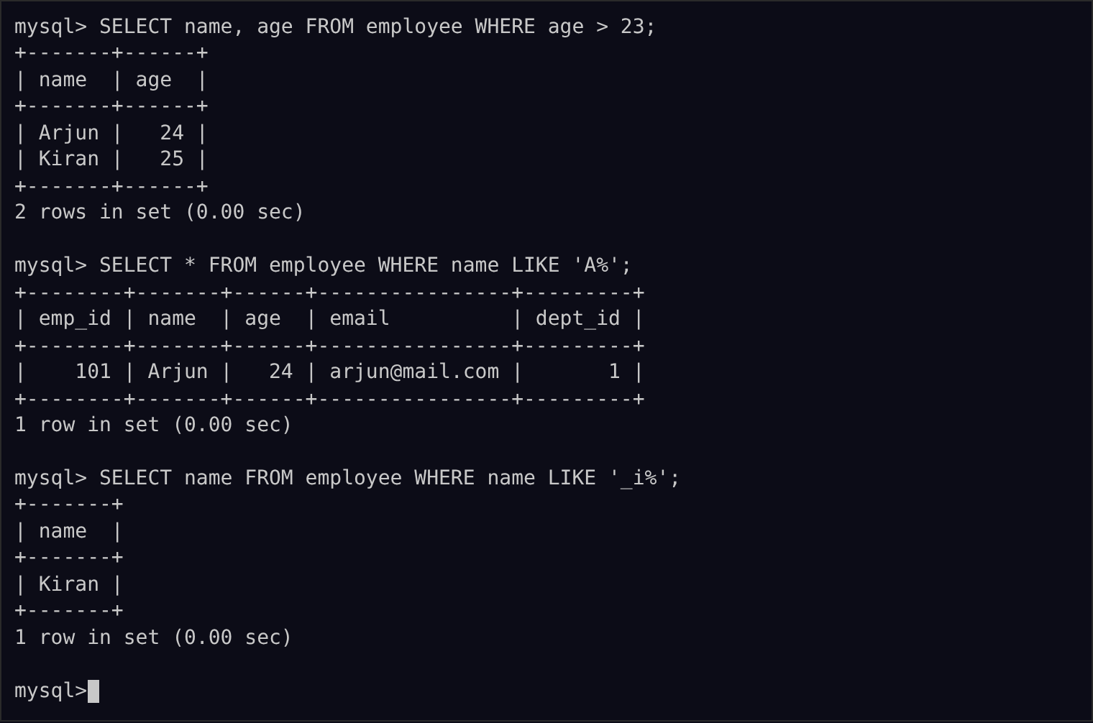

Experiment 8: SELECT with various clauses – BETWEEN, IN, Aggregate Function
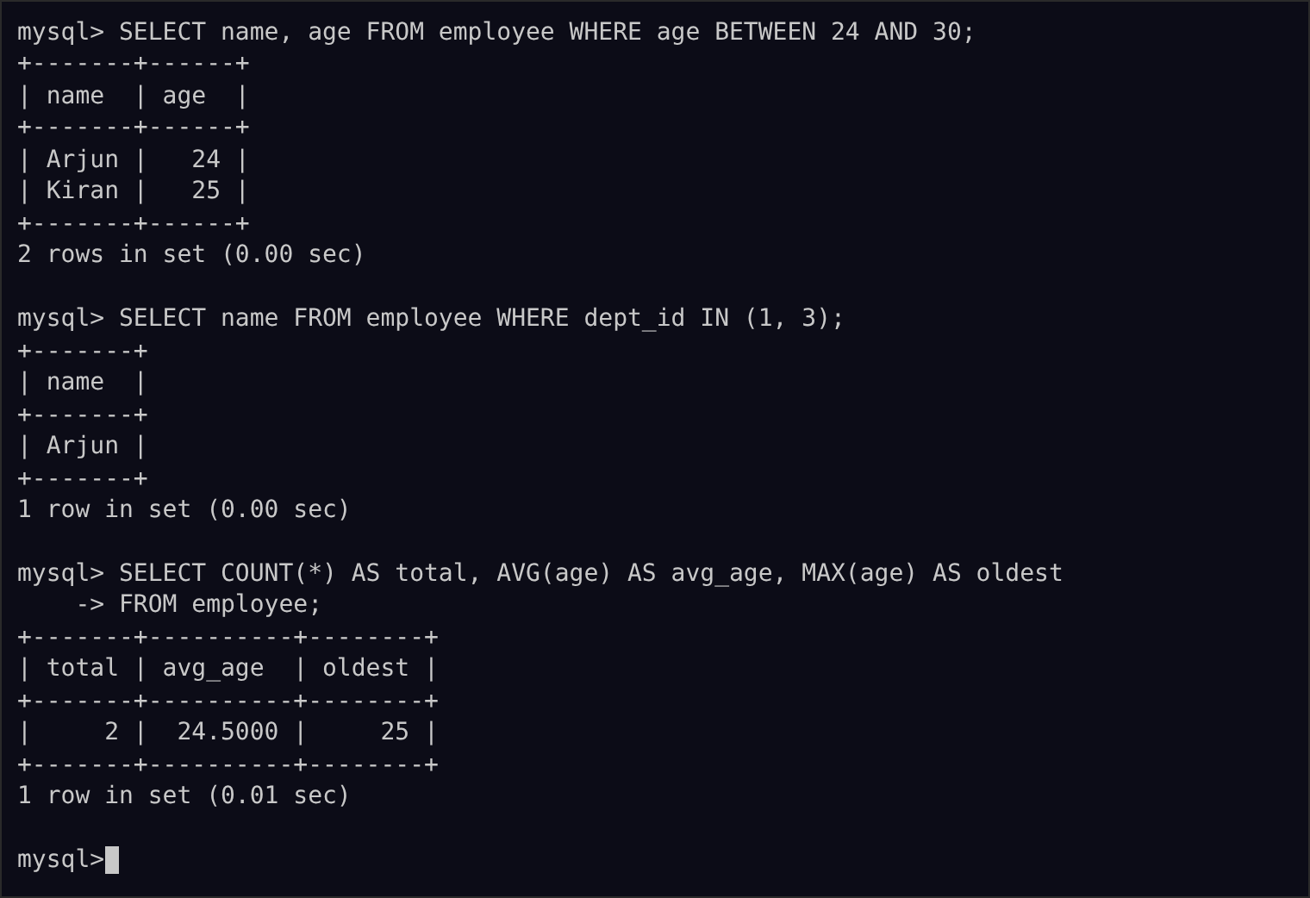

Experiment 9: SELECT with various clauses – GROUP BY, HAVING, ORDER BY
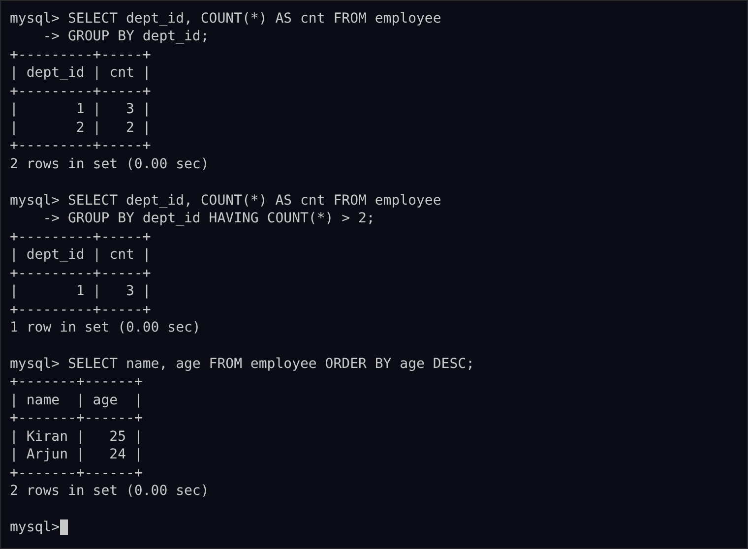

Experiment 10: Query with SubQuery & Correlated Query
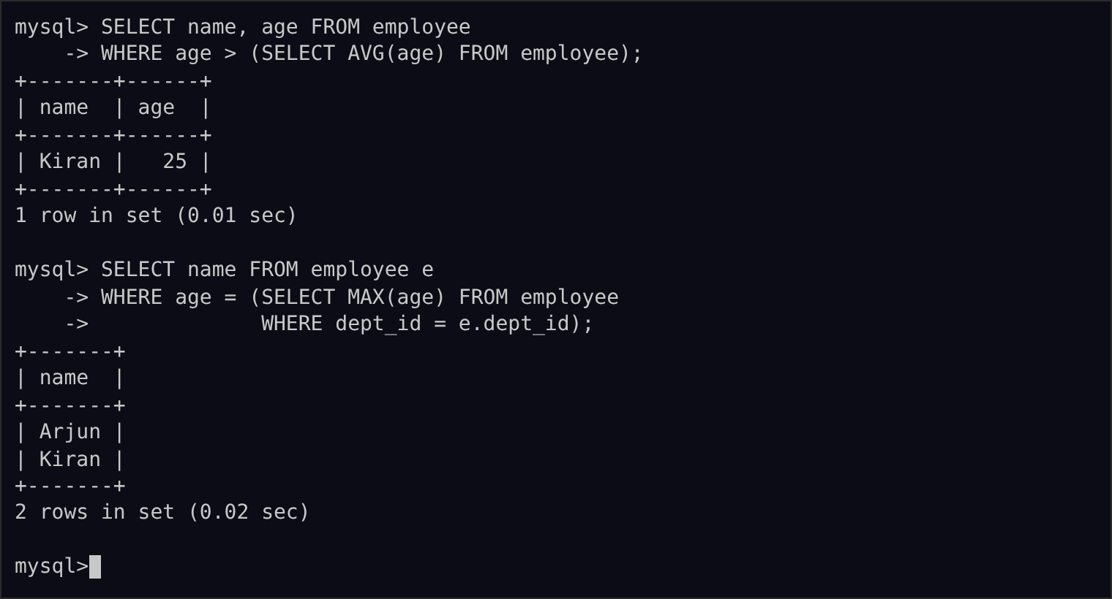

Experiment 11: Query with Joins – EquiJoin, InnerJoin, OuterJoin
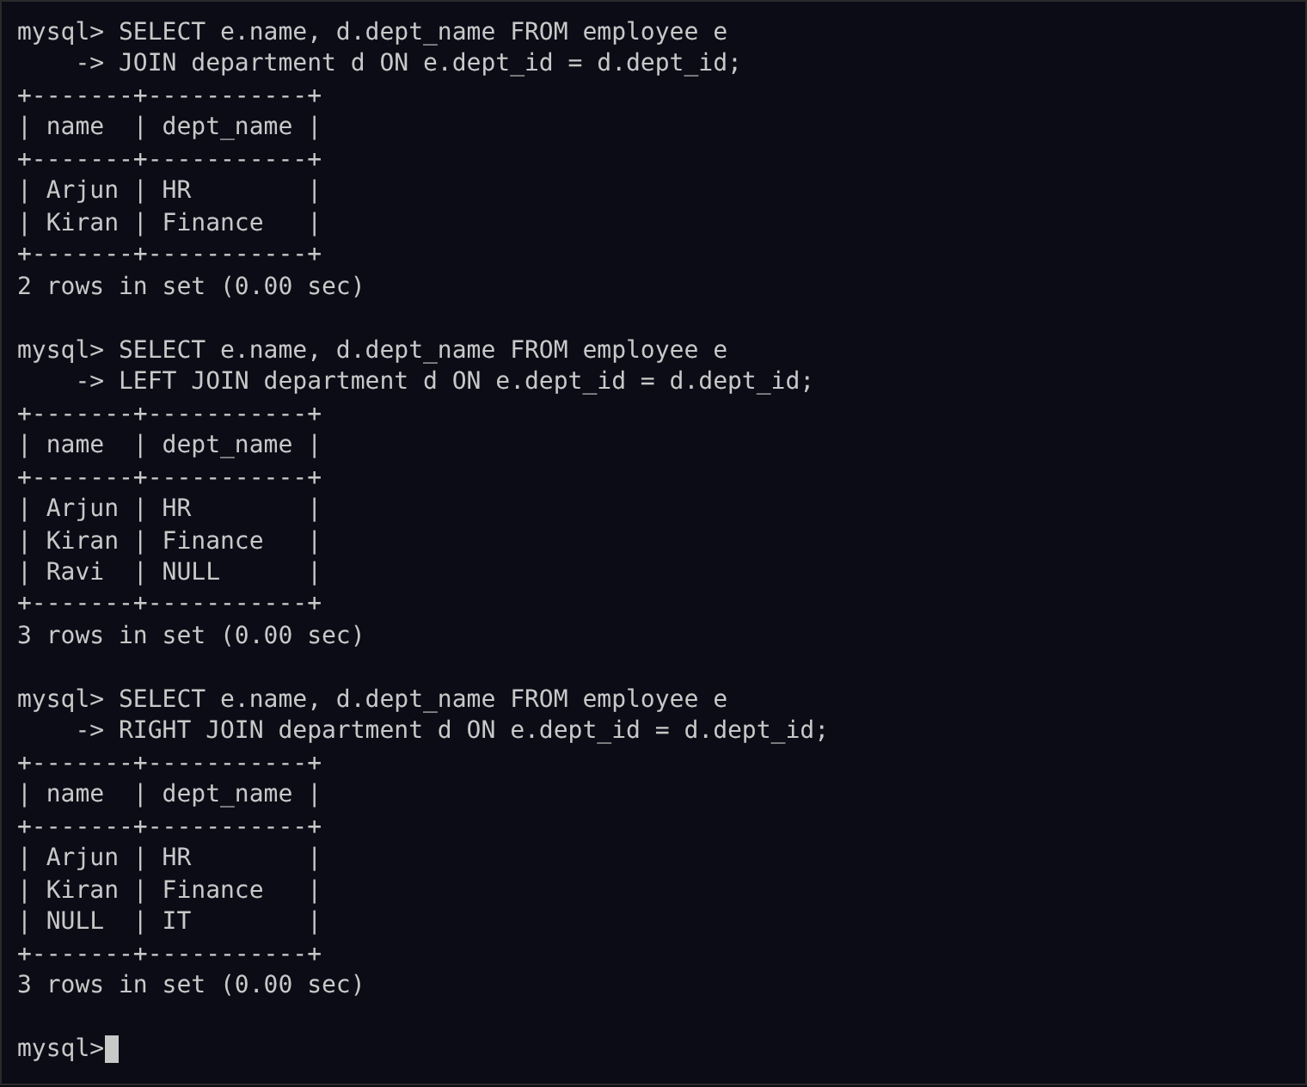

Experiment 12: Query with VIEW and INDEX
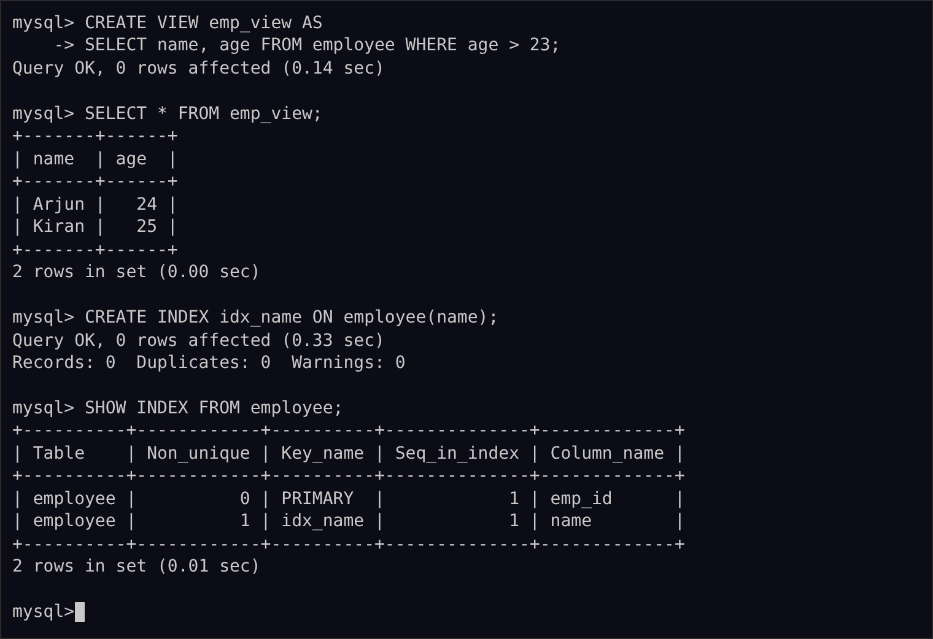

Experiment 13: Query with AUTO_INCREMENT SEQUENCES
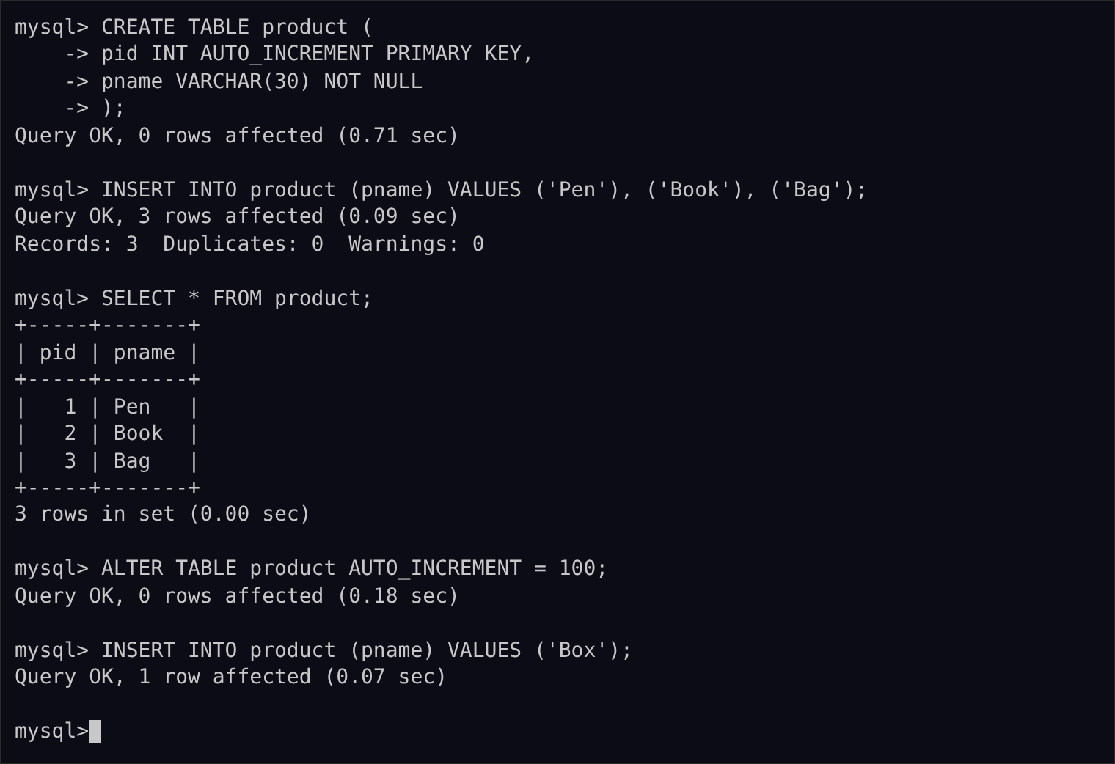

Experiment 14: Simple programming using REPEAT and WHILE
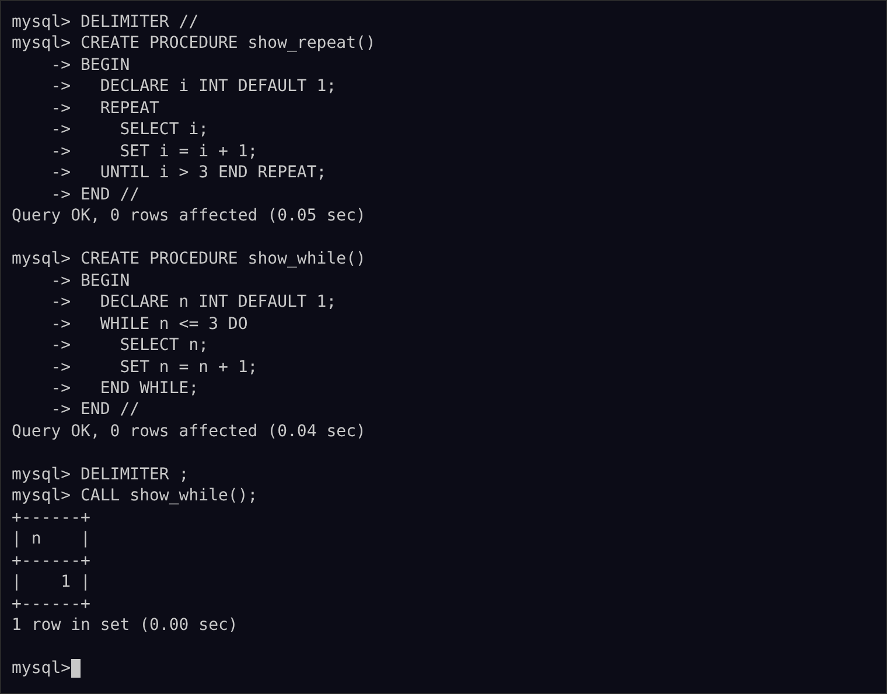

Experiment 15: Simple programming using CASE and LOOP
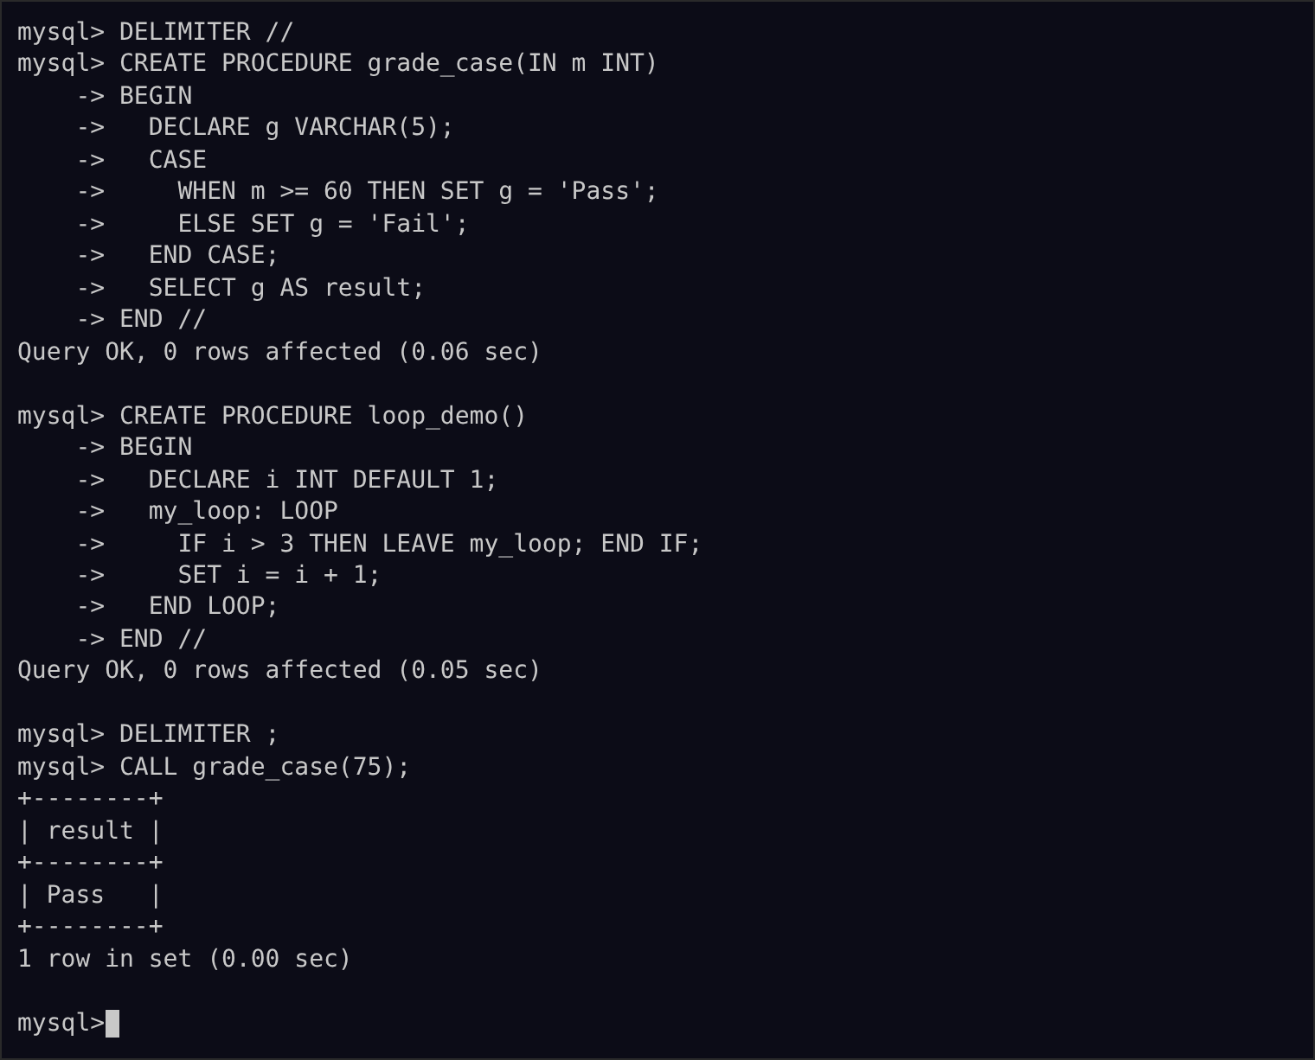

Experiment 16: High Level Programming Extensions – Procedures
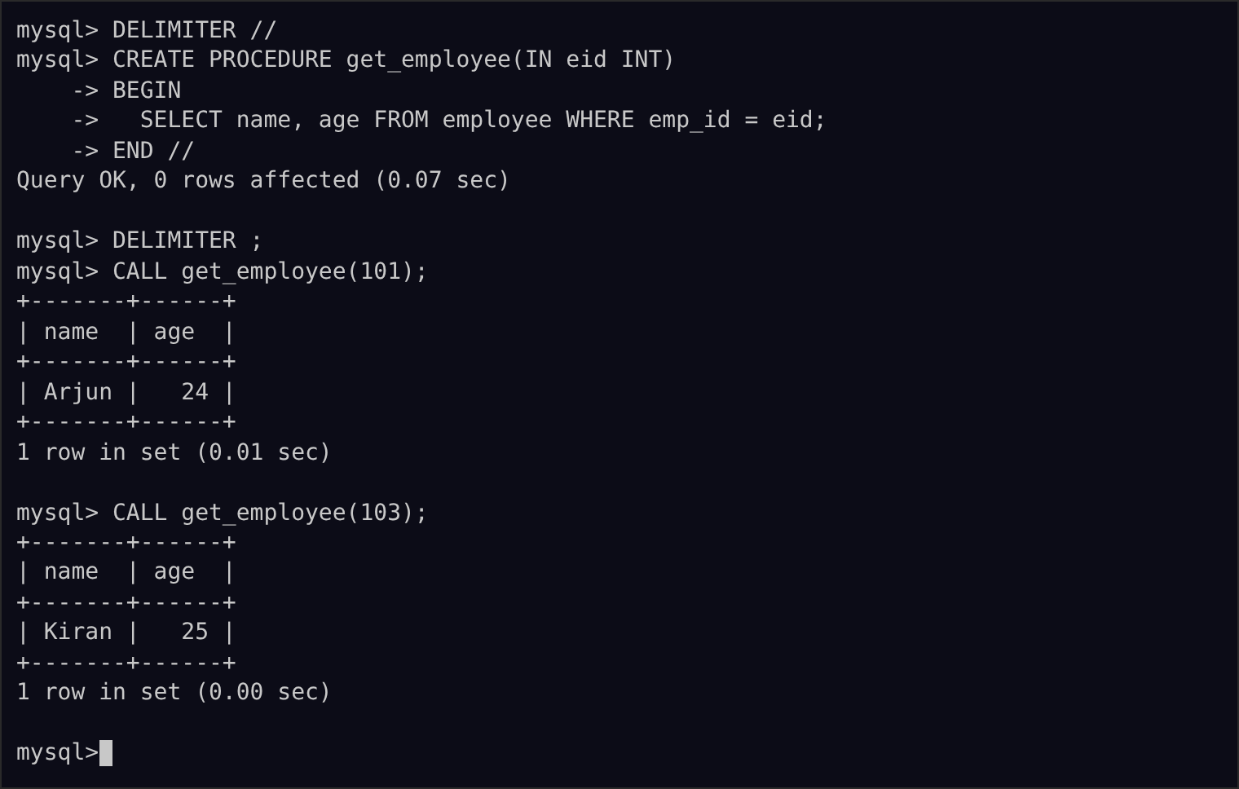

Experiment 17: High Level Programming Extensions – Function
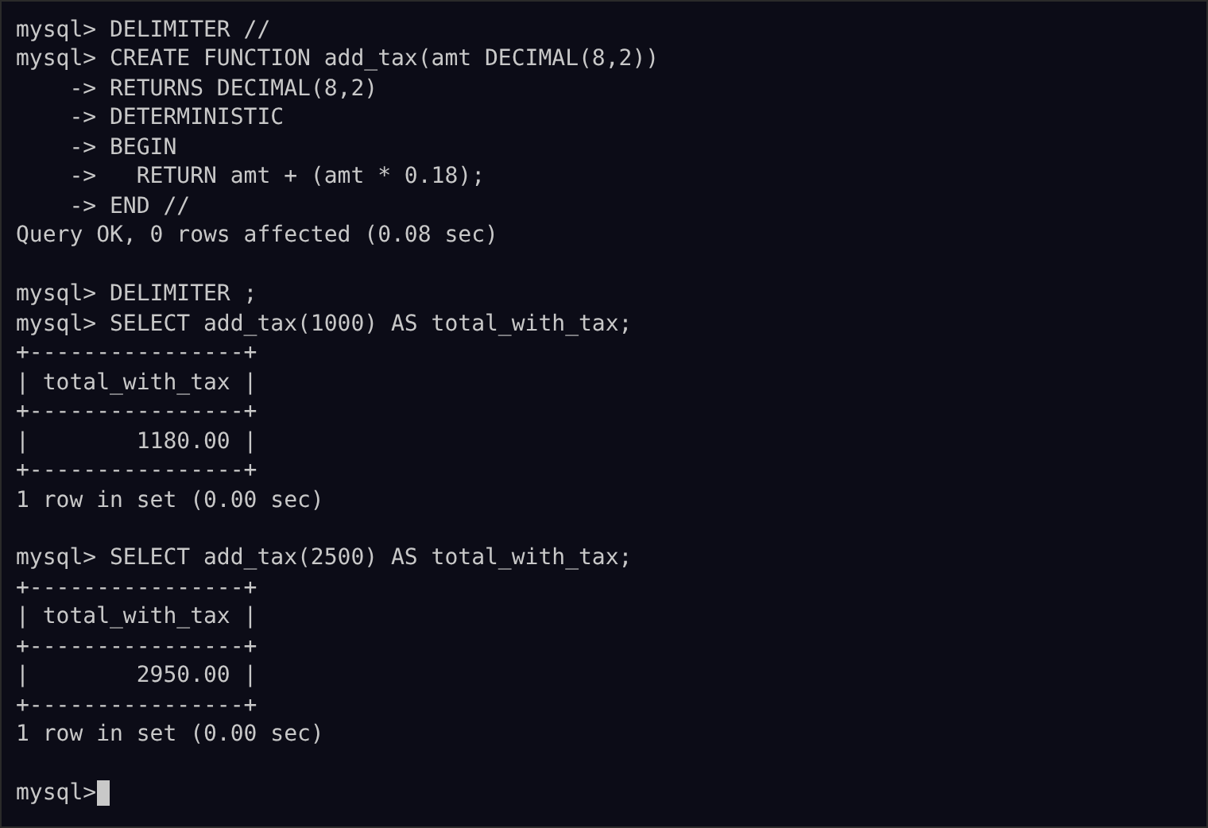

Experiment 18: High Level Programming Extensions – Cursors
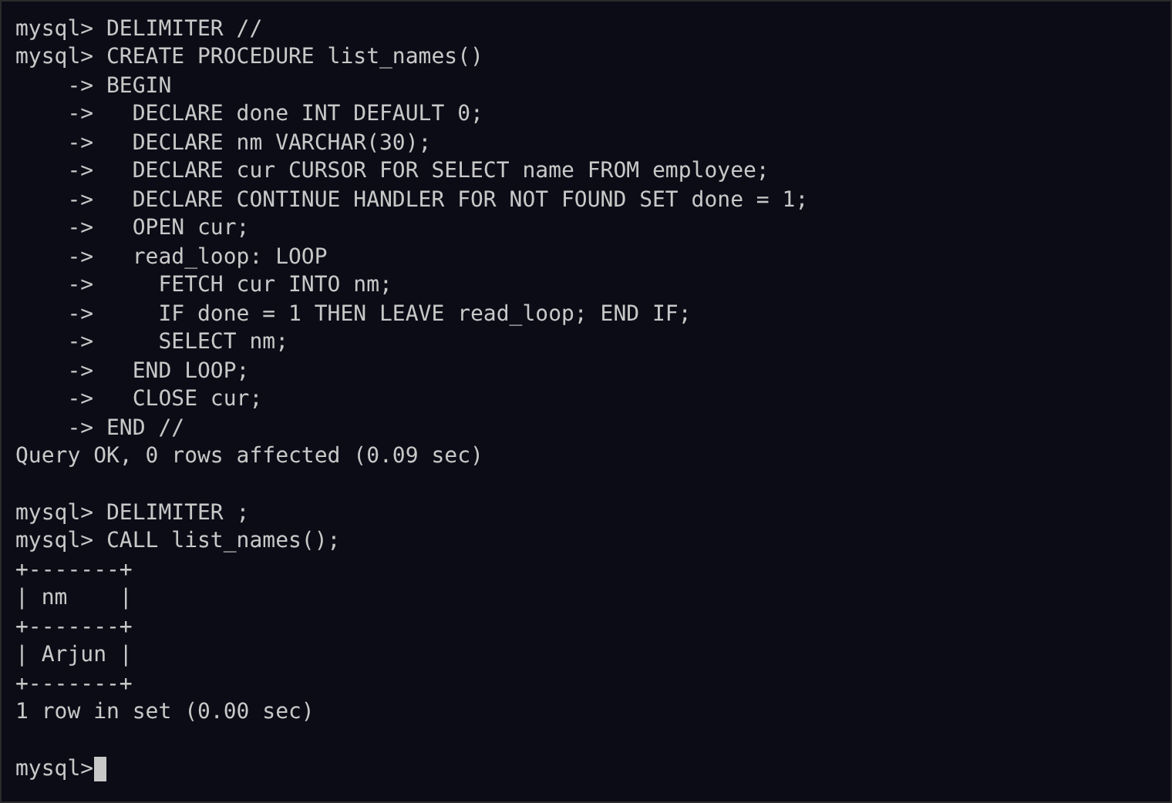

Experiment 19: High Level Programming Extensions – Triggers
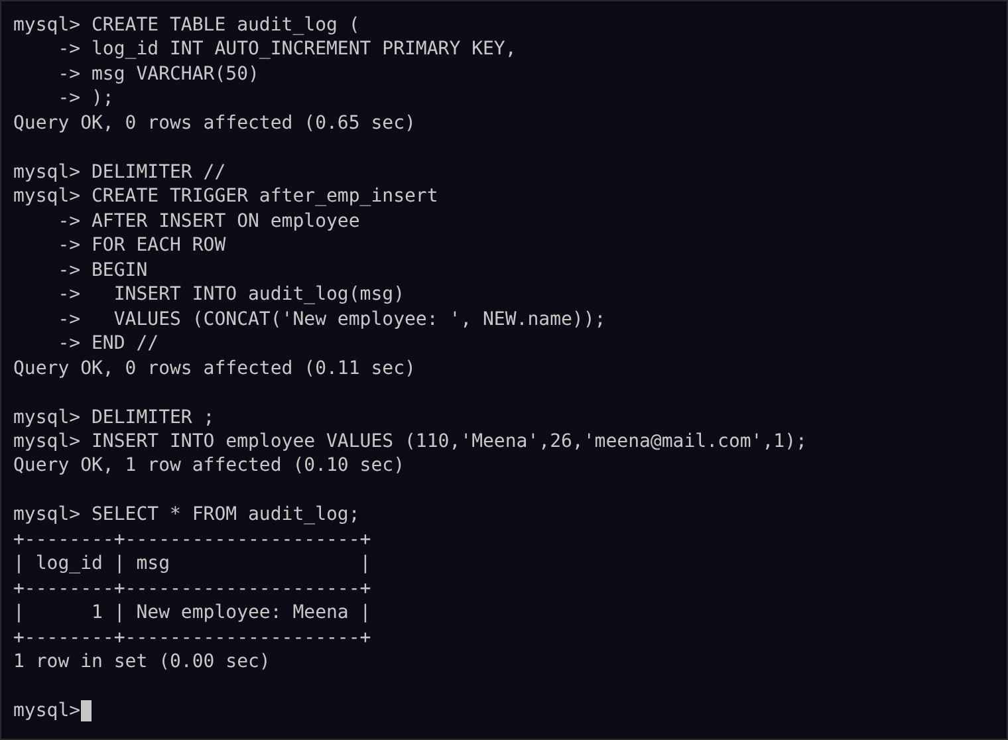

Experiment 20: MySQL String Functions – REPLACE, REPEAT, REVERSE, RIGHT, LEFT, RPAD, LPAD
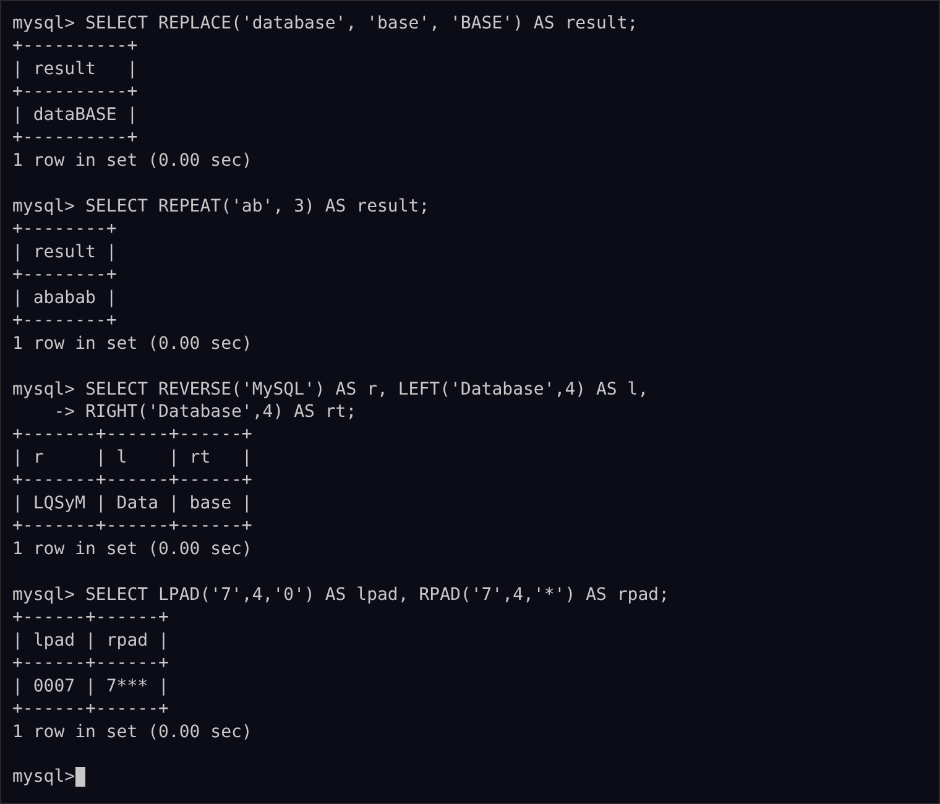

Experiment 21: MySQL String Functions – SPACE, SUBSTR, UPPER, LOWER, TRIM, LENGTH
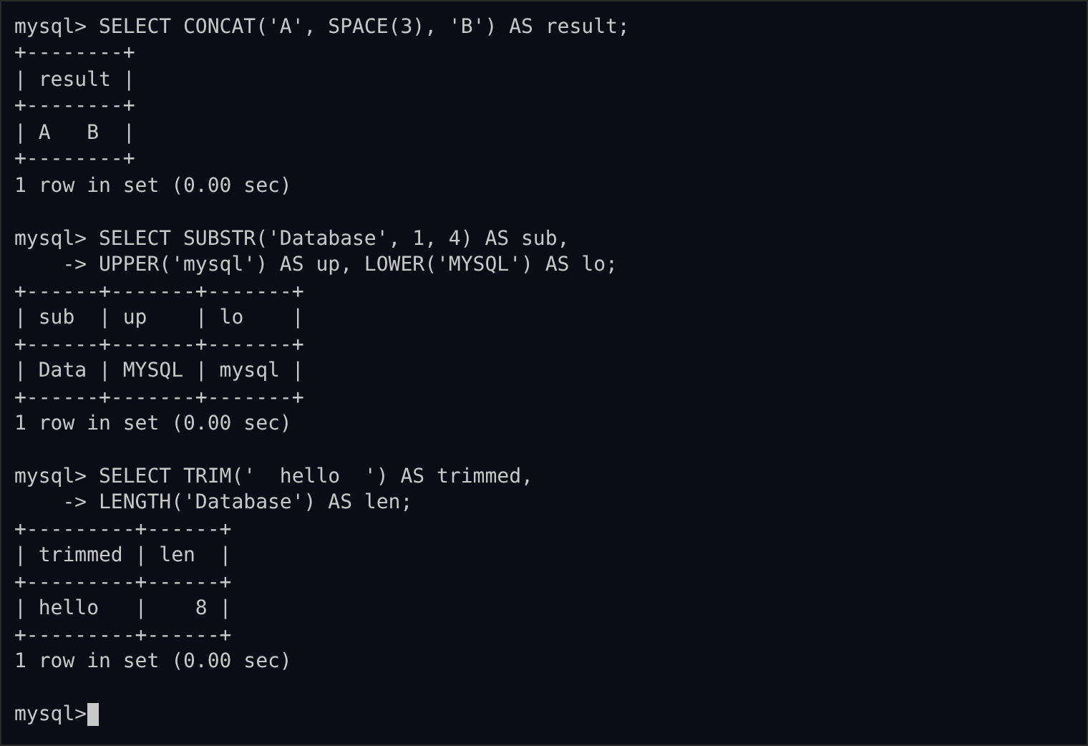

Experiment 22: Database Connectivity Using PHP and MySQL
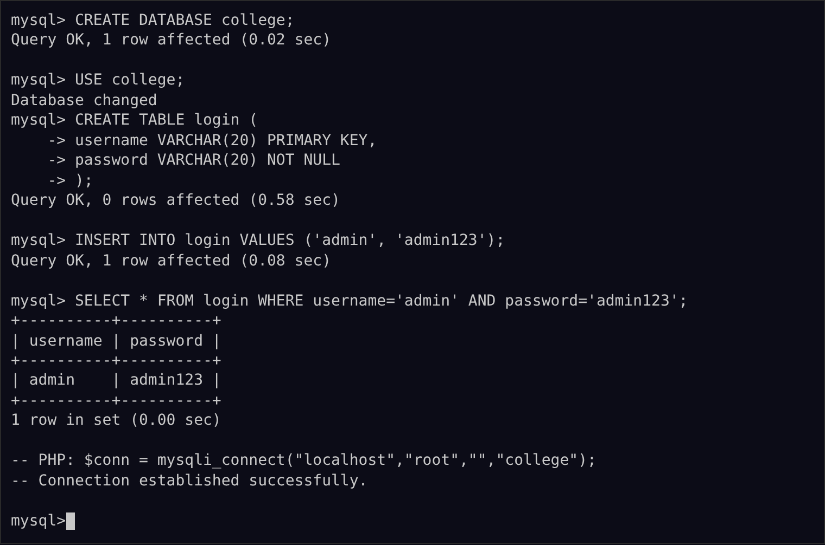

Experiment 23: Case Scenario: Train Ticket Reservation System
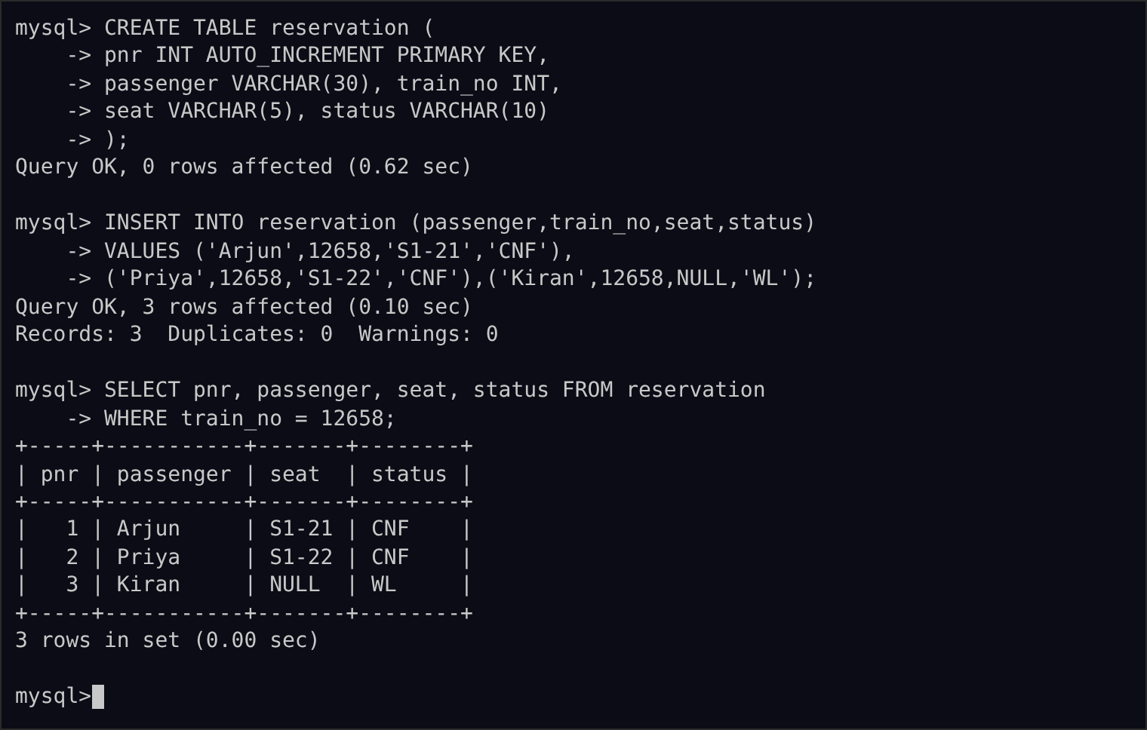

Experiment 24: Case Scenario: College Admission Form
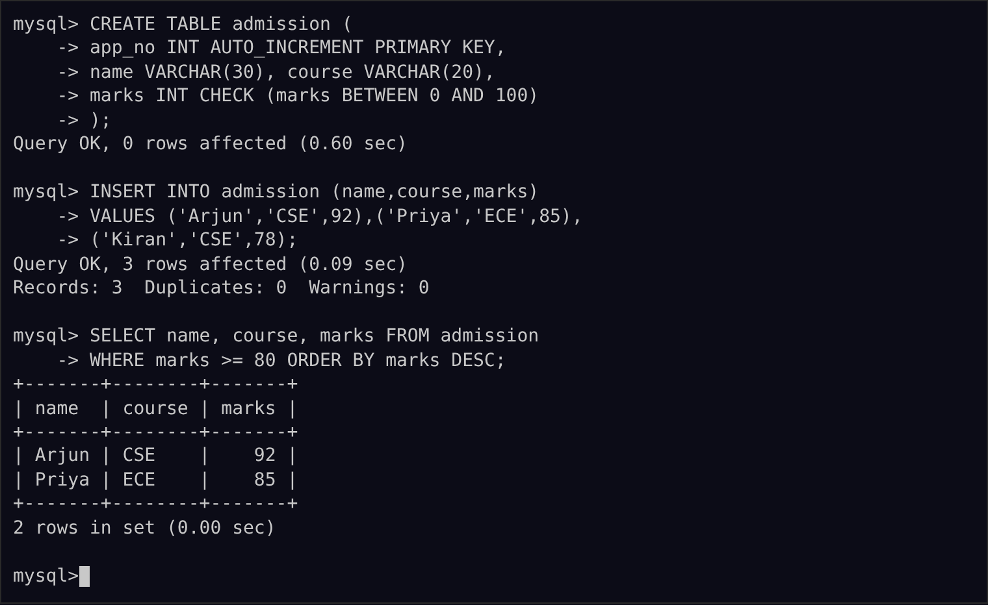

Experiment 25: Case Scenario: QR Enabled Automatic Bus Ticket Booking System
