Conversational Expense Tracker Platform
Enterprise Architecture & Capability Overview
Document date: August 18, 2026
Classification: Internal — Technical Overview
Repository: expense-tracker-bot

1. Executive Summary
The Conversational Expense Tracker Platform is a production-grade, chat-driven personal finance assistant. Authorized users interact in natural language via Telegram; the system interprets intent, extracts structured expense data using a large language model (LLM), persists records to a configurable ledger, and answers analytical questions such as category totals, date-range spend, and period-over-period comparisons.
The solution is designed with enterprise software patterns—layered architecture, provider abstraction, typed configuration, comprehensive automated testing, and observable audit trails—while remaining lightweight to deploy on free-tier or self-hosted infrastructure.

1.1 Business Capabilities
- Log expenses from conversational messages (e.g., “spent $42 on groceries today”).
- Query historical spend by category, date, or natural-language filters.
- Generate summaries (week, month, year) with optional comparisons to prior periods.
- Correct entries via undo and edit commands with ledger consistency.
- Multi-currency support with automatic foreign-exchange conversion where configured.

1.2 Design Principles
- Secure by default — explicit user allow-list; no anonymous public access.
- Auditable — every chat turn and LLM invocation is traceable in append-only logs.
- Storage-agnostic — one ledger interface; switch Google Sheets or Postgres with a single setting.
- Provider-agnostic LLM — Groq, OpenAI, Anthropic, or local Ollama without rewriting business logic.
- Fail gracefully — user-facing errors are plain language; stack traces never surface in chat.

2. System Architecture
The platform follows a five-layer architecture. Each layer exposes narrow interfaces so that presentation, orchestration, intelligence, and persistence can evolve independently.
Layer | Responsibility | Key modules
Presentation | Telegram gateway, command handlers, health checks, access control | telegram_app/
Orchestration | End-to-end chat pipeline: classify → act → reply; write/read/correct paths | pipeline/
Intelligence | Intent classification, structured JSON extraction, category vocabulary | extractor/ · llm/
Persistence | Ledger abstraction; Sheets or Postgres backends; FX and workbook builders | ledger/
Observability | Conversation history and LLM call traces for debugging and audit | storage/

2.1 Architecture Diagram
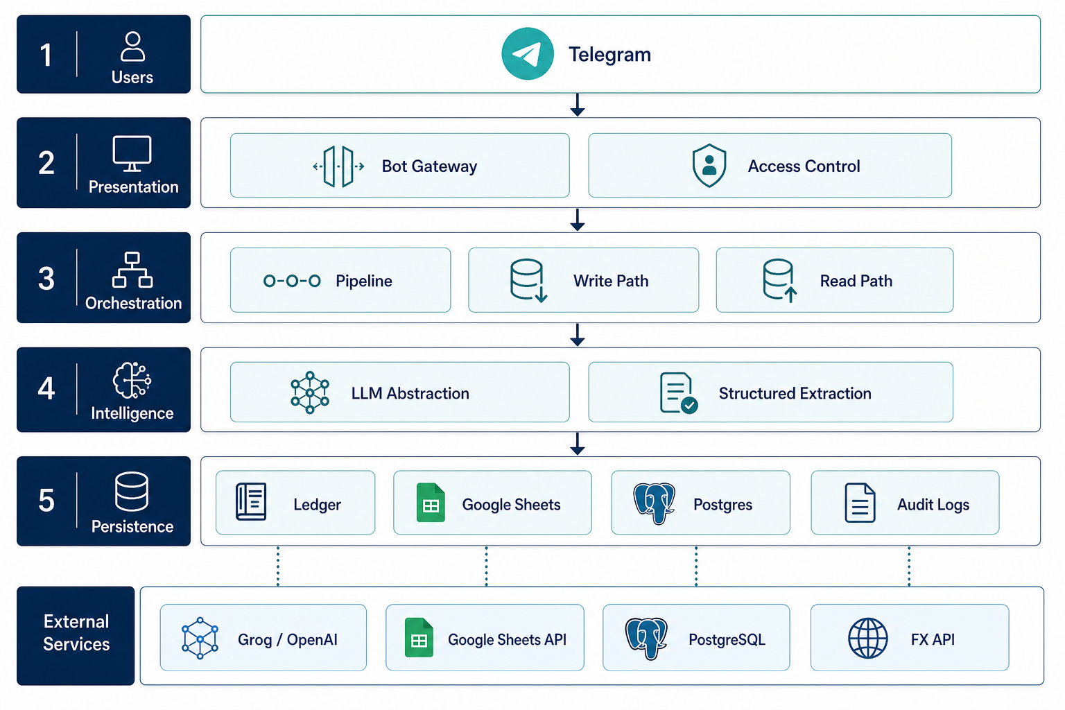
Figure 1 — Platform architecture (high level)

An editable Mermaid source is maintained at docs/company/architecture-diagram.mmd for Confluence, GitHub, or presentation exports (PNG/SVG via mermaid.live).

2.2 Request Flow (Log Expense)
- 1. User sends a natural-language message on Telegram.
- 2. Presentation layer validates the sender against the configured allow-list.
- 3. Orchestration invokes the extractor to classify intent and parse structured fields.
- 4. LLM abstraction calls the configured provider (JSON-mode, temperature-controlled).
- 5. Write path maps extracted fields to ledger rows (category, amount, date, currency).
- 6. Optional FX conversion normalizes amounts to a base currency.
- 7. Ledger backend persists the transaction (Google Sheets tab or Postgres row).
- 8. A conversational confirmation is returned; the full turn is logged for audit.

2.3 Request Flow (Query / Summary)
For query intents, the orchestration layer routes to the retrieval engine, which reads from the active ledger backend, applies filters derived from the user’s question, aggregates results, and formats a natural-language reply. No write operations occur on the query path.

3. Component Overview

3.1 Telegram Front-End
Built on the python-telegram-bot SDK. Handles inbound messages, slash commands (/undo, /edit), and exposes a minimal HTTP /health endpoint for platform health checks (Render, systemd, Docker).

3.2 Conversation Pipeline
Central orchestrator composing extraction, logging, retrieval, summary, correction, and reply formatting. Ensures one user message produces one persisted conversation turn with complete action metadata.

3.3 LLM & Extraction
Multi-provider LLM factory with retries, timeouts, JSON repair, and structured tracing. Default production configuration uses Groq Cloud (openai/gpt-oss-20b) on the free tier; providers are swappable via environment configuration without code changes.

3.4 Ledger Backends
Edition | Use case | Technology
Google Sheets (default) | Zero infrastructure; mobile-friendly spreadsheet view | Google Sheets API · service account
Postgres / NocoDB | Typed schema, audit log, soft-delete, long-term scale | PostgreSQL · SQLAlchemy · Alembic · NocoDB UI
Mirror (roadmap) | Sheets for daily use + Postgres for durable backup/analytics | Dual-write reconciliation

4. Security & Governance
Control | Implementation
Authentication | Telegram user ID allow-list (deny-all when unset)
Secrets | Environment variables / .env — never committed to source control
Least privilege | Google service account scoped to one spreadsheet; DB role limited to app schema
Data isolation | Single-tenant personal ledger per deployment instance
Observability | JSONL logs for conversations and LLM calls (local or mounted volume)
Failure handling | Errors contained in pipeline; no sensitive data in user replies

5. Deployment Options
Target | Profile | Notes
Render Free | Managed Docker, 24/7 with keep-alive | Recommended starter; Sheets edition
Oracle Cloud Free VM | systemd self-hosted | Full control; Sheets or NocoDB stack
Docker | Portable container | Multi-stage Dockerfile included
Local CLI | Development / offline | Ollama provider; fake LLM for tests
Continuous integration runs automated tests (Python 3.10–3.12), linting, and Dockerfile validation on every push via GitHub Actions.

6. Technology Stack
Category | Technologies
Language | Python 3.10+
Chat interface | Telegram Bot API · python-telegram-bot
LLM integration | Groq SDK · OpenAI-compatible clients · LiteLLM-ready patterns
Sheets ledger | gspread · Google service account
Postgres ledger | SQLAlchemy 2 · Alembic · NocoDB
Configuration | pydantic-settings (typed, validated env)
Testing | pytest (~500+ hermetic unit tests)
Packaging | pyproject.toml · Docker multi-stage build

7. Quality Assurance
- Hermetic unit tests with fake LLM and in-memory ledger backends.
- Module-level test coverage across extractor, pipeline, ledger, and Telegram auth.
- Structured JSON schemas validated on every LLM extraction response.
- Self-healing sheet format rebuilders for monthly/year/YTD workbook consistency.

8. Evolution & Roadmap
- Mirror storage edition — dual-write Sheets + Postgres with reconciliation.
- Additional LLM providers and cost-aware routing.
- Enhanced analytics exports from Postgres ledger.

Appendix A — Diagram Source
Mermaid source file: docs/company/architecture-diagram.mmd
To export for presentations:
1. Open https://mermaid.live
2. Paste the contents of architecture-diagram.mmd
3. Export as PNG or SVG
4. Insert into PowerPoint or this document as needed.

Appendix B — Related Documentation
- docs/HANDBOOK.md — Full operational setup and module reference
- docs/ARCHITECTURE.md — Developer module map
- docs/MASTER_GUIDE.md — Deployment history and runbooks
- README.md — Repository entry point
— End of document — Generated for internal technical communication. Operational details may change; refer to the repository for the latest configuration.

