**ReadMe**

**E-Commerce Platform using Java Spring**

**Overview**

This project is a comprehensive e-commerce platform developed using the Java Spring framework. It aims to provide users with a seamless and secure online shopping experience, incorporating key functionalities such as user authentication, product catalog management, shopping cart operations, and secure payment processing.

**Features**

1. User Authentication:

- Secure user registration and login processes.

- Password recovery and account verification mechanisms.

2. Product Catalog Management:

- Admin capabilities for adding, updating, and deleting products.

- User-friendly product browsing with filtering options.

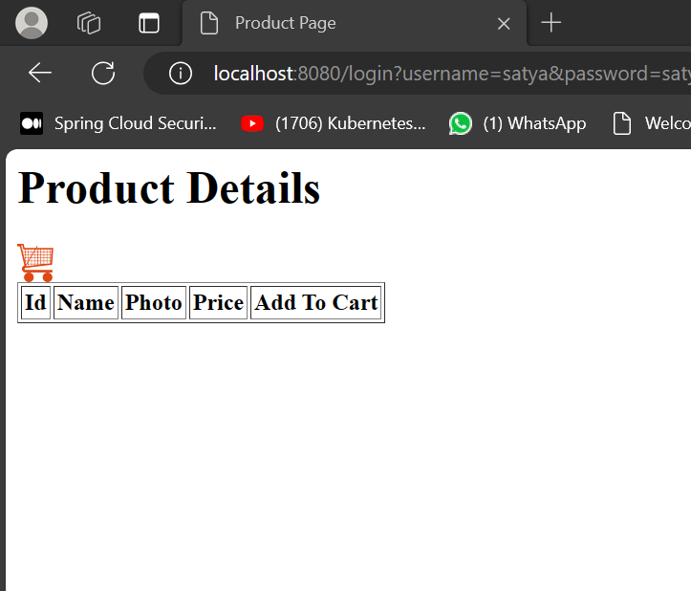

<http://localhost:8080/h2-console/>

Password: password.

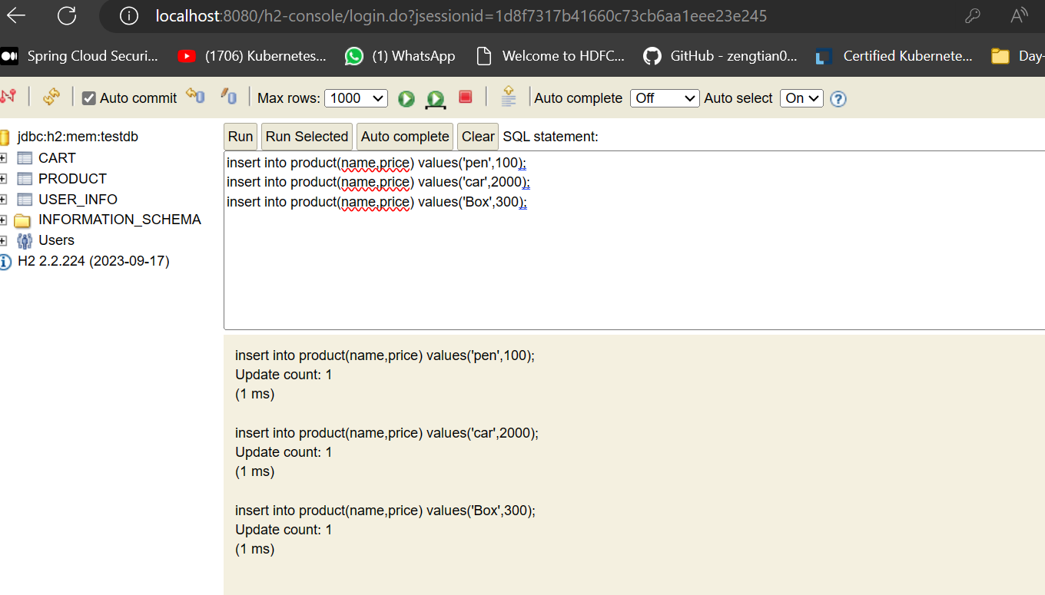

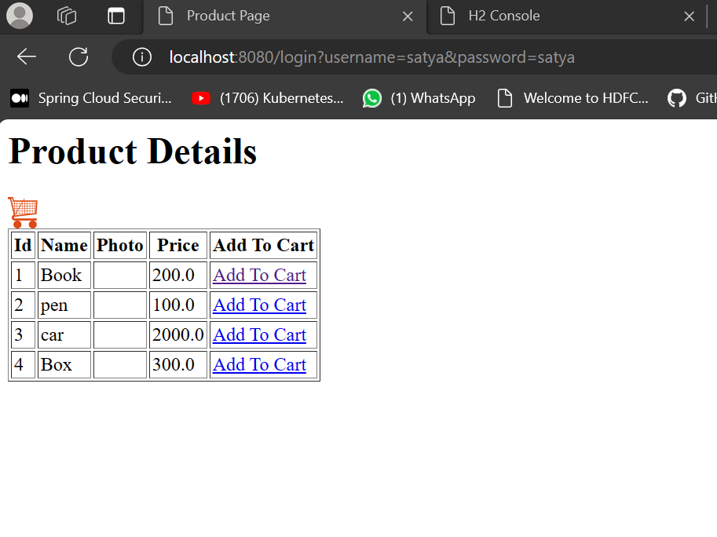s

3. Shopping Cart Operations:

- Intuitive addition and removal of items from the shopping cart.

- Clear display of selected items and total cost.

4. Secure Payment Processing:

- Integration with a reliable payment gateway.

- Confirmation of successful transactions.

5. Java Spring Features:

- Leveraging dependency injection for loose coupling.

- Utilizing Spring MVC for responsive and user-friendly web development.

- Applying aspect-oriented programming for cross-cutting concerns.

6. Integration of Design Patterns:

- Factory Method pattern for creating product objects.

- Observer pattern for real-time updates in the shopping cart.

**System Architecture**

The project follows the Model-View-Controller (MVC) architectural pattern provided by Java Spring. Dependency Injection (DI) is used for loose coupling, and Aspect-Oriented Programming (AOP) modularizes cross-cutting concerns.

**Getting Started**

1. Prerequisites:

- Java Development Kit (JDK) installed.

- Maven for dependency management.

2. Installation:

```bash

*git clone https://github.com/vinay3099/CPSC_61200_WK8_PHASE_4.git*

*cd ecommerce*

*mvn clean install*

```

3. Run the Application:

```bash

java -jar target/e-commerce-1.0.jar

```

4. Access the Application:

Open a web browser and go to <http://localhost:8080/registration>

**Security Measures**

The application incorporates secure coding practices, and Spring Security is employed to ensure a secure platform. Passwords are encrypted, and user sessions are managed securely.