MediCluster
Patient Health Risk Segregation Platform
Comprehensive Technical Report | Version 1.0 | May 2026

1. SYSTEM ARCHITECTURE
MediCluster follows a modern three-tier microservices architecture with a React frontend, Node.js API gateway, and Python ML engine.
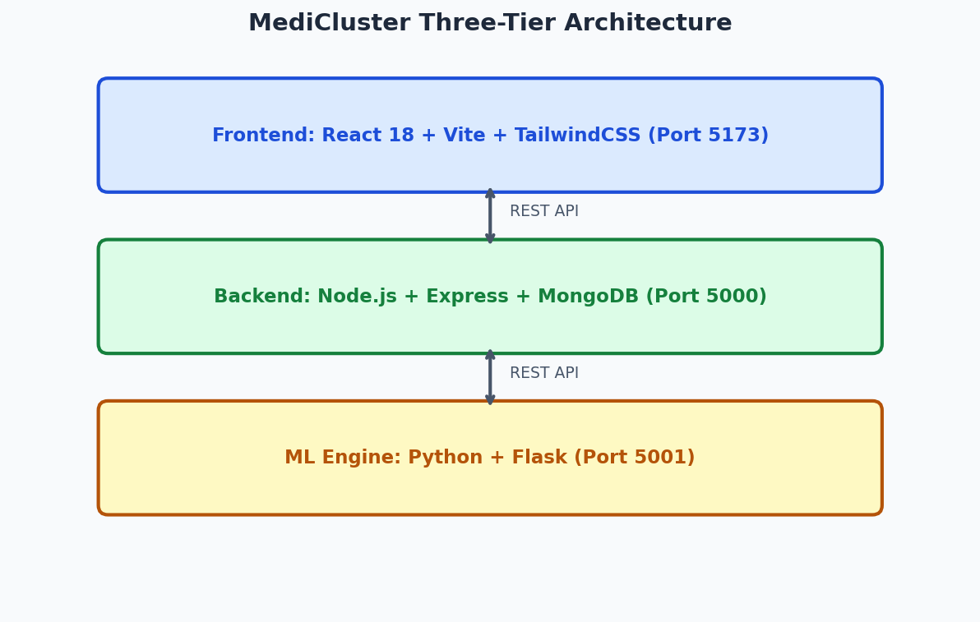

2. RISK SCORING SYSTEM
The Advanced Risk module classifies patients into 4 tiers using a composite clinical scoring engine based on vital signs, lab values, comorbidities, and free-text clinical notes.
Risk Tier | Score Range | Triage Priority | Action
Low | 0-24 | P4 - Routine | Standard monitoring
Moderate | 25-49 | P3 - Soon | Follow-up review
High | 50-74 | P2 - Urgent | Same-day doctor review
Critical | 75-100 | P1 - Immediate | Emergency response

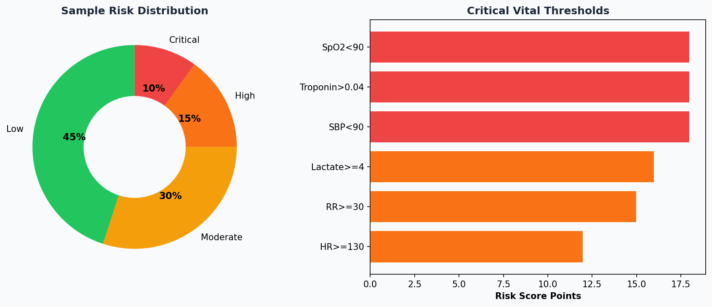

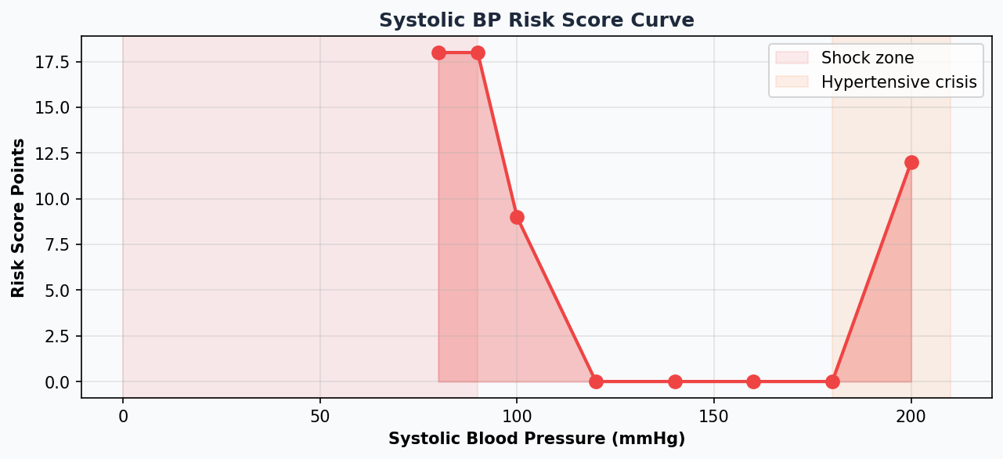

3. CLUSTERING ALGORITHMS
MediCluster supports four clustering algorithms, each suited for different clinical data patterns.
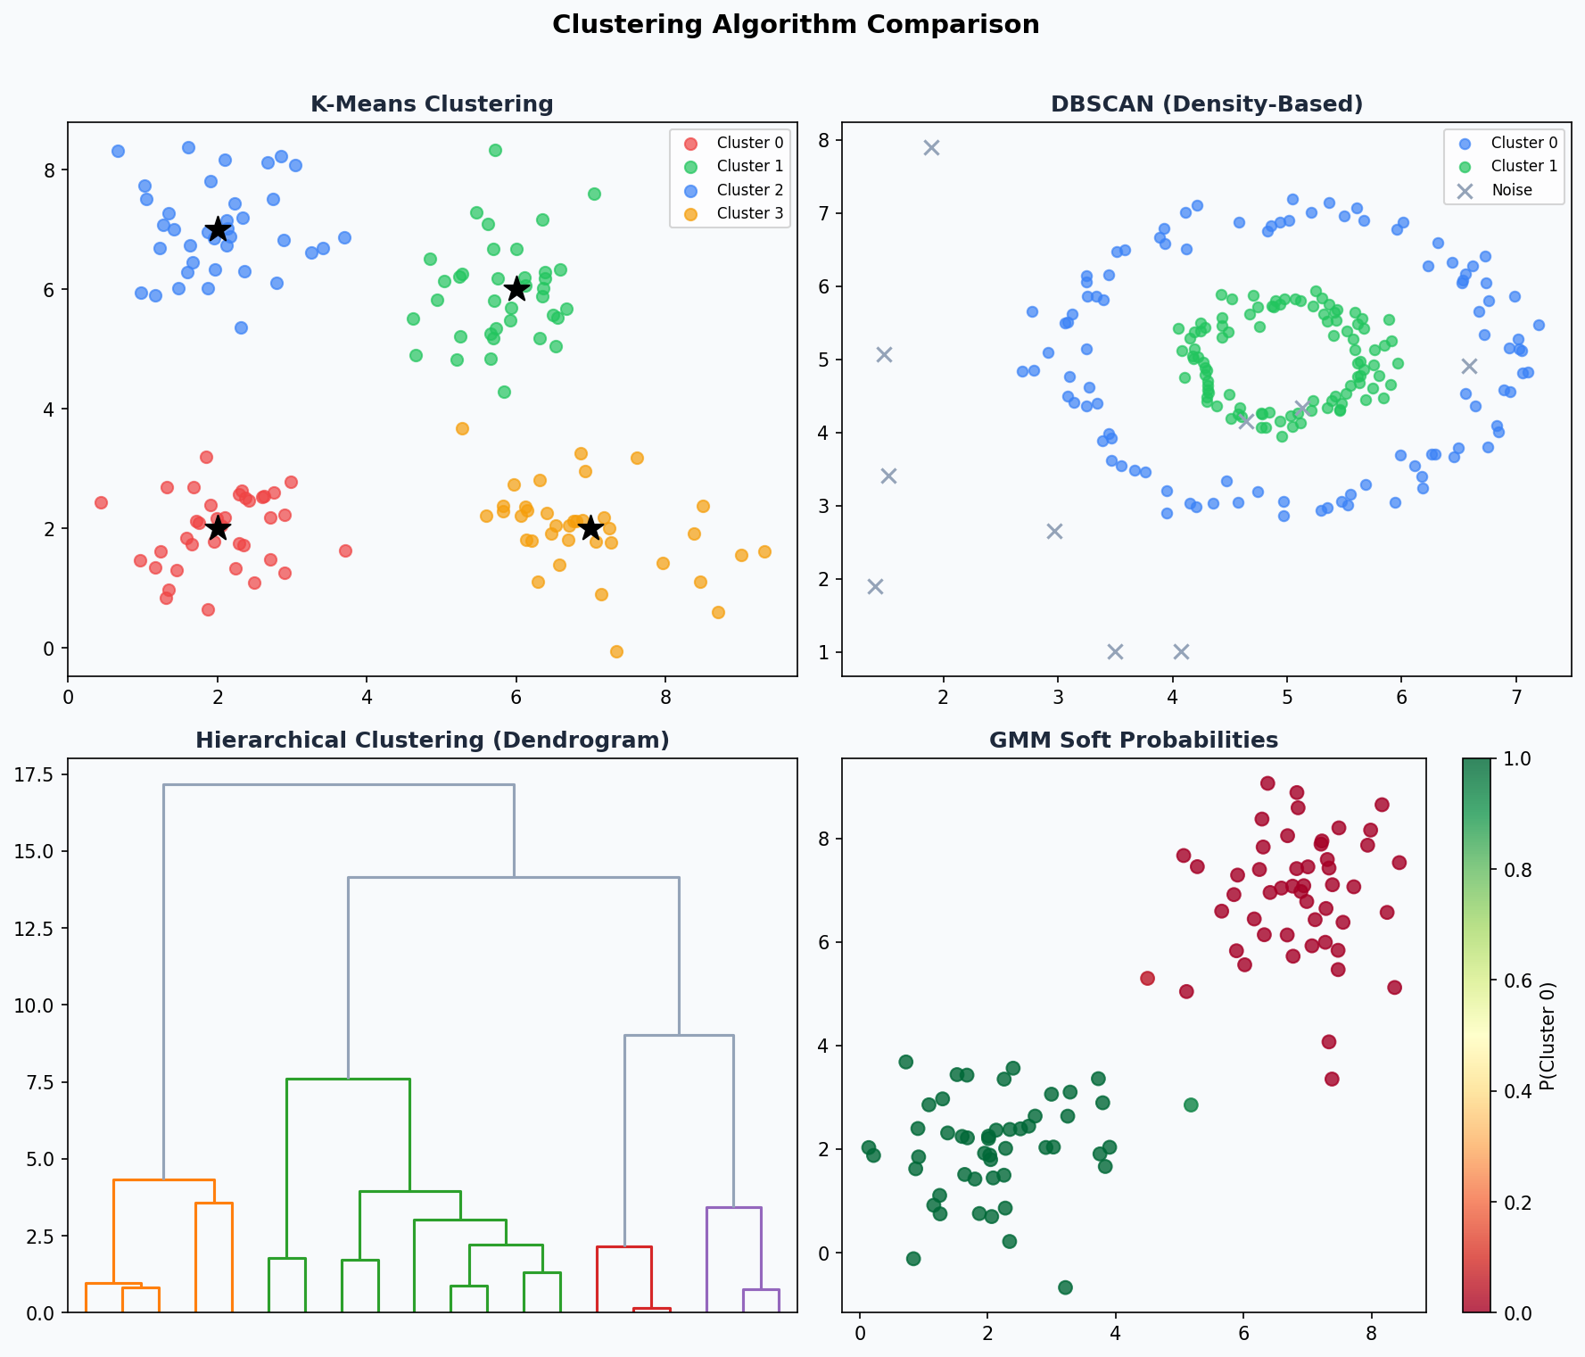

Algorithm | Best For | Key Parameter | Detects Noise?
K-Means | Large, spherical clusters | K (num clusters) | No
DBSCAN | Arbitrary shapes, outliers | eps, min_samples | Yes
Hierarchical | Unknown K, tree analysis | n_clusters, linkage | No
GMM | Soft assignments, uncertainty | n_components, cov_type | No

4. NLP CLINICAL NOTES ANALYZER
The NLP module processes free-text clinical notes using an 18-step pipeline combining SpaCy biomedical NER, regex patterns, and HuggingFace Transformers.
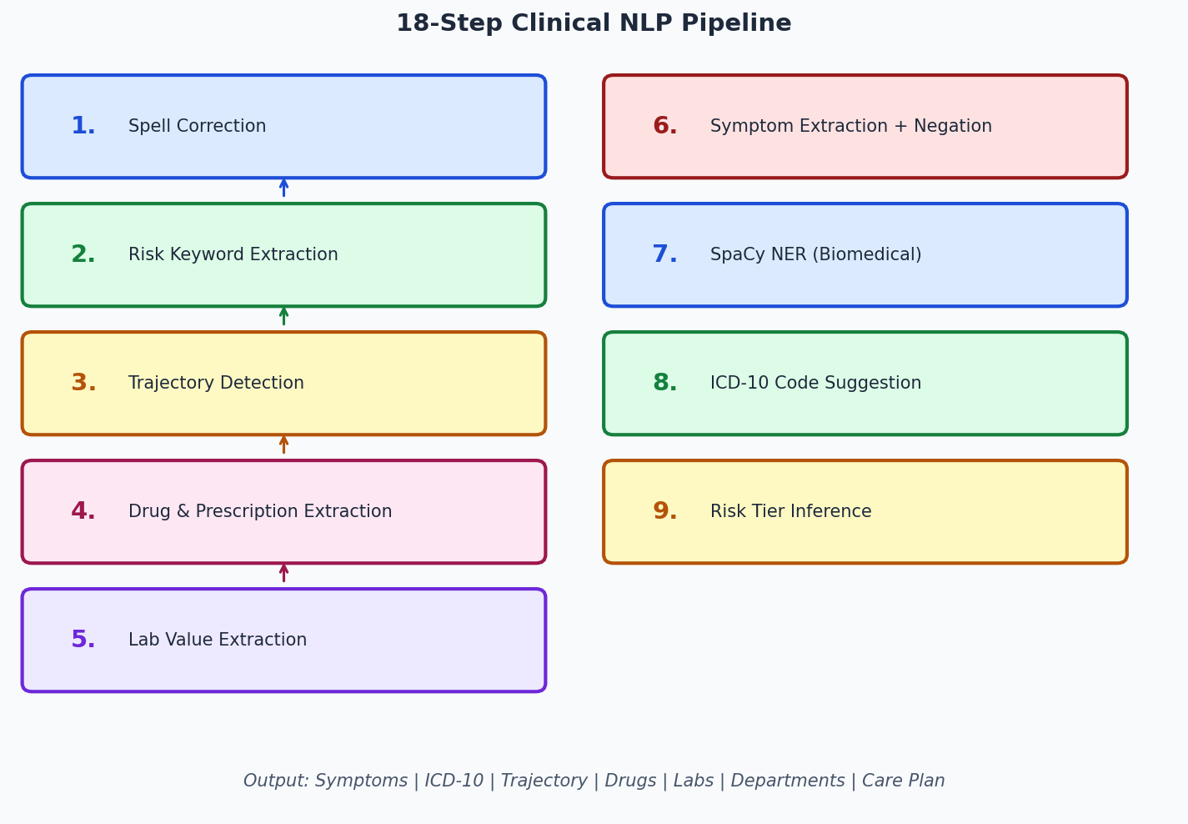

Keyword | ICD-10 Code | Description
pneumonia | J18.9 | Pneumonia, unspecified organism
sepsis | A41.9 | Sepsis, unspecified organism
heart failure | I50.9 | Heart failure, unspecified
myocardial infarction | I21.9 | Acute MI, unspecified
diabetes | E11.9 | Type 2 diabetes without complications
stroke | I63.9 | Cerebral infarction, unspecified
pulmonary embolism | I26.99 | PE without cor pulmonale
acute kidney injury | N17.9 | Acute kidney failure, unspecified
copd | J44.9 | COPD, unspecified
hypertension | I10 | Essential hypertension

5. VITAL SIGNS FORECASTING (LSTM + PROPHET + MEWS)
The forecasting module predicts future vital sign values and calculates the Modified Early Warning Score (MEWS) for deterioration risk.
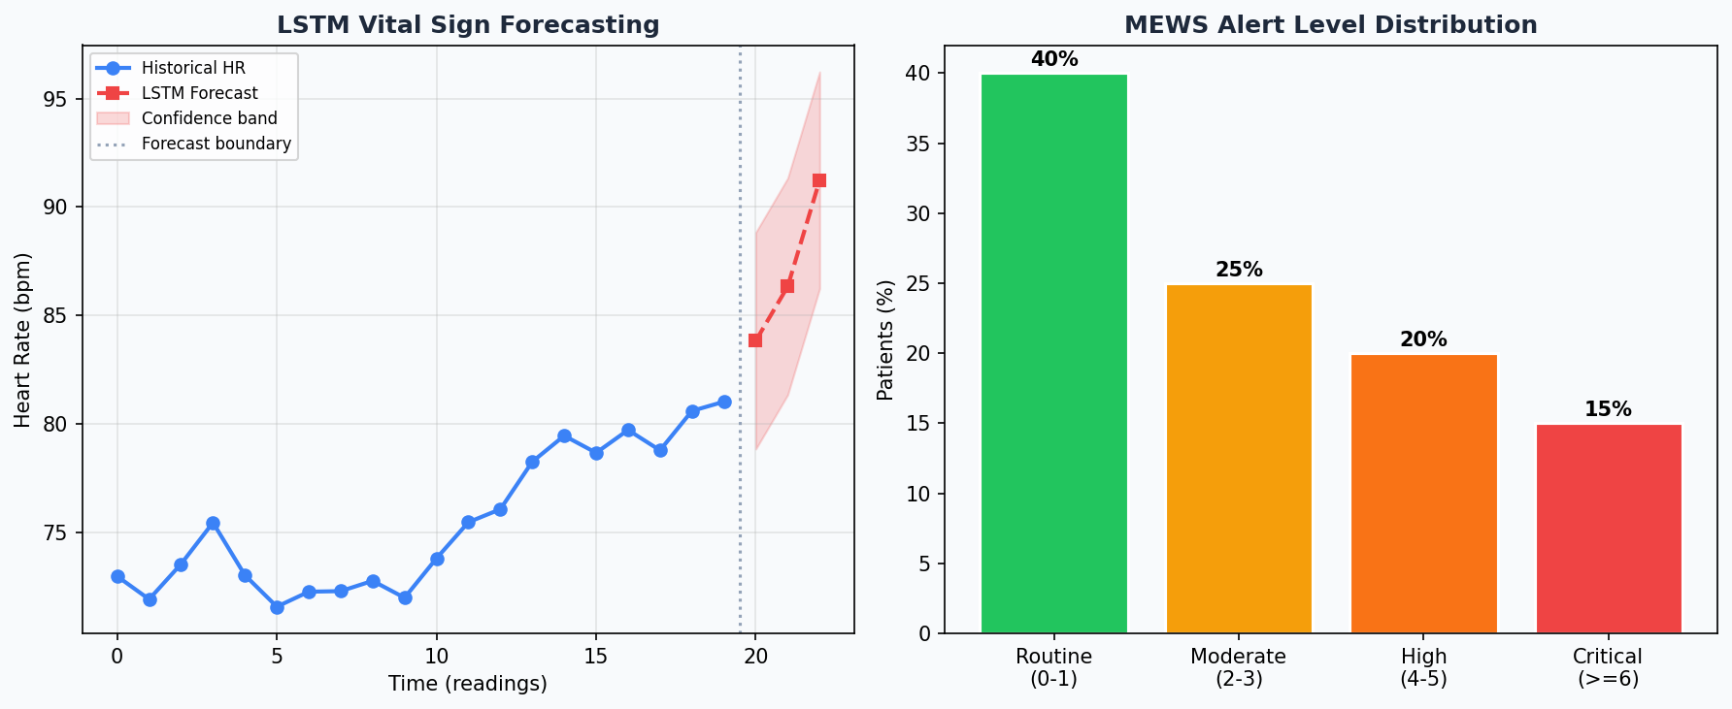

MEWS Score | Alert Level | Action Required
0-1 | Low | Routine monitoring every 12 hours
2-3 | Moderate | Increased monitoring every 4 hours, notify charge nurse
4-5 | High | Urgent medical review within 30 minutes
6+ | Critical | IMMEDIATE medical emergency response

6. MEDICAL IMAGING AI (CHEST X-RAY)
MediCluster uses 5 pre-trained deep CNN models from TorchXRayVision for chest X-ray pathology detection. The default model (CheXNet) was trained on 224,000 expert-labeled Stanford CheXpert images.
Model | Architecture | Training Data | Input Size
densenet121-res224-chex (DEFAULT) | DenseNet-121 | Stanford CheXpert (224k) | 224x224
densenet121-res224-all | DenseNet-121 | CheXpert+NIH+MIMIC+PadChest | 224x224
resnet50-res512-all | ResNet-50 | All datasets (high-res) | 512x512
densenet121-res224-nih | DenseNet-121 | NIH ChestX-ray14 | 224x224
densenet121-res224-pc | DenseNet-121 | PadChest (widest range) | 224x224

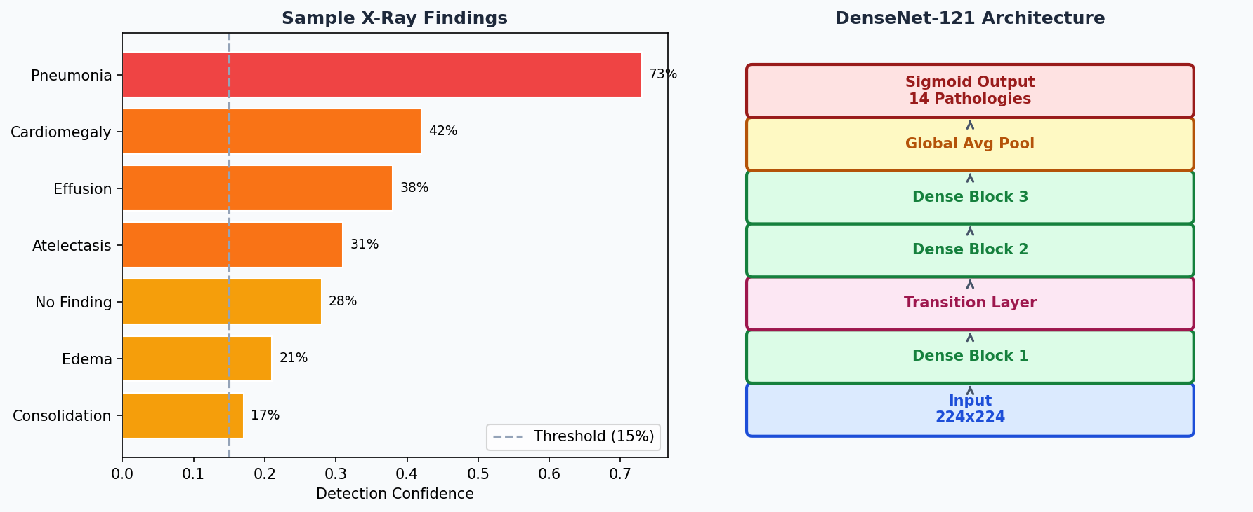

7. SHAP EXPLAINABILITY
SHAP (SHapley Additive exPlanations) explains why each patient was assigned to their cluster. A Ridge regression proxy is trained on cluster labels, then SHAP LinearExplainer computes per-feature contributions.
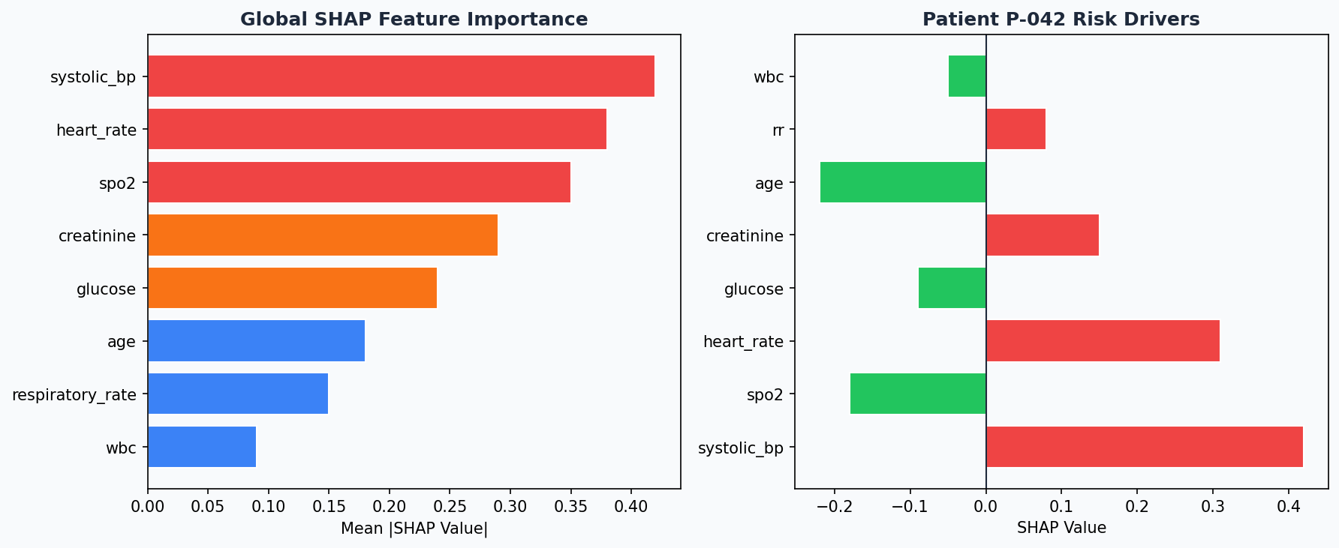

8. ANOMALY DETECTION (ISOLATION FOREST)
Isolation Forest detects statistically unusual patients whose clinical values deviate significantly from the majority. These patients receive a Noise risk tier and are shown in the Anomaly Watchlist.
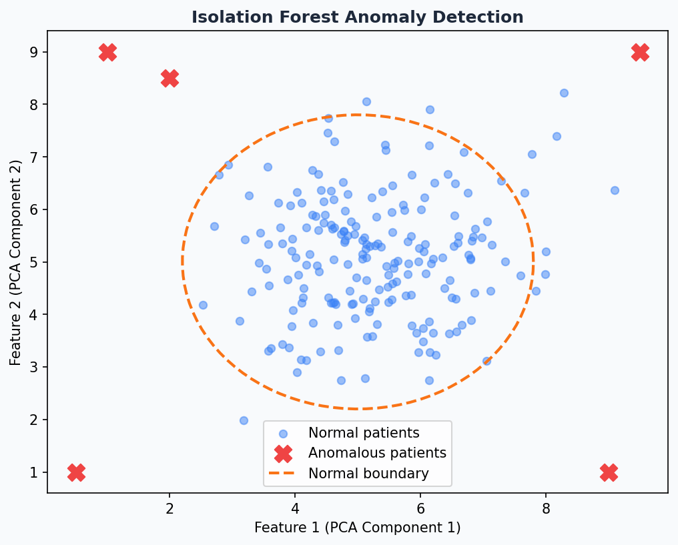

9. AUTOML — OPTIMAL K & FEATURE SELECTION
AutoML features automatically select the best number of clusters and rank features by their clinical discriminative power.
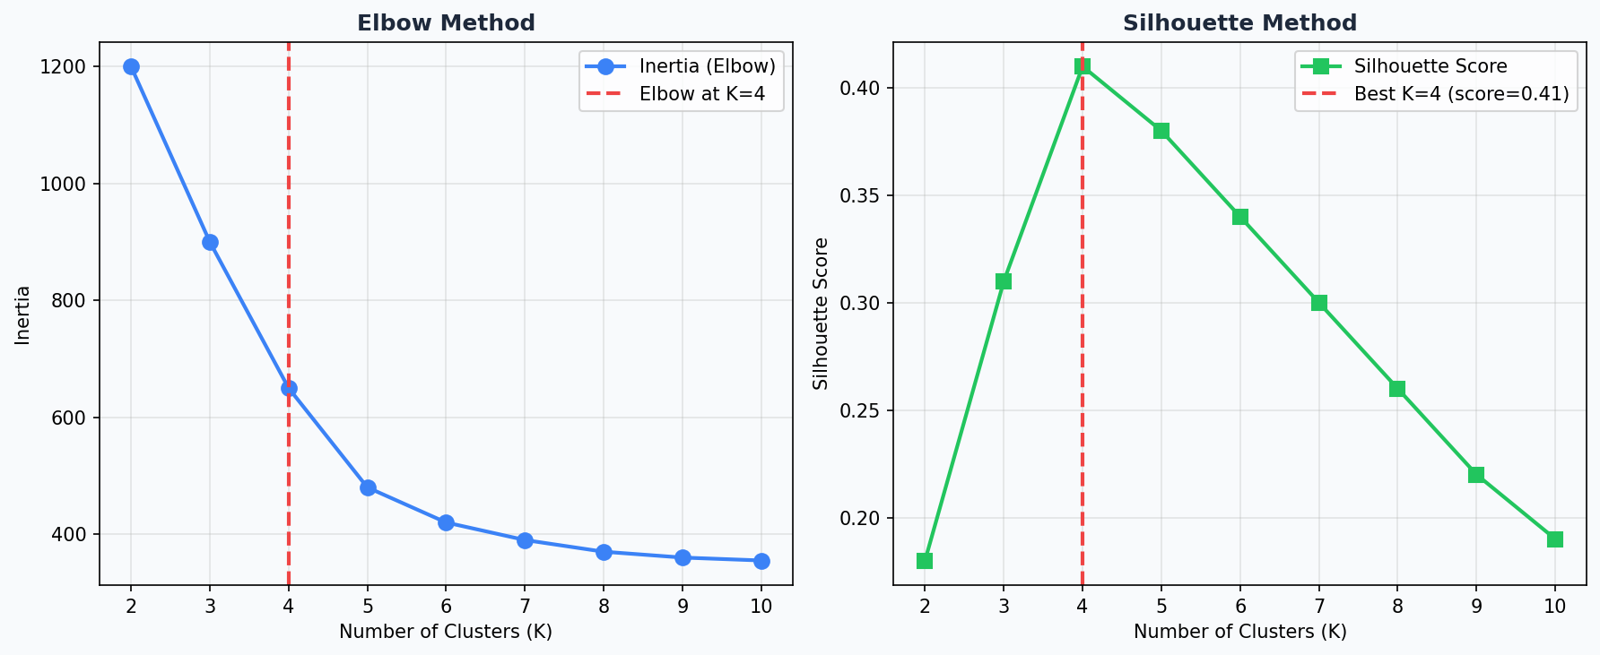

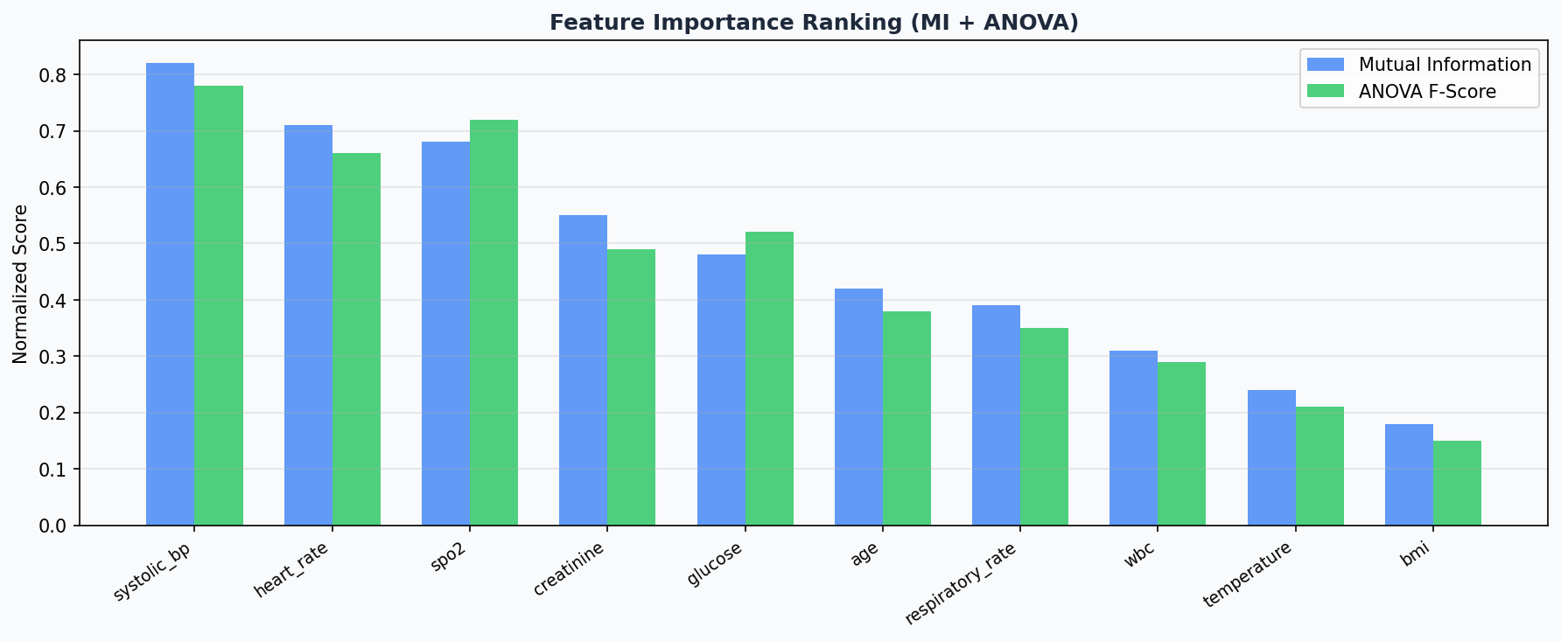

10. SUPERVISED AUTOML LEADERBOARD
When labelled patient data is available, MediCluster trains three baseline models and returns a ranked leaderboard.
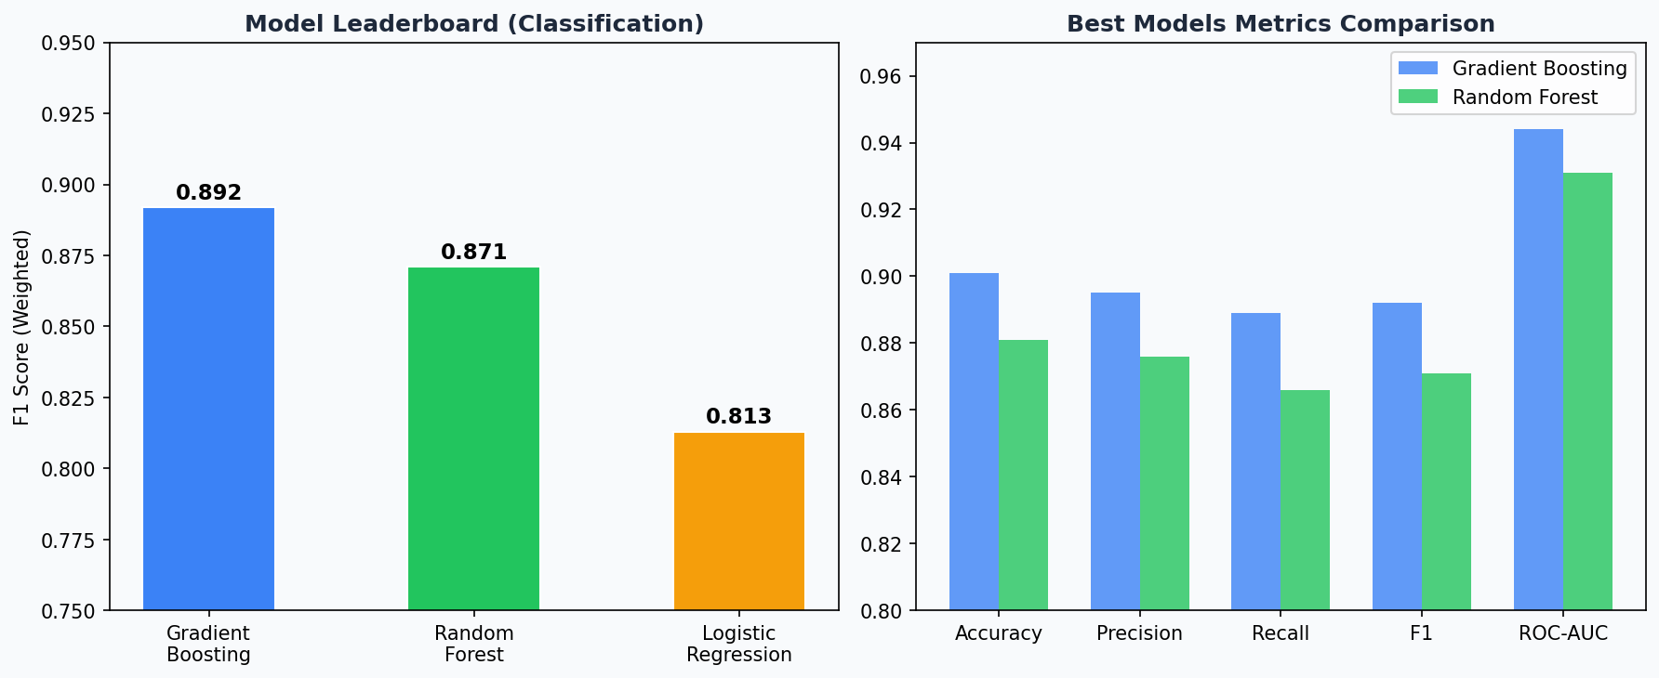

Model | Task | F1 Score | ROC-AUC | Status
Gradient Boosting | Classification | 0.892 | 0.944 | BEST
Random Forest | Classification | 0.871 | 0.931
Logistic Regression | Classification | 0.813 | 0.901
Gradient Boosting Reg. | Regression (LOS) | R²=0.741 | MAE=1.2d | BEST
Random Forest Reg. | Regression (LOS) | R²=0.718 | MAE=1.4d

11. ARCHITECTURE & DATA FLOW DIAGRAMS
The following diagrams illustrate the end-to-end data flow for the core patient clustering and clinical notes analysis pipelines.
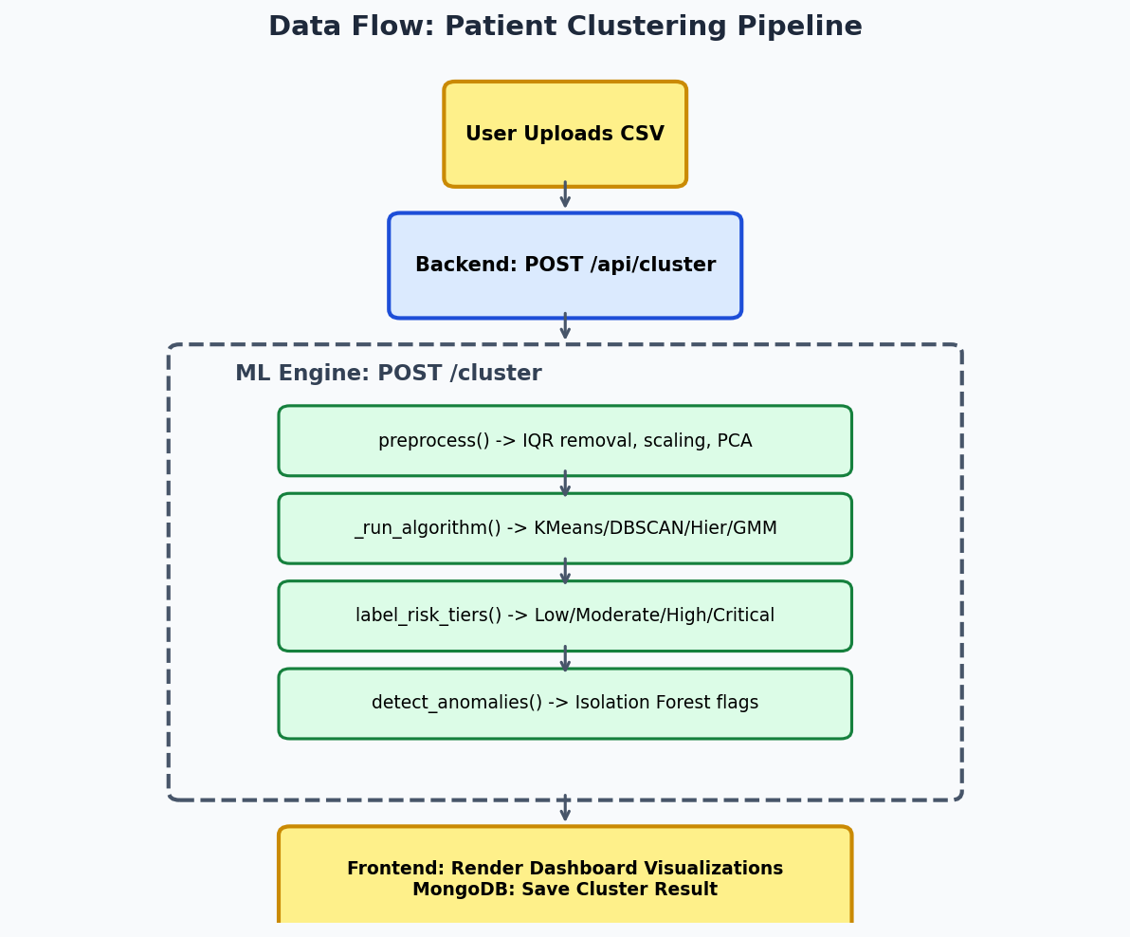

12. FRONTEND ARCHITECTURE & PAGES
The MediCluster frontend is a modern React 18 SPA built with Vite, TailwindCSS, and Recharts. It communicates with the backend via REST APIs and features 13 distinct application views.
Page Name | Primary Function | Key Components
Dashboard | Data clustering & visualization | Scatter Plot, Radar Chart, Dendrogram, Patient Table
Clinical AI | NLP notes analysis & risk scoring | Text Area, Entities Table, Triage Engine, MEWS Calculator
Imaging | Chest X-Ray analysis | Upload Zone, Findings Cards, Grad-CAM Overlay
ML Tools | AutoML & advanced stats | Optimal K Finder, Supervised Model Leaderboard
Patients | Patient records management | Search, Patient History Timeline, Media Viewer
Dispatch | Ambulance & emergency triage | OSRM Routing Map, Triage Form, Dispatch Queue
MCI Board | Mass Casualty Incident management | START Triage Grid (Red/Yellow/Green/Black)
Ask AI | Natural language clinical queries | RAG Chatbot UI, Filter Chips, Matched Patients List
Reminders | Clinical task management | Calendar View, Priority Flags, Status Toggles

13. CONCLUSION
MediCluster delivers a comprehensive, production-grade approach to AI-powered patient health risk segregation. By combining unsupervised machine learning, clinical NLP, deep learning imaging, time-series forecasting, and real-time dispatch coordination into a single unified platform, it addresses the full spectrum of clinical decision support needs.
Key Innovations:
- Zero-label risk stratification: Delivers meaningful risk tiers from raw patient data without any pre-labelled training data.
- Graceful degradation architecture: Every component has a rule-based fallback if ML libraries are unavailable.
- Clinical transparency: Every prediction includes SHAP explanations, confidence scores, and natural-language care plans.
- Field alias resolution: Handles diverse EHR column naming conventions automatically.
- Integrated emergency ecosystem: Covers the complete workflow from patient risk scoring to ambulance dispatch.

