Guaranteed Higher Scores! Only with easyMath

Yearly Courses

**Monthly Courses**

**Grade 6**

1 Month Money Refund Same Day*

1620 2888

324 per session 5 Sessions

10% OFF

1620 24000 3060 13600

324 per session 506 per session

**2 Month Money Refund Same Day\***

3060 3600 15% OFF

306 per session 10 Sessions

• • •

Month to 2 Month some do 3 Month curanter

Month more than

3 Month Higher Score Guaranteed**

**5760 3200 20% OFF**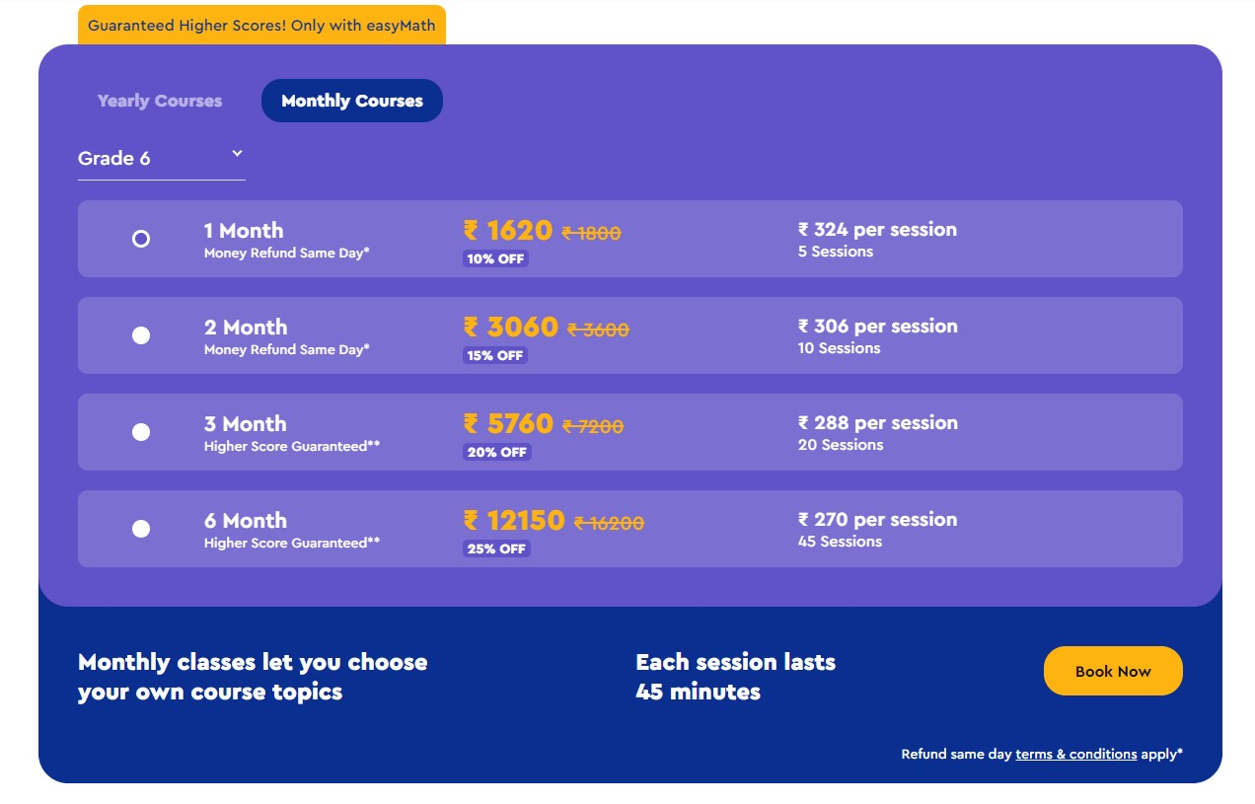

288 per session 20 Sessions

6 Month Higher Score Guaranteed**

12150 216200

12150 16200

*270 per session 45 Sessions

270 per session

**25% OFF**

**Monthly classes let you choose your own course topics**

**Each session lasts 45 minutes**

Book Now

**Refund same day terms & conditions apply**