Mask2Flow-TSE
Two-Stage Target Speaker Extraction with Masking and Flow Matching
Phase One Project Report
A from-scratch reproduction of Moon et al. (arXiv:2603.12837), implemented from the paper text alone, carried from first training run to a validated, cross-corpus-verified system.
Vinay Reddy Galigutta
Roll No: 25CS60R85
M.Tech, Computer Science and Engineering
Indian Institute of Technology Kharagpur
Supervisor: Prof. K. Sreenivasa Rao
Professor, IIT Kharagpur
September 2026

Abstract
Target speaker extraction (TSE) isolates one chosen talker from a mixture of simultaneous voices, given a short reference recording of that speaker. Unlike blind source separation, which returns every source and leaves the caller to decide which is which, TSE must itself decide identity — which makes speaker fidelity, not merely signal quality, the property that has to be correct.
This report documents Phase One of a from-scratch implementation of Mask2Flow-TSE, a two-stage architecture combining a discriminative masking network with a generative rectified-flow refinement stage. No public reference implementation exists, so every architectural and training decision was derived from the paper text and then verified against measured behaviour.
The delivered system achieves 86.2% corpus-wide speaker-verification accuracy against a 71.0% do-nothing baseline and a 90.8% ceiling, holding up on Libri2Mix — a benchmark built by an independent toolchain. Over the reporting period, fifteen candidate changes were formally evaluated against decision rules fixed before results were seen; four were promoted and eleven rejected. Three characterized limitations were diagnosed and two substantially mitigated: the catastrophic-outlier rate fell 3.6×, and a regime in which the system was measurably worse than doing nothing was converted into a 19 percentage-point improvement.
A concluding ceiling analysis establishes that the remaining extraction headroom is approximately 4.6 percentage points and lies almost entirely in Stage 1, while the measurement chain — the vocoder and speaker encoder — costs approximately 9.7 points. This prediction was then tested: five consecutive inference-time experiments all failed to move the system, as a saturated operating point implies. That analysis defines the Phase Two programme.
A deliberate emphasis throughout is on negative results. Eleven of fifteen evaluated changes were rejected, several after appearing to succeed on the metric that motivated them, and the mechanisms behind those failures constitute a substantial part of what the project learned.

Contents
1 Introduction and objectives
2 Background and related work
3 System architecture
4 Training methodology
5 Evaluation methodology
6 Development chronology: the five campaigns
6.1 Campaign 1 — the t≈0 catastrophic-outlier problem
6.2 Campaign 2 — speaker-count generalization
6.3 Campaign 3 — cross-corpus validation
6.4 Campaign 4 — the low-SNR coverage gap
6.5 Campaign 5 — the onset gate
7 Results
8 Ceiling analysis
9 Characterized limitations
10 Engineering record
11 Infrastructure
12 Phase Two
13 Conclusion
A Appendix: complete decision log
B Appendix: reproduction commands

Note: this report is generated as an editable document. To insert page numbers against these entries in Word, use References → Table of Contents, which will pick up the heading styles used throughout.

1 Introduction and objectives

1.1 The problem
The cocktail-party problem — attending to one voice among many — is trivial for human listeners and difficult for machines. Two families of approach exist. Blind source separation returns all constituent sources and defers the identification question. Target speaker extraction, the subject of this project, is given an enrollment recording of the desired speaker and must return that speaker alone.
This difference has a consequence that shapes the entire evaluation strategy of this project. A separation system can be judged on signal-reconstruction quality. An extraction system cannot, because a system that produces a clean, high-fidelity rendering of the wrong speaker has failed completely while scoring well on signal metrics. Speaker identity must be measured directly.

1.2 The paper being reproduced
Moon et al., Mask2Flow-TSE (arXiv:2603.12837, submitted to Interspeech 2026), proposes a two-stage design. A discriminative masking module performs coarse suppression, and a generative flow-matching module refines its output toward the clean-speech distribution. The stated motivation is computational allocation: masking is cheap and handles the bulk of the suppression, so the expensive generative model only has to correct a comparatively small residual.
No public implementation exists. Every design decision in this project was therefore derived from the paper text and then checked against measured behaviour — a process which, as Section 6.4 documents, eventually uncovered a significant under-specification in the paper itself.

1.3 Objectives and success criteria
Three criteria were adopted, in order of weight:
- Signal quality, measured as SI-SDR improvement over the unprocessed mixture. This is the standard metric in the separation literature and therefore the figure comparable to external work.
- Speaker fidelity, measured as verification accuracy of the extracted audio against the enrollment clip. This is the criterion specific to target extraction.
- Honesty of the record: limitations characterized with an established root cause rather than absorbed into aggregate scores that conceal them.
The third criterion is not conventional, and it materially changed how the project was run. It is the reason a formal decision-rule discipline was adopted (Section 5.3), and the reason this report devotes as much space to rejected changes as to accepted ones.

2 Background and related work

2.1 Discriminative and generative approaches
Discriminative methods learn a direct mapping from mixture to target. Given a mixture, the model predicts a mask or a waveform and is trained to minimize reconstruction error. They are fast and stable, but they characteristically over-suppress: because the objective penalizes any deviation from the target, the safest prediction in an uncertain region is attenuation, which removes target energy along with interference.
Generative methods instead learn the distribution of clean speech and then transform toward it. They can synthesize plausible content in regions where the mixture is uninformative, rather than merely attenuating — but they are more expensive and can hallucinate.
Mask2Flow-TSE combines them: masking first, generation second, with the generative stage trained on the frozen output of the masking stage. That freezing decision is architecturally minor and turns out to be responsible for several of this project's most important findings — the two stages become co-adapted, and neither one's quality predicts the pipeline's.

2.2 Components adopted from prior work
Component | Source | Role in this system
WavLM-base-plus-sv | Chen et al., WavLM | Frozen speaker encoder producing the enrollment embedding
DiT (Diffusion Transformer) | Peebles & Xie | Stage 2 backbone, with AdaLN-Zero conditioning
Rectified flow / flow matching | Liu et al.; Lipman et al. | Stage 2 training objective
Classifier-free guidance | Ho & Salimans | Inference-time conditioning strength
RoPE | Su et al. | Relative position encoding in Stage 2 attention
HiFi-GAN | Kong et al. | Vocoder, trained from scratch here
Table 2.1 — External components. All citations were verified against arXiv and publisher records; one attribution error (SpEx+ credited to Xu et al. rather than Ge et al.) was found and corrected during that check.

3 System architecture
Four components in series. Only the first two constitute the system proper; the vocoder and speaker encoder are supporting infrastructure, which Section 8 shows to be far more consequential than that description suggests.
Component | Role | Parameters | State
Stage 1 — Masking Module | Predicts a soft mask over the mixture log-mel | 11,160,176 | Trained; fine-tuned once
Stage 2 — Flow Matching (DiT) | Refines Stage 1 output toward the clean target | 77,260,624 | Trained; fine-tuned four times
Speaker Encoder (WavLM) | Produces the d-vector from the enrollment clip | 94,400,000 | Frozen (pre-trained)
Speaker projection | Maps WavLM output to 512-d conditioning | 393,728 | Trained
Vocoder (HiFi-GAN) | Log-mel back to waveform | ≈13–14 M | Trained from scratch; frozen
Table 3.1 — Component inventory. Trained system total ≈88.5 M parameters, which corresponds closely to the ≈85 M reported in the paper.

3.1 Signal path
- The mixture waveform is converted to an 80-dimensional log-mel spectrogram (n_fft = 1024, hop = 160, win = 400, at 16 kHz — a Whisper-aligned configuration).
- The enrollment waveform is passed to WavLM, mean-pooled, projected to 512 dimensions and L2-normalized, producing the speaker vector d. WavLM consumes the raw waveform through its own front end and never touches this project's mel pipeline.
- Stage 1 predicts a mask M and produces X_enh = X ⊙ M.
- Stage 2 performs four Euler steps of a rectified-flow velocity field conditioned on d, with classifier-free guidance at scale 2.5.
- The HiFi-GAN vocoder converts the resulting log-mel back to a waveform.

3.2 Stage 1 — the masking module
Four Conv2d layers feed a two-layer BiLSTM with 416 hidden units, matching the paper's §5.2.2. The speaker vector is concatenated at both LSTM layers rather than only at the input, giving consistent speaker guidance through the depth of the network. A final linear projection and sigmoid produce the mask.
A structural finding about this formulation
This project's log-mel is log(mel + 1e−8), so every bin quieter than unit linear power is negative. Multiplying a negative value by a mask in [0,1] moves it toward zero — that is, makes it louder. The claim that masking performs pure deletion therefore holds only where the log-mel is non-negative. Measured on real audio, 74.2% of mixture bins are negative at low SNR, and 73.5% of target bins are unreachable by any mask in [0,1]. The paper reports D = 100% and I = 0% and does not specify its log offset or base, so this is an under-specified paper detail rather than an implementation error. Section 6.4 prices its cost at 16.9 percentage points.

3.3 Stage 2 — flow matching
A nine-block DiT (768-dimensional, 8 heads) with rotary position embeddings and AdaLN-Zero conditioning. Conditioning is formed as c = MLP(t) + W_d·d, combining timestep and speaker information, and modulates every block. The output projection is zero-initialized for training stability.
Stage 2 is trained with a rectified-flow objective on the frozen output of Stage 1. It therefore only ever learns to correct the particular error distribution that Stage 1 produces. This coupling is the single most consequential architectural detail in the project: it explains why a markedly better Stage 1 produced a worse pipeline (Section 6.4.6), and why the onset defect of Section 6.5 is reachable by neither stage alone.
At inference the velocity field is integrated with four Euler steps. Classifier-free guidance blends conditional and unconditional velocities as v = v_uncond + s·(v_cond − v_uncond).

3.4 Architecture verification
The architecture diagrams prepared at the start of the project were audited line by line against the running code. Four genuine errors were found and corrected:
- the reference-audio path was drawn through the mel extractor, when WavLM in fact consumes the raw waveform through its own feature extractor;
- inference was drawn as a single Euler step, correct only for the paper's default, whereas the deployed configuration runs four, each evaluating the network twice for guidance;
- a final AdaLN modulation layer between the last DiT block and the output projection was missing entirely — its presence confirmed by an exact parameter-count match against the training log's reported 1,242,704 output parameters;
- the vocoder's described element-wise sum is in fact an average over three residual blocks.
The corrected diagrams were rebuilt as Mermaid source so that they live in the repository as checked-in text and cannot silently drift from the code again.

4 Training methodology

4.1 Mixture construction
Mixtures are constructed on the fly rather than pre-generated, so each epoch presents fresh speaker pairings and SNRs. Every sample draws a target speaker, one or more interferers, and a reference utterance that is always a different recording of the target speaker — never the utterance being extracted.
Setting | Value | Note
Segment length | 10 s at 16 kHz | fixed training window
Enrollment length | 3.0 s | swept in Phase One; 3.0 s retained (§6.6)
SNR range | 1 to 10 dB | the floor responsible for limitation §9.2
Condition mix | clean 0.33 / additive 0.33 / reverb 0.34 | reverb used synthetic RIRs until 2026-09-19
Stage 1 schedule | 200,000 steps, lr 2e−4, EMA 0.9999 | best checkpoint at step 130,000
Stage 2 schedule | 300,000 steps, lr 2e−4, CFG dropout 0.1 | trained on frozen Stage 1 output
Table 4.1 — Training configuration.

4.2 Curriculum fine-tuning as the primary experimental tool
Rather than retraining from scratch for each hypothesis, most changes were implemented as fine-tunes from a known checkpoint with a modified sampling curriculum, typically 25,000 steps. This makes a change attributable: only the curriculum differs, so a measured difference is a difference in that curriculum rather than in initialization, data order or schedule.
Two curricula recur. A speaker-count curriculum draws 2, 3 or 4 total speakers with probability 0.5 / 0.3 / 0.2. A low-SNR curriculum draws some fraction of samples from [−10, 1) dB. A design rule emerged early and was applied consistently thereafter: when fine-tuning for a new condition, keep the curriculum that produced the previously validated behaviour switched on, or the fine-tune surrenders the earlier gain while chasing the new one.

4.3 Why validation loss was not used for checkpoint selection
The validation set is 2-speaker at trained SNR. A fine-tune training on a harder mixture distribution is therefore measured on an easier distribution than it is learning, and the proxy carries little information about the thing being optimized.
This was observed repeatedly. Across five fine-tunes the validation loss was flat or worse while the real metrics improved; on one occasion — the Stage 2 adaptation of Section 6.4.7 — it improved while two headline metrics worsened. Checkpoint selection consequently used the final step of a completed run rather than the best-by-validation step, and promotion always required the full evaluation battery.

5 Evaluation methodology

5.1 Three metric families, deliberately weighted
Tier | Metric | Rationale
Primary | SI-SDR improvement | Field standard, comparable to external work. Reported as a median because the mean is dominated by the outlier tail.
Secondary | Speaker-verification accuracy (1 − EER), AUC | The metric specific to target extraction. SI-SDR cannot indicate whether the correct speaker was extracted.
Diagnostic | Mel-MSE improvement, catastrophic rate | Internal use only. Unbounded and non-standard, so never a headline — but it located every failure mode in Section 9.
Table 5.1 — Metric hierarchy.
These three families disagree, and the disagreements proved informative rather than noisy. Section 10.2 documents three separate occasions on which a change improved every metric then under observation and was nonetheless not free.

5.2 The evaluation battery
Every promotion candidate ran the same five-stage battery, ordered so the decisive stage runs first and an unpromising candidate can be cancelled early:
- Controlled in-domain low-SNR test, n = 300 at [−10, 1) dB — identical corpus, mixer, speakers and seed as the baseline, so only the checkpoint differs.
- Libri2Mix cross-corpus, n = 6000 — yielding both the in-distribution and out-of-distribution slices from a single run.
- In-domain full test-clean, n = 2620 — the primary headline figure.
- Corpus-wide speaker-verification accuracy, n = 400.
- Speaker-count conditions at 2, 3 and 4 speakers, n = 300 each.
Paired-comparison discipline
Each battery reports two checkpoint-independent probes — the unprocessed mixture and the ground-truth target — passed through the identical chain. If those match the baseline run to four decimal places, the two runs scored the same samples and the comparison is genuinely paired. This check proved decisive twice: when enrollment length and the speaker projection were varied, the probes moved, revealing that those changes had altered the reference embedding itself. The apparent system numbers were being measured on a different scale rather than reflecting better extraction.

5.3 Pre-registered decision rules
From the low-SNR campaign onward, every candidate was judged against a rule written into the project record before its results were seen. Each rule specifies a primary target, a set of retention bars that must not be breached, and the action to take in each outcome.
The motivation is straightforward: with fifteen candidates and three metric families across five evaluation conditions, there is almost always some cut of the data on which a change appears favourable. Fixing the criteria in advance removes that latitude.
The discipline did real work. Eleven of fifteen candidates were rejected, several of which would plausibly have been argued into acceptance after the fact. One promotion, documented in Section 6.4.7, knowingly overrode two of its own bars; that override and its justification are reported rather than concealed, because a pre-registration that is silently abandoned provides no assurance at all.

6 Development chronology: the five campaigns
Each campaign begins from a measured failure rather than a hypothesis, and each is documented here in the order it was run, including the attempts that failed.
# | Campaign | Outcome | Headline result
1 | t≈0 catastrophic outliers | Promoted | Catastrophic rate 12.7% → 3.5%
2 | Speaker-count generalization | Promoted | 4-speaker 72.6% → 76.7%
3 | Cross-corpus validation | Diagnostic | Confirmed on Libri2Mix; found the SNR gap
4 | Low-SNR coverage gap | Promoted | 61.3% → 80.3%; a 22 dB SI-SDR swing
5 | Onset gate | Open | Root-caused as a stage interaction
Table 6.1 — Campaign summary.

6.1 Campaign 1 — the t≈0 catastrophic-outlier problem

6.1.1 Symptom
12.7% of test samples emerged worse than the Stage 1 input they started from, some collapsing to −75 dB SI-SDR. The median was healthy; the tail was not. Because a median is insensitive to a small fraction of extreme values, this had gone unnoticed in earlier aggregate reporting.

6.1.2 Diagnosis
The Euler integration loop was instrumented to record the guidance disagreement at each step. For the failing samples, ‖v_cond − v_uncond‖ at t = 0 ran 5 to 40 times its magnitude at every later step; for example, one sample measured 2133 at t = 0 against 110–173 thereafter. All flagged samples showed this same shape, and steps 1 through 3 appeared normal.
The mechanism follows from the architecture. At t = 0 the flow input equals Stage 1's output exactly, so there is no interpolation signal toward the target and the network must extrapolate an entire trajectory from a single frozen point. Classifier-free guidance then multiplies that raw disagreement into an oversized first Euler step, which the remaining three steps cannot correct — they continue extrapolating from an already-corrupted state.

6.1.3 Alternatives ruled out
Three cheaper explanations were tested first and each was rejected: reducing the guidance scale did not remove the outliers; running the first steps unguided did not remove them; and increasing the Euler step count did not help, because the damage is done by the first step. Only after exhausting these was a retraining intervention justified.

6.1.4 Intervention and result
If the model performs poorly at t ≈ 0 because it rarely trains there, the remedy is to train there more. A fine-tune was run with t ≈ 0 over-weighted in the sampling distribution — a change to the training curriculum, not to inference.
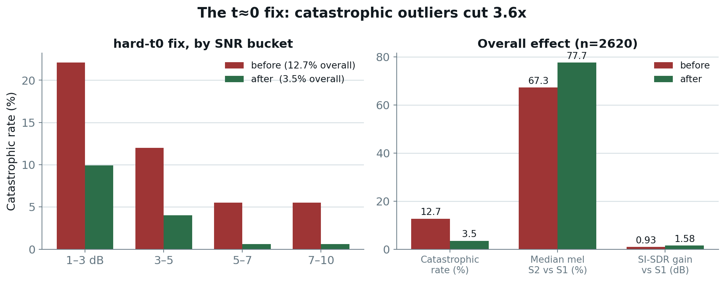
Figure 6.1 — Effect of the hard-t0 fine-tune, n = 2620. Left: catastrophic rate by SNR bucket. Right: overall metrics. The improvement appears in every bucket.
The catastrophic rate fell from 12.7% to 3.5%, a 3.6× reduction; median mel improvement rose from 67.3% to 77.7%, and median SI-SDR gain from +0.93 to +1.58 dB. Crucially the improvement appeared in every SNR bucket rather than only in aggregate, which is what confirmed the diagnosed cause had been addressed rather than an insensitive statistic moved.
This established the template applied in every later campaign: diagnose the coverage gap, then change the curriculum that created it.

6.2 Campaign 2 — speaker-count generalization
The model had only ever been trained on 2-speaker mixtures. No measurement existed of its behaviour with three or four simultaneous talkers — a condition any deployed system would encounter.
The first measurement established the gap: 86.3% accuracy at two speakers, 76.7% at three, and 72.6% at four. The degradation is substantial and entirely attributable to training coverage.
A speaker-count curriculum was introduced during fine-tuning, drawing 2, 3 or 4 total speakers with probability 0.5 / 0.3 / 0.2 — weighted to preserve the validated 2-speaker condition while providing exposure to the others. Three-speaker accuracy rose to 81.9% and four-speaker to 76.7%, while two-speaker held flat at 86.7%.
The gains concentrated precisely where coverage had been absent and left the covered condition unchanged, which is the signature of a coverage fix rather than a fortunate checkpoint.

6.3 Campaign 3 — cross-corpus validation

6.3.1 Motivation
Every result to this point had been produced by a single in-house mixture generator. That leaves an unavoidable question: was the system being measured, or the data pipeline built for it? Libri2Mix, a standard benchmark generated by an independent toolchain, provides an external check. Its test set was generated and the full pipeline run over 6,000 samples.
This also exercised the variable-length chunked inference path end-to-end for the first time, since Libri2Mix mixtures are real utterances rather than the fixed ten-second training window.

6.3.2 An aggregate that looked like failure
The raw aggregate was poor: median mel improvement 23.9%, catastrophic rate 26.7%, and SI-SDR against the mixture of −0.61 dB. Taken at face value the system appeared to fail on external data.
The cause was not generalization failure. Libri2Mix applies no SNR floor: each source is loudness-normalized independently, so the target is quieter than the interferer in 60.6% of samples. This project's mixer uses snr_min = 1.0 dB, meaning the model had never, in its entire training history, encountered a mixture in which the target was the quieter voice.
Splitting exactly on that boundary separates a generalization question from a coverage question:
Slice | Share | Median mel S2 vs S1 | Catastrophic | SI-SDR vs S1
In-distribution (≥ 1 dB) | 39.4% | 73.4% | 5.7% | +2.37 dB
Out-of-distribution (< 1 dB) | 60.6% | −19.0% | 40.3% | −1.50 dB
Table 6.2 — Libri2Mix split at the trained SNR floor, n = 6000.
The in-distribution slice at 73.4% / 5.7% is consistent with — and on SI-SDR better than — the in-house headline of 77.7% / 3.5%, on a corpus this project did not construct. That is the cross-corpus evidence that the gains are properties of the system.

6.3.3 The shape of the failure identifies its cause
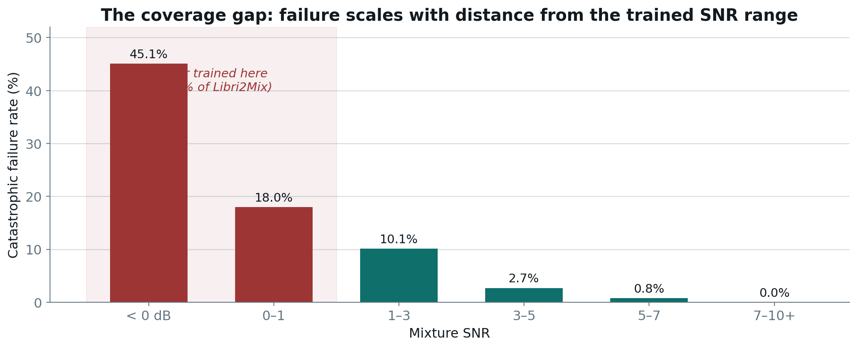
Figure 6.2 — Catastrophic rate by mixture SNR on Libri2Mix, measured before the low-SNR campaign. The shaded region is the regime the training mixer structurally cannot produce.
The trend is smooth and monotonic rather than a cliff: performance degrades in proportion to how far a mixture sits outside the trained range. An architectural limitation would not be this orderly. This is what identified the problem as a training-coverage gap and made it a candidate for a curriculum intervention.

6.4 Campaign 4 — the low-SNR coverage gap
The largest single line of work in Phase One, and the one in which most attempts failed. In the sub-1 dB regime the system scored 61.3% accuracy against a 64.0% do-nothing baseline: running the extractor made the result measurably worse than not running it. Since that regime constitutes the majority of a standard benchmark, it could not be left uncharacterized.

6.4.1 Stage attribution
A local analysis of existing evaluation records, costing no GPU time, split the failure by stage and SNR. Below −5 dB, Stage 2 made 94.8% of samples worse than Stage 1 — the dominant failure. But Stage 1 also degraded, with its mel improvement falling from 8.1% to 1.1% and its hurt-rate rising from 2.6% to 20.3%.
A third observation proved important: Stage 1's metrics disagreed in direction at low SNR, mildly positive in mel (+1.1%) while severely negative in SI-SDR (−7.83 dB). A deletion-only mask forced to remove most of the spectrum takes target energy with it — the mel statistic records the removal of interference, the SI-SDR statistic records the loss of target.

6.4.2 Attempt 1 — a 50% low-SNR curriculum on Stage 2
The target regime improved decisively: accuracy 61.3% → 71.3%, SI-SDR −5.94 → +4.11 dB. But corpus-wide accuracy fell 86.5% → 82.0% and the in-domain catastrophic rate rose 3.7% → 15.5%, a 4.2× increase. Per-bucket analysis showed genuine capacity reallocation — failures at low SNR fell from 45.0% to 31.9% while failures at 5–7 dB rose from 0.8% to 4.7% — rather than noise.
Rejected: unlike the two earlier fine-tunes, the cost was not confined to the diagnostic metric.

6.4.3 Attempt 2 — a 25% low-SNR curriculum
Run specifically to test whether a gentler mixture located a sweet spot. It did not. The result retained 38–76% of the stronger run's gain and 62–73% of its cost — approximately proportional, with no knee in the curve.
Two points on one trade-off curve established that the trade is inherent at Stage 2 rather than a tuning failure. Curriculum-weight tuning was stopped at that point rather than continued into a third mixture, and attention moved to locating the actual constraint.

6.4.4 The mask-formulation finding
Examination of the Stage 1 code, prompted by the metric disagreement of Section 6.4.1, established the structural property described in Section 3.2: because the log-mel is log(mel + 1e−8), quiet bins are negative, and multiplying a negative value by a mask in [0,1] makes it louder rather than quieter. Suppressing a louder interferer to reveal a quieter target — precisely the low-SNR task — is therefore structurally impossible in those bins.
The paper was re-read to determine whether this was an implementation error. It specifies the same formulation (Eq. 9, mask applied to log-mel, sigmoid-bounded) and reports D = 100% / I = 0%, but does not specify its log offset or base. The conclusion is that this is an under-specified detail in the source material, not a defect in this implementation.

6.4.5 The oracle decomposition
To determine whether the constraint was the network or the formulation — two diagnoses with opposite remedies — Stage 1 was replaced by two oracles constructed from the clean target. This is an evaluation-only experiment: the oracles use information unavailable at inference and can never be deployed.
- Oracle A computes the best mask that exists within the paper's formulation, the per-bin least-squares optimum clip(Y/X, 0, 1). If this barely improves on the trained network, the network is already near its formulation's limit and retraining Stage 1 cannot help.
- Oracle B performs true energy deletion, an ideal ratio mask on linear power. This prices what changing the formulation could buy.
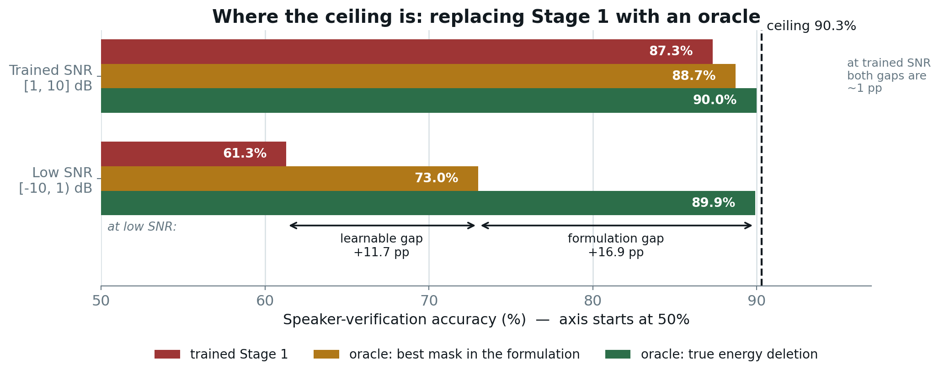
Figure 6.3 — Accuracy with the trained Stage 1 replaced by each oracle, at low and trained SNR, against the 90.3% ceiling.
At low SNR the learnable gap (network → best mask) measures 11.7 points and the formulation gap (best mask → true deletion) measures 16.9 points. Both are real and both open specifically at low SNR; at trained SNR each collapses to approximately one point.
This answered a question that had until then been argued from intuition, and redirected the campaign from Stage 2 curricula — which had just failed twice — to Stage 1, where the next attempt succeeded. It also produced the ceiling estimate that governs Section 8 and defines the Phase Two programme.

6.4.6 The Stage 1 A/B and the co-adaptation finding
Two Stage 1 arms were fine-tuned, identical in curriculum, seed, step count and learning rate, differing only in mask formulation: the paper's multiplicative form, and an additive log-gain form x + logsigmoid(·) which makes true deletion achievable.
The log-gain arm produced the most accurate Stage 1 measured anywhere in this project — median masked mel error 2.296 against 5.939 for the multiplicative arm, a 2.6× improvement, with deletion at exactly 100% by construction.
It then failed. Paired with the frozen Stage 2, it worsened its own input in 97.7–98.7% of samples. Stage 2 had been trained for 300,000 steps against multiplicative-mask output and had never encountered a mask output below the mixture.
The finding this produced
A better Stage 1 is worthless to a Stage 2 that was not trained against it. Pipeline quality is not a function of either stage's quality in isolation. A later experiment (Section 6.4.8) co-adapted both stages and still failed, which recast this from a distribution-shift problem into a structural property of the two-stage design.

The multiplicative arm passed every pre-registered bar and was promoted: low-SNR accuracy rose 61.3% → 69.7% at no corpus-wide cost (86.5% → 86.5%), where the equivalent Stage 2 change had cost 4.5 points. Speaker-count accuracy fell by 2.4 / 2.1 / 1.6 points, within the ±3-point retention bar fixed before the run. This was the first Stage 1 promotion since 2026-08-02.

6.4.7 Stage 2 adaptation, and a documented override
With Stage 1 changed, Stage 2's input distribution had moved beneath it, and Stage 2 was subtracting at low SNR (−1.40 dB relative to Stage 1). It was re-adapted using the same curriculum, so that it would see the distribution Stage 1 now produces.
The target was met decisively: Stage 2's contribution moved from −1.40 to +1.79 dB, and low-SNR accuracy from 69.7% to 78.7%. Two retention bars, however, failed: in-domain mel catastrophic rate rose 4.6% → 9.7% against a bar of ≤5%, and the Libri2Mix in-distribution rate 4.9% → 7.3% against a bar of ≤6%.
The candidate was promoted regardless. The justification was that both failing bars belonged to the mel proxy, and a severity check in the audio domain contradicted them: severe regressions (SI-SDR worse than −10 dB relative to Stage 1) moved only from 2.1% to 2.7%, while the proportion of mel-'catastrophic' cases whose audio was in fact acceptable rose to 64%. The mel statistic was breaking down as an indicator rather than the audio deteriorating.
Why this is reported as an override
Moving a threshold after seeing results is precisely the behaviour pre-registration exists to prevent. The decision was taken deliberately, with the contradicting evidence recorded, and is reported here as an override rather than presented as a clean pass. A reader is entitled to discount it accordingly.

6.4.8 Revisiting log-gain with a co-adapted Stage 2
Section 6.4.6 rejected log-gain for a single reason: the frozen Stage 2 destroyed its output. Section 6.4.7 then demonstrated that Stage 2 can be adapted to a changed Stage 1 using this exact recipe. The cause of the original rejection had been removed, so the experiment was repeated properly, with both stages co-adapted.
It failed every bar — corpus-wide accuracy 83.5% against a required 86.5%. The mechanism is the result: Stage 2's improvement over Stage 1 collapsed from +74.1% mel to +11.7%, and turned negative at low SNR. The final output was worse in absolute terms (mel MSE ≈ 2.0) than the existing pipeline (≈1.54), despite Stage 1's own error being 2.6× lower.
Two conclusions follow. First, 300,000 steps of Stage 2 training against one input family cannot be re-pointed at another in 25,000. Second, and more fundamentally, the residual that Stage 2 learned to predict is much smaller when its input is already close to the target — so a more accurate Stage 1 leaves less for Stage 2 to contribute, and the pipeline does not simply inherit the improvement.

6.4.9 The guidance re-tune
The classifier-free guidance scale had been set to 1.5 and validated when both stages were different models. After two promotions it had not been revisited. A sweep found it mis-tuned for the current pipeline.
Moving to 2.5 raised accuracy across the board — 2/3/4-speaker from 84.3 / 78.3 / 74.9 to 85.7 / 80.0 / 77.0, corpus-wide from 85.2% to 86.2%, low-SNR from 78.7% to 80.3% — at a cost of 0.09 dB SI-SDR and 0.5 points of catastrophic rate. Accuracy plateaued at 2.5 while outliers began rising at 3.0, so the sweep was stopped there.
This was the largest single recovery in the campaign and required no training whatsoever. The general lesson: after replacing components, the operating point must be re-validated, because it had silently become wrong.

6.4.10 Campaign outcome
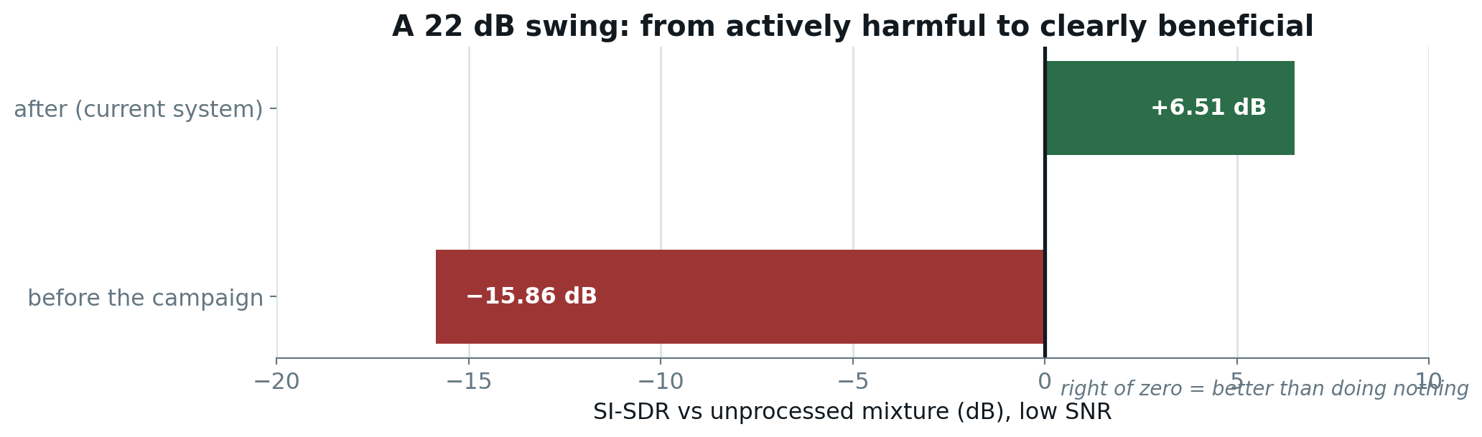
Figure 6.4 — SI-SDR against the unprocessed mixture in the low-SNR regime, before and after the campaign. Left of zero indicates the extractor degraded the audio.
Low-SNR accuracy rose from 61.3% to 80.3% and the Libri2Mix aggregate from −0.04 to +3.39 dB. The honest cost, measured against doing nothing: in-domain SI-SDR fell from +1.90 to +1.75 dB, and 2- and 3-speaker accuracy sit 1.6 and 2.1 points below their all-time peak. Four-speaker accuracy is at its best recorded value.
Both framings are reported because both are defensible. A reader concerned only with in-domain two-speaker performance should regard this campaign as a small net loss; the case for it rests on the low-SNR and cross-corpus regimes, where the system moved from harmful to beneficial.

6.5 Campaign 5 — the onset gate

6.5.1 A defect no metric detected
Following the low-SNR campaign, every quantitative metric indicated improvement. A routine listening check indicated otherwise: the first half-second of some utterances was audibly damped. This is the second occasion on which listening located something the battery could not (the first, in September, was a trailing-silence bug that had been understating results).
Measured against ground truth, the affected output sits on a flat ≈−60 dB floor for roughly half a second and then switches on abruptly — a gate rather than gradual attenuation. Localization:
Region | Level vs ground truth
First speech burst (from frame 0) | −4.08 dB median, worst −16 dB
Interior speech onsets (after ≥0.2 s silence) | +0.29 dB
Sustained speech | +0.01 dB
Table 6.3 — The defect is attached to sequence position, not acoustic event.
Interior onsets are acoustically identical events and are reproduced accurately. The defect is therefore attached to position 0 of the sequence: frame 0 is the only frame with no left context for the DiT's rotary attention, and Stage 2 generates its output where Stage 1 merely scales the mixture and so inherits a plausible level even when its mask is wrong.

6.5.2 Which change introduced it
Both pre-promotion checkpoints had been retained, so every combination could be evaluated at the deployed operating point, with the old/old cell serving as the method's own control.
Stage 1 | Stage 2 | Gated samples | Median onset | 4-speaker gated
old | old | 1 / 24 | −1.00 dB | 0 / 8
new | old | 1 / 24 | −2.01 dB | 0 / 8
old | new | 2 / 24 | −1.95 dB | 0 / 8
new | new (deployed) | 7 / 24 | −4.67 dB | 3 / 8
Table 6.4 — 2×2 checkpoint ablation. A sample is 'gated' when its onset falls below −10 dB relative to ground truth.
Neither promotion produces the defect alone — each is indistinguishable from the control. Only the pair gates, and superadditively: summing the individual effects predicts approximately 2/24 and −2.96 dB, against a measured 7/24 and −4.67 dB. Every gated four-speaker sample requires both new checkpoints to be present.
This removes the cheapest available remedy. Had either promotion carried the defect, the fix would have been to revert it and retain the other's gains. Because each is individually clean and jointly defective, there is nothing to revert; any fix must address the coupling.

6.5.3 Two mitigations, both rejected
The bar was fixed in advance at ≤1/24 gated — the pre-campaign level — on the grounds that a defect introduced by the campaign should be absent after a fix.
The first attempt fine-tuned Stage 2 against the failing condition. It improved matters, 7/24 → 4/24, cleaning two-speaker entirely and reducing three-speaker from 3/8 to 1/8, but four-speaker did not move at all and the total missed the bar. In hindsight the shortfall is explained by the ablation: it adjusted one stage for a defect residing in the coupling.
The second was an inference-side repair requiring no retraining: run Stage 2 twice, once with a silent lead-in so the weak region falls into frames discarded before vocoding, and splice the repaired opening onto the ordinary output with a short cross-fade. Everything past the cross-fade remains bit-identical, so utterance-averaged metrics can only move through the region that improved. It recovered one sample, 7/24 → 6/24, with no accuracy change — and four-speaker was again unmoved.
Both mitigations failing in the same condition is what the interaction diagnosis predicts. A defect living in the coupling between two checkpoints is reachable neither by adjusting one stage nor by post-processing the pair's output. It is reported as a characterized limitation with an established cause.
Why the battery could not see it
The speaker embedding is mean-pooled over the entire utterance, so half a second of a four- to ten-second clip barely shifts it. The evaluation suite was structurally incapable of detecting this defect. That is the argument for retaining a human listening check regardless of how comprehensive the quantitative suite appears.

7 Results

7.1 Delivered system
Condition | Do nothing | This system | Ceiling | SI-SDR vs mixture
Corpus-wide (n = 400) | 71.0% | 86.2% | 90.8% | —
2 speakers (n = 300) | 70.3% | 85.7% | 90.3% | +1.88 dB
3 speakers (n = 300) | 64.3% | 80.0% | 90.3% | +2.31 dB
4 speakers (n = 300) | 61.4% | 77.0% | 90.3% | +2.37 dB
Low SNR [−10, 1) dB | 64.0% | 80.3% | 90.3% | +6.51 dB
In-domain (n = 2620) | — | — | — | +1.75 dB
Libri2Mix (n = 6000) | — | — | — | +3.39 dB
Table 7.1 — Deployed configuration. Accuracy is 1 − EER over genuine/impostor trials across the whole evaluated set.

7.2 Accuracy across the promoted path
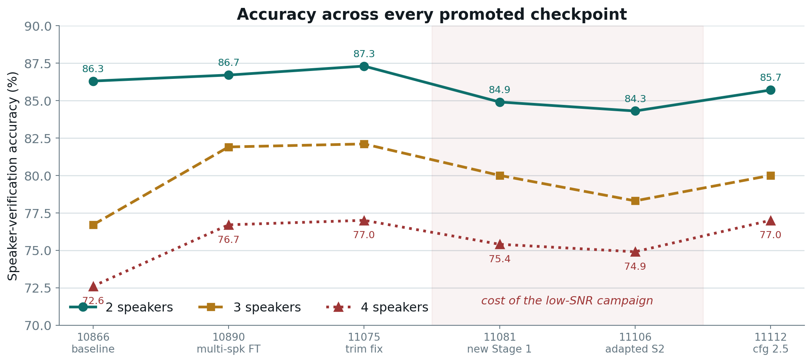
Figure 7.1 — Speaker-verification accuracy at each promoted checkpoint. The shaded region marks the deliberate cost of the low-SNR campaign.
Two features are worth reading from the shape. The rise through the first three points is the multi-speaker fine-tune performing as designed: three- and four-speaker accuracy climb sharply while two-speaker, already covered by training, remains flat. The dip that follows is the price of low-SNR capability, paid knowingly, and the recovery at the final point came from re-tuning guidance at no training cost.
Condition | First measured | Best recorded | Current | Net change
2 speakers | 86.3% | 87.3% | 85.7% | −0.6
3 speakers | 76.7% | 82.1% | 80.0% | +3.3
4 speakers | 72.6% | 77.0% | 77.0% | +4.4
Low SNR | 61.3% | 80.3% | 80.3% | +19.0
Table 7.2 — Net movement across Phase One, in percentage points.
The two- and three-speaker shortfall against the best recorded value is the residual cost of low-SNR capability. Four-speaker accuracy is at its all-time best, and the low-SNR regime moved from actively harmful — 61.3% against a 64.0% do-nothing baseline — to clearly beneficial.

7.3 Qualitative verification
Playable audio was exported for 2-, 3- and 4-speaker mixtures at the deployed checkpoint: for each sample, the mixture, the system output, the Stage 1 intermediate, the enrollment clip and the vocoded ground truth. Two listening passes were conducted.
The first confirmed that extraction produces the correct words in the correct voice across all three speaker counts, and incidentally exposed a trailing-silence bug that had been understating the reported numbers. The second located the onset gate of Section 6.5.
One sample is worth noting for interpretation: in a two-speaker case the extracted output scored 0.60 speaker similarity against a vocoded ceiling of 0.54 — higher than ground truth. This is not an error. Both pass through the same vocoder, and the extraction happens to land marginally closer to the reference embedding than the vocoded original. It is a useful reminder that the ceiling is a measurement artifact of the evaluation chain, not a physical bound.

8 Ceiling analysis
Late in Phase One the governing question became how much room remained. The oracle decomposition of Section 6.4.5, together with the ceiling probe, answers it quantitatively.
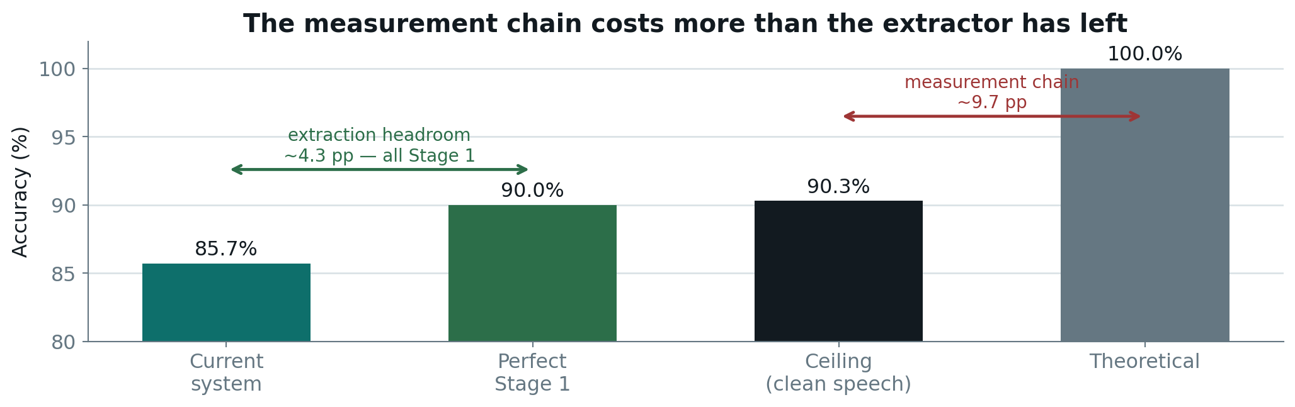
Figure 8.1 — Headroom decomposition at the trained operating point, two speakers.
The ceiling probe passes the ground-truth clean target through the same mel → HiFi-GAN → WavLM chain as every other probe. Consequently 90.3% is what perfect extraction of perfectly clean speech scores, and the remaining 9.7 points are lost by the vocoder and speaker encoder before extraction quality is involved at all.
The remaining headroom therefore divides into two unequal pools:
- Extraction: approximately 4.6 points, of which the oracle indicates 4.3 are recoverable through Stage 1 alone. Stage 2 and the operating point are effectively saturated at the trained SNR.
- Measurement chain: approximately 9.7 points — more than twice what remains in the extractor. Improving it would raise the ceiling and the system figure together, which is a legitimate result to report but not the same claim as a better extractor.

8.1 The prediction, and its test
A saturated operating point implies that inference-time tuning should yield nothing. Five such experiments were run, and all five failed:
Experiment | Rationale | Outcome
Onset padding / splice | Repair the gate at inference | 7/24 → 6/24; no accuracy change
CFG warm-up | Flagged as improving every measured metric | Accuracy fell in every condition
Longer enrollment (5 s) | Enrollment length is a strong known lever | Worse; the ceiling itself fell
Heun ODE solver | 2nd-order integration at equal compute | Worse, particularly at low SNR
Alternate speaker projection | A never-evaluated checkpoint | Same accuracy, lower AUC
Table 8.1 — Five inference-side experiments, all rejected.
Five rejections from five attempts is not adverse luck; it is the signature of a saturated operating point, and it constitutes the strongest available evidence that the ceiling analysis is correct. It also redirected Phase Two away from inference-time tuning entirely.

8.2 Two instructive rejections
The Heun solver result is worth recording because it is counter-intuitive. A second-order integrator should reduce discretization error. But Stage 2 is trained with a rectified-flow objective, which explicitly optimizes for straight trajectories — and Euler integration is exact on a straight line. There was no integration error remaining to recover, while halving the step count to hold compute fixed also halved the number of guidance applications, to which this pipeline is demonstrably sensitive. A unit test confirms the implemented solver is more accurate on a curved field; the model simply does not produce one.
The CFG warm-up result is instructive for a different reason. It had been flagged twice in the project record as the only change improving every measured metric with nothing worse. It had never been measured on accuracy, because only one of five evaluation scripts exposed the flag. Once wired through all five and measured, the quality gains replicated at full corpus scale while accuracy fell in every condition. Warm-up runs the first two of four steps unguided and is therefore simply weaker guidance re-parameterized — an axis already swept and deliberately optimized in the opposite direction.

9 Characterized limitations
Four limitations, each with an established root cause. Two were substantially mitigated, one closed, one remains open.

9.1 The t≈0 training-coverage gap — mitigated 3.6×
Described in Section 6.1. Diagnosed by instrumenting the guidance disagreement per step, and mitigated by over-weighting t ≈ 0 in the fine-tuning distribution. The catastrophic rate fell from 12.7% to 3.5%. It is not solved: the worst samples still collapse, and the residual 3.5% represents a genuine remaining failure mode.

9.2 SNR coverage below 1 dB — closed
The mixer's snr_min = 1.0 floor meant the model never trained on a mixture in which the target was the quieter speaker — 60.6% of Libri2Mix. In that regime the system was actively harmful. Closed by the Stage 1 fine-tune, the Stage 2 adaptation and the guidance re-tune: accuracy 80.3%, SI-SDR −15.86 → +6.51 dB.

9.3 Speaker-count generalization — mitigated
Trained on 2-speaker mixtures only; three and four speakers were out of distribution. The speaker-count curriculum raised four-speaker accuracy from 72.6% to 77.0%, where it remains. Performance still degrades with speaker count, and the mel improvement at four speakers (≈51.6%) is well below the two-speaker figure (≈74.1%).

9.4 The onset gate — open
Described in Section 6.5. Established by ablation as an interaction between the two promoted checkpoints rather than a fault in either. Two mitigations were measured against a bar fixed in advance and both failed, both in the four-speaker condition. The only remaining avenue consistent with an interaction defect is co-adapting both stages or weighting the training loss toward the failing frames; neither was attempted, at 4–13 hours per attempt with no evidence that training budget is the binding constraint.
It is reported as a characterized limitation with an established cause, in the same form as the SNR-coverage gap before it was closed.

10 Engineering record
Defects found and corrected during Phase One. Several would have produced plausible-looking results rather than errors, which is why they are documented here rather than treated as routine maintenance.

10.1 Defects and their consequences
Defect | Consequence had it persisted
Padding dilution — enrollment clips shorter than 3.0 s were zero-padded before mean-pooled embedding | Diluted every speaker vector. Correcting it moved 2/3/4-speaker accuracy by +0.6 / +0.2 / +0.3 points — a measurement correction that re-based every subsequent comparison.
Unseeded speaker projection | Non-reproducible conditioning between otherwise identical runs.
Upstream LibriMix bug — a write call issued unconditionally for a directory created only in another branch | Every generation worker crashed. Patched in the vendored copy with a dated comment so it is not mistaken for upstream behaviour.
Metadata path level — LibriMix writes metadata as a sibling of the split directory, not inside it | Three evaluation jobs failed at the final step after full GPU allocation and checkpoint loading.
Missing training data — the configuration listed three LibriSpeech splits; only one was present on disk | Every checkpoint trained on ≈100 hours instead of ≈960, with no error raised anywhere. Found by checking the filesystem against the configuration.
RIR contamination — the reverb corpus ships 843 noise recordings alongside the impulse responses | A recursive glob would have convolved speech with noise clips as though they were impulse responses, affecting roughly 0.7% of training samples. Caught before any training used it.
Silent download failure — the downloader printed one error line and continued | A 13 MB log terminated in 'Download complete' with a split absent. Now collects failures and exits non-zero.
Partial-extraction trap — every existence check treated a split directory as complete | An interrupted extraction left 83,232 of 104,014 files, 80% complete. Because tar extracts sequentially by path, the missing fifth comprised whole speaker directories — for a speaker-conditioned task, considerably worse than scattered losses.
Table 10.1 — Defects found during Phase One.
The common property is that none raised an exception. The project consequently adopted a standing rule: verify completeness by count against an expected value, never by existence.

10.2 A recurring methodological trap
The lesson, learned three times
A change that improves every metric you happen to be observing has not been shown to be free. The productive habit is to ask which axis the current diagnostic cannot see, and to measure that axis before accepting the result.

Three instances arose independently:
- At low SNR, mel-MSE and SI-SDR disagreed in direction — mel mildly positive, SI-SDR severely negative — because a deletion-only mask forced to remove most of the spectrum removes target energy along with interference.
- The log-gain Stage 1 was 2.6× more accurate and produced a worse pipeline, because Stage 2 had never been trained against that input family.
- CFG warm-up improved mel and SI-SDR with nothing worse, because the diagnostic that surfaced it never measured accuracy — the sole axis carrying the cost.

11 Infrastructure
A material fraction of Phase One's elapsed time was consumed by cluster faults rather than experiments. They are recorded because they shaped the schedule and because the diagnostic practices they forced are reusable.
Fault | Diagnosis and response
SLURM authentication daemon died mid-job | The munge socket vanished during extraction, terminating the job. A cluster-level fault; job scripts were subsequently made idempotent so that resubmission resumes rather than restarts.
GPU occupied by a foreign process | 14,994 MiB of a 16,384 MiB P100 held by another process. Per-sample time degraded from 5.5 s to 76.8 s — a 14× slowdown — and a stage budgeted at five minutes took 347. Visible only because the launcher prints nvidia-smi at job start.
HuggingFace fetch hung | Two jobs exhausted their entire time limit retrying a model-configuration request. Resolved by forcing offline mode; the weights were always present in the node cache.
Filesystem exhaustion | A 15.5-hour training run terminated at step 21,874 with ENOSPC. The shared volume also fell from 161 GB to 38 GB overnight through other users' activity.
NFS write failures | Extraction of a checksum-verified archive failed twice with I/O errors and partial writes, with over 450 GB free — a storage-layer fault rather than capacity. Unresolved at the time of writing and referred onward.
Table 11.1 — Infrastructure failures encountered.
Two practices emerged and are now standard in every job script. First, print environment diagnostics — GPU state, disk, resolved interpreter — before performing any work, since the GPU contention was otherwise invisible. Second, make every long-running job idempotent and verify completeness by count, since three separate failures left partially-complete artifacts that downstream checks would have accepted as finished.

12 Phase Two
Phase One concludes with the extraction side saturated at its trained operating point and the remaining headroom precisely located. Phase Two follows that analysis rather than continuing to tune inference.

12.1 Data expansion
The ceiling analysis identifies Stage 1 as the locus of remaining extraction headroom, and the obvious lever is additional training data. The project discovered during this work that it had far less than the configuration claimed.
 | Before | Now
Training hours | ≈100 h | ≈600 h
Training speakers | 251 | ≈1,417
Splits on disk | train-clean-100 | + train-other-500
Table 12.1 — Training data before and after the expansion campaign.
For a speaker-conditioned task the 5.6× increase in speaker count is arguably more relevant than the increase in hours: the model had previously seen only 251 distinct identities. A third split, train-clean-360, is downloaded and checksum-verified but remains blocked by the NFS fault of Section 11. It would add 360 hours on top of 600 — a smaller relative increment than the first expansion — and is therefore not a blocker.

12.2 Planned work, in dependency order
# | Step | Rationale | Estimated cost
1 | Stage 1 retrain on ≈600 h | The oracle indicates all remaining extraction headroom (≈4.3 points) resides here. | ≈47 h
2 | Stage 2 adaptation | Mandatory, not optional — Section 6.4.6 established that a better Stage 1 alone degrades the pipeline. | ≈13 h
3 | Measurement chain | The larger pool at ≈9.7 points: the from-scratch vocoder and the frozen speaker encoder, which jointly bound every figure in this report. | 1–2 d
4 | Multi-utterance enrollment | Phase One rejected a longer window on a single utterance; pooling embeddings across several utterances adds genuine speech and is untested. | hours
5 | Onset gate | The only remaining fix class consistent with an interaction defect: co-adapt both stages, or weight the loss toward the failing frames. | 4–13 h each
Table 12.2 — Phase Two programme.
Further inference-side tuning is explicitly not planned. Guidance scale, ODE solver, step count, enrollment window and projection checkpoint have all been measured and rejected, which is what a saturated operating point implies and what the ceiling analysis predicted in advance.

13 Conclusion
Phase One delivered a working two-stage target speaker extraction system, implemented from a paper description without reference code, and validated on two independently constructed corpora across three speaker-count conditions and a qualitative listening test. It achieves 86.2% corpus-wide speaker-verification accuracy against a 71.0% do-nothing baseline and a 90.8% measurement ceiling.
Four substantive outcomes are worth restating:
- A validated system, whose gains hold on a corpus the project did not construct — the Libri2Mix in-distribution slice at 73.4% median improvement and 5.7% catastrophic rate is consistent with the in-house figures.
- A quantified ceiling, which establishes where further effort will and will not pay: approximately 4.3 points remain in Stage 1, approximately 9.7 in the measurement chain, and nothing at the operating point. This prediction was tested by five consecutive inference-side experiments, all of which failed as implied.
- Four characterized limitations, each with an established root cause — two substantially mitigated, one closed, one open and explained rather than obscured.
- A decision discipline that demonstrably functioned: pre-registered rules rejected eleven of fifteen candidates, several of which appeared successful on the metric that motivated them.
The emphasis on negative results is deliberate and, in the author's assessment, the more valuable half of the work. A system whose failure modes are understood and priced is in a better position than one whose successes are unexplained. The mechanisms behind the rejections — that rectified flow leaves no integration error for a higher-order solver to recover; that a more accurate Stage 1 can degrade a pipeline whose second stage was trained against a different input family; that a defect can live in the interaction between two individually-clean components — are transferable findings about two-stage generative pipelines, not merely records of what did not work here.

A Appendix: complete decision log
Every change formally evaluated in Phase One, in the order run.
Change | Verdict | Reason
Safety-net fallback | Rejected | Fired on ≈16% of frames; median fell 75.8% → 46.6%
hard-t0 fine-tune | Promoted | Catastrophic 12.7% → 3.5%, improving in every SNR bucket
hard-multispeaker fine-tune | Promoted | 3/4-speaker +5.2 / +4.1 points; 2-speaker flat
50% low-SNR curriculum (Stage 2) | Rejected | Corpus-wide −4.5 points; catastrophic 3.7% → 15.5%
25% low-SNR curriculum (Stage 2) | Rejected | Proportional trade, no knee; curriculum tuning stopped
Oracle decomposition | Diagnostic | Located the ceiling; redirected the campaign to Stage 1
log-gain Stage 1, frozen Stage 2 | Rejected | Best Stage 1 measured; frozen Stage 2 destroyed it
Stage 1 low-SNR fine-tune | Promoted | Low-SNR +8.4 points at no corpus-wide cost
Stage 2 adaptation | Promoted (override) | Target met; two mel-proxy bars failed — see §6.4.7
Guidance 1.5 → 2.5 | Adopted | +1.4 / +1.7 / +2.1 points, at no training cost
log-gain pair, both stages | Rejected | Failed every bar; established stage co-adaptation
Onset fine-tune | Rejected | 7/24 → 4/24 against a ≤1/24 bar; 4-speaker unmoved
Onset padding / splice | Rejected | 7/24 → 6/24; no accuracy change
CFG warm-up | Rejected | Weaker guidance re-parameterized; accuracy fell
Enrollment length 5 s | Rejected | Ceiling itself fell — a worse speaker reference
Heun ODE solver | Rejected | Rectified flow is straight; Euler already exact
Alternate speaker projection | Rejected | Same accuracy, lower AUC, compressed scale
Table A.1 — Complete decision log: 4 promoted, 11 rejected, 1 diagnostic, 1 adopted inference setting.

B Appendix: reproduction commands
All evaluation is driven through a single generic evaluator so that every candidate is judged on identical ground.
Full promotion battery — six positional arguments, plus any extra flags forwarded to all stages:
sbatch scripts/run_eval_candidate_gpu.sh <flow_ckpt> <tag> [mask_ckpt] \
[cfg_scale] [onset_pad] [cfg_warmup] [--extra ...]
Reproduce the deployed system's figures (Table 7.1):
sbatch scripts/run_eval_candidate_gpu.sh \
checkpoints_v2/flow/flow_best.pt repro \
checkpoints_v2/masking/mask_best.pt 2.5 0 0
Cheap onset-gate screen, approximately 25 minutes — invisible to every battery metric:
sbatch scripts/run_diag_gate_candidate_gpu.sh \
checkpoints_v2/flow/flow_best.pt gate \
checkpoints_v2/masking/mask_best.pt 2.5
Libri2Mix in-distribution / out-of-distribution split behind Table 6.2:
python3 eval/snr_split_summary.py \
outputs/results/eval_libri2mix_min_<tag>.jsonl
Export playable audio for a listening check:
python3 eval/export_listening_samples.py
Local unit tests, runnable on CPU without cluster access:
Test | Checks | Covers
test_onset_splice.py | 30 | Onset repair; disabled path bit-identical
test_flow_solvers.py | 23 | ODE solvers against hand-derived integrals
test_mask_formulation.py | 14 | Multiplicative vs log-gain mask modes
test_stage1_oracle.py | 13 | Oracle construction and formulation statistics
test_chunk_overlap_add.py | 41 | Variable-length chunked inference
Table B.1 — Local test suite.

Supporting documents in the project repository:
- docs/methodology_and_project_history.md — 36-entry development timeline, the authoritative chronological record
- docs/results_and_limitations.md — authoritative source for every reported figure; never overwrites a superseded number
- docs/PROJECT_STATE.md — operational state: what is deployed, blocked, and next
- docs/phase1_report.html — presentation-format report with interactive diagrams
- presentation/Mask2Flow_TSE_Phase1.pptx — slide deck with embedded audio samples

