

**Synopsis on**

**Face mask Detection**

# 

# Submitted By: -

**Aditi Dwivedi (1903820100048)**

**Saumya Tiwari (1903820100048)**

# Manisha Yadav (1903820100034)

# Pooja Maurya (1903820100039)

**Submitted to the Department of Computer Science & Engineering in partial fulfillment of the requirements**

# for the degree of Bachelor of Technology In

**Computer Science & Engineering**

**Kamla Nehru Institute Of Physical and Social Sciences**

**Faridipur campus, Sultanpur, Uttar Pradesh**

2019 - 2023





Introduction

* Face mask detection is a computer technology being used in a variety of application that identifies human faces in Digital images
* Face detection also refers to the psychological process by which humans locate and attend to faces in a visual scene.
* Gestural communication is always in the scope of confidential and secure communication.
* Object detection is a computer vision for detecting and locating objects in a images and video. Object detection can detect instances of visual of specific classes such as persons, animals, cars or building in digital picture .

● Deep learning algorithm have recently been developed that deliver face identifying results.

* In addition to the OpenCV framework, a variety of package of machine learning, deep learning, approaches and image processing technique were used.
* Artificial intelligence enables image and video detection algorithm that can accurately detect an object and determine whether the human is wearing or not wearing a mask. Face mask identification can be done with diverse datasets utilizing deep learning and machine learning approaches.





Objective & Ideology

# Objective: -

* Face mask detection refers to detect whether a person is wearing a mask or not. In fact, the problem is reverse engineering of face detection where the face is detected using different machine learning algorithms for the purpose of security, authentication and surveillance.
* The objective of this project is to identify the symbolic expression through images so that can accurately detect mask over the face in public areas to identifying mask is wearing or not.

# Related Work : -

* + One of the approaches included key point detection of Image using SIFT and then matching the key point of a new image with the key points of standard images per alphabet in a database to classify the new image with the label of one with the closest match. Another one calculated the eigen vectors of covariance matrix calculated from the vector representation of image and used Euclidean distance of new image eigen vector with those in training data set to classify new image.

# Proposed Work : -

* + In this work, we proposed an idea for feasible communication between hearing impaired and normal person with the help of: -
    1. Machine Learning
    2. OpenCV for camera purpose
    3. Media pipe open-source library
    4. TensorFlow.js
    5. Deep Learning
    6. CNN
    7. Numpy and Matplotlib



**1: Machine Learning**

* Machine learning (ML) is the study of computer algorithms that can improve automatically through experience and by the use of data.
* Machine learning algorithms build a model based on sample data, known as training data, in order to make predictions or decisions without being explicitly programmed to do so.
* Machine learning approaches are traditionally divided into three broad categories, depending on the nature of the "signal" or "feedback" available to the learning system: -

1. **Supervised learning:** The computer is presented with example inputs and their desired outputs, given by a "teacher", and the goal is to learn a general rule that maps inputs to outputs.
2. **Unsupervised learning:** No labels are given to the learning algorithm, leaving it on its own to find structure in its input. Unsupervised learning can be a goal in itself (discovering hidden patterns in data) or a means towards an end (feature learning).
3. **Reinforcement learning:** A computer program interacts with a dynamic environment in which it must perform a certain goal (such as driving a vehicle or playing a game against an opponent). As it navigates its problem space, the program is provided feedback that's analogous to rewards, which it tries to maximize

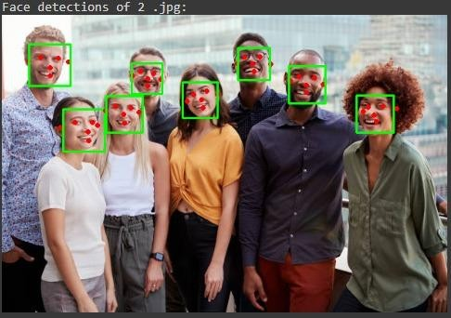

## Pattern Recognition using ML



**2: OpenCV**

* OpenCV is a library of programming functions mainly aimed at real-time computer vision.
* OpenCV is the huge open-source library for the computer vision, machine learning, and image processing and now it plays a major role in real-time operation which is very important in today’s systems. By using it, one can process images and videos to identify objects, faces, or even handwriting of a human. When it integrated with various libraries, such as NumPy, python is capable of processing the OpenCV array structure for analysis. To Identify image pattern and its various features we use vector space and perform mathematical operations on these features.
* Applications of OpenCV: There are lots of applications which are solved using OpenCV, some of them are listed below: -

1. face recognition
2. object recognition
3. Automated inspection and surveillance
4. Sign Language Recognition, etc.

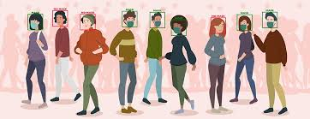

## OpenCV Real Time Image Recognition



**3: Media Pipe**

* + Media Pipe is one of the most widely shared and re-usable libraries for media processing within Google.
  + It aims to make our life easy by providing some integrated computer vision and machine learning features. Media Pipe is a framework for building multi modal (e.g., video, audio or any time series data), cross-platform (i.e., i.e., devices) applied ML pipelines. Media pipe also facilitates the deployment of machine learning technology into demos and applications on a wide variety of different hardware platforms.
  + It effectively manages resources (CPU and GPU) to achieve low latency performance, handles synchronization of time series data such as audio and video frames and more valid reasons why Media Pipe is necessary.
  + Applications
  1. Face Detection
  2. Multi-hand Tracking
  3. Object Detection and Tracking
  4. Objection: 3D Object Detection and Tracking

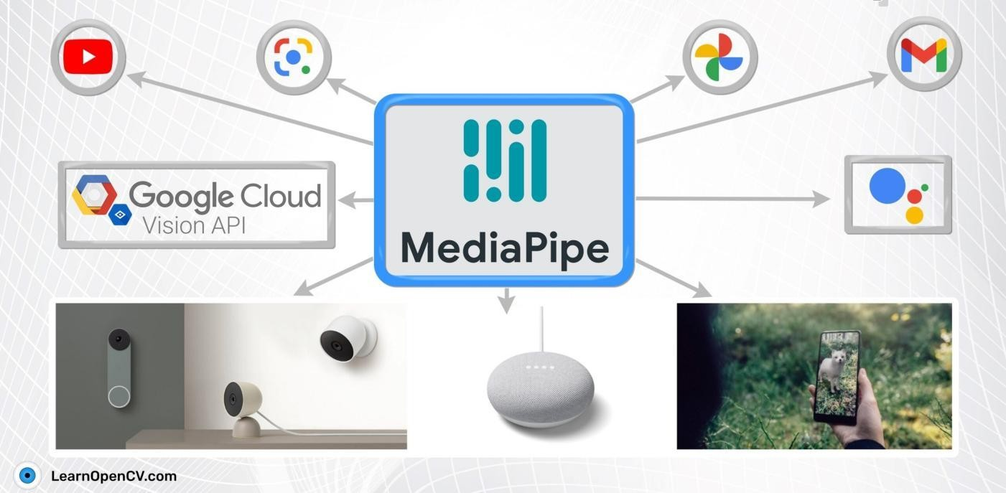

## Media Pipe



**4: TensorFlow**

* + TensorFlow provides a collection of workflows to develop and train models using Python or JavaScript, and to easily deploy in the cloud, in the browser, or on-device no matter what language you use. The **ft.** data API enables you to build complex input pipelines from simple, reusable pieces.
  + TensorFlow provides some special kind of image classification pre-trained and optimized model containing many different kinds of objects. It is powerful to identify hundreds of different kinds of objects that include people, activities, animals, plants and places many more.
  + TensorFlow.js is a JavaScript library to define and operate on Tensors. The main data type in TensorFlow.js is the Tensor.
  + A Tensor is much the same as a multidimensional array.
  + 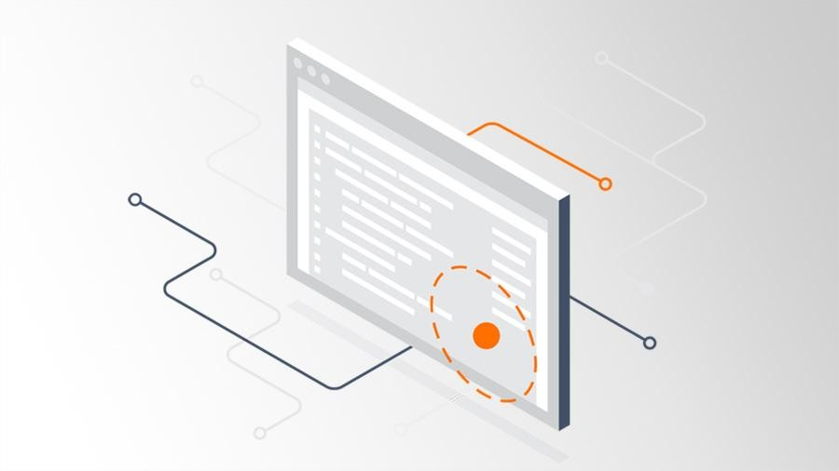Data Types of Tensors
    1. bool
    2. int32
    3. float32 (default)
    4. complex64
    5. string

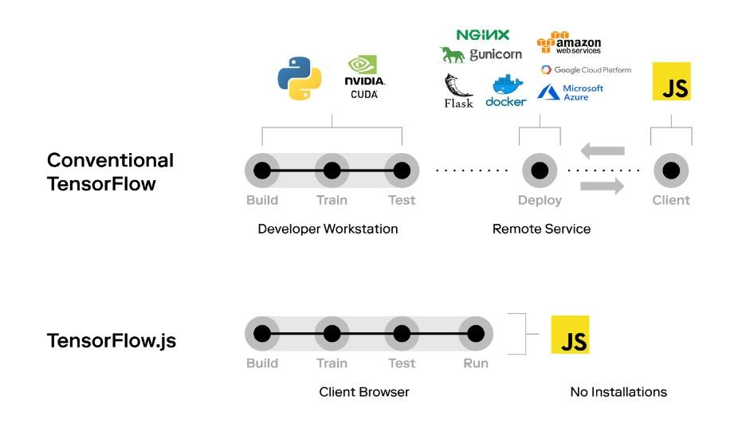



**5: Deep Learning**

* + - Deep learning is based on the branch of machine learning, which is a subset of artificial intelligence. Basically, it is a machine learning class that makes use of numerous nonlinear processing units so as to perform feature extraction as well as transformation
    - Deep learning is implemented with the help of Neural Networks, and the idea behind the motivation of [Neural Network](https://www.javatpoint.com/artificial-neural-network) is the biological neurons, which is nothing but a brain cell.
    - Deep learning is a collection of statistical techniques of machine learning for learning feature hierarchies that are actually based on artificial neural networks.
    - Types Deep Learning Network

1. Feed forward neural Network
2. Recurrent neural Network
3. Convolutional Neural Network
4. Autoencoders

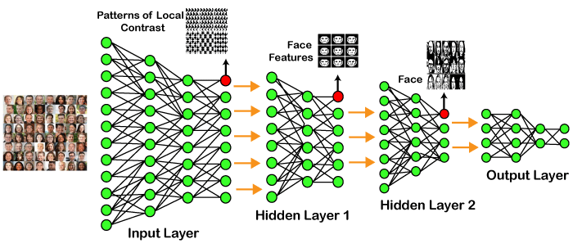



**6: CNN and RNN**

* + **Convolutional Neural Network** is one of the main categories to do image classification and image recognition in neural networks. Scene labeling, objects detections, and face recognition, etc., are some of the areas where convolutional neural networks are widely used.
  + **Recurrent Neural Network (RNN)** is a type of [Neural Network](https://www.geeksforgeeks.org/tag/neural-network/) where the **output from the previous step are fed as input to the current step**. The main and most important feature of RNN is **Hidden state**, which remembers some information about a sequence.

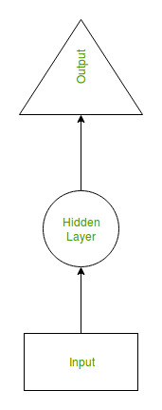 

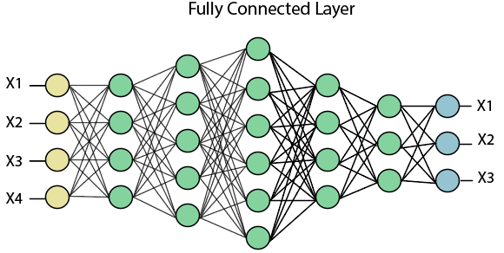



**7: Numpy and matplotlib**

* + NumPy stands for numeric python which is a python package for the computation and processing of the multidimensional and single dimensional array elements.
  + NumPy provides a convenient and efficient way to handle the vast amount of data. NumPy is also very convenient with Matrix multiplication and data reshaping. NumPy is fast which makes it reasonable to work with a large set of data.
  + The **John D. Hunter** originally conceived the matplotlib in **2002**. It has an active development community and is distributed under a **BSD-style license**. Its first version was released in 2003, and the latest **version 3.1.1** is released on **1 July 2019**.

There are three different layers in the architecture of the matplotlib which are the following:

i Backend Layer

ii Artist layer

iii Scripting layer

