Que1: What is software? What is software engineering.

Ans : Software is a set of instruction , data or programs used to operate computers and execute specific task. A device’s running programs, scripts, and applications are collectively referred to as “software” in this context.

Software Engineering : Software engineering is the branch of computer science that deals with the design, development, testing, and maintain of software application.

Que2: Explain types of Software?

Ans: (1) Application Software

(2) System Software

(3) Programming Software

(4) Middleware Software

(1) System Software :

\* Operating system

\* Language Processor

(2) Application software :

\* General purpose software

\* Utility Software

Que3: What is SDLC? Explain each phase of SDLC.

Ans: SDLC means “Software Develop Life Cycle”. It is a structured process that is used to design, develop, and test good- quality software.

There are some steps of SDLC.

1. Planning : Planning is a crucial step in everything , just as a software development.
2. Analysis : This phase involves gathering information about the software requirements from stakeholder, such as customers, and users, and business analysts.
3. Design : In this phase, the software design is created, which includes the overall architecture of the software, Data structure and Interfaces.
4. Implementation : The design is then implemented in code, usually in several iterations and this phase is also called as development.
5. Testing : The software is thoroughly tested to ensure that it meets the requirements and works correctly.
6. Maintenance : This phase includes ongoing support, bug fixes, and updates to the software.

Que4: What is DFD? Create a diagram on Flipkart.

Ans: DFD means “Data Flow Diagram” is a graphical representation that uses a standardized set of symbol and notions to describe a business operation through data movement.

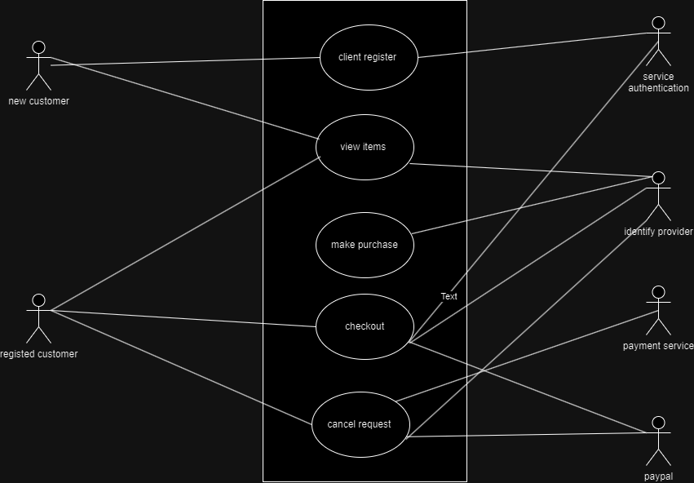

Que5: What is Flowchart? Create a flowchart to make addition of two numbers.

Ans: Flowchart are nothing but the Graphical representation of the data or the algorithm for a better understanding of the code visually.

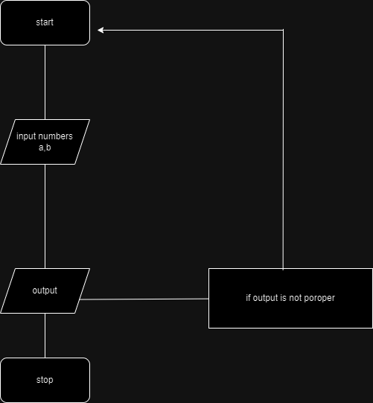

Que6: What is Use Case Diagram? Create a use case diagram on bill payment on paytm.

Ans: A use case diagram is a graphical depiction of a users possible interaction with a system.

