ShopNest E-Commerce Analytics Dashboard
Name: Vinay Giri
Tool Used: Microsoft Power BI
Dataset: ShopNest E-commerce (Anonymized)

1. Introduction
ShopNest is a leading e-commerce marketplace that connects small businesses to customers through a unified platform. This project leverages Power BI to analyze sales performance, delivery efficiency, customer satisfaction, payment behavior, and regional and seasonal trends. The objective is to provide a comprehensive, data-driven dashboard that supports informed business decision-making.

2. Dashboard Overview
The dashboard is designed as a single-page executive report that consolidates key performance indicators (KPIs) and analytical visuals. It enables stakeholders to quickly assess overall performance while also exploring specific operational and sales-related insights.
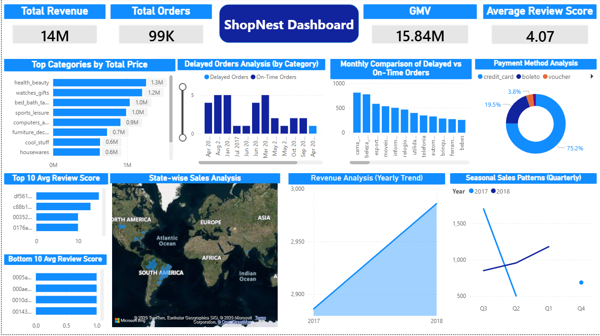

3.1. Top Categories by Total Revenue
Question Statement:
Identify and visualize the top 10 product categories based on total sales value.
Visualization:
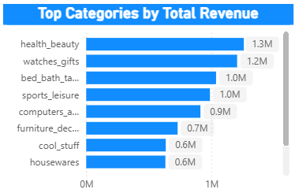
Explanation:
This visualization highlights the top-performing product categories by total revenue, allowing the business to identify key revenue drivers and prioritize high-performing categories.

3.2. Delayed Orders Analysis (By Category)
Question Statement:
Determine the number of delayed orders in each product category, where the actual delivery date exceeds the estimated delivery date.
Visualization:
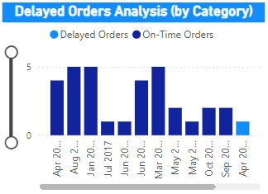
Explanation:
This chart shows how delivery delays vary across product categories, helping identify categories that may require improvements in logistics or supplier coordination.

3.3. Monthly Delayed vs On-Time Orders
Question Statement:
Compare the number of delayed and on-time orders on a monthly basis to evaluate delivery performance trends.
Visualization:
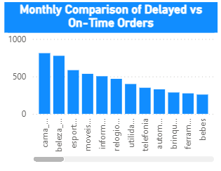
Explanation:
This stacked column chart provides a month-by-month comparison of delayed and on-time orders, revealing trends in delivery efficiency and highlighting periods with higher delays.

3.4. Payment Method Analysis
Question Statement:
Analyze the most frequently used payment methods by customers.
Visualization:
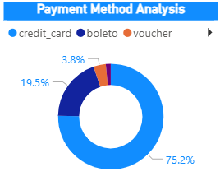
Explanation:
The donut chart displays the distribution of payment methods, showing customer preferences and helping the business optimize payment options and partnerships.

3.5. Customer Satisfaction Analysis (Order-Level)
Question Statement:
Identify the top 10 highest-rated and bottom 10 lowest-rated orders based on customer review scores.
Visualization:
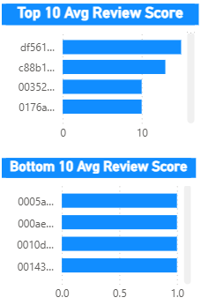
Explanation:
Customer satisfaction is analyzed at the order level using individual review scores, ensuring analytical accuracy since reviews are recorded per order in the dataset.

3.6. State-wise Sales Analysis
Question Statement:
Analyze and visualize sales performance across different states to understand regional contribution.

Visualization:
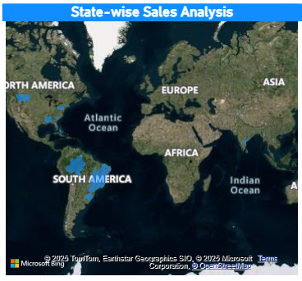
Explanation:
The filled map visual represents state-wise sales distribution, where darker regions indicate higher revenue contribution and help identify key geographic markets.

3.7. Seasonal Sales Patterns (Quarterly)
Question Statement:
Investigate quarterly seasonal patterns and trends in sales data.
Visualization:
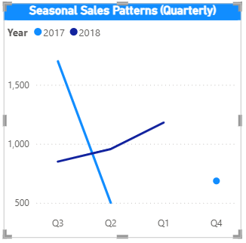
Explanation:
This line chart highlights seasonal fluctuations in sales across quarters, helping identify peak and low-demand periods.

3.8. Revenue Analysis (Yearly Trend)
Question Statement:
Determine the total revenue generated over the years and analyze how it changes annually.

Visualization:
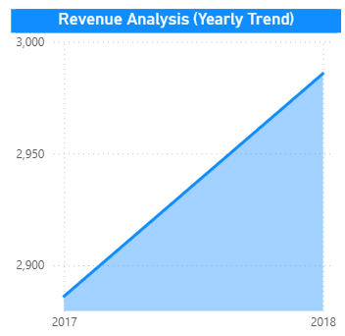
Explanation:
The yearly revenue trend visual shows how ShopNest’s revenue has evolved over time, providing insights into long-term business growth and performance.

4. Conclusion
The ShopNest Power BI dashboard provides a comprehensive overview of business performance by integrating sales, delivery, customer satisfaction, payment behavior, and geographic insights into a single analytical view. This dashboard enables stakeholders to monitor performance, identify improvement areas, and make informed, data-driven decisions.

