**Name: Vinay kumar rao**

**Student ID: 700734549**

**Course: Machine Learning**

**Question 1:**

**By Using NumPy create random vector of size 15 having only Integers in the range 1-20.**

**Output:**

* **Reshape the array to 3 by 5**
* **Print array shape**
* **Replace the max in each row by 0**

**Output:**

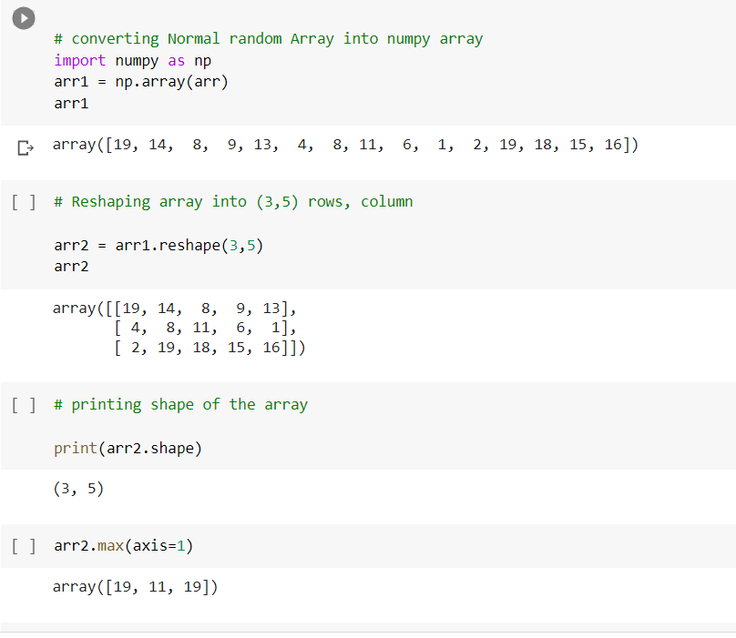

**Question 2:**

* **Read the provided CSV file ‘data.csv’.** [**https://drive.google.com/drive/folders/1h8C3mLsso-R-sIOLsvoYwPLzy2fJ4IOF?usp=sharing**](https://drive.google.com/drive/folders/1h8C3mLsso-R-sIOLsvoYwPLzy2fJ4IOF?usp=sharing%20)
* **Show the basic statistical description about the data.**
* **Check if the data has null values.**
  + **Replace the null values with the mean**
* **Select at least two columns and aggregate the data using: min, max, count, mean.**
* **Filter the dataframe to select the rows with calories values between 500 and 1000.**
* **Filter the dataframe to select the rows with calories values > 500 and pulse < 100.**
* **Create a new “df_modified” dataframe that contains all the columns from df except for “Maxpulse”.**
* **Delete the “Maxpulse” column from the main df dataframe**
* **Convert the datatype of Calories column to int datatype.**
* **Using pandas create a scatter plot for the two columns (Duration and Calories).**

**Output:**

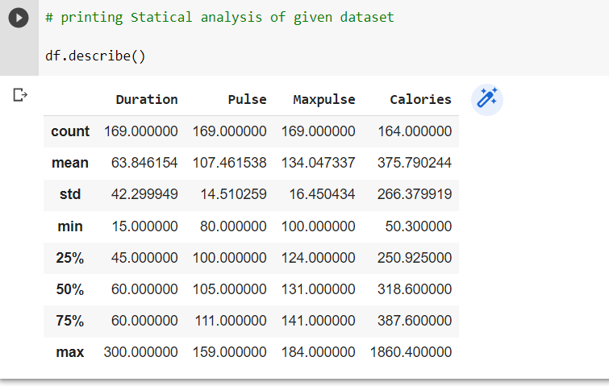

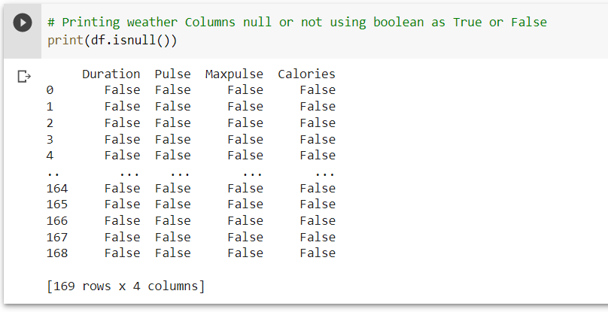

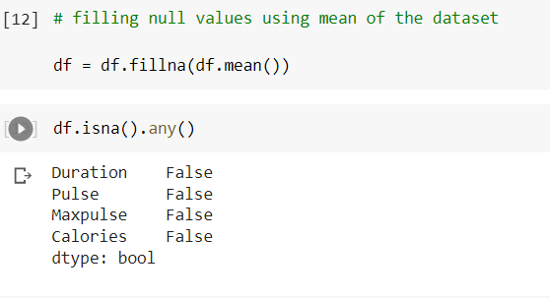

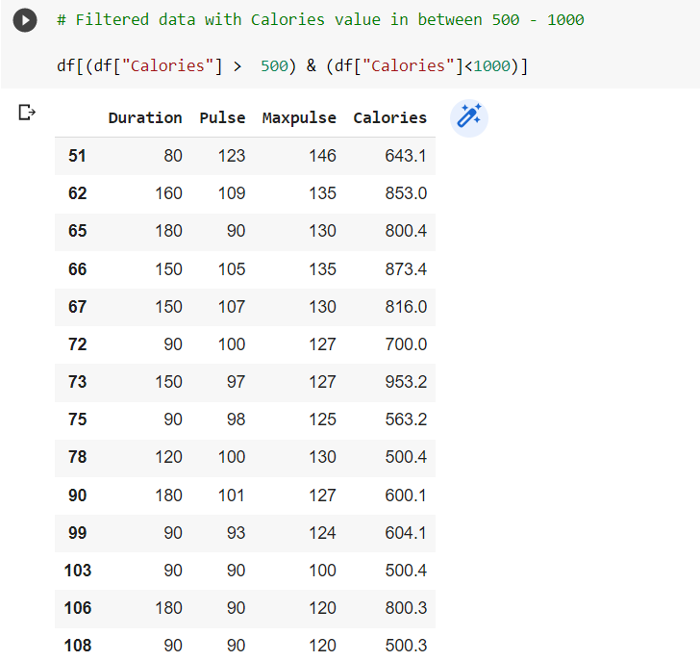

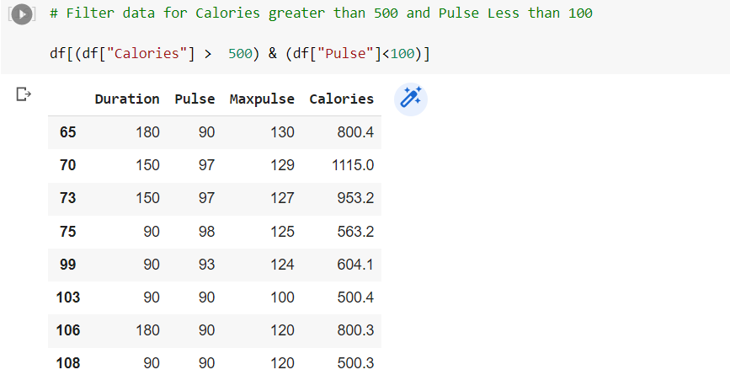

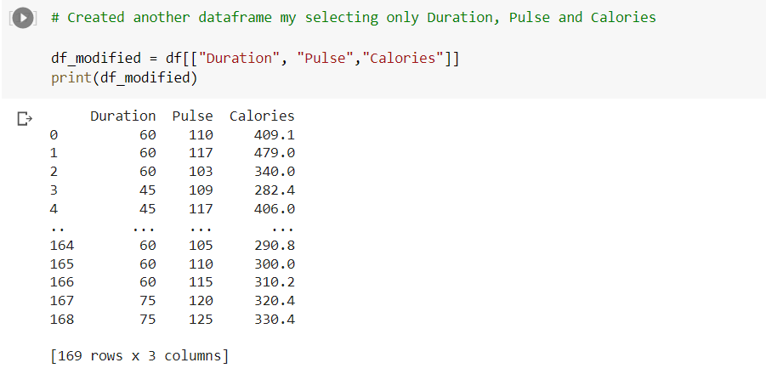

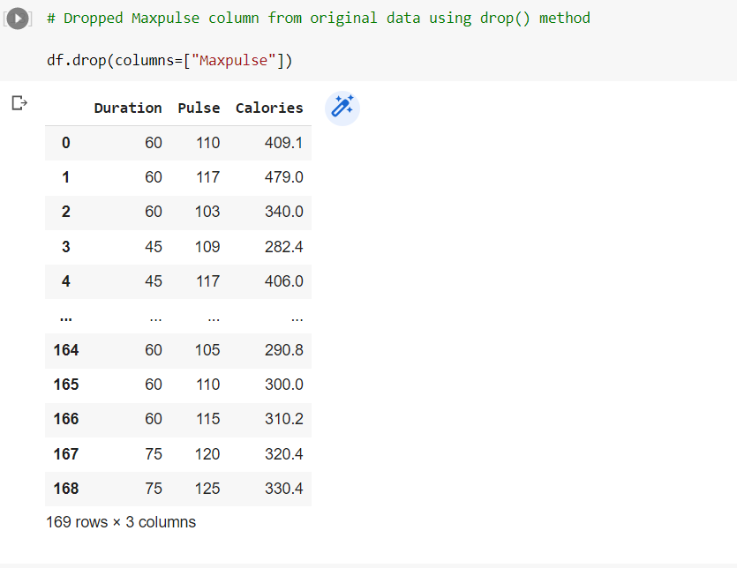

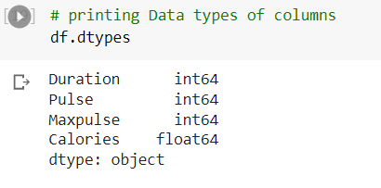

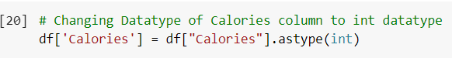

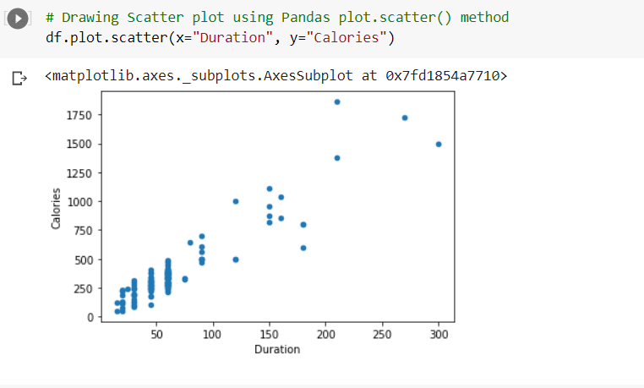

**Question 3:**

**Write a Python programming to create a below chart of the popularity of programming Languages.**

**Sample data: Programming languages: Java, Python, PHP, JavaScript, C#, C++ Popularity: 22.2, 17.6, 8.8, 8, 7.7, 6.7**

