**Name: Vinay kumar rao**

**Student ID: 700734549**

**Course: Machine Learning**

Github Link: <https://github.com/vinay779/assignment_3.git>

Video link: <https://youtu.be/lJcVYRjdTK4>

**Finding the correlation between ‘survived’ (target column) and ‘sex’ column for the Titanic use case in class.**

**At least two visualizations to describe or show correlations**

**Implement Naïve Bayes method using scikit-learn library and report the accuracy**

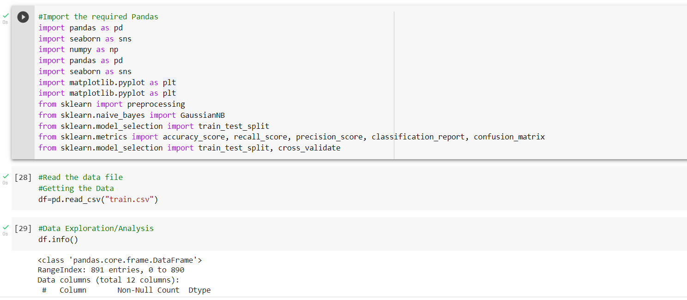

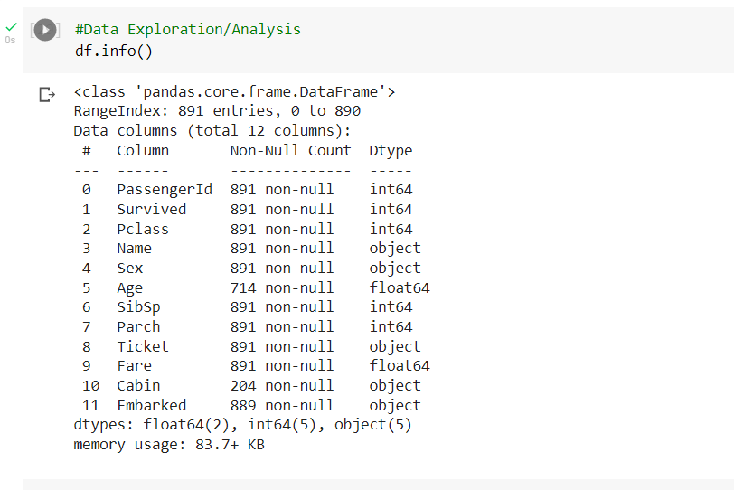

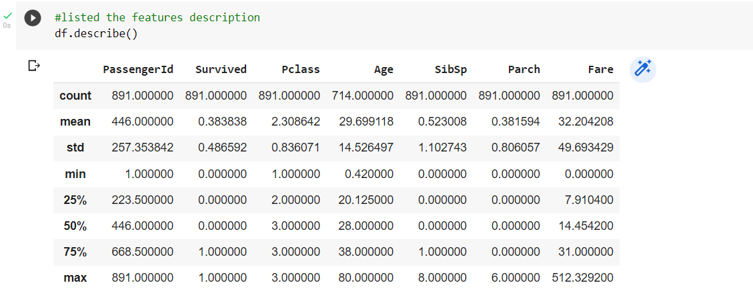

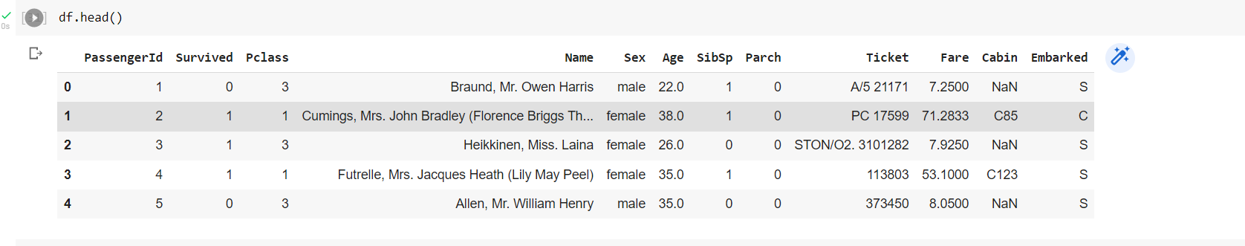

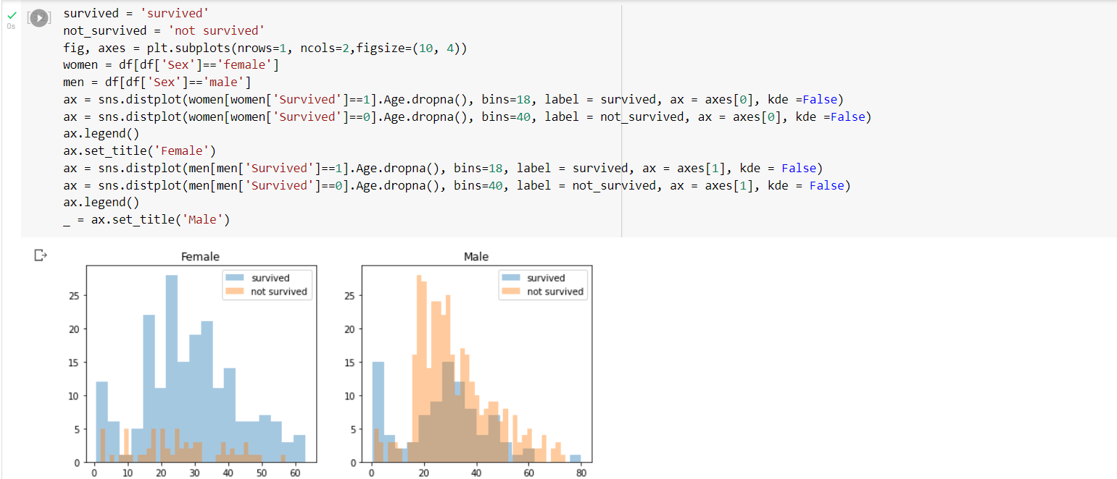

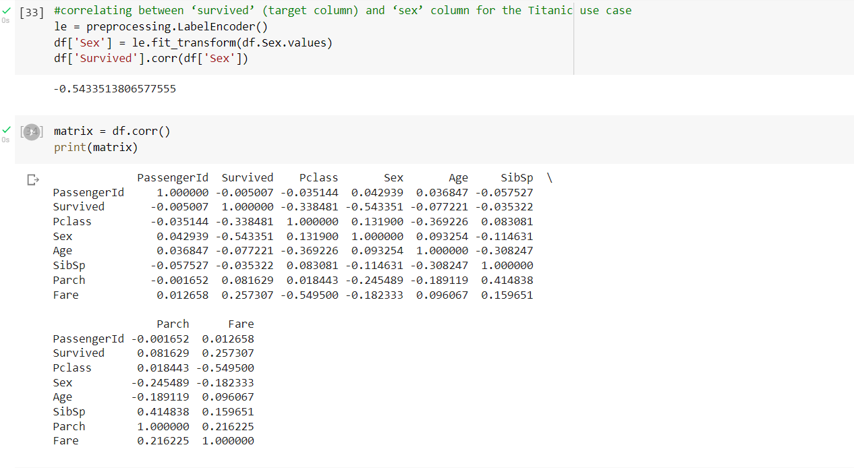

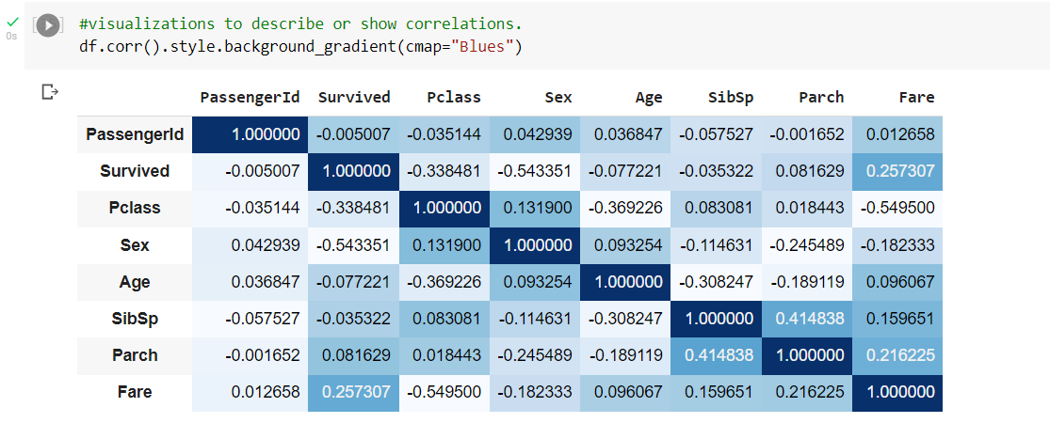

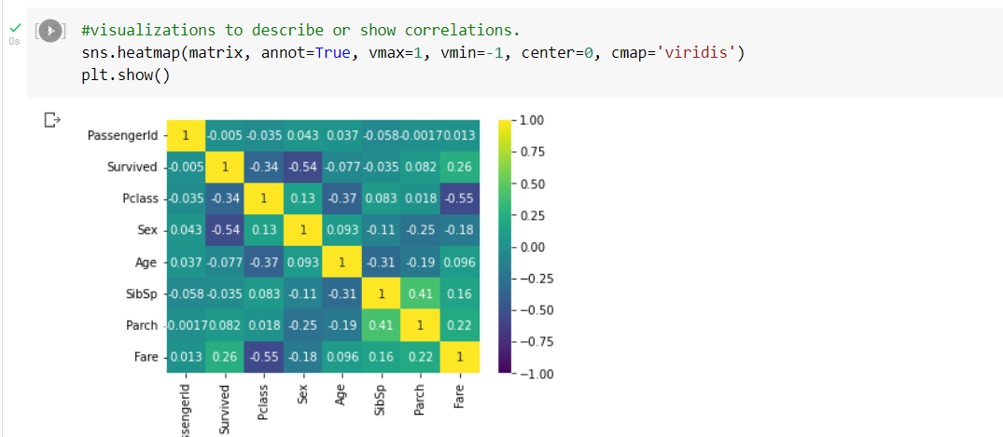

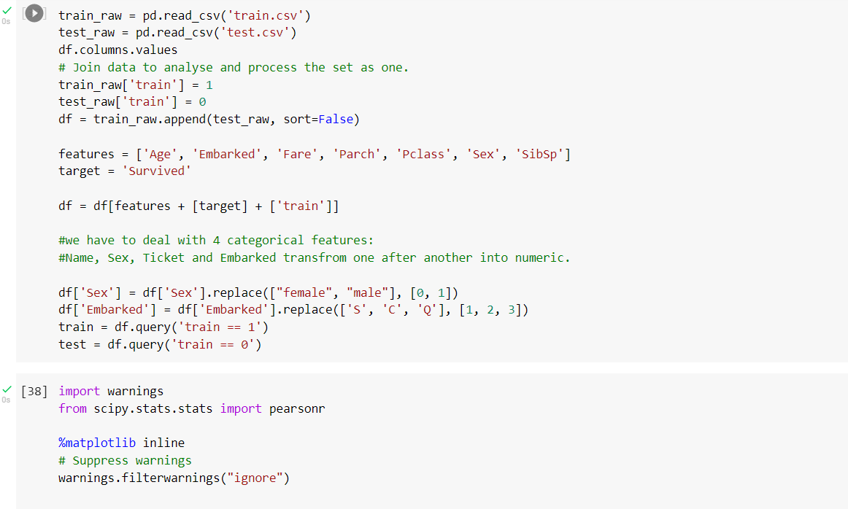

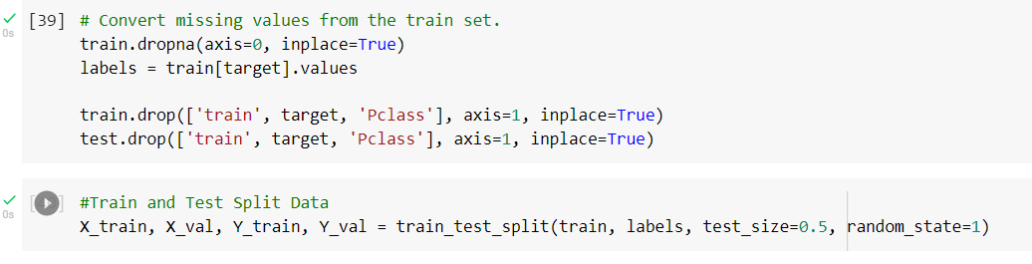

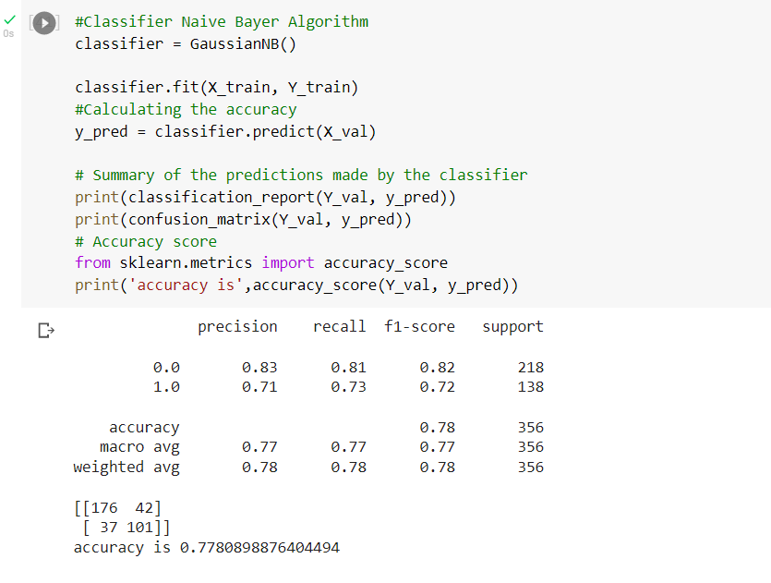

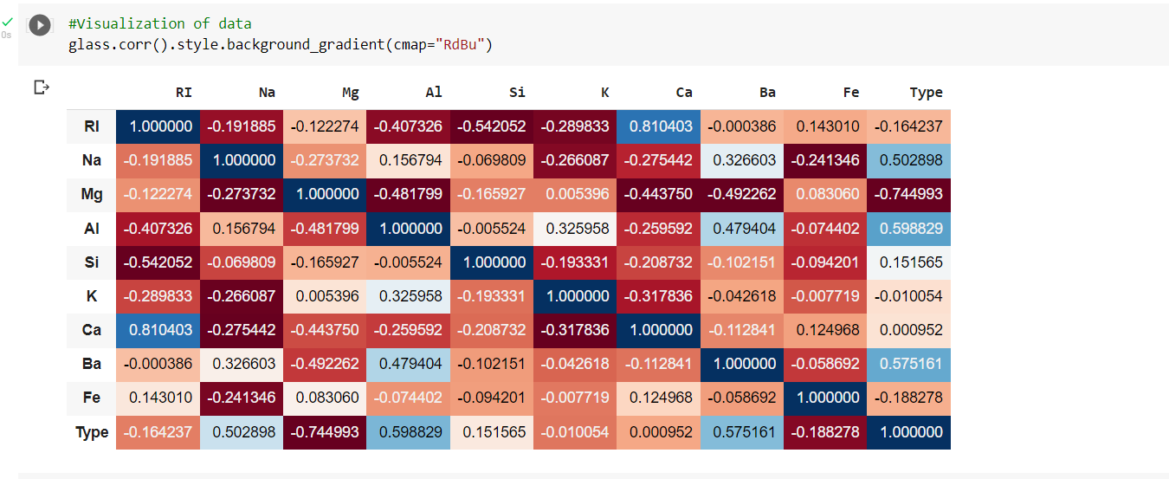

**Question 2:**

**Implementing Naïve Bayes method using scikit-learn library**

**Implement linear SVM method using scikit library**

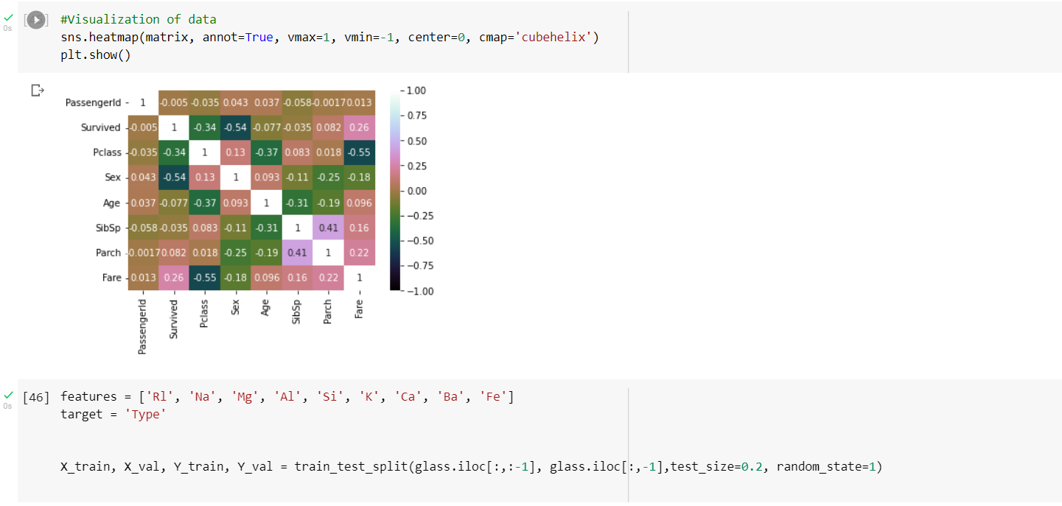

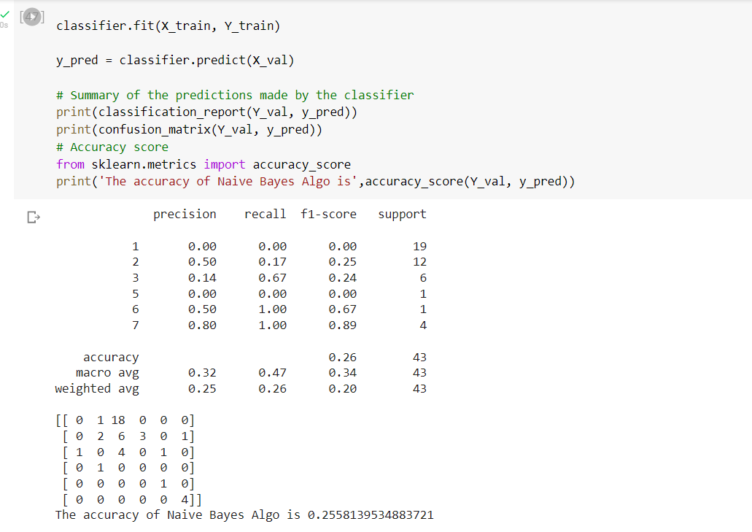

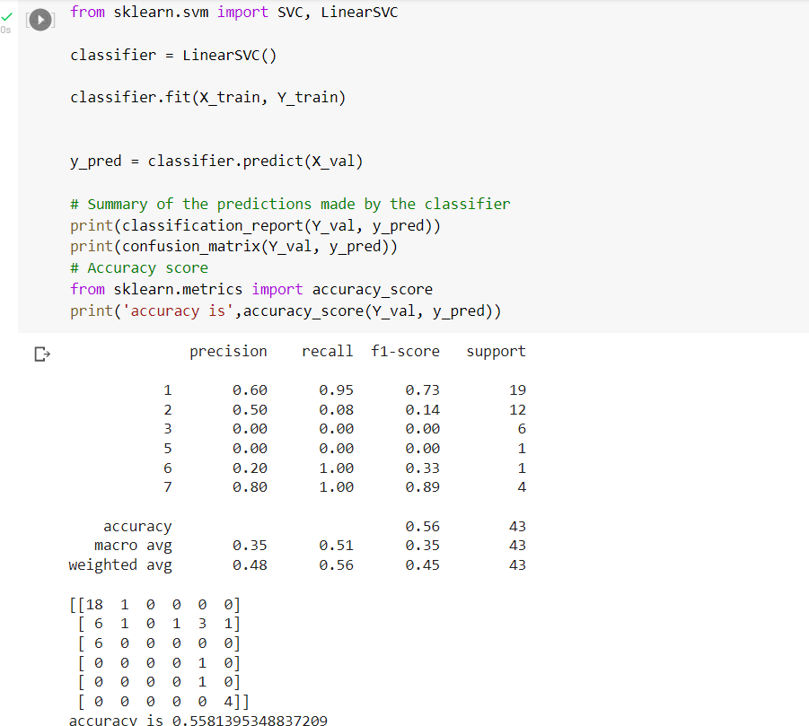

**For Glass data set linear SVM will perform better than Gaussian NB model because Naive Bayes is a probabilistic model where it assumes each feature as a individual feature while the linear SVM builds linear relationship between each feature.**

**Therefore SVM performs well on this non linear data set.**

**SVM generalizes well for non linear data.**