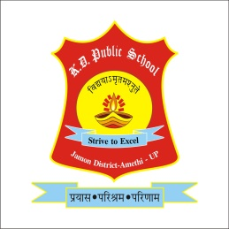

K. D. PUBLIC SCHOOL

Jamon- Amethi

**Teacher’s Registration Form**

**Personal Information**

Name: ........................................................................

Gender: ....................Date of birth: ……....................

Mobile No: ...................................................................

Your preferable teaching area: ....................................................................

Class you can teach: Up to 5th Up to 8th

Subjects you can teach: ...............................................................................

Any experience of teaching: ........................................................................

Qualification:

10th - Board: ........................ Science/ Art: ............................... Percentage: ...........

12th - Board: ........................ Science/Art/Commerce: .............. Percentage: ...........

Graduation: Institute/College: ......................... Subjects: ...........................................

PG/Diploma/Certificate course: ............................................ (B.Ed./BTC/D.EL.ED)

Last institute of your job: ......................................... Last Salary: .............per month

Expected salary at KDPS: ............................. (per month)

How do you find us: .....................................................................

(eg. Friends, internet, website, colleague, newspaper.)