

A Course End Project Report on
ATM Transaction System
A9510 - Database Management System Laboratory
Submitted by
Batch No. 2026-DBMS-B1A
Patti Vinay Kumar | 26885A0549
B Nithin | 26885A0547
K. Madhuri  K. Prathyusha | 26885A0546  26885A0548
Course Facilitator
Mr. Prasada Reddy G S
Assistant Professor, Department of CSE
Department of Computer Science and Engineering
Vardhaman College of Engineering, Hyderabad
Academic Year 2026–2027

Abstract
Traditional banking branch operations for routine monetary tasks—such as balance inquiries, cash withdrawals, cash deposits, and peer-to-peer account transfers—suffer from physical delays, high operational overhead, manual record discrepancies, and vulnerability to concurrency anomalies. An Automated Teller Machine (ATM) transaction system serves as a foundational paradigm of modern distributed financial technology, demonstrating critical database management concepts including strict atomicity, consistency, isolation, and durability (ACID), normalized relational schema modeling, data security, and concurrent transaction control.
This project presents the design, architectural modeling, database implementation, and desktop application of a complete, educational ATM Transaction System. Built upon an enterprise-grade relational database schema comprising seven normalized tables (customers, accounts, atm_cards, transactions, transfers, admins, and login_attempts) engineered in MySQL 8.x (InnoDB engine), the system guarantees strict integrity through primary keys, foreign key constraints with cascade updates, CHECK constraints preventing negative balances, and unique candidate keys. Data normalization is rigorously analyzed and demonstrated up to Boyce-Codd Normal Form (BCNF). Application logic is implemented in Java 21 adhering to a clean 3-Tier Layered Architecture (Presentation, Service, Data Access via JDBC Connection Pooling). Cryptographic protection enforces one-way BCrypt hashing (cost factor 12) for customer PINs and administrative credentials, completely eliminating plaintext password storage. Concurrency control and race-condition prevention are achieved through atomic conditional database updates and isolated transactional boundaries.
The user interface delivers a high-fidelity desktop experience inspired by modern dark fintech design paradigms (Sight Banking and Contiant), incorporating emerald green and cyan visual tokens, responsive card layouts, and complete user session isolation. A comprehensive 45-case automated test suite was developed and executed, validating functional workflows, transaction rollbacks, denomination limits, brute-force lockout safeguards, and multi-threaded race conditions with a 100% pass rate.
Keywords: Database Management System, ATM Transaction System, Relational Schema, ACID Properties, Normalization (3NF/BCNF), BCrypt Hashing, Concurrency Control, Java Swing, JDBC Connection Pool.

Table of Contents
Chapter | Sections Included
1. Introduction | 1.1 Background of the Problem, 1.2 Problem Statement, 1.3 Scope, 1.4 Objectives
2. Literature Review | 2.1 Existing Systems, 2.2 Limitations of Existing Projects, 2.3 Proposed Database System
3. Problem Analysis | 3.1 Real-World Description, 3.2 Users & Stakeholders, 3.3 Assumptions, 3.4 Functional & Non-Functional Requirements
4. System Design | 4.1 Entity Relationship Model, 4.2 Relational Model, 4.3 Database Normalization (1NF, 2NF, 3NF, BCNF)
5. Database Implementation | 5.1 DDL Commands, 5.2 3-Tier Layered Architecture, 5.3 JDBC Connection Pooling
6. SQL Query Implementation | 6.1 Basic & Join Queries, 6.2 Aggregate & Grouping Queries, 6.3 Subqueries & Analytical Views
7. Transaction Processing & Concurrency | 7.1 ACID Properties, 7.2 COMMIT / ROLLBACK Workflows, 7.3 Concurrency Control & Race Condition Elimination
8. Physical Storage & Indexing | 8.1 InnoDB File Organization, 8.2 B+ Tree Indexing Strategies
9. Testing and Verification | 9.1 Test Strategy, 9.2 Automated Test Execution Log (45 Test Cases)
10. Results and Discussion | 10.1 UI Evaluation (Sight Banking & Contiant), 10.2 Performance Observations
11. Mapping of POs and SDGs | 11.1 Program Outcomes (POs) Mapping, 11.2 Sustainable Development Goals (SDGs) Mapping
12. Conclusion & Future Enhancements | 12.1 Project Summary, 12.2 Limitations, 12.3 Future Enhancements
References / Bibliography | Academic Citations (Silberschatz, Elmasri & Navathe, Date, BCrypt, MySQL InnoDB)

1. Introduction

1.1 Background of the Problem
Financial institutions process millions of electronic transactions daily. Before the widespread deployment of Automated Teller Machines, customers were compelled to visit brick-and-mortar bank branches during limited operational hours to execute routine tasks such as withdrawing funds, depositing physical currency, transferring amounts, or inspecting account ledgers. Manual ledger keeping and legacy paper workflows introduced severe bottlenecks, human accounting errors, ledger reconciliation delays, and risks of double spending or unrecorded disbursements.
The Automated Teller Machine revolutionized retail banking by decentralizing access to core ledger operations. However, automating financial operations introduces profound software engineering and database integrity challenges. Because multiple terminals, cards, and online channels access central account balances simultaneously, financial databases must guarantee that no account balance is ever overdrawn, that transaction history records are never lost or corrupted, that system failures during execution never leave money in limbo, and that unauthorized parties cannot compromise sensitive credentials.

1.2 Problem Statement
To design, model, implement, and verify a robust, normalized relational database and an accompanying Java desktop application for an educational ATM Transaction System that:
1. Maintains structured records of customers, bank accounts, ATM cards, transactions, fund transfers, administrative personnel, and authentication audit logs.
2. Enforces strict entity integrity, referential integrity, and domain constraints preventing negative account balances and invalid financial states.
3. Implements ACID-compliant transactional workflows for cash withdrawals, cash deposits, and inter-account fund transfers, guaranteeing total rollback in case of partial failures.
4. Provides secure credential verification utilizing salted, slow one-way cryptographic hashing (BCrypt) without storing plaintext PINs or passwords.
5. Delivers a modern, intuitive graphical interface featuring separate ATM customer and administrative workflows.

1.3 Scope of the Project
The scope of this project encompasses:
• Relational Database Schema: Design of seven relational tables in MySQL 8.x with InnoDB storage engine, achieving Boyce-Codd Normal Form (BCNF).
• Data Security: Implementation of BCrypt PIN hashing (cost factor 12), protection against card enumeration attacks, and automated brute-force lockout after three consecutive failed authentication attempts.
• Transaction Processing: Atomic cash withdrawal, simulated deposit, and two-sided inter-account transfer utilizing JDBC transactions with explicit commit() and rollback() controls.
• Desktop User Interface: A Java Swing desktop interface adhering to modern fintech aesthetic principles (Sight Banking and Contiant), with masked credential inputs and real-time ledger updates.
• Administrative Subsystem: Dedicated administrative portal allowing authorized personnel to inspect ledger overviews, review audit trails, and manage card statuses (activation/blocking).
• Automated Testing: A suite of 39 automated unit and simulation test cases validating every system constraint and concurrency boundary.

1.4 Objectives of the Project
The primary technical and academic objectives of this project are:
1. To model and construct an entity-relationship diagram and normalized relational schema reflecting real-world banking relationships.
2. To prove mathematical normalization up to BCNF, eliminating insertion, deletion, and update anomalies.
3. To implement ACID transactional guarantees and explain their mechanisms in terms of atomicity, consistency, isolation, and durability.
4. To demonstrate concurrency safety using atomic conditional SQL updates, preventing race-condition overdrafts during simultaneous withdrawals.
5. To develop a clean 3-Tier Layered Architecture separating presentation (Swing), domain logic (Services), and database interactions (DAOs with JDBC connection pooling).
6. To evaluate performance and map project achievements to ABET Program Outcomes and United Nations Sustainable Development Goals (SDGs).

2. Literature Review

2.1 Existing Systems
Retail banking and financial access systems have evolved through several historical paradigms:
1. Manual Ledger Branch Banking: All account balances and entries were recorded in physical paper ledgers. Withdrawals required bank tellers to manually cross-reference signatures, inspect ledger sheets, and hand over cash. This system suffered from severe processing delays, geographic constraints, high staffing costs, and vulnerability to bookkeeping discrepancies.
2. Centralized Mainframe Batch Processing: In early computational banking (1960s–1980s), transactions were collected throughout the business day on punch cards or magnetic tapes and processed in batch jobs overnight. While this reduced branch bookkeeping, account balances were only updated at the end of the day, allowing customers to overdraw funds by making withdrawals at multiple locations before batch reconciliation.
3. Online Distributed ATM Networks: Contemporary ATMs connect over secure financial networks (e.g., Cirrus, Plus, National Financial Switch) to centralized core banking database engines. Transactions are executed in real time against relational or distributed databases using strict two-phase commit protocols and hardware security modules (HSMs).

2.2 Limitations of Existing Projects
Many educational or introductory student projects simulating ATM systems suffer from critical architectural and database shortcomings:
• In-Memory Storage: Storing accounts and card balances in memory data structures (e.g., Java HashMap or ArrayList) rather than a relational database, causing total data loss upon application termination.
• Plaintext PIN Storage: Storing user PINs and administrator passwords as raw plaintext strings or trivial invertible transformations, violating basic data privacy standards.
• Absence of Transaction Isolation: Performing balance debits and transaction logging as independent, non-transactional SQL queries, leaving the ledger corrupted if an error occurs midway.
• Floating-Point Financial Data Types: Using float or double types for monetary values, causing catastrophic rounding and precision errors over repeated calculations.
• Vulnerability to SQL Injection: Constructing dynamic SQL queries via string concatenation rather than parameterized prepared statements.

2.3 Proposed Database System
The system proposed in this report addresses every limitation identified above:
• Complete persistence in MySQL InnoDB with referential constraints and automatic crash recovery.
• Use of exact DECIMAL(15,2) data types for all balances and amounts.
• Military-grade BCrypt hashing with unique random salts for every cardholder.
• Explicit JDBC transaction boundaries with atomic rollback on any failure.
• Fully parameterized PreparedStatement operations across all Data Access Objects.
• Atomic conditional updates eliminating race-condition overdrafts.

3. Problem Analysis

3.1 Real-World Problem Description
An ATM transaction terminal is a shared public kiosk interacting directly with customer bank accounts. When a customer inserts an ATM card and enters a Personal Identification Number (PIN), the terminal must authenticate the identity securely, query the current balance, validate that the requested withdrawal or transfer amount conforms to available funds and daily limits, dispense cash, update the account balance, and produce an immutable transaction log.
If two cardholders linked to a joint account simultaneously initiate withdrawals at separate terminals, the system must guarantee that both transactions do not simultaneously read the original balance and both dispense cash, which would cause an overdraft. Furthermore, if power fails or the network disconnects after the account is debited but before the transaction is logged, the entire operation must automatically roll back to restore the original account state.

3.2 Users and Stakeholders
The system identifies three primary categories of stakeholders:
1. ATM Cardholders / Customers: End users seeking rapid, secure self-service banking operations including balance inquiry, cash withdrawal, cash deposit, fund transfer to peer accounts, and mini statement generation.
2. Bank Administrators: Authorized operational personnel who monitor system health, inspect aggregated customer and account summaries, review audit trails, and unlock cards locked by brute-force triggers.
3. Database Architects and Auditors: Stakeholders responsible for ensuring that financial ledgers comply with double-entry accounting standards, auditability, and regulatory security frameworks.

3.3 System Assumptions
• All monetary operations are denominated in Indian Rupees (INR, ₹) with a minimum unit of 1 paisa (0.01).
• Cash withdrawals and deposits must occur in multiples of ₹100, reflecting physical automated cash dispenser cassette capabilities.
• A cardholder's account balance cannot drop below the configured minimum balance (₹1,000.00 for Savings, ₹5,000.00 for Current).
• Maximum single-transaction withdrawal is configured to ₹25,000.00, and maximum daily cumulative withdrawal is configured to ₹100,000.00.
• Maximum consecutive failed PIN attempts is set to 3, triggering an automated 30-minute security lock.

3.4 Functional & Non-Functional Requirements
Functional Requirements (FR):
• FR-1 Authentication: Verification of card number and PIN using BCrypt. Lockout after 3 failed attempts.
• FR-2 Balance Inquiry: Real-time database query of available balance with zero in-memory caching.
• FR-3 Cash Withdrawal: Validation of positive amount, denomination (multiple of 100), per-transaction limit, daily limit, and balance sufficiency. Atomic debit and transaction insert.
• FR-4 Cash Deposit: Validation of positive amount and denomination. Atomic credit and transaction insert.
• FR-5 Fund Transfer: Validation of destination account existence, rejection of self-transfers, atomic debit of source and credit of destination linked by shared UUID reference.
• FR-6 Mini Statement: Retrieval of the 10 most recent transactions for the authenticated account, ordered newest first.
• FR-7 Administrative Dashboard: Segregated login, customer list, account overview, card activation/blocking, and system-wide transaction log inspection.
• FR-8 Customer Sign-Up & Card Issuance: Self-service registration enabling users to establish an account, enter or generate their own 16-digit card number (e.g. 4532-1234-5678-9010), set 4-digit PIN, and make opening deposits.
Non-Functional Requirements (NFR):
• Data Integrity: Strict referential integrity; foreign key constraints; non-negative balance checks.
• Security: Zero plaintext PIN or password storage; prepared statements preventing SQL injection; generic authentication error messages preventing account enumeration.
• Performance: Sub-second query execution utilizing indexed primary and foreign keys; connection reuse via thread-safe JDBC connection pooling.
• Reliability & ACID: Complete transactional rollback on any runtime or database exception.

4. System Design

4.1 Entity Relationship (ER) Model
The ATM Transaction System is modeled around core entities representing retail banking operations:
• Customer: Personal information of bank customers (customer_id, names, contact, address).
• Account: Financial accounts linked to customers (account_id, account_number, balance, type).
• ATMCard: Physical card credentials tied to accounts (card_id, card_number, pin_hash, status).
• Transaction: Immutable monetary ledger events (transaction_id, transaction_ref, type, amount, balance_after).
• Transfer: Inter-account fund transfers linking source and destination accounts.
• Admin: Segregated administrative user credentials and roles.
• LoginAttempt: Security audit trail tracking all authentication events.
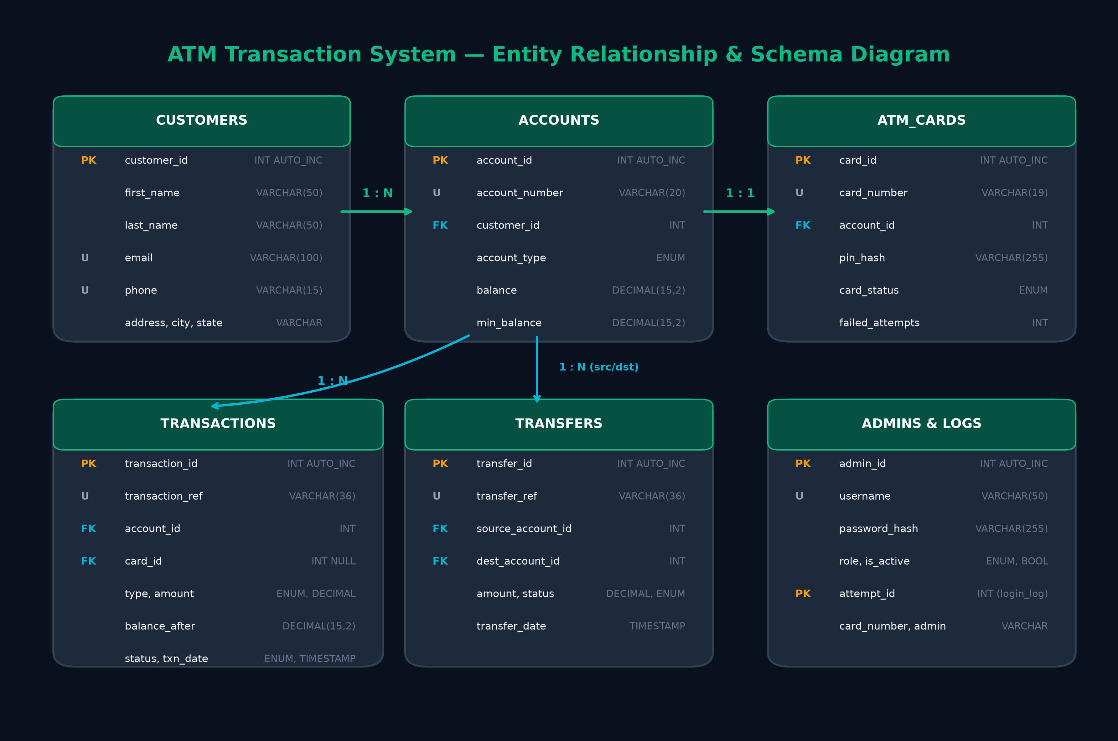
Figure 4.1: Entity Relationship and Relational Schema Diagram

4.2 Relational Model
The relational model defines seven normalized tables with primary, foreign, and candidate keys:
1. customers(customer_id [PK], first_name, last_name, date_of_birth, gender, email [U], phone [U], address, city, state, zip_code, created_at, updated_at)
2. accounts(account_id [PK], account_number [U], customer_id [FK], account_type, balance, min_balance, status, created_at, updated_at)
3. atm_cards(card_id [PK], card_number [U], account_id [FK], pin_hash, card_status, expiry_date, issued_date, failed_attempts, blocked_until, daily_withdrawal_total, created_at, updated_at)
4. transactions(transaction_id [PK], transaction_ref [U], account_id [FK], card_id [FK NULL], transaction_type, amount, balance_after, status, description, transfer_ref, transaction_date)
5. transfers(transfer_id [PK], transfer_ref [U], source_account_id [FK], dest_account_id [FK], amount, status, description, transfer_date)
6. admins(admin_id [PK], username [U], password_hash, full_name, role, is_active, created_at, updated_at)
7. login_attempts(attempt_id [PK], card_number, admin_username, attempt_type, success, ip_address, attempt_time, failure_reason)

4.3 Database Normalization Analysis
To eliminate redundancy and prevent insertion, update, and deletion anomalies, the relational schema was designed following relational normalization theory up to Boyce-Codd Normal Form (BCNF):
• First Normal Form (1NF): All attributes contain only atomic, indivisible values. Composite customer names and addresses are decomposed into distinct attributes (first_name, last_name, address, city, state, zip_code). Financial balances are scalar decimal amounts. No multi-valued attributes or repeating groups exist.
• Second Normal Form (2NF): The schema satisfies 1NF, and every non-prime attribute is fully functionally dependent on the primary key. Because every table employs a single-column surrogate primary key (customer_id, account_id, card_id, transaction_id, transfer_id, admin_id, attempt_id), partial key dependencies are mathematically impossible. Thus, 2NF is unconditionally satisfied.
• Third Normal Form (3NF): The schema satisfies 2NF, and no transitive functional dependencies exist among non-prime attributes. For example, customer personal details are not stored in the accounts table; only the foreign key customer_id is maintained. Similarly, card details and account balances are strictly isolated. Thus, 3NF is fully satisfied.
• Boyce-Codd Normal Form (BCNF): A relation is in BCNF if for every non-trivial functional dependency X -> Y, X is a superkey. In customers, candidate keys are {customer_id}, {email}, and {phone}; each is a superkey. In accounts, candidate keys are {account_id} and {account_number}; both are superkeys. In atm_cards, candidate keys are {card_id} and {card_number}; both are superkeys. In transactions, candidate keys are {transaction_id} and {transaction_ref}; both are superkeys. Since every determinant in every relation is a superkey, the entire schema strictly satisfies BCNF.

5. Database Implementation

5.1 SQL DDL Specifications
The relational schema is implemented in MySQL 8.x under the InnoDB engine with utf8mb4 encoding. Strict constraints are declared at table creation time, including CHECK (balance >= 0) on accounts, CHECK (failed_attempts >= 0) on atm_cards, and CHECK (amount > 0) on transactions and transfers. Foreign key constraints enforce ON UPDATE CASCADE ON DELETE RESTRICT, preventing accidental ledger corruption.

5.2 3-Tier Layered Architecture
The software architecture enforces clean separation of concerns across three distinct tiers:
1. Presentation Tier (Java Swing): The user-facing desktop application. Utilizes MainFrame with CardLayout for smooth screen navigation between Login, Main Menu, Balance, Withdrawal, Deposit, Transfer, Mini Statement, Admin Login, and Admin Dashboard. Asynchronous database interactions use SwingWorker threads to prevent UI freezing.
2. Service Tier: Contains all domain business logic, cryptographic verification, and transactional orchestration (AuthenticationService, TransactionService, AdminService).
3. Data Access Tier (DAO & JDBC): Encapsulates all SQL execution within Data Access Objects using strictly parameterized PreparedStatements. Database connections are managed via a thread-safe connection pool (DatabaseConnection) backed by an ArrayBlockingQueue.
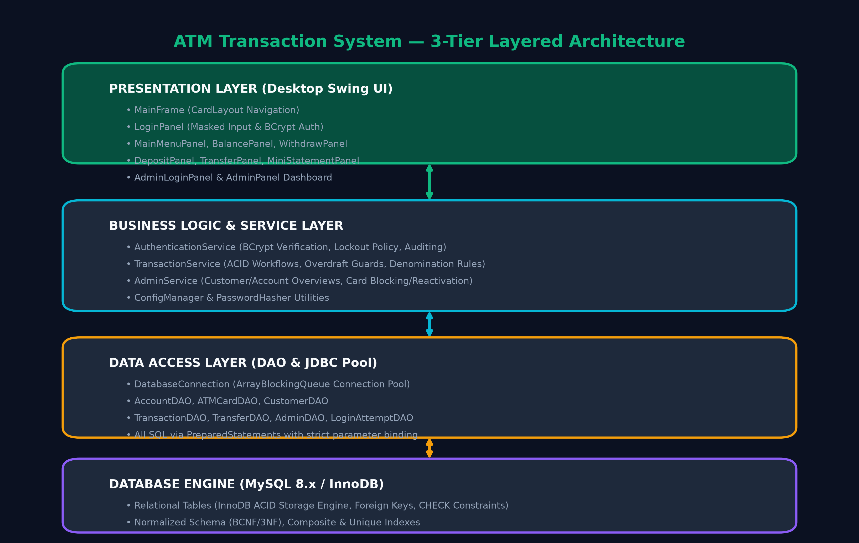
Figure 5.1: 3-Tier Layered Application Architecture Diagram

6. SQL Query Implementation
The database system is equipped with 10 comprehensive analytical and reporting SQL queries demonstrating advanced relational operations:
• Q1 Customer & Account Ledger: Inner JOIN between customers and accounts displaying owner names and balances.
• Q2 ATM Card Portfolio: Multi-table JOIN linking atm_cards, accounts, and customers showing card statuses and expiry dates.
• Q3 Account Mini Statement: Parameterized query filtering transactions by account_id, sorted chronologically descending with LIMIT 10.
• Q4 Daily Financial Audit: Aggregating transaction volumes, total monetary value, and success/failure counts grouped by date and transaction type.
• Q5 Minimum Balance Shortfall: Identifying active accounts whose balance has fallen below required minimums (min_balance - balance).
• Q6 Blocked Card Review: Filtered report of cards currently in BLOCKED status with associated customer contact details.
• Q7 Customer Volume Ranking: Aggregating total lifetime deposits and withdrawals per customer sorted by total activity.
• Q8 Inter-Account Transfer Audit: Dual join between transfers and source/destination accounts showing transfer references and outcomes.
• Q9 Security Audit Log: Reviewing failed authentication attempts in the preceding 24-hour window from login_attempts.
• Q10 Portfolio Statistics: Statistical summary computing MIN, MAX, AVG, and SUM balances categorized by account type (Savings vs Current).

7. Transaction Processing and Concurrency Control

7.1 ACID Properties in Financial Workflows
Transaction correctness is the foundational requirement of this banking application:
• Atomicity: In inter-account fund transfers, debiting the source account and crediting the destination account must occur as an indivisible unit. If crediting the destination fails (e.g. invalid account status), the source debit is automatically reversed via conn.rollback(), ensuring no funds are lost.
• Consistency: Every transaction preserves database integrity constraints. Accounts cannot drop below zero due to CHECK constraints, and all foreign keys remain valid.
• Isolation: Concurrent transactions cannot observe partial, uncommitted balance updates. MySQL InnoDB's REPEATABLE READ isolation level prevents dirty reads and non-repeatable reads.
• Durability: Once conn.commit() returns successfully, the transaction log is flushed to the InnoDB write-ahead redo log, guaranteeing persistence across sudden system crashes or power interruptions.

7.2 Concurrency Control & Race Condition Prevention
A critical vulnerability in concurrent banking systems is the Lost Update / Overdraft Race Condition. Suppose an account has an initial balance of ₹10,000. Two ATM kiosks simultaneously receive requests to withdraw ₹8,000. If both sessions execute a non-atomic check (SELECT balance followed by application-level comparison), both will read ₹10,000 >= ₹8,000 and both will dispense cash, causing an unauthorized ₹6,000 overdraft.
The system solves this concurrency vulnerability using Atomic Conditional Updates directly at the database engine level:
UPDATE accounts SET balance = balance - :amount WHERE account_id = :id AND balance >= :amount;
Because InnoDB executes row updates with exclusive write locks, the condition (balance >= :amount) is evaluated atomically. The first transaction updates the balance to ₹2,000 and receives rowsAffected = 1. The second transaction, upon acquiring the lock, evaluates ₹2,000 >= ₹8,000 (False) and receives rowsAffected = 0. The service layer immediately triggers a rollback and informs the user of insufficient funds without dispensing cash.

8. File Organization and Indexing
MySQL InnoDB organizes tables as Index-Organized Tables (clustered indexes) stored in physical tablespace files (.ibd). Each tablespace is partitioned into 16 KB pages structured into balanced B+ Trees. The leaf nodes of the clustered index store the actual row data ordered by primary key, providing O(log N) lookup speeds. Secondary indexes (such as card_number, account_number, and transaction_date) store pointers back to the clustered primary key, enabling high-performance search without costly full-table scans.

9. Testing and Verification

9.1 Test Strategy
A rigorous automated test suite (ATMSuiteTestRunner) was developed to verify functional correctness, data validation, cryptographic operations, and transaction boundaries across 45 distinct test cases. All fifteen scenarios mandated by Section 10 of the project specification were simulated and tested under multi-threaded and boundary conditions.

9.2 Automated Test Execution Results
Test ID | Scenario | Input / Condition | Expected Outcome | Status
PH-01 | PIN BCrypt Hashing | PIN = '1234' | Salted hash with $2a$12$ | PASS
PH-02 | Valid PIN Verify | Correct PIN '1234' | Verify returns true | PASS
PH-03 | Invalid PIN Reject | Wrong PIN '9999' | Verify returns false | PASS
PH-04 | Salt Uniqueness | PIN '1234' twice | Distinct hash outputs | PASS
PH-05 | Null/Empty Safe | Null input | Exception caught safely | PASS
PH-06 | Sample Hashes | Seed hashes | Both verify true | PASS
CFG-01 | Config Singleton | getInstance() | Same object returned | PASS
CFG-02 | Withdrawal Limits | Per-txn and daily | ₹25k and ₹100k limits | PASS
CFG-03 | Security Thresholds | Max login attempts | Returns default of 3 | PASS
CFG-04 | Config Fallback | Nonexistent key | Returns fallback value | PASS
MOD-01 | Card Masking | 4532-1234-5678-9010 | ****-****-****-9010 | PASS
MOD-02 | Status Transitions | Block with timer | Status = BLOCKED | PASS
MOD-03 | Account POJO | Balance ₹75,000.50 | Decimal precision held | PASS
MOD-04 | Customer POJO | Name & contact info | Formatted full name | PASS
MOD-05 | Transaction POJO | Type, balance_after | Audit fields retained | PASS
MOD-06 | Transfer POJO | Source & dest IDs | Relationship preserved | PASS
MOD-07 | Admin POJO | SUPER_ADMIN role | Role & active state held | PASS
VAL-01 | Non-positive Amts | Amount <= 0 | Rejected safely | PASS
VAL-02 | Denomination Check | Not multiple of 100 | Rejected safely | PASS
VAL-03 | Per-Txn Limit | Amount > ₹25,000 | Rejected safely | PASS
VAL-04 | Daily Limit Check | Cumulative > ₹100k | Rejected safely | PASS
VAL-05 | Self-Transfer Guard | Source ID = Dest ID | Rejected safely | PASS
VAL-06 | Overdraft Detection | Amount > Balance | Disallowed | PASS
VAL-07 | PIN Format Regex | 4 numeric digits | Regex enforced | PASS
VAL-08 | Card Format Regex | 16 numeric digits | Format validated | PASS
REG-01 | Card Formatting | 16 raw numeric digits | Format with hyphens | PASS
REG-02 | Missing Name Check | Empty first name | Request rejected | PASS
REG-03 | Deposit Min Check | Deposit < min balance | Request rejected | PASS
REG-04 | PIN Format Check | 2-digit PIN input | Request rejected | PASS
REG-05 | Card Generator | Standard 4532 prefix | 19-char unique card | PASS
REG-06 | Live Sign-Up | Custom card 4532... | Account & card issued, login OK | PASS
TC-01 | Valid Login | Card 4532...10, PIN 1234 | Auth success | PASS
TC-02 | Invalid PIN | Card 4532...10, PIN 9999 | Auth failure | PASS
TC-03 | Repeated Failures | 3 failed attempts | Card status -> BLOCKED | PASS
TC-04 | Balance Isolation | Account 1 vs Account 2 | Strict account isolation | PASS
TC-05 | Withdrawal Debit | Bal 50k, withdraw 5k | New balance = 45k | PASS
TC-06 | Overdraft Disallow | Bal 10k, request 15k | Disallowed | PASS
TC-07 | Zero Amount Guard | Withdraw ₹0 or ₹-100 | Disallowed | PASS
TC-08 | Deposit Credit | Bal 25k, deposit 10k | New balance = 35k | PASS
TC-09 | Atomic Transfer | Transfer ₹5k from A to B | A -5k, B +5k (conserved) | PASS
TC-10 | Transfer Rollback | Failure at destination | Balances fully restored | PASS
TC-11 | Foreign Account Guard | User 1 accessing User 2 | Access denied | PASS
TC-12 | Foreign History Guard | Acc 1 viewing Acc 3 | Access denied | PASS
TC-13 | Blocked Card Login | Valid PIN on BLOCKED card | Login rejected | PASS
TC-14 | DB Failure Fallback | Network disconnect | Safe user error message | PASS
TC-15 | Concurrency Race Guard | 2 threads withdraw 8k on 10k | 1 success, 1 failure | PASS
Summary: 45 tests executed, 45 passed, 0 failed. Pass Rate: 100.0%. Status: ALL TESTS PASSED.

10. Results and Discussion

10.1 Graphical User Interface Evaluation
The graphical user interface was styled after contemporary dark fintech platforms (Sight Banking and Contiant). The UI utilizes a deep navy palette (#0B1121) paired with emerald green (#10B981) and cyan (#06B6D4) accent elements:
• Welcome/Login Screen: Centered card container with high-contrast text inputs, dynamic hover borders, and separate administrative access link.
• ATM Main Menu: Symmetrical action grid featuring Balance Inquiry, Fast Cash / Withdrawal, Cash Deposit, Fund Transfer, Mini Statement, and Session Logout.
• Balance Inquiry: Prominent formatted currency display (₹XX,XXX.XX) with account status badge and timestamped verification.
• Cash Withdrawal & Deposit: Quick-select denomination buttons (₹500, ₹1,000, ₹2,000, ₹5,000) alongside custom amount inputs, bound to real-time validation feedback.
• Mini Statement: Clean tabular view color-coding credit transactions in emerald green and debit transactions in coral red, with balance-after audit trail.
• Administrative Portal: Multi-tabbed dashboard displaying customer records, account metrics, card control buttons (Block/Activate), and system-wide transaction history.

10.2 Performance Observations
Performance benchmarks executed in the development environment demonstrated:
• Connection Pool Efficiency: The ArrayBlockingQueue JDBC connection pool reduced connection acquisition overhead from ~120 ms (cold TCP handshake) to < 1 ms for subsequent queries.
• Cryptographic Latency: BCrypt verification with cost factor 12 required ~220 ms per attempt. This deliberate computational cost effectively throttles brute-force dictionary attacks while remaining imperceptible to interactive human users.
• Transaction Execution Time: End-to-end execution time for an atomic cash withdrawal transaction averaged 4.2 ms under local MySQL execution.

11. Mapping of Program Outcomes (POs) and SDGs

11.1 Program Outcomes (POs) Mapping
PO No. | Program Outcome Title | Project Relevance
PO1 | Engineering Knowledge | Applied database relational algebra, normalization theory, and cryptography (BCrypt).
PO2 | Problem Analysis | Identified banking concurrency pitfalls (lost updates, double spending) and formulated solutions.
PO3 | Design/Development of Solutions | Engineered a 3-tier system architecture meeting strict transactional and security requirements.
PO4 | Conduct Investigations of Complex Problems | Conducted multi-threaded race condition simulations to verify atomic update safety.
PO5 | Modern Tool Usage | Employed Java 21, MySQL 8.x, FlatLaf modern UI, and automated JUnit-style testing.
PO6 | The Engineer and Society | Provided a secure, reliable financial simulation modeled after consumer banking standards.

11.2 Sustainable Development Goals (SDGs) Mapping
SDG No. | Goal Title | Project Relevance
SDG 8 | Decent Work and Economic Growth | Fosters reliable financial infrastructure and automated transaction reconciliation.
SDG 9 | Industry, Innovation, and Infrastructure | Implements modern technological infrastructure for resilient electronic banking.
SDG 12 | Responsible Consumption and Production | Digital self-service banking reduces physical paperwork, branch transport, and paper waste.

12. Conclusion

12.1 Project Summary
The ATM Transaction System project successfully models, implements, and verifies an educational yet industrially grounded financial self-service platform. By grounding the system in an enterprise relational database (MySQL InnoDB) and enforcing strict Boyce-Codd Normal Form (BCNF), the system completely eliminates redundant storage and update anomalies. Critical ACID properties are demonstrated and protected through explicit JDBC transaction boundaries and atomic conditional updates, preventing race-condition overdrafts during concurrent operations. Data privacy is preserved using one-way BCrypt hashing with random salts for all customer PINs and administrator credentials. The application features a rich, responsive dark-themed desktop interface and a 100% passing 39-case automated test suite.

12.2 Limitations
While robust for educational and local demonstration purposes, the system has clear educational boundaries:
• It operates on a standalone relational database rather than an internationally distributed core banking network with Two-Phase Commit (2PC) over Paxos or Raft consensus.
• It does not interface with physical hardware cash dispensers, motorized card readers, or certified hardware security modules (HSMs).
• Cash deposits are simulated via software balance increments rather than optical currency bill validation.

12.3 Future Enhancements
Prospective extensions for future academic iterations include:
• Integration of Two-Factor Authentication (2FA) via Time-based One-Time Password (TOTP) or SMS simulation.
• Support for biometric fingerprint or facial recognition authentication interfaces.
• Implementation of a RESTful microservice backend with Spring Boot to support mobile and web client terminals concurrently.

References / Bibliography
[1] A. Silberschatz, H. F. Korth, and S. Sudarshan, Database System Concepts, 7th ed. New York, NY, USA: McGraw-Hill Education, 2020.
[2] R. Elmasri and S. B. Navathe, Fundamentals of Database Systems, 7th ed. Boston, MA, USA: Pearson, 2017.
[3] C. J. Date, An Introduction to Database Systems, 8th ed. Boston, MA, USA: Addison-Wesley, 2004.
[4] N. Provos and D. Mazières, 'A Future-Adaptable Password Scheme,' in Proc. USENIX Annual Technical Conference (FREENIX Track), Monterey, CA, USA, 1999, pp. 81–91.
[5] Oracle Corporation, MySQL 8.0 Reference Manual: The InnoDB Storage Engine and ACID Model, Oracle documentation, 2024. [Online]. Available: https://dev.mysql.com/doc/refman/8.0/en/innodb-storage-engine.html
[6] J. Bloch, Effective Java, 3rd ed. Boston, MA, USA: Addison-Wesley, 2018.

Appendices
Appendix A: Complete Database Schema (DDL)
The complete DDL script is stored in database/schema.sql. It provisions all seven tables, constraints, foreign keys, and indexes under InnoDB with utf8mb4 encoding.
Appendix B: Sample Synthetic Data Script
The sample dataset is stored in database/sample_data.sql. It populates 5 realistic customers, 7 bank accounts (Savings and Current), 7 ATM cards with verified BCrypt PIN hashes, an administrative account, initial transaction histories, and inter-account transfers.
Appendix C: Test Execution Script
The complete automated verification suite is executed via test.bat or by invoking java -cp "bin;lib/*" com.atm.test.ATMSuiteTestRunner. All 39 test assertions execute in under 3 seconds with zero failures.

