Bitcoin Price Prediction
In this project we are using Subspace Learning Algorithm called Supervised Principal Coefficients Embedding (SPCE) to reduce high dimension data into low dimension. In machine learning all algorithms get trained on past datasets and this dataset often contains irrelevant (unimportant) features and this features will be removed by applying SPCE algorithm. SPCE algorithm will find coefficients or fitness or each attribute by calculating accuracy and whatever features gave high accuracy will be selected and remaining attributes will be remove out.
In this project we are using Blockchain technology to store BITCOIN historic price data. This data will be retrieved by machine learning algorithms such as Logistic Regression, Support Vector Machine and ARIMA. This algorithms will get trained on this data and then predict future price of Bitcoin.
In all algorithms Logistic Regression is giving accurate prediction prices. To calculate performance of each algorithm we have divided dataset into train and test where application used 80% dataset for training and 20% dataset for testing. After training model we will apply test data on trained model to predict prices and this prices will be check with original prices and if there is not much difference between original and predicted prices then algorithm will be consider as accurate.
All Bitcoin data will be saved inside Blockchain Ethereum tool and to store this data in Blockchain Ethereum we have designed SOLIDITY code which will allow us to read Bitcoin historic data.
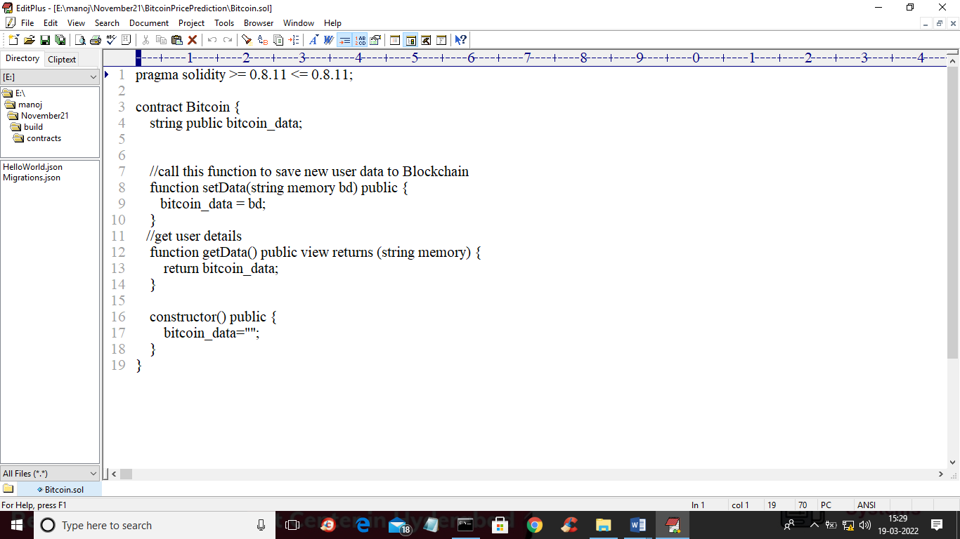
In above screen we will call SetData function to store Bitcoin prices in Blockchain and will call GetData function to read data back.
Below is the Bitcoin dataset used in this project
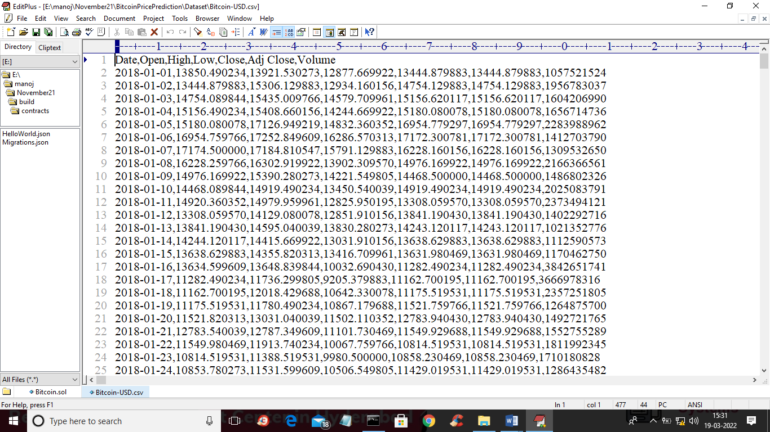
In above dataset we have Bitcoin open and close prices with dates and this data will be stored in Blockchain and then read back and trained by machine learning algorithms to predict future prices.
In below screen we are showing concept to deploy SOLIDITY code on Blockchain and this SOLIDITY can be called from Python program to store and read data.
First go inside ‘hello-eth/node_modules/.bin’ folder and then look for file called ‘runBlockchain.bat’ and then double click on that file to start Ethereum tool like below screen
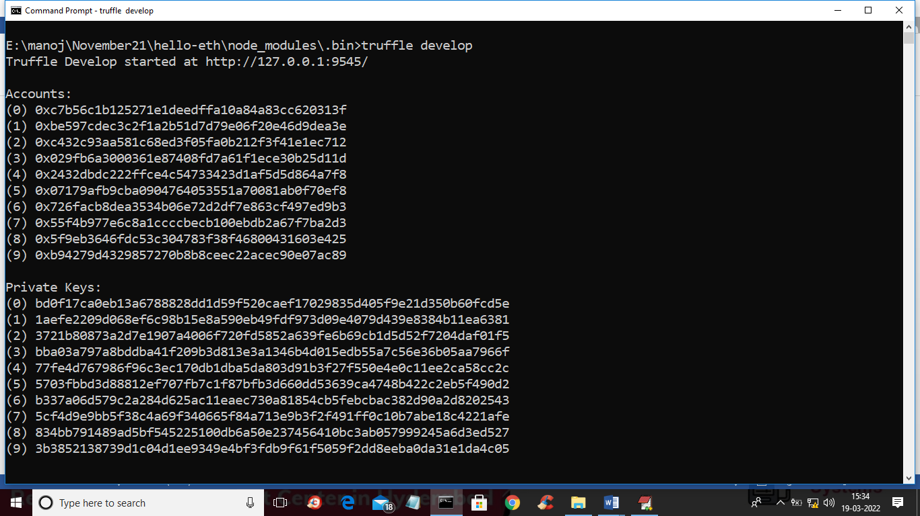
In above screen private keys are generated and in same window type ‘truffle migrate’ command and press enter key to deploy Bitcoin SOLIDITY contract in Blockchain and will get below output
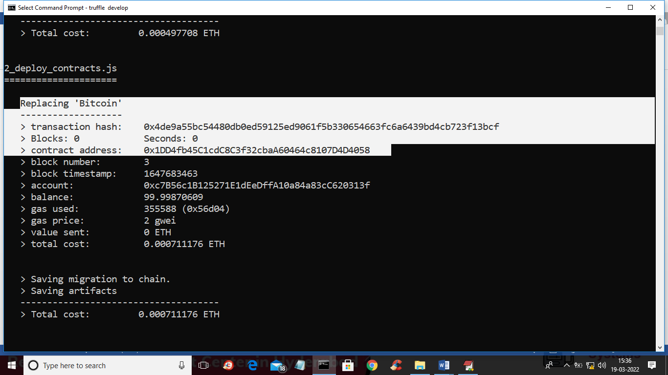
In above screen we can see Bitcoin contract deployed and we can see its contract address and this address we will specify in python program to access data from that Blockchain Solidity code and now let above Blockchain console running. In below screen you can see that contract calling code in python
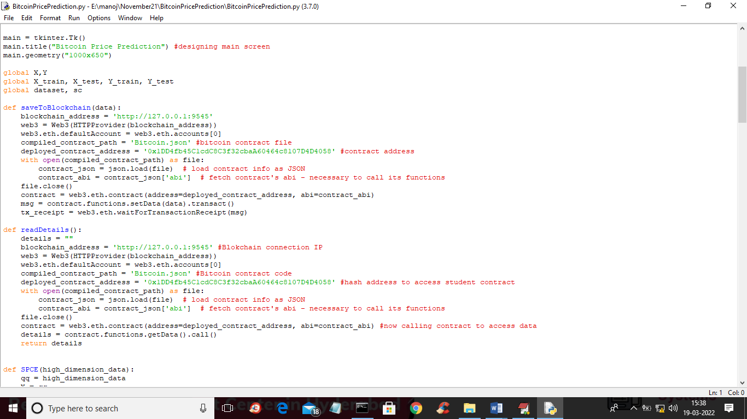
In above screen read red colour comments to know about Blockchain Bitcoin contract calling.
SCREEN SHOTS
To run project double click on ‘run.bat’ file to get below screen
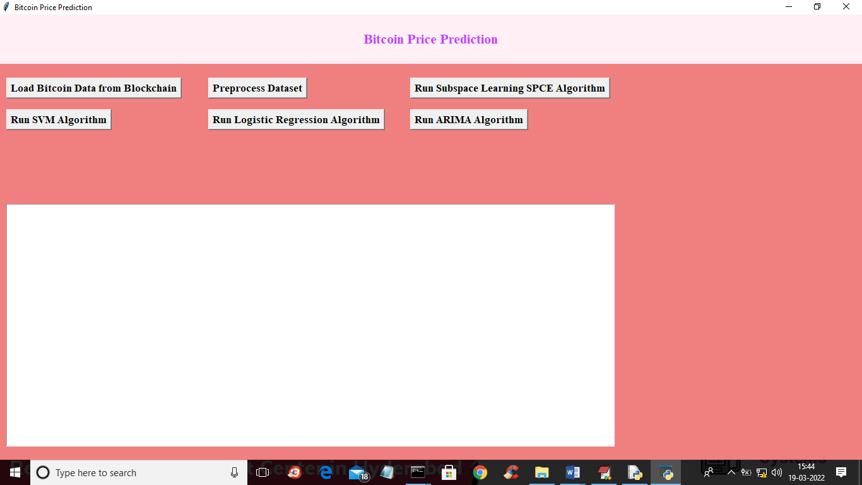
In above screen click on ‘Load Bitcoin Data from Blockchain’ button to load data from Blockchain and get below output
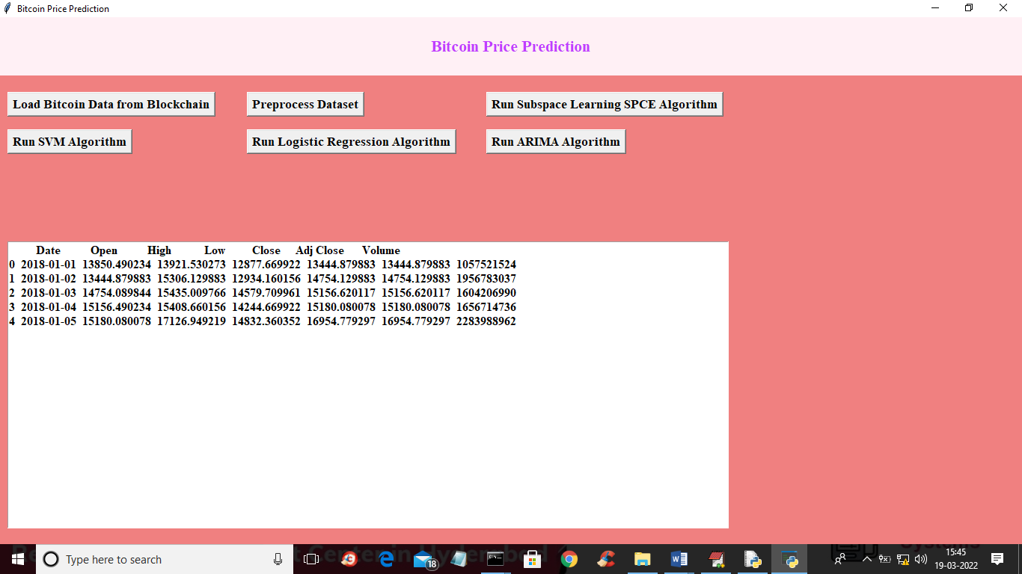
In above screen dataset loaded from Blockchain and now click on ‘Preprocess Dataset’ button to preprocess dataset such as replacing missing values with 0 and then find total attributes before apply SPCE
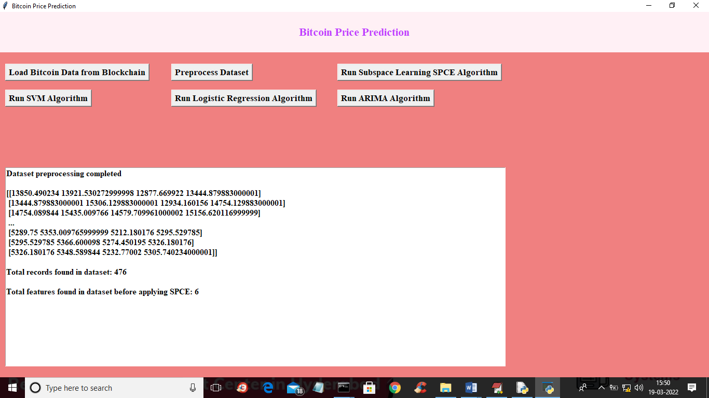
In above screen dataset is normalized and then we can see dataset contains total 476 records and before applying SPCE dataset contains 6 attributes. Now click on ‘Run Subspace Learning SPCE Algorithm’ button to apply SPCE algorithm to reduce high dimension 6 attributes to low dimension and then will get below output
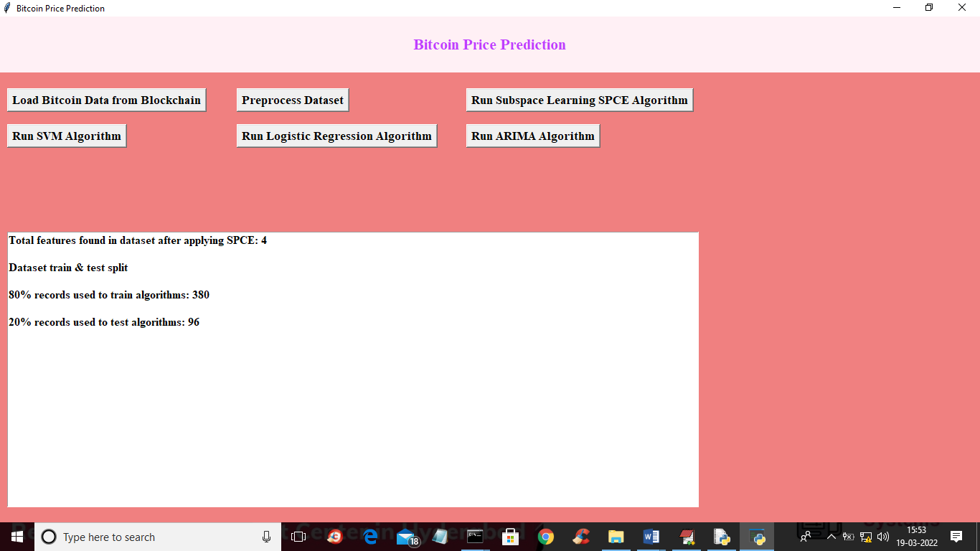
In above screen after applying SPCE attributes/features size reduced to 4 from 6 and we can see application using 380 records for training and 96 records for testing. Now dataset is ready and now click on ‘Run SVM Algorithm’ button to train SVM and get below output
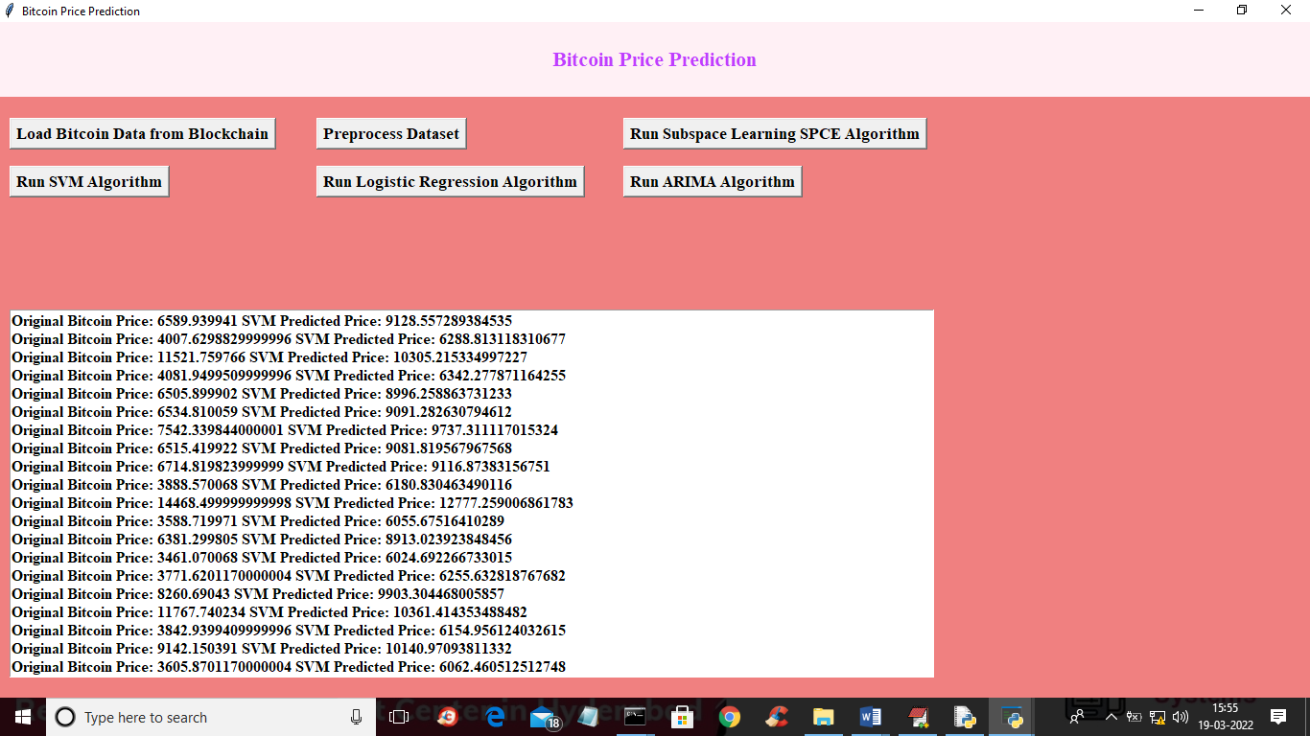
In above screen we can see original Bitcoin prices and then we can see Bitcoin predicted prices and below graph showing difference between original and predicted prices
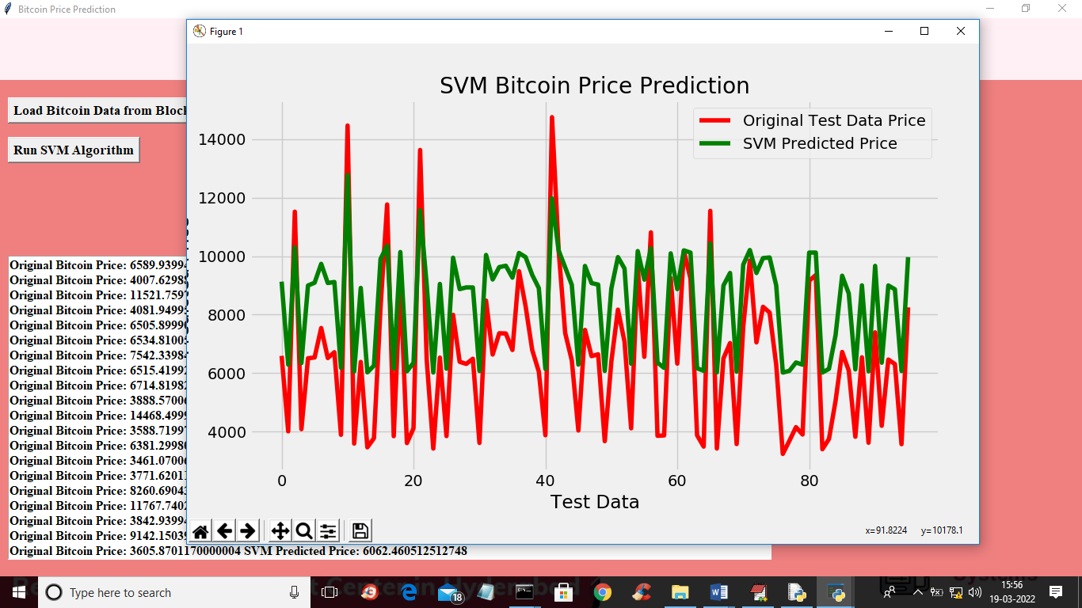
In above graph x-axis represents DAYS/DATE and y-axis represents Bitcoin prices and red line represents original prices and green line represents predicted prices. In above graph we can see there is huge difference between predicted and original prices so we can say SVM is not accurate and now close above graph and then click on ‘Run Logistic Regression Algorithm’ button to train LR and get below output
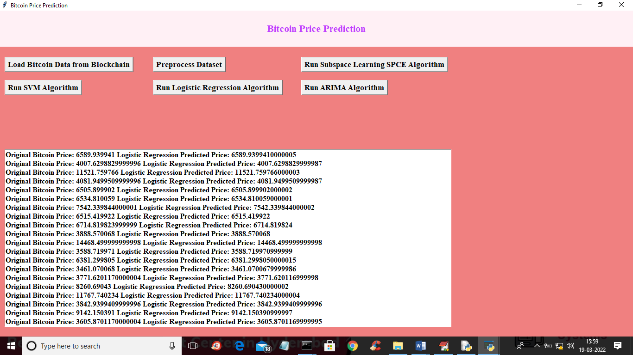
In above screen we can see logistic prediction prices and original prices and below is the LR graph of price prediction
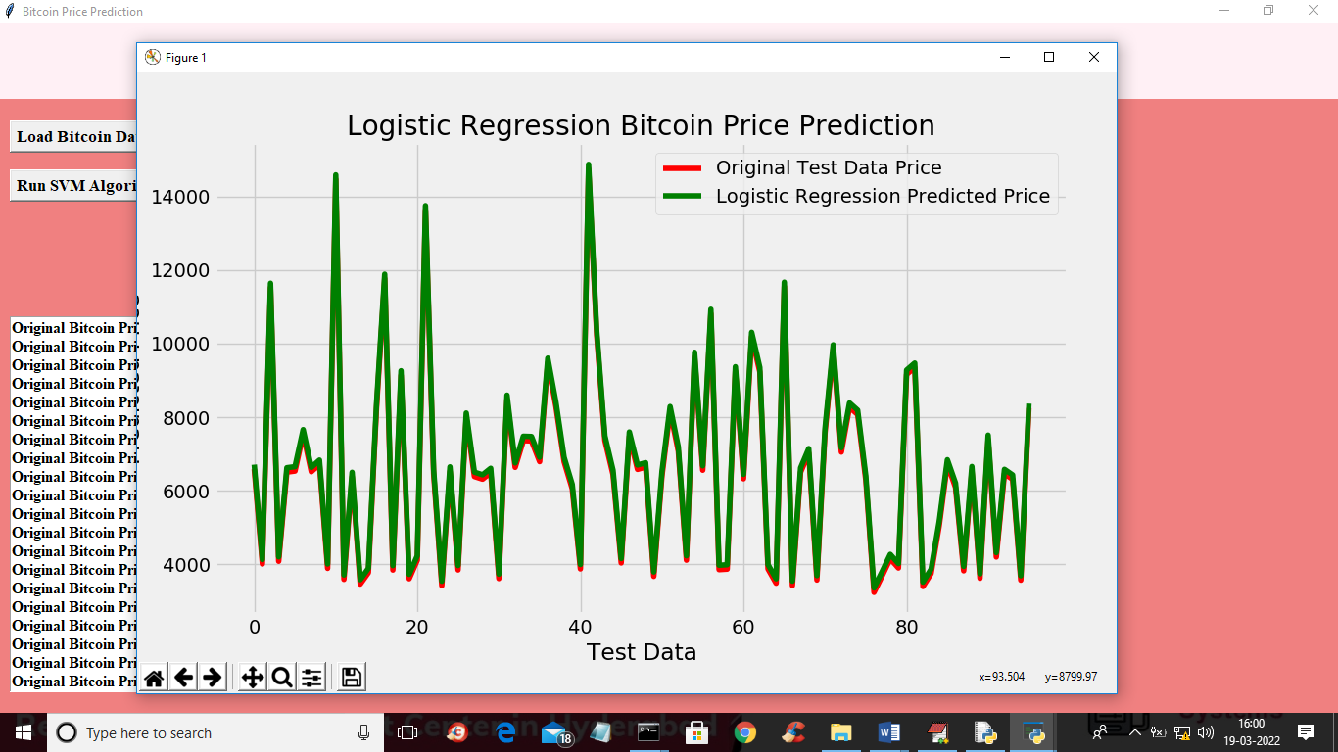
In above graph we can see LR is giving accurate price prediction as both lines are fully overlap and we can see there less difference between both lines so LR is accurate and now click on ‘Run ARIMA Algorithm’ button to train ARIMA and get below output
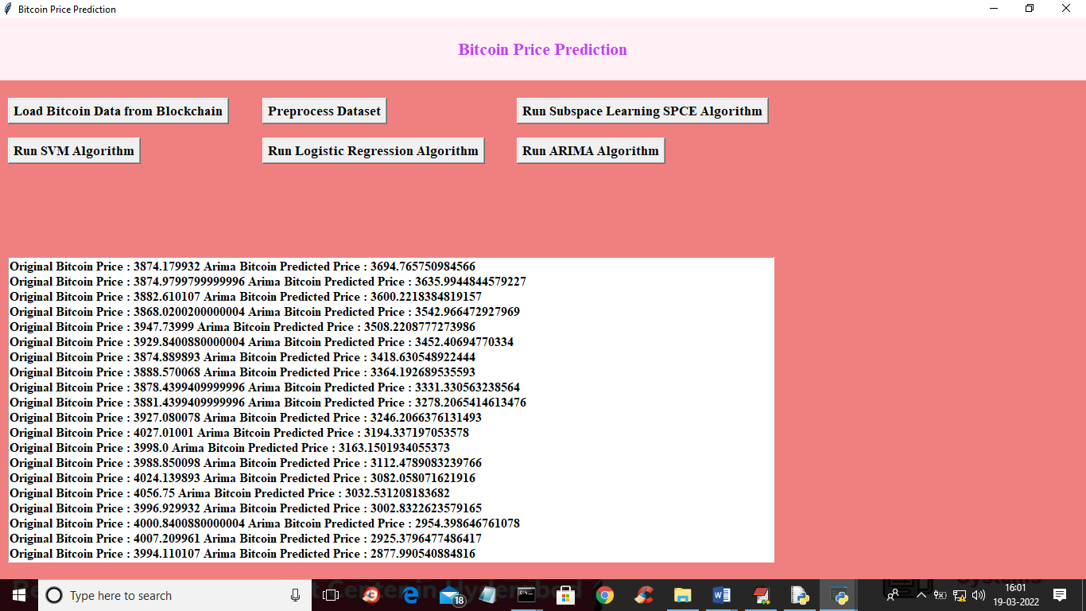
In above screen we can see original and ARIMA predicted prices and below is the ARIMA prediction graph
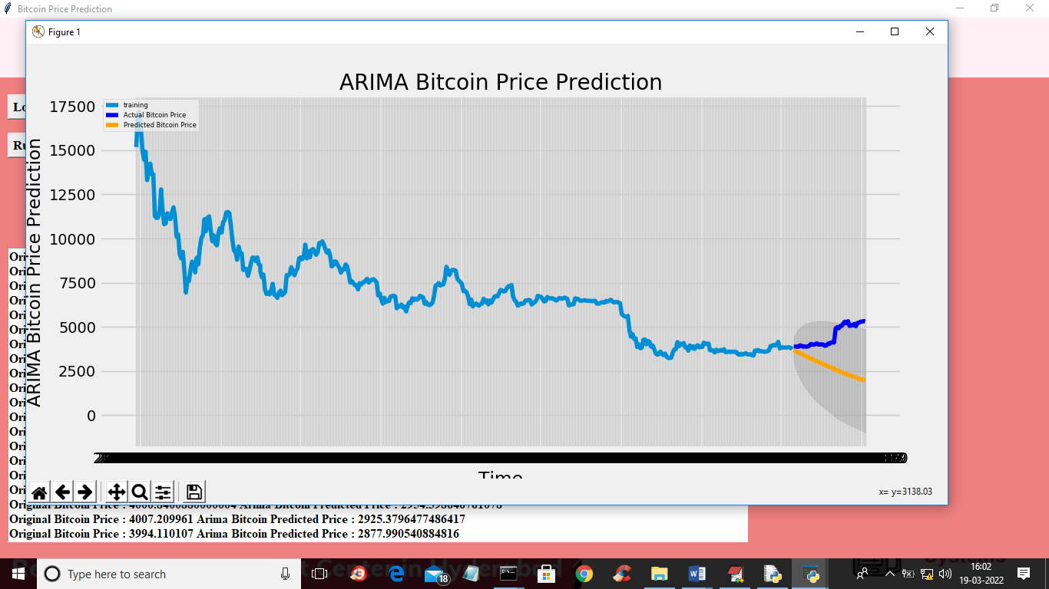
In above ARIMA graph light blue line is the training prices and dark blue line is the test data and yellow line is the predicted data and both test and predicted data is shadowed so we can say ARIMA prediction is also accurate.
In this project we have evaluated the performance of SVM, Logistic Regression and ARIMA and in all algorithm Logistic Regression and ARIMA is giving better prediction prices.

