# Introduction

* Pāṭimokkha: 227 rules, 4 entails automatic expulsion (defeat)
* They contain moral principles, sense restraint, situational protocols, etiquette
* No physical punishment but procedures, forfeit, confession
* The Buddha established the rules one at a time
* Dhamma-Vinaya, Teaching and Discipline
* Self-motivated: the Vinaya can’t stop evil, it aims to guide virtue
* Each rule includes its origin story, amendments and exceptions
* 5 factors: object, effort, intention, perception, result
* Blanket exemptions: insane, possessed by spirits, delirious with pain, the first offender
* Common non-offences: unknowingly, unthinkingly, unintentionally
* 4 Great Standards to judge modern cases
* Min. 4 bhikkhus for Sangha actions, decisons and Patimokkha
* Min. 5 bhikkhus for ordination and Kathina
* Ordination requires min. 5 bhikkhus
* Disrobe at free will but follow the correct procedure
* ‘Kor wat’ house-rules per monastery
* International agreements (Mahathera Samakorn, ECM)

The ten reasons for the establishing of the Pāṭimokkha:

1. "For the excellence of the Sangha;
2. for the wellbeing of the Sangha;
3. for the control of ill-controlled bhikkhus;
4. for the comfort of wellbehaved bhikkhus;
5. for the restraint of the *āsavā* in this present state;
6. for protection against the *āsavā* in a future state;
7. to give confidence to those of little faith;
8. to increase the confidence of the faithful;
9. to establish the True Dhamma;
10. to support the Vinaya."

(Vin.III.20; A.V.70)

Four things not to be done, *akaraṇīya*:

1. sexual intercourse: as a man with his head cut off cannot live
2. theft: as a withered leaf separated from its stalk cannot become green again
3. depriving a human being of life: as a flat stone, broken in half, cannot be put together again
4. claiming false attainments: as a palm tree, cut off at the crown, is incapable of further growth

([Vin.I.96-97](https://suttacentral.net/pli-tv-kd1/en/horner-brahmali))

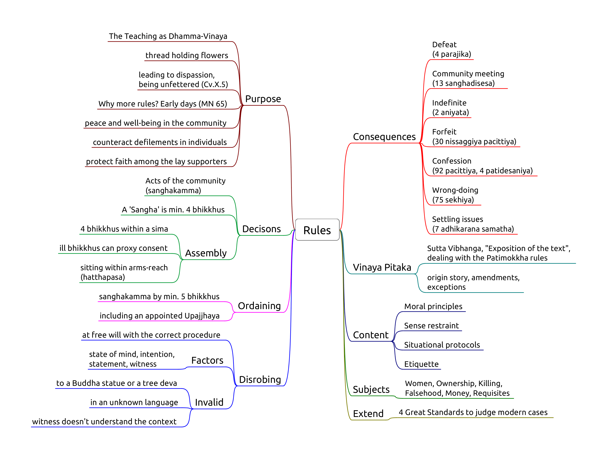

Introduction

## The Four Great Standards

Not already prohibited:  
**if** it conforms with what is prohibited,  
**or** it goes against what is allowable,  
that is **prohibited**.

Not already prohibited:  
**if** it conforms with what is allowable,  
**or** it goes against what is prohibited,  
that is **allowable**.

Not already allowed:  
**if** it conforms with what is prohibited,  
**or** it goes against what is allowable,  
that is **prohibited**.

Not already allowed:  
**if** it conforms with what is allowable,  
**or** it goes against what is prohibited,  
that is **allowable**.

(Mv.VI.40.1)