# Killing and Harming

* **Pr 3,** Killing a human being
* **Pc 61,** Killing an animal
* **Pc 20,** Pouring water containing living beings
* **Pc 62,** Drinking water containing living beings
* **Pc 10,** Digging soil
* **Pc 11,** Damaging living plants or seeds

## Pr 3, Killing a human being

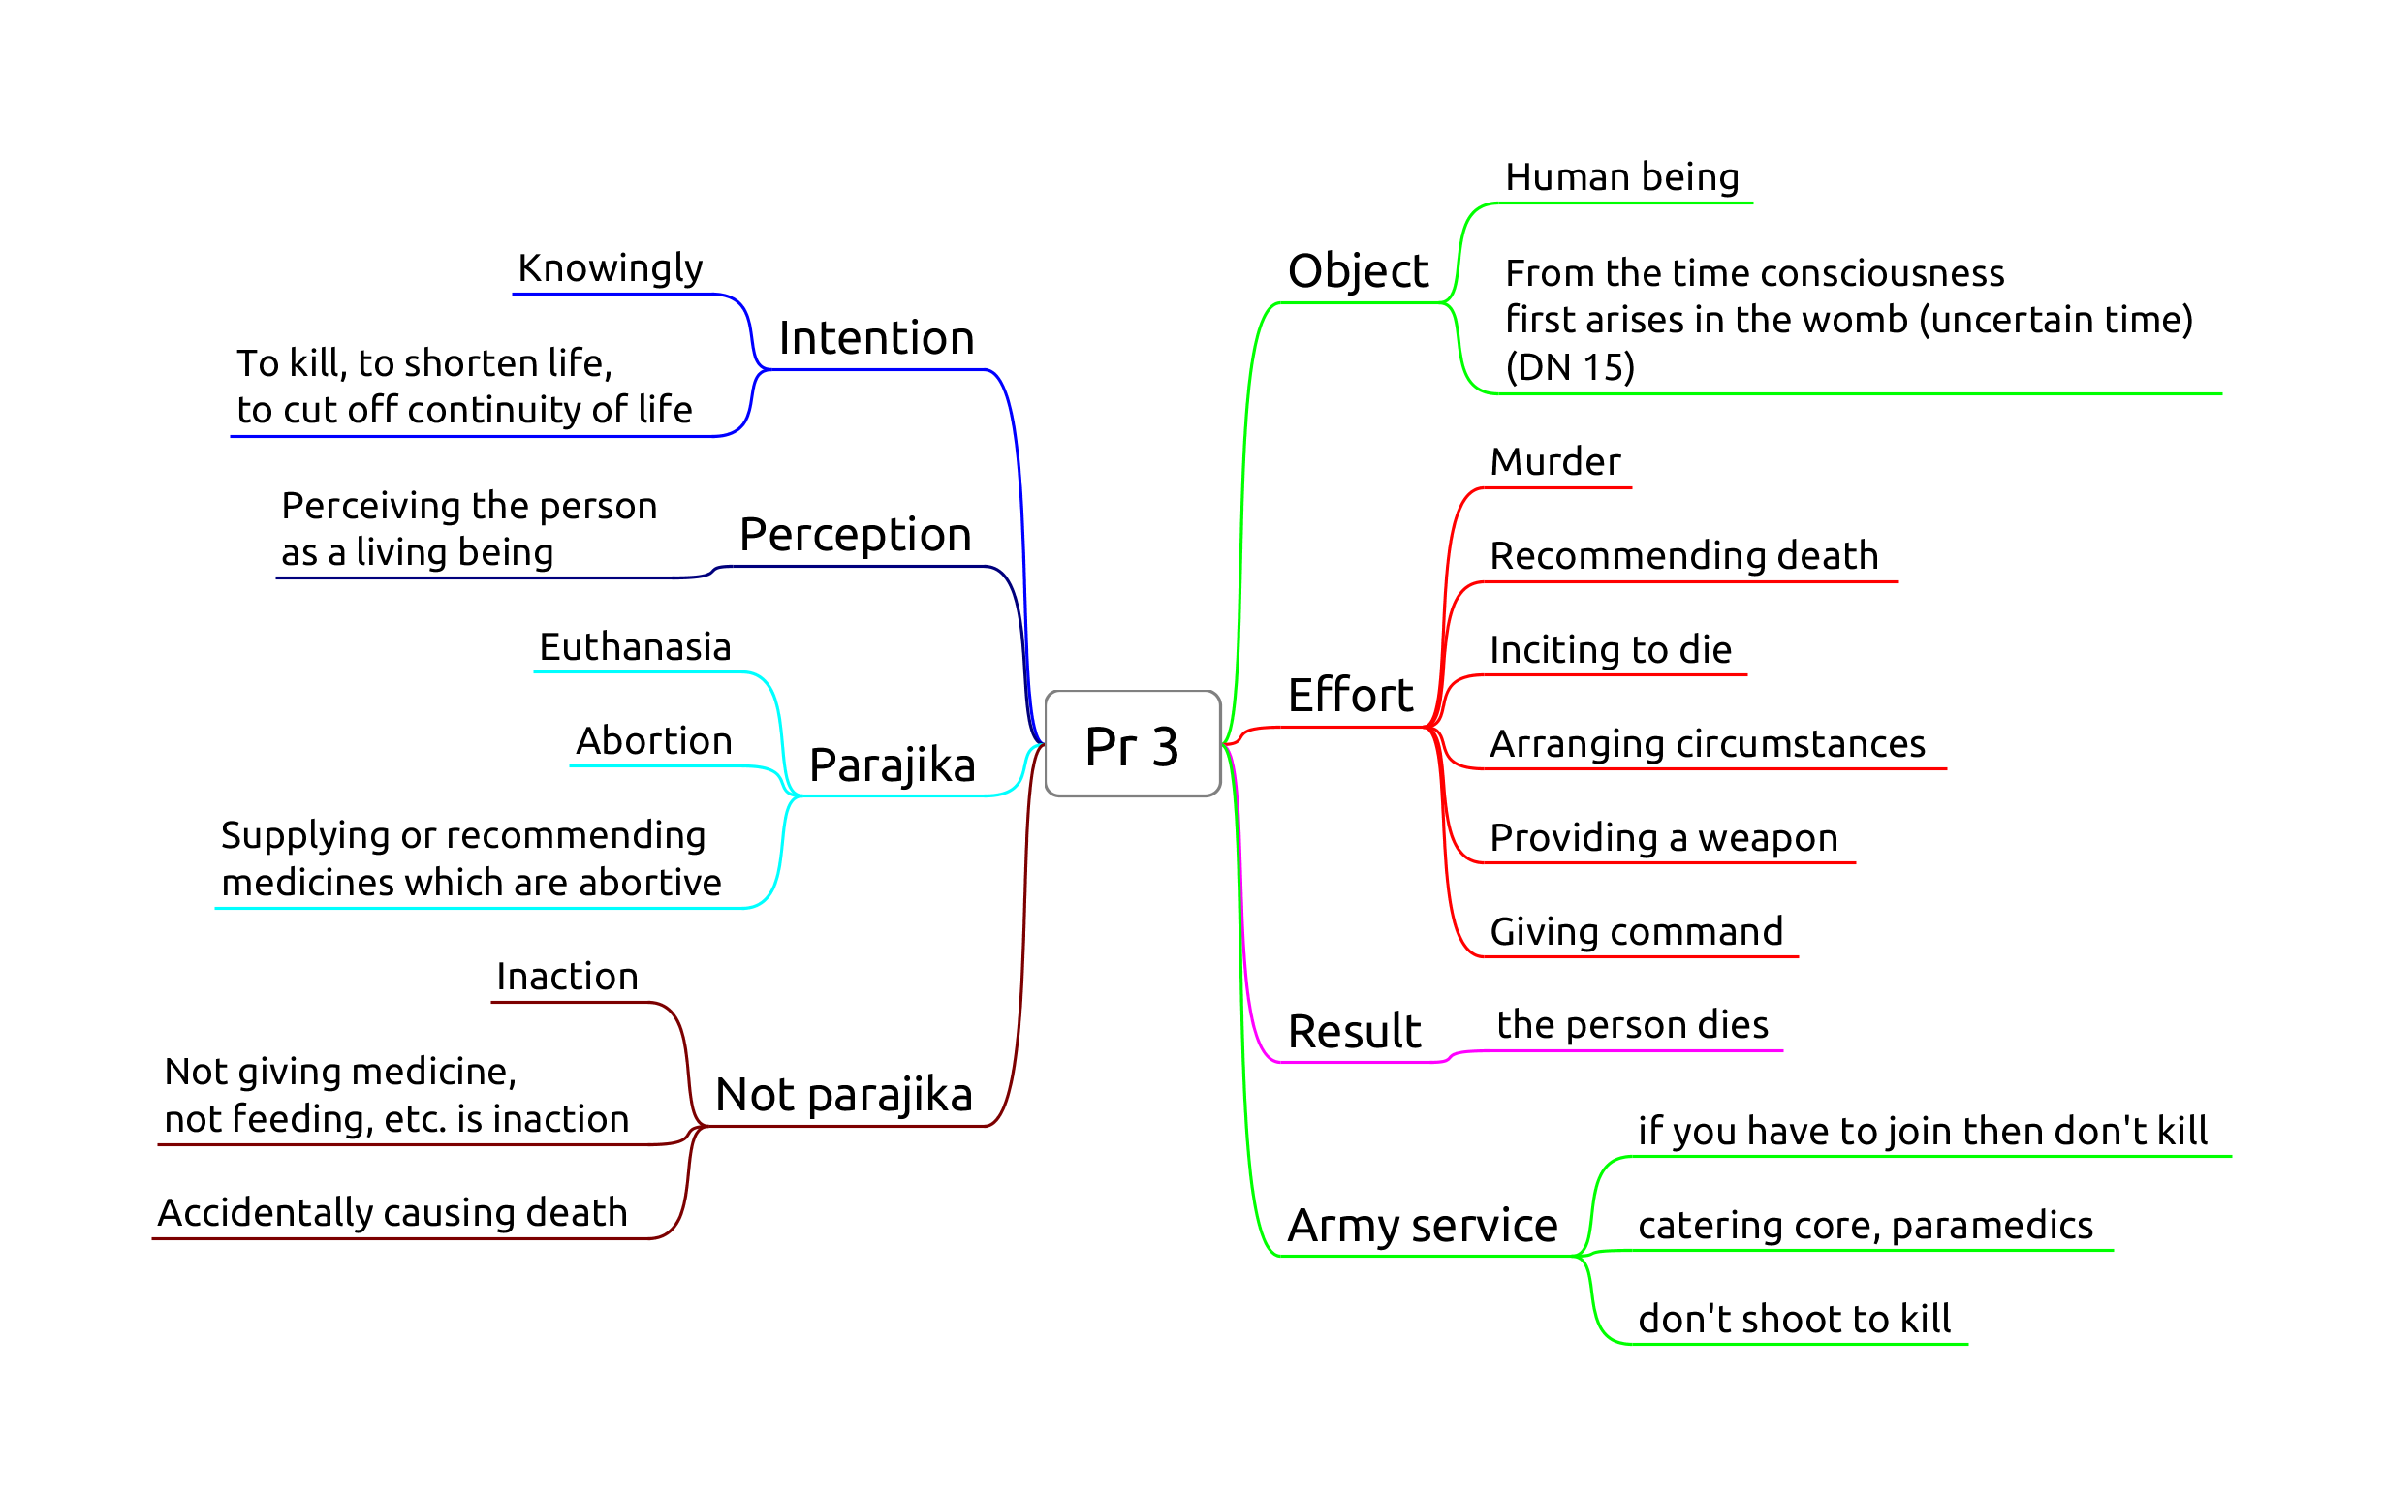

Pr-3

**Origin:** bhikkhus develop aversion to the body and kill themselves or ask an assassin to kill them.

Recommending death or euthanasia can be **parajika** if the instruction is followed. Hinting fulfils effort, such as “death would be better for you”.

A human being is regarded as such from the time when the ‘being to be born’ is established in the womb. This is an uncertain time, sometime after conception during embryo development. The embryo can’t develop otherwise.

“If consciousness were not to descend into the mother’s womb, would name-and-form take shape in the womb?”

“No, lord.”

“If, after descending into the womb, consciousness were to depart, would name-and-form be produced for this world?”

“No, lord.”

“If the consciousness of the young boy or girl were to be cut off, would name-and-form ripen, grow, and reach maturity?”

“No, lord.”

([DN 15](https://www.accesstoinsight.org/tipitaka/dn/dn.15.0.than.html))

## Pc 61, Killing an animal

Giving an order fulfils effort.

**Result** is a factor.

Doesn’t include animals smaller than visible to the naked eye. Doesn’t include accidents (sweeping). No room for ‘phrasing it right’.

Origin: Ven. Udayin is killing crows by shooting them with arrows, cutting their heads off and putting them in a row on a stake. The Buddha scolds him, “How can you, foolish man, intentionally deprive a living thing of life? …” ([Vibh. Pc 61](https://suttacentral.net/pli-tv-bu-vb-pc61/en/horner))

Mercy killing by the owner, or euthanasia practices by vets fulfil effort. Having a pet means responsibility.

Acting in doubt, going ahead anyway is dukkata. Such as when the bhikkhu thinks that cleaning an item may or may not kill living beings. Trying carefully not to kill insects while cleaning is not an offence.

**Perception** is a factor. Stepping on a twig with the intention to crush a snake is dukkata.

## Pc 20, Pouring water containing living beings

Knowing they will die from pouring it. It can also include knowingly adding poisonous substances.

If the water doesn’t contain living beings, but the bhikkhu thinks it does, pouring or using it is dukkata.

Giving an order fulfils effort.

Result is not a factor. Doesn’t include accidents.

Can’t water plants if one plans to eat its fruit, but may indicate it for others.

Kutis may use small gutters as water moats around the stilts to keep out ants. One has to treat the water with household chemicals, otherwise mosquitoes will breed in the water.

## Pc 62, Drinking water containing living beings

Knowing they will die from drinking it, even accidentally.

Using water strainers or robe. Determining a corner of the sanghati as a water-filter.

Result is not a factor.

## Pc 10, Digging soil

**Origin:** relates to the ancient belief that soil is alive, and loses life when dug up.

**Object:** ‘genuine’ soil.

*Not* genuine soil:

* dust from wind erosion
* pure or mostly rock, stones, gravel, sand are never ‘genuine’ soil
* burnt or already dup up soil is not ‘genuine’ until rained on for four months

If someone digs up the soil, a bhikkhu may shovel it into a wheelbarrow without offence.

**Effort:** Digging, burning, making a hole, or giving command to do it.

Putting tent pegs in the ground is to be confessed.

**Non-offenses:**

* unknowingly, unthinkingly, unintentionally
* indicating a general need or task
* asking for clay or or soil
* digging a trapped person or animal out

Allowance to indicate a need or general task to a lay person by “wording it right (*kappiya-vohāra*,”allowable expression," or “wording it right”).

A specific command would be an offense (‘dig a hole here’), but an indication (‘dig a hole’) of a desire or intent would not (‘it would be good to have a hole for this post’).

## Pc 11, Damaging living plants or seeds

**Origin:** a bhikkhu cuts down a tree where a deva was living. The rule is formed later, when people complained of the bhikkhus mistreating one-facultied life.

**Object:** Living plant or seed. Lower plant life (i.e. mold, algae, fungi) is not included.

**Effort:** cutting, breaking, cooking, or getting others to do it.

**Fruit with seeds:** allowance to make allowable (kappiyam). Fruit can be kappied in one “heap”.

To ‘kappi’ fruit is about the feelings of the donor, not killing the fruit or transfering kamma.

Knowingly eating un-kappied seeds is dukkata.

**Non-offenses:**

* unknowingly, unthinkingly, unintentionally
* asking a lay person for flowers etc. in general, or indicating a general task
* removing branches or leaves which are already dead
* can cut a trapped person or animal out
* counter-fire

**Note:** Pc 10 and Pc 11 prevents bhikkhus from engaging in agriculture, which is probably part of the intended results, although not their direct origin.