# Stealing

* **Pr 2,** Stealing
* **NP 25,** Snatching back robe
* **Pc 59,** Using cloth or bowl under shared ownership

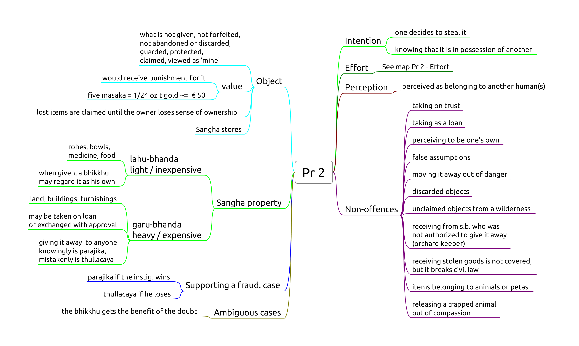

Pr-2

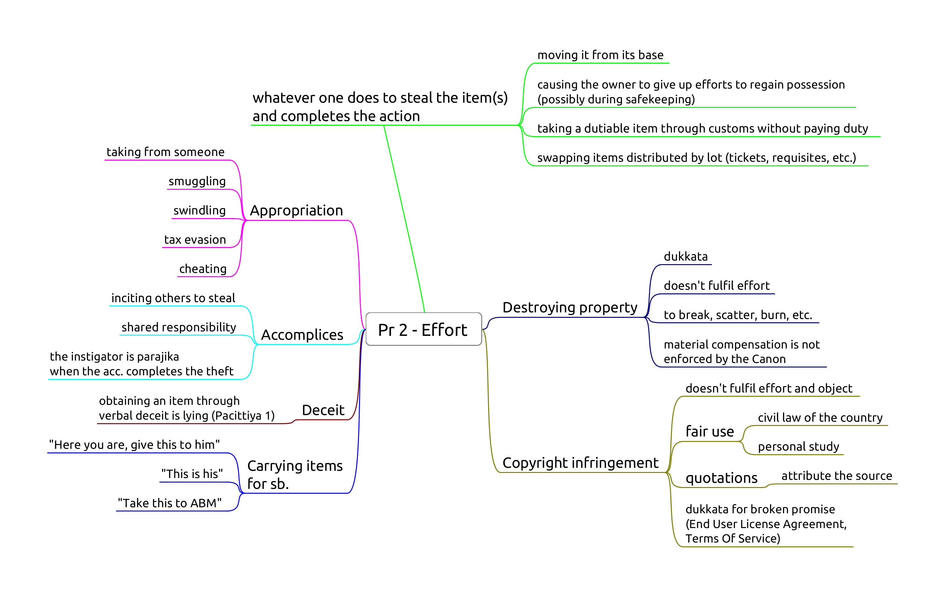

## Pr 2, Stealing

See the maps *Pr 2* and *Pr 2 – Effort*.

The ECM made a decision that items in the stores belong to all bhikkhus of the ECM monasteries, therefore a bhikkhu can’t steal what is already theirs by agreement.

When carrying items, there is a difference in ownership whether the sender says “this is his” or “this is for him”.

Smuggling is parajika (undeclared taxable items at customs).

Breaking a promise is dukkata (not following software or website TOS (Terms of Service) or EULA (End User License Agreement)).

## NP 25, Snatching back robe

**Object:** a piece of robe-cloth, at least 4x8 fingerbreadth.

**Perception:** one still considers the robe as one’s own, otherwise it could be *parajika*.

**Intention:** impelled by anger or displeasure. Taking it on trust is not an offense.

**Effort:** snatching back or having someone to snatch it back.

Dukkata for:

* giving the command
* other than cloth
* snatching from a *non-bhikkhu*
* hinting with anger

**Non-offenses:**

* recipient returns the robe on his own accord
* donor takes it back on trust
* hinting without anger

## Pc 59, Using cloth or bowl under shared ownership

*Vikappana* is an arrangement whereby a bhikkhu places robe or cloth under shared ownership so that it may be stored for any length of time.

While the shared ownership is in effect, none of the bhikkhus may use the item.

If the bhikkhu simply gives the robe back to the stores, he has given up ownership of it and another bhikkhu would be free to take it.

*Vikkappana* allows a bhikkhu to determine a smaller sanghati while travelling, but not entirely giving up his regular sanghati.

**Object:** robe-cloth, min. 4x8 fingerbreadths, that one has placed under shared ownership.

**Perception** of ownership is not a factor.

**Effort:** using the cloth without the ownership being rescinded.

**Non-offenses:**

* rescinded ownership
* using it on trust (shared with friends)