# Food 2

* **NP 23,** Over-kept tonics
* **Pc 39,** Requesting finer staple foods
* **Pc 47,** Exceeding an invitation
* **Pc 41,** Handing food to members of other religions
* **Pd 3,** Protected families

## NP 23, Over-kept tonics

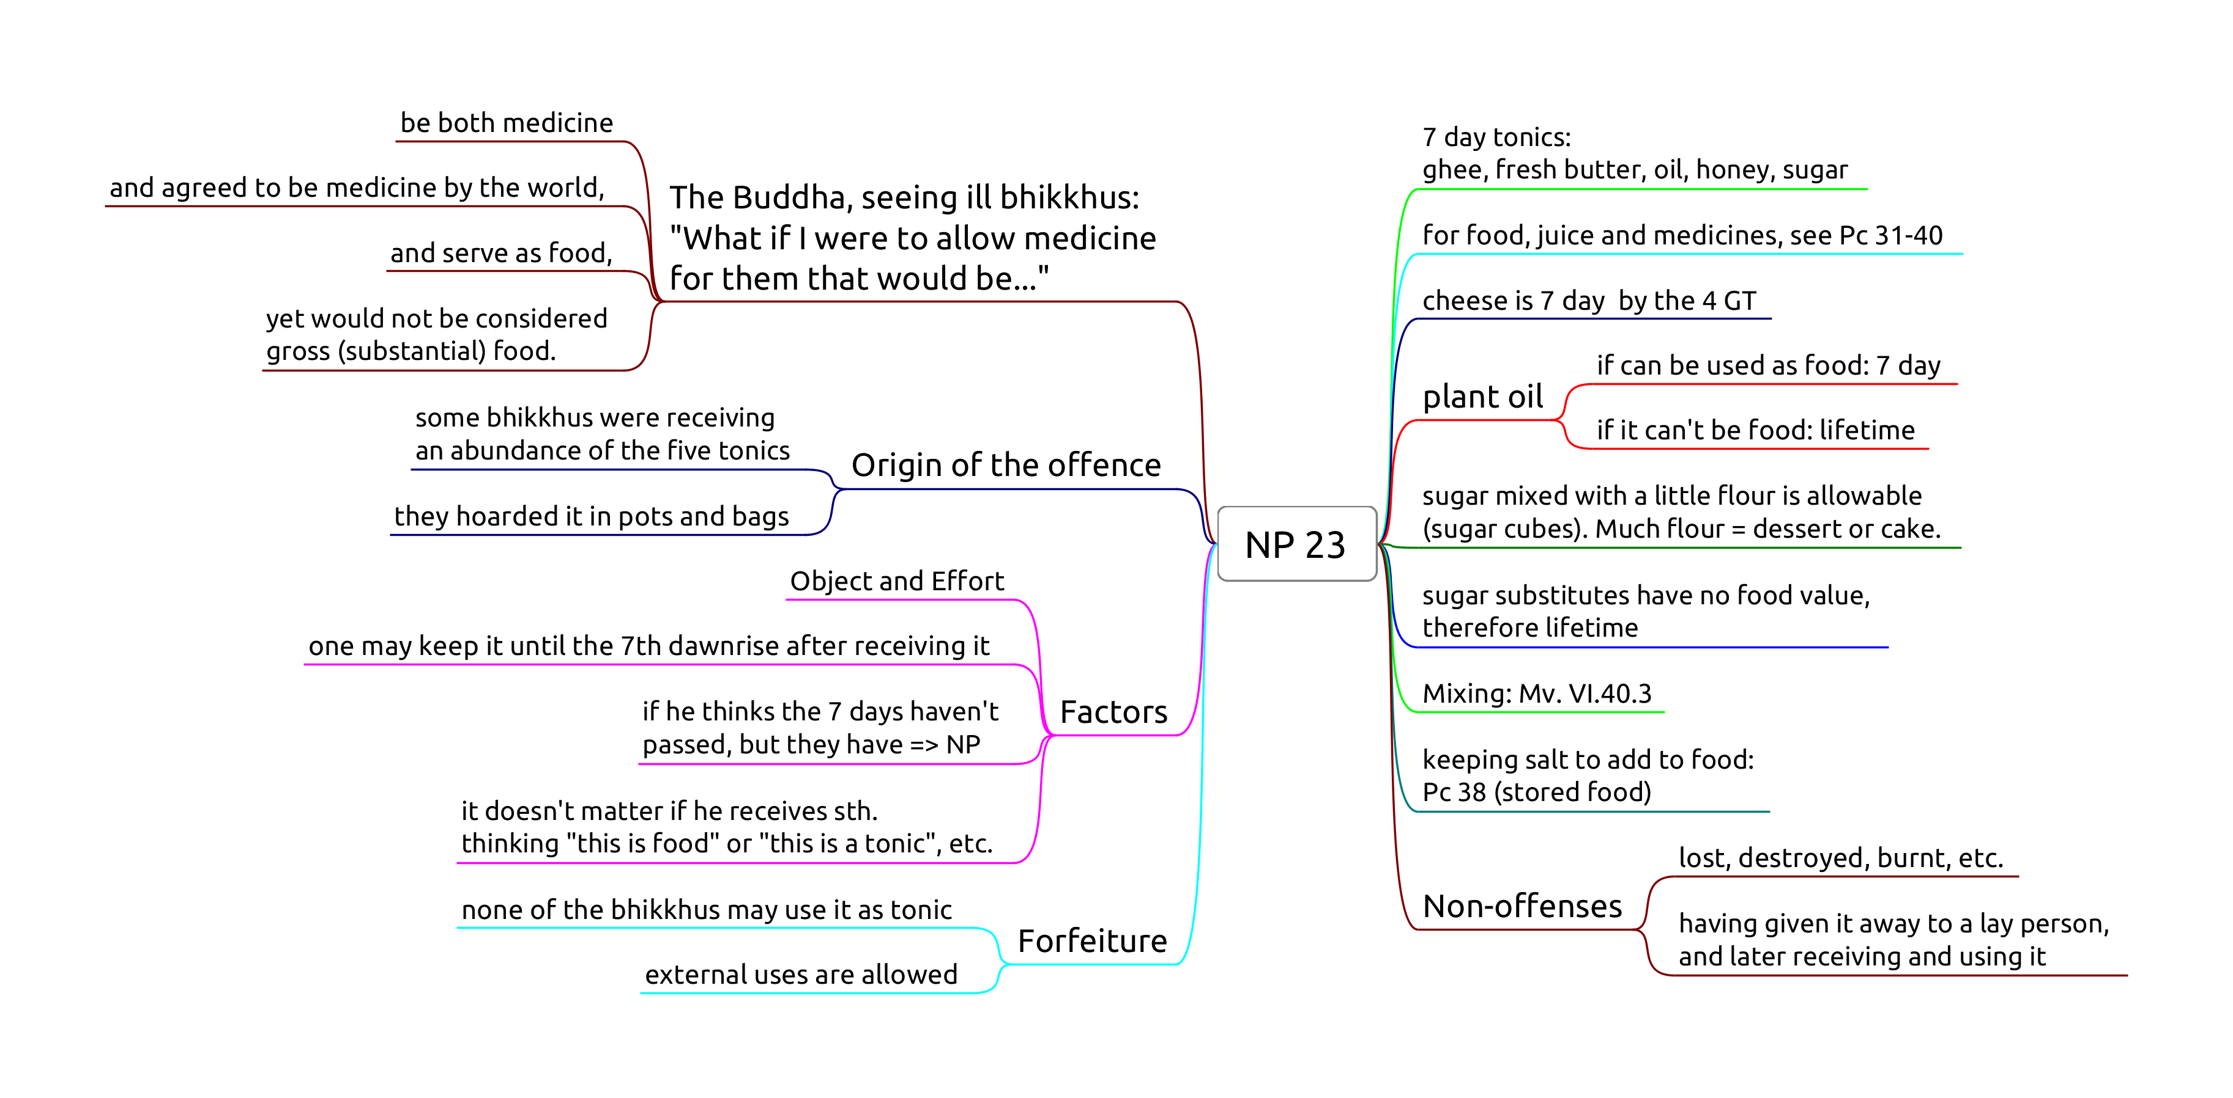

NP 23 Tonics

**Object:** any of the five tonics.

**Effort:** one keeps the tonic past the 7th dawnrise after receiving it.

**Perception** is not a factor.

If one thinks the 7th dawn haven’t passed, but it has, it is still NP.

If one thinks “I receive *this* salt as food for the morning, and *this* salt as medicine for later”, it may be a personal practice, but not part of the rule. It doesn’t affect the period of how long the item may be used by oneself or any other bhikkhu.

**Mixing:** The mixture takes on the shortest lifetime of the ingredients. (Mv. VI.40.3.)

a.

1d juice

rec. that morning

+

food

rec. that morning

→

that morning

b.

7d tonic

rec. that morning

+

food

rec. that morning

→

that morning

c.

lifetime medicine

rec. that morning

+

food

rec. that morning

→

that morning

d.

7d tonic

rec. sometime

+

juice

rec. that day

→

until dawn

e.

lifetime medicine

rec. sometime

+

juice

rec. that day

→

until dawn

f.

lifetime medicine

rec. sometime

+

7d tonic

rec. sometime

→

7 days

### 7 days

*Sattāha paramaṃ*, “up to seven days”. The Vinaya counts days from dawn to dawn, hence one may use a 7 day tonic *until the 7th dawn*.

Confusion arises from “7 days” meaning either “for 7 days” (interval) or “on the 7th day” (ordinal).

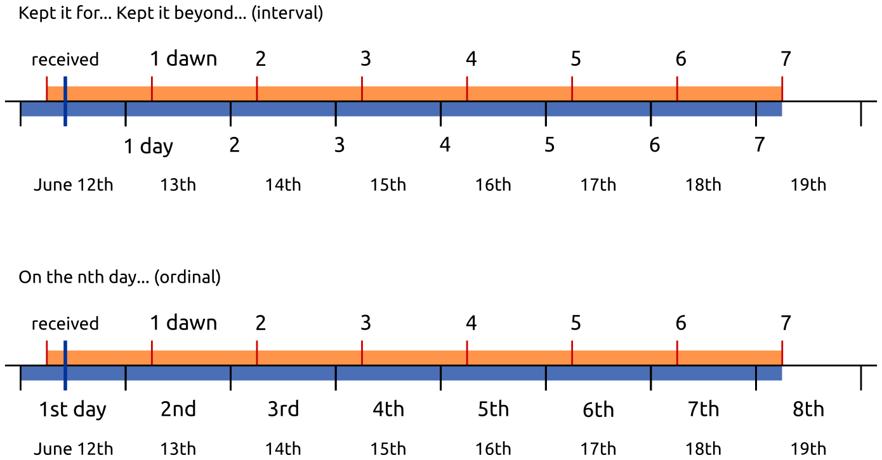

### Breakfast tray

After dawn, one receives a tray with bread, jams, honey, butter and salt. At this point the lifetimes are:

* bread, jams: morning
* honey, butter: 7 days
* salt: lifetime

If the knife which one used carries bread morsels or jam into the honey or the butter, these will be only allowable in the morning.

If one is careful to clean the knife and avoid mixing, one may use them on the bread and keep the rest until their allowed lifetimes.

The next day, one receives a tray with only bread. One may **not** mix the allowables from the previous day with the food received today.

Putting the salt, honey or butter (rec. yesterday) on the bread would be Pc 38 (eating stored food).

## Pc 39, Requesting finer staple foods

Finer staple foods: ghee, fresh butter, oil, honey, sugar, fish, meat, milk, curds.

Object, effort, result.

Sk 37 covers non-fine staples: “Not being ill, I will not eat rice or bean curry that I have requested for my own sake: a training to be observed.”

Hence, dukkata for requesting and consuming other staple foods, except when one is ill.

### Non-offenses

*Not ill:* one is able to fare comfortably without these foods.

* being ill
* was requested for the sake of an ill bhikkhu, and is now left over
* from relatives
* from those who gave invitation to ask
* for the sake of another
* from one’s own resources

## Pc 47, Exceeding an invitation

When an invitation is made that one may ask for certain requisites, one may use it until four months, unless it has been repeated, or is a permanent invitation.

### Non-offenses

* from relatives
* for the sake of another
* from one’s own resources
* being ill, if one shows consideration

“The time period for which we were invited has passed, but we have need of medicine.”

## Pc 41, Handing food to members of other religions

One places oneself in the position of the followers of other religions.

It is not an offense to prepare food in a tray and placing it so that they can help themselves.

## Pd 3, Protected families

The purpose is to avoid damaging the faith of those supporters who might suffer financially if they give too much.

### Non-offenses

* being ill
* invited
* juice, tonics, medicines
* the almsfood is supplied by others
* the family members take turns
* eating the leftovers of another bhikkhu
* the family offers outside their residence