**VINAYA SV**

**727721EUIT178**

**IT-C**

**CC1**

**Question 1:**

**Region us-east-1:**

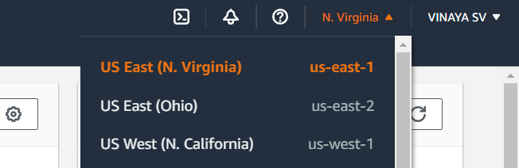

**Tag name-ec2usecase1:**

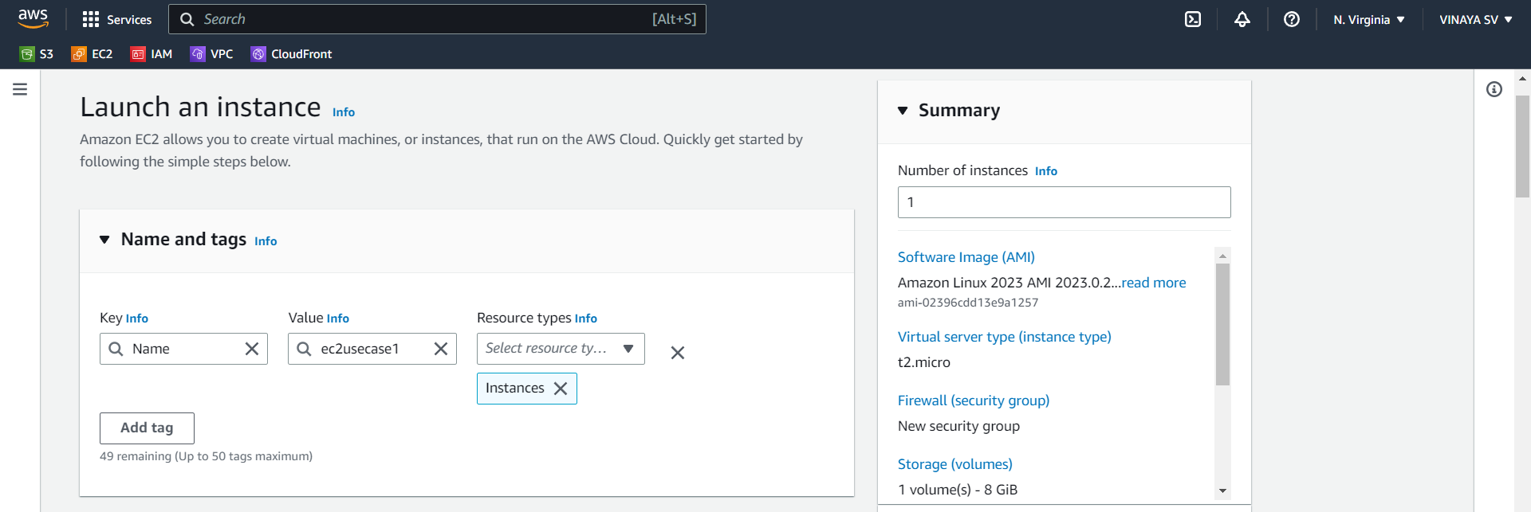

**AMI-Amazon Linux 2**

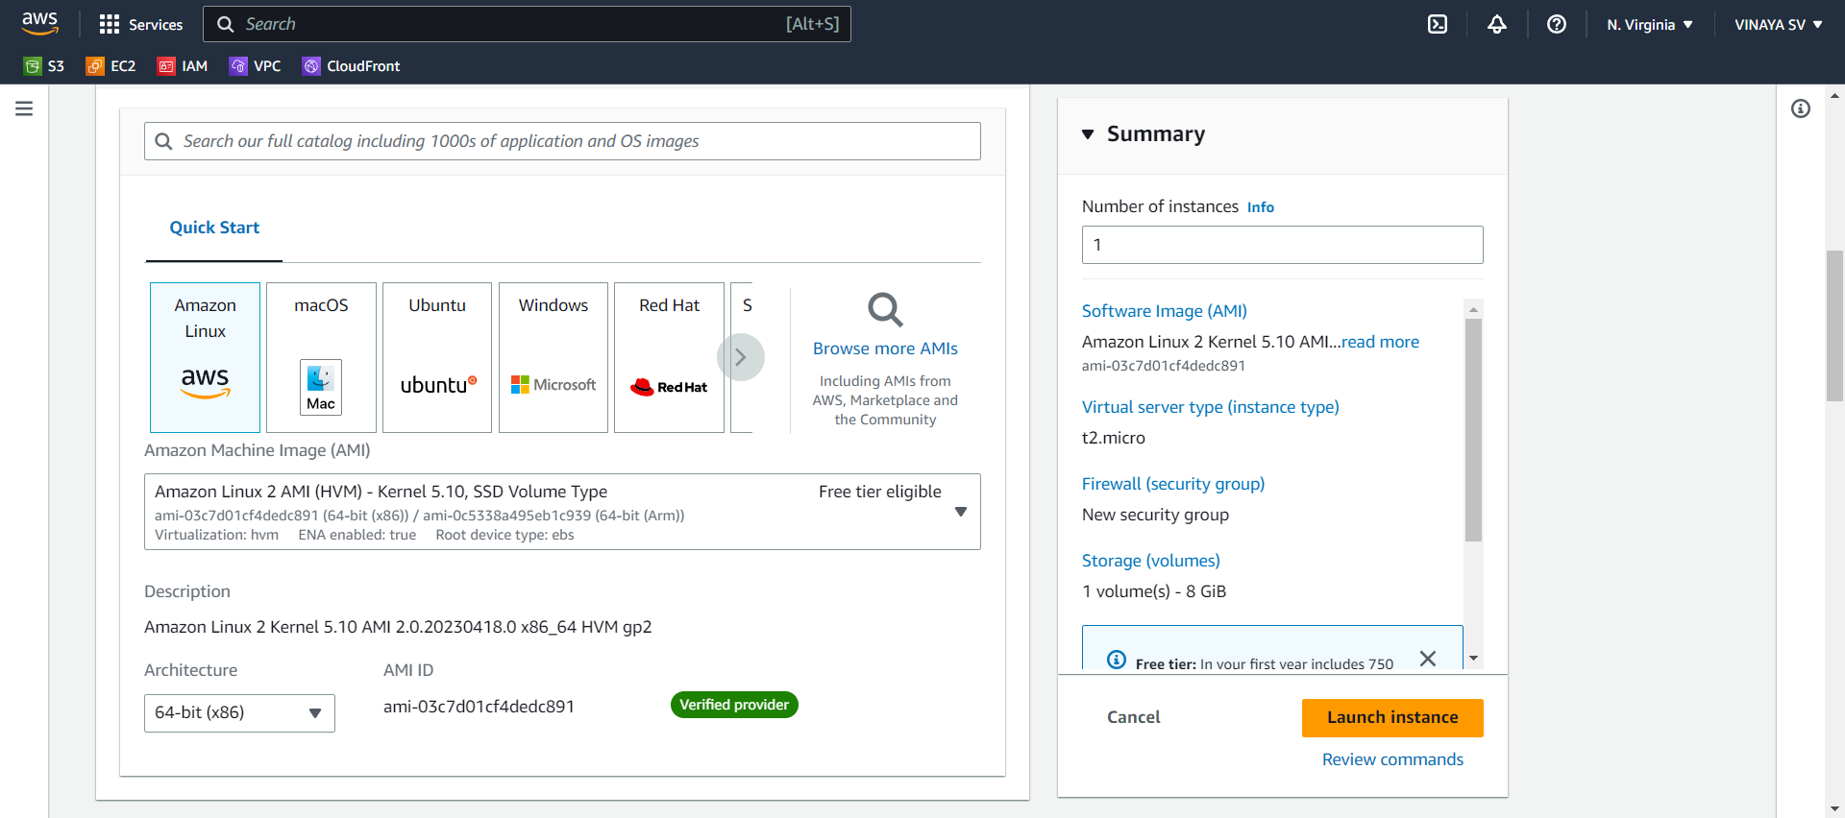

**Key pair – ec2usecase1:**

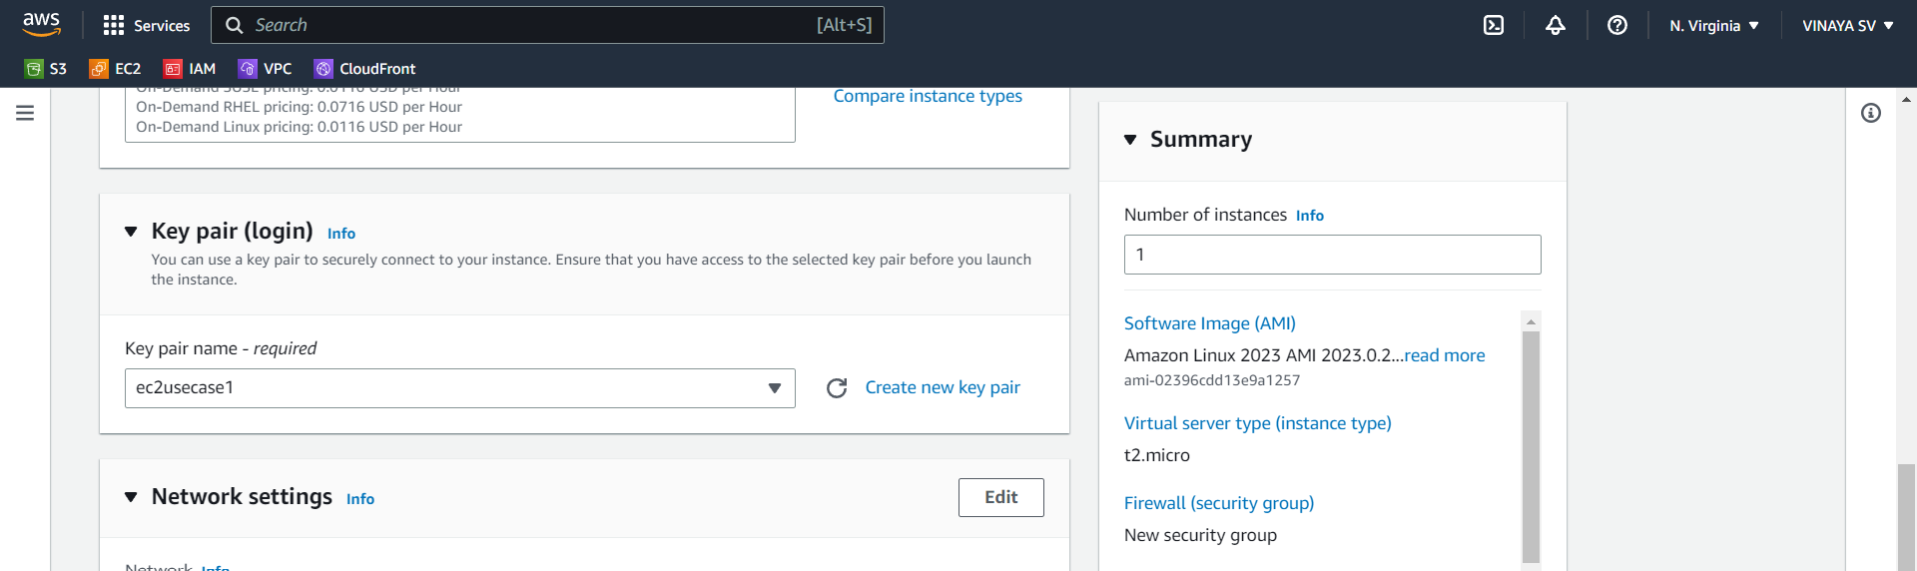

**SSH,HTTP,HTTPS traffic allowed:**

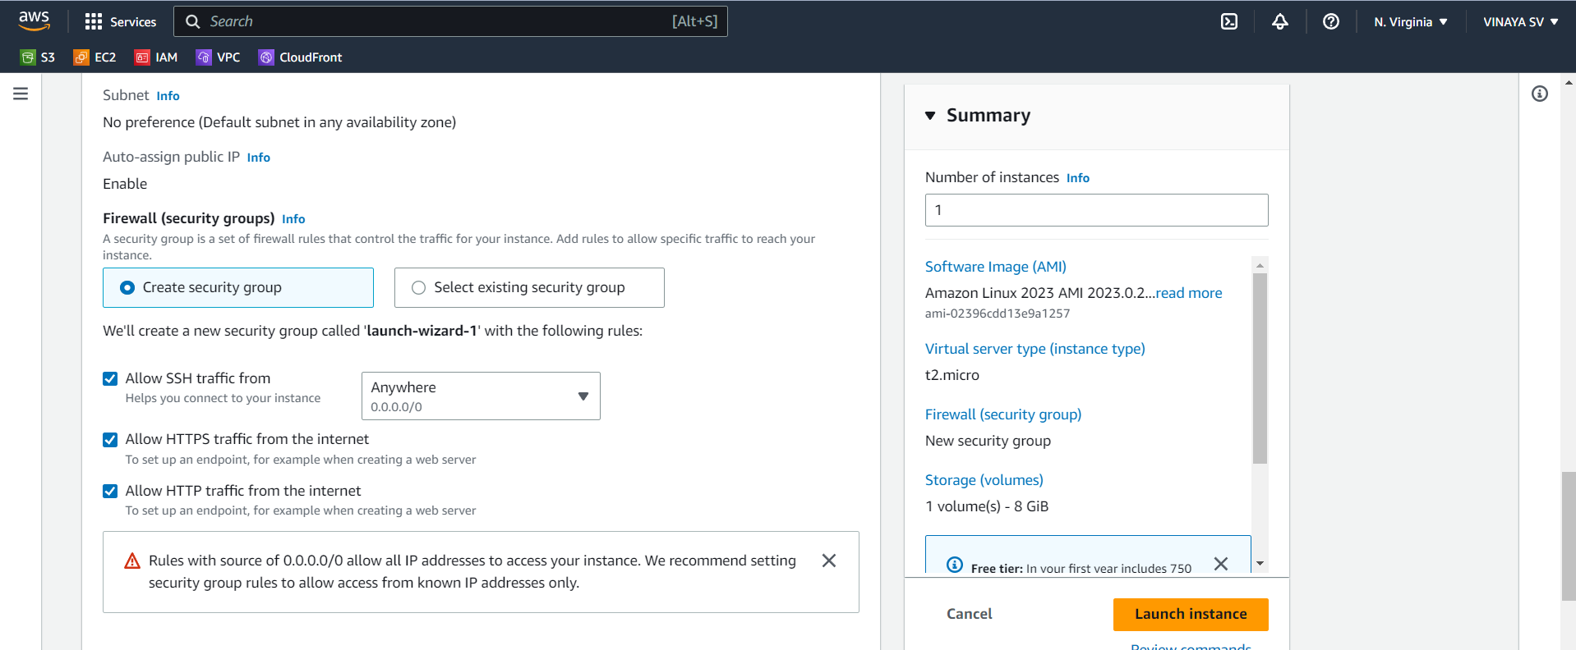

**Output**

