**VINAYA SV**

**727721EUIT178**

**IT-C**

**CC1**

**Question 2:**

**User group creation:**

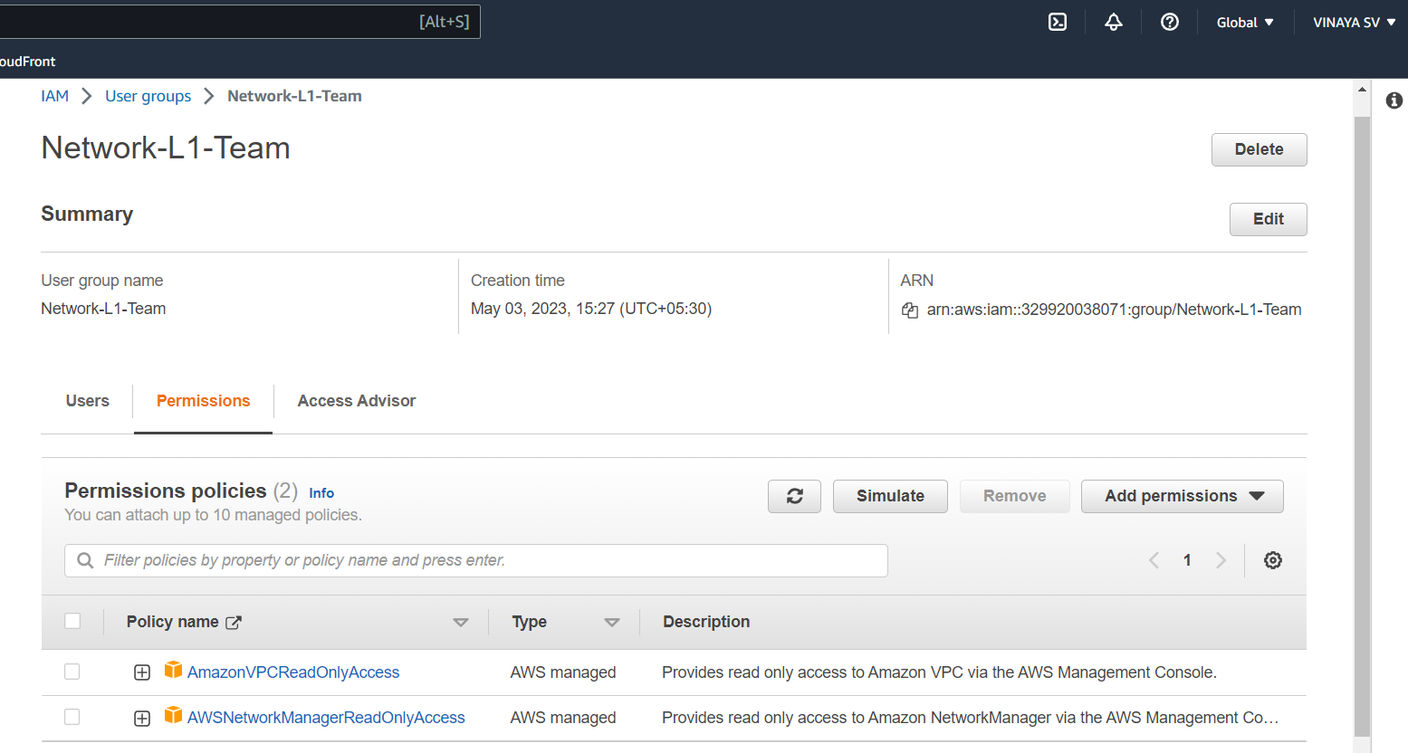

**User creation:**

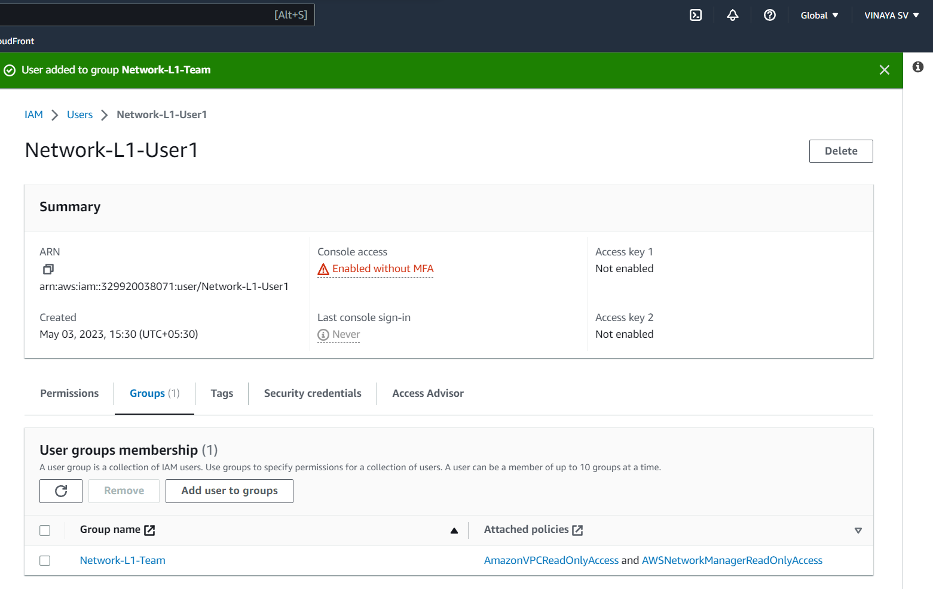

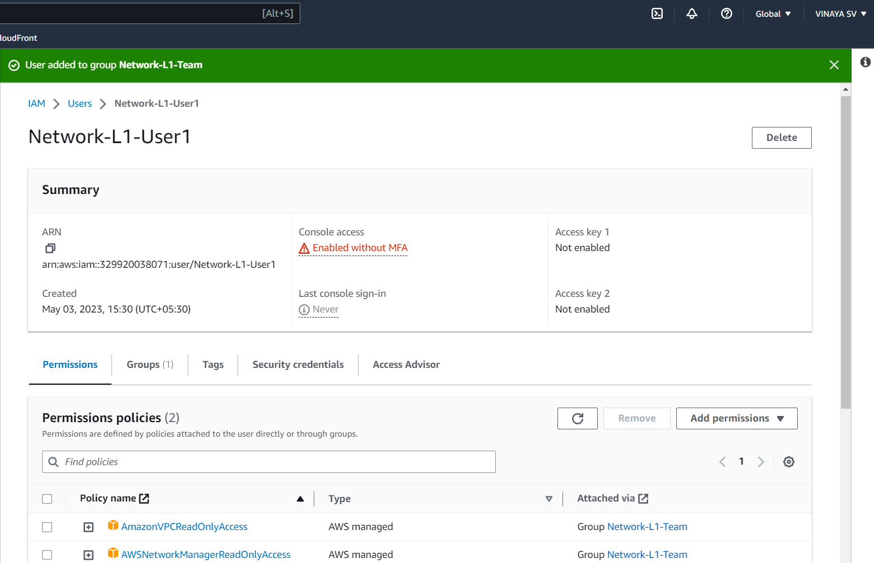

**Signing in as IAM user:**

