**VINAYA SV**

**727721EUIT178**

**IT-C**

**CC1**

**Question 3:**

**Region: Stockholm**

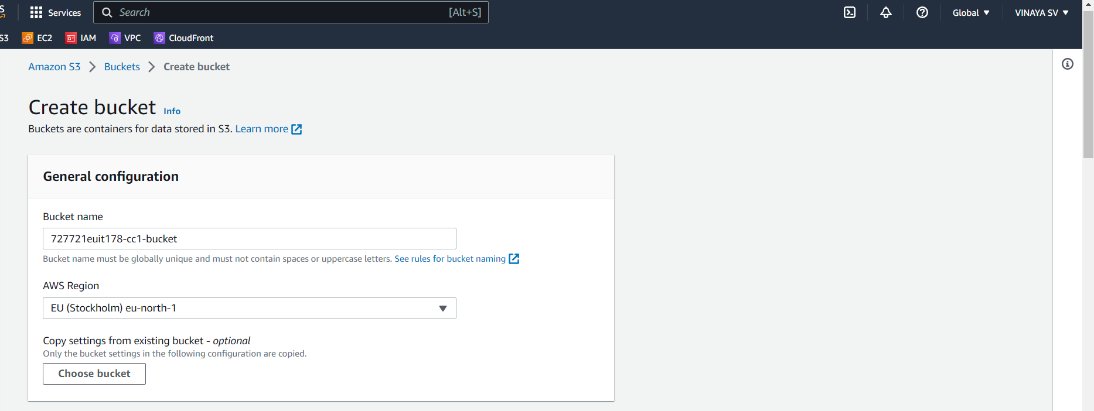

**Making the bucket accessible by everyone by enabling ACL:**

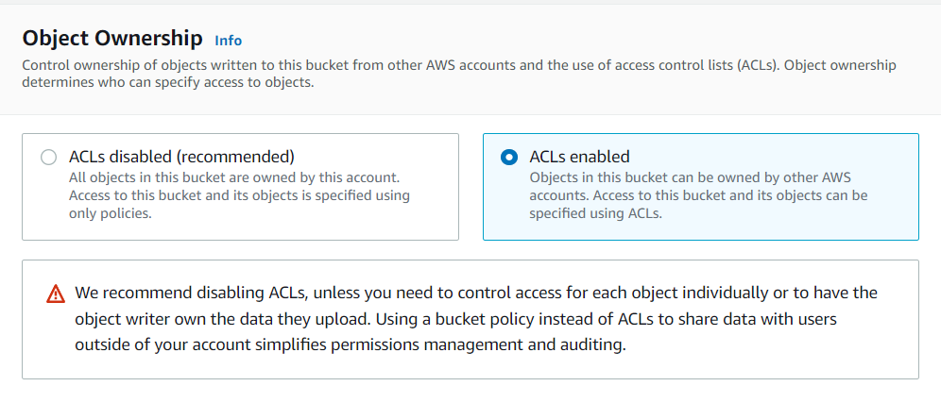

**Bucket creation successful:**

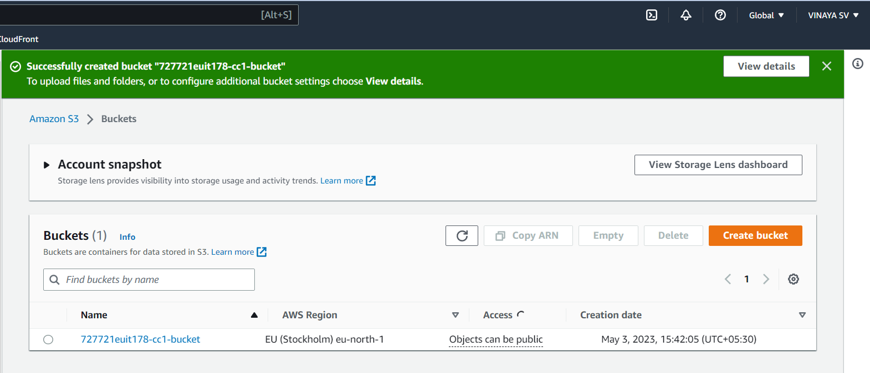

**Object accounts.txt added to 727721euit178-cc1-bucket:**

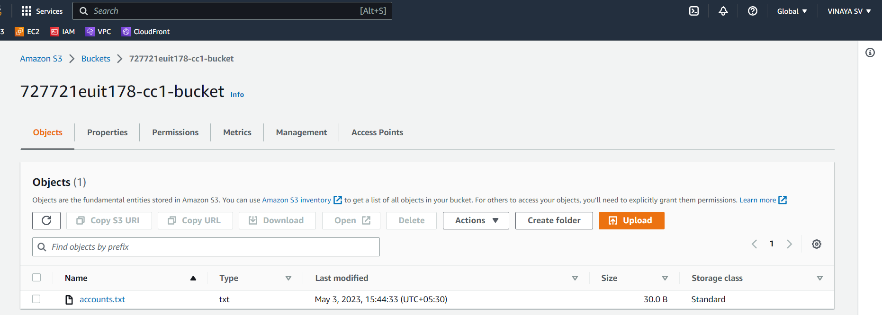

**Displaying object by object URL:**

