EMPLOYEE MANAGEMENT SYSTEM
Java Program Screenshots and Working Summary
Program Overview
This is a menu-driven Java console application for basic employee management. It stores employee records temporarily in an ArrayList and allows the user to create employees, display all employees, increase an employee’s salary, and exit the program. Input validation is used for names, age, designation, and raise percentage so that only acceptable values are processed.
How the Program Works
1. The main menu repeats until the user confirms that they want to exit.
2. Create collects validated employee details and assigns a base salary according to designation.
3. Display prints every employee currently stored in the ArrayList.
4. Raise salary finds an employee by name and increases the current salary by 1% to 10%.
5. Exit requests confirmation before ending the program.

Figure 1: Employee class and main menu
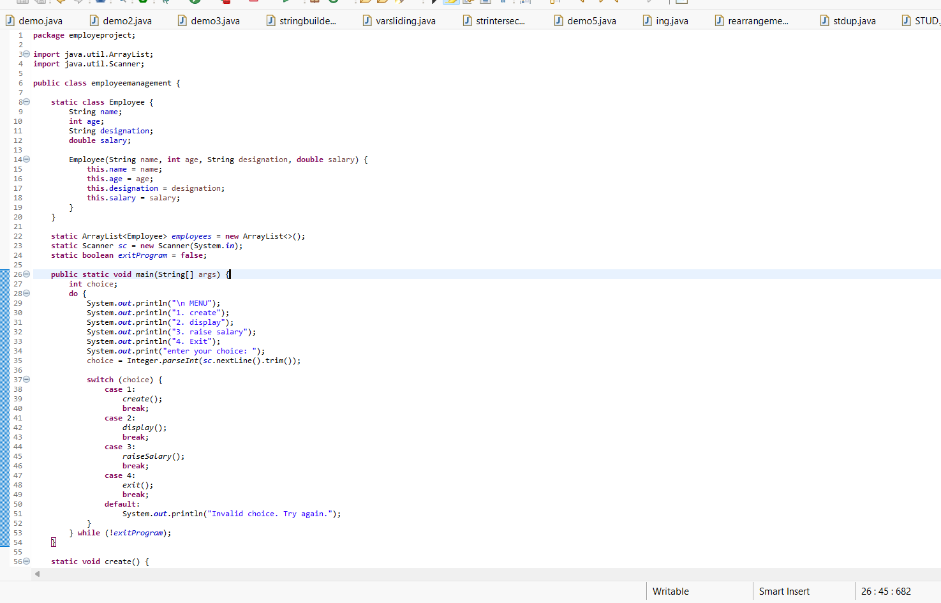
Figure 1: Employee class and main menu
The program defines an Employee object with name, age, designation, and salary fields. Employee records are stored in an ArrayList. The main method repeatedly displays four menu choices—create, display, raise salary, and exit—and sends the user’s selection to the corresponding method.

Figure 2: Creating and validating employee records
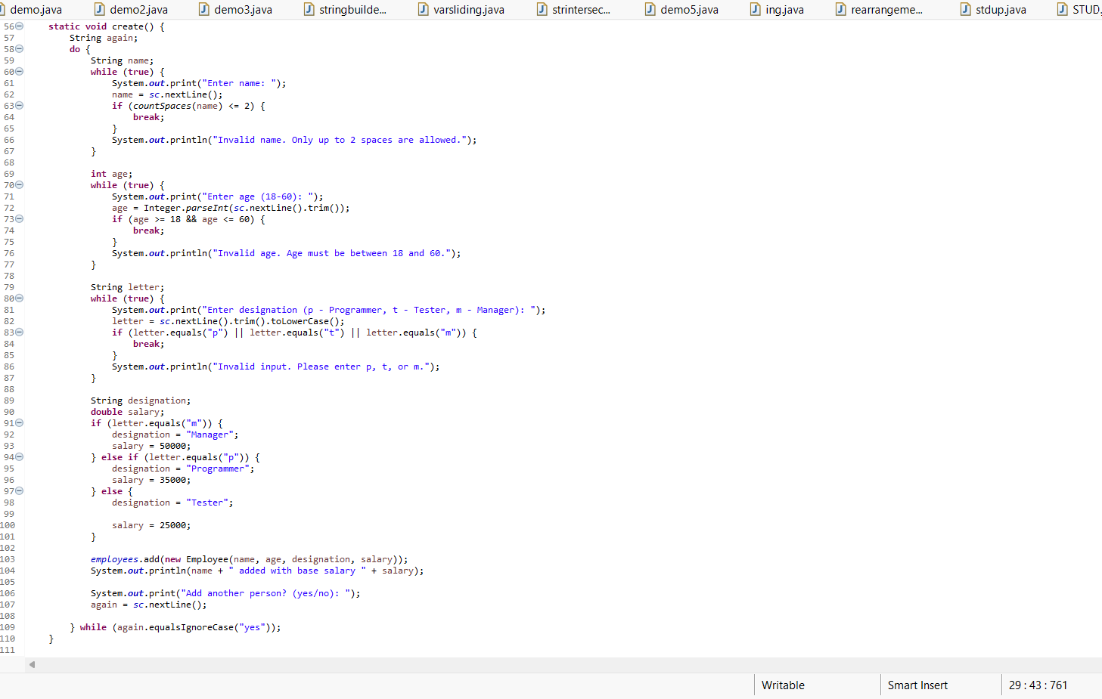
Figure 2: Creating and validating employee records
The create method collects an employee’s name and accepts names containing no more than two spaces. It validates that age is between 18 and 60 and limits the designation choice to Programmer, Tester, or Manager. A fixed base salary is then assigned: 35,000 for Programmer, 25,000 for Tester, and 50,000 for Manager. The completed record is added to the employee list, and the user may enter another employee.

Figure 3: Continuation of employee creation logic
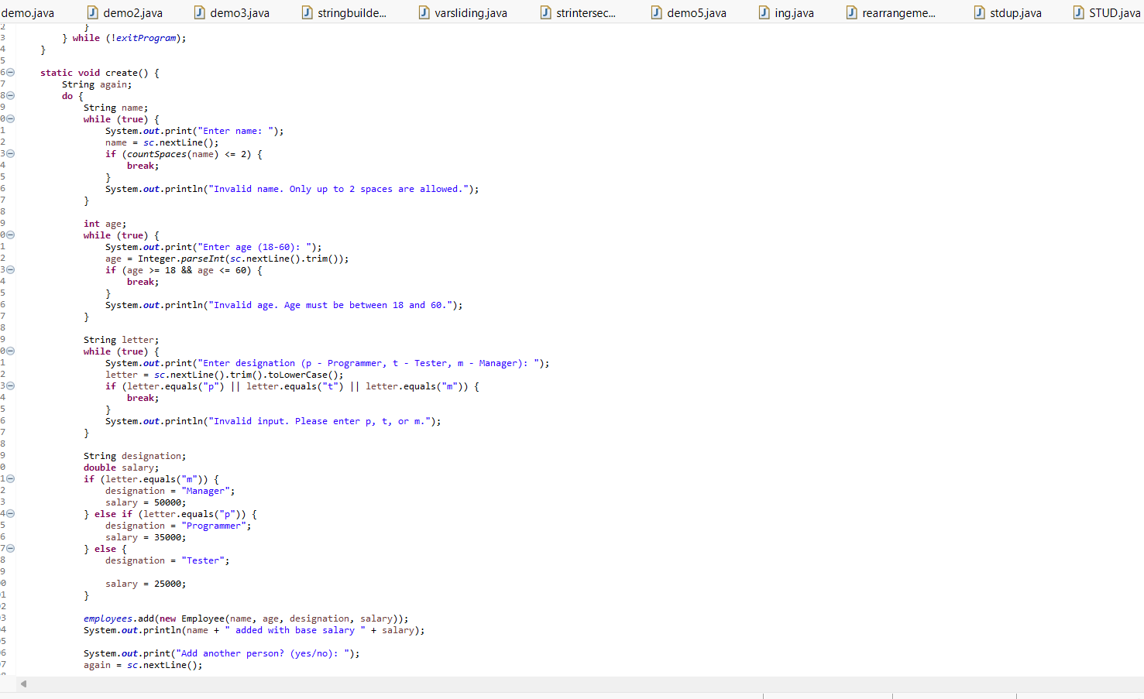
Figure 3: Continuation of employee creation logic
This screen provides another view of the create workflow. Input-validation loops keep asking until valid values are entered. The designation letter is converted to the full job title, the matching base salary is selected, and a new Employee object is stored in the shared ArrayList.

Figure 4: Name checking, employee display, and salary search
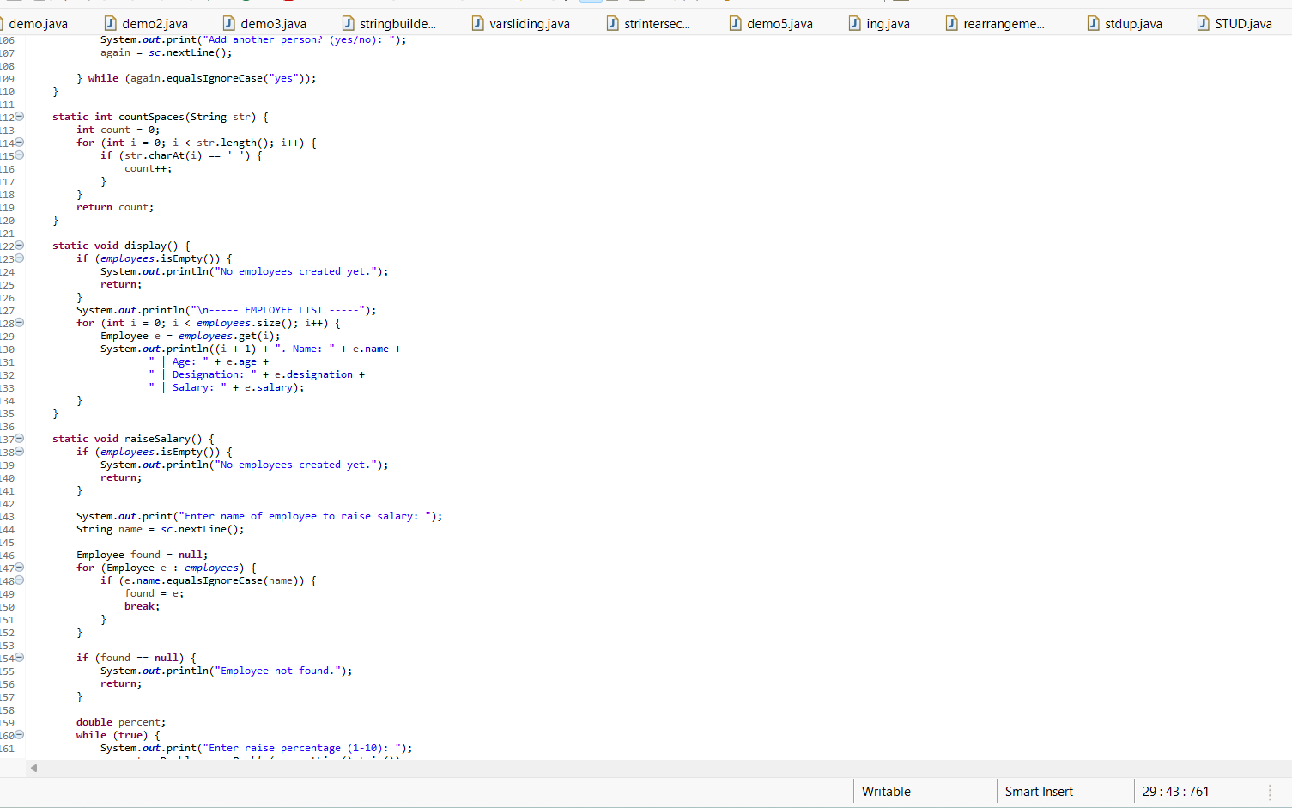
Figure 4: Name checking, employee display, and salary search
The countSpaces helper checks the employee name format. The display method first confirms that records exist, then prints each employee’s number, name, age, designation, and salary. The raiseSalary method asks for an employee name and searches the list without considering uppercase or lowercase differences.

Figure 5: Salary calculation and program exit
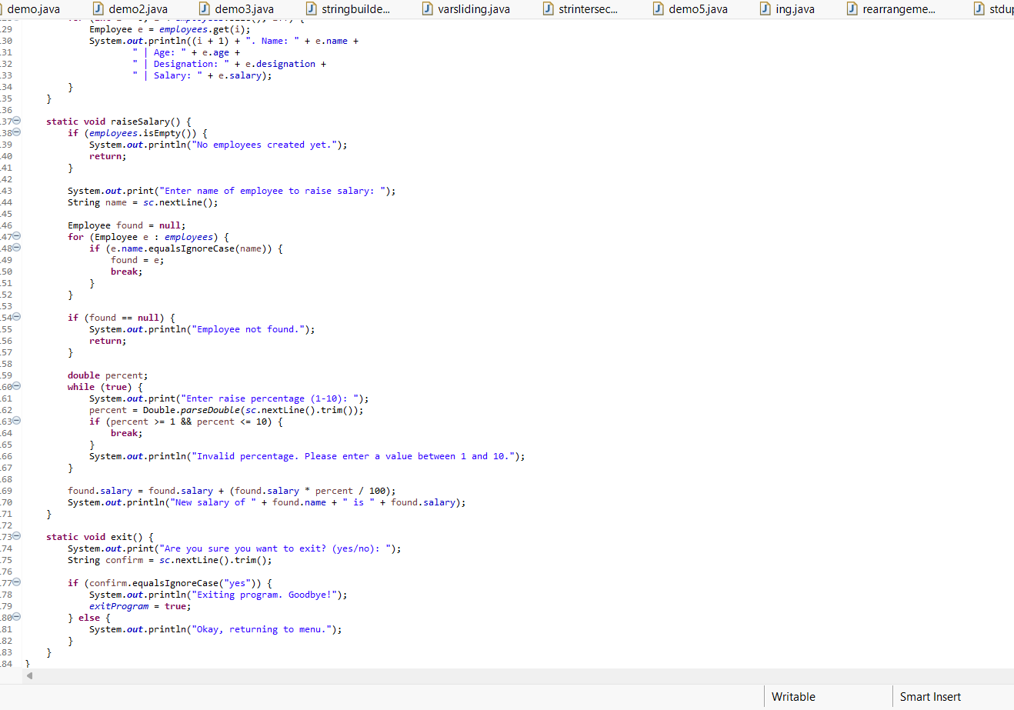
Figure 5: Salary calculation and program exit
After locating an employee, the program accepts a raise percentage from 1 to 10. It calculates the new salary by adding the selected percentage of the current salary. The exit method asks for confirmation; entering yes ends the loop, while any other response returns the user to the menu.

Figure 6: Sample execution—create, display, and raise salary
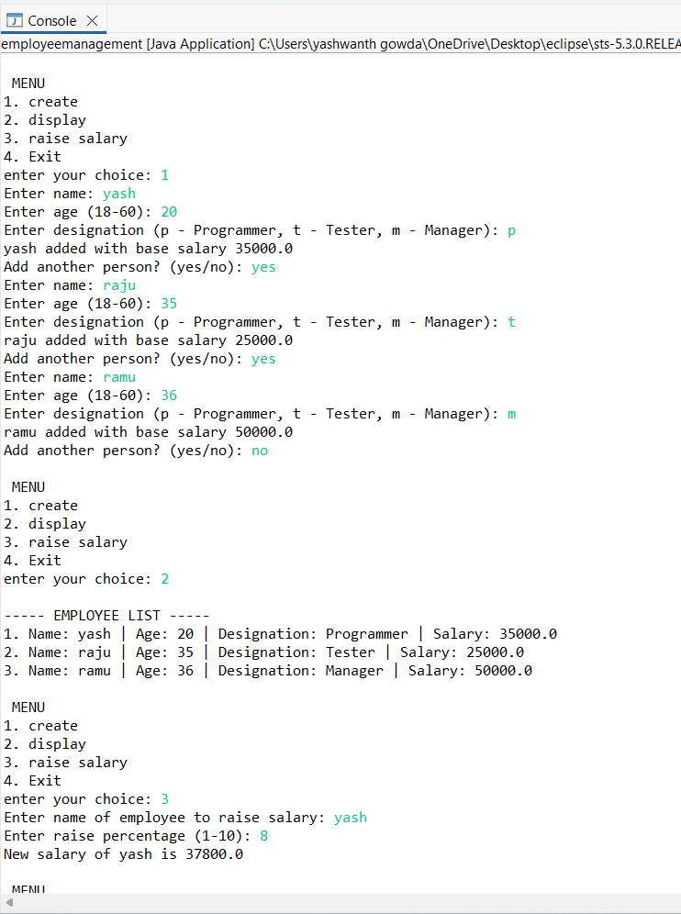
Figure 6: Sample execution—create, display, and raise salary
The console output demonstrates the complete workflow. Three employees are created with different designations and their automatically assigned base salaries. Option 2 displays all saved records. Option 3 selects Yash and applies an 8% raise, increasing the salary from 35,000 to 37,800.

Figure 7: Sample execution—exit confirmation
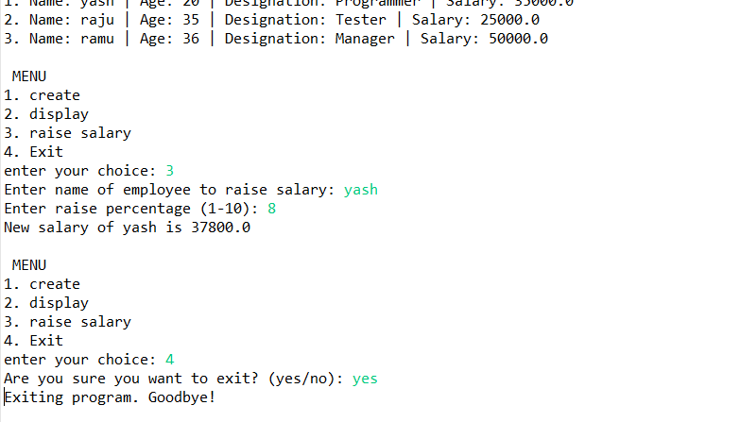
Figure 7: Sample execution—exit confirmation
The final console screen confirms the updated salary and shows the exit process. When the user selects option 4 and enters yes, the program prints a goodbye message and terminates normally.

