PROJECT REPORT
India's Agricultural Crop Production Analysis (1997–2021)
Submitted by
Sri Vinayak Chikkala
23B91A6125
Department of AIML
SRKR Engineering College
July 2026

Certificate
This is to certify that Sri Vinayak Chikkala (23B91A6125) completed this project as part of SkillWallet.

Acknowledgement
I thank SRKR Engineering College, SkillWallet and my faculty for their support.

Abstract
This project develops Tableau dashboards and a Flask website for agricultural crop production analysis.

Table of Contents
Introduction, Objectives, Problem Statement, Existing System, Proposed System, Requirements, Dataset, Methodology, Worksheets, Dashboard, Story, Flask, GitHub, Testing, Results, Conclusion, Future Scope, References, Appendix.

Introduction
Agriculture is one of the largest and most vital sectors of the Indian economy, employing a majority of the population and contributing significantly to the country's GDP. With crop production varying widely across states, seasons, and years, there is a growing need for tools that can convert raw agricultural data into clear, actionable insights.
This project, "India's Agricultural Crop Production Analysis (1997–2021)," uses Tableau to build interactive dashboards and visual stories from a 25-year dataset of India's crop production, and integrates these visualizations into a Flask-based web application so that the analysis can be accessed and explored through a simple website interface.

Objectives
The key objectives of this project are:
- Analyze crop production across India using historical data from 1997 to 2021.
- Compare state-wise agricultural production across India.
- Study seasonal production trends (Kharif, Rabi, and other cropping seasons).
- Visualize cultivated area by crop to understand land utilization patterns.
- Publish an interactive Tableau Story summarizing key findings.
- Integrate the Tableau dashboards and story into a Flask website for easy access.

Problem Statement
Agricultural crop production data spanning multiple decades, states, seasons, and crop types is available in raw tabular form, but its scale and complexity make it difficult for stakeholders to identify patterns, trends, or anomalies simply by inspecting spreadsheets. Without proper visualization, valuable insights about production trends, seasonal performance, and state-wise comparisons remain hidden, making it harder for planners and researchers to make informed, data-driven decisions.

Existing System
Traditionally, crop production data has been analyzed using spreadsheet tools such as Microsoft Excel, where users manually create charts and pivot tables. This approach is time-consuming, difficult to update with new data, offers limited interactivity, and makes it hard to explore relationships across multiple dimensions such as state, season, crop, and year simultaneously.

Proposed System
The proposed system uses Tableau to build a set of interconnected worksheets, an interactive dashboard, and a guided story that allow users to explore India's crop production data dynamically by state, season, crop, and year. These Tableau visualizations are published to Tableau Public and then embedded into a lightweight Flask web application, giving users a single, easy-to-access website through which to view the Home page, Project Information, and the Tableau Story.

Requirements
Software Requirements:
- Tableau Desktop and Tableau Public
- Python and Flask
- HTML and CSS
- Git and GitHub for version control
- Microsoft Excel
Hardware Requirements:
- A Windows PC with a minimum of 4GB RAM for running Tableau Desktop and the Flask development server.

Dataset
The project uses India's Agricultural Crop Production dataset, provided in Microsoft Excel (.xlsx) format and covering the years 1997 to 2021. The dataset records crop-wise, state-wise, and season-wise production and cultivated area figures across India, forming the foundation for all worksheets, dashboards, and the story built in Tableau.

Methodology
The project was carried out in the following stages:
- Collect the India Agricultural Crop Production dataset (1997–2021) in Excel format.
- Clean and prepare the data for analysis in Tableau.
- Create individual Tableau worksheets for production, cultivated area, crop comparison, and seasonal analysis.
- Combine the worksheets into an interactive dashboard.
- Build a Tableau Story to present the key insights in a guided narrative.
- Publish the dashboard and story to Tableau Public.
- Integrate the published visualizations into a Flask website.
- Test the website and verify that all visualizations display and function correctly.

Worksheets
A set of individual Tableau worksheets was built to explore different facets of the dataset before being combined into the final dashboard and story. These worksheets include:
- India Agricultural Performance Summary – an overall snapshot of national production.
- State-wise Production – comparing crop output across Indian states.
- State-wise Cultivated Area – visualizing land area used for cultivation by state.
- Crop Comparison – comparing production levels across different crops.
- Year-wise Production Trend – tracking how production has changed from 1997 to 2021.
- Production Distribution and Seasonal Analysis – examining how production is spread across seasons such as Kharif and Rabi.
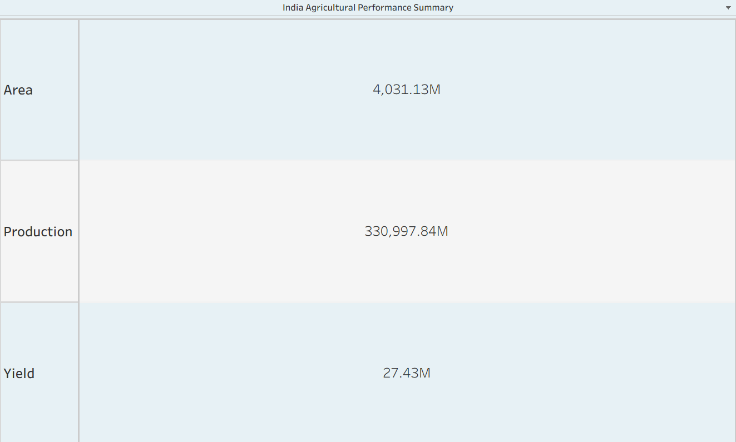
India Agricultural Performance Summary
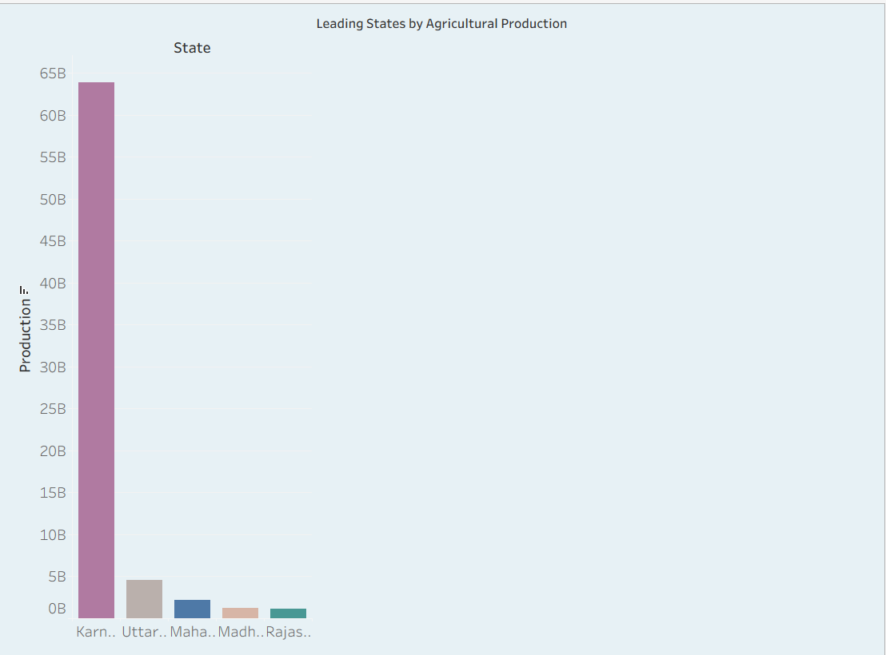
Leading States by Agricultural Production
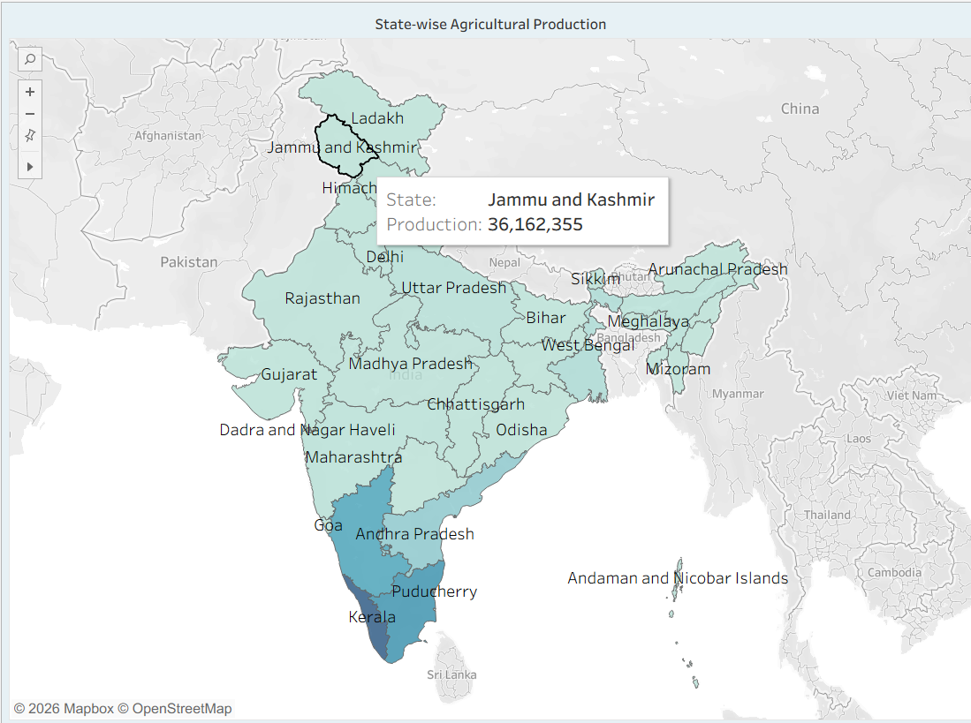
State-wise Agricultural Production (map)
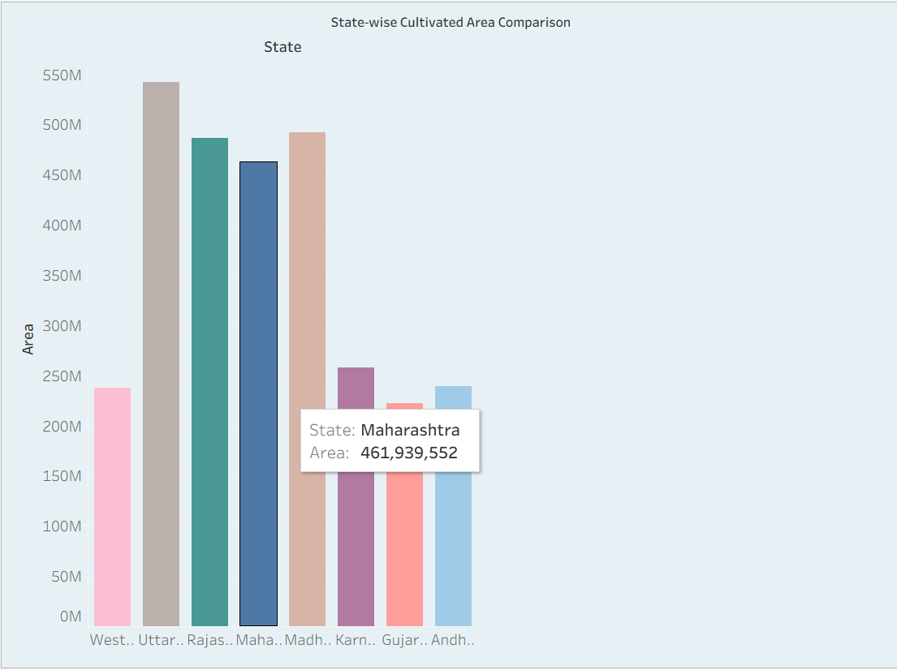
State-wise Cultivated Area Comparison
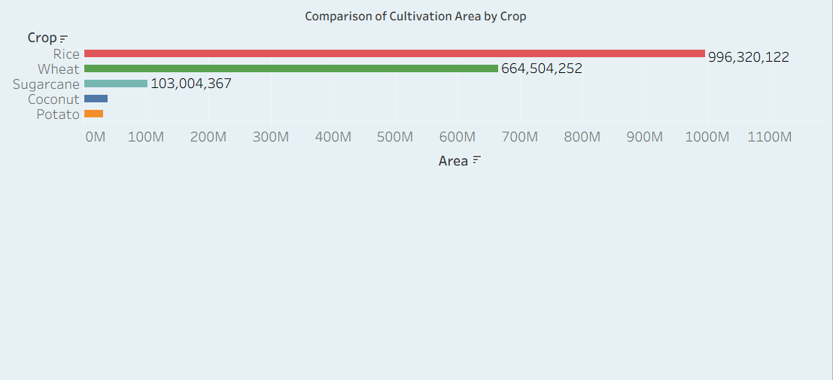
Comparison of Cultivation Area by Crop
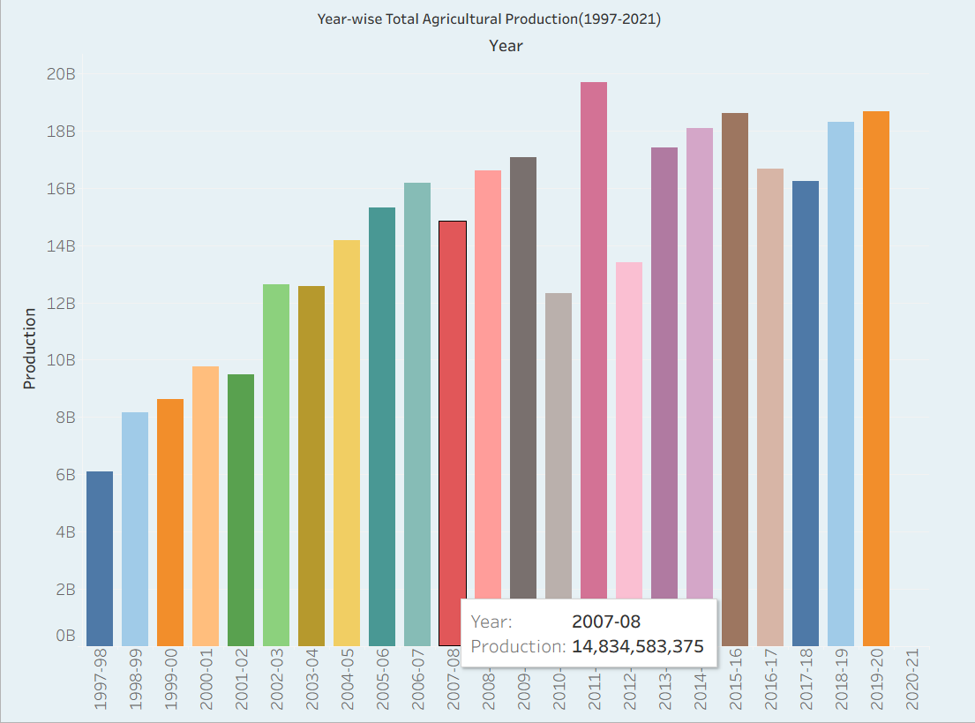
Year-wise Total Agricultural Production
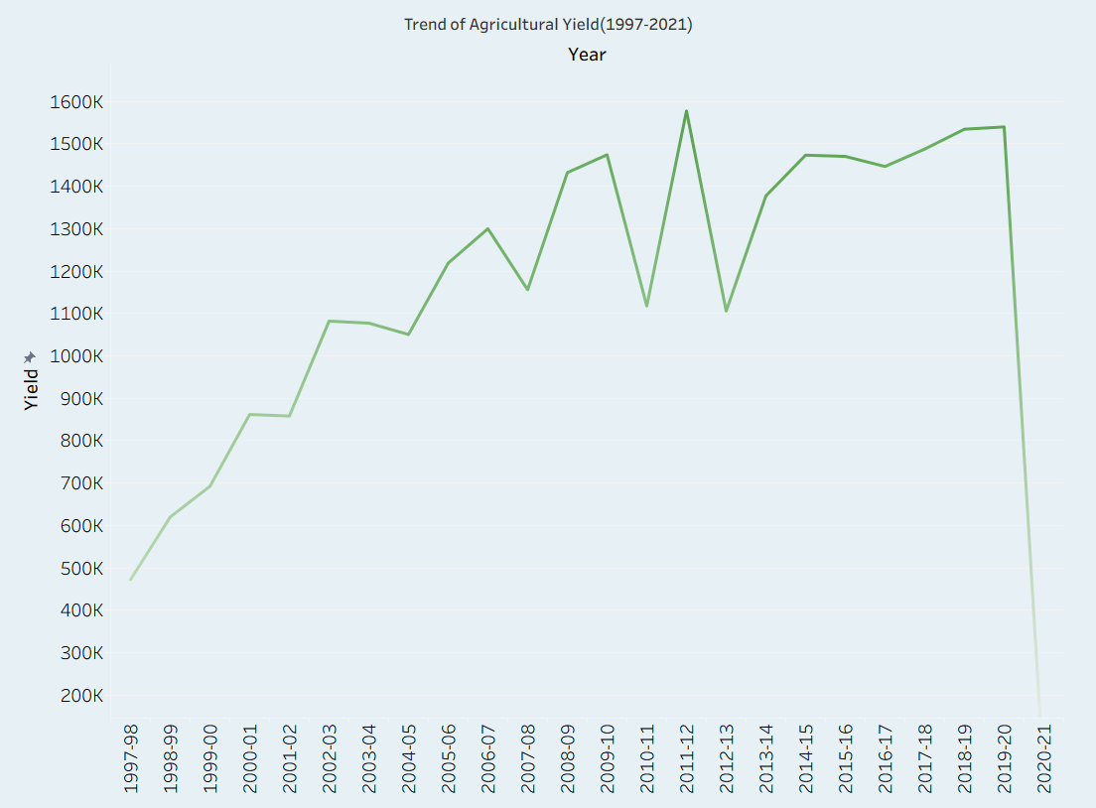
Trend of Agricultural Yield
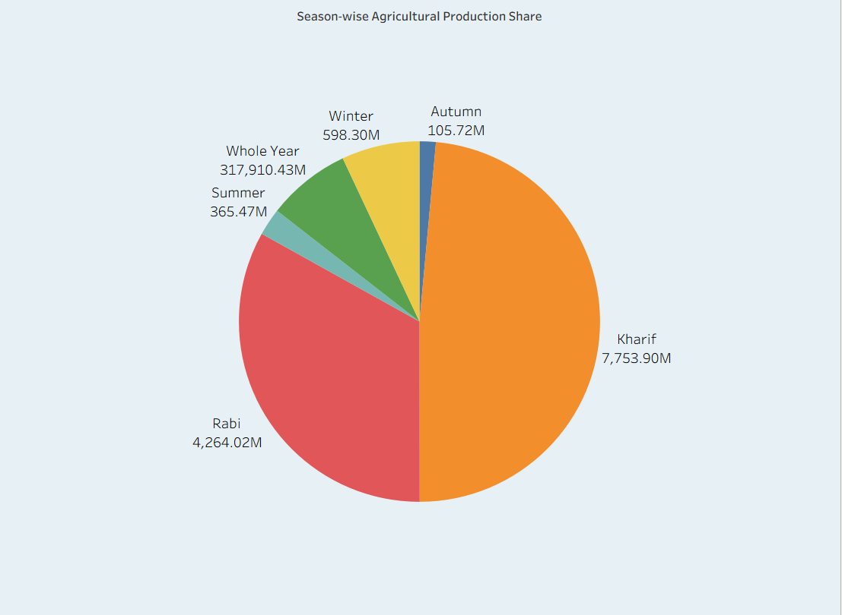
Season-wise Agricultural Production Share
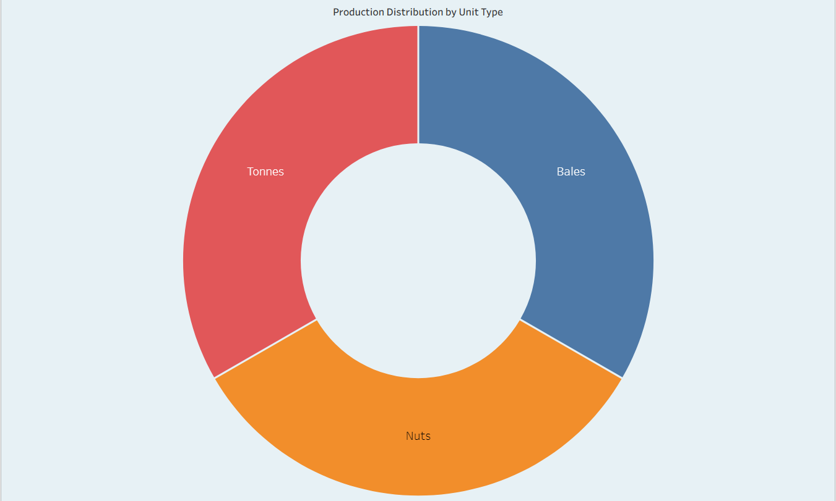
Production Distribution by Unit Type

Dashboard
The Tableau dashboard brings together the individual worksheets into a single, unified view, allowing users to filter and cross-explore India's agricultural performance summary, state-wise production, state-wise cultivated area, crop comparison, year-wise production trend, and production distribution all in one place. The dashboard layout is designed to be interactive, letting a user click on any state or crop to filter the related visualizations dynamically.
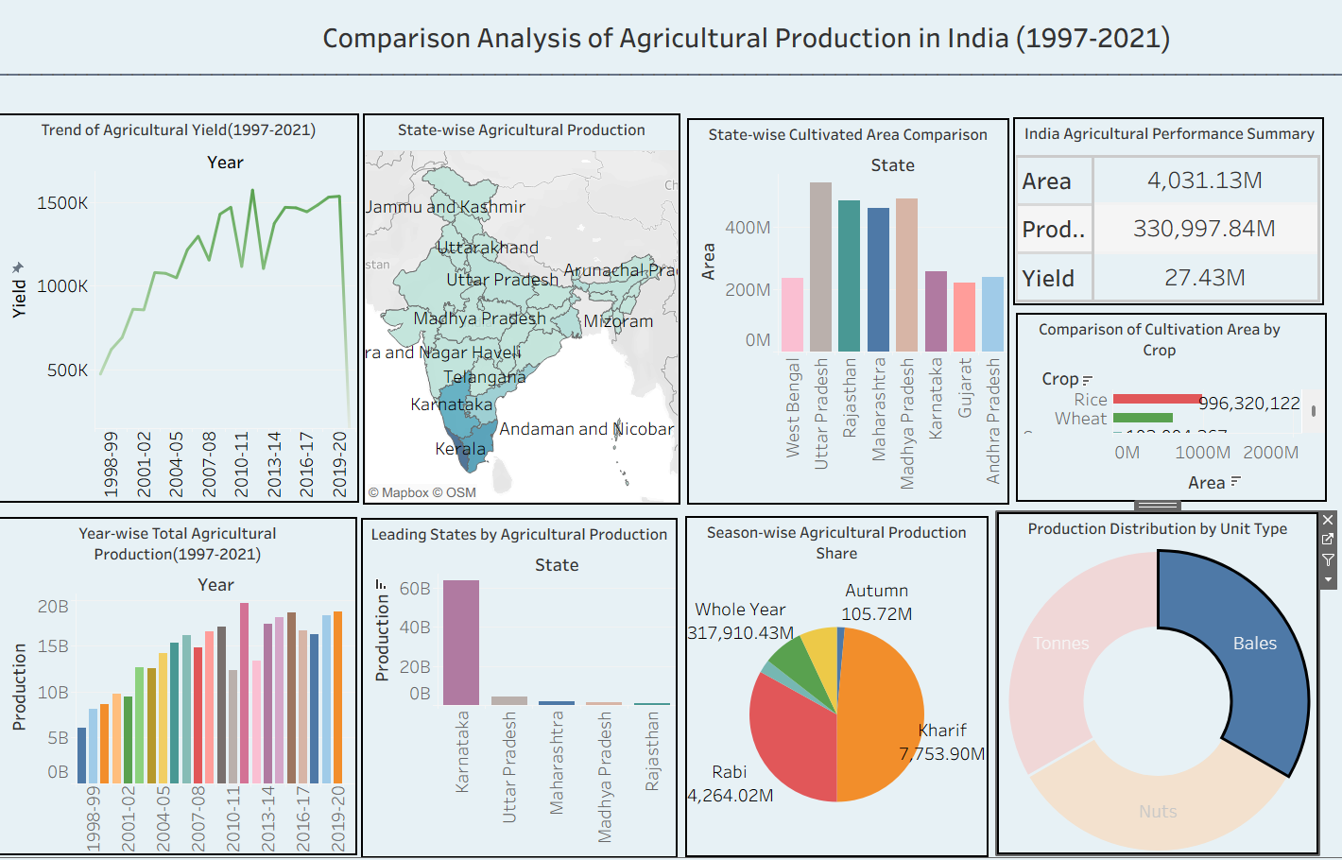
Combined Tableau Dashboard – Comparison Analysis of Agricultural Production in India (1997-2021)

Story
The Tableau Story presents the dashboard's insights as a guided, narrative sequence of story points, walking the viewer through India's overall agricultural performance, state-wise comparisons, seasonal production patterns, and year-wise trends from 1997 to 2021. This story has been published to Tableau Public and is embedded directly into the Flask website's Story page.
[Insert story screenshot here.]

Flask Website
A lightweight Flask website was built to host and present the Tableau visualizations. It is built primarily with Python (Flask), HTML, and CSS, and runs locally at http://127.0.0.1:5000. The website contains three main pages:
- Home Page – the landing page introducing the project.
- Project Information Page – describing the objectives, dataset, and dashboard.
- Tableau Story Page – embedding the published Tableau Story for interactive viewing.
The website can be run locally with the following steps:
- git clone <repository-url>
- cd India-Agricultural-Crop-Production-Analysis
- pip install -r requirements.txt
- python app.py

GitHub
The project source code is version-controlled and hosted on GitHub at the following repository: https://github.com/vinayak-9090/India-Agricultural-Crop-Production-Analysis. The repository is composed mainly of HTML (for the Flask templates) and Python (for the Flask application logic), along with a README describing the project overview, objectives, dataset, technologies used, dashboard features, and installation instructions. Git was used throughout development to track changes and maintain a clean commit history.

Testing
Testing was carried out to ensure that the dashboard, story, and website all function as expected. This included verifying that each Tableau worksheet renders correctly with accurate filters, confirming that the dashboard's interactive filtering behaves correctly across all linked worksheets, checking that the published Tableau Public visualizations load properly when embedded in the Flask Story page, and testing that all three Flask pages (Home, Project Information, and Story) load correctly when the application is run locally.

Results
The completed dashboard and story successfully surface meaningful patterns in India's agricultural crop production between 1997 and 2021, including variation in production across states, differences between cropping seasons, and shifts in year-wise production trends. The Flask website makes these insights accessible through a simple browser-based interface, allowing a user to move between the Home, Project Information, and Story pages without needing Tableau Desktop installed.

Conclusion
This project successfully demonstrates how raw agricultural data can be transformed into clear, interactive visualizations using Tableau and made widely accessible through a Flask website. By combining worksheets, a dashboard, and a guided story, the project provides an effective way to explore and understand 25 years of India's crop production data, achieving the objectives set out at the start of the project.

Future Scope
Future improvements to this project could include incorporating predictive analytics and machine learning models to forecast future crop production, adding district-level granularity to the dataset, including additional factors such as rainfall and fertilizer usage, and deploying the Flask website to a cloud platform so it is publicly accessible beyond the local environment.

References
The following resources were referred to during this project:
- Tableau Desktop and Tableau Public official documentation
- Flask official documentation
- GitHub documentation
- Microsoft Excel documentation
- Project repository: https://github.com/vinayak-9090/India-Agricultural-Crop-Production-Analysis

Appendix
This section is reserved for pasting supporting screenshots of the Tableau worksheets, dashboard, story, and the Flask website pages (Home, Project Information, and Story), as captured during development and testing.

