1 Introduction

1.1 Objective of the Project
- To empower communities with income and recognition.
- To provide corporates with trusted, audit-ready credits.
- To scale up meaningful climate action globally.

1.2 Brief Description of the Project
The Carbon Wallet project is a digital platform designed to connect grassroots environmental contributors such as farmers, NGOs, and local communities with corporate buyers seeking verified carbon credits. The system enables users to submit geo-tagged photos and documents as proof of climate-positive activities, such as afforestation, waste reduction, or soil restoration. These submissions undergo AI-based validation and third-party verification, ensuring that the generated carbon credits are authentic, traceable, and audit-ready.
Once verified, the credits are stored securely and transferred to the seller’s digital wallet, where they can be listed on a marketplace. Corporate buyers can browse available credits, receive AI-based seller recommendations, and purchase credits directly through the platform. By bridging the gap between grassroots sustainability efforts and corporate environmental commitments, Carbon Wallet helps democratize access to carbon finance and promotes transparent, data-driven climate action.
Carbon Wallet uses a multi-layered approach that blends digital innovation with sustainability expertise:
- Activity Logging (Web App): Grassroot actors log their climate-positive actions via a user-friendly application. The system automatically captures geo-tagged photos, GPS data, and digital forms, ensuring each action is tied to a real-world location and participant.
- Smart Validation System:
  - AI/ML Models: Trained algorithms analyse data for consistency, detect anomalies, and quantify environmental impact. This reduces reliance on manual audits, making the process cost-effective and scalable.
  - 3rd-Party Verification: Adds an independent review step, ensuring credibility and trustworthiness.
- Secure Ledger for Credit Recording: Instead of using blockchain, Carbon Wallet relies on a secure, tamper-proof ledger. This ensures each verified credit is uniquely recorded, traceable, and auditable, eliminating risks like double-counting or fraudulent reporting.
- Carbon Credit Conversion: Verified actions are converted into standardized, globally recognized carbon credits, aligned with Gold Standard and Verra frameworks. These frameworks provide corporate buyers with confidence that credits are scientifically valid and internationally accepted.
- Marketplace & AI Agent:
  - Sellers: Verified users and NGOs can list their available credits.
  - Buyers: Corporates access a dashboard to calculate credit requirements and view available listings.
  - AI Agent: Enhances the buying process by analysing the buyer’s credit needs and recommending a shortlist of NGOs and user groups who best match those requirements. For example, if a corporate buyer needs large-scale urban afforestation credits, the AI might suggest UrbanEco NGO or Community Green Foundation.
This AI-driven matchmaking ensures buyers don’t just purchase credits, they invest in targeted, verified sustainability projects that align with their values.

1.3 Technology Used
Static Website
- Frontend: HTML, CSS, Javascript

1.3.1 Hardware Requirements
• A standard laptop/desktop computer
• Internet connection
• Modern browser (Chrome/Firefox/Safari)

1.3.2 Software Requirements
• HTML, CSS, JavaScript
• VS Code Editor
• Upcoming backend technologies: Node.js / Python Flask, MongoDB / SQL

2 Design Description

2.1 Flow Chart of the Web App
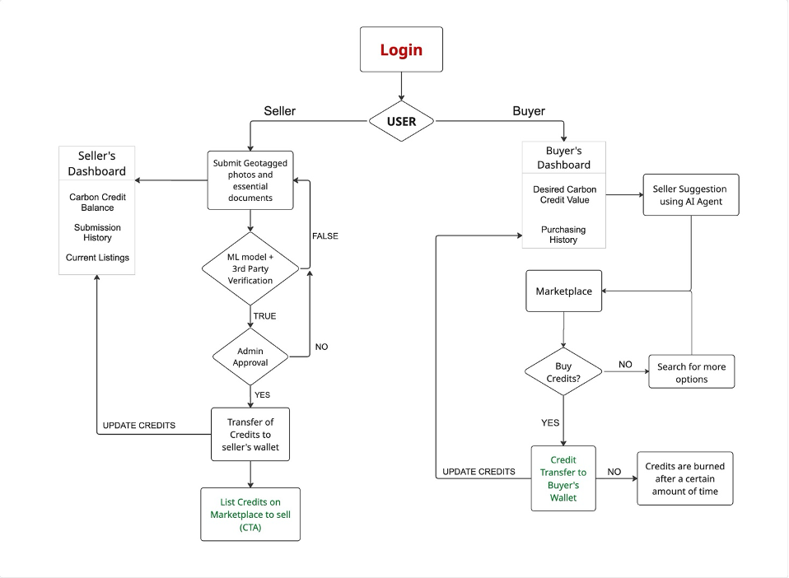
Figure 1: Workflow of Carbon Wallet Application

2.2 Data Flow Diagram (Level-1)
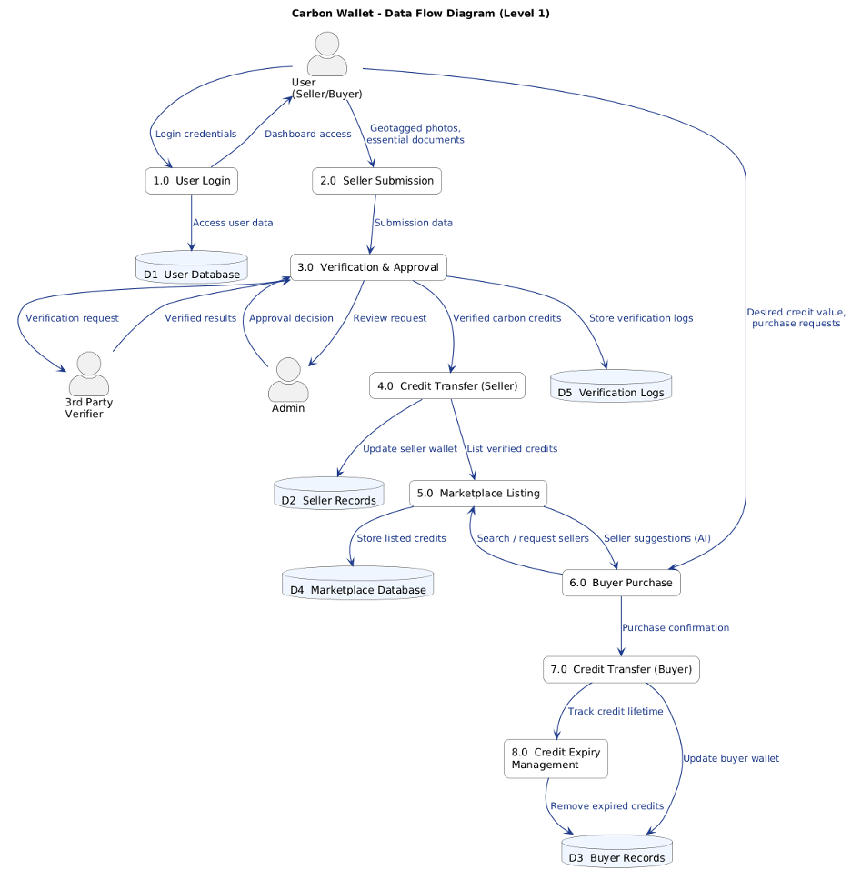
Figure 2: Level-1 DFD of Carbon Wallet System

2.3 Entity Relationship Diagram (ER Diagram)
The ER diagram will be finalized after backend design. Expected entities: User, Submission, Credits, Transactions, VerificationLog.

3 Project Description

3.1 Database
The database will store user accounts, submissions, verification records, carbon credit logs, and marketplace transactions.

3.2 Table Description
• User Table – stores user info, login credentials, type (buyer/seller)
• Submission Table – stores geotagged photos, documents
• Credits Table – stores verified and pending credits
• Transactions Table – buyer/seller transactions
• Verification Logs – ML model output and third-party validation

3.3 File / Database Design
To be completed post backend integration.

4 Input/Output Form Design (UI Screens)
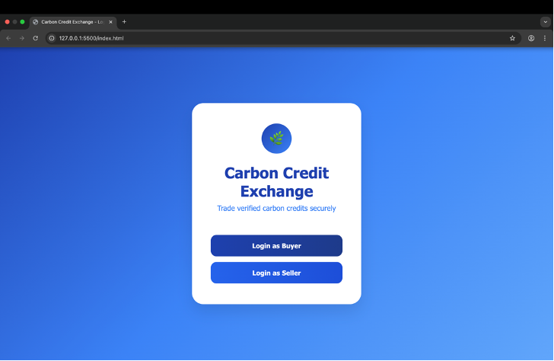
Figure 3: Login Page of Carbon Wallet
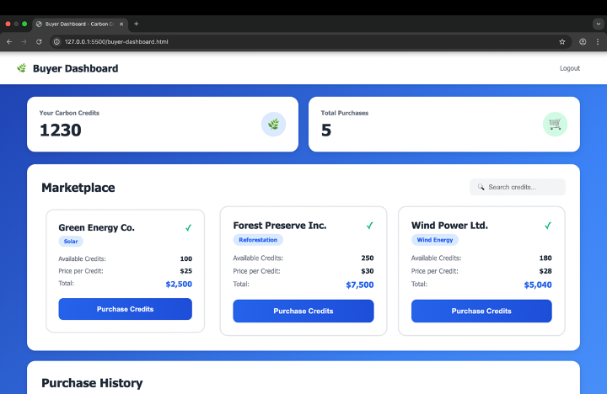
Figure 4: Buyer Dashboard Interface
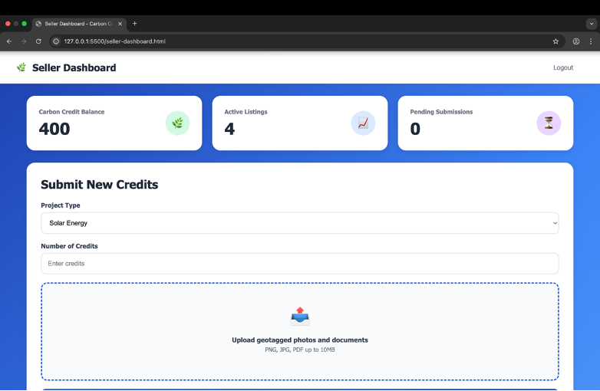
Figure 5: Seller Dashboard Interface

5 Testing & Tools Used
Frontend testing included layout verification, responsiveness testing, and user interaction checks.
Testing was done using Live Server and Tools used was VS code.

6 Implementation & Maintenance
Implementation of backend, APIs, database, and AI verification modules will be done in upcoming stages.

7 Conclusion and Future Work
The Carbon Wallet project currently stands at a developed design for a static web prototype that was designed in HTML, CSS, and JavaScript. The prototype will depict a multi-layer concept of the platform which includes a buyer/seller separate login, dashboard to list and view carbon credits, and upload geotagged images and documents being used to substantiate climate-positive activities.
In terms of implementation, the prototype will validate user flow, interface design, and overall feasibility of the Carbon Wallet. The prototype is a proof-of-concept that will provide sound thinking for building the next developments: implementation of AI/ML- based validation for documents created, secure or tamper-proof database shared ledger for recording, carbon credit conversion ways to be aligned with standards, and an intelligent marketplace with AI in the buyer-seller match.

8 Outcome
- Developed a complete static frontend with buyer/seller dashboards, login system, and core user interactions.
- Initiated backend development, beginning with database design as the foundational step.
- Planned integration of AI-based recommendations and buyer–seller matchmaking for the upcoming development phase.

9 Bibliography
[1] Gold Standard. (2025). Gold Standard Annual Report 2024. Available at: https://www.goldstandard.org/publications/annual-report-2024
[2] Verra. (n.d.). Verified Carbon Standard (VCS): How it Works. Available at: https://verra.org/programs/verified-carbon-standard/#how-it-works
[3] Manjunatha, N. and Ravi Kumar, K. (2024). “A Study on Carbon Credits Trading in Indian Context.” International Journal of Commerce and Management Studies (IJCAMS), Vol. 9, No. 3, ISSN 2456-3684. Available at: www.ijcams.com
[4] W3Schools. (n.d.). Web Development Tutorials. Available at: https://www.w3schools.com/

