MACHINE LEARNING / 2026

Handwritten Digit
Recognition
A simple project report for Digit Studio
Student: __________________________ | Class: ____________________________

1. About the project
Digit Studio is a website that recognizes handwritten numbers. A user draws a digit from 0 to 9, and a machine-learning model predicts which digit it is.

2. How it works
- The user draws on the website canvas.
- The app cleans and resizes the image to 8 ? 8 pixels.
- The selected model predicts the digit and shows its scores.
- The page also shows charts that explain model results.

3. Data and models
The project uses scikit-learn?s digits dataset. It contains 1,797 small images of handwritten digits. The data was split into training and test sets. Training images were also varied slightly in stroke thickness, size, and position to help the models handle different drawings.
Model | Test accuracy | Variation accuracy
SVM | 99.44% | 97.22%
Random Forest | 98.06% | 96.30%
Neural Network (MLP) | 98.89% | 96.67%
The SVM had the highest test accuracy (99.44%). The website starts with Random Forest selected, and lets the user switch between models. Variation accuracy measures test images with controlled computer-made changes; it is not a score on a large collection of real people?s drawings.

4. Results at a glance
PCA chart  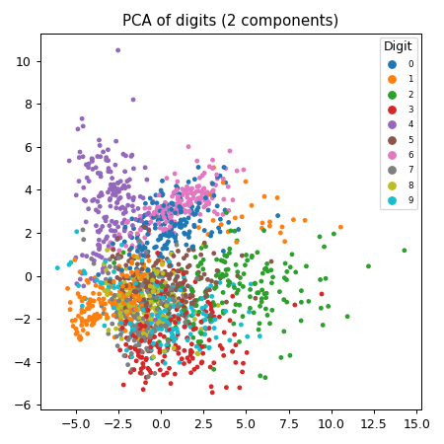  A two-dimensional view of the digit data. | Confusion matrix  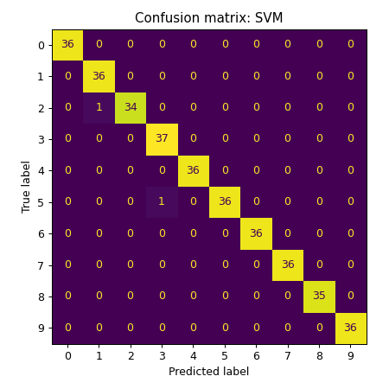  Shows which digits the model gets right or mixes up.

5. Tools used
Python, Flask, scikit-learn, Pillow, NumPy, Matplotlib, and HTML/CSS/JavaScript.

6. Limitations and conclusion
The training images are small and limited in number. Different handwriting, thin strokes, or unusual shapes can still be misread. The accuracy scores describe this dataset and its controlled variations; they do not promise perfect results for every user. This project demonstrates how image preprocessing, machine learning, and a web interface can work together to recognize digits.

