Swiss Federal Information Security Act Compliance for Log360
Tagline: Strengthen federal data security posture and meet Switzerland's ISA requirements using Log360.

Overview
The Swiss Federal Information Security Act (ISA) Compliance extension for Log360 helps Swiss federal bodies and organizations handling federal data align with Switzerland's binding information security legislation.
Log360 continuously collects and correlates log data from Active Directory, Windows, Unix/Linux, Microsoft 365, cloud platforms, and network devices, mapping security events to ISA requirements. Security teams gain real-time visibility into data access, system changes, and incidents, enabling them to detect threats early, demonstrate due diligence to federal auditors, and generate compliance-ready reports with a single click.

Key Features
- Generate predefined audit reports aligned to ISA requirements covering data access, system integrity, and incident response activities.
- Monitor user authentication events, privilege changes, and administrative actions across on-premises and cloud environments in real time.
- Export compliance reports in PDF and CSV formats for submission to federal oversight authorities and internal governance teams.
- Configure threshold-based alerts for critical ISA-relevant events such as unauthorized access attempts, audit log tampering, and policy violations.
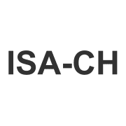
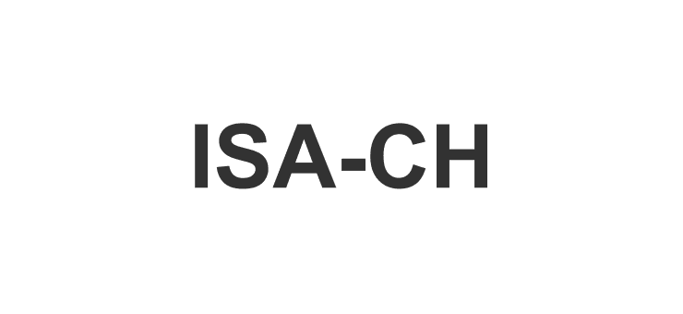

Screenshots
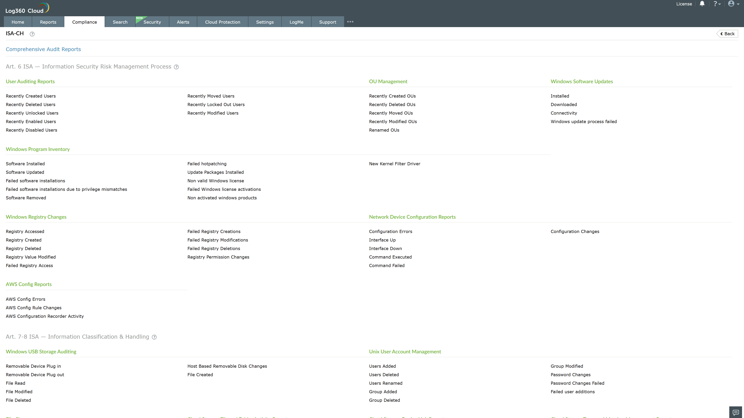
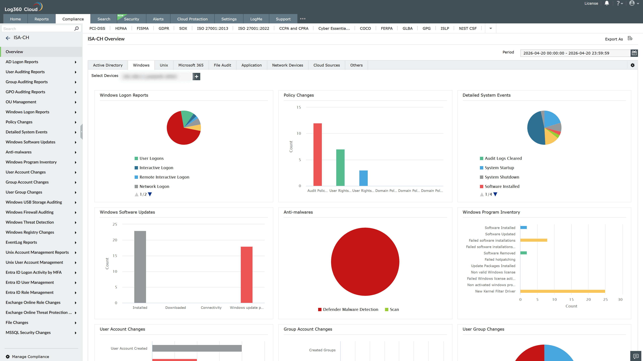
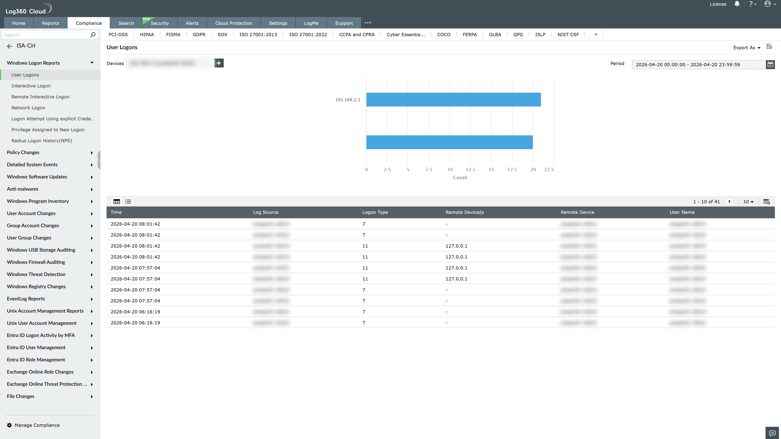
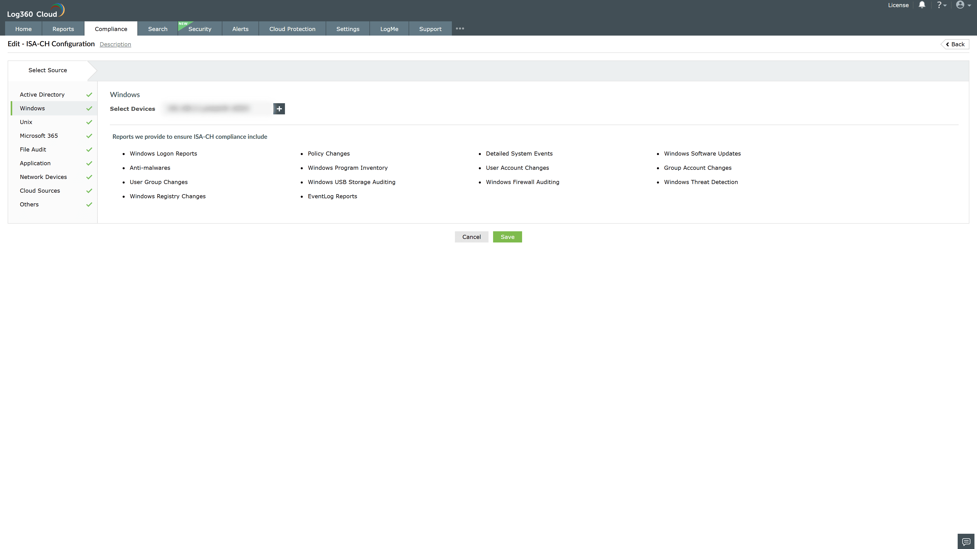

Valid Submission : Yes
Supported Editions : Free, Basic, Standard, Professional, MSSP
Help Document : https://www.manageengine.com/log-management/help/integrations/compliance-extensions.html
Help Video : Not provided
Tags : Log360, Compliance, Privacy monitoring, Data privacy, Regulatory compliance
Supported DCs : US, IN, JP, CA, AU, UK and EU
Privacy Policy:
Terms of Service:
Release Notes:
Predefined reports for the swiss federal information security act isa compliance

