BDDK IS Regulation Compliance for Log360
Tagline: Meet Turkey's banking security requirements with unified log monitoring from Log360.

Overview
The BDDK IS Regulation (Banks' Information Systems) Compliance extension for Log360 helps Turkish banks and financial institutions regulated by the Banking Regulation and Supervision Agency (BDDK) meet the information systems security, access control, and audit requirements of the BDDK IS Regulation.
Log360 continuously collects and correlates logs from core banking systems, payment platforms, cloud environments, and network infrastructure, providing security teams with detailed visibility into IT security events. Compliance teams can monitor access to sensitive financial data, detect anomalies, and generate reports for BDDK examinations.

Key Features
- Generate BDDK IS Regulation-aligned audit reports covering access management, system integrity monitoring, and security incident detection in banking environments.
- Track privileged user activities, administrative system changes, and access to core banking applications in real time.
- Centralize log data from across your infrastructure to maintain real-time visibility into user activity and access patterns, supporting proactive threat identification and compliance posture.
- Export audit evidence in PDF and CSV formats for BDDK on-site inspections and internal IT audit reviews.
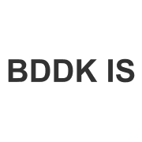
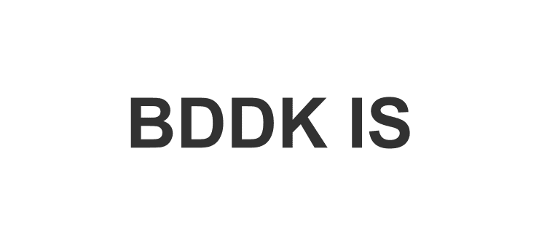

Screenshots
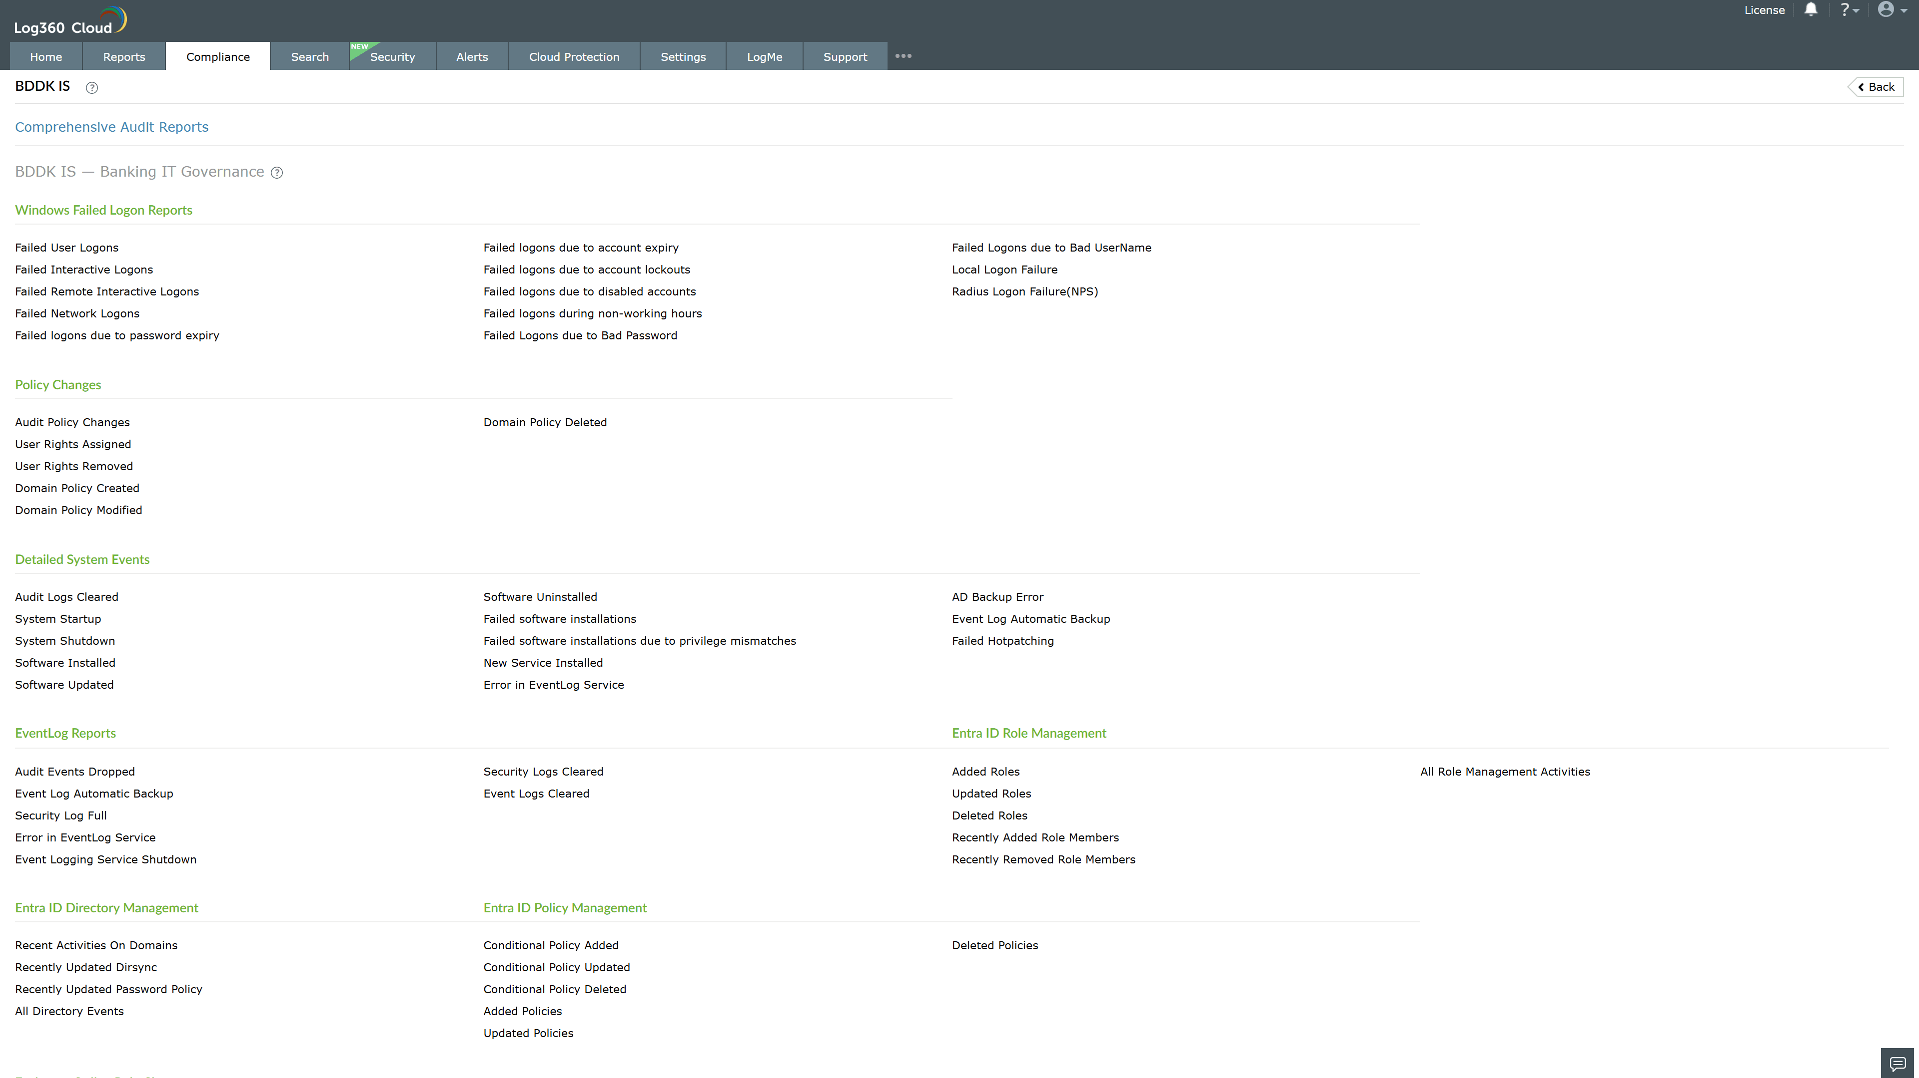
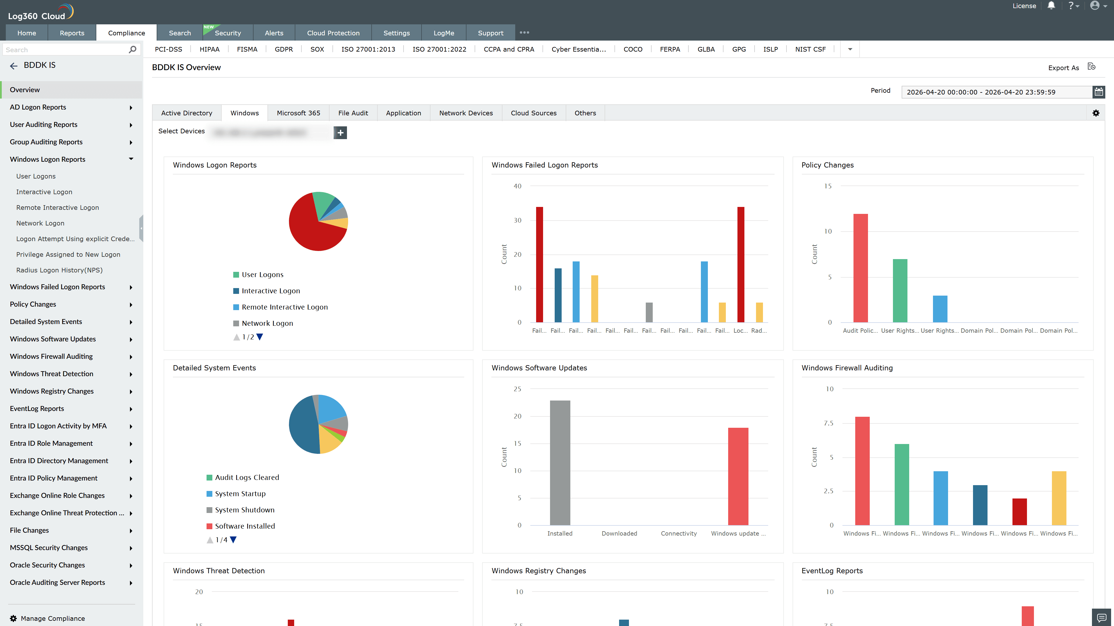
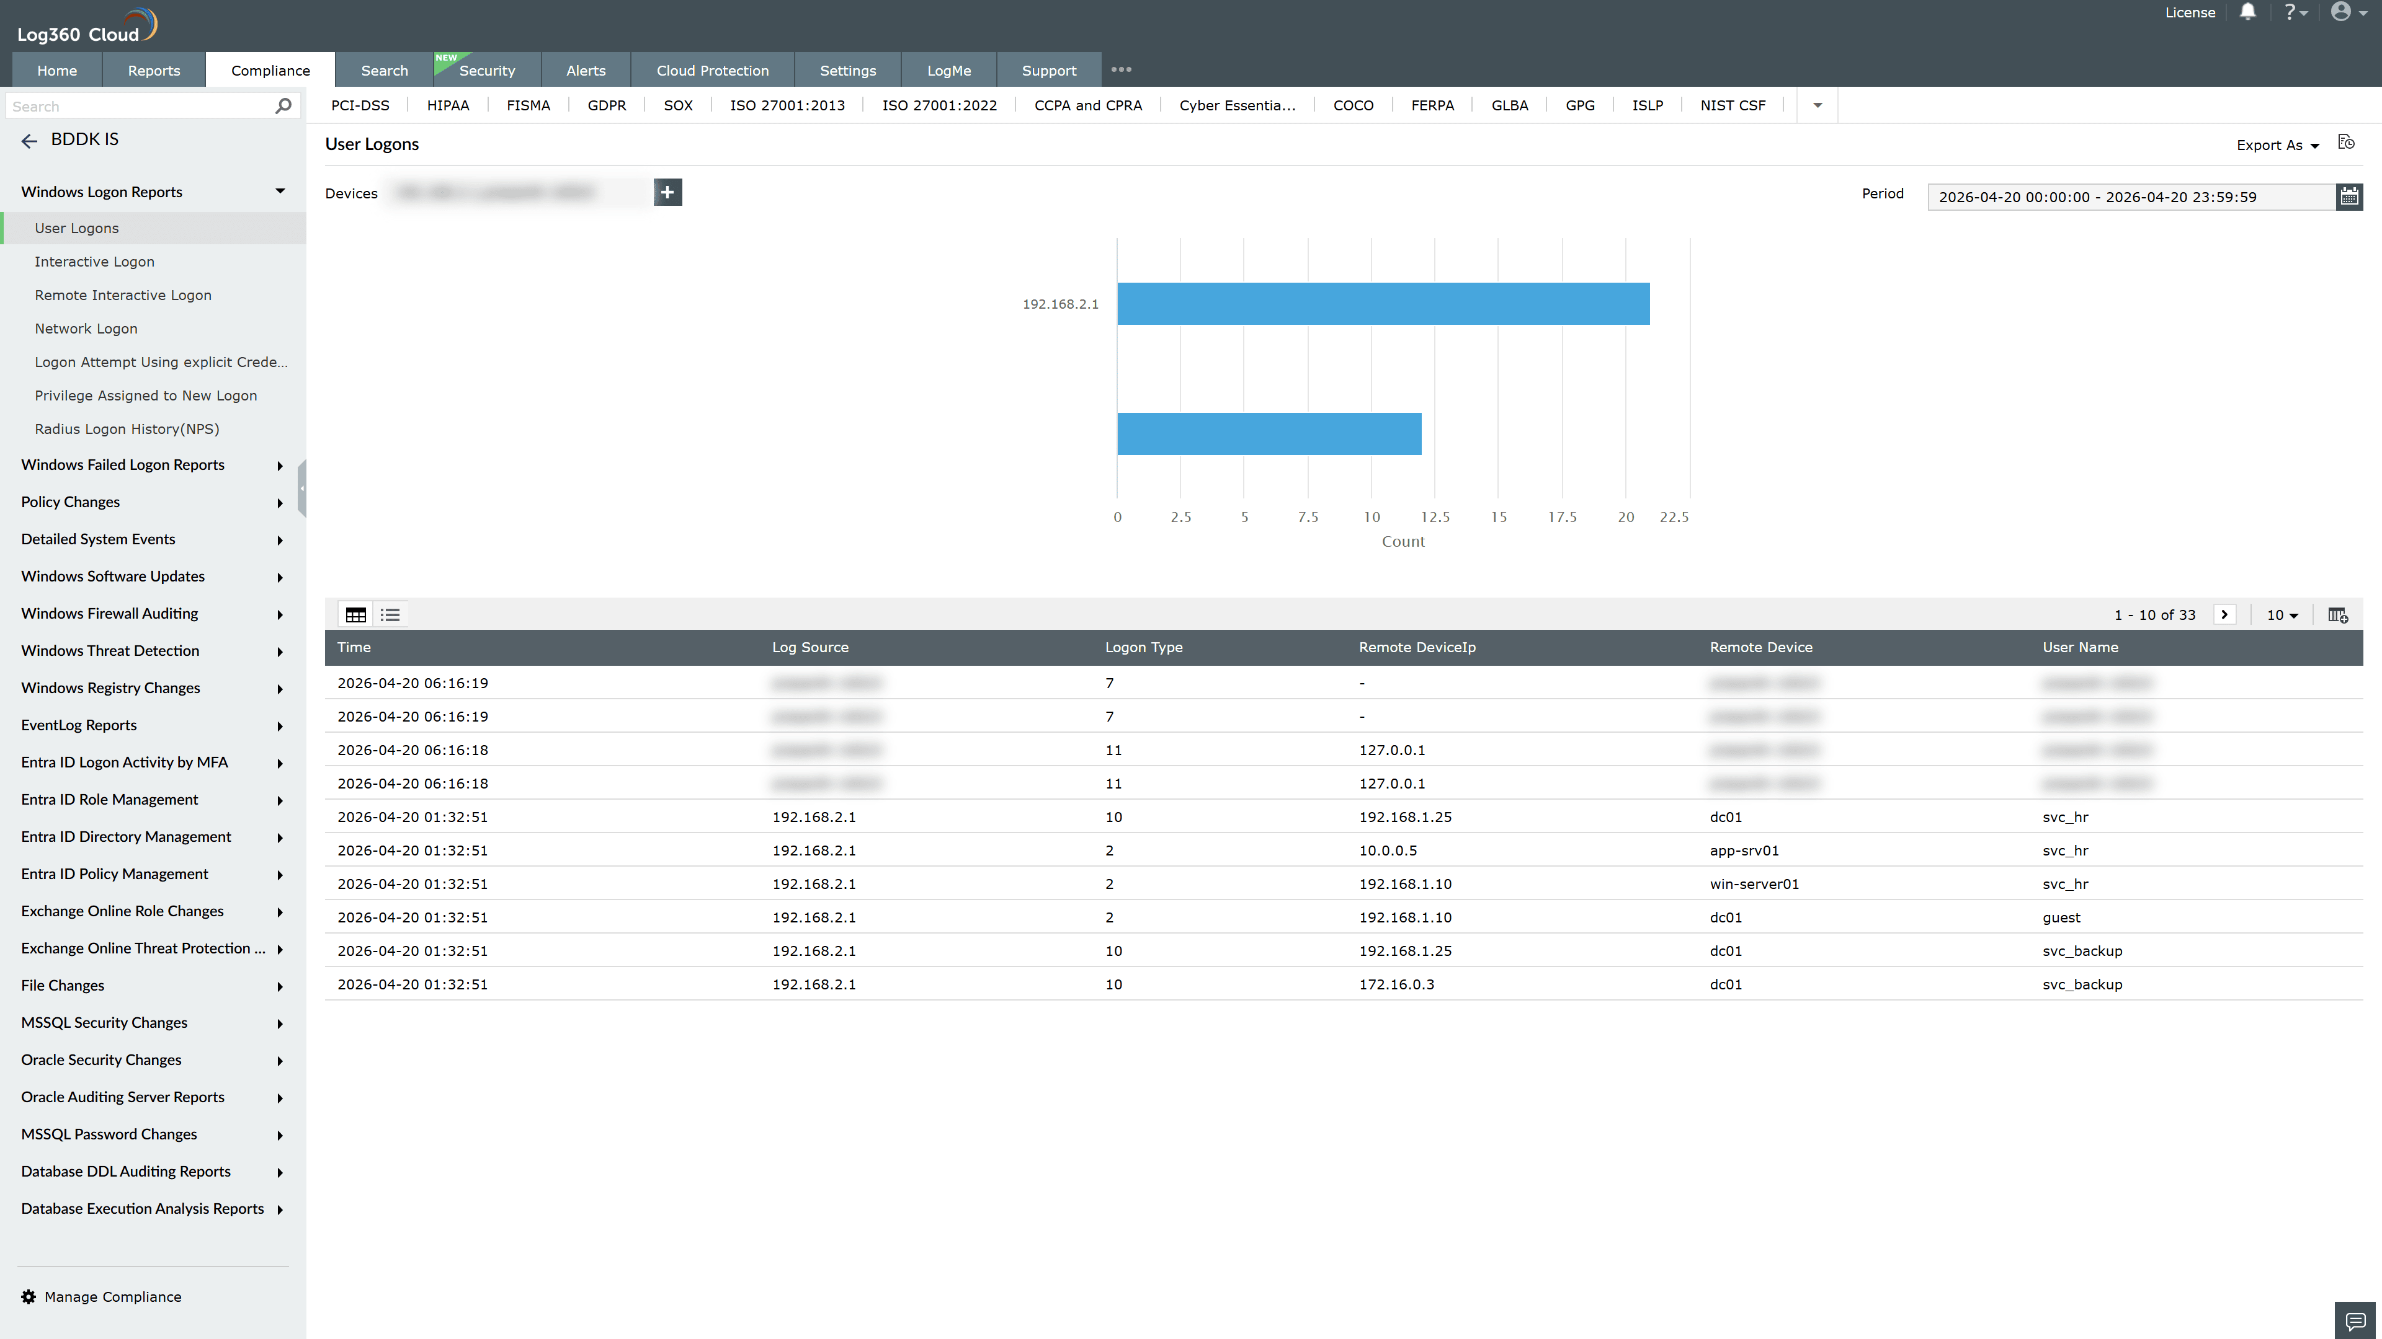
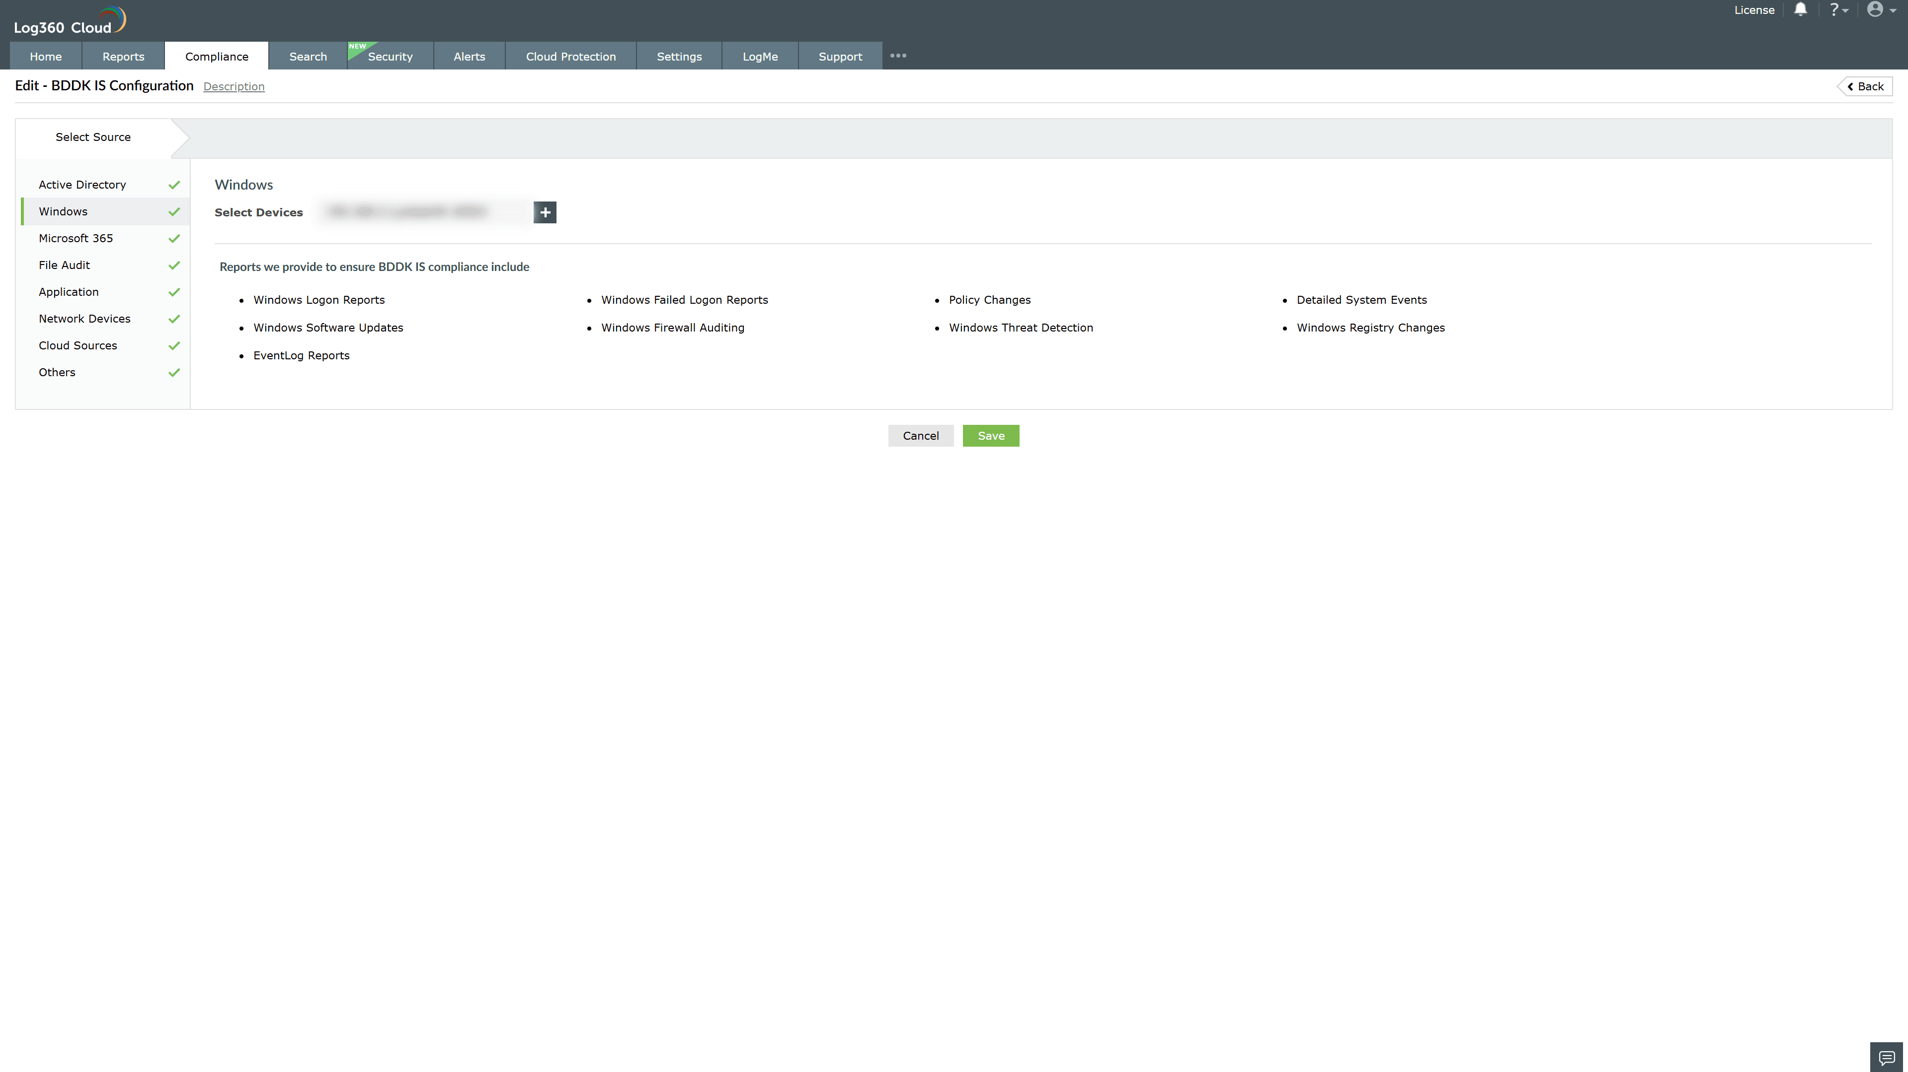

Valid Submission : Yes
Supported Editions : Free, Basic, Standard, Professional, MSSP
Help Document : https://www.manageengine.com/log-management/help/integrations/compliance-extensions.html
Help Video : Not provided
Tags : Log360, Compliance, Privacy monitoring, Data privacy, Regulatory compliance
Supported DCs : US, IN, JP, CA, AU, UK and EU
Privacy Policy:
Terms of Service:
Release Notes:
Predefined reports for the BDDK IS Regulation Compliance

