KAIT - ZAIT Compliance for Log360
Tagline: Satisfy BaFin's capital market with unified monitoring from Log360.

Overview
The KAIT / ZAIT (BaFin Capital Market IT / Payment Service IT) Compliance extension for Log360 helps German capital market service providers and payment institutions meet BaFin's IT supervisory requirements for IT governance, access management, and operational security.
Log360 ingests and correlates logs from trading systems, payment processing platforms, cloud environments, and identity systems, providing continuous monitoring of IT security events. Compliance and security teams can track privileged access, detect anomalies, and generate audit-grade documentation for BaFin examinations.

Key Features
- Generate predefined KAIT/ZAIT compliance reports covering IT governance controls, access management, and security incident monitoring for capital markets and payment services.
- Monitor user access to trading and payment systems, detect unauthorized configuration changes, and track privileged operations in real time.
- Continuously correlate security events across your IT environment to detect suspicious activity and policy violations aligned with KAIT/ZAIT incident detection and response obligations.
- Export compliance evidence in PDF and CSV formats for BaFin supervisory examinations and internal IT risk governance reviews.

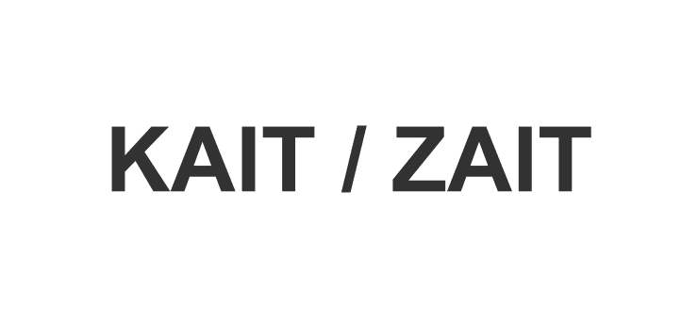

Screenshots
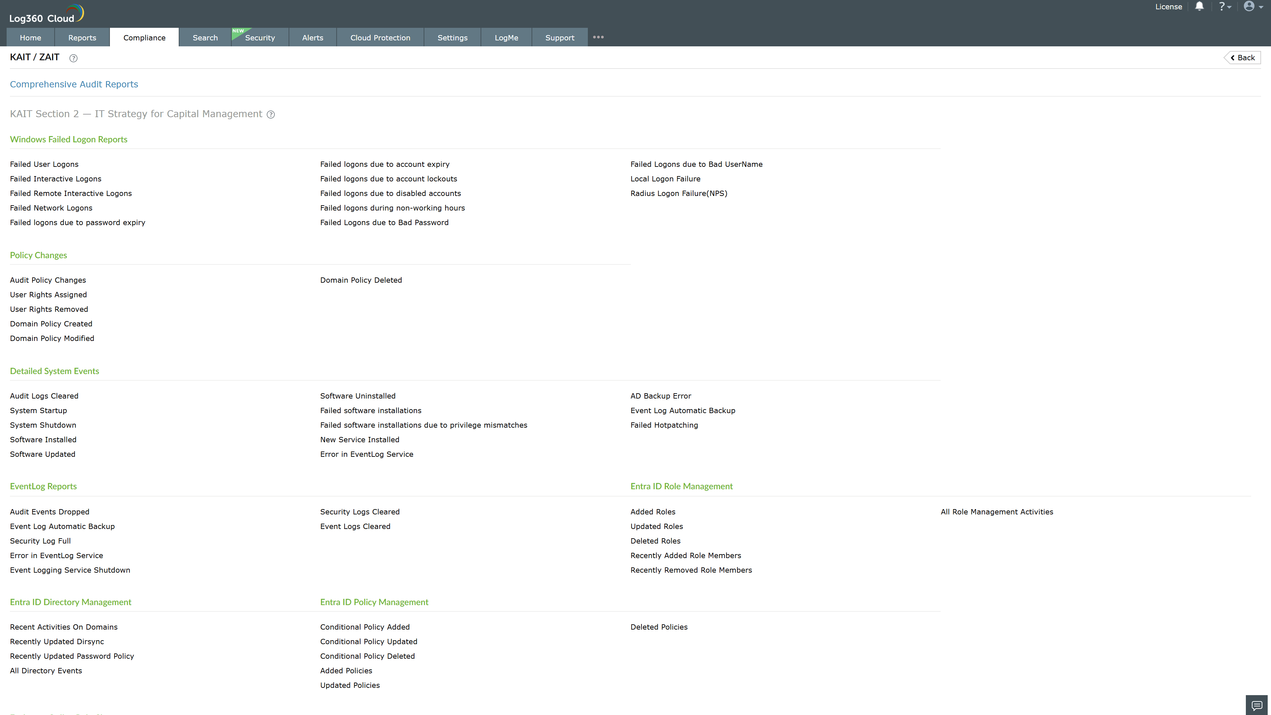
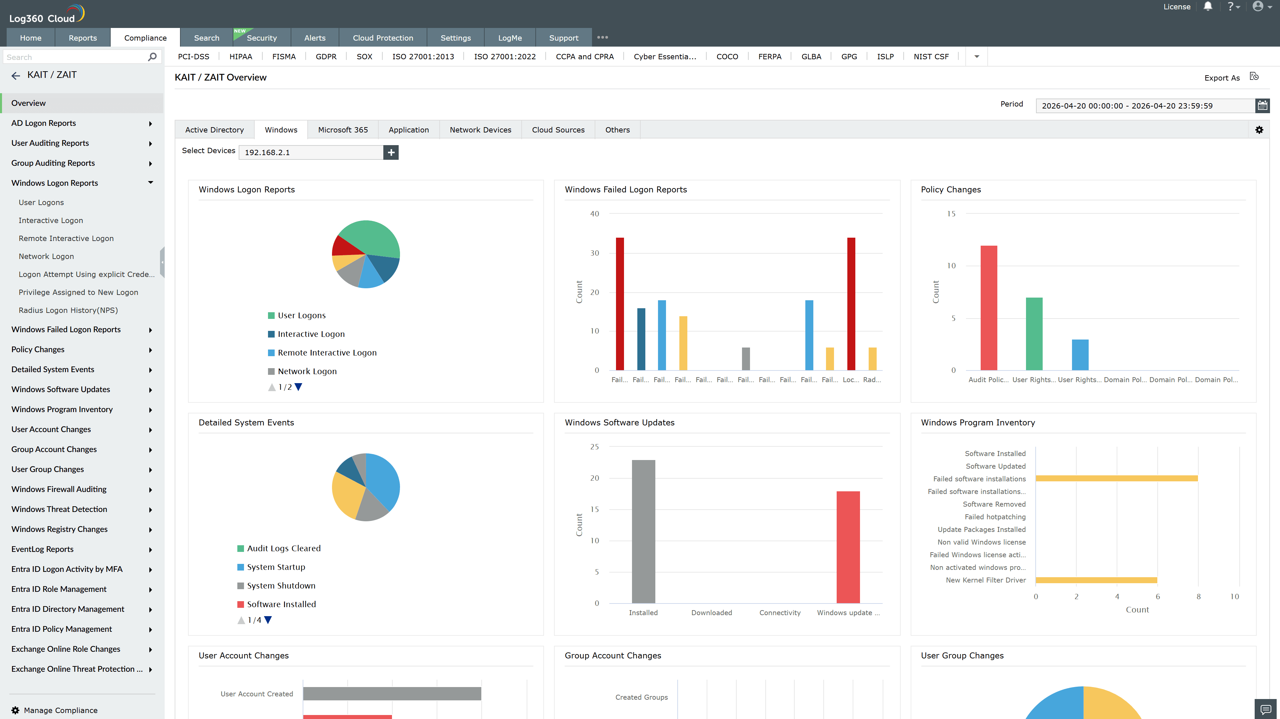
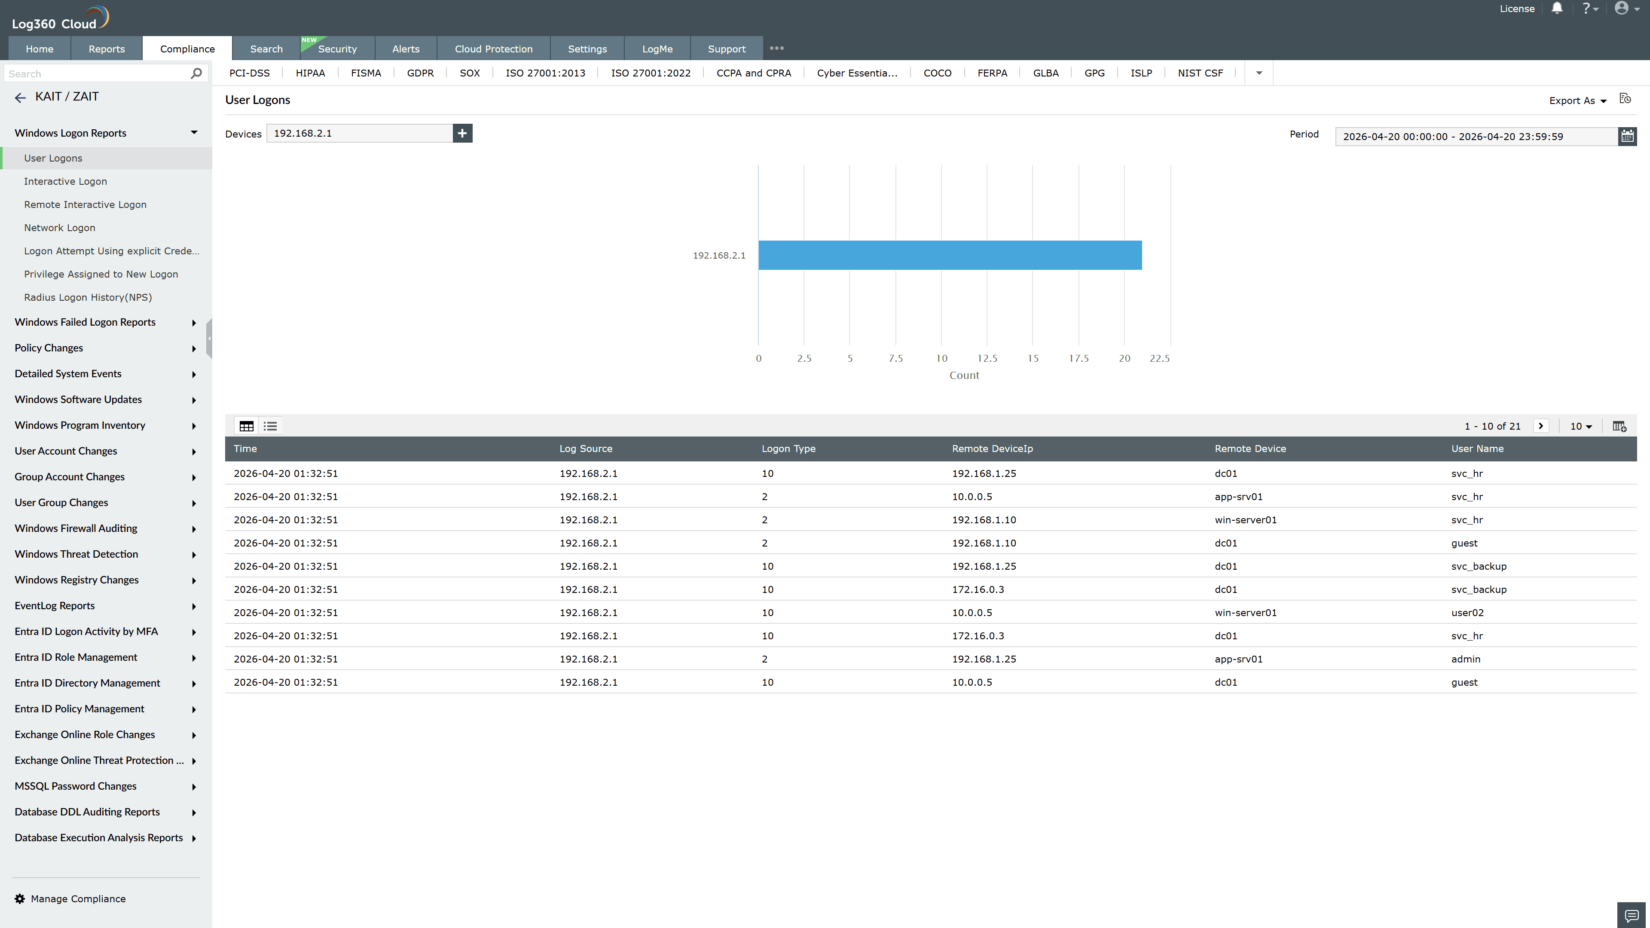
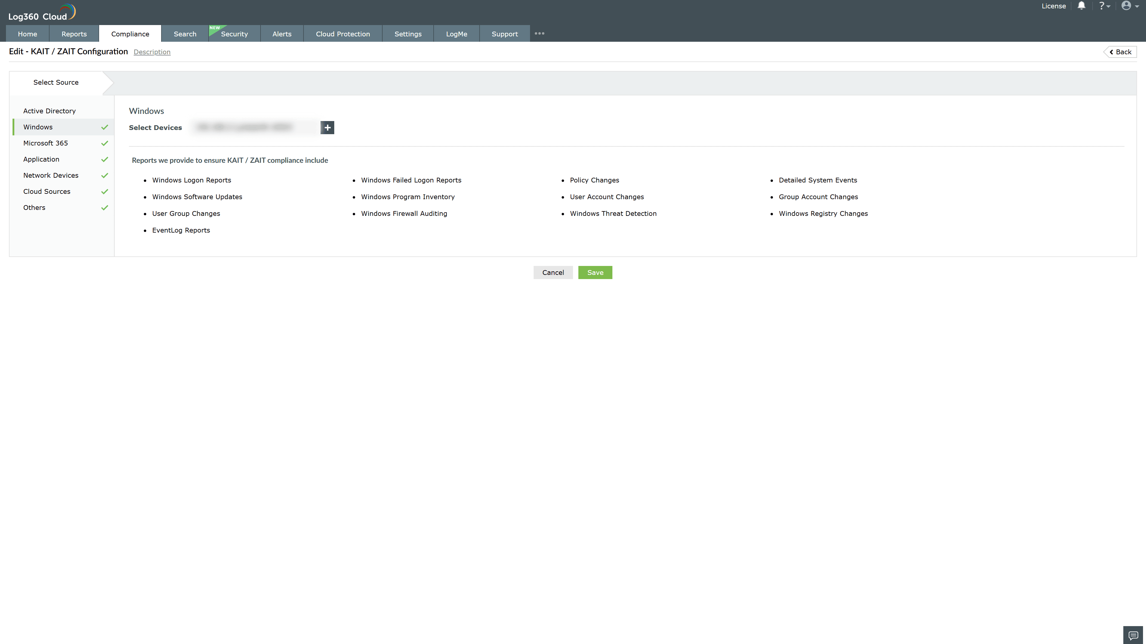

Valid Submission : Yes
Supported Editions : Free, Basic, Standard, Professional, MSSP
Help Document : https://www.manageengine.com/log-management/help/integrations/compliance-extensions.html
Help Video : Not provided
Tags : Log360, Compliance, Privacy monitoring, Data privacy, Regulatory compliance
Supported DCs : US, IN, JP, CA, AU, UK and EU
Privacy Policy:
Terms of Service:
Release Notes:
Predefined reports for the KAIT / ZAIT Compliance

