INCIBE National Reporting Guide and Cybersecurity Strategy Compliance for Log360
Tagline: Align with Spain's national cybersecurity strategy and INCIBE incident reporting guidance using Log360.

Overview
The INCIBE National Reporting Guide & Cybersecurity Strategy Compliance extension for Log360 helps Spanish organizations, SMEs, and critical infrastructure operators align with INCIBE's incident reporting guidelines and Spain's National Cybersecurity Strategy.
Log360 collects and analyzes logs from IT systems, cloud platforms, network devices, and endpoints, providing security teams with continuous detection capabilities and the forensic evidence needed for INCIBE incident submissions. Compliance teams can monitor their cybersecurity posture, respond to incidents, and generate the documentation required for national cybersecurity reporting.

Key Features
- Generate compliance reports covering INCIBE-aligned security monitoring requirements including access control, incident detection, and threat response activities.
- Continuously correlate security events across your IT environment to detect suspicious activity and policy violations aligned with INCIBE incident detection and response obligations.
- Centralize log data from across your infrastructure to maintain real-time visibility into user activity and access patterns, supporting proactive threat identification and INCIBE compliance posture.
- Export incident documentation in PDF and CSV formats for INCIBE national reporting submissions and internal cybersecurity governance records.



Screenshots
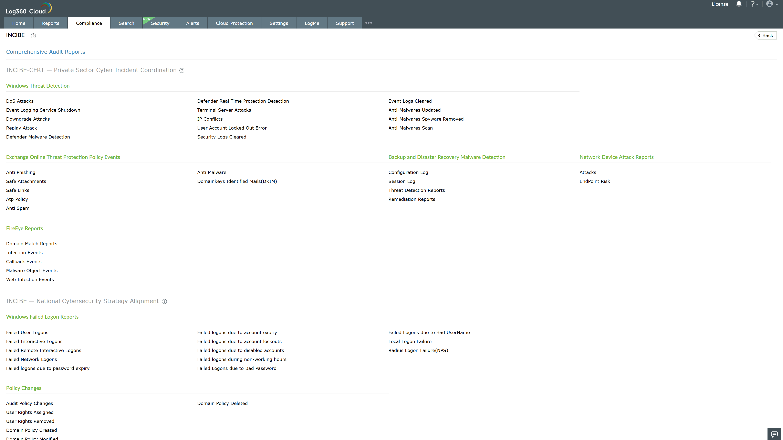
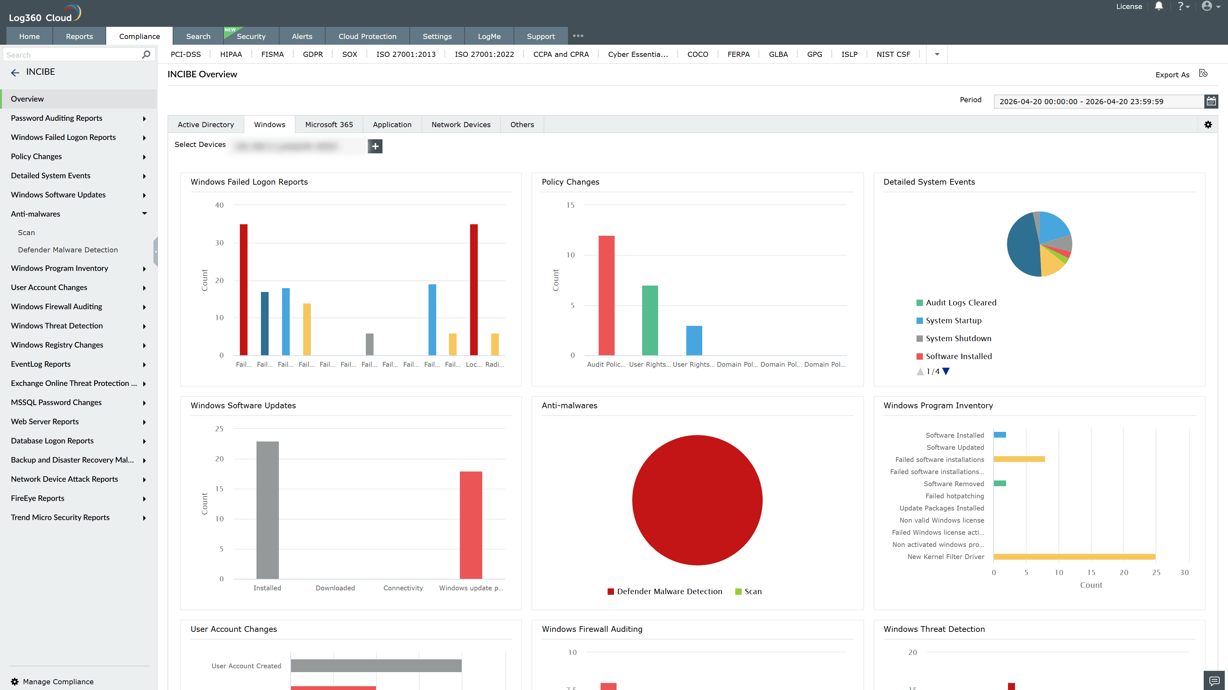
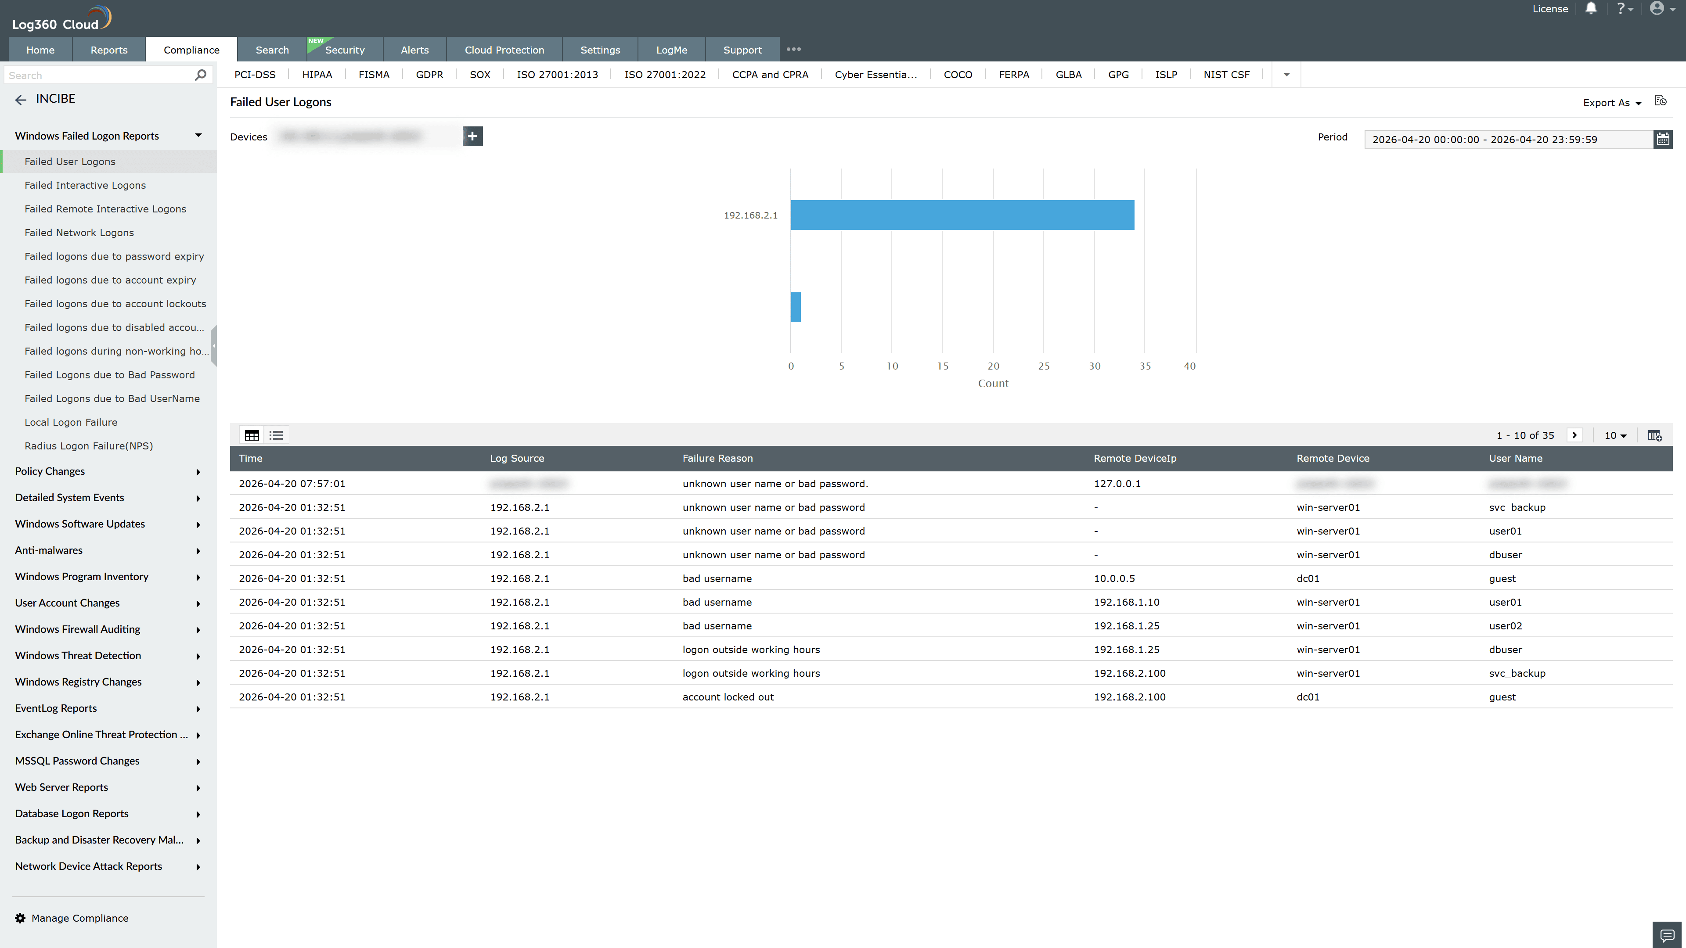
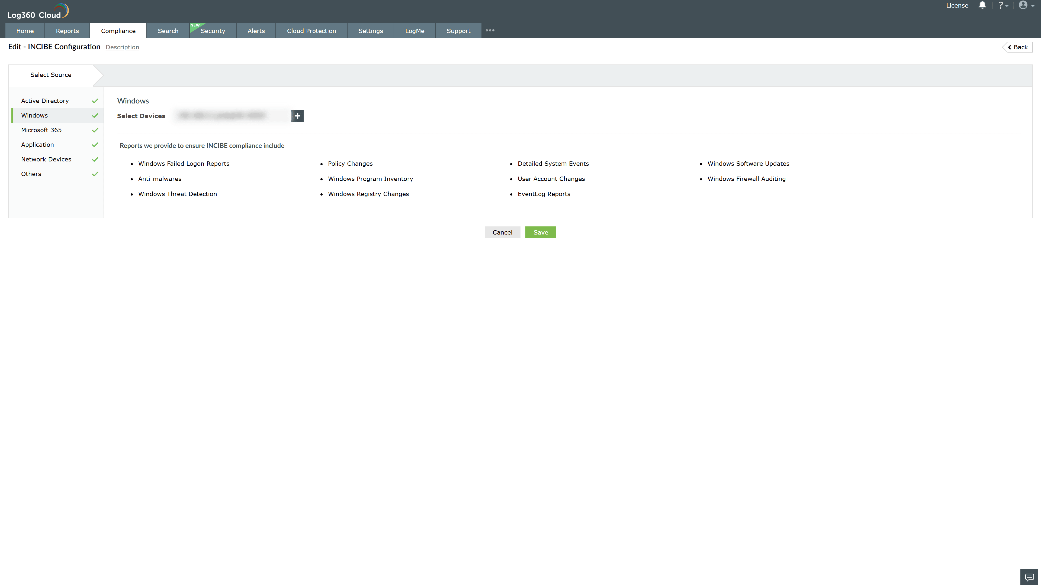
Valid Submission : Yes
Supported Editions : Free, Basic, Standard, Professional, MSSP
Help Document : https://www.manageengine.com/log-management/help/integrations/compliance-extensions.html
Help Video : Not provided
Tags : Log360, Compliance, Privacy monitoring, Data privacy, Regulatory compliance
Supported DCs : US, IN, JP, CA, AU, UK and EU
Privacy Policy:
Terms of Service:
Release Notes:
Predefined reports for the INCIBE Compliance

