Italian NIS2 Transposition Compliance for Log360
Tagline: Achieve NIS2 compliance with real-time threat detection from Log360.

Overview
The Italian NIS2 Transposition (Legislative Decree 138/2024) Compliance extension for Log360 helps Italian essential and important entities meet the cybersecurity risk management, incident reporting, and supply chain security obligations introduced by Italy's NIS2 implementation.
Log360 collects and analyzes log data from servers, endpoints, cloud services, and network devices, mapping events to NIS2 control categories. Security and compliance teams can continuously monitor their environments, detect incidents in real time, and generate the audit-ready documentation required for ACN reporting.

Key Features
- Generate audit reports mapped to NIS2 risk management requirements, covering access control, incident detection, and business continuity monitoring.
- Continuously monitor network traffic, system events, and access logs across essential and important entities to detect and alert on security incidents in alignment with Legislative Decree 138/2024 incident detection and response obligations.
- Correlate security events across IT and OT environments to maintain real-time visibility into risk exposure, supporting the proactive risk management and proportionality assessment requirements mandated under the Italian NIS2 transposition.
- Export compliance evidence in PDF and CSV formats to support ACN incident notifications and supervisory authority submissions.
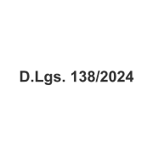


Screenshots
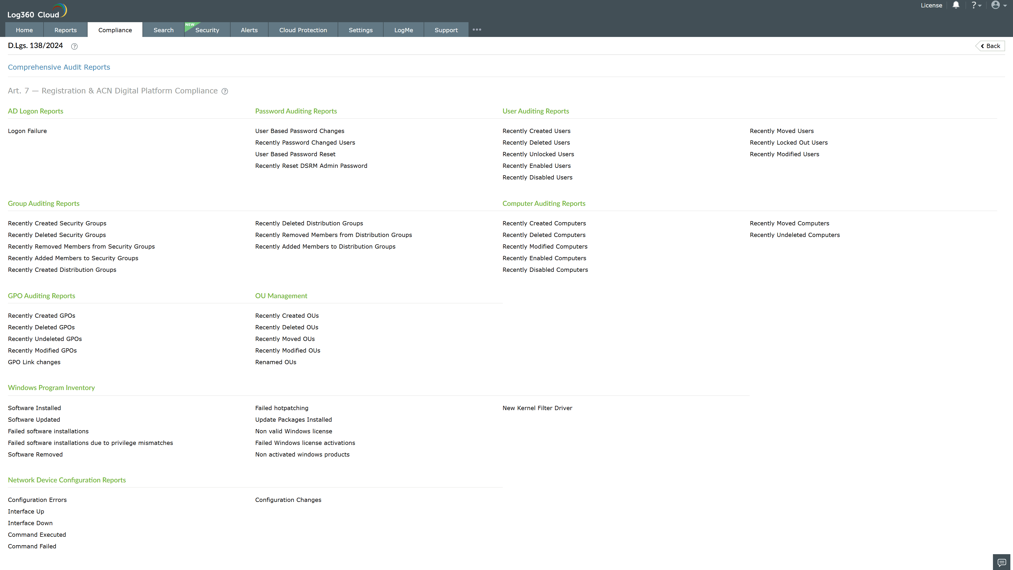
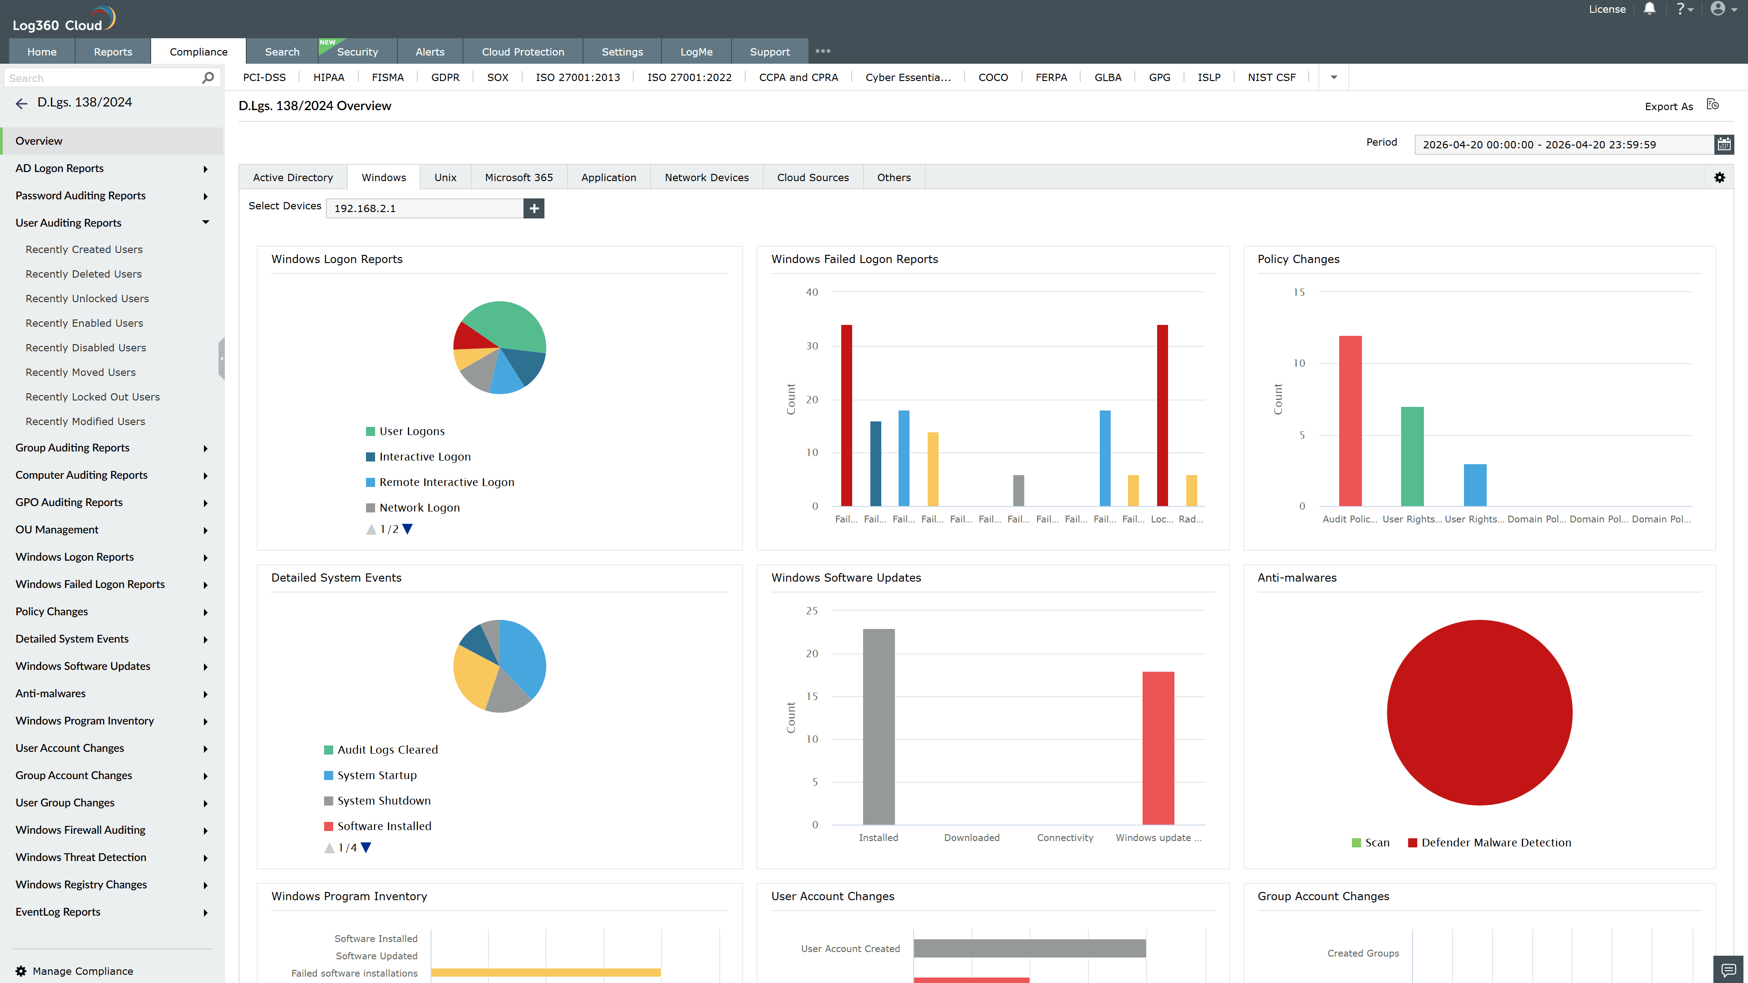
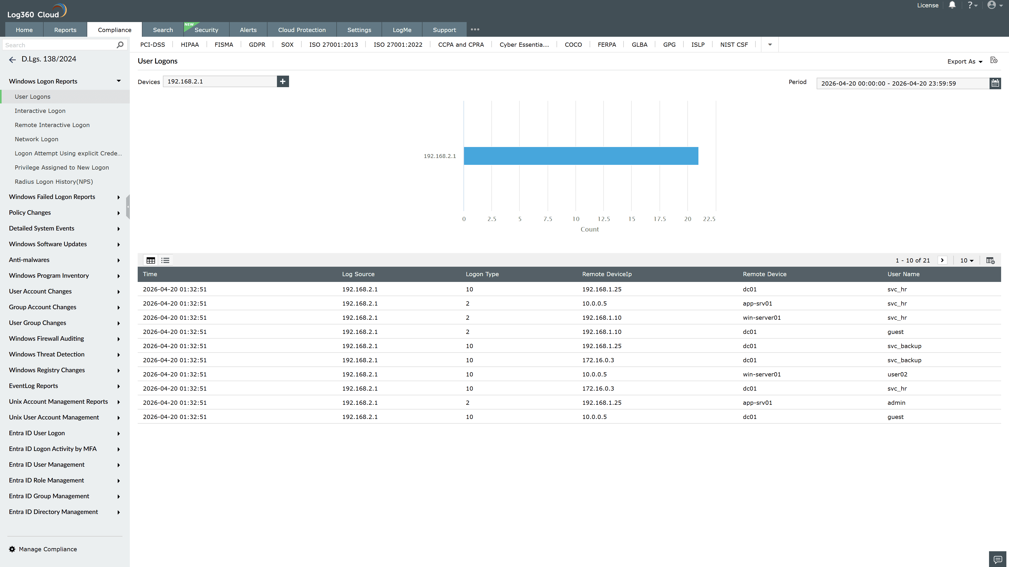
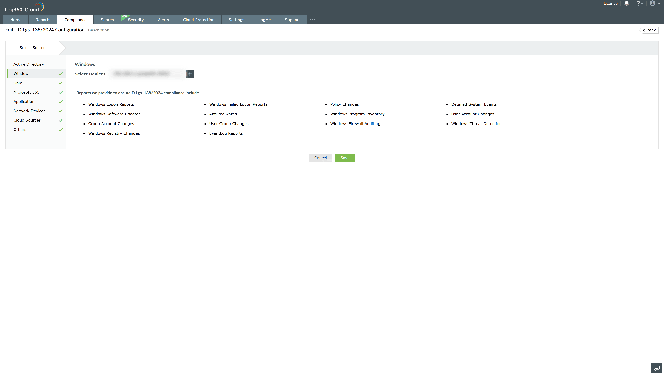
Valid Submission : Yes
Supported Editions : Free, Basic, Standard, Professional, MSSP
Help Document : https://www.manageengine.com/log-management/help/integrations/compliance-extensions.html
Help Video : Not provided
Tags : Log360, Compliance, Privacy monitoring, Data privacy, Regulatory compliance
Supported DCs : US, IN, JP, CA, AU, UK and EU
Privacy Policy:
Terms of Service:
Release Notes:
Predefined reports for the Italian NIS2 Transposition Compliance

