Italian Privacy Code Compliance for Log360
Tagline: Support Italy’s privacy and GDPR compliance with comprehensive log monitoring from Log360.

Overview
The Italian Privacy Code (D.Lgs. 196/2003 as amended) Compliance extension for Log360 helps Italian data controllers and processors meet the security monitoring, data access audit, and breach notification requirements of Italy's Privacy Code.
Log360 collects and analyzes logs from databases, cloud services, endpoints, and identity systems, providing granular visibility into who accessed personal data, when, and from where. Security and DPO teams can detect unauthorized access to personal data, track consent-related system changes, and generate audit-ready records to satisfy Garante inspections.

Key Features
- Generate predefined privacy compliance reports covering personal data access events, authentication logs, and system changes relevant to the Italian Privacy Code.
- Track database access, file activity, and cloud storage events to detect unauthorized processing of personal data in real time.
- Configure alerts for critical privacy events such as bulk data exports, unauthorized access to sensitive records, and audit log modifications.
- Export compliance evidence in PDF and CSV formats for Garante investigations, DPA submissions, and internal data protection governance.



Screenshots
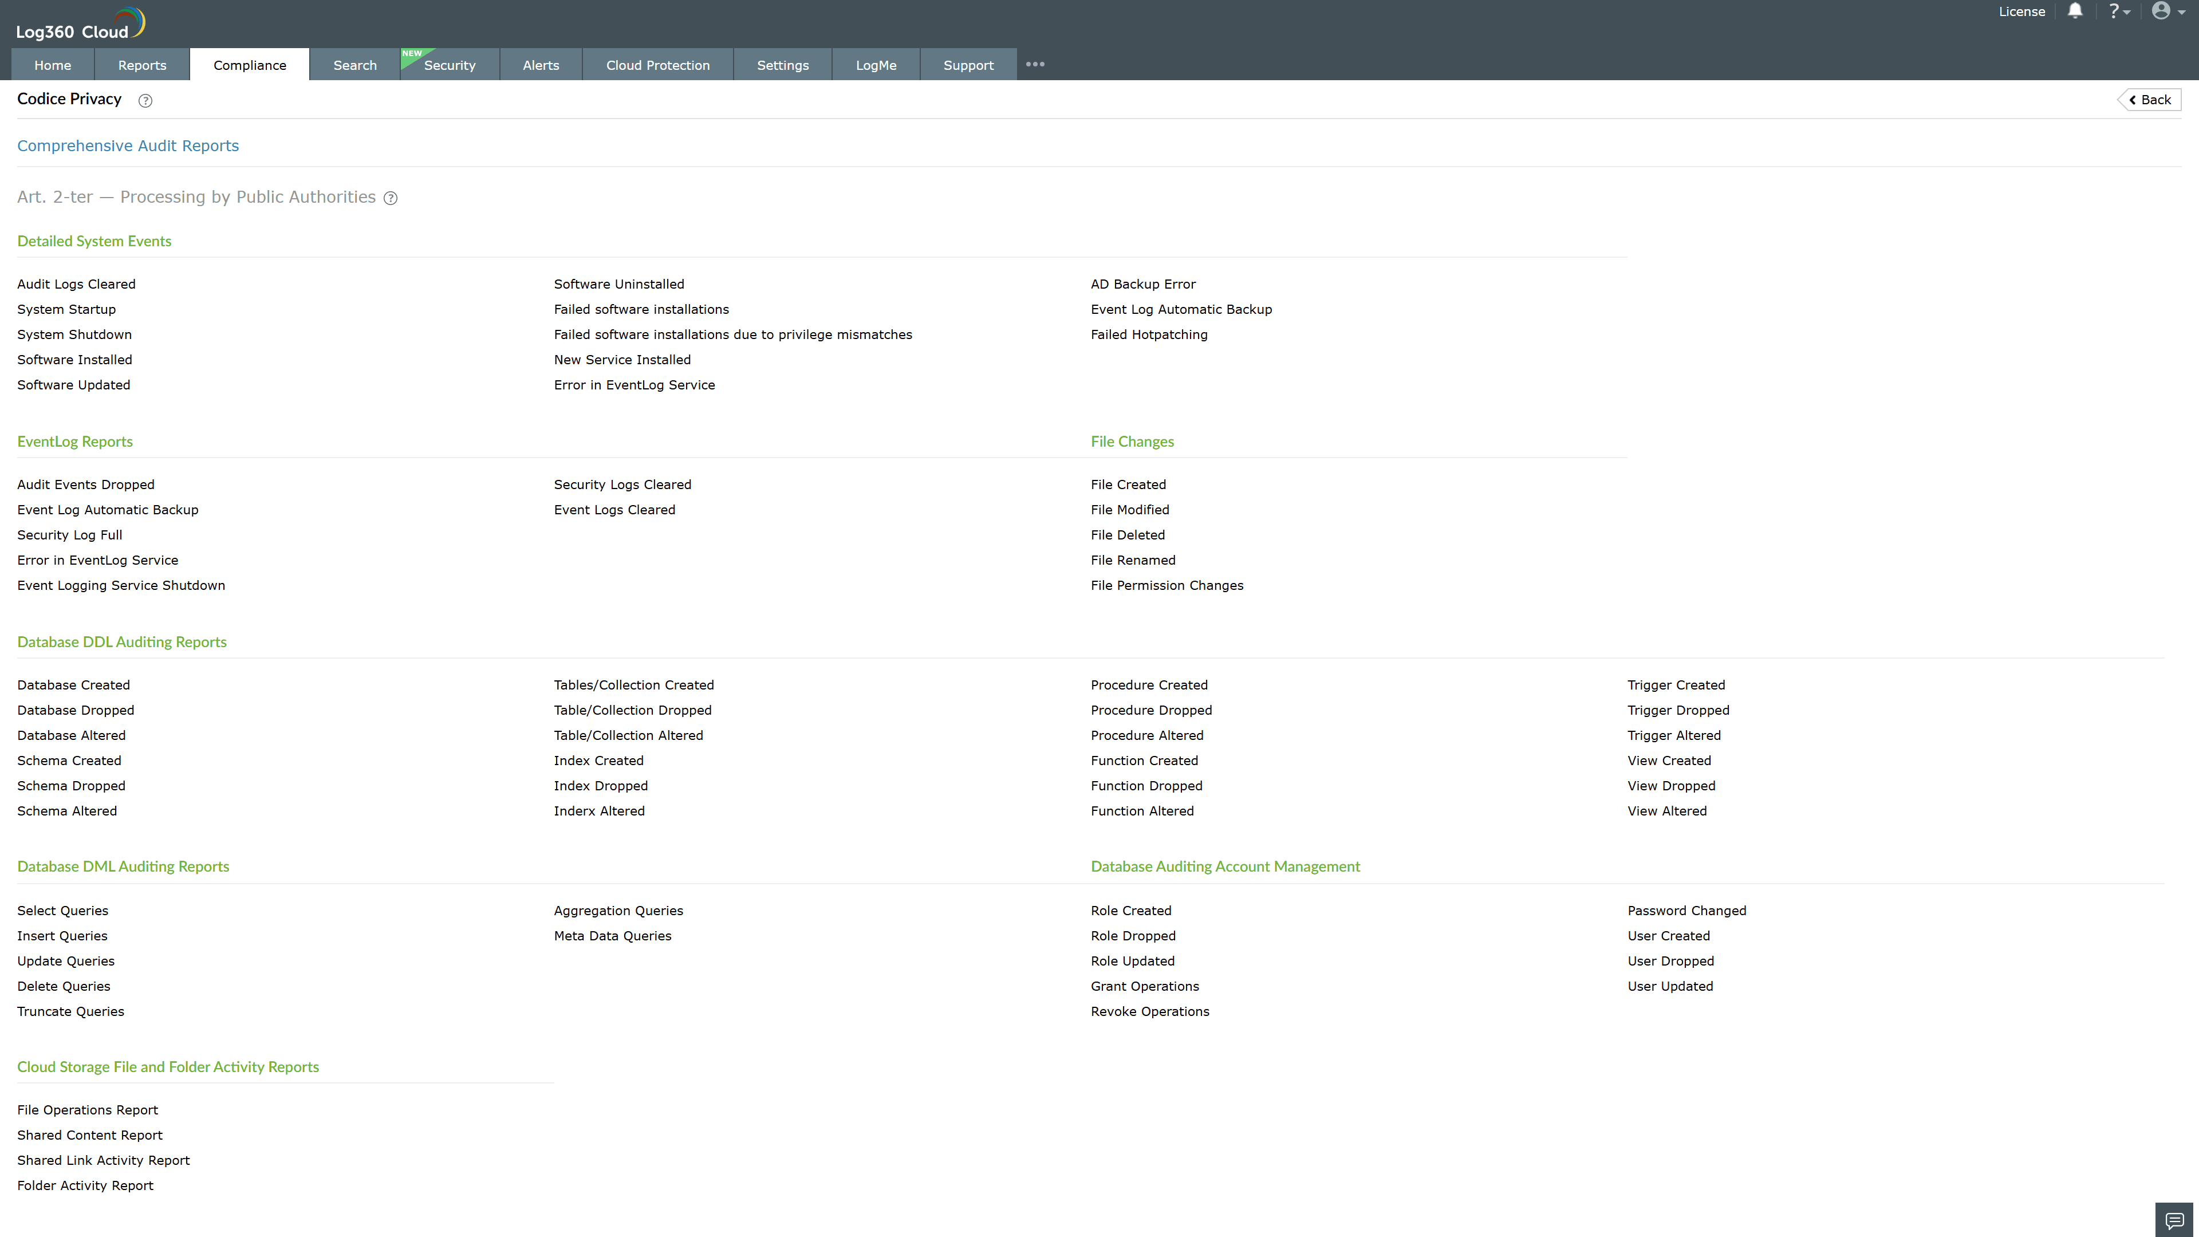
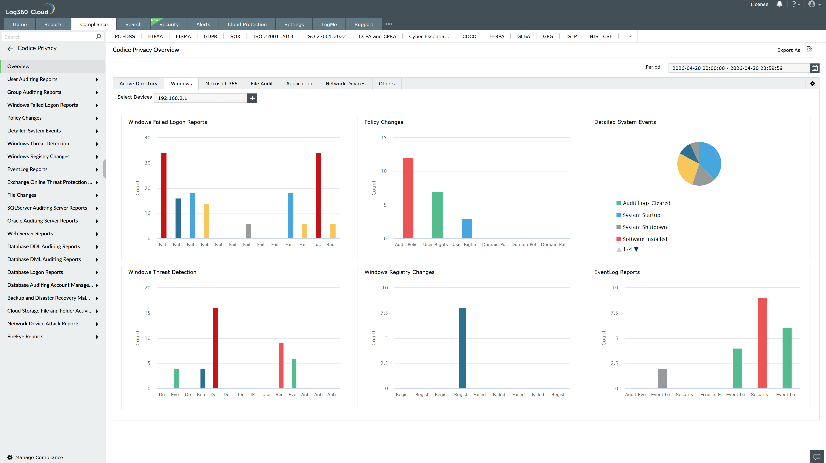
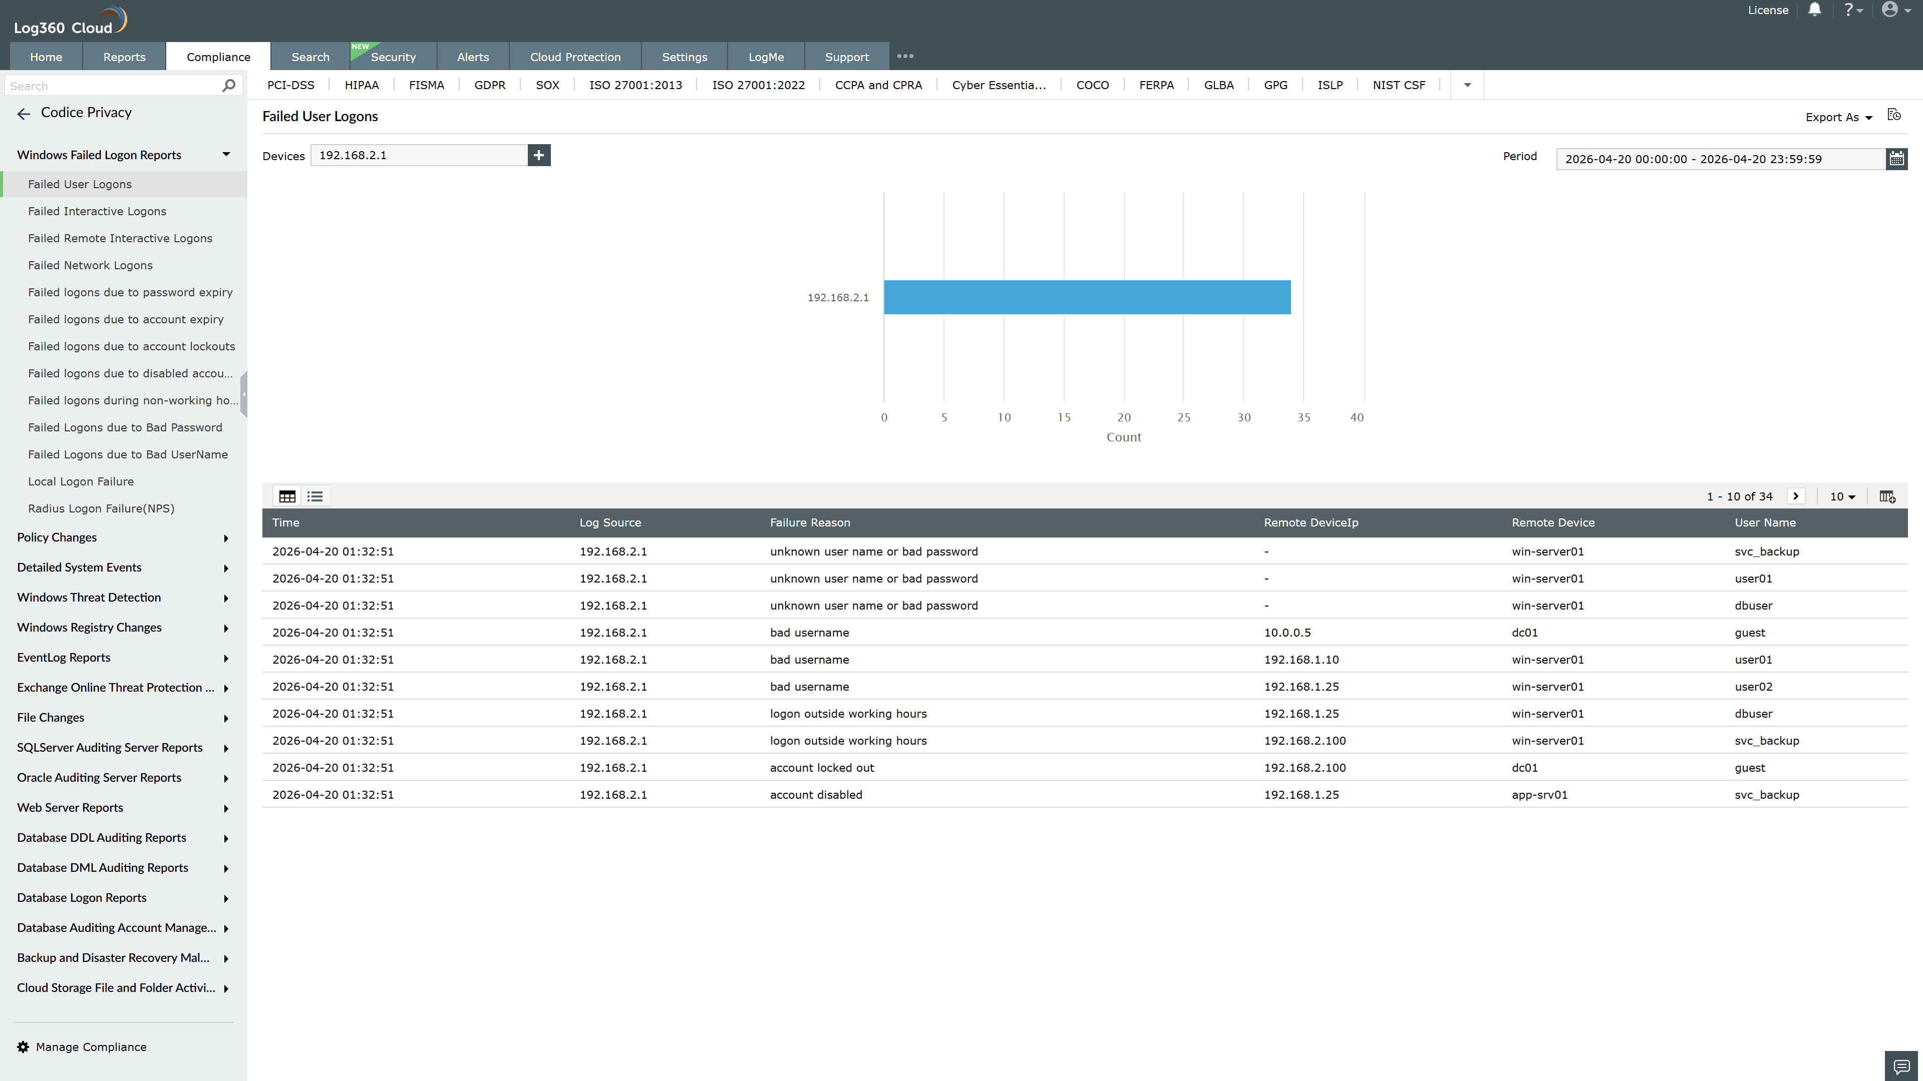
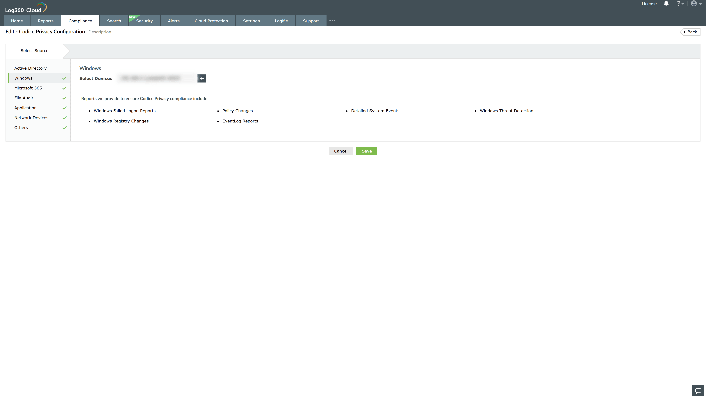
Valid Submission : Yes
Supported Editions : Free, Basic, Standard, Professional, MSSP
Help Document : https://www.manageengine.com/log-management/help/integrations/compliance-extensions.html
Help Video : Not provided
Tags : Log360, Compliance, Privacy monitoring, Data privacy, Regulatory compliance
Supported DCs : US, IN, JP, CA, AU, UK and EU
Privacy Policy:
Terms of Service:
Release Notes:
Predefined reports for the Italian Privacy Code Compliance

