NABIDH Compliance for Log360
Tagline: Support NABIDH health data compliance with continuous monitoring and reporting from Log360.

Overview
The NABIDH (Dubai Unified Health Record) Compliance extension for Log360 helps Dubai healthcare providers and digital health platforms meet the data security, access control, and audit requirements established by the Dubai Health Authority under the NABIDH framework.
Log360 ingests and analyzes logs from health information systems, cloud services, and network infrastructure, providing security teams with full visibility into patient data access and transmission events. Compliance teams can rapidly detect policy violations, investigate incidents, and generate reports demonstrating adherence to NABIDH data governance obligations.

Key Features
- Generate audit reports mapped to NABIDH data access and security requirements, covering health record access, user authentication, and data transmission events.
- Monitor access to patient health records across integrated systems, detecting unauthorized queries, bulk exports, and data sharing violations.
- Configure threshold-based alerts for critical NABIDH compliance events such as unauthorized access to sensitive health data and audit log modifications.
- Export compliance evidence in PDF and CSV formats to support DHA audits and internal healthcare data governance reviews.

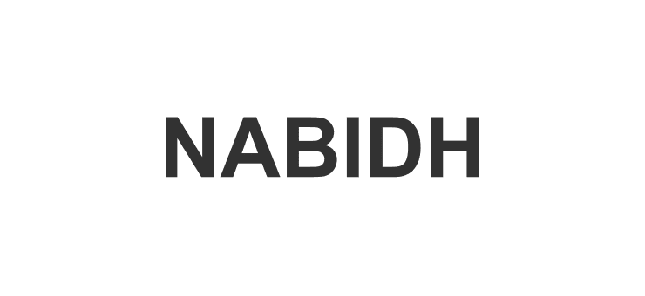

Screenshots
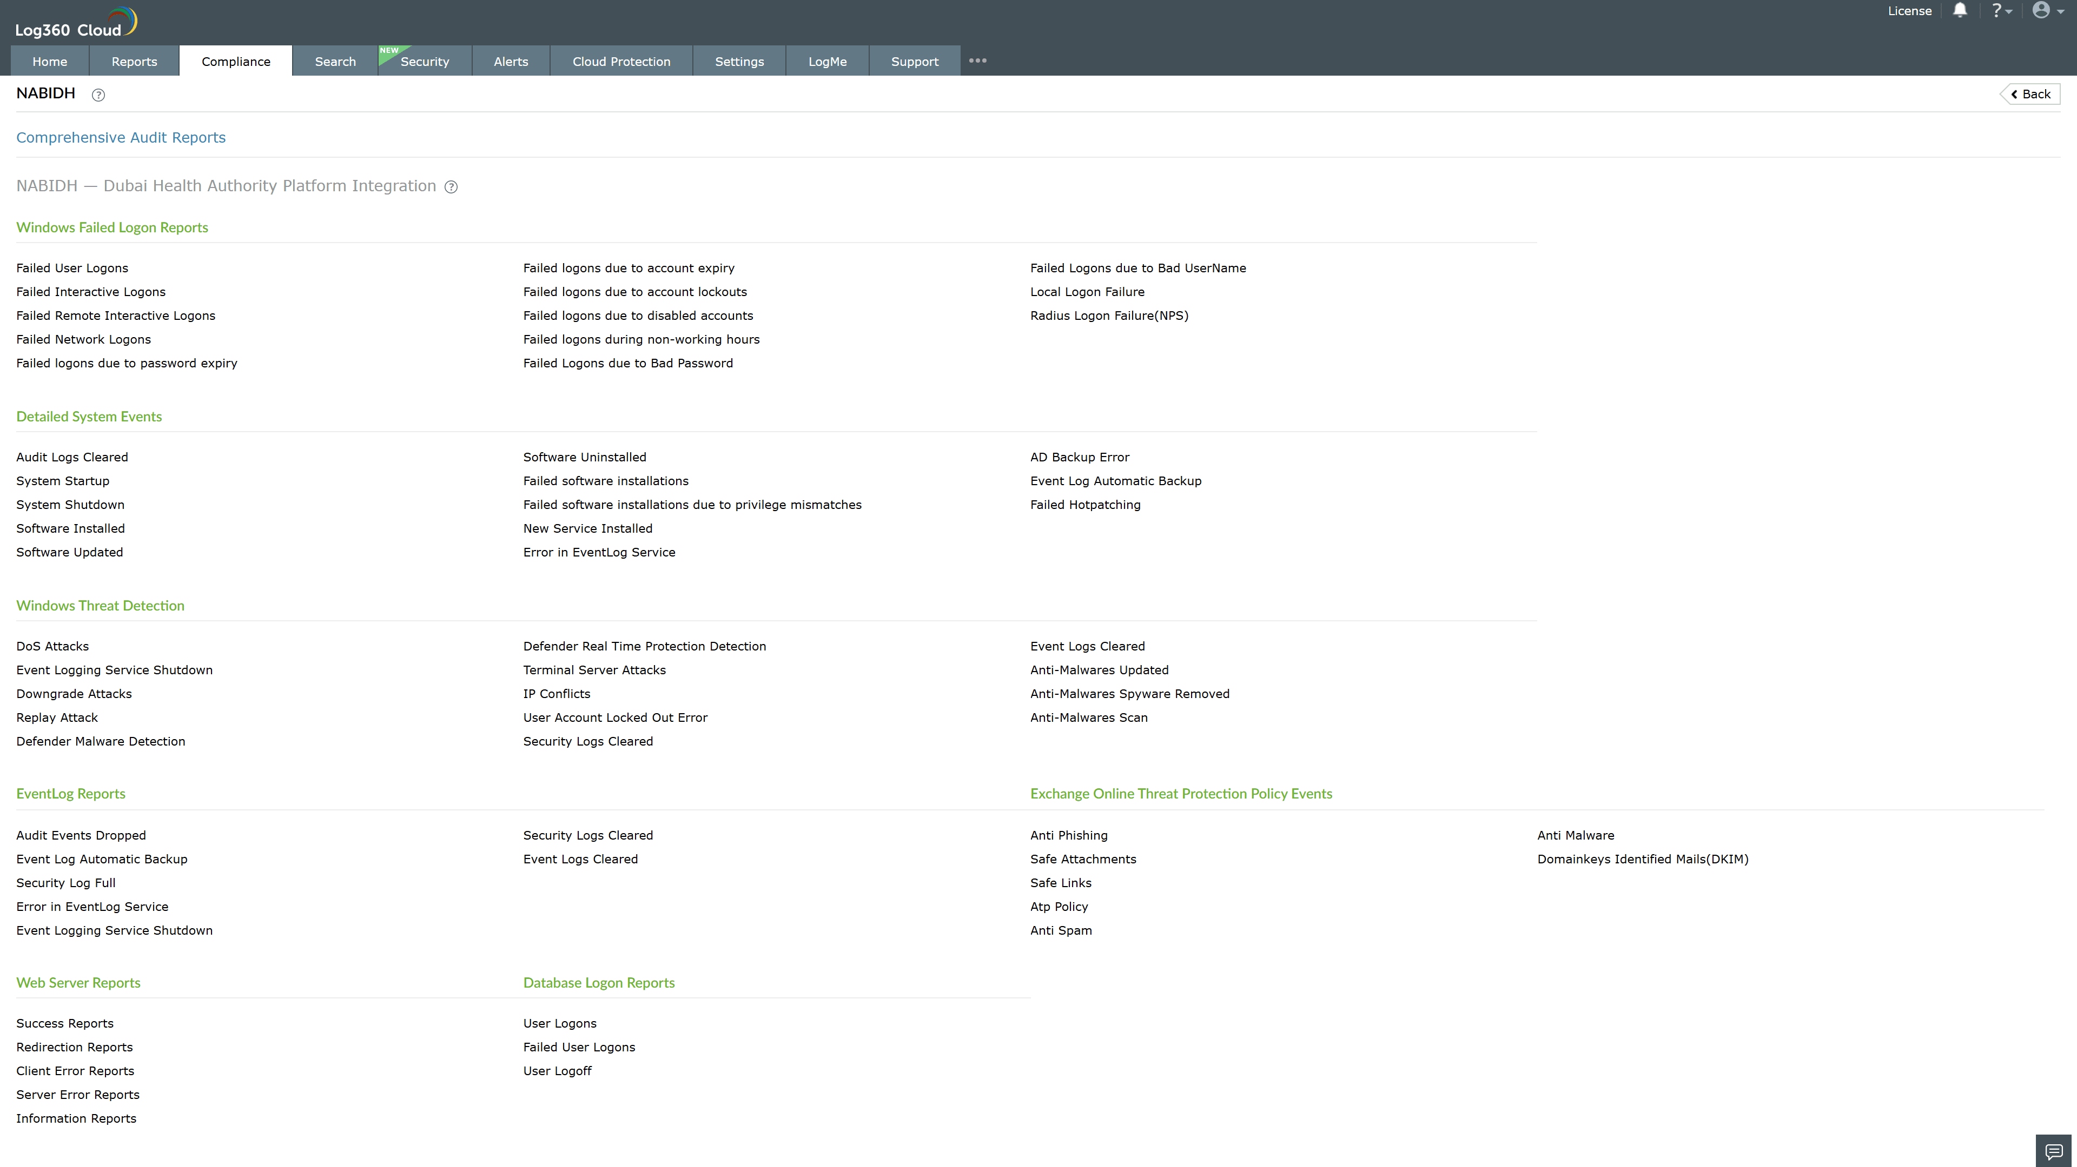
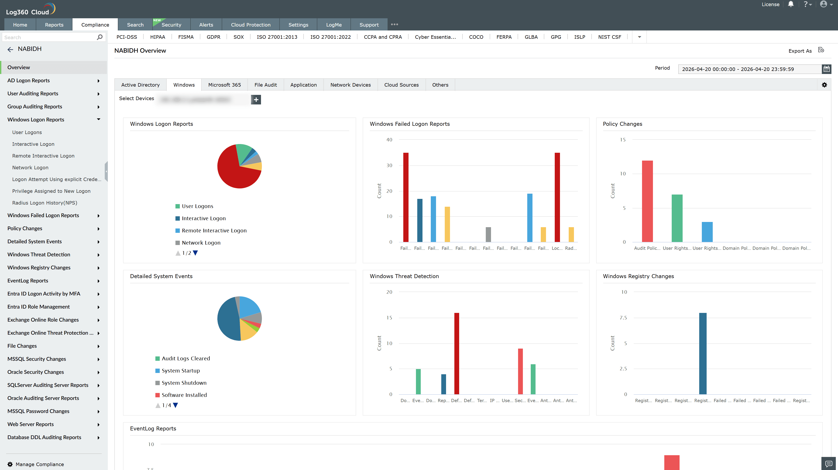
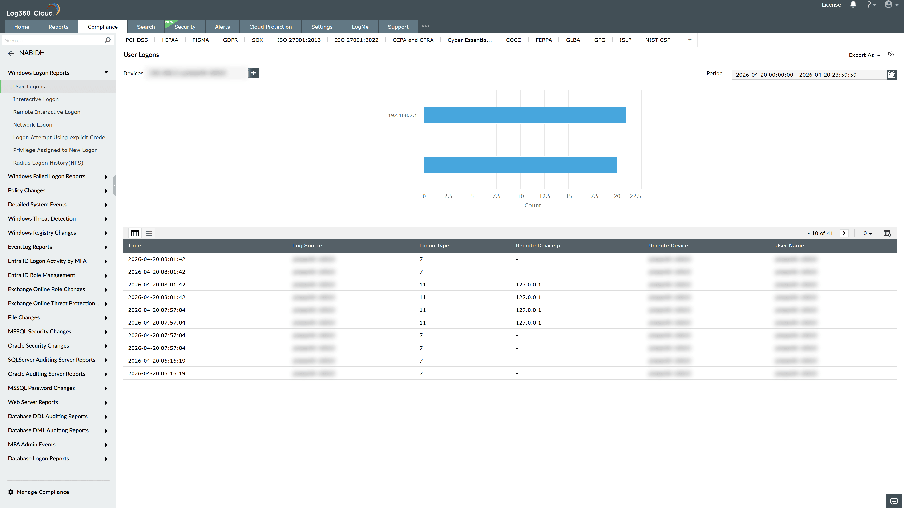
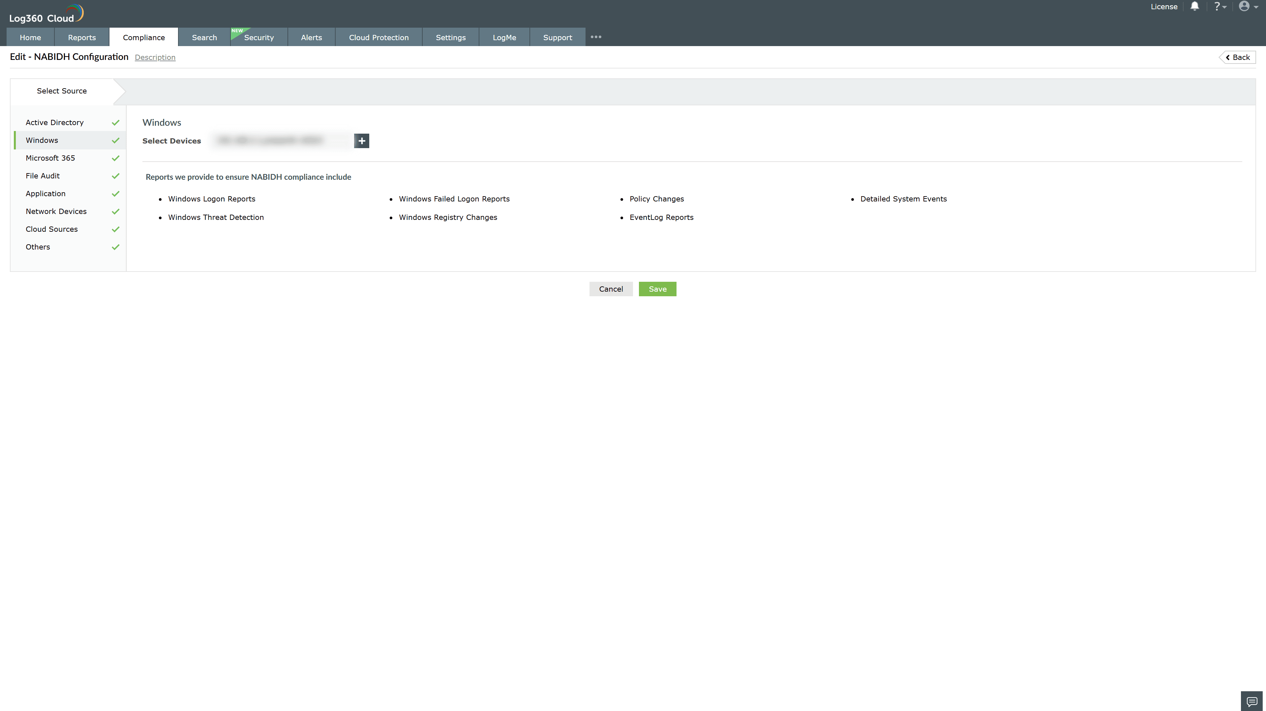
Valid Submission : Yes
Supported Editions : Free, Basic, Standard, Professional, MSSP
Help Document : https://www.manageengine.com/log-management/help/integrations/compliance-extensions.html
Help Video : Not provided
Tags : Log360, Compliance, Privacy monitoring, Data privacy, Regulatory compliance
Supported DCs : US, IN, JP, CA, AU, UK and EU
Privacy Policy:
Terms of Service:
Release Notes:
Predefined reports for the NABIDH Compliance

