NCSC Minimum ICT Standard Compliance for Log360
Tagline: Meet Switzerland's NCSC requirements with audit reporting from Log360.

Overview
The NCSC Minimum ICT Standard (IKT-Minimalstandard) Compliance extension for Log360 helps Swiss federal agencies and operators of critical infrastructure implement the NCSC's baseline cybersecurity measures for IT systems.
Log360 collects and correlates logs from servers, endpoints, network devices, and cloud environments, enabling security teams to continuously monitor controls across the five IKT-Minimalstandard function categories: identify, protect, detect, respond, and recover. Compliance teams can assess their control coverage, remediate gaps, and generate audit evidence for NCSC reviews.

Key Features
- Generate compliance reports mapped to IKT-Minimalstandard function categories covering asset monitoring, threat detection, access control, and incident response.
- Correlate events across your Swiss federal and critical infrastructure IT environment to instantly identify complex threats and suspicious patterns, supporting the identification and response function requirements of the IKT-Minimalstandard.
- Monitor authentication events, system configuration changes, and privileged access activities to verify protective control effectiveness.
- Export audit-ready reports in PDF and CSV formats for NCSC reporting and internal cybersecurity governance assessments.
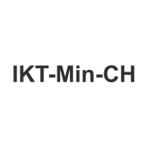
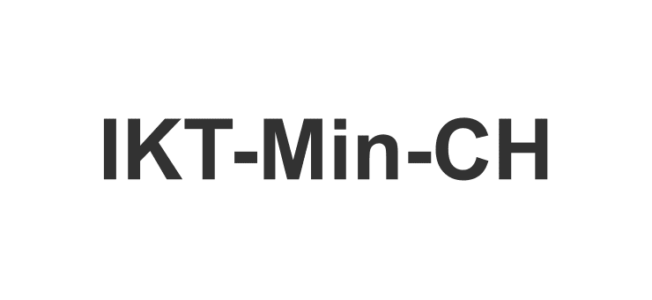

Screenshots
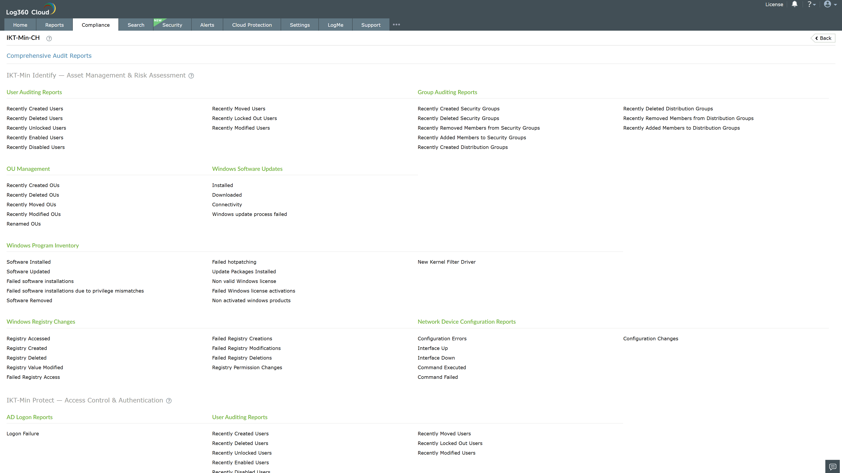
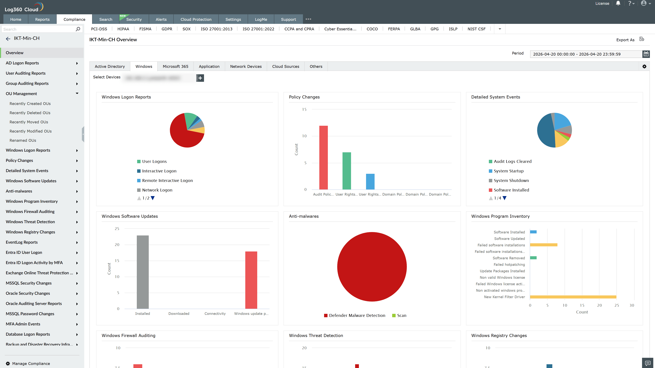
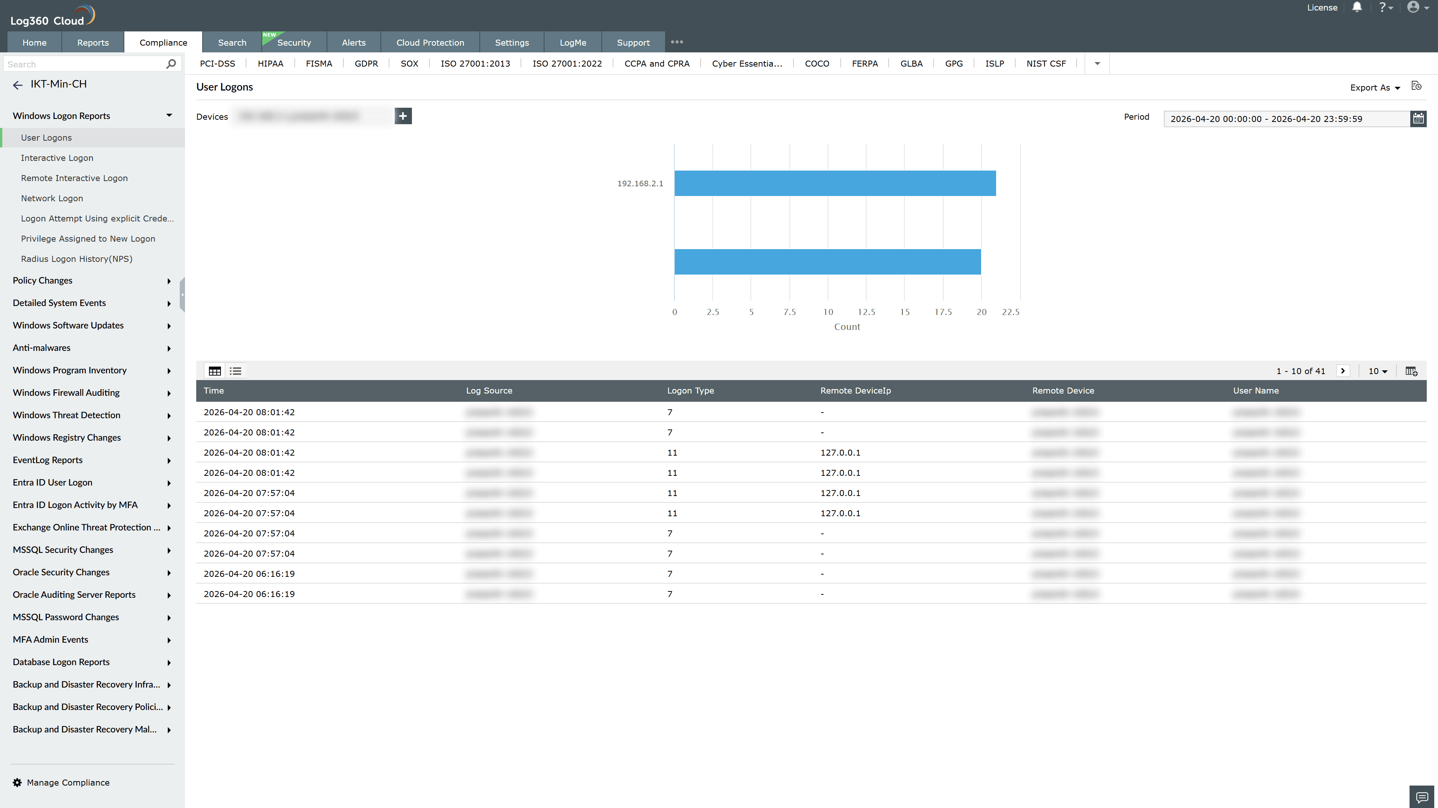
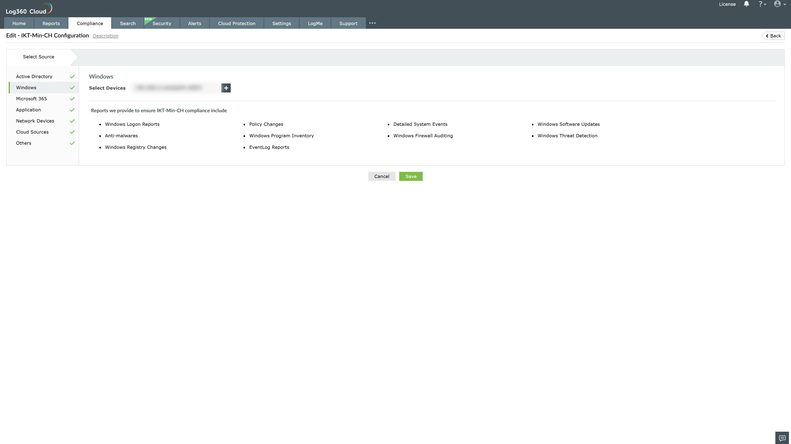
Valid Submission : Yes
Supported Editions : Free, Basic, Standard, Professional, MSSP
Help Document : https://www.manageengine.com/log-management/help/integrations/compliance-extensions.html
Help Video : Not provided
Tags : Log360, Compliance, Privacy monitoring, Data privacy, Regulatory compliance
Supported DCs : US, IN, JP, CA, AU, UK and EU
Privacy Policy:
Terms of Service:
Release Notes:
Predefined reports for the NCSC Compliance

