PASSI Compliance for Log360
Tagline: Support ANSSI-qualified operations with monitoring capabilities from Log360.

Overview
The PASSI (Prestataires d'Audit de la Sécurité des Systèmes d'Information) Compliance extension for Log360 helps French information security audit firms seeking or maintaining ANSSI PASSI qualification, as well as organizations undergoing PASSI audits, demonstrate the security monitoring and audit trail quality required under the PASSI framework.
Log360 provides comprehensive log collection, correlation, and audit trail capabilities across IT environments, enabling organizations to demonstrate audit evidence quality to certification bodies. Security teams can document monitoring coverage and generate reports that support ANSSI qualification reviews.

Key Features
- Generate predefined audit reports demonstrating log collection coverage, security event monitoring, and audit trail integrity across IT environments.
- Monitor access to audit tools, sensitive findings repositories, and client data to maintain the confidentiality required under PASSI qualification obligations.
- Configure real-time alerts for security events relevant to PASSI security requirements including unauthorized access and data exfiltration indicators.
- Export compliance evidence in PDF and CSV formats for ANSSI PASSI qualification submissions and internal security audit governance.



Screenshots
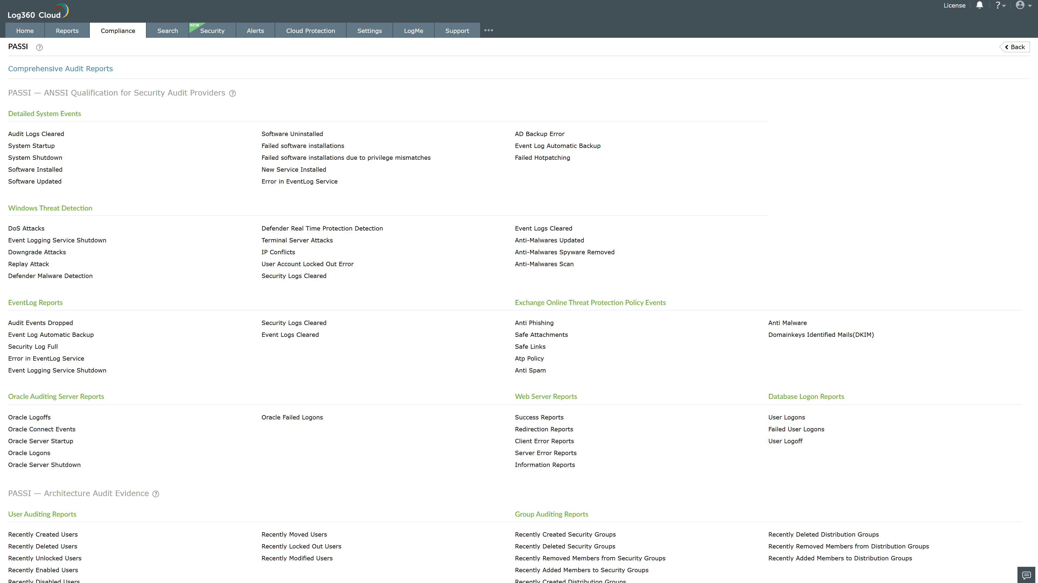
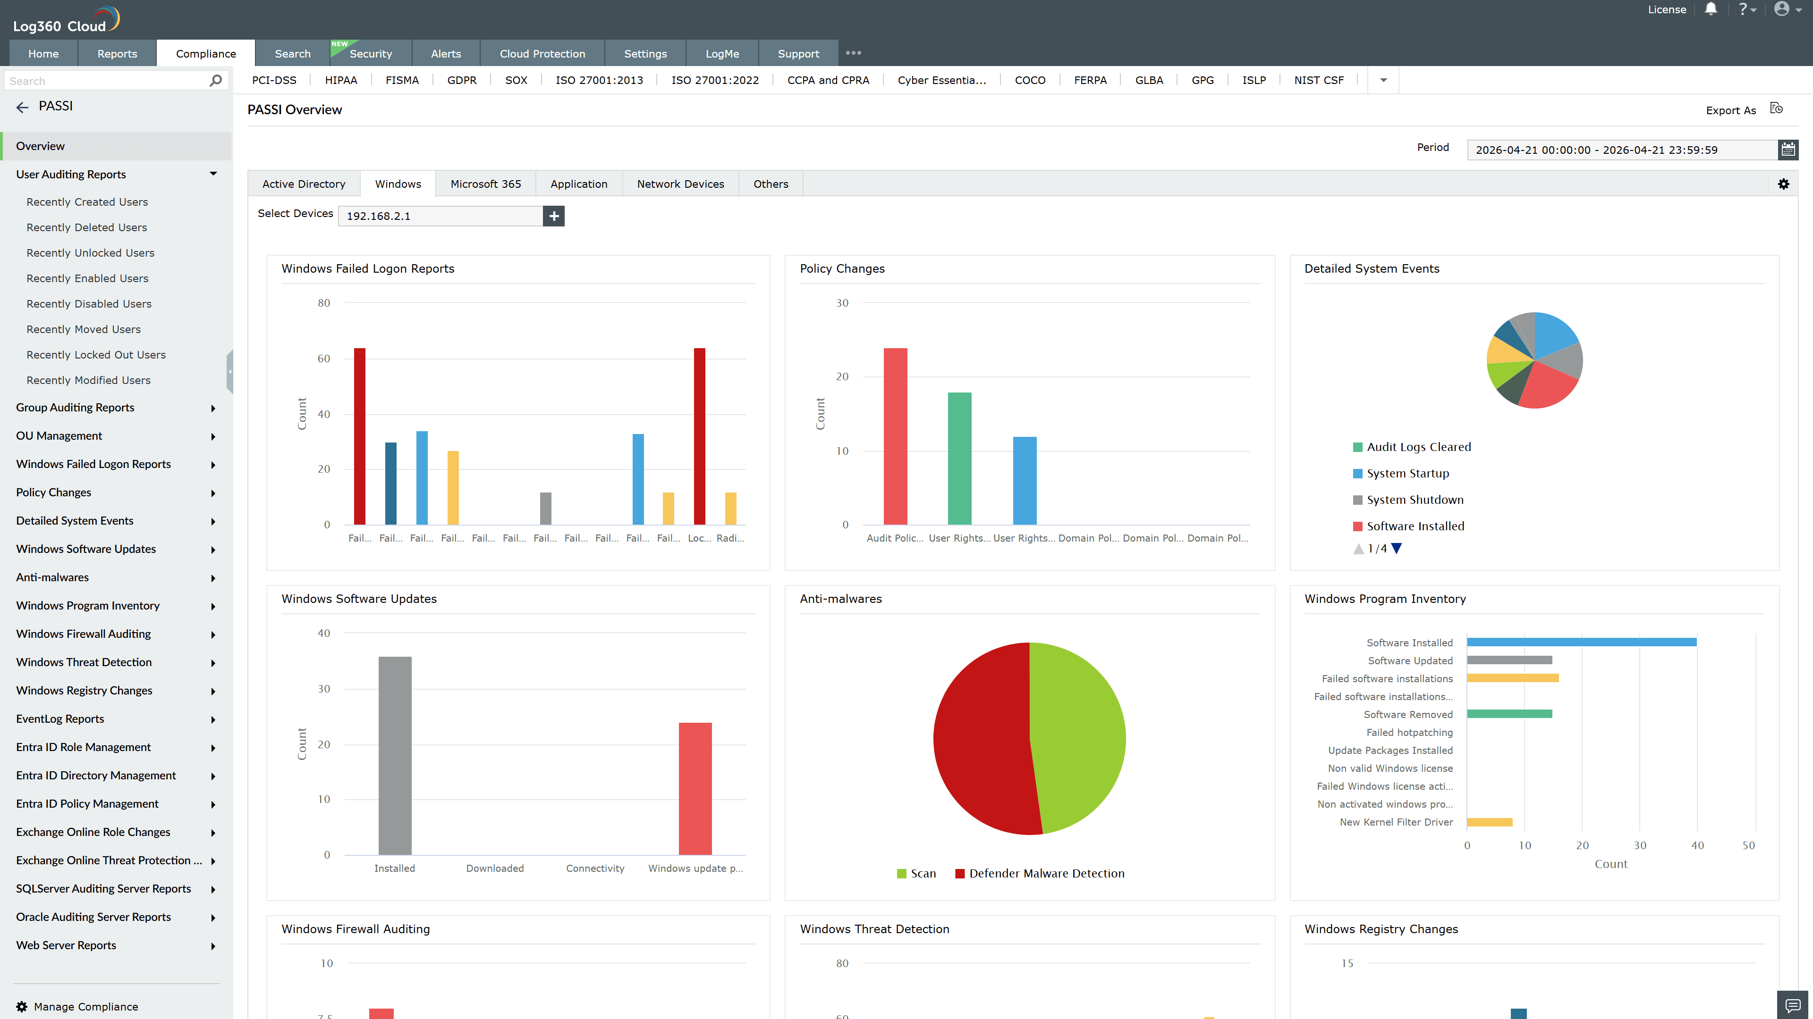
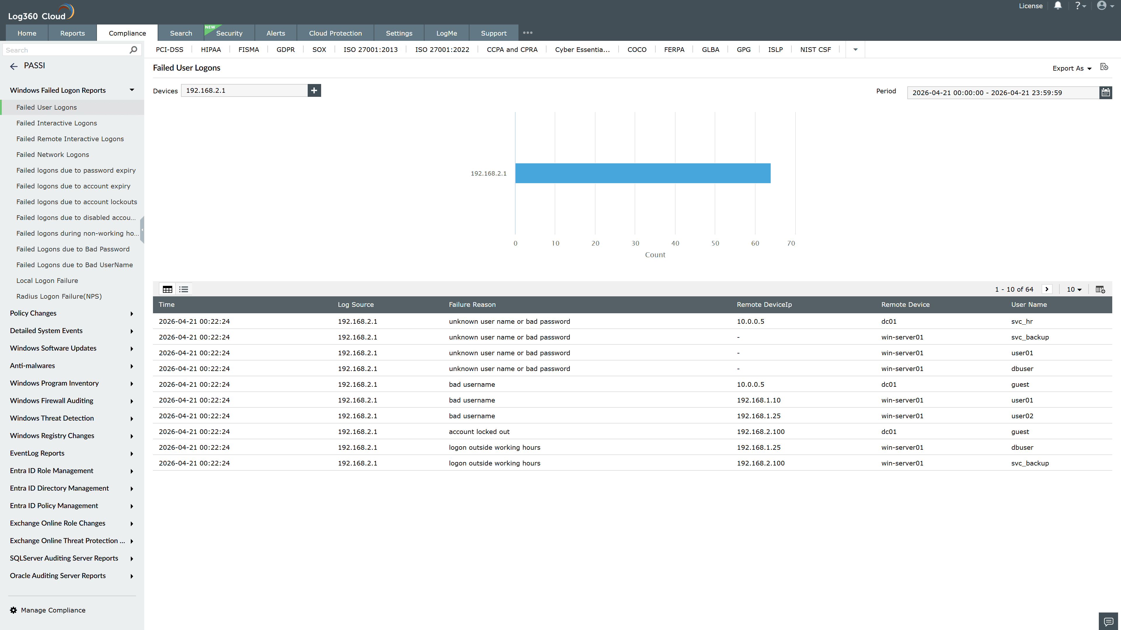
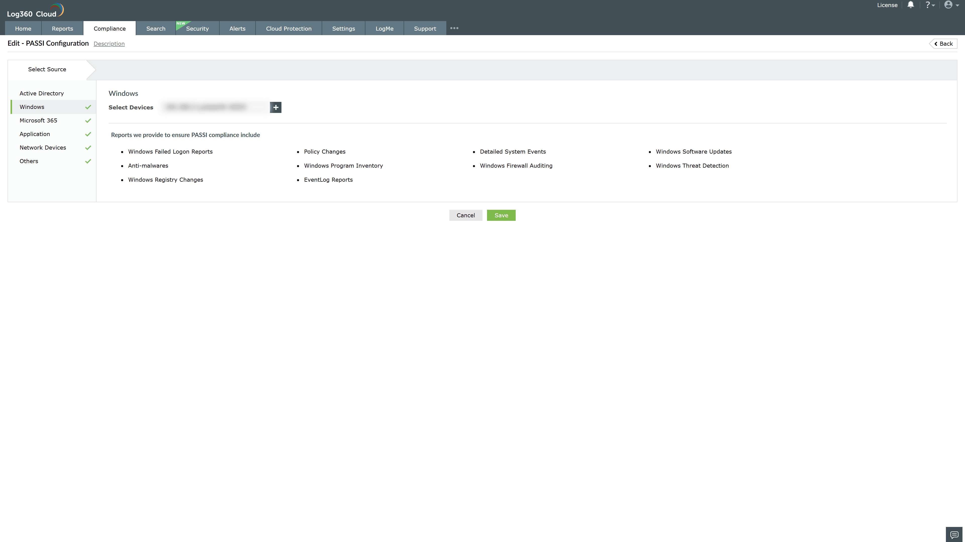
Valid Submission : Yes
Supported Editions : Free, Basic, Standard, Professional, MSSP
Help Document : https://www.manageengine.com/log-management/help/integrations/compliance-extensions.html
Help Video : Not provided
Tags : Log360, Compliance, Privacy monitoring, Data privacy, Regulatory compliance
Supported DCs : US, IN, JP, CA, AU, UK and EU
Privacy Policy:
Terms of Service:
Release Notes:
Predefined reports for the PASSI Compliance

