PGSSI-S Compliance for Log360
Tagline: Implement France's PGSSI-S with unified monitoring from Log360.

Overview
The PGSSI-S (Politique Générale de Sécurité des Systèmes d'Information de Santé) Compliance extension for Log360 enables French healthcare organizations, hospitals, and health information system operators to implement the security monitoring and access control requirements of the PGSSI-S framework published by ANS.
Log360 collects and correlates logs from health information systems, electronic health records, cloud platforms, and network infrastructure, providing security teams with continuous visibility into patient data access and system events. Compliance teams can track PGSSI-S control adherence and generate audit evidence for HAS and ANS oversight.

Key Features
- Generate predefined compliance reports aligned to PGSSI-S security requirements covering patient data access, user authentication, and clinical system monitoring.
- Monitor health information systems for unauthorized access to patient records, anomalous user behavior, and security policy violations in real time.
- Centralize and correlate security events across clinical systems, EHR platforms, and health data infrastructure to maintain continuous visibility into access patterns and security posture aligned with PGSSI-S audit and traceability requirements.
- Export PGSSI-S compliance documentation in PDF and CSV formats for ANS reporting and internal healthcare information security governance.



Screenshots
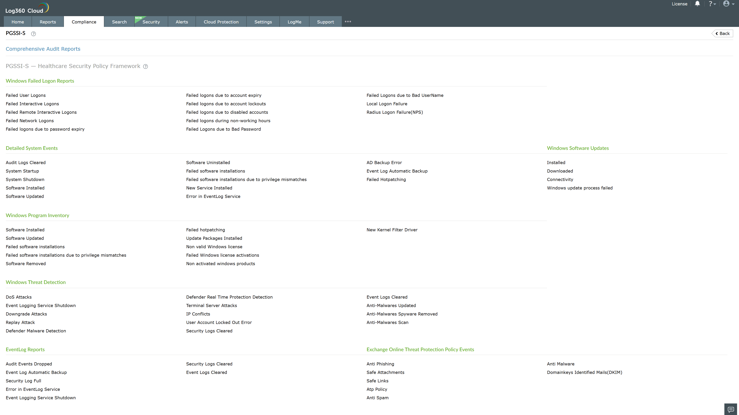
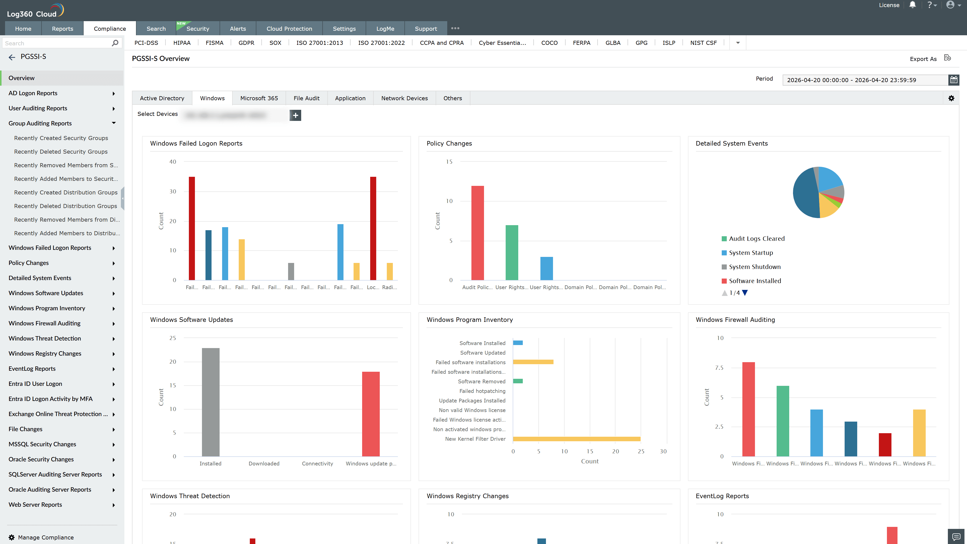
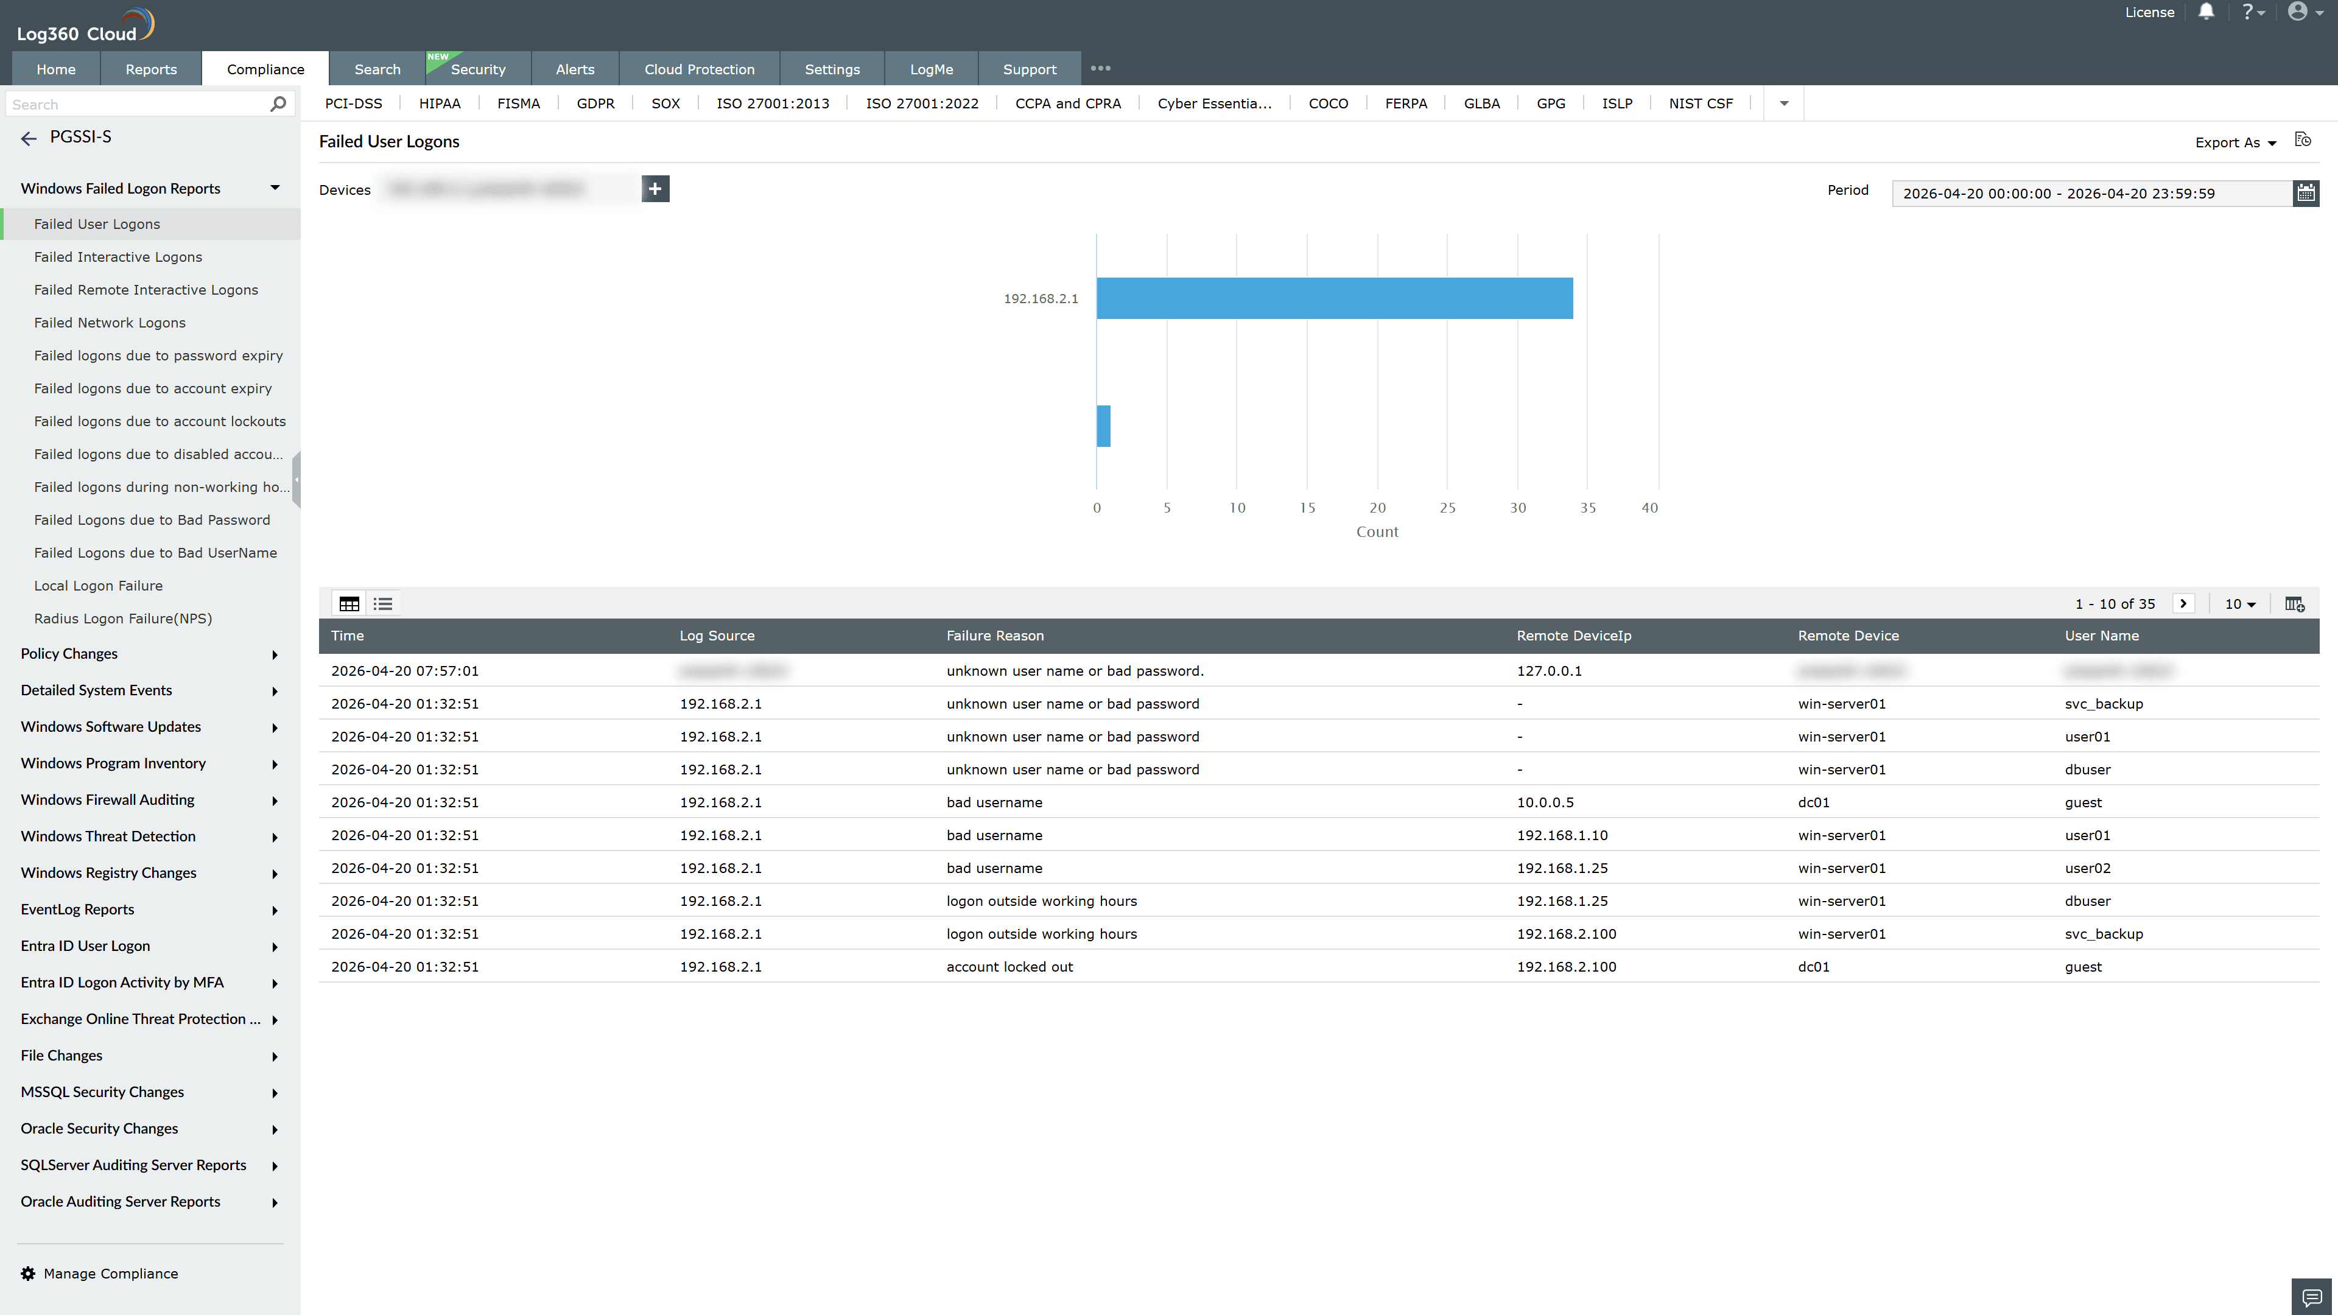
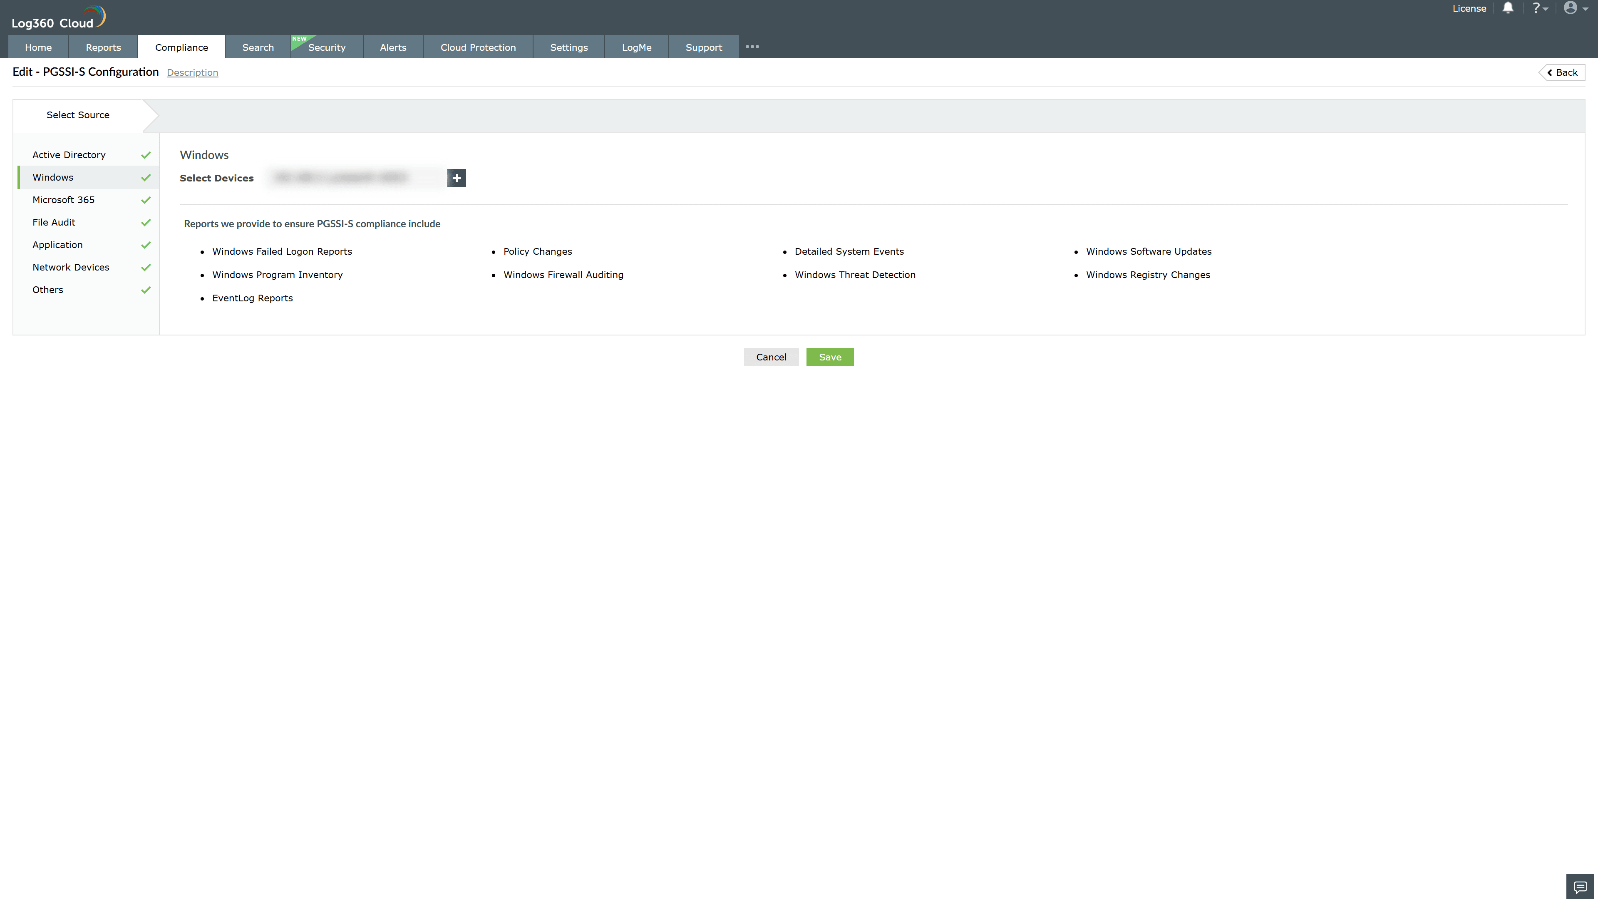
Valid Submission : Yes
Supported Editions : Free, Basic, Standard, Professional, MSSP
Help Document : https://www.manageengine.com/log-management/help/integrations/compliance-extensions.html
Help Video : Not provided
Tags : Log360, Compliance, Privacy monitoring, Data privacy, Regulatory compliance
Supported DCs : US, IN, JP, CA, AU, UK and EU
Privacy Policy:
Terms of Service:
Release Notes:
Predefined reports for the PGSSI-S Compliance

